Accessions/ Fruit characters | Collec-  tor ID | Fruit weight (gm) | Fruit length (cm) | Fruit width (cm) | Pulp weight (gm) | Pulp (%) | Seed weight (gm) | Seed (%) | No. of seeds | Shell weight (gm) | Shell (%) | Shell thickness (mm) | Pulp: shell
B-1 | 14/24 | 1478.80ª | 10.60ª | 11.60ª | 894.30ª | 60.477^{b} | 50.^{40e} | 3.407^{n} | 38 | 534.10ª | 36.117^{gh} | 2.50^{c} | 1.67^{ab}
B-2 | 13/20 | 605.60^{d} | 8.55^{d} | 8.70^{d} | 320.80e | 52.97 ^{e} | 48.80^{g} | 8.06^{j} | 37 | 236.00^{c} | 38.97^{ef} | 2.50^{c} | 1.36^{bc}
B-3 | 11/22 | 503.00^{g} | 9.10^{b} | 7.95^{ef} | 273.10^{g} | 54.29 ^{de} | 28.40^{m} | 5.647^{m} | 20 | 201.50^{g} | 40.06e | 2.40^{d} | 1.36^{bc}
B-4 | 13/19 | 587.70de | 8.35e | 7.75^{gh} | 354.40^{d} | 60.303^{b} | 35.30^{k} | 6.01^{m} | 27 | 198.00^{gh} | 33.69^{j} | 2.50^{c} | 1.79^{ab}
B-5 | 18/6 | 255.20^{m} | 7.40^{gh} | 6.60^{l} | 38.70^{r} | 15.163^{op} | 55.00^{c} | 21.553ª | 45 | 161.50^{k} | 63.283ª | 2.50^{c} | 0.24^{g}
B-6 | 14/9 | 573.20e | 7.50^{g} | 7.85^{fg} | 321.10e | 56.02 ^{cd} | 42.80^{i} | 7.467^{kl} | 33 | 209.30^{f} | 36.513^{gh} | 2.60^{b} | 1.53^{bc}
B-7 | 12/20 | 412.40^{j} | 7.40^{gh} | 7.05^{k} | 229.70^{i} | 55.69 ^{cd} | 43.00^{i} | 10.427^{f} | 33 | 139.70^{l} | 33.877^{ij} | 2.40^{d} | 1.64^{ab}
B-8 | 12/21 | 691.20^{c} | 9.05^{bc} | 9.00^{c} | 421.60^{c} | 61^{ab} | 52.00^{d} | 7.523^{k} | 40 | 217.60e | 31.483^{k} | 1.80^{f} | 1.94ª
B-9 | 18/2 | 353.20^{k} | 7.90^{f} | 6.65^{l} | 93.9 | 26.583^{m} | 65.00ª | 18.407^{c} | 50 | 194.30^{hi} | 55.01^{b} | 2.50^{c} | 0.48^{g}
B-10 | 11/23 | 359.20^{k} | 7.15^{i} | 7.50^{ij} | 206.50^{j} | 57.487^{c} | 30.00^{l} | 8.35^{ij} | 23 | 122.70^{m} | 34.16^{ij} | 2.50^{c} | 1.68^{ab}
B-11 | 12/23 | 527.30^{f} | 8.90^{c} | 8.10e | 287.40^{f} | 54.50 ^{de} | 52.00^{d} | 9.86^{gh} | 42 | 187.90^{ij} | 35.633^{hi} | 2.20e | 1.53^{bc}
B-12 | 18/14 | 293.60^{l} | 6.65^{j} | 6.35^{m} | 146.70^{m} | 49.967^{f} | 29.00^{lm} | 9.877^{gh} | 20 | 117.90^{m} | 40.157e | 2.50^{c} | 1.24^{cd}
B-13 | 14/6 | 484.80^{gh} | 7.25^{hi} | 7.65^{hi} | 203.80^{j} | 42.04^{hi} | 50.00^{ef} | 10.313^{fg} | 44 | 231.00^{cd} | 47.65^{cd} | 2.70ª | 0.88^{cde}
B-14 | 18/5 | 461.50^{i} | 8.40de | 7.40^{j} | 186.30^{k} | 40.367^{ij} | 49.00^{fg} | 10.62^{f} | 44 | 226.20^{d} | 49.01^{c} | 2.50^{c} | 0.82^{cde}
B-15 | 12/19 | 482.80^{h} | 8.45de | 7.40^{j} | 255.60^{h} | 52.94e | 45.20^{h} | 9.36^{h} | 38 | 182.00^{j} | 37.697^{fg} | 2.50^{c} | 1.40^{cd}
B-16 | 18/9 | 372.90^{k} | 8.45de | 8.55^{d} | 229.80^{i} | 61.623^{ab} | 38.50^{j} | 10.323^{fg} | 24 | 104.60^{n} | 28.05^{l} | 2.50^{c} | 2.20ª
B-17 | 12/10 | 427.80^{j} | 7.35^{gh} | 7.35^{j} | 165.60^{m} | 38.71^{j} | 58.60^{b} | 13.697e | 48 | 203.60^{fg} | 47.593^{cd} | 2.50^{c} | 0.81^{cde}
B-18 | 12/7 | 1007.20^{b} | 10.55ª | 9.70^{b} | 631.00^{b} | 62.65ª | 35.80^{k} | 3.553^{n} | 25 | 340.40^{b} | 33.797^{ij} | 2.70ª | 1.85ª
B-19 | 10/3 | 290.20^{l} | 5.50^{k} | 6.30^{m} | 130.00^{n} | 44.797^{g} | 20.20^{op} | 6.96l | 14 | 140.00^{l} | 48.243^{c} | 2.50^{c} | 0.93^{cd}
B-20 | 11/2 | 230.00^{n} | 4.55^{m} | 5.40^{n} | 100.00^{op} | 43.477^{gh} | 20^{op} | 8.697^{i} | 13 | 110.00^{n} | 47.827^{cd} | 2.70ª | 0.91^{cde}
B-21 | 11/3 | 108.10^{op} | 4.65^{m} | 5.30^{n} | 36.00^{rs} | 33.303^{k} | 22.10^{n} | 20.447^{b} | 15 | 50.00^{op} | 46.253^{d} | 2.60^{b} | 0.72^{ef}
B-22 | 10/2 | 95.4^{op} | 4.65^{m} | 4.85^{op} | 32.00^{rs} | 33.543^{k} | 19.4^{op} | 20.337^{b} | 12 | 44^{op} | 46.123^{d} | 2.5^{c} | 0.73^{ef}
B-23 | 9/3 | 88^{op} | 4.95^{l} | 4.75^{op} | 26.00st | 29.543^{l} | 12.00^{t} | 13.637e | 8 | 50^{op} | 56.817^{b} | 2.60^{b} | 0.52^{fg}
B-24 | 9/2 | 79^{op} | 3.50^{n} | 3.25^{r} | 15.00^{t} | 18.99^{n} | 14.00^{s} | 17.72^{d} | 10 | 50^{op} | 63.293ª | 2.50^{c} | 0.30^{g}

Accessions/ Fruit characters | Collec-  tor ID | TSS (⁰B) | Total sugars (g/100g) | Carotenoids (µg/g fw) | FRAP (mg AEAC/100g) | DPPH (mg AEAC/100g) | Vitamin C (mg/100g) | Acidity (%) | Total phenols (mg GAE/g fw) | Flavonoids (mg CE/g fw)
B-1 | 14/24 | 33^{bcd} | 25.07ª | 5.68^{ghi} | 146.66^{abcd} | 89.90^{cdefgh} | 35.42^{hi} | 0.12^{l} | 12.56^{lm} | 24.97^{ij}
B-2 | 13/20 | 36ª | 17.16^{gh} | 5.24^{ij} | 148.99^{abc} | 85.17^{h} | 37.72^{hi} | 0.45^{hijk} | 20.69^{cd} | 49.34^{d}
B-3 | 11/22 | 33b^{cd} | 16.15^{hi} | 6.53^{efg} | 148.02^{abc} | 94.36^{abc} | 56.58^{cd} | 0.43^{ijk} | 21.39^{c} | 57.65^{c}
B-4 | 13/19 | 34^{abc} | 21.78^{cd} | 8.78^{c} | 148.22^{abc} | 85.26^{gh} | 64.86^{ab} | 0.56^{fgh} | 23.44^{ab} | 55.62^{c}
B-5 | 18/6 | 28^{f} | 5.91^{l} | 6.46^{fgh} | 145.50^{abcd} | 90.52^{cdefg} | 58.88^{c} | 0.35^{jk} | 16.05^{jk} | 26.82^{hi}
B-6 | 14/9 | 32^{cd} | 15.19^{i} | 4.96^{ijk} | 148.41^{abc} | 90.08^{cdefgh} | 49.22^{ef} | 0.36^{jk} | 18.00^{gh} | 49.40^{d}
B-7 | 12/20 | 34^{abc} | 21.04de | 3.98^{klm} | 150.16^{ab} | 90.17^{cdefgh} | 48.76^{ef} | 0.34^{k} | 19.38e | 47.92^{d}
B-8 | 12/21 | 33^{bcd} | 23.96^{ab} | 4.88^{ijk} | 150.16^{ab} | 92.04^{abcdef} | 47.84^{ef} | 0.34^{k} | 18.30^{fg} | 55.70^{c}
B-9 | 18/2 | 27^{f} | 22.11^{bcd} | 11.26^{b} | 145.69^{abcd} | 90.79^{bcdef} | 68.08ª | 0.69de | 20.01de | 29.70^{h}
B-10 | 11/23 | 34^{abc} | 21.03de | 3.33^{lm} | 150.93^{ab} | 93.38^{abcd} | 46.00^{ef} | 0.61^{ef} | 22.89^{b} | 74.63ª
B-11 | 12/23 | 36ª | 23.71^{abc} | 3.25^{m} | 146.47^{abcd} | 88.20^{defgh} | 32.20^{i} | 0.69de | 19.31^{ef} | 38.50^{f}
B-12 | 18/14 | 35^{ab} | 17.72^{fgh} | 3.40^{lm} | 145.11^{abcd} | 92.22^{abcde} | 34.04^{hi} | 0.55^{fghi} | 15.43^{jk} | 42.78e
B-13 | 14/6 | 33^{bcd} | 23.75^{ab} | 6.31^{fgh} | 145.50^{abcd} | 92.13^{abcdef} | 45.08^{f} | 0.61^{ef} | 22.84^{b} | 69.14^{b}
B-14 | 18/5 | 29^{ef} | 11.59^{j} | 3.52^{lm} | 141.62^{cdef} | 96.24ª | 49.22^{ef} | 0.59^{efg} | 17.55^{gh} | 27.63^{hi}
B-15 | 12/19 | 33^{bcd} | 19.05^{fg} | 4.30^{jkl} | 142.59^{bcde} | 89.45^{cdefgh} | 38.64^{gh} | 0.59^{ef} | 22.95^{b} | 57.05^{c}
B-16 | 18/9 | 29^{ef} | 19.48^{ef} | 14.96ª | 139.29^{defg} | 85.26^{gh} | 44.16^{fg} | 0.51^{fghi} | 15.19^{k} | 37.23^{fg}
B-17 | 12/10 | 31de | 22.09^{bcd} | 5.88^{fghi} | 138.52^{defg} | 94.27^{abc} | 58.42^{c} | 0.58^{efg} | 24.39ª | 66.41^{b}
B-18 | 12/7 | 33^{bcd} | 17.20^{gh} | 4.00^{klm} | 133.47^{fghi} | 90.35^{cdefgh} | 36.80^{hi} | 0.47^{ghij} | 16.38^{ij} | 34.49^{g}
B-19 | 10/3 | 33^{bcd} | 6.86^{kl} | 5.48^{hi} | 129.40^{hi} | 89.19^{cdefgh} | 59.34^{bc} | 1.11^{bc} | 11.66^{m} | 15.91^{lm}
B-20 | 11/2 | 34^{abc} | 7.61^{kl} | 10.29^{b} | 125.32^{i} | 96.06^{ab} | 64.86^{ab} | 0.75^{d} | 13.16^{l} | 16.51^{l}
B-21 | 11/3 | 32^{cd} | 8.15^{k} | 8.27^{cd} | 129.98^{hi} | 86.86^{fgh} | 62.10^{bc} | 1.21^{ab} | 13.40^{l} | 18.96^{bl}
B-22 | 10/2 | 33^{bcd} | 3.92^{n} | 8.23^{cd} | 128.43^{i} | 87.22^{efgh} | 58.88^{c} | 1.23ª | 12.69^{lm} | 16.78^{l}
B-23 | 9/3 | 34^{abc} | 1.56^{n} | 6.84^{ef} | 136.77^{efgh} | 85.35^{gh} | 51.52de | 1.20^{ab} | 15.76^{jk} | 21.25^{jk}
B-24 | 9/2 | 34^{abc} | 1.99^{mn} | 7.50de | 131.144^{ghi} | 91.24^{abcdef} | 23.00^{j} | 1.03^{c} | 17.12^{hi} | 12.32^{m}

Supplementary Table S1. Analysis of variance for various pomological traits in 24 A. marmelos genotypes. Means followed by similar case letters in each column are not significantly different (p>0.05)

 | PC1 | PC2 | PC3 | PC4
Fruit_weight | -0.25 | 0.16 | -0.29 | 0.00
Fruit_length | -0.27 | -0.01 | -0.12 | -0.11
Fruit_width | -0.28 | 0.09 | -0.14 | -0.12
Pulp_weight | -0.25 | 0.24 | -0.22 | 0.00
Seed_weight | -0.19 | -0.36 | -0.20 | -0.21
Seeds_number | -0.18 | -0.39 | -0.20 | -0.13
Shell_weight | -0.23 | 0.06 | -0.39 | 0.01
Shell_thickness | 0.10 | 0.09 | -0.16 | -0.02
Pulp: shell | -0.23 | 0.26 | 0.27 | -0.11
Pulp_per | -0.23 | 0.27 | 0.25 | -0.01
Seed_per | 0.21 | -0.27 | -0.08 | -0.18
Shell_per | 0.22 | -0.24 | -0.31 | 0.12
TSS | -0.27 | -0.11 | 0.13 | -0.02
Total_sugars | -0.26 | -0.12 | 0.12 | -0.13
Carotenoids | 0.11 | 0.06 | 0.01 | -0.65
FRAP | -0.22 | -0.24 | 0.14 | 0.02
DPPH | -0.03 | -0.20 | -0.14 | 0.45
Vitamin_C | 0.09 | -0.14 | 0.02 | -0.44
Acidity_per | 0.26 | 0.10 | 0.07 | -0.05
Total_phenols | -0.13 | -0.37 | 0.31 | 0.08
Flavonoids | -0.19 | -0.24 | 0.37 | 0.10
TSS: acidity | -0.25 | 0.04 | -0.17 | 0.03
Variance | 76.553 | 8.716 | 6.946 | 2.561
% Total variance | 76.553 | 85.269 | 92.215 | 94.776

Supplementary Table S2. Eigenvectors of principal component axes from the PCA for morphological and biochemical characters in A. marmelos genotypes.

Source | df | SS | MS | Est. Var. | %
Among Pops | 1 | 59.396 | 59.396 | 5.740 | 70%
Within Pops | 22 | 54.437 | 2.474 | 2.474 | 30%
Total | 23 | 113.833 |  | 8.214 | 100%
Stat | Value | P(rand >= data)
PhiPT | 0.699 | 0.001

Supplementary Table S3. AMOVA analysis of genetic variances within and among populations of A. marmelos

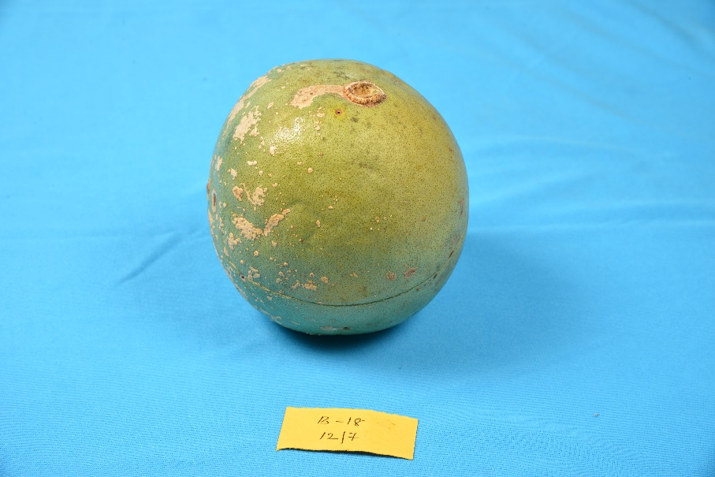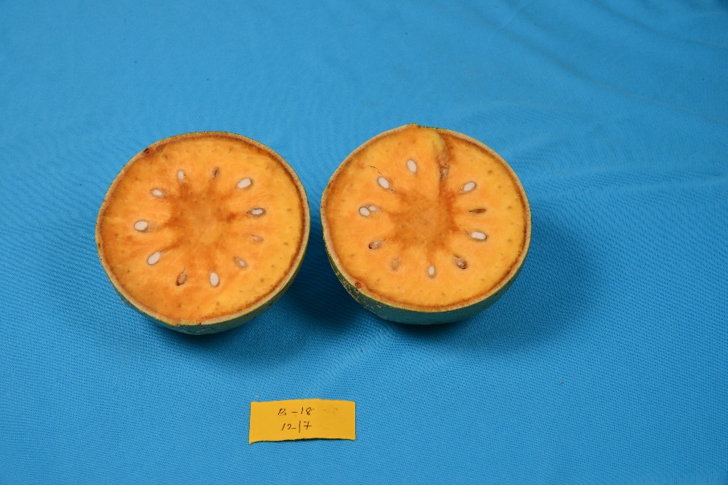
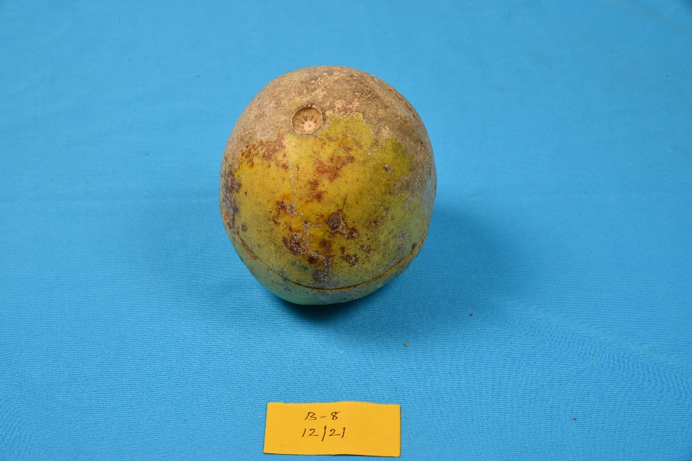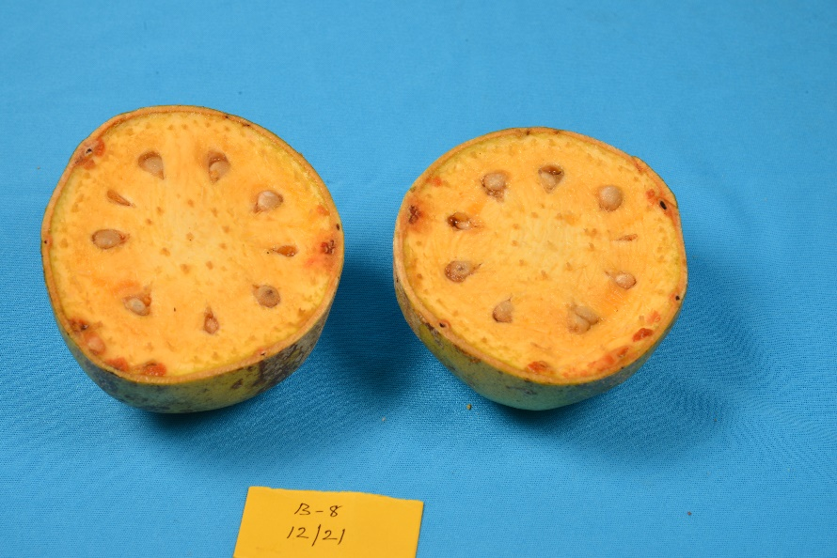
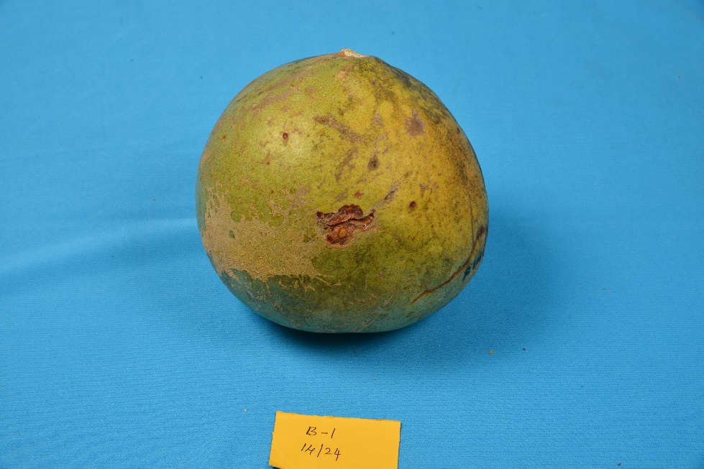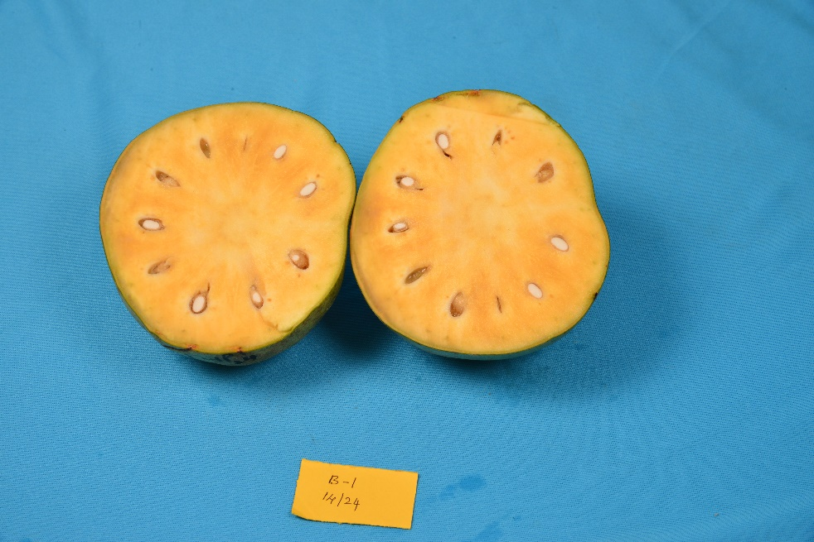
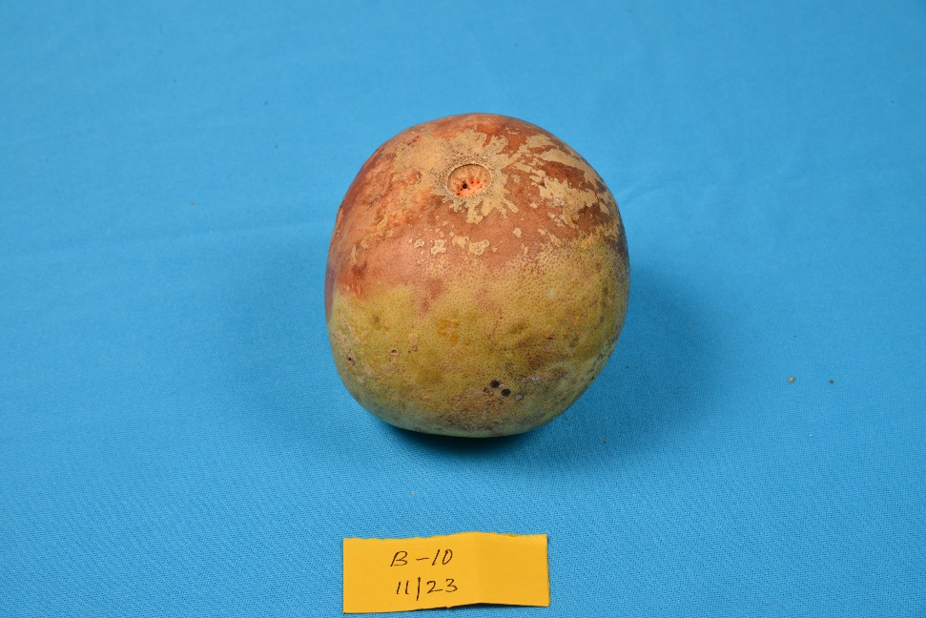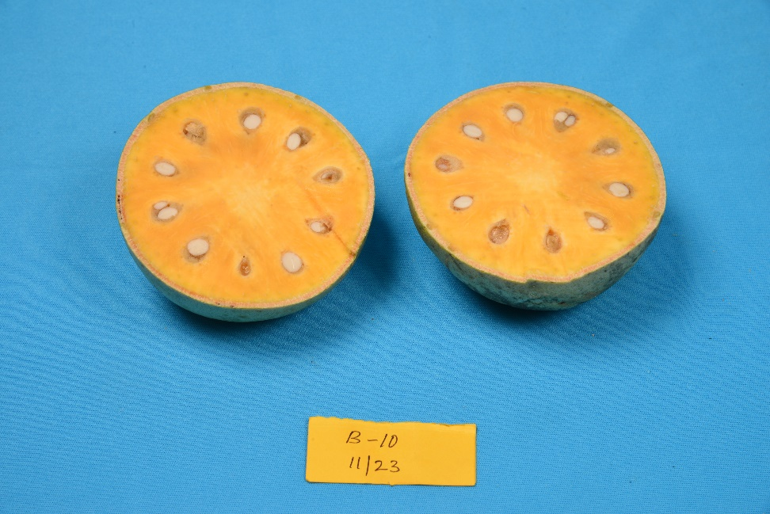
Supplementary Figure S1: The whole and cut fruits of genotype B18, B8, B1and B10 identified as superior in the study.

