Tables
Table 1. Details of the cardamom accessions used in the genetic diversity analysis
Sl. No | Name of the land race/ variety | Type | Source | Remarks
1 | ACC 1 | Vazhukka | Selection from Appangala region | Around 3 panicles per tiller, small globose shaped light green capsules
2 | ALFRED CLONE | Malabar | From farmers’ field | Presence of both terminal and basal panicle
3 | BEP 1 | Vazhukka | Selection from farmers’ field | Close internodes between raceme
4 | BEP 2 | Vazhukka |  | Four panicles per tiller, light green color capsules
5 | CHETTI 1 | Malabar | Selection from farmers’ field | Short stature
6 | CHETTI 2 | Malabar |  | Tolerant to pest and diseases
7 | CHETTI 3 | Malabar
8 | CLONE 37 | Malabar | From Indian Institute of Spices Research (ISSR) Regional Station, Appangala | Released as Appangala 1
9 | CLONE 57 | Malabar | From IISR Regional Station, Appangala | Globose light green capsule
10 | COM.PAN | Malabar | Collection from Kodagu region. | Branched panicles
11 | GREEN GOLD | Vazhukka | Famers variety of Idukki | High yield with quick fertilizer response
12 | HEMA | Vazhukka |  | Seventeen seeds per capsule
13 | MANJURABAD | Malabar | From Shakleshpur | Three to four panicles per tiller
14 | MBP | Malabar | Collection from Kodagu | Multibranched panicles
15 | MCC 11 | - | From Indian Cardamom Research Institute, Myladumapra
16 | MCC 40 | Malabar | From Indian Cardamom Research Institute, Myladumapra | High yielder
17 | MCC 61 | Vazhukka | From Indian Cardamom Research Institute, Myladumapra | Released as ICRI 2
18 | MINI PINK | Malabar | Pampadumpara region | Pink coloration at the base of the pseudostem
19 | PINK BASE | Malabar | Pampadumpara region | Pink coloration in the pseudostem
20 | PPK 1 | Vazhukka | Selection from farmers field | Long bold capsules
21 | PPK 2 | Vazhukka | Selection form green gold, Farmers variety | Extra-long panicle but smaller capsules
22 | PRO 17 | - | - | Light green colored rhizome
23 | PRO 107 | - | - | Lower surface of leaf is glabrous
24 | PS 10 | Malabar | Plant selection from Cardamom Research Station | Elongated green color bold capsules
25 | PS 12 | Vazhukka | - do - | Three panicles per tiller
26 | PS 13 | Malabar | - do - | Globose light green capsules
27 | PS 14 | Malabar | - do - | Round and light green-color bold capsules
28 | PS 16 | Vazhukka | - do - | Elongated light green bold capsules
29 | PS 17 | Malabar | - do - | Light green color capsules
30 | PS 18 | Vazhukka | - do - | Elongated light green color capsules
31 | PS 19 | Vazhukka | - do - | Elongated green capsules
32 | PS 2 | Malabar | - do - | Bold elongated light green color capsules
33 | PS 21 | Vazhukka | - do - | Elongated light green capsules
34 | PS 22 | Vazhukka | - do - | Light green color bold capsules
35 | PS 23 | Malabar | - do - | Elongated green capsule
36 | PS 24 | Malabar | - do - | Green elongated bold capsules
37 | PS 25 | Malabar | - do - | Elongated light green capsules
38 | PS 26 | Malabar | - do - | Around fourteen seeds per capsule
39 | PS 27 | Malabar | - do - | High yielder with bold capsules
40 | PS 28 | Malabar | - do - | Green elongated capsules
41 | PS 29 | Malabar | - do - | Green elongated bold capsules
42 | PS 30 | Malabar | - do - | Bold elongated light green color capsules
43 | PS 31 | Vazhukka | - do - | Bold elongated green color capsules
44 | PS 32 | Malabar | - do - | Bold elongated green color capsules
45 | PS 4 | Malabar | - do - | Green elongated bold capsules
46 | PS 5 | Malabar | - do - | Green elongated bold capsules
47 | PS 7 | Malabar | - do - | Light green globose shaped capsules
48 | PS 8 | Vazhukka | - do - | Light green globose shaped capsules
49 | PS 9 | Vazhukka | Plant selection from Cardamom Research Station | Elongated green capsules
50 | PV 10 | Mysore | - do - | Light green color rhizome
51 | PV 11 | Vazhukka | - do - | Glabrous leaves
52 | PV 12 | Vazhukka | - do - | Elongated bold green color capsules
53 | PV 2 | Vazhukka | - do - | Bold elongated light green color capsule
54 | PV 33 | Malabar | Cardamom Research Station, Pampadumpara | Light green elongated capsule
55 | PV 34 | Malabar | Cardamom Research Station, Pampadumpara | Higher volatile oil content
56 | PV 5 | Malabar | - do - | Light green color globose shaped capsules
57 | PV 6 | Malabar | - do - | Dark green color capsules
58 | PV 7 | Malabar | - do - | Poor yielder
59 | PV 8 | Mysore | - do - | Narrow leaf lamina
60 | PV1 | Malabar | Cardamom Research Station, Pampadumpara | Released variety with long thin capsules
61 | S 1 | Malabar | Seedling selection from commercial plantation of Cardamom Research Station | Higher yielder with long bold dark green capsules
62 | Sinchona sel | Mysore |  | Light green color capsules
63 | Type 1 | Malabar | Seedling selection from the Malabar types | Around eighteen seeds per capsule
64 | Type 103 | Malabar | Seedling selection from the Malabar types | Around ten seeds per capsule
65 | Type 4 | Malabar | Seedling selection from Cardamom Research Station, Pampadumpara | Light green color rhizome
66 | Type 6 | Malabar | Seedling selection from Cardamom Research Station, Pampadumpara | Globose shaped light green color capsules
67 | VEERAPUTHRAN | Malabar | From Indian Cardamom Research Institute, Myladumapra | Released as ICRI 1 variety.

Table 2. Pooled analysis (2016-2018) of yield and biotic stress characters
Name of cultivar | Wet weight (g) | Dry weight (g) | 100 capsules weight | Incidence of thrips (%) | Incidence of borer (%) | Incidence of Azhukal (%)
ACC 1 | 1373.500 | 297.000 | 97.000 | 21.656 | 0.707 | 1.171
ALFRED CLONE | 922.500 | 163.000 | 92.500 | 19.358 | 0.977 | 0.707
BEP 1 | 2103.500 | 456.500 | 104.000 | 12.494 | 0.707 | 0.707
BEP 2 | 2034.000 | 445.000 | 94.000 | 25.411 | 1.171 | 1.225
CHETTI 1 | 2074.500 | 319.000 | 75.000 | 27.271 | 0.977 | 0.707
CHETTI 2 | 1137.000 | 209.000 | 105.500 | 20.889 | 0.977 | 0.707
CHETTI 3 | 930.500 | 172.000 | 99.000 | 25.741 | 1.171 | 1.171
CLONE 37 | 421.500 | 87.500 | 89.000 | 16.430 | 0.707 | 0.707
CLONE 57 | 1772.500 | 90.500 | 116.000 | 18.787 | 0.707 | 1.171
COM.PAN | 1610.166 | 367.500 | 104.000 | 13.554 | 1.331 | 0.977
GREENGOLD | 1865.000 | 399.000 | 103.500 | 25.463 | 1.728 | 0.707
HEMA | 210.300 | 46.500 | 76.500 | 15.105 | 0.977 | 0.707
MANJURABAD | 1016.500 | 187.500 | 98.000 | 26.176 | 1.559 | 1.225
MBP | 2001.000 | 405.500 | 99.000 | 20.257 | 1.225 | 0.707
MCC 11 | 1060.500 | 200.500 | 100.500 | 25.411 | 1.595 | 0.707
MCC 40 | 910.500 | 178.500 | 94.500 | 17.171 | 0.977 | 0.707
MCC 61 | 1170.000 | 185.000 | 101.500 | 21.837 | 1.171 | 1.171
MINI PINK | 289.500 | 63.000 | 88.000 | 23.033 | 0.977 | 1.331
PINK BASE | 160.500 | 34.625 | 95.000 | 17.948 | 1.470 | 0.707
PPK 1 | 1623.000 | 334.500 | 115.000 | 21.898 | 1.693 | 0.707
PPK 2 | 3051.000 | 509.000 | 81.000 | 22.396 | 0.707 | 1.171
PR 17 | 456.000 | 103.000 | 83.500 | 16.833 | 1.171 | 0.707
PRO 107 | 259.500 | 59.000 | 92.500 | 22.455 | 0.707 | 0.707
PS 10 | 2635.500 | 558.000 | 107.000 | 18.824 | 0.707 | 0.707
PS 12 | 2166.500 | 454.500 | 104.000 | 20.584 | 0.977 | 1.171
PS 13 | 1891.500 | 411.000 | 102.500 | 14.535 | 1.693 | 0.707
PS 14 | 1566.750 | 319.000 | 92.500 | 18.265 | 1.171 | 0.707
PS 16 | 2580.500 | 194.000 | 86.000 | 14.049 | 0.707 | 0.707
PS 17 | 412.150 | 79.000 | 85.000 | 7.759 | 0.977 | 0.707
PS 18 | 1383.500 | 203.500 | 95.500 | 19.166 | 0.707 | 0.707
PS 19 | 1022.500 | 207.500 | 94.000 | 33.825 | 1.331 | 0.707
PS 2 | 1571.000 | 322.350 | 94.000 | 19.533 | 0.707 | 0.707
PS 21 | 1208.500 | 233.500 | 111.000 | 12.746 | 1.581 | 0.977
PS 22 | 1655.500 | 273.500 | 115.500 | 19.166 | 1.581 | 1.331
PS 23 | 1337.333 | 376.000 | 104.000 | 11.477 | 1.470 | 0.707
PS 24 | 887.500 | 163.000 | 99.000 | 25.161 | 1.331 | 0.707
PS 25 | 995.000 | 184.000 | 104.000 | 45.407 | 0.707 | 0.707
PS 26 | 1515.000 | 319.000 | 101.000 | 28.308 | 0.707 | 0.977
PS 27 | 2478.500 | 459.500 | 98.500 | 15.956 | 0.707 | 0.707
PS 28 | 3018.000 | 560.000 | 100.000 | 28.956 | 0.977 | 0.707
PS 29 | 1016.000 | 201.500 | 102.500 | 10.611 | 1.225 | 0.977
PS 30 | 493.500 | 89.500 | 87.500 | 13.481 | 0.977 | 0.707
PS 31 | 630.000 | 139.000 | 82.500 | 15.240 | 1.331 | 0.977
PS 32 | 1175.500 | 234.000 | 86.500 | 18.741 | 1.171 | 0.707
PS 4 | 1321.000 | 263.500 | 88.500 | 10.765 | 1.559 | 0.707
PS 5 | 1488.000 | 331.500 | 93.500 | 15.889 | 0.977 | 0.707
PS 7 | 692.000 | 113.500 | 73.000 | 11.021 | 0.707 | 0.707
PS 8 | 676.000 | 107.000 | 91.500 | 14.707 | 1.693 | 0.977
PS 9 | 1011.500 | 224.500 | 91.500 | 20.495 | 1.171 | 1.171
PV 10 | 1643.000 | 367.500 | 91.000 | 14.764 | 0.977 | 0.707
PV 11 | 620.500 | 131.500 | 89.000 | 17.948 | 0.707 | 0.707
PV 12 | 1321.500 | 266.500 | 103.500 | 15.846 | 1.728 | 0.707
PV 2 | 918.500 | 204.000 | 92.000 | 25.489 | 0.707 | 0.707
PV 33 | 718.000 | 139.500 | 91.000 | 26.720 | 0.707 | 0.707
PV 34 | 476.000 | 90.000 | 96.500 | 19.680 | 0.707 | 0.707
PV 5 | 407.250 | 92.500 | 84.000 | 16.739 | 1.559 | 0.977
PV 6 | 161.500 | 35.000 | 83.500 | 22.384 | 0.707 | 0.977
PV 7 | 249.500 | 42.166 | 74.000 | 18.421 | 1.225 | 0.707
PV 8 | 422.500 | 139.500 | 75.000 | 17.777 | 0.707 | 0.707
PV1 | 905.000 | 186.000 | 90.500 | 29.374 | 1.225 | 0.977
S 1 | 1291.000 | 225.900 | 100.000 | 18.880 | 1.171 | 0.977
Sinchona sel | 2516.500 | 440.500 | 106.500 | 23.292 | 0.707 | 0.977
Type 1 | 855.000 | 155.500 | 106.000 | 20.889 | 1.171 | 0.707
Type 103 | 1027.500 | 203.000 | 103.000 | 17.441 | 0.977 | 0.707
Type 4 | 609.000 | 136.000 | 100.500 | 16.078 | 1.171 | 0.977
Type 6 | 256.000 | 49.500 | 112.000 | 18.824 | 0.707 | 0.707
VEERAPUTHRAN | 655.500 | 149.000 | 98.500 | 14.049 | 0.707 | 0.707
CV | 50.203 | 68.197 | 31.431 | 32.641 | 28.704 | 24.1
CD (1%) | 1266.21 | 350.814 | 65.540 | 13.494 | 0.647 | 0.425
CD (5 %) | 963.42 | 266.92 | 49.864 | 10.267 | 0.492 | 0.323

Table 2.1 Pooled analysis (2016) of yield and biotic stress characters
Name of cultivar | Wet weight (g) | Dry weight (g) | 100 capsules weight | Incidence of thrips (%) | Incidence of borer (%) | Incidence of Azhukal (%)
ACC 1 | 1373.5 | 297 | 97 | 14 | 0 | 1
ALFRED CLONE | 922.5 | 163 | 92.5 | 11 | 0.5 | 0
BEP 1 | 2103.5 | 456.5 | 104 | 5 | 0 | 0
BEP 2 | 2034 | 445 | 94 | 18.5 | 1 | 1
CHETT 1 | 2074.5 | 319 | 75 | 21 | 0.5 | 0
CHETTI 2 | 1137 | 209 | 105.5 | 13 | 0.5 | 0
CHETTI 3 | 930.5 | 172 | 99 | 19.5 | 1 | 1
CLONE 37 | 421.5 | 87.5 | 89 | 8 | 0 | 0
CLONE 57 | 421.5 | 90.5 | 116 | 11.5 | 0 | 1
COM.PAN | 1772.5 | 367.5 | 104 | 5.5 | 1.5 | 0.5
GREENGOLD | 1865 | 399 | 103.5 | 18.5 | 2.5 | 0
HEMA | 210.3 | 46.5 | 76.5 | 7 | 0.5 | 0
MANJURABAD | 1016.5 | 187.5 | 98 | 19.5 | 2 | 1
MBP | 2001 | 405.5 | 99 | 12 | 1 | 0
MCC 11 | 1060.5 | 200.5 | 100.5 | 18.5 | 2.5 | 0
MCC 40 | 910.5 | 178.5 | 94.5 | 9 | 0.5 | 0
MCC 61 | 1170 | 185 | 101.5 | 14 | 1 | 1
MINI PINK | 289.5 | 63 | 88 | 17 | 0.5 | 1.5
PINK BASE | 160.5 | 34.625 | 95 | 9.5 | 2 | 0
PPK 1 | 1623 | 334.5 | 115 | 14 | 2.5 | 0
PPK 2 | 3051 | 509 | 81 | 15 | 0 | 1
PR 17 | 456 | 103 | 83.5 | 8.5 | 1 | 0
PRO 107 | 259.5 | 59 | 92.5 | 15.5 | 0 | 0
PS 10 | 2635.5 | 558 | 107 | 10.5 | 0 | 0
PS 12 | 2166.5 | 454.5 | 104 | 13.5 | 0.5 | 1
PS 13 | 1891.5 | 411 | 352.5 | 7.5 | 2.5 | 0
PS 14 | 1566.75 | 319 | 92.5 | 10.5 | 1 | 0
PS 16 | 2580.5 | 194 | 86 | 6 | 0 | 0
PS 17 | 412.15 | 79 | 85 | 4 | 0.5 | 0
PS 18 | 1383.5 | 203.5 | 95.5 | 11 | 0 | 0
PS 19 | 1022.5 | 207.5 | 94 | 33.5 | 1.5 | 0
PS 2 | 1571 | 322.35 | 94 | 13 | 0 | 0
PS 21 | 1208.5 | 233.5 | 111 | 5 | 2 | 0.5
PS 22 | 1655.5 | 273.5 | 115.5 | 11 | 2 | 1.5
PS 23 | 1910.5 | 376 | 104 | 4 | 2 | 0
PS 24 | 887.5 | 163 | 99 | 19 | 1.5 | 0
PS 25 | 995 | 184 | 104 | 50.5 | 0 | 0
PS 26 | 1515 | 1319 | 101 | 22.5 | 0 | 0.5
PS 27 | 2478.5 | 459.5 | 98.5 | 8.5 | 0 | 0
PS 28 | 3018 | 560 | 100 | 23.5 | 0.5 | 0
PS 29 | 1016 | 201.5 | 102.5 | 3.5 | 1 | 0.5
PS 30 | 493.5 | 89.5 | 87.5 | 5.5 | 0.5 | 0
PS 31 | 630 | 139 | 82.5 | 7 | 1.5 | 0.5
PS 32 | 1175.5 | 234 | 86.5 | 10.5 | 1 | 0
PS 4 | 1321 | 263.5 | 88.5 | 3.5 | 2 | 0
PS 5 | 1488 | 331.5 | 93.5 | 7.5 | 0.5 | 0
PS 7 | 692 | 113.5 | 73 | 8 | 0 | 0
PS 8 | 676 | 107 | 91.5 | 6.5 | 2.5 | 0.5
PS 9 | 1011.5 | 224.5 | 91.5 | 12.5 | 1 | 1
PV 10 | 1643 | 367.5 | 91 | 6.5 | 0.5 | 0
PV 11 | 620.5 | 131.5 | 89 | 9.5 | 0 | 0
PV 12 | 1321.5 | 266.5 | 103.5 | 8 | 2.5 | 0
PV 2 | 918.5 | 204 | 92 | 19.5 | 0 | 0
PV 33 | 718 | 139.5 | 91 | 21 | 0 | 0
PV 34 | 476 | 90 | 96.5 | 11.5 | 0 | 0
PV 5 | 407.25 | 92.5 | 84 | 9 | 2 | 0.5
PV 6 | 161.5 | 35 | 83.5 | 16.5 | 0 | 0.5
PV 7 | 249.5 | 42.5 | 74 | 10 | 1 | 0
PV 8 | 422.5 | 139.5 | 75 | 20 | 0 | 0
PV1 | 905 | 186 | 90.5 | 24.5 | 1 | 0.5
S 1 | 1291 | 225.9 | 100 | 11 | 1 | 0.5
Sinchona sel | 2516.5 | 440.5 | 106.5 | 18.5 | 0 | 0.5
Type 1 | 855 | 155.5 | 106 | 13 | 1 | 0
Type 103 | 1027.5 | 203 | 103 | 9 | 0.5 | 0
Type 4 | 609 | 136 | 100.5 | 8 | 1 | 0.5
Type 6 | 256 | 49.5 | 112 | 10.5 | 0 | 0
VEERAPUTHRAN | 655.5 | 149 | 98.5 | 6 | 0 | 0

Table 2.2 Pooled analysis (2017) of yield and biotic stress characters
Name of cultivar | Wet weight (g) | Dry weight (g) | 100 capsules weight | Incidence of thrips (%) | Incidence of borer (%) | Incidence of Azhukal (%)
ACC 1 | 1432 | 329 | 99 | 20 | 0 | 0
ALFRED CLONE | 605 | 78 | 95 | 12 | 1 | 0
BEP 1 | 2202 | 461 | 105 | 8 | 0 | 0
BEP 2 | 2053 | 440 | 93 | 22 | 0 | 1
CHETT 1 | 1199 | 231 | 75 | 20 | 0 | 0
CHETTI 2 | 1108 | 222 | 103 | 8 | 0 | 0
CHETTI 3 | 321 | 69 | 98 | 29 | 0 | 0
CLONE 37 | 250 | 52 | 88 | 8 | 0 | 0
CLONE 57 | 250 | 52 | 122 | 3 | 0 | 0
COM.PAN | 1078 | 239 | 103 | 6 | 3 | 0
GREENGOLD | 1750 | 363 | 102 | 20 | 2 | 0
HEMA | 120.6 | 25 | 75 | 10 | 1 | 0
MANJURABAD | 1407 | 282 | 98 | 17 | 3 | 1
MBP | 815 | 175 | 105 | 11 | 1 | 0
MCC 11 | 996 | 191 | 103 | 22 | 0 | 0
MCC 40 | 739 | 162 | 101 | 5 | 0 | 0
MCC 61 | 540 | 100 | 103 | 18 | 2 | 2
MINI PINK | 163 | 39 | 78 | 4 | 1 | 0
PINK BASE | 35 | 9.25 |  | 9 | 0 | 0
PPK 1 | 1666 | 368 | 120 | 11 | 4 | 0
PPK 2 | 3217 | 520 | 78 | 22 | 0 | 0
PR 17 | 299 | 71 | 92 | 6 | 0 | 0
PRO 107 | 226 | 48 | 87 | 6 | 0 | 0
PS 10 | 871 | 181 | 109 | 13 | 0 | 0
PS 12 | 733 | 159 | 108 | 23 | 1 | 2
PS 13 | 983 | 202 | 105 | 14 | 1 | 0
PS 14 | 1283.5 | 278 | 100 | 17 | 0 | 0
PS 16 | 1261 | 243 | 102 | 8 | 0 | 0
PS 17 | 14.3 | 3 |  |  | 0 | 0
PS 18 | 417 | 77 | 96 | 15 | 0 | 0
PS 19 | 645 | 140 | 103 | 60 | 0 | 0
PS 2 | 842 | 164.7 | 103 | 24 | 0 | 0
PS 21 | 217 | 47 | 112 | 7 | 2 | 0
PS 22 | 1856 | 287 | 121 | 15 | 2 | 0
PS 23 | 321 | 62 | 98 | 5 | 0 | 0
PS 24 | 305 | 61 | 113 | 30 | 0 | 0
PS 25 | 80 | 18 | 98 | 90 | 0 | 0
PS 26 | 1100 | 2248 | 107 | 21 | 0 | 1
PS 27 | 1357 | 289 | 97 | 15 | 0 | 0
PS 28 | 436 | 90 | 100 | 20 | 0 | 0
PS 29 | 232 | 43 | 110 | 2 | 1 | 0
PS 30 | 217 | 39 | 80 | 4 | 1 | 0
PS 31 | 380 | 78 | 85 | 9 | 0 | 0
PS 32 | 351 | 73 | 98 | 7 | 0 | 0
PS 4 | 1292 | 292 | 92 | 4 | 1 | 0
PS 5 | 676 | 198 | 102 | 8 | 0 | 0
PS 7 | 54 | 12 | 81 | 8 | 0 | 0
PS 8 | 52 | 9 | 83 | 8 | 1 | 1
PS 9 | 1458 | 329 | 113 | 17 | 0 | 2
PV 10 | 186 | 45 | 92 | 7 | 0 | 0
PV 11 | 673 | 161 | 80 | 9 | 0 | 0
PV 12 | 1805 | 380 | 114 | 13 | 3 | 0
PV 2 | 727 | 158 | 74 | 31 | 0 | 0
PV 33 | 766 | 164 | 102 | 32 | 0 | 0
PV 34 | 392 | 80 | 93 | 8 | 0 | 0
PV 5 | 81.5 | 17 | 73 | 3 | 1 | 0
PV 6 | 222 | 49 | 82 | 30 | 0 | 0
PV 7 | 276 | 43 | 68 | 9 | 1 | 0
PV 8 | 7 | 2 |  |  | 0 | 0
PV1 | 1320 | 271 | 96 | 34 | 1 | 0
S 1 | 1272 | 201.8 | 102 | 17 | 0 | 1
Sinchona sel | 1116 | 241 | 108 | 35 | 0 | 0
Type 1 | 295 | 61 | 110 | 8 | 2 | 0
Type 103 | 1365 | 253 | 95 | 8 | 1 | 0
Type 4 | 198 | 47 | 103 | 12 | 2 | 0
Type 6 | 132 | 24 | 116 | 13 | 0 | 0
VEERAPUTHRAN | 800 | 200 | 102 | 8 | 0 | 0

Table 2.3 Pooled analysis (2018) of yield and biotic stress characters
Name of cultivar | Wet weight (g) | Dry weight (g) | 100 capsules weight | Incidence of thrips (%) | Incidence of borer (%) | Incidence of Azhukal (%)
ACC 1 | 1315 | 265 | 95 | 8 | 0 | 2
ALFRED CLONE | 1240 | 248 | 90 | 10 | 0 | 0
BEP 1 | 2005 | 452 | 103 | 2 | 0 | 0
BEP 2 | 2015 | 450 | 95 | 15 | 2 | 1
CHETT 1 | 2950 | 407 | 75 | 22 | 1 | 0
CHETTI 2 | 1166 | 196 | 108 | 18 | 1 | 0
CHETTI 3 | 1540 | 275 | 100 | 10 | 2 | 2
CLONE 37 | 593 | 123 | 90 | 8 | 0 | 0
CLONE 57 | 593 | 129 | 110 | 20 | 0 | 2
COM.PAN | 2467 | 496 | 105 | 5 | 0 | 1
GREENGOLD | 1980 | 435 | 105 | 17 | 3 | 0
HEMA | 300 | 68 | 78 | 4 | 0 | 0
MANJURABAD | 626 | 93 | 98 | 22 | 1 | 1
MBP | 3187 | 636 | 93 | 13 | 1 | 0
MCC 11 | 1125 | 210 | 98 | 15 | 5 | 0
MCC 40 | 1082 | 195 | 88 | 13 | 1 | 0
MCC 61 | 1800 | 270 | 100 | 10 | 0 | 0
MINI PINK | 416 | 87 | 98 | 30 | 0 | 3
PINK BASE | 286 | 60 | 95 | 10 | 4 | 0
PPK 1 | 1580 | 301 | 110 | 17 | 1 | 0
PPK 2 | 2885 | 498 | 84 | 8 | 0 | 2
PR 17 | 613 | 135 | 75 | 11 | 2 | 0
PRO 107 | 293 | 70 | 98 | 25 | 0 | 0
PS 10 | 4400 | 935 | 105 | 8 | 0 | 0
PS 12 | 3600 | 750 | 100 | 4 | 0 | 0
PS 13 | 2800 | 620 | 600 | 1 | 4 | 0
PS 14 | 1850 | 360 | 85 | 4 | 2 | 0
PS 16 | 3900 | 145 | 70 | 4 | 0 | 0
PS 17 | 810 | 155 | 85 | 4 | 1 | 0
PS 18 | 2350 | 330 | 95 | 7 | 0 | 0
PS 19 | 1400 | 275 | 85 | 7 | 3 | 0
PS 2 | 2300 | 480 | 85 | 2 | 0 | 0
PS 21 | 2200 | 420 | 110 | 3 | 2 | 1
PS 22 | 1455 | 260 | 110 | 7 | 2 | 3
PS 23 | 3500 | 690 | 110 | 3 | 4 | 0
PS 24 | 1470 | 265 | 85 | 8 | 3 | 0
PS 25 | 1910 | 350 | 110 | 11 | 0 | 0
PS 26 | 1930 | 390 | 95 | 24 | 0 | 0
PS 27 | 3600 | 630 | 100 | 2 | 0 | 0
PS 28 | 5600 | 1030 | 100 | 27 | 1 | 0
PS 29 | 1800 | 360 | 95 | 5 | 1 | 1
PS 30 | 770 | 140 | 95 | 7 | 0 | 0
PS 31 | 880 | 200 | 80 | 5 | 3 | 1
PS 32 | 2000 | 395 | 75 | 14 | 2 | 0
PS 4 | 1350 | 235 | 85 | 3 | 3 | 0
PS 5 | 2300 | 465 | 85 | 7 | 1 | 0
PS 7 | 1330 | 215 | 65 |  | 0 | 0
PS 8 | 1300 | 205 | 100 | 5 | 4 | 0
PS 9 | 565 | 120 | 70 | 8 | 2 | 0
PV 10 | 3100 | 690 | 90 | 6 | 1 | 0
PV 11 | 568 | 102 | 98 | 10 | 0 | 0
PV 12 | 838 | 153 | 93 | 3 | 2 | 0
PV 2 | 1110 | 250 | 110 | 8 | 0 | 0
PV 33 | 670 | 115 | 80 | 10 | 0 | 0
PV 34 | 560 | 100 | 100 | 15 | 0 | 0
PV 5 | 733 | 168 | 95 | 15 | 3 | 1
PV 6 | 101 | 21 | 85 | 3 | 0 | 1
PV 7 | 223 | 42 | 80 | 11 | 1 | 0
PV 8 | 838 | 277 | 75 | 20 | 0 | 0
PV1 | 490 | 101 | 85 | 15 | 1 | 1
S 1 | 1310 | 250 | 98 | 5 | 2 | 0
Sinchona sel | 3917 | 640 | 105 | 2 | 0 | 1
Type 1 | 1415 | 250 | 102 | 18 | 0 | 0
Type 103 | 690 | 153 | 111 | 10 | 0 | 0
Type 4 | 1020 | 225 | 98 | 4 | 0 | 1
Type 6 | 380 | 75 | 108 | 8 | 0 | 0
VEERAPUTHRAN | 511 | 98 | 95 | 4 | 0 | 0

Table 3. Pooled analysis (2016-2018) of yield attributing characters
Accession | Plant height(cm) | No. of tillers/clump | No. of panicles/clump | No. of capsules/clump | Panicle length (cm) | No.of panicles /tiller) | Number of internodes/panicle | No. of seeds /capsule
ACC 1 | 266.66 | 28.66 | 12 | 466.3 | 42 | 3 | 22 | 16.1
Alfred clone | 152.66 | 44.66 | 3.33 | 501.3 | 39 | 3 | 22 | 16.7
BEP 1 | 295.33 | 27.66 | 18.33 | 1355.5 | 24 | 4 | 19 | 16.5
BEP 2 | 225 | 40.33 | 13 | 815.6 | 45 | 3 | 21 | 14.7
CHETTI 1 | 282 | 34.33 | 28.33 | 1041.3 | 25 | 2 | 19 | 12.3
CHETTI 2 | 265.66 | 19.66 | 15 | 1114.7 | 32 | 2 | 22 | 13.3
CHETTI 3 | 268.33 | 32.33 | 13 | 954.6 | 24 | 3 | 24 | 15.8
CLONE 37 | 256 | 35 | 18 | 1186.6 | 50 | 4 | 25 | 14.9
CLONE 57 | 228 | 41.66 | 18.33 | 1067.2 | 43 | 2 | 22 | 13.1
COM. PAN | 329.33 | 45.33 | 23 | 1502.2 | 85 | 3 | 34 | 14.7
GREEN GOLD | 255.33 | 26.33 | 8.33 | 1451.6 | 19 | 2 | 16 | 15.3
HEMA | 269.66 | 34 | 16.6 | 889 | 71 | 3 | 29 | 16.8
MANJURABAD | 220.33 | 48.66 | 8.6 | 924.3 | 25 | 3 | 17 | 17.1
MBP | 328.66 | 32.33 | 31 | 3139.2 | 69 | 2 | 34 | 11.8
MCC 11 | 266.2 | 26 | 21.66 | 2010.6 | 34 | 2 | 25 | 14.4
MCC 40 | 292 | 29 | 10 | 1041.2 | 19 | 1 | 16 | 11.7
MCC 61 | 241.33 | 28.33 | 5 | 156.3 | 12 | 1 | 7 | 13.1
MINI PINK | 306.66 | 21 | 14.66 | 178.4 | 43 | 3 | 21 | 11.7
PINK BASE | 245 | 24 | 9.33 | 203.3 | 55 | 3 | 1 | 14
PPK 1 | 213.66 | 51 | 24 | 739 | 30 | 3 | 14 | 12.7
PPK 2 | 261 | 32.33 | 31 | 1050.6 | 32 | 3 | 18 | 14.4
PRO107 | 291 | 32.66 | 23.66 | 1111.6 | 29 | 2 | 19 | 16.2
PRO17 | 260 | 23 | 23 | 450.6 | 14 | 2 | 11 | 16.6
PS 10 | 301 | 36 | 16.33 | 1637.6 | 39 | 3 | 20 | 11.5
PS 12 | 325 | 22.66 | 31.33 | 1895.9 | 49 | 3 | 20 | 20.3
PS 13 | 214 | 26.66 | 8.66 | 991.6 | 28 | 2 | 17 | 14.3
PS 14 | 210.66 | 38.33 | 7.33 | 790.9 | 42 | 4 | 22 | 12.8
PS 16 | 218.33 | 24 | 12 | 1158.6 | 39 | 3 | 20 | 15.4
PS 17 | 215 | 40.33 | 14.33 | 298 | 38 | 2 | 21 | 14.9
PS 18 | 330 | 24.66 | 40.66 | 783.2 | 47 | 2 | 12 | 12.9
PS 19 | 251.66 | 5.33 | 27.33 | 536.8 | 39 | 4 | 28 | 14.1
PS 2 | 270.66 | 23.33 | 3.66 | 1141.6 | 43 | 1 | 17 | 13.3
PS 21 | 274.66 | 18 | 5.66 | 673.3 | 21 | 2 | 20 | 19.9
PS 22 | 278.66 | 18.66 | 23.66 | 1207.8 | 63 | 1 | 17 | 15.4
PS 23 | 239.66 | 35 | 21.66 | 920 | 42 | 2 | 19 | 13.5
PS 24 | 295.33 | 30 | 33 | 1817.9 | 30 | 3 | 20 | 14.4
PS 25 | 264.33 | 35.66 | 20.66 | 409.3 | 63 | 2 | 33 | 13.7
PS 26 | 229 | 32 | 23 | 1356.9 | 18 | 2 | 30 | 14.3
PS 27 | 284.33 | 27.33 | 17 | 1433.5 | 23 | 3 | 19 | 11.3
PS 28 | 224 | 37.33 | 15.33 | 576.6 | 17 | 2 | 16 | 13.7
PS 29 | 265 | 32 | 28 | 1687.6 | 34 | 3 | 21 | 12.4
PS 30 | 252.33 | 31 | 20.33 | 779.9 | 34 | 2 | 25 | 10.4
PS 31 | 312.66 | 26 | 30.33 | 2050.5 | 60 | 2 | 24 | 17.3
PS 32 | 244 | 24 | 11 | 110 | 30 | 2 | 18 | 12.5
PS 4 | 290 | 24 | 23.33 | 1852.6 | 85 | 4 | 19 | 14.8
PS 5 | 318.33 | 24.6 | 15 | 1188.3 | 43 | 3 | 37 | 16.4
PS 7 | 288.3 | 31.66 | 36 | 1621.9 | 26 | 2 | 16 | 14.1
PS 8 | 296.66 | 31.33 | 16.66 | 430.5 | 30 | 2 | 13 | 10.6
PS 9 | 358 | 29 | 33.66 | 2674.4 | 45 | 2 | 21 | 15.6
PV 33 | 332.33 | 15.33 | 17.66 | 813.6 | 42 | 3 | 24 | 15.1
PV 34 | 269 | 23.33 | 11 | 529 | 20 | 2 | 16 | 12.8
PV1 | 156.33 | 31.33 | 4 | 474.5 | 15 | 2 | 8 | 9.6
PV10 | 234 | 46.33 | 14.66 | 132.9 | 26 | 2 | 16 | 9.4
PV11 | 207.66 | 37.66 | 27 | 273 | 19 | 1 | 11 | 12.5
PV12 | 216.66 | 62 | 8.6 | 261.9 | 33 | 2 | 19 | 13.5
PV2 | 220 | 35 | 20.3 | 558.2 | 40 | 4 | 11 | 12.1
PV5 | 277.33 | 43 | 17 | 589.2 | 68 | 2 | 23 | 14.1
PV6 | 242.33 | 37 | 24.33 | 719.9 | 50 | 2 | 21 | 15.3
PV7 | 194 | 31.33 | 8 | 326 | 14 | 2 | 10 | 10
PV8 | 215 | 44 | 12.66 | 281 | 10 | 2 | 9 | 8.1
S -1 | 340.66 | 33.66 | 37.33 | 2464 | 60 | 4 | 28 | 17.3
Sinchona sel. | 254.33 | 20 | 20 | 861.6 | 29 | 1 | 14 | 18.5
TYPE 1 | 294 | 53.66 | 29 | 602.3 | 30 | 2 | 16 | 18.5
Type 103 | 271.66 | 25 | 19.66 | 700.2 | 90 | 4 | 38 | 10.6
TYPE 4 | 282 | 33.66 | 16.3 | 267 | 24 | 2 | 15 | 11.9
TYPE 6 | 211 | 27 | 5 | 256.3 | 44 | 3 | 24 | 10.9
Veeraputhran | 356 | 38.33 | 46.66 | 1936.3 | 48 | 3 | 22 | 14.8
Mean | 263.3679 | 31.71269 | 18.86 | 1005 | 38.26 | 2.476 | 19.63 | 14.01
SD | 43.77519 | 9.566578 | 9.5737 | 647.9 | 18.21 | 0.831 | 6.913 | 2.4662
CV | 16.62 | 30.16 | 50.73 | 64.40 | 47.6 | 33.5 | 35.21 | 17.6
CD 0.01 | 8.778 | 4.298 | 4.189 | 4.325 | 3.943 | NA | 3.824 | 4.223
CD 0.05 | 6.679 | 3.271 | 3.187 | 3.291 | 3 | NA | 2.91 | 3.213

Table 4. Cluster details of landraces/cultivars
Cluster Number | Accessions included | Number of accessions | Central accession | Vazhukka | Mysore | Malabar
1 | ACC 1, PRO 17 | 2 | ACC 1 | 1
2 | Alfred clone, BEP 2, Chetti 1, Chetti 3, Hema, MCC 40, PPK 1, PRO 107, PS 14, PS 19, PS 23, PS 30, PS 5, PV 1, PV 6, Sinchona Sel. | 16 | Sinchona selection | 4 | 1 | 10
3 | BEP 1, Chetti 2, Clone 37, Clone 57, Compound panicle, Green gold, Manjurabad, MBP, MCC 11, Mini pink, PPK 2, PS 10, PS 12, PS 13, PS 16, PS 2, PS 22, PS 24, PS 26, PS 27, PS 29, PS 31, PS 4, PS 7,PS 9, S1, Veeraputhran | 27 | PS 7 | 8 |  | 18
4 | MCC 61 | 1 | MCC 61 | 1
5 | Pink base | 1 | Pink base |  |  | 1
6 | PS 17, PS 25, PS 8 | 3 | PS 25 | 1 |  | 2
7 | PS 18, PS 21, PS 28, PV 33, PV 34, PV 2, PV 5, PV 7, Type 1 | 9 | Type 1 | 3 |  | 6
8 | PS 32 | 1 | PS 32 |  |  | 1
9 | PV 10 | 1 | PV 10 |  | 1
10 | PV 11, PV 8 | 2 | PV 11 | 1 | 1
11 | PV 12 | 1 | PV 12 | 1
12 | Type 103 | 1 | Type 103 |  |  | 1
13 | Type 4 | 1 | Type 4 |  |  | 1
14 | Type 6 | 1 | Type 6 |  |  | 1

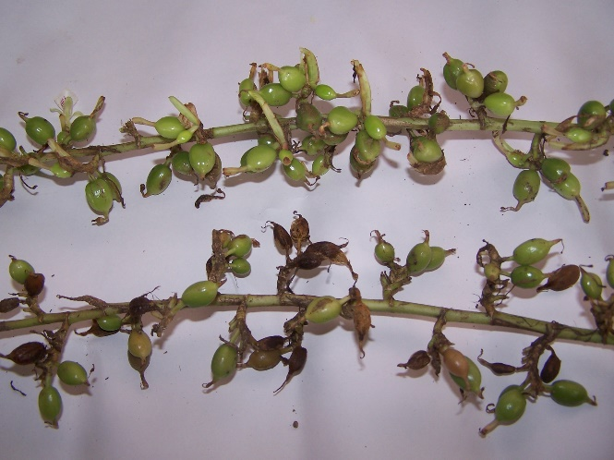
Fig.3: Mini Pink: Accession with highest incidence of Azhukal disease on cardamom capsules
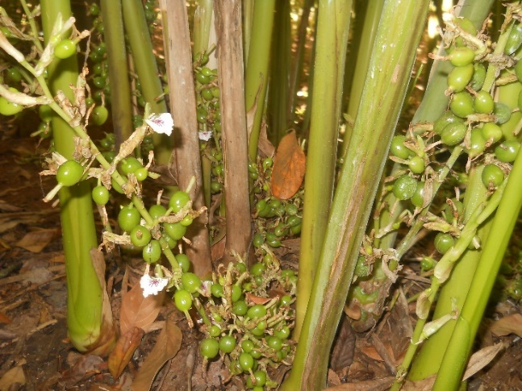
Fig 4: PPK2 – Accession with least incidence of Azhukal disease on cardamom capsules

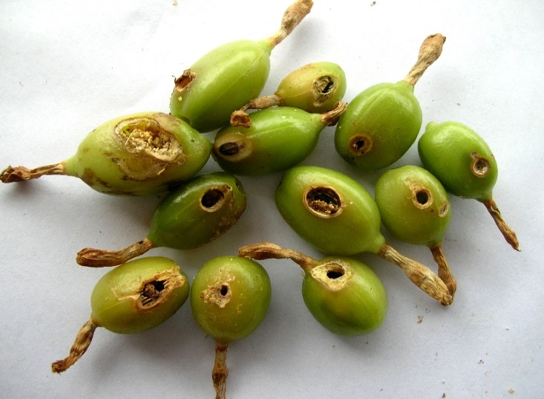
Fig 5: Green Gold - accession with the highest incidence of capsule borer.

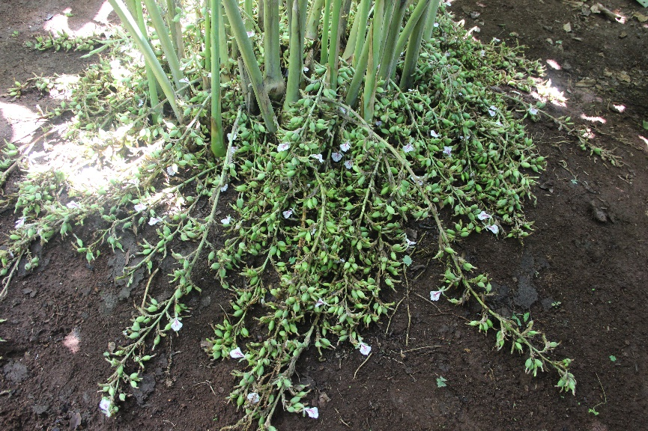
Fig 6: PS 27 - accession with the highest incidence of capsule borer.

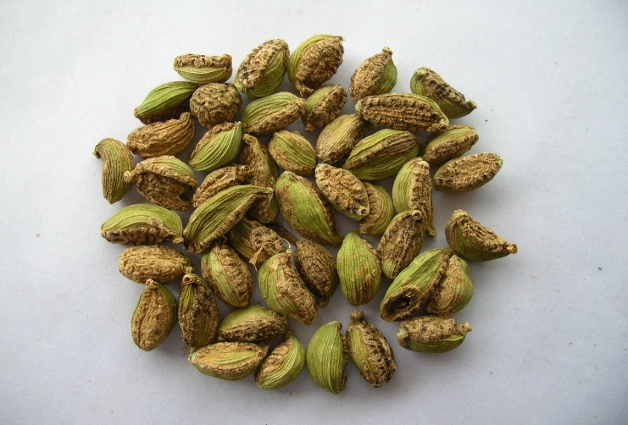
Fig 7: PS 25 - accession with the highest incidence of Thrips.

Fig 8: PS 23 - accession with the least incidence of Thrips.

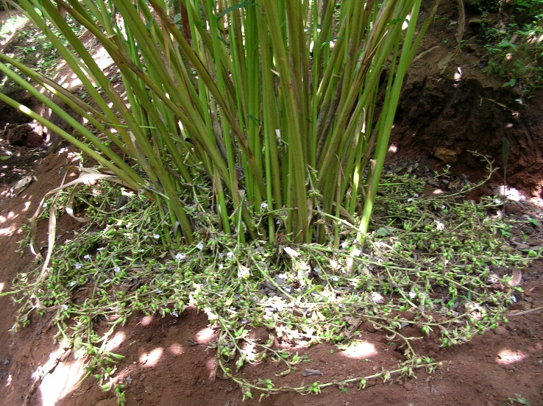
Fig 9: Malabar variety of Cardamom

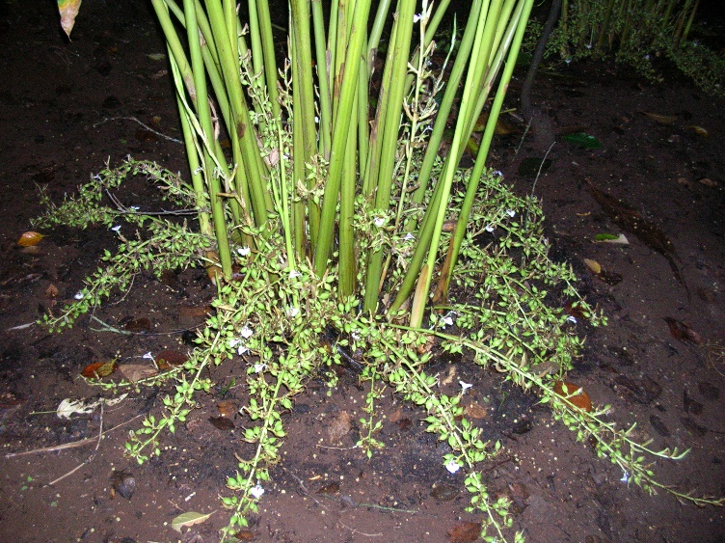
Fig 10: Vazhukka variety of Cardamom

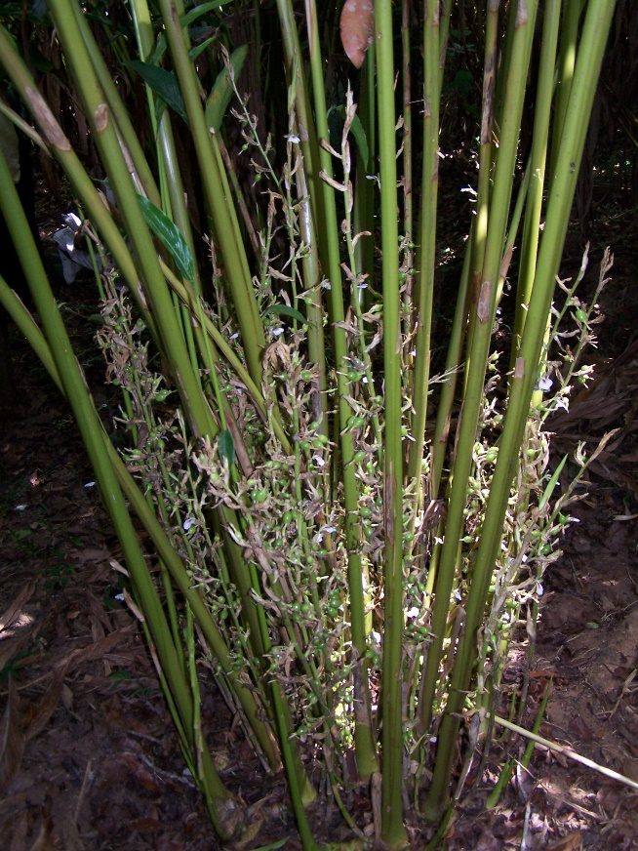
Fig 11: Mysore variety of Cardamom

