Table S1 Genetic diversity parameters in Ziziphus jujube cultivars based on SCoT marker.

POP | Na | Ne | I | He | uHe | %P
POP 1 | 0.385 | 1.018 | 0.013 | 0.009 | 0.011 | 1.92%
POP 2 | 0.750 | 1.114 | 0.106 | 0.069 | 0.077 | 21.15%
POP 3 | 0.404 | 1.018 | 0.013 | 0.009 | 0.011 | 1.92%
POP 4 | 0.692 | 1.079 | 0.091 | 0.056 | 0.064 | 21.15%
POP 5 | 0.692 | 1.141 | 0.120 | 0.082 | 0.098 | 21.15%
POP 6 | 0.423 | 1.027 | 0.023 | 0.016 | 0.018 | 3.85%
POP 7 | 0.692 | 1.153 | 0.134 | 0.089 | 0.102 | 25.00%
POP 8 | 0.385 | 1.083 | 0.061 | 0.043 | 0.049 | 9.62%
POP 9 | 0.558 | 1.132 | 0.119 | 0.079 | 0.088 | 23.08%
POP 10 | 0.442 | 1.050 | 0.048 | 0.031 | 0.035 | 9.62%

b Na: No. of alleles.
c Ne: Effective No. of alleles.
d He: Gene diversity.
e UHe: Unbiased gene diversity.
f %P: Polymorphism percentage.

Table S2 Genetic diversity parameters in Ziziphus jujube cultivars based on REMAP marker.

POP | Na | Ne | I | He | uHe | %P
POP 1 | 0.364 | 1.000 | 0.000 | 0.000 | 0.000 | 0.00%
POP 2 | 0.485 | 1.026 | 0.020 | 0.014 | 0.016 | 3.03%
POP 3 | 0.485 | 1.026 | 0.029 | 0.018 | 0.022 | 6.06%
POP 4 | 0.455 | 1.021 | 0.018 | 0.013 | 0.014 | 3.03%
POP 5 | 0.333 | 1.000 | 0.000 | 0.000 | 0.000 | 0.00%
POP 6 | 0.333 | 1.000 | 0.000 | 0.000 | 0.000 | 0.00%
POP 7 | 0.485 | 1.049 | 0.045 | 0.029 | 0.033 | 9.09%
POP 8 | 0.394 | 1.000 | 0.000 | 0.000 | 0.000 | 0.00%
POP 9 | 0.455 | 1.030 | 0.021 | 0.015 | 0.017 | 3.03%
POP 10 | 0.182 | 1.000 | 0.000 | 0.000 | 0.000 | 0.00%

b Na: No. of alleles.
c Ne: Effective No. of alleles.
d He: Gene diversity.
e UHe: Unbiased gene diversity.
f %P: Polymorphism percentage.

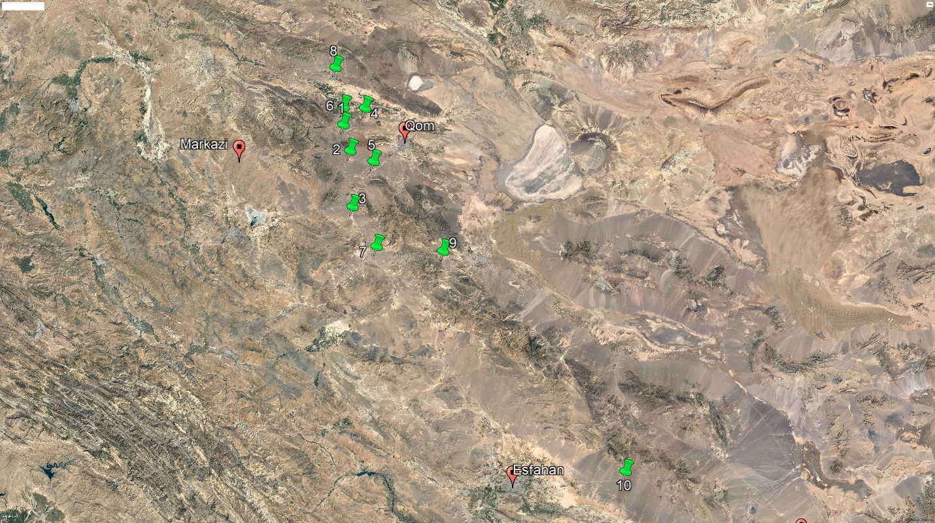
Fig. S1. Details of the studied populations in Ziziphus jujube.

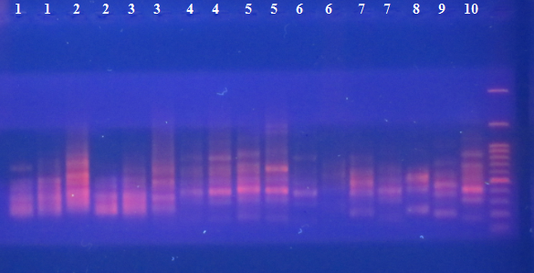
Fig. S2. Pattern of amplified DNA fragments with Scot2 primer.

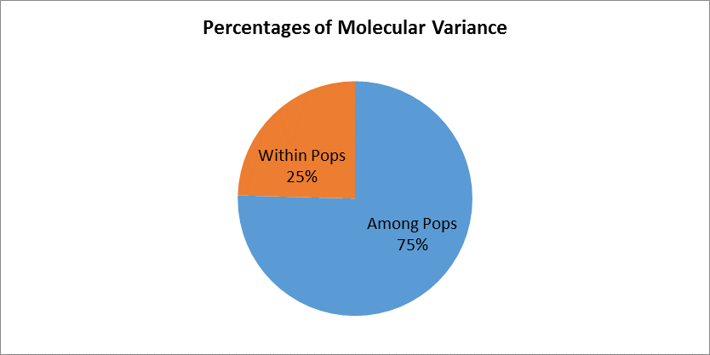
Fig. S3. AMOVA test based on SCoT marker.

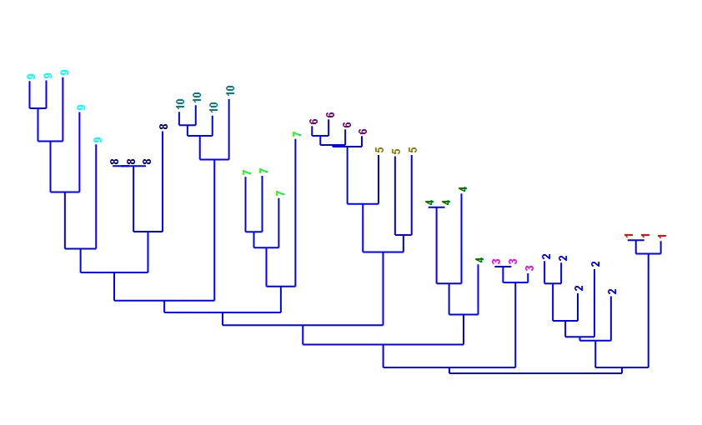
Fig. S4. NJ plot of SCoT marker in Ziziphus jujube.

Fig. S5. Pattern of amplified DNA fragments with REMAP primer.

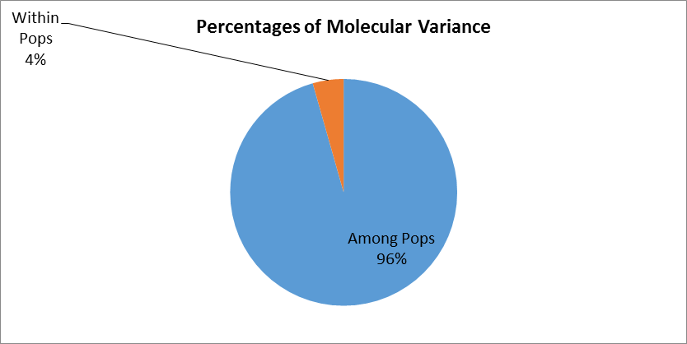

Fig. S6. AMOVA test based on REMAP marker.

