Supplementary Figure 1. Trajectories of healthcare utilization in patients on home-based palliative care
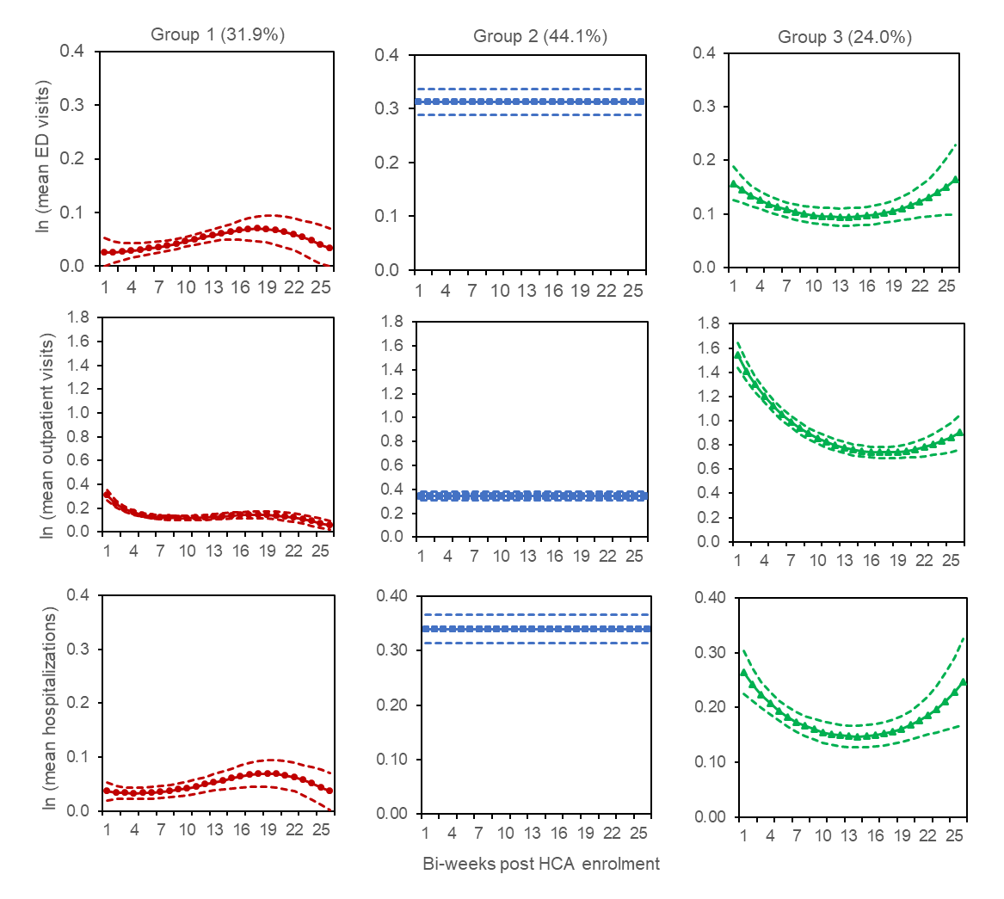Note: This qualitative study recruited family caregivers from group 1 (low stable) and group 2 (persistently high)

