SUPPLEMENTARY MATERIAL
“Left Behind” and an Undemocratic Mind?
The Link Between Perceived Marginalization and Democratic Orientations

A1 Data Distribution 3
A2 Survey Information 4
A3 Variables & Distribution 5
A3.1 Lack of Recognition 5
A3.1.1 Factor analysis 6
A3.1.2 Distribution & Correlation 9
A3.2 Socio-economic factors 10
A3.3 Individual-level subjective perception of disadvantage 11
A3.4 Covariates 12
A3.5 Democracy Variables 14
A4 Lack of Recognition and Socio-Economic factors 16
A5 Lack of Recognition and Individual-Level Measures of Disadvantage 18
A6 Results Regression Analyses 19
A6.1 Democratic Satisfaction 19
A6.2 Democratic Relevance 22
A6.3 Understanding of Politics 26
A6.3.1 Liberal Understanding 27
A6.3.2 Authoritarian Understanding 30
A6.3.3 Majoritarian Understanding 34
A6.3.4 Social Democratic Understanding 39
A6.4 Governance Preferences 43
A6.4.1 Representative 43
A6.4.2 Authoritarian 47
A6.4.3 Direct Democratic 51
A6.4.4 Lottocratic 55
A6.4.5 Technocratic 59
A6.4.6 Military 63
A6.4.7 Strong President 67
A7 Predicted Values Lack of Recognition 71
A7.1 Predicted values lack of recognition US 71
A7.1.1 Predicted values lack of cultural recognition 71
A7.1.2 Predicted values lack of economic recognition 72
A7.1.3 Predicted values lack of political recognition 73
A7.2 Predicted Values lack of recognition Germany 74
A7.2.1 Predicted values lack of cultural recognition 74
A7.2.2 Predicted values lack of economic recognition 75
A7.2.2 Predicted values lack of political recognition 76
A8 VIF Values 76
A9 Pooled Data Regression Analyses 80
A10 Additional Regression Analyses 86

A1 Data Distribution
Germany
Age  Source: Fortschreibung des Bevölkerungsstand Deutschland; Stichtag 31.12.2021 | Population (18-74) | Sample
18-29 | 18% | 19%
30-39 | 18% | 18%
40-49 | 17% | 17%
50-59 | 22% | 22%
60-74 | 25% | 25%
Gender  Source: Fortschreibung des Bevölkerungsstand Deutschland; Stichtag 31.12.2021 | Population (18-74) | Sample
Female | 50% | 49%
Male | 50% | 51%
Income  Source: Mikrozensus Deutschland, Stand: 21.03.23 | Population (18-74) | Sample
<1,500 Euro | 22% | 21%
1,500 - < 2,500 Euro | 28% | 27%
2,500 - < 3,500 Euro | 19% | 19%
3,500 - < 5,000 Euro | 17% | 18%
< 5,000 Euro | 15% | 15%
Region  Source: Statistisches Bundesamt, Stand: 31.12.2022 | Population (18-74) | Sample
< 5,000 residents (Landgemeinde) | 14% | 14%
5,000 – 20,000 residents (Kleinstadt) | 27% | 27%
20,000 – 100,000 (Mittelstadt) | 27% | 27%
>100,000 (Großstadt) | 32% | 32%
US
Age  Source: Census Bureau; https://data.census.gov/table/ACSST5Y2020.S0101?q=age+and+gender | Population (18-74) | Sample
18-24 | 13% | 13%
25-34 | 20% | 19%
35-49 | 27% | 27%
50-64 | 27% | 28%
65-74 | 13% | 14%
Gender  Source: Census Bureau; https://data.census.gov/table?q=gender&y=2022 | Population (18-74) | Sample
Female | 51% | 50%
Male | 49% | 49%
Income  Source: Census Bureau; https://data.census.gov/table/ACSST5Y2020.S1901?q=income | Population (18-74) | Sample
Less than 25,000 $ | 18% | 17%
25,000 – 49,999 $ | 21% | 21%
50,000 – 74,999 $ | 17% | 17%
75,000 – 99,999 $ | 13% | 13%
100,000 – 200,000 $ | 23% | 23%
More than 200,000 $ | 8% | 8%
Germany
Ideology  (Left-Right-Spectrum) | Sample  (n=2574) | ESS 2023  (ranging from 0 to 10 recoded from 1 to 11 for overview)
1 (=left) | 2,72% (n=70) | 3,7% (n=86)
2 | 3,77% (n=97) | 2,7% (n=63)
3 | 8,97% (n=231) | 6,6% (n=152)
4 | 8,82% (n=227) | 13.6% (n=312)
5 | 21,45% (n=552) | 12,2% (n=281)
6 | 27,74% (n=714) | 39% (n=897)
7 | 10,37% (n=267) | 9,9% (n=227)
8 | 7,19% (n=185) | 7% (n=160)
9 | 3,89% (n=100) | 3,5% (n=80)
10 | 2,06% (n=53) | 0,9% (n=21)
11 (=right) | 3,03% (n=78) | 0,9% (n=20)
US
Ideology  (Left-Right-Spectrum) | Sample  (n=2603) | ANES 2024  (n=4643)
1 (=left) | 5,99% (n=156) | 3,98% (n=185)
2 | 3,88% (n=101) | 4,31% (n=200)
3 | 7,95% (n=207) | 7,56% (n=351)
4 | 7,18% (n=187) | 7,99% (n=371)
5 | 14,91% (n=388) | 8,53% (n=396)
6 | 21,24% (n=553) | 23,09% (n=1072)
7 | 8,72% (n=227) | 7,78% (n=361)
8 | 9,03% (n=235) | 8,92% (n=414)
9 | 6,76% (n=176) | 10,53% (n=489)
10 | 5,34% (n=139) | 6,53% (n=303)
11 (=right) | 8,99% (n=234) | 10,79% (n=501)

A2 Survey Information

The survey was fielded between March 22 and March 30, 2023. It was part of a funded research project and was programmed by the research team. The survey received approval by the university ethics board before implementation (reference withheld). Recruitment, incentivization, and distribution of the survey link were handled by the survey company Bilendi, targeting their panelists with particular attention to quotas for gender, age, income, and (only in Germany) region.
Attention Check
The survey included two attention checks. The first is included in a battery of trade-off questions and is considered failed if the slider between two options is not moved (after a warning) in more than 2 comparisons. The second is an unrelated "number task" (wording: “Which number lies between 6 and 8?”) and failed if an incorrect number is entered or the question is simply skipped. Only if the respondent failed both attention checks, he/she was excluded from the survey and unable to continue.
Speeder Check
Respondents were defined as “speeders” if they answered two of three selected (matrix) questions in less than 8 seconds. When they answered too fast for the first time, they received a warning. At the second time, they were excluded and unable to continue with the survey. Respondents who completed the survey in under 5 minutes were excluded post-survey due to concerns about data quality. Given the predicted duration of 15–20 minutes, a completion time under 5 minutes was deemed insufficient to provide considered responses. The median in Germany is about 19 minutes and 17 minutes in the US.

Straightliner Check
A straightliner check was applied using several batteries included in the survey. Respondents were flagged as straightliners if they provided a consecutive string of identical responses within a battery. Specifically, respondents were excluded if they straightlined in:
(1) both the battery on understandings of politics and the battery on cosmopolitan and feminist attitudes, or
(2) any of the following batteries: populism, societal recognition, democratic preferences, political efficacy, or political trust.
Identified straightliners were excluded from the dataset after the survey.

 | US | GER
Started survey | 3213 | 4104
Incompletes (abort, speeder, inattentive) | 463 | 1383
Straightliner (post-survey)0F0F | 113 | 89
Speeder (post-survey)1 | 31 | 53
Included | 2606 | 2579

A3 Variables & Distribution

A3.1 Lack of Recognition

Item Wording
Please indicate how much you agree or disagree with the following statements. "People like me" refers to people in our society who are in a similar situation to you or to whom you feel you belong
- completely disagree (1), somewhat disagree (2), neither agree nor disagree (3), somewhat agree (4), completely agree (5)
Lack of Cultural Recognition
- The cultural interests of people like me are given too little consideration in society.
- The values of people like me are becoming less and less important in society.
- People like me are no longer allowed to express their opinions freely in public.
Lack of Economic Recognition
- The work of people like me is not recognized enough in society.
- The economic situation of people like me receives too little attention in society.
Lack of Political Recognition
- The problems of people like me are unimportant to most politicians.
- The concerns of people like me are not noticed by politicians.

A3.1.1 Factor analysis

Germany
Variable | Factor 1 (Political) | Factor 2 (Economic) | Factor 3 (Cultural) | Communality (h²) | Uniqueness (u²)
sr_work | 0.01 | 0.57 | 0.14 | 0.48 | 0.52
sr_financial | -0.02 | 0.88 | -0.05 | 0.68 | 0.32
sr_values | 0.09 | 0.02 | 0.70 | 0.60 | 0.40
sr_opinion | -0.05 | 0.01 | 0.60 | 0.33 | 0.67
sr_pol_prob | 1.07 | -0.06 | -0.04 | 1.00 | 0.01
sr_pol_wor | 0.43 | 0.29 | 0.13 | 0.61 | 0.39

Note: Factor analysis was conducted using maximum likelihood extraction and Promax rotation on six indicators of societal recognition.
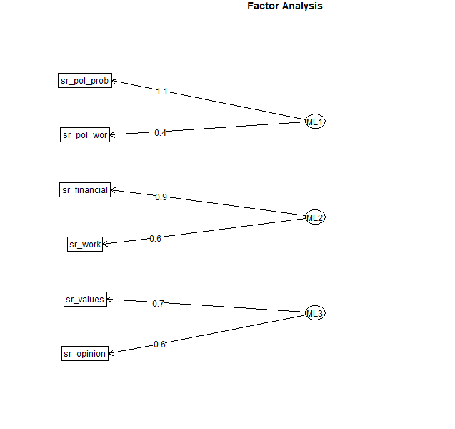

US
Variable | Factor 1 (Political) | Factor 2 (Economic) | Factor 3 (Cultural) | Communality (h²) | Uniqueness (u²)
sr_work | -0.04 | 0.80 | 0.02 | 0.62 | 0.38
sr_financial | 0.33 | 0.40 | 0.03 | 0.49 | 0.51
sr_values | 0.13 | -0.05 | 0.70 | 0.59 | 0.41
sr_opinion | -0.03 | 0.07 | 0.56 | 0.34 | 0.66
sr_pol_prob | 0.79 | -0.02 | -0.01 | 0.59 | 0.41
sr_pol_wor | 0.62 | 0.03 | 0.13 | 0.57 | 0.43

Note: Factor analysis was conducted using maximum likelihood extraction and Promax rotation on six indicators of societal recognition.

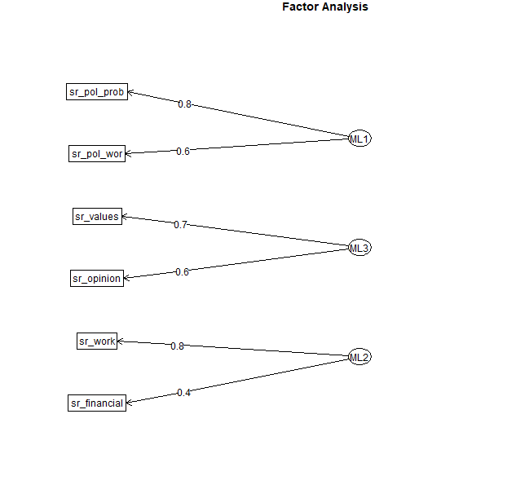

A3.1.2 Distribution & Correlation

Figure 1. Distribution of Lack of Recognition across dimensions.
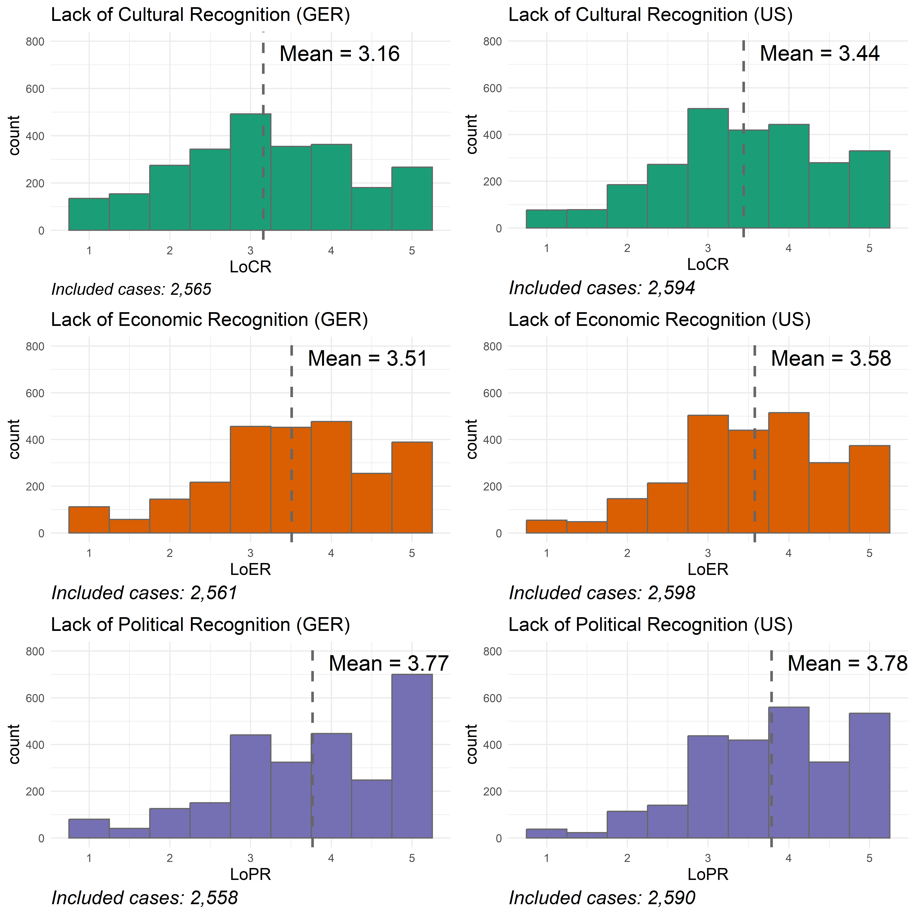

Figure 2. Correlation Matrix of Societal Recognition in Germany and US.
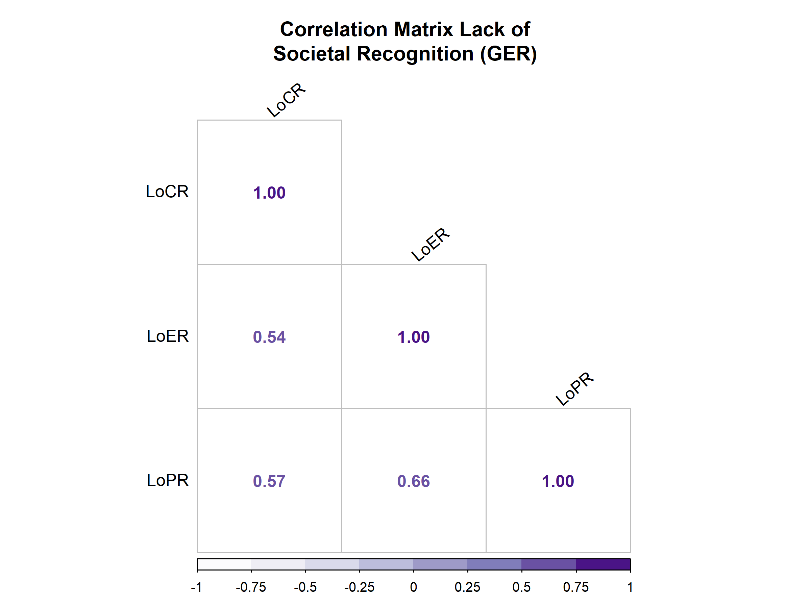 | 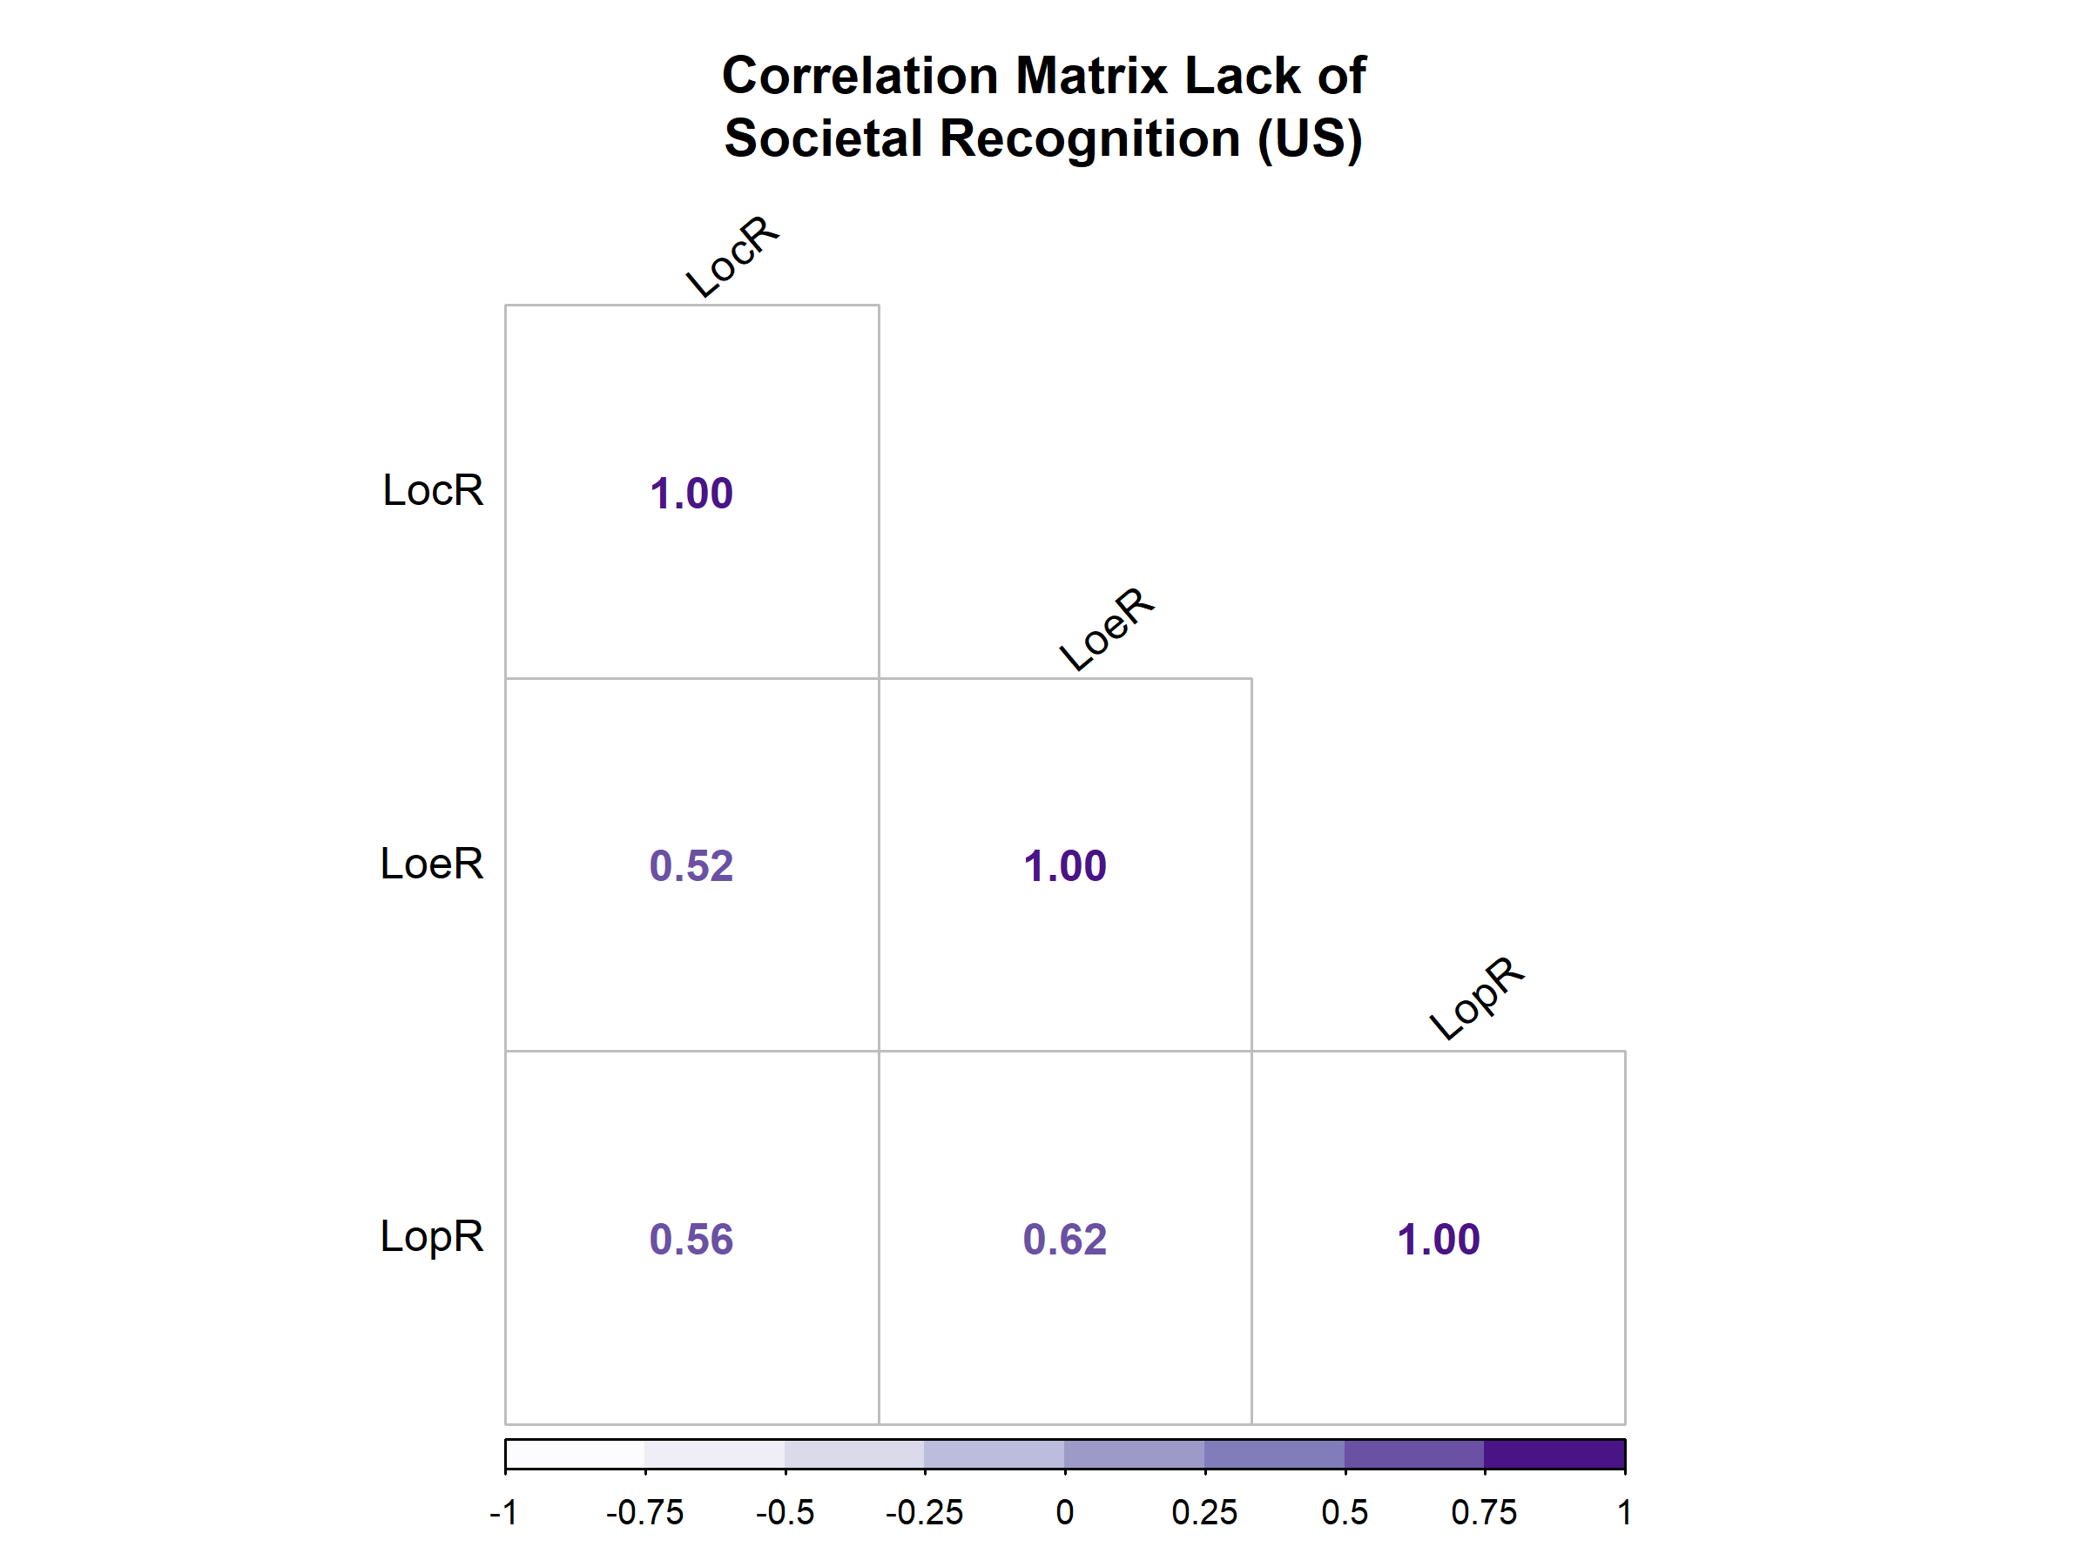

A3.2 Socio-economic factors

Income
In the regression analyses, the income group “low” was included. This includes 555 cases (21,1% of respondents) in Germany and 442 cases (17% of respondents) in the US.
Item Wording
Germany
If you add up all your incomes, what is the total net monthly income of your household (your income after taxes and all other deductions)? If you do not know the exact amount, please estimate.

- up to 1500 euros (1); 1500 to under 2500 euros (2); 2500 to under 3500 euros (3); 3500 to under 5000 euros (4); 5000 euros and more (5)
- 1 is classified as “income low”; 2-3 is classified as “income middle” and 4-5 is classified as “income high”
US
Which figure describes your household's annual income from all sources? If you don't know the exact figure, please give an estimate.
- less than 25,000 (1); 25,000 - 49,999 (2); 50,000 - 74,999 (3); 75,000 - 99,999 (4); 100,000 - 200,000 (5); More than 200,000 (6)
- 1 is classified as “income low”; 2-4 as “income middle” and 5-6 as “income high”
Occupation
In the regression analyses, the occupation “blue-collar worker” was included. This includes respondents that stated that they are skilled or unskilled or farm workers. In Germany, this includes 672 respondents (26,7 %). In the US, it includes 672 respondents (26,3%).
Item Wording
Which of the following descriptions best describes the sort of work you do/did? Just choose the category you think fits best.
Professional and technical occupations (such as: doctor, teacher, artist, engineer) (1), Higher administrator occupations (such as: executive in big business, high government official, union official) (2), Clerical occupations (such as: secretary, office manager, book keeper) (3), Sales and service occupations (such as: sales manager, waiter, caretaker, armed forces) (4), Skilled worker (such as: painter, motor mechanic, electrician) (5), Unskilled worker (such as: labourer, unskilled factory worker) (6), Farm worker (such as: farmer, fisherman) (7)
Urbanity
In the regression analyses, “rural” was included. This includes respondents, that stated that they are living in a country village or a farm or home in the country. In Germany, these are 475 respondents (18,4%) and 256 respondents (9,8%) in the US that are classified as “rural”.
Item Wording
Which of the following categories on this list best describes where you live?
- Big city (1), Suburb or outskirts of a big city (2), Small city or town (3), Country village (4), Farm or home in the country (5)
- 4 and 5 are classified as “rural”.

A3.3 Individual-level subjective perception of disadvantage

Relative Deprivation
In Germany, 379 respondents (14,8% of the respondents) can be classified as “deprived”. In the US, this includes 271 respondents (10,4% of respondents).
Item Wording
Compared with how others live in Germany/ the US: Do you think you get ...
- your fair share (1), more than your fair share (2), somewhat less than your fair share (3), very much less than your fair share? (4)
- 4 is classified as “deprived”.
Subjective Social Class
In Germany, 948 respondents (36,8% of the respondents) can be classified as lower and working class. In the US, this includes 934 respondents (35,9% of the respondents).
Item Wording
There is a lot of talk about social class these days. What class would you describe yourself as belonging to?
- lower class (1), working class (2), middle class (3), upper middle class (4), upper class (5), none of these classes (6)
- 1 and 2 are classified as “lower and working class”.
Subjective Social Position
In Germany and the US, most respondents position themselves in the middle of the scale (Mean Germany: 5.02; Mean US: 5,44)
Item Wording
In our society there are groups which tend to be towards the top and those that are towards the bottom. Here we have a scale that runs from top to bottom. Where would you put yourself on this scale? [Item was included with reversed values in the regression analyses]
- 10 (top) - 0 (bottom)

A3.4 Covariates

Region
Item Wording
Please enter your postal code.
Germany
Respondents were assigned to Bundesländer based on their postal code. The variable “Eastern Germany” includes the Bundesländer Brandenburg, Mecklenburg-Vorpommern, Sachsen, Sachsen-Anhalt, Thüringen, former Ost-Berlin. This includes 390 respondents (15,3% of respondents).
US
Respondents were assigned to States based on their postal code. The variable “Rust Belt State” includes the States Illinois, Indiana, Michigan, New York, Ohio, Pennsylvania, West Virginia, Wisconsin. This includes 770 respondents (30% of respondents).
Ideology (left – right positioning)
Item Wording
In political matters, people talk of "the left" and "the right." How would you place your views on this scale, generally speaking?
- 1 (left) - 11 (right)

Age
Item Wording
In which year were you born?
Education
In the regression analyses, the education group “low” was included as a covariate. This included 508 cases (20% of respondents) in Germany and 95 cases (3,6% of respondents) in the US. Low educated respondents are under-represented in the US. However, the variable was included as covariate for comparability.
Item Wording
Germany
What is the highest level of education you have completed?
- Still at school (1), left school without qualifications (2), lower secondary school leaving certificate or completed 8th or 9th grade at a pre-vocational high school (3), intermediate school leaving certificate, lower secondary school leaving certificate or completed 10th grade at a pre-vocational high school (4 ), advanced technical college certificate (graduation from a technical secondary school, etc.) (5), A levels or extended secondary school leaving certificate with graduation in year 12 (university entrance qualification) (6), bachelor's, master's, diploma, magister (7), doctorate (8), other school leaving certificate (9)

- 2-3 were categorized as “education low”; 4-6 as “education middle” and 7-8 as “education high”
US
What is the highest educational level that you have attained?
- still in school (1), Less than high school/​Early childhood education and kindergarten (2), Some high school, no diploma/​ Elementary or middle school (3), Graduated from high school - Diploma or equivalent (GED) (4), Some college or non-degree programs (5), Associate degree (AA, AS) (6), Baccalaureate or Masters degree (7), Doctorate or professional degree (8)

- values 2-3 were categorized as “education low”; 4-6 as “education middle” and 7-8 as “education high”.
Gender
Item Wording
Are you ... ?
- male (1), female (2), non-binary (3), no answer (4)
- value 1 was categorized as “male” and introduced as a binary variable in the regression analyses.

A3.5 Democracy Variables

Democratic Satisfaction
Item Wording
On the whole, how satisfied are you with the way democracy works in Germany/ the US?
- 0 (extremely dissatisfied) - 10 (extremely satisfied)
Distribution
 | Germany | US
Mean | 6.51 | 6.94

Democratic Relevance
Item Wording
How important is it for you to live in a country that is governed democratically?
- 0 (not at all important) - 10 (extremely important)
Distribution
 | Germany | US
Mean | 9.57 | 9.18

Understanding of Politics
Item Wording
How important do you think the following aspects for a democracy are in general?
- 1 (Not at all important) - 7 (Extremely important)
Liberal Understanding
- People choose their leaders in free elections.
- Civil rights protect people from state oppression.
- The courts are able to stop the government acting beyond its authority.
Authoritarian Understanding
- The government uses violence to enforce public order.
- Elections only serve to confirm the ruling party in office.
- The government limits civic freedoms to rule efficiently.
Majoritarian Understanding
- The majority can always overrule the minority.
- Any law can be changed if there is a majority for it.
- The minority must accept the will of the majority in all circumstances.
Social Democratic Understanding
- The government protects all citizens against poverty.
- The government takes measures to reduce differences in income levels.
- Society shows solidarity towards the weak and those in need of help.

Distribution
Mean | Germany | US
Liberal Understanding | 5.65 | 5.64
Authoritarian Understanding | 3.42 | 3.73
Majoritarian Understanding | 4.69 | 4.62
Social Democratic Understanding | 5.01 | 4.81

Governance Preferences
Do you favor or oppose the following types of policy-making in Germany/ the US?
- 1 (Strongly oppose) - 7 (Strongly support)
Representative
- Elected politicians should decide on policy issues.
Authoritarian
- The President should decide on policy issues and be able to override Congress.
- The army should take over and decide on policy issues when government is incompetent.
Direct Democratic
- Citizens entitled to vote should decide on policy issues through referendum.
Lottocratic
- Citizens drawn by lot should discuss and decide on policy issues and Congress should adopt these results.
Technocratic
- Experts should decide on policy issues by applying their expertise.
Distribution
Mean | Germany | US
Representative | 4.57 | 4.6
Authoritarian | 2.99 | 3.28
Direct Democratic | 5.06 | 5.23
Lottocratic | 3.74 | 3.89
Technocratic | 4.44 | 4.31

A4 Lack of Recognition and Socio-Economic factors

Germany
 | Dependent variable:
 | Lack of Cultural Recognition | Lack of Economic Recognition | Lack of Political Recognition
 | (1) | (2) | (3)
Worker | 0.277*** | 0.228*** | 0.230***
 | (0.052) | (0.050) | (0.051)
Low Income | 0.090 | 0.285*** | 0.229***
 | (0.056) | (0.054) | (0.055)
Rural | 0.181** | 0.133* | 0.252***
 | (0.056) | (0.054) | (0.055)
Left - Right | 0.114*** | 0.027** | 0.049***
 | (0.010) | (0.010) | (0.010)
Eastern Germany | 0.139* | 0.133* | 0.114
 | (0.060) | (0.058) | (0.059)
Low Education | 0.169** | 0.162** | 0.169**
 | (0.057) | (0.056) | (0.057)
Male | -0.143** | -0.208*** | -0.199***
 | (0.045) | (0.044) | (0.044)
Age | -0.003 | 0.0002 | 0.005**
 | (0.001) | (0.001) | (0.001)
Constant | 2.531*** | 3.254*** | 3.171***
 | (0.095) | (0.092) | (0.094)
Observations | 2,445 | 2,442 | 2,440
R² | 0.073 | 0.045 | 0.054
Adjusted R² | 0.070 | 0.042 | 0.051
Residual Std. Error | 1.063 (df = 2436) | 1.032 (df = 2433) | 1.046 (df = 2431)
F Statistic | 24.098*** (df = 8; 2436) | 14.306*** (df = 8; 2433) | 17.377*** (df = 8; 2431)
Note: | *p<0.05; **p<0.01; ***p<0.001

US
 | Dependent variable:
 | Lack of Cultural Recognition | Lack of Economic Recognition | Lack of Political Recognition
 | (1) | (2) | (3)
Worker | 0.148** | 0.212*** | 0.167***
 | (0.047) | (0.046) | (0.044)
Low Income | 0.034 | 0.068 | 0.060
 | (0.055) | (0.054) | (0.053)
Rural | 0.088 | 0.049 | 0.174**
 | (0.066) | (0.065) | (0.063)
Left - Right | 0.113*** | 0.041*** | 0.032***
 | (0.007) | (0.007) | (0.007)
Rust Belt | 0.078 | 0.085* | 0.036
 | (0.043) | (0.042) | (0.041)
Low Education | 0.067 | 0.143 | 0.021
 | (0.110) | (0.109) | (0.105)
Male | -0.013 | -0.076 | -0.018
 | (0.040) | (0.039) | (0.038)
Age | -0.001 | -0.005*** | 0.003*
 | (0.001) | (0.001) | (0.001)
Constant | 2.717*** | 3.492*** | 3.391***
 | (0.079) | (0.077) | (0.075)
Observations | 2,504 | 2,508 | 2,502
R² | 0.095 | 0.035 | 0.022
Adjusted R² | 0.092 | 0.032 | 0.019
Residual Std. Error | 0.980 (df = 2495) | 0.960 (df = 2499) | 0.931 (df = 2493)
F Statistic | 32.769*** (df = 8; 2495) | 11.476*** (df = 8; 2499) | 7.088*** (df = 8; 2493)
Note: | *p<0.05; **p<0.01; ***p<0.001

A5 Lack of Recognition and Individual-Level Measures of Disadvantage

 | Lack of Cultural Recognition
 | Germany |  |  |  |  | US
 | Mean | t |  | p-value |  | Mean | t | p-value
Not deprived - Deprived | 3.05 - 3.76 | -11.85 |  | <0.001 |  | 3.4 – 3.8 | -6.09 | <0.001
Other classes - Lower and Working class | 3 – 3.41 | -9.24 |  | <0.001 |  | 3.37 – 3.57 | -4.81 | <0.001
 | Lack of Economic Recognition
 | Germany |  |  |  |  | US
 | Mean |  | t |  | p-value | Mean | t | p-value
Not deprived - Deprived | 3.38 – 4.22 |  | -14.9 |  | <0.001 | 3.51 – 4.16 | -10.51 | <0.001
Other classes - Lower and Working class | 3.28 – 3.9 |  | -15.39 |  | <0.001 | 3.41 – 3.87 | -11.84 | <0.001
 | Lack of Political Recognition
 | Germany |  |  |  |  | US
 | Mean |  | t |  | p-value | Mean | t | p-value
Not deprived - Deprived | 3.65 – 4.45 |  | -13.95 |  | <0.001 | 3.74 – 4.18 | -7.3 | <0.001
Other classes - Lower and Working class | 3.55 – 4.13 |  | -13.64 |  | <0.001 | 3.67 – 4 | -8.77 | <0.001

 | Subjective Social Position (0 = bottom; 10 = top) x Lack of Recognition | Pearson r | p-value | CI Lower | CI Upper
GER | Lack of Cultural Recognition | -0.19 | <0.001 | -0.23 | -0.16
GER | Lack of Economic Recognition | -0.31 | <0.001 | -0.34 | -0.27
GER | Lack of Political Recognition | -0.31 | <0.001 | -0.35 | -0.28
US | Lack of Cultural Recognition | -0.04 | <0.05 | -0.08 | 0.00
US | Lack of Economic Recognition | -0.18 | <0.001 | -0.22 | -0.14
US | Lack of Political Recognition | -0.2 | <0.001 | -0.23 | -0.16

A6 Results Regression Analyses

A6.1 Democratic Satisfaction

Germany
 | Dependent variable:
 | Democratic Satisfaction (GER)
 | (1) | (2) | (3)
LoCR | -0.897*** | -0.884*** | -0.820***
 | (0.058) | (0.058) | (0.060)
LoER | 0.073 | 0.086 | 0.092
 | (0.065) | (0.066) | (0.067)
LoPR | -0.628*** | -0.608*** | -0.634***
 | (0.066) | (0.067) | (0.068)
Worker |  | -0.291* | -0.377**
 |  | (0.117) | (0.123)
Low Income |  | -0.428*** | -0.472***
 |  | (0.127) | (0.132)
Rural |  | -0.455*** | -0.470***
 |  | (0.132) | (0.132)
Ideology (Left-Right) |  |  | -0.084***
 |  |  | (0.025)
Eastern Germany |  |  | -0.628***
 |  |  | (0.142)
Low Education |  |  | 0.006
 |  |  | (0.136)
Male |  |  | 0.227*
 |  |  | (0.107)
Age |  |  | 0.012***
 |  |  | (0.003)
Constant | 11.449*** | 11.540*** | 11.310***
 | (0.198) | (0.201) | (0.284)
Observations | 2,538 | 2,468 | 2,423
R² | 0.243 | 0.254 | 0.270
Adjusted R² | 0.242 | 0.252 | 0.267
Residual Std. Error | 2.531 (df = 2534) | 2.519 (df = 2461) | 2.495 (df = 2411)
F Statistic | 271.158*** (df = 3; 2534) | 139.716*** (df = 6; 2461) | 81.078*** (df = 11; 2411)
Note: | *p<0.05; **p<0.01; ***p<0.001

 | Dependent variable:
 | Democratic Satisfaction (GER)
 | (4) | (5)
LoCR | -0.856*** | -0.785***
 | (0.057) | (0.059)
LoER | 0.171** | 0.172**
 | (0.066) | (0.066)
LoPR | -0.525*** | -0.555***
 | (0.067) | (0.067)
Worker | -0.204 | -0.293*
 | (0.118) | (0.123)
Low Income | 0.026 | -0.037
 | (0.137) | (0.140)
Rural | -0.416** | -0.428**
 | (0.130) | (0.130)
Deprived | -1.135*** | -1.090***
 | (0.156) | (0.157)
Working/Low Class | 0.081 | 0.106
 | (0.130) | (0.131)
Subj. Social Position | -0.145*** | -0.157***
 | (0.031) | (0.031)
Ideology (Left-Right) |  | -0.098***
 |  | (0.025)
Eastern Germany |  | -0.591***
 |  | (0.140)
Low Education |  | 0.099
 |  | (0.135)
Male |  | 0.179
 |  | (0.105)
Age |  | 0.014***
 |  | (0.003)
Constant | 11.581*** | 11.427***
 | (0.220) | (0.299)
Observations | 2,455 | 2,410
R² | 0.284 | 0.300
Adjusted R² | 0.281 | 0.296
Residual Std. Error | 2.469 (df = 2445) | 2.445 (df = 2395)
F Statistic | 107.809*** (df = 9; 2445) | 73.199*** (df = 14; 2395)
Note: | *p<0.05; **p<0.01; ***p<0.001

US
 | Dependent variable:
 | Democratic Satisfaction (US)
 | (1) | (2) | (3)
LoCR | -0.078 | -0.076 | -0.207**
 | (0.065) | (0.066) | (0.067)
LoER | 0.055 | 0.099 | 0.185*
 | (0.073) | (0.074) | (0.074)
LoPR | -0.472*** | -0.492*** | -0.505***
 | (0.078) | (0.079) | (0.079)
Worker |  | -0.402** | -0.466***
 |  | (0.126) | (0.127)
Low Income |  | -0.542*** | -0.282
 |  | (0.149) | (0.150)
Rural |  | -0.313 | -0.429*
 |  | (0.182) | (0.180)
Ideology (Left-Right) |  |  | 0.111***
 |  |  | (0.021)
Rust Belt |  |  | -0.007
 |  |  | (0.116)
Low Education |  |  | -0.444
 |  |  | (0.301)
Male |  |  | 0.602***
 |  |  | (0.109)
Age |  |  | 0.018***
 |  |  | (0.004)
Constant | 8.788*** | 8.945*** | 7.354***
 | (0.243) | (0.244) | (0.305)
Observations | 2,572 | 2,518 | 2,484
R² | 0.028 | 0.043 | 0.080
Adjusted R² | 0.027 | 0.041 | 0.075
Residual Std. Error | 2.719 (df = 2568) | 2.700 (df = 2511) | 2.647 (df = 2472)
F Statistic | 24.488*** (df = 3; 2568) | 18.878*** (df = 6; 2511) | 19.416*** (df = 11; 2472)
Note: | *p<0.05; **p<0.01; ***p<0.001

 | Dependent variable:
 | Democratic Satisfaction (US)
 | (4) | (5)
LoCR | -0.128* | -0.222***
 | (0.065) | (0.067)
LoER | 0.197** | 0.261***
 | (0.074) | (0.073)
LoPR | -0.404*** | -0.436***
 | (0.078) | (0.078)
Worker | -0.234 | -0.330*
 | (0.126) | (0.128)
Low Income | -0.166 | -0.0001
 | (0.152) | (0.153)
Rural | -0.155 | -0.290
 | (0.180) | (0.179)
Deprived | -0.946*** | -0.909***
 | (0.186) | (0.186)
Working/Low Class | -0.001 | 0.075
 | (0.132) | (0.132)
Subj. Social Position | -0.208*** | -0.182***
 | (0.030) | (0.030)
Ideology (Left-Right) |  | 0.085***
 |  | (0.021)
Rust Belt |  | -0.058
 |  | (0.115)
Low Education |  | -0.352
 |  | (0.301)
Male |  | 0.558***
 |  | (0.108)
Age |  | 0.017***
 |  | (0.003)
Constant | 9.371*** | 7.905***
 | (0.258) | (0.319)
Observations | 2,512 | 2,478
R² | 0.083 | 0.109
Adjusted R² | 0.080 | 0.104
Residual Std. Error | 2.646 (df = 2502) | 2.606 (df = 2463)
F Statistic | 25.193*** (df = 9; 2502) | 21.577*** (df = 14; 2463)
Note: | *p<0.05; **p<0.01; ***p<0.001

A6.2 Democratic Relevance

Germany
 | Dependent variable:
 | Democratic Relevance (GER)
 | (1) |  | (2) |  | (3)
LoCR | -0.410*** |  | -0.393*** |  | -0.349***
 | (0.047) |  | (0.047) |  | (0.048)
LoER | 0.058 |  | 0.056 |  | 0.086
 | (0.054) |  | (0.054) |  | (0.054)
LoPR | 0.144** |  | 0.169** |  | 0.118*
 | (0.054) |  | (0.055) |  | (0.054)
Worker |  |  | -0.286** |  | -0.254*
 |  |  | (0.095) |  | (0.099)
Low Income |  |  | -0.337** |  | -0.257*
 |  |  | (0.103) |  | (0.106)
Rural |  |  | -0.048 |  | -0.048
 |  |  | (0.108) |  | (0.106)
Ideology (Left-Right) |  |  |  |  | -0.003
 |  |  |  |  | (0.020)
Eastern Germany |  |  |  |  | -0.369**
 |  |  |  |  | (0.114)
Low Education |  |  |  |  | -0.529***
 |  |  |  |  | (0.109)
Male |  |  |  |  | 0.088
 |  |  |  |  | (0.086)
Age |  |  |  |  | 0.026***
 |  |  |  |  | (0.003)
Constant | 10.126*** |  | 10.152*** |  | 9.000***
 | (0.162) |  | (0.163) |  | (0.228)
Observations | 2,539 |  | 2,469 |  | 2,424
R² | 0.031 |  | 0.038 |  | 0.081
Adjusted R² | 0.029 |  | 0.036 |  | 0.077
Residual Std. Error | 2.068 (df = 2535) |  | 2.050 (df = 2462) |  | 2.007 (df = 2412)
F Statistic | 26.608*** (df = 3; 2535) |  | 16.247*** (df = 6; 2462) |  | 19.391*** (df = 11; 2412)
Note: | *p<0.05; **p<0.01; ***p<0.001
 |  | Dependent variable:
 |  | Democratic Relevance (GER)
 |  | (4) |  | (5)
LoCR |  | -0.395*** |  | -0.348***
 |  | (0.047) |  | (0.048)
LoER |  | 0.083 |  | 0.106
 |  | (0.055) |  | (0.054)
LoPR |  | 0.192*** |  | 0.141*
 |  | (0.055) |  | (0.055)
Worker |  | -0.214* |  | -0.205*
 |  | (0.097) |  | (0.101)
Low Income |  | -0.199 |  | -0.146
 |  | (0.113) |  | (0.115)
Rural |  | -0.034 |  | -0.033
 |  | (0.108) |  | (0.107)
Deprived |  | -0.079 |  | -0.099
 |  | (0.129) |  | (0.128)
Working/Low Class |  | -0.132 |  | -0.028
 |  | (0.108) |  | (0.108)
Subj. Social Position |  | -0.048 |  | -0.056*
 |  | (0.025) |  | (0.025)
Ideology (Left-Right) |  |  |  | -0.010
 |  |  |  | (0.020)
Eastern Germany |  |  |  | -0.358**
 |  |  |  | (0.114)
Low Education |  |  |  | -0.476***
 |  |  |  | (0.111)
Male |  |  |  | 0.081
 |  |  |  | (0.086)
Age |  |  |  | 0.025***
 |  |  |  | (0.003)
Constant |  | 10.226*** |  | 9.161***
 |  | (0.182) |  | (0.245)
Observations |  | 2,456 |  | 2,411
R² |  | 0.042 |  | 0.083
Adjusted R² |  | 0.039 |  | 0.078
Residual Std. Error |  | 2.042 (df = 2446) |  | 2.001 (df = 2396)
F Statistic |  | 11.982*** (df = 9; 2446) |  | 15.480*** (df = 14; 2396)
Note: |  | *p<0.05; **p<0.01; ***p<0.001

US
 | Dependent variable:
 | Democratic Relevance (US)
 | (1) | (2) | (3)
LoCR | -0.150* | -0.159** | -0.167**
 | (0.061) | (0.059) | (0.059)
LoER | -0.119 | -0.021 | 0.146*
 | (0.068) | (0.067) | (0.064)
LoPR | 0.238** | 0.218** | 0.079
 | (0.073) | (0.071) | (0.068)
Worker |  | -0.657*** | -0.564***
 |  | (0.114) | (0.111)
Low Income |  | -1.539*** | -1.105***
 |  | (0.135) | (0.131)
Rural |  | 0.029 | -0.125
 |  | (0.165) | (0.157)
Ideology (Left-Right) |  |  | 0.009
 |  |  | (0.018)
Rust Belt |  |  | -0.201*
 |  |  | (0.101)
Low Education |  |  | -1.544***
 |  |  | (0.262)
Male |  |  | 0.495***
 |  |  | (0.095)
Age |  |  | 0.046***
 |  |  | (0.003)
Constant | 9.223*** | 9.416*** | 7.016***
 | (0.228) | (0.221) | (0.265)
Observations | 2,576 | 2,522 | 2,488
R² | 0.005 | 0.078 | 0.180
Adjusted R² | 0.004 | 0.075 | 0.176
Residual Std. Error | 2.557 (df = 2572) | 2.451 (df = 2515) | 2.303 (df = 2476)
F Statistic | 4.626** (df = 3; 2572) | 35.294*** (df = 6; 2515) | 49.455*** (df = 11; 2476)
Note: | *p<0.05; **p<0.01; ***p<0.001

 | Dependent variable:
 | Democratic Relevance (US)
 | (4) | (5)
LoCR | -0.160** | -0.158**
 | (0.060) | (0.059)
LoER | 0.041 | 0.185**
 | (0.068) | (0.065)
LoPR | 0.230** | 0.090
 | (0.072) | (0.069)
Worker | -0.574*** | -0.516***
 | (0.116) | (0.113)
Low Income | -1.349*** | -0.991***
 | (0.140) | (0.135)
Rural | 0.095 | -0.082
 | (0.165) | (0.158)
Deprived | -0.721*** | -0.639***
 | (0.171) | (0.163)
Working/Low Class | -0.249* | -0.086
 | (0.121) | (0.116)
Subj. Social Position | -0.021 | -0.023
 | (0.027) | (0.026)
Ideology (Left-Right) |  | 0.001
 |  | (0.018)
Rust Belt |  | -0.218*
 |  | (0.101)
Low Education |  | -1.458***
 |  | (0.265)
Male |  | 0.494***
 |  | (0.095)
Age |  | 0.046***
 |  | (0.003)
Constant | 9.350*** | 7.041***
 | (0.237) | (0.280)
Observations | 2,516 | 2,482
R² | 0.089 | 0.186
Adjusted R² | 0.085 | 0.181
Residual Std. Error | 2.437 (df = 2506) | 2.295 (df = 2467)
F Statistic | 27.041*** (df = 9; 2506) | 40.267*** (df = 14; 2467)
Note: | *p<0.05; **p<0.01; ***p<0.001

A6.3 Understanding of Politics

A6.3.1 Liberal Understanding

Germany
 | Dependent variable:
 | Liberal Understanding (GER)
 | (1) | (2) | (3)
LoCR | -0.245*** | -0.237*** | -0.199***
 | (0.027) | (0.027) | (0.027)
LoER | -0.033 | -0.043 | -0.020
 | (0.030) | (0.031) | (0.030)
LoPR | 0.245*** | 0.263*** | 0.218***
 | (0.031) | (0.031) | (0.030)
Worker |  | -0.041 | -0.065
 |  | (0.054) | (0.055)
Low Income |  | -0.040 | -0.022
 |  | (0.059) | (0.059)
Rural |  | -0.150* | -0.143*
 |  | (0.061) | (0.059)
Ideology (Left-Right) |  |  | -0.018
 |  |  | (0.011)
Eastern Germany |  |  | -0.106
 |  |  | (0.063)
Low Education |  |  | -0.321***
 |  |  | (0.061)
Male |  |  | 0.180***
 |  |  | (0.047)
Age |  |  | 0.022***
 |  |  | (0.002)
Constant | 5.618*** | 5.608*** | 4.643***
 | (0.092) | (0.094) | (0.126)
Observations | 2,520 | 2,450 | 2,405
R² | 0.042 | 0.045 | 0.138
Adjusted R² | 0.041 | 0.043 | 0.134
Residual Std. Error | 1.169 (df = 2516) | 1.167 (df = 2443) | 1.105 (df = 2393)
F Statistic | 36.843*** (df = 3; 2516) | 19.352*** (df = 6; 2443) | 34.734*** (df = 11; 2393)
Note: | *p<0.05; **p<0.01; ***p<0.001

 | Dependent variable:
 | Liberal Understanding (GER)
 | (4) | (5)
LoCR | -0.241*** | -0.202***
 | (0.027) | (0.027)
LoER | -0.041 | -0.023
 | (0.031) | (0.030)
LoPR | 0.267*** | 0.220***
 | (0.032) | (0.030)
Worker | -0.023 | -0.061
 | (0.056) | (0.056)
Low Income | -0.032 | -0.030
 | (0.065) | (0.064)
Rural | -0.151* | -0.146*
 | (0.062) | (0.059)
Deprived | 0.036 | 0.010
 | (0.074) | (0.071)
Working/Low Class | -0.032 | 0.039
 | (0.062) | (0.060)
Subj. Social Position | -0.007 | -0.009
 | (0.015) | (0.014)
Ideology (Left-Right) |  | -0.019
 |  | (0.011)
Eastern Germany |  | -0.106
 |  | (0.063)
Low Education |  | -0.314***
 |  | (0.061)
Male |  | 0.179***
 |  | (0.048)
Age |  | 0.022***
 |  | (0.002)
Constant | 5.637*** | 4.696***
 | (0.104) | (0.136)
Observations | 2,437 | 2,392
R² | 0.046 | 0.138
Adjusted R² | 0.043 | 0.133
Residual Std. Error | 1.165 (df = 2427) | 1.105 (df = 2377)
F Statistic | 13.132*** (df = 9; 2427) | 27.109*** (df = 14; 2377)
Note: | *p<0.05; **p<0.01; ***p<0.001

US
 | Dependent variable:
 | Liberal Understanding (US)
 | (1) | (2) | (3)
LoCR | -0.102*** | -0.107*** | -0.108***
 | (0.027) | (0.027) | (0.028)
LoER | -0.023 | 0.009 | 0.072*
 | (0.031) | (0.031) | (0.030)
LoPR | 0.271*** | 0.263*** | 0.205***
 | (0.033) | (0.033) | (0.032)
Worker |  | -0.190*** | -0.159**
 |  | (0.053) | (0.052)
Low Income |  | -0.373*** | -0.241***
 |  | (0.062) | (0.062)
Rural |  | 0.057 | -0.026
 |  | (0.076) | (0.074)
Ideology (Left-Right) |  |  | -0.003
 |  |  | (0.009)
Rust Belt |  |  | -0.065
 |  |  | (0.048)
Low Education |  |  | -0.280*
 |  |  | (0.124)
Male |  |  | 0.164***
 |  |  | (0.045)
Age |  |  | 0.019***
 |  |  | (0.001)
Constant | 5.048*** | 5.088*** | 4.174***
 | (0.102) | (0.102) | (0.125)
Observations | 2,563 | 2,509 | 2,475
R² | 0.031 | 0.053 | 0.124
Adjusted R² | 0.030 | 0.051 | 0.120
Residual Std. Error | 1.142 (df = 2559) | 1.127 (df = 2502) | 1.085 (df = 2463)
F Statistic | 27.547*** (df = 3; 2559) | 23.533*** (df = 6; 2502) | 31.585*** (df = 11; 2463)
Note: | *p<0.05; **p<0.01; ***p<0.001

 | Dependent variable:
 | Liberal Understanding (US)
 | (4) | (5)
LoCR | -0.111*** | -0.108***
 | (0.028) | (0.028)
LoER | 0.029 | 0.085**
 | (0.031) | (0.031)
LoPR | 0.269*** | 0.211***
 | (0.033) | (0.033)
Worker | -0.156** | -0.136*
 | (0.054) | (0.053)
Low Income | -0.307*** | -0.197**
 | (0.065) | (0.064)
Rural | 0.085 | -0.003
 | (0.077) | (0.075)
Deprived | -0.120 | -0.108
 | (0.079) | (0.078)
Working/Low Class | -0.134* | -0.065
 | (0.056) | (0.055)
Subj. Social Position | -0.007 | -0.011
 | (0.013) | (0.012)
Ideology (Left-Right) |  | -0.006
 |  | (0.009)
Rust Belt |  | -0.069
 |  | (0.048)
Low Education |  | -0.258*
 |  | (0.125)
Male |  | 0.162***
 |  | (0.045)
Age |  | 0.019***
 |  | (0.001)
Constant | 5.072*** | 4.201***
 | (0.110) | (0.133)
Observations | 2,503 | 2,469
R² | 0.057 | 0.125
Adjusted R² | 0.054 | 0.120
Residual Std. Error | 1.125 (df = 2493) | 1.084 (df = 2454)
F Statistic | 16.852*** (df = 9; 2493) | 25.004*** (df = 14; 2454)
Note: | *p<0.05; **p<0.01; ***p<0.001

A6.3.2 Authoritarian Understanding

Germany
 | Dependent variable:
 | Authoritarian Understanding (GER)
 | (1) | (2) | (3)
LoCR | 0.284*** | 0.275*** | 0.227***
 | (0.029) | (0.030) | (0.030)
LoER | 0.085* | 0.083* | 0.076*
 | (0.033) | (0.034) | (0.034)
LoPR | -0.158*** | -0.157*** | -0.122***
 | (0.034) | (0.034) | (0.034)
Worker |  | 0.187** | 0.146*
 |  | (0.060) | (0.062)
Low Income |  | -0.095 | -0.069
 |  | (0.065) | (0.067)
Rural |  | -0.139* | -0.118
 |  | (0.068) | (0.067)
Ideology (Left-Right) |  |  | 0.054***
 |  |  | (0.013)
Eastern Germany |  |  | 0.169*
 |  |  | (0.072)
Low Education |  |  | 0.180**
 |  |  | (0.069)
Male |  |  | 0.071
 |  |  | (0.054)
Age |  |  | -0.015***
 |  |  | (0.002)
Constant | 2.813*** | 2.831*** | 3.171***
 | (0.101) | (0.103) | (0.144)
Observations | 2,523 | 2,455 | 2,410
R² | 0.048 | 0.053 | 0.090
Adjusted R² | 0.047 | 0.050 | 0.086
Residual Std. Error | 1.285 (df = 2519) | 1.284 (df = 2448) | 1.262 (df = 2398)
F Statistic | 42.445*** (df = 3; 2519) | 22.634*** (df = 6; 2448) | 21.671*** (df = 11; 2398)
Note: | *p<0.05; **p<0.01; ***p<0.001

 | Dependent variable:
 | Authoritarian Understanding (GER)
 | (4) | (5)
LoCR | 0.277*** | 0.233***
 | (0.030) | (0.030)
LoER | 0.107** | 0.099**
 | (0.034) | (0.034)
LoPR | -0.128*** | -0.097**
 | (0.034) | (0.034)
Worker | 0.219*** | 0.183**
 | (0.061) | (0.063)
Low Income | 0.042 | 0.056
 | (0.071) | (0.072)
Rural | -0.124 | -0.107
 | (0.068) | (0.067)
Deprived | -0.157 | -0.162*
 | (0.081) | (0.081)
Working/Low Class | 0.065 | 0.018
 | (0.067) | (0.068)
Subj. Social Position | -0.072*** | -0.061***
 | (0.016) | (0.016)
Ideology (Left-Right) |  | 0.048***
 |  | (0.013)
Eastern Germany |  | 0.186*
 |  | (0.072)
Low Education |  | 0.209**
 |  | (0.070)
Male |  | 0.057
 |  | (0.054)
Age |  | -0.014***
 |  | (0.002)
Constant | 2.947*** | 3.270***
 | (0.114) | (0.154)
Observations | 2,442 | 2,397
R² | 0.065 | 0.100
Adjusted R² | 0.061 | 0.095
Residual Std. Error | 1.277 (df = 2432) | 1.256 (df = 2382)
F Statistic | 18.729*** (df = 9; 2432) | 18.865*** (df = 14; 2382)
Note: | *p<0.05; **p<0.01; ***p<0.001

US
 | Dependent variable:
 | Authoritarian Understanding (US)
 | (1) | (2) | (3)
LoCR | 0.351*** | 0.350*** | 0.256***
 | (0.034) | (0.035) | (0.035)
LoER | 0.343*** | 0.342*** | 0.272***
 | (0.038) | (0.039) | (0.038)
LoPR | -0.251*** | -0.257*** | -0.167***
 | (0.041) | (0.041) | (0.040)
Worker |  | 0.153* | 0.060
 |  | (0.066) | (0.065)
Low Income |  | 0.170* | 0.090
 |  | (0.078) | (0.077)
Rural |  | -0.207* | -0.157
 |  | (0.096) | (0.092)
Ideology (Left-Right) |  |  | 0.093***
 |  |  | (0.011)
Rust Belt |  |  | 0.066
 |  |  | (0.060)
Low Education |  |  | 0.310*
 |  |  | (0.155)
Male |  |  | 0.040
 |  |  | (0.056)
Age |  |  | -0.024***
 |  |  | (0.002)
Constant | 2.243*** | 2.228*** | 2.970***
 | (0.128) | (0.129) | (0.156)
Observations | 2,560 | 2,506 | 2,473
R² | 0.101 | 0.108 | 0.192
Adjusted R² | 0.100 | 0.105 | 0.188
Residual Std. Error | 1.426 (df = 2556) | 1.421 (df = 2499) | 1.353 (df = 2461)
F Statistic | 96.190*** (df = 3; 2556) | 50.228*** (df = 6; 2499) | 53.134*** (df = 11; 2461)
Note: | *p<0.05; **p<0.01; ***p<0.001

 | Dependent variable:
 | Authoritarian Understanding (US)
 | (4) | (5)
LoCR | 0.305*** | 0.230***
 | (0.034) | (0.034)
LoER | 0.360*** | 0.289***
 | (0.039) | (0.037)
LoPR | -0.193*** | -0.114**
 | (0.041) | (0.040)
Worker | 0.224*** | 0.136*
 | (0.066) | (0.065)
Low Income | 0.306*** | 0.210**
 | (0.080) | (0.078)
Rural | -0.128 | -0.077
 | (0.095) | (0.091)
Deprived | 0.126 | 0.134
 | (0.098) | (0.095)
Working/Low Class | 0.185** | 0.147*
 | (0.069) | (0.067)
Subj. Social Position | -0.167*** | -0.152***
 | (0.016) | (0.015)
Ideology (Left-Right) |  | 0.079***
 |  | (0.011)
Rust Belt |  | 0.040
 |  | (0.059)
Low Education |  | 0.283
 |  | (0.154)
Male |  | -0.002
 |  | (0.055)
Age |  | -0.024***
 |  | (0.002)
Constant | 2.707*** | 3.502***
 | (0.136) | (0.163)
Observations | 2,500 | 2,467
R² | 0.147 | 0.224
Adjusted R² | 0.144 | 0.220
Residual Std. Error | 1.389 (df = 2490) | 1.326 (df = 2452)
F Statistic | 47.774*** (df = 9; 2490) | 50.582*** (df = 14; 2452)
Note: | *p<0.05; **p<0.01; ***p<0.001

A6.3.3 Majoritarian Understanding

Germany
 | Dependent variable:
 | Majoritarian Understanding (GER)
 | (1) | (2) | (3)
LoCR | 0.101*** | 0.090*** | 0.070**
 | (0.026) | (0.027) | (0.027)
LoER | 0.021 | 0.020 | 0.041
 | (0.030) | (0.030) | (0.030)
LoPR | 0.036 | 0.051 | 0.023
 | (0.030) | (0.031) | (0.031)
Worker |  | 0.154** | 0.116*
 |  | (0.053) | (0.055)
Low Income |  | -0.201*** | -0.220***
 |  | (0.058) | (0.060)
Rural |  | -0.111 | -0.103
 |  | (0.060) | (0.059)
Ideology (Left-Right) |  |  | 0.067***
 |  |  | (0.011)
Eastern Germany |  |  | 0.037
 |  |  | (0.064)
Low Education |  |  | 0.071
 |  |  | (0.061)
Male |  |  | 0.087
 |  |  | (0.048)
Age |  |  | 0.013***
 |  |  | (0.002)
Constant | 4.160*** | 4.171*** | 3.208***
 | (0.091) | (0.092) | (0.128)
Observations | 2,526 | 2,457 | 2,412
R² | 0.017 | 0.025 | 0.070
Adjusted R² | 0.016 | 0.022 | 0.066
Residual Std. Error | 1.154 (df = 2522) | 1.147 (df = 2450) | 1.124 (df = 2400)
F Statistic | 14.467*** (df = 3; 2522) | 10.402*** (df = 6; 2450) | 16.497*** (df = 11; 2400)
Note: | *p<0.05; **p<0.01; ***p<0.001

 | Dependent variable:
 | Majoritarian Understanding (GER)
 | (4) | (5)
LoCR | 0.090*** | 0.073**
 | (0.027) | (0.027)
LoER | 0.039 | 0.058
 | (0.031) | (0.030)
LoPR | 0.070* | 0.041
 | (0.031) | (0.031)
Worker | 0.192*** | 0.148**
 | (0.055) | (0.056)
Low Income | -0.115 | -0.144*
 | (0.064) | (0.065)
Rural | -0.098 | -0.091
 | (0.060) | (0.060)
Deprived | -0.095 | -0.125
 | (0.073) | (0.072)
Working/Low Class | -0.026 | -0.008
 | (0.061) | (0.061)
Subj. Social Position | -0.039** | -0.037**
 | (0.014) | (0.014)
Ideology (Left-Right) |  | 0.063***
 |  | (0.011)
Eastern Germany |  | 0.052
 |  | (0.064)
Low Education |  | 0.091
 |  | (0.062)
Male |  | 0.080
 |  | (0.048)
Age |  | 0.013***
 |  | (0.002)
Constant | 4.216*** | 3.262***
 | (0.103) | (0.138)
Observations | 2,444 | 2,399
R² | 0.032 | 0.076
Adjusted R² | 0.028 | 0.071
Residual Std. Error | 1.144 (df = 2434) | 1.121 (df = 2384)
F Statistic | 8.863*** (df = 9; 2434) | 14.094*** (df = 14; 2384)
Note: | *p<0.05; **p<0.01; ***p<0.001

US
 | Dependent variable:
 | Majoritarian Understanding (US)
 | (1) | (2) | (3)
LoCR | 0.167*** | 0.163*** | 0.112***
 | (0.029) | (0.030) | (0.031)
LoER | 0.160*** | 0.161*** | 0.164***
 | (0.033) | (0.033) | (0.034)
LoPR | -0.051 | -0.044 | -0.030
 | (0.035) | (0.036) | (0.036)
Worker |  | 0.039 | -0.001
 |  | (0.057) | (0.059)
Low Income |  | -0.057 | -0.015
 |  | (0.067) | (0.069)
Rural |  | -0.132 | -0.167*
 |  | (0.082) | (0.083)
Ideology (Left-Right) |  |  | 0.047***
 |  |  | (0.010)
Rust Belt |  |  | 0.032
 |  |  | (0.053)
Low Education |  |  | 0.152
 |  |  | (0.139)
Male |  |  | 0.133**
 |  |  | (0.050)
Age |  |  | 0.00002
 |  |  | (0.002)
Constant | 3.667*** | 3.666*** | 3.416***
 | (0.109) | (0.110) | (0.140)
Observations | 2,566 | 2,512 | 2,478
R² | 0.042 | 0.043 | 0.055
Adjusted R² | 0.040 | 0.041 | 0.051
Residual Std. Error | 1.225 (df = 2562) | 1.221 (df = 2505) | 1.215 (df = 2466)
F Statistic | 37.048*** (df = 3; 2562) | 18.873*** (df = 6; 2505) | 13.158*** (df = 11; 2466)
Note: | *p<0.05; **p<0.01; ***p<0.001

 | Dependent variable:
 | Majoritarian Understanding (US)
 | (4) | (5)
LoCR | 0.140*** | 0.101**
 | (0.030) | (0.031)
LoER | 0.180*** | 0.178***
 | (0.034) | (0.034)
LoPR | -0.006 | -0.0001
 | (0.036) | (0.036)
Worker | 0.085 | 0.039
 | (0.057) | (0.059)
Low Income | 0.042 | 0.060
 | (0.069) | (0.071)
Rural | -0.083 | -0.121
 | (0.082) | (0.083)
Deprived | -0.067 | -0.071
 | (0.085) | (0.086)
Working/Low Class | 0.077 | 0.097
 | (0.060) | (0.061)
Subj. Social Position | -0.092*** | -0.084***
 | (0.014) | (0.014)
Ideology (Left-Right) |  | 0.037***
 |  | (0.010)
Rust Belt |  | 0.016
 |  | (0.053)
Low Education |  | 0.165
 |  | (0.140)
Male |  | 0.108*
 |  | (0.050)
Age |  | -0.0001
 |  | (0.002)
Constant | 3.906*** | 3.697***
 | (0.118) | (0.148)
Observations | 2,506 | 2,472
R² | 0.064 | 0.071
Adjusted R² | 0.061 | 0.066
Residual Std. Error | 1.207 (df = 2496) | 1.204 (df = 2457)
F Statistic | 18.982*** (df = 9; 2496) | 13.504*** (df = 14; 2457)
Note: | *p<0.05; **p<0.01; ***p<0.001

A6.3.4 Social Democratic Understanding

Germany
 | Dependent variable:
 | Social Democratic Understanding (GER)
 | (1) | (2) | (3)
LoCR | -0.244*** | -0.238*** | -0.193***
 | (0.032) | (0.033) | (0.034)
LoER | 0.122*** | 0.108** | 0.109**
 | (0.037) | (0.037) | (0.037)
LoPR | 0.108** | 0.113** | 0.092*
 | (0.037) | (0.038) | (0.038)
Worker |  | -0.005 | 0.016
 |  | (0.065) | (0.069)
Low Income |  | 0.157* | 0.160*
 |  | (0.071) | (0.074)
Rural |  | -0.005 | -0.013
 |  | (0.074) | (0.074)
Ideology (Left-Right) |  |  | -0.063***
 |  |  | (0.014)
Eastern Germany |  |  | -0.117
 |  |  | (0.080)
Low Education |  |  | -0.202**
 |  |  | (0.076)
Male |  |  | -0.003
 |  |  | (0.060)
Age |  |  | 0.009***
 |  |  | (0.002)
Constant | 4.986*** | 4.966*** | 4.893***
 | (0.111) | (0.113) | (0.159)
Observations | 2,526 | 2,456 | 2,411
R² | 0.024 | 0.026 | 0.046
Adjusted R² | 0.023 | 0.023 | 0.041
Residual Std. Error | 1.410 (df = 2522) | 1.409 (df = 2449) | 1.396 (df = 2399)
F Statistic | 20.843*** (df = 3; 2522) | 10.833*** (df = 6; 2449) | 10.422*** (df = 11; 2399)
Note: | *p<0.05; **p<0.01; ***p<0.001

 | Dependent variable:
 | Social Democratic Understanding (GER)
 | (4) | (5)
LoCR | -0.242*** | -0.197***
 | (0.033) | (0.034)
LoER | 0.072 | 0.072
 | (0.038) | (0.038)
LoPR | 0.086* | 0.066
 | (0.038) | (0.038)
Worker | -0.075 | -0.055
 | (0.067) | (0.070)
Low Income | -0.013 | -0.002
 | (0.078) | (0.080)
Rural | -0.021 | -0.028
 | (0.074) | (0.074)
Deprived | 0.195* | 0.191*
 | (0.089) | (0.089)
Working/Low Class | 0.194** | 0.250***
 | (0.074) | (0.075)
Subj. Social Position | 0.036* | 0.027
 | (0.017) | (0.018)
Ideology (Left-Right) |  | -0.062***
 |  | (0.014)
Eastern Germany |  | -0.132
 |  | (0.079)
Low Education |  | -0.250**
 |  | (0.077)
Male |  | 0.001
 |  | (0.060)
Age |  | 0.009***
 |  | (0.002)
Constant | 4.988*** | 4.934***
 | (0.125) | (0.170)
Observations | 2,443 | 2,398
R² | 0.038 | 0.058
Adjusted R² | 0.034 | 0.053
Residual Std. Error | 1.403 (df = 2433) | 1.389 (df = 2383)
F Statistic | 10.534*** (df = 9; 2433) | 10.571*** (df = 14; 2383)
Note: | *p<0.05; **p<0.01; ***p<0.001

US
 | Dependent variable:
 | Social Democratic Understanding (US)
 | (1) | (2) | (3)
LoCR | -0.277*** | -0.275*** | -0.180***
 | (0.034) | (0.034) | (0.035)
LoER | 0.319*** | 0.315*** | 0.295***
 | (0.038) | (0.039) | (0.039)
LoPR | 0.104* | 0.110** | 0.095*
 | (0.040) | (0.041) | (0.041)
Worker |  | -0.007 | -0.043
 |  | (0.066) | (0.067)
Low Income |  | 0.143 | 0.089
 |  | (0.078) | (0.079)
Rural |  | -0.314** | -0.249**
 |  | (0.095) | (0.095)
Ideology (Left-Right) |  |  | -0.100***
 |  |  | (0.011)
Rust Belt |  |  | 0.009
 |  |  | (0.061)
Low Education |  |  | -0.020
 |  |  | (0.159)
Male |  |  | 0.013
 |  |  | (0.057)
Age |  |  | -0.005**
 |  |  | (0.002)
Constant | 4.231*** | 4.210*** | 4.875***
 | (0.126) | (0.128) | (0.160)
Observations | 2,569 | 2,515 | 2,481
R² | 0.048 | 0.054 | 0.090
Adjusted R² | 0.047 | 0.052 | 0.086
Residual Std. Error | 1.418 (df = 2565) | 1.414 (df = 2508) | 1.392 (df = 2469)
F Statistic | 43.217*** (df = 3; 2565) | 24.009*** (df = 6; 2508) | 22.101*** (df = 11; 2469)
Note: | *p<0.05; **p<0.01; ***p<0.001

 | Dependent variable:
 | Social Democratic Understanding (US)
 | (4) | (5)
LoCR | -0.282*** | -0.189***
 | (0.035) | (0.036)
LoER | 0.304*** | 0.294***
 | (0.039) | (0.039)
LoPR | 0.126** | 0.116**
 | (0.042) | (0.042)
Worker | -0.023 | -0.036
 | (0.067) | (0.068)
Low Income | 0.140 | 0.118
 | (0.081) | (0.082)
Rural | -0.305** | -0.226*
 | (0.096) | (0.095)
Deprived | -0.030 | -0.063
 | (0.099) | (0.099)
Working/Low Class | 0.288*** | 0.252***
 | (0.070) | (0.070)
Subj. Social Position | -0.057*** | -0.073***
 | (0.016) | (0.016)
Ideology (Left-Right) |  | -0.103***
 |  | (0.011)
Rust Belt |  | 0.002
 |  | (0.061)
Low Education |  | -0.022
 |  | (0.160)
Male |  | -0.009
 |  | (0.057)
Age |  | -0.005**
 |  | (0.002)
Constant | 4.374*** | 5.079***
 | (0.137) | (0.169)
Observations | 2,509 | 2,475
R² | 0.063 | 0.099
Adjusted R² | 0.059 | 0.094
Residual Std. Error | 1.409 (df = 2499) | 1.386 (df = 2460)
F Statistic | 18.519*** (df = 9; 2499) | 19.272*** (df = 14; 2460)
Note: | *p<0.05; **p<0.01; ***p<0.001

A6.4 Governance Preferences

A6.4.1 Representative

Germany
 | Dependent variable:
 | Representative (GER)
 | (1) | (2) | (3)
LoCR | -0.309*** | -0.303*** | -0.261***
 | (0.035) | (0.035) | (0.036)
LoER | -0.016 | -0.010 | 0.003
 | (0.039) | (0.040) | (0.040)
LoPR | -0.254*** | -0.237*** | -0.269***
 | (0.040) | (0.040) | (0.040)
Worker |  | -0.224** | -0.303***
 |  | (0.070) | (0.073)
Low Income |  | -0.177* | -0.211**
 |  | (0.076) | (0.078)
Rural |  | -0.063 | -0.044
 |  | (0.079) | (0.078)
Ideology (Left-Right) |  |  | -0.036*
 |  |  | (0.015)
Eastern Germany |  |  | -0.087
 |  |  | (0.084)
Low Education |  |  | -0.074
 |  |  | (0.081)
Male |  |  | 0.219***
 |  |  | (0.063)
Age |  |  | 0.016***
 |  |  | (0.002)
Constant | 6.561*** | 6.577*** | 5.908***
 | (0.119) | (0.120) | (0.169)
Observations | 2,532 | 2,462 | 2,417
R² | 0.119 | 0.125 | 0.155
Adjusted R² | 0.118 | 0.122 | 0.151
Residual Std. Error | 1.514 (df = 2528) | 1.504 (df = 2455) | 1.481 (df = 2405)
F Statistic | 114.190*** (df = 3; 2528) | 58.243*** (df = 6; 2455) | 40.000*** (df = 11; 2405)
Note: | *p<0.05; **p<0.01; ***p<0.001

 | Dependent variable:
 | Representative (GER)
 | (4) | (5)
LoCR | -0.300*** | -0.255***
 | (0.035) | (0.035)
LoER | 0.008 | 0.021
 | (0.040) | (0.040)
LoPR | -0.211*** | -0.242***
 | (0.040) | (0.040)
Worker | -0.208** | -0.287***
 | (0.071) | (0.074)
Low Income | -0.090 | -0.119
 | (0.083) | (0.084)
Rural | -0.059 | -0.038
 | (0.079) | (0.078)
Deprived | -0.293** | -0.333***
 | (0.095) | (0.094)
Working/Low Class | 0.106 | 0.131
 | (0.079) | (0.079)
Subj. Social Position | -0.048* | -0.053**
 | (0.019) | (0.019)
Ideology (Left-Right) |  | -0.039**
 |  | (0.015)
Eastern Germany |  | -0.075
 |  | (0.084)
Low Education |  | -0.065
 |  | (0.082)
Male |  | 0.206**
 |  | (0.063)
Age |  | 0.016***
 |  | (0.002)
Constant | 6.621*** | 5.964***
 | (0.133) | (0.180)
Observations | 2,449 | 2,404
R² | 0.132 | 0.164
Adjusted R² | 0.129 | 0.159
Residual Std. Error | 1.496 (df = 2439) | 1.472 (df = 2389)
F Statistic | 41.392*** (df = 9; 2439) | 33.489*** (df = 14; 2389)
Note: | *p<0.05; **p<0.01; ***p<0.001
US
 | Dependent variable:
 | Representative (US)
 | (1) | (2) | (3)
LoCR | 0.100** | 0.101** | 0.022
 | (0.038) | (0.038) | (0.039)
LoER | -0.033 | -0.009 | 0.024
 | (0.042) | (0.043) | (0.043)
LoPR | -0.113* | -0.122** | -0.125**
 | (0.045) | (0.046) | (0.046)
Worker |  | -0.041 | -0.109
 |  | (0.073) | (0.075)
Low Income |  | -0.252** | -0.138
 |  | (0.087) | (0.088)
Rural |  | -0.297** | -0.336**
 |  | (0.106) | (0.105)
Ideology (Left-Right) |  |  | 0.072***
 |  |  | (0.012)
Rust Belt |  |  | -0.001
 |  |  | (0.068)
Low Education |  |  | -0.192
 |  |  | (0.177)
Male |  |  | 0.400***
 |  |  | (0.064)
Age |  |  | 0.004
 |  |  | (0.002)
Constant | 4.805*** | 4.840*** | 4.202***
 | (0.141) | (0.142) | (0.178)
Observations | 2,572 | 2,518 | 2,484
R² | 0.005 | 0.012 | 0.047
Adjusted R² | 0.003 | 0.010 | 0.042
Residual Std. Error | 1.582 (df = 2568) | 1.573 (df = 2511) | 1.549 (df = 2472)
F Statistic | 3.960** (df = 3; 2568) | 5.226*** (df = 6; 2511) | 11.001*** (df = 11; 2472)
Note: | *p<0.05; **p<0.01; ***p<0.001

 | Dependent variable:
 | Representative (US)
 | (4) | (5)
LoCR | 0.075* | 0.013
 | (0.038) | (0.039)
LoER | 0.033 | 0.056
 | (0.043) | (0.043)
LoPR | -0.081 | -0.093*
 | (0.046) | (0.046)
Worker | 0.059 | -0.026
 | (0.074) | (0.075)
Low Income | -0.069 | -0.001
 | (0.089) | (0.090)
Rural | -0.213* | -0.263*
 | (0.106) | (0.106)
Deprived | -0.143 | -0.122
 | (0.110) | (0.110)
Working/Low Class | -0.168* | -0.130
 | (0.078) | (0.078)
Subj. Social Position | -0.092*** | -0.077***
 | (0.017) | (0.018)
Ideology (Left-Right) |  | 0.061***
 |  | (0.012)
Rust Belt |  | -0.019
 |  | (0.068)
Low Education |  | -0.164
 |  | (0.178)
Male |  | 0.380***
 |  | (0.064)
Age |  | 0.003
 |  | (0.002)
Constant | 5.048*** | 4.460***
 | (0.151) | (0.188)
Observations | 2,512 | 2,478
R² | 0.035 | 0.062
Adjusted R² | 0.032 | 0.056
Residual Std. Error | 1.556 (df = 2502) | 1.537 (df = 2463)
F Statistic | 10.094*** (df = 9; 2502) | 11.593*** (df = 14; 2463)
Note: | *p<0.05; **p<0.01; ***p<0.001

A6.4.2 Authoritarian

Germany
 | Dependent variable:
 | Authoritarian (GER)
 | (1) | (2) | (3)
LoCR | 0.390*** | 0.375*** | 0.302***
 | (0.034) | (0.034) | (0.034)
LoER | 0.129*** | 0.141*** | 0.127***
 | (0.038) | (0.039) | (0.038)
LoPR | -0.245*** | -0.254*** | -0.216***
 | (0.039) | (0.040) | (0.039)
Worker |  | 0.091 | 0.125
 |  | (0.069) | (0.071)
Low Income |  | -0.127 | -0.129
 |  | (0.075) | (0.076)
Rural |  | 0.043 | 0.027
 |  | (0.078) | (0.076)
Ideology (Left-Right) |  |  | 0.090***
 |  |  | (0.015)
Eastern Germany |  |  | 0.158
 |  |  | (0.082)
Low Education |  |  | 0.350***
 |  |  | (0.078)
Male |  |  | -0.236***
 |  |  | (0.062)
Age |  |  | -0.021***
 |  |  | (0.002)
Constant | 2.225*** | 2.254*** | 2.895***
 | (0.117) | (0.119) | (0.164)
Observations | 2,533 | 2,464 | 2,419
R² | 0.067 | 0.066 | 0.133
Adjusted R² | 0.066 | 0.064 | 0.129
Residual Std. Error | 1.486 (df = 2529) | 1.488 (df = 2457) | 1.437 (df = 2407)
F Statistic | 60.337*** (df = 3; 2529) | 29.042*** (df = 6; 2457) | 33.636*** (df = 11; 2407)
Note: | *p<0.05; **p<0.01; ***p<0.001

 | Dependent variable:
 | Authoritarian (GER)
 | (4) | (5)
LoCR | 0.377*** | 0.308***
 | (0.034) | (0.035)
LoER | 0.157*** | 0.143***
 | (0.040) | (0.039)
LoPR | -0.234*** | -0.198***
 | (0.040) | (0.039)
Worker | 0.092 | 0.136
 | (0.071) | (0.072)
Low Income | -0.028 | -0.034
 | (0.083) | (0.082)
Rural | 0.065 | 0.045
 | (0.078) | (0.076)
Deprived | -0.073 | -0.072
 | (0.094) | (0.092)
Working/Low Class | 0.213** | 0.150
 | (0.078) | (0.077)
Subj. Social Position | -0.084*** | -0.074***
 | (0.018) | (0.018)
Ideology (Left-Right) |  | 0.083***
 |  | (0.015)
Eastern Germany |  | 0.168*
 |  | (0.082)
Low Education |  | 0.361***
 |  | (0.079)
Male |  | -0.249***
 |  | (0.062)
Age |  | -0.020***
 |  | (0.002)
Constant | 2.439*** | 3.062***
 | (0.132) | (0.176)
Observations | 2,451 | 2,406
R² | 0.076 | 0.140
Adjusted R² | 0.073 | 0.135
Residual Std. Error | 1.482 (df = 2441) | 1.434 (df = 2391)
F Statistic | 22.444*** (df = 9; 2441) | 27.751*** (df = 14; 2391)
Note: | *p<0.05; **p<0.01; ***p<0.001

US
 | Dependent variable:
 | Authoritarian (US)
 | (1) | (2) | (3)
LoCR | 0.241*** | 0.245*** | 0.127**
 | (0.039) | (0.040) | (0.039)
LoER | 0.331*** | 0.317*** | 0.236***
 | (0.044) | (0.045) | (0.043)
LoPR | -0.284*** | -0.279*** | -0.162***
 | (0.047) | (0.047) | (0.045)
Worker |  | 0.092 | -0.010
 |  | (0.076) | (0.074)
Low Income |  | 0.383*** | 0.304***
 |  | (0.090) | (0.087)
Rural |  | -0.358** | -0.296**
 |  | (0.110) | (0.104)
Ideology (Left-Right) |  |  | 0.120***
 |  |  | (0.012)
Rust Belt |  |  | 0.062
 |  |  | (0.067)
Low Education |  |  | 0.144
 |  |  | (0.176)
Male |  |  | -0.021
 |  |  | (0.063)
Age |  |  | -0.031***
 |  |  | (0.002)
Constant | 2.338*** | 2.307*** | 3.244***
 | (0.146) | (0.147) | (0.177)
Observations | 2,575 | 2,521 | 2,487
R² | 0.049 | 0.061 | 0.170
Adjusted R² | 0.048 | 0.058 | 0.166
Residual Std. Error | 1.640 (df = 2571) | 1.631 (df = 2514) | 1.535 (df = 2475)
F Statistic | 44.123*** (df = 3; 2571) | 27.089*** (df = 6; 2514) | 46.125*** (df = 11; 2475)
Note: | *p<0.05; **p<0.01; ***p<0.001

 | Dependent variable:
 | Authoritarian (US)
 | (4) | (5)
LoCR | 0.193*** | 0.099*
 | (0.039) | (0.039)
LoER | 0.347*** | 0.267***
 | (0.044) | (0.042)
LoPR | -0.204*** | -0.099*
 | (0.047) | (0.045)
Worker | 0.192* | 0.096
 | (0.076) | (0.074)
Low Income | 0.573*** | 0.479***
 | (0.092) | (0.088)
Rural | -0.257* | -0.190
 | (0.108) | (0.103)
Deprived | 0.071 | 0.073
 | (0.112) | (0.107)
Working/Low Class | 0.113 | 0.042
 | (0.079) | (0.076)
Subj. Social Position | -0.187*** | -0.168***
 | (0.018) | (0.017)
Ideology (Left-Right) |  | 0.101***
 |  | (0.012)
Rust Belt |  | 0.030
 |  | (0.066)
Low Education |  | 0.132
 |  | (0.175)
Male |  | -0.066
 |  | (0.062)
Age |  | -0.031***
 |  | (0.002)
Constant | 2.832*** | 3.835***
 | (0.155) | (0.184)
Observations | 2,515 | 2,481
R² | 0.103 | 0.205
Adjusted R² | 0.100 | 0.201
Residual Std. Error | 1.595 (df = 2505) | 1.503 (df = 2466)
F Statistic | 32.075*** (df = 9; 2505) | 45.431*** (df = 14; 2466)
Note: | *p<0.05; **p<0.01; ***p<0.001

A6.4.3 Direct Democratic

Germany
 | Dependent variable:
 | Direct Democratic (GER)
 | (1) | (2) | (3)
LoCR | 0.156*** | 0.153*** | 0.135***
 | (0.035) | (0.035) | (0.036)
LoER | 0.017 | 0.015 | 0.027
 | (0.039) | (0.040) | (0.040)
LoPR | 0.276*** | 0.282*** | 0.271***
 | (0.040) | (0.040) | (0.041)
Worker |  | 0.070 | 0.092
 |  | (0.070) | (0.074)
Low Income |  | -0.156* | -0.105
 |  | (0.077) | (0.080)
Rural |  | 0.003 | 0.017
 |  | (0.080) | (0.080)
Ideology (Left-Right) |  |  | 0.049**
 |  |  | (0.015)
Eastern Germany |  |  | 0.259**
 |  |  | (0.086)
Low Education |  |  | -0.164*
 |  |  | (0.082)
Male |  |  | 0.015
 |  |  | (0.065)
Age |  |  | 0.004
 |  |  | (0.002)
Constant | 3.465*** | 3.478*** | 3.035***
 | (0.119) | (0.121) | (0.172)
Observations | 2,536 | 2,466 | 2,421
R² | 0.075 | 0.077 | 0.087
Adjusted R² | 0.074 | 0.074 | 0.083
Residual Std. Error | 1.517 (df = 2532) | 1.519 (df = 2459) | 1.510 (df = 2409)
F Statistic | 68.602*** (df = 3; 2532) | 33.979*** (df = 6; 2459) | 20.953*** (df = 11; 2409)
Note: | *p<0.05; **p<0.01; ***p<0.001

 | Dependent variable:
 | Direct Democratic (GER)
 | (4) | (5)
LoCR | 0.155*** | 0.137***
 | (0.035) | (0.036)
LoER | 0.025 | 0.033
 | (0.041) | (0.041)
LoPR | 0.288*** | 0.275***
 | (0.041) | (0.041)
Worker | 0.086 | 0.102
 | (0.072) | (0.076)
Low Income | -0.099 | -0.065
 | (0.084) | (0.087)
Rural | 0.009 | 0.020
 | (0.080) | (0.080)
Deprived | -0.042 | -0.060
 | (0.096) | (0.097)
Working/Low Class | -0.060 | -0.043
 | (0.080) | (0.081)
Subj. Social Position | -0.007 | -0.0005
 | (0.019) | (0.019)
Ideology (Left-Right) |  | 0.048**
 |  | (0.015)
Eastern Germany |  | 0.252**
 |  | (0.086)
Low Education |  | -0.153
 |  | (0.084)
Male |  | 0.007
 |  | (0.065)
Age |  | 0.004
 |  | (0.002)
Constant | 3.464*** | 3.020***
 | (0.135) | (0.185)
Observations | 2,453 | 2,408
R² | 0.077 | 0.087
Adjusted R² | 0.074 | 0.082
Residual Std. Error | 1.519 (df = 2443) | 1.511 (df = 2393)
F Statistic | 22.784*** (df = 9; 2443) | 16.370*** (df = 14; 2393)
Note: | *p<0.05; **p<0.01; ***p<0.001
US
 | Dependent variable:
 | Direct Democratic (US)
 | (1) | (2) | (3)
LoCR | 0.044 | 0.045 | 0.051
 | (0.036) | (0.036) | (0.038)
LoER | 0.038 | 0.068 | 0.079
 | (0.040) | (0.041) | (0.041)
LoPR | 0.173*** | 0.159*** | 0.146***
 | (0.043) | (0.043) | (0.044)
Worker |  | -0.168* | -0.178*
 |  | (0.069) | (0.072)
Low Income |  | -0.348*** | -0.308***
 |  | (0.082) | (0.084)
Rural |  | 0.154 | 0.127
 |  | (0.100) | (0.101)
Ideology (Left-Right) |  |  | -0.012
 |  |  | (0.012)
Rust Belt |  |  | 0.049
 |  |  | (0.065)
Low Education |  |  | -0.055
 |  |  | (0.169)
Male |  |  | 0.078
 |  |  | (0.061)
Age |  |  | 0.005**
 |  |  | (0.002)
Constant | 4.286*** | 4.317*** | 4.095***
 | (0.134) | (0.134) | (0.171)
Observations | 2,574 | 2,520 | 2,486
R² | 0.021 | 0.033 | 0.036
Adjusted R² | 0.019 | 0.030 | 0.032
Residual Std. Error | 1.499 (df = 2570) | 1.488 (df = 2513) | 1.488 (df = 2474)
F Statistic | 17.937*** (df = 3; 2570) | 14.136*** (df = 6; 2513) | 8.411*** (df = 11; 2474)
Note: | *p<0.05; **p<0.01; ***p<0.001

 | Dependent variable:
 | Direct Democratic (US)
 | (4) | (5)
LoCR | 0.042 | 0.050
 | (0.036) | (0.038)
LoER | 0.080 | 0.089*
 | (0.041) | (0.042)
LoPR | 0.162*** | 0.150***
 | (0.044) | (0.045)
Worker | -0.140* | -0.152*
 | (0.071) | (0.073)
Low Income | -0.308*** | -0.271**
 | (0.085) | (0.087)
Rural | 0.174 | 0.149
 | (0.101) | (0.102)
Deprived | 0.037 | 0.036
 | (0.105) | (0.106)
Working/Low Class | -0.103 | -0.085
 | (0.074) | (0.075)
Subj. Social Position | -0.012 | -0.016
 | (0.017) | (0.017)
Ideology (Left-Right) |  | -0.015
 |  | (0.012)
Rust Belt |  | 0.046
 |  | (0.066)
Low Education |  | -0.040
 |  | (0.172)
Male |  | 0.077
 |  | (0.061)
Age |  | 0.005*
 |  | (0.002)
Constant | 4.342*** | 4.161***
 | (0.145) | (0.182)
Observations | 2,514 | 2,480
R² | 0.034 | 0.037
Adjusted R² | 0.030 | 0.032
Residual Std. Error | 1.488 (df = 2504) | 1.488 (df = 2465)
F Statistic | 9.765*** (df = 9; 2504) | 6.785*** (df = 14; 2465)
Note: | *p<0.05; **p<0.01; ***p<0.001

A6.4.4 Lottocratic

Germany
 | Dependent variable:
 | Lottocratic (GER)
 | (1) | (2) | (3)
LoCR | 0.239*** | 0.227*** | 0.187***
 | (0.042) | (0.042) | (0.043)
LoER | 0.258*** | 0.248*** | 0.227***
 | (0.047) | (0.048) | (0.048)
LoPR | -0.049 | -0.043 | -0.018
 | (0.048) | (0.049) | (0.049)
Worker |  | 0.154 | 0.183*
 |  | (0.085) | (0.089)
Low Income |  | -0.064 | -0.079
 |  | (0.092) | (0.096)
Rural |  | -0.037 | -0.035
 |  | (0.096) | (0.096)
Ideology (Left-Right) |  |  | 0.047**
 |  |  | (0.018)
Eastern Germany |  |  | 0.269**
 |  |  | (0.103)
Low Education |  |  | 0.259**
 |  |  | (0.099)
Male |  |  | -0.181*
 |  |  | (0.078)
Age |  |  | -0.013***
 |  |  | (0.002)
Constant | 2.260*** | 2.293*** | 2.728***
 | (0.143) | (0.146) | (0.206)
Observations | 2,536 | 2,466 | 2,421
R² | 0.054 | 0.052 | 0.071
Adjusted R² | 0.053 | 0.050 | 0.067
Residual Std. Error | 1.824 (df = 2532) | 1.827 (df = 2459) | 1.813 (df = 2409)
F Statistic | 47.884*** (df = 3; 2532) | 22.422*** (df = 6; 2459) | 16.724*** (df = 11; 2409)
Note: | *p<0.05; **p<0.01; ***p<0.001

 | Dependent variable:
 | Lottocratic (GER)
 | (4) | (5)
LoCR | 0.219*** | 0.181***
 | (0.043) | (0.044)
LoER | 0.237*** | 0.215***
 | (0.049) | (0.049)
LoPR | -0.037 | -0.012
 | (0.049) | (0.050)
Worker | 0.145 | 0.178
 | (0.087) | (0.091)
Low Income | -0.079 | -0.099
 | (0.102) | (0.104)
Rural | -0.039 | -0.039
 | (0.096) | (0.097)
Deprived | 0.193 | 0.215
 | (0.116) | (0.116)
Working/Low Class | 0.131 | 0.114
 | (0.096) | (0.097)
Subj. Social Position | -0.037 | -0.036
 | (0.023) | (0.023)
Ideology (Left-Right) |  | 0.042*
 |  | (0.018)
Eastern Germany |  | 0.279**
 |  | (0.104)
Low Education |  | 0.252*
 |  | (0.100)
Male |  | -0.183*
 |  | (0.078)
Age |  | -0.013***
 |  | (0.003)
Constant | 2.445*** | 2.896***
 | (0.163) | (0.222)
Observations | 2,453 | 2,408
R² | 0.054 | 0.073
Adjusted R² | 0.051 | 0.067
Residual Std. Error | 1.827 (df = 2443) | 1.813 (df = 2393)
F Statistic | 15.494*** (df = 9; 2443) | 13.407*** (df = 14; 2393)
Note: | *p<0.05; **p<0.01; ***p<0.001

US

 | Dependent variable:
 | Lottocratic (US)
 | (1) | (2) | (3)
LoCR | 0.171*** | 0.180*** | 0.091
 | (0.047) | (0.047) | (0.047)
LoER | 0.436*** | 0.414*** | 0.315***
 | (0.052) | (0.053) | (0.051)
LoPR | -0.210*** | -0.207*** | -0.086
 | (0.055) | (0.056) | (0.055)
Worker |  | 0.228* | 0.097
 |  | (0.090) | (0.089)
Low Income |  | 0.224* | 0.135
 |  | (0.107) | (0.105)
Rural |  | -0.177 | -0.064
 |  | (0.130) | (0.126)
Ideology (Left-Right) |  |  | 0.089***
 |  |  | (0.015)
Rust Belt |  |  | 0.033
 |  |  | (0.081)
Low Education |  |  | 0.020
 |  |  | (0.211)
Male |  |  | 0.053
 |  |  | (0.076)
Age |  |  | -0.037***
 |  |  | (0.002)
Constant | 2.536*** | 2.491*** | 3.820***
 | (0.173) | (0.174) | (0.213)
Observations | 2,569 | 2,515 | 2,481
R² | 0.047 | 0.052 | 0.142
Adjusted R² | 0.046 | 0.050 | 0.139
Residual Std. Error | 1.939 (df = 2565) | 1.932 (df = 2508) | 1.845 (df = 2469)
F Statistic | 42.034*** (df = 3; 2565) | 23.147*** (df = 6; 2508) | 37.282*** (df = 11; 2469)
Note: | *p<0.05; **p<0.01; ***p<0.001

 | Dependent variable:
 | Lottocratic (US)
 | (4) | (5)
LoCR | 0.151** | 0.076
 | (0.047) | (0.047)
LoER | 0.424*** | 0.328***
 | (0.053) | (0.052)
LoPR | -0.162** | -0.050
 | (0.057) | (0.055)
Worker | 0.275** | 0.153
 | (0.091) | (0.090)
Low Income | 0.310** | 0.214*
 | (0.111) | (0.108)
Rural | -0.127 | -0.009
 | (0.130) | (0.126)
Deprived | 0.187 | 0.206
 | (0.135) | (0.131)
Working/Low Class | 0.121 | 0.027
 | (0.096) | (0.093)
Subj. Social Position | -0.115*** | -0.096***
 | (0.022) | (0.021)
Ideology (Left-Right) |  | 0.078***
 |  | (0.015)
Rust Belt |  | 0.017
 |  | (0.081)
Low Education |  | 0.009
 |  | (0.213)
Male |  | 0.022
 |  | (0.076)
Age |  | -0.037***
 |  | (0.002)
Constant | 2.817*** | 4.165***
 | (0.187) | (0.225)
Observations | 2,509 | 2,475
R² | 0.064 | 0.152
Adjusted R² | 0.061 | 0.147
Residual Std. Error | 1.920 (df = 2499) | 1.835 (df = 2460)
F Statistic | 19.047*** (df = 9; 2499) | 31.501*** (df = 14; 2460)
Note: | *p<0.05; **p<0.01; ***p<0.001

A6.4.5 Technocratic

Germany
 | Dependent variable:
 | Technocratic (GER)
 | (1) | (2) | (3)
LoCR | -0.107** | -0.098** | -0.088*
 | (0.036) | (0.037) | (0.038)
LoER | 0.032 | 0.024 | 0.010
 | (0.041) | (0.042) | (0.042)
LoPR | 0.038 | 0.062 | 0.070
 | (0.042) | (0.042) | (0.043)
Worker |  | -0.167* | -0.100
 |  | (0.074) | (0.078)
Low Income |  | -0.143 | -0.099
 |  | (0.080) | (0.084)
Rural |  | -0.128 | -0.138
 |  | (0.083) | (0.084)
Ideology (Left-Right) |  |  | -0.027
 |  |  | (0.016)
Eastern Germany |  |  | 0.239**
 |  |  | (0.090)
Low Education |  |  | -0.210*
 |  |  | (0.086)
Male |  |  | -0.134*
 |  |  | (0.068)
Age |  |  | -0.003
 |  |  | (0.002)
Constant | 4.529*** | 4.533*** | 4.848***
 | (0.125) | (0.126) | (0.180)
Observations | 2,537 | 2,467 | 2,422
R² | 0.003 | 0.008 | 0.017
Adjusted R² | 0.002 | 0.006 | 0.013
Residual Std. Error | 1.589 (df = 2533) | 1.587 (df = 2460) | 1.585 (df = 2410)
F Statistic | 2.952* (df = 3; 2533) | 3.283** (df = 6; 2460) | 3.871*** (df = 11; 2410)
Note: | *p<0.05; **p<0.01; ***p<0.001

 | Dependent variable:
 | Technocratic (GER)
 | (4) | (5)
LoCR | -0.097** | -0.085*
 | (0.037) | (0.038)
LoER | 0.048 | 0.030
 | (0.042) | (0.043)
LoPR | 0.088* | 0.095*
 | (0.043) | (0.043)
Worker | -0.122 | -0.061
 | (0.076) | (0.080)
Low Income | -0.008 | 0.025
 | (0.088) | (0.091)
Rural | -0.109 | -0.118
 | (0.084) | (0.084)
Deprived | -0.135 | -0.120
 | (0.100) | (0.102)
Working/Low Class | -0.064 | -0.038
 | (0.083) | (0.085)
Subj. Social Position | -0.045* | -0.049*
 | (0.020) | (0.020)
Ideology (Left-Right) |  | -0.032*
 |  | (0.016)
Eastern Germany |  | 0.252**
 |  | (0.090)
Low Education |  | -0.194*
 |  | (0.087)
Male |  | -0.141*
 |  | (0.068)
Age |  | -0.002
 |  | (0.002)
Constant | 4.574*** | 4.910***
 | (0.141) | (0.193)
Observations | 2,454 | 2,409
R² | 0.013 | 0.022
Adjusted R² | 0.010 | 0.017
Residual Std. Error | 1.584 (df = 2444) | 1.581 (df = 2394)
F Statistic | 3.618*** (df = 9; 2444) | 3.914*** (df = 14; 2394)
Note: | *p<0.05; **p<0.01; ***p<0.001

US
 | Dependent variable:
 | Technocratic (US)
 | (1) | (2) | (3)
LoCR | -0.041 | -0.040 | -0.066
 | (0.041) | (0.042) | (0.043)
LoER | 0.214*** | 0.228*** | 0.162***
 | (0.046) | (0.047) | (0.047)
LoPR | -0.082 | -0.090 | -0.025
 | (0.049) | (0.050) | (0.050)
Worker |  | 0.019 | -0.069
 |  | (0.080) | (0.081)
Low Income |  | 0.049 | -0.025
 |  | (0.095) | (0.096)
Rural |  | -0.409*** | -0.338**
 |  | (0.116) | (0.114)
Ideology (Left-Right) |  |  | 0.022
 |  |  | (0.013)
Rust Belt |  |  | 0.094
 |  |  | (0.074)
Low Education |  |  | -0.073
 |  |  | (0.195)
Male |  |  | 0.018
 |  |  | (0.069)
Age |  |  | -0.024***
 |  |  | (0.002)
Constant | 3.997*** | 3.991*** | 5.021***
 | (0.153) | (0.155) | (0.194)
Observations | 2,571 | 2,517 | 2,483
R² | 0.009 | 0.015 | 0.061
Adjusted R² | 0.007 | 0.013 | 0.057
Residual Std. Error | 1.721 (df = 2567) | 1.719 (df = 2510) | 1.681 (df = 2471)
F Statistic | 7.389*** (df = 3; 2567) | 6.411*** (df = 6; 2510) | 14.619*** (df = 11; 2471)
Note: | *p<0.05; **p<0.01; ***p<0.001

 | Dependent variable:
 | Technocratic (US)
 | (4) | (5)
LoCR | -0.064 | -0.077
 | (0.042) | (0.043)
LoER | 0.258*** | 0.198***
 | (0.047) | (0.047)
LoPR | -0.049 | 0.013
 | (0.050) | (0.050)
Worker | 0.095 | 0.021
 | (0.081) | (0.082)
Low Income | 0.193* | 0.125
 | (0.098) | (0.098)
Rural | -0.339** | -0.253*
 | (0.116) | (0.115)
Deprived | -0.080 | -0.106
 | (0.120) | (0.119)
Working/Low Class | -0.034 | -0.108
 | (0.085) | (0.084)
Subj. Social Position | -0.098*** | -0.094***
 | (0.019) | (0.019)
Ideology (Left-Right) |  | 0.010
 |  | (0.013)
Rust Belt |  | 0.073
 |  | (0.073)
Low Education |  | -0.053
 |  | (0.196)
Male |  | -0.008
 |  | (0.069)
Age |  | -0.025***
 |  | (0.002)
Constant | 4.227*** | 5.336***
 | (0.166) | (0.204)
Observations | 2,511 | 2,477
R² | 0.029 | 0.077
Adjusted R² | 0.026 | 0.072
Residual Std. Error | 1.708 (df = 2501) | 1.669 (df = 2462)
F Statistic | 8.431*** (df = 9; 2501) | 14.646*** (df = 14; 2462)
Note: | *p<0.05; **p<0.01; ***p<0.001

A6.4.6 Military

Germany
 | Dependent variable:
 | Military (GER)
 | (1) | (2) | (3)
LoCR | 0.547*** | 0.533*** | 0.440***
 | (0.040) | (0.040) | (0.040)
LoER | 0.092* | 0.106* | 0.089*
 | (0.045) | (0.046) | (0.045)
LoPR | -0.269*** | -0.281*** | -0.222***
 | (0.046) | (0.047) | (0.045)
Worker |  | 0.082 | 0.118
 |  | (0.081) | (0.082)
Low Income |  | -0.074 | -0.030
 |  | (0.088) | (0.088)
Rural |  | 0.026 | 0.016
 |  | (0.092) | (0.088)
Ideology (Left-Right) |  |  | 0.111***
 |  |  | (0.017)
Eastern Germany |  |  | 0.074
 |  |  | (0.095)
Low Education |  |  | 0.262**
 |  |  | (0.091)
Male |  |  | -0.202**
 |  |  | (0.071)
Age |  |  | -0.031***
 |  |  | (0.002)
Constant | 1.595*** | 1.616*** | 2.610***
 | (0.137) | (0.139) | (0.190)
Observations | 2,535 | 2,466 | 2,421
R² | 0.085 | 0.083 | 0.168
Adjusted R² | 0.084 | 0.081 | 0.164
Residual Std. Error | 1.745 (df = 2531) | 1.747 (df = 2459) | 1.669 (df = 2409)
F Statistic | 77.983*** (df = 3; 2531) | 37.164*** (df = 6; 2459) | 44.131*** (df = 11; 2409)
Note: | *p<0.05; **p<0.01; ***p<0.001

 | Dependent variable:
 | Military (GER)
 | (4) | (5)
LoCR | 0.533*** | 0.444***
 | (0.041) | (0.040)
LoER | 0.114* | 0.098*
 | (0.047) | (0.045)
LoPR | -0.266*** | -0.212***
 | (0.047) | (0.046)
Worker | 0.085 | 0.129
 | (0.083) | (0.084)
Low Income | -0.001 | 0.030
 | (0.097) | (0.096)
Rural | 0.045 | 0.030
 | (0.092) | (0.089)
Deprived | 0.059 | 0.045
 | (0.110) | (0.107)
Working/Low Class | 0.165 | 0.087
 | (0.092) | (0.090)
Subj. Social Position | -0.073*** | -0.053*
 | (0.022) | (0.021)
Ideology (Left-Right) |  | 0.106***
 |  | (0.017)
Eastern Germany |  | 0.083
 |  | (0.095)
Low Education |  | 0.264**
 |  | (0.092)
Male |  | -0.205**
 |  | (0.072)
Age |  | -0.031***
 |  | (0.002)
Constant | 1.803*** | 2.734***
 | (0.155) | (0.204)
Observations | 2,453 | 2,408
R² | 0.089 | 0.169
Adjusted R² | 0.085 | 0.164
Residual Std. Error | 1.742 (df = 2443) | 1.668 (df = 2393)
F Statistic | 26.441*** (df = 9; 2443) | 34.819*** (df = 14; 2393)
Note: | *p<0.05; **p<0.01; ***p<0.001

US
 | Dependent variable:
 | Military (US)
 | (1) | (2) | (3)
LoCR | 0.312*** | 0.316*** | 0.141**
 | (0.047) | (0.048) | (0.047)
LoER | 0.315*** | 0.299*** | 0.207***
 | (0.053) | (0.053) | (0.051)
LoPR | -0.283*** | -0.278*** | -0.131*
 | (0.056) | (0.057) | (0.054)
Worker |  | 0.110 | 0.006
 |  | (0.091) | (0.088)
Low Income |  | 0.428*** | 0.345***
 |  | (0.108) | (0.104)
Rural |  | -0.409** | -0.359**
 |  | (0.132) | (0.124)
Ideology (Left-Right) |  |  | 0.179***
 |  |  | (0.014)
Rust Belt |  |  | 0.080
 |  |  | (0.080)
Low Education |  |  | 0.134
 |  |  | (0.209)
Male |  |  | -0.007
 |  |  | (0.075)
Age |  |  | -0.036***
 |  |  | (0.002)
Constant | 1.784*** | 1.752*** | 2.663***
 | (0.175) | (0.177) | (0.210)
Observations | 2,576 | 2,522 | 2,488
R² | 0.043 | 0.053 | 0.176
Adjusted R² | 0.042 | 0.051 | 0.172
Residual Std. Error | 1.970 (df = 2572) | 1.959 (df = 2515) | 1.828 (df = 2476)
F Statistic | 38.231*** (df = 3; 2572) | 23.450*** (df = 6; 2515) | 48.026*** (df = 11; 2476)
Note: | *p<0.05; **p<0.01; ***p<0.001

 | Dependent variable:
 | Military (US)
 | (4) | (5)
LoCR | 0.257*** | 0.110*
 | (0.047) | (0.046)
LoER | 0.336*** | 0.242***
 | (0.053) | (0.051)
LoPR | -0.194*** | -0.063
 | (0.057) | (0.054)
Worker | 0.229* | 0.127
 | (0.091) | (0.088)
Low Income | 0.648*** | 0.538***
 | (0.110) | (0.106)
Rural | -0.297* | -0.247*
 | (0.130) | (0.124)
Deprived | 0.054 | 0.053
 | (0.135) | (0.128)
Working/Low Class | 0.092 | 0.019
 | (0.096) | (0.091)
Subj. Social Position | -0.205*** | -0.176***
 | (0.022) | (0.020)
Ideology (Left-Right) |  | 0.160***
 |  | (0.014)
Rust Belt |  | 0.048
 |  | (0.079)
Low Education |  | 0.099
 |  | (0.209)
Male |  | -0.055
 |  | (0.074)
Age |  | -0.037***
 |  | (0.002)
Constant | 2.319*** | 3.278***
 | (0.187) | (0.220)
Observations | 2,516 | 2,482
R² | 0.090 | 0.204
Adjusted R² | 0.087 | 0.199
Residual Std. Error | 1.923 (df = 2506) | 1.799 (df = 2467)
F Statistic | 27.487*** (df = 9; 2506) | 45.023*** (df = 14; 2467)
Note: | *p<0.05; **p<0.01; ***p<0.001

A6.4.7 Strong President

Germany
 | Dependent variable:
 | Strong President (GER)
 | (1) | (2) | (3)
LoCR | 0.235*** | 0.218*** | 0.166***
 | (0.041) | (0.042) | (0.043)
LoER | 0.163*** | 0.175*** | 0.162***
 | (0.047) | (0.048) | (0.048)
LoPR | -0.219*** | -0.225*** | -0.208***
 | (0.047) | (0.048) | (0.049)
Worker |  | 0.095 | 0.129
 |  | (0.084) | (0.089)
Low Income |  | -0.189* | -0.237*
 |  | (0.092) | (0.095)
Rural |  | 0.066 | 0.042
 |  | (0.095) | (0.095)
Ideology (Left-Right) |  |  | 0.069***
 |  |  | (0.018)
Eastern Germany |  |  | 0.249*
 |  |  | (0.102)
Low Education |  |  | 0.438***
 |  |  | (0.098)
Male |  |  | -0.275***
 |  |  | (0.077)
Age |  |  | -0.011***
 |  |  | (0.002)
Constant | 2.848*** | 2.888*** | 3.177***
 | (0.142) | (0.145) | (0.205)
Observations | 2,536 | 2,466 | 2,421
R² | 0.023 | 0.024 | 0.050
Adjusted R² | 0.022 | 0.021 | 0.046
Residual Std. Error | 1.813 (df = 2532) | 1.817 (df = 2459) | 1.796 (df = 2409)
F Statistic | 19.603*** (df = 3; 2532) | 10.007*** (df = 6; 2459) | 11.627*** (df = 11; 2409)
Note: | *p<0.05; **p<0.01; ***p<0.001

 | Dependent variable:
 | Strong President (GER)
 | (4) | (5)
LoCR | 0.222*** | 0.175***
 | (0.042) | (0.043)
LoER | 0.199*** | 0.186***
 | (0.049) | (0.049)
LoPR | -0.199*** | -0.183***
 | (0.049) | (0.049)
Worker | 0.094 | 0.141
 | (0.086) | (0.090)
Low Income | -0.065 | -0.110
 | (0.101) | (0.103)
Rural | 0.089 | 0.064
 | (0.095) | (0.095)
Deprived | -0.213 | -0.198
 | (0.115) | (0.115)
Working/Low Class | 0.268** | 0.220*
 | (0.095) | (0.096)
Subj. Social Position | -0.095*** | -0.094***
 | (0.022) | (0.023)
Ideology (Left-Right) |  | 0.060***
 |  | (0.018)
Eastern Germany |  | 0.259*
 |  | (0.102)
Low Education |  | 0.455***
 |  | (0.099)
Male |  | -0.297***
 |  | (0.077)
Age |  | -0.010***
 |  | (0.002)
Constant | 3.069*** | 3.383***
 | (0.161) | (0.219)
Observations | 2,453 | 2,408
R² | 0.035 | 0.060
Adjusted R² | 0.031 | 0.055
Residual Std. Error | 1.810 (df = 2443) | 1.790 (df = 2393)
F Statistic | 9.729*** (df = 9; 2443) | 10.960*** (df = 14; 2393)
Note: | *p<0.05; **p<0.01; ***p<0.001

US
 | Dependent variable:
 | Strong President (US)
 | (1) | (2) | (3)
LoCR | 0.170*** | 0.174*** | 0.113*
 | (0.044) | (0.044) | (0.045)
LoER | 0.347*** | 0.336*** | 0.266***
 | (0.049) | (0.050) | (0.049)
LoPR | -0.285*** | -0.280*** | -0.192***
 | (0.052) | (0.053) | (0.053)
Worker |  | 0.074 | -0.027
 |  | (0.085) | (0.085)
Low Income |  | 0.338*** | 0.264**
 |  | (0.100) | (0.101)
Rural |  | -0.307* | -0.233
 |  | (0.123) | (0.121)
Ideology (Left-Right) |  |  | 0.061***
 |  |  | (0.014)
Rust Belt |  |  | 0.044
 |  |  | (0.078)
Low Education |  |  | 0.154
 |  |  | (0.203)
Male |  |  | -0.035
 |  |  | (0.073)
Age |  |  | -0.026***
 |  |  | (0.002)
Constant | 2.894*** | 2.863*** | 3.825***
 | (0.163) | (0.164) | (0.204)
Observations | 2,575 | 2,521 | 2,487
R² | 0.033 | 0.040 | 0.092
Adjusted R² | 0.032 | 0.038 | 0.088
Residual Std. Error | 1.826 (df = 2571) | 1.822 (df = 2514) | 1.775 (df = 2475)
F Statistic | 29.031*** (df = 3; 2571) | 17.517*** (df = 6; 2514) | 22.816*** (df = 11; 2475)
Note: | *p<0.05; **p<0.01; ***p<0.001

 | Dependent variable:
 | Strong President (US)
 | (4) | (5)
LoCR | 0.129** | 0.087
 | (0.044) | (0.045)
LoER | 0.358*** | 0.291***
 | (0.050) | (0.049)
LoPR | -0.214*** | -0.134*
 | (0.053) | (0.052)
Worker | 0.155 | 0.066
 | (0.085) | (0.086)
Low Income | 0.499*** | 0.420***
 | (0.103) | (0.103)
Rural | -0.217 | -0.133
 | (0.122) | (0.120)
Deprived | 0.089 | 0.092
 | (0.126) | (0.125)
Working/Low Class | 0.131 | 0.063
 | (0.089) | (0.088)
Subj. Social Position | -0.168*** | -0.159***
 | (0.020) | (0.020)
Ideology (Left-Right) |  | 0.043**
 |  | (0.014)
Rust Belt |  | 0.013
 |  | (0.077)
Low Education |  | 0.165
 |  | (0.203)
Male |  | -0.078
 |  | (0.072)
Age |  | -0.026***
 |  | (0.002)
Constant | 3.346*** | 4.393***
 | (0.175) | (0.214)
Observations | 2,515 | 2,481
R² | 0.068 | 0.117
Adjusted R² | 0.064 | 0.112
Residual Std. Error | 1.797 (df = 2505) | 1.751 (df = 2466)
F Statistic | 20.174*** (df = 9; 2505) | 23.376*** (df = 14; 2466)
Note: | *p<0.05; **p<0.01; ***p<0.001

A7 Predicted Values Lack of Recognition

A7.1 Predicted values lack of recognition US

A7.1.1 Predicted values lack of cultural recognition
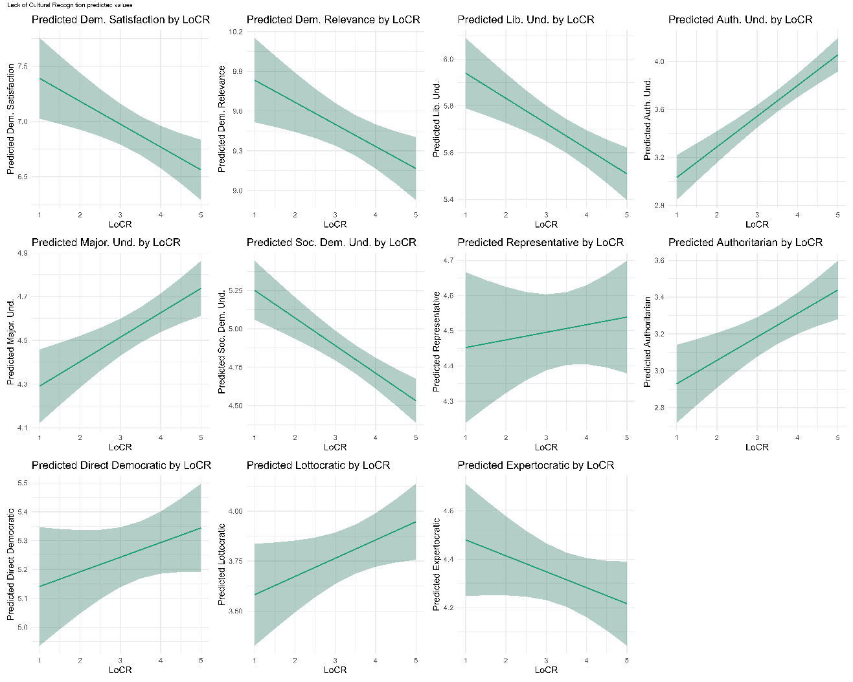

A7.1.2 Predicted values lack of economic recognition
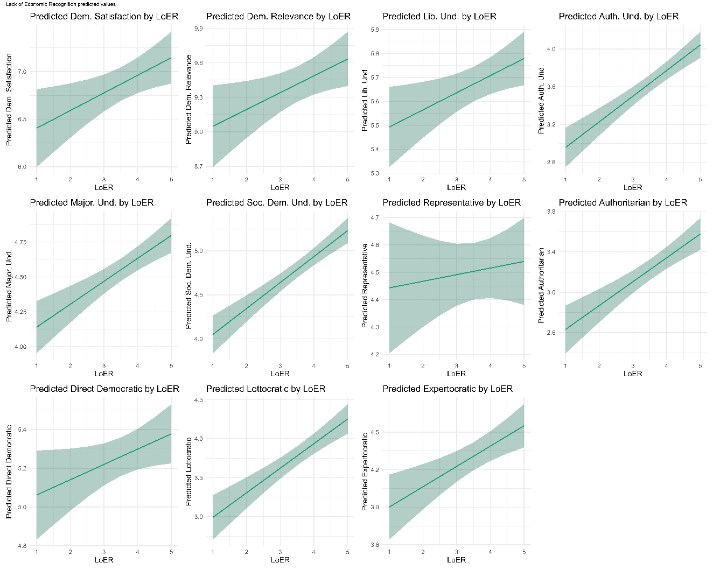

A7.1.3 Predicted values lack of political recognition
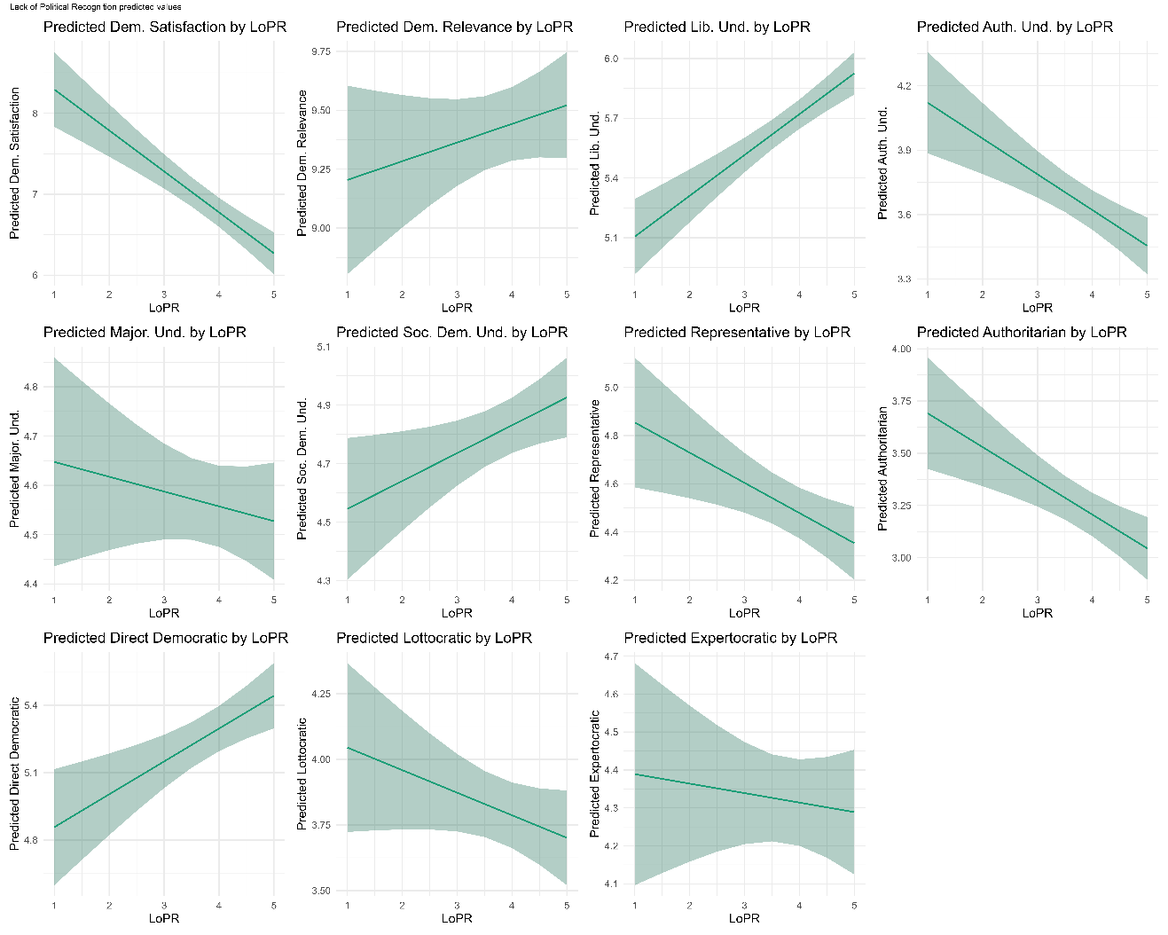

A7.2 Predicted Values lack of recognition Germany

A7.2.1 Predicted values lack of cultural recognition

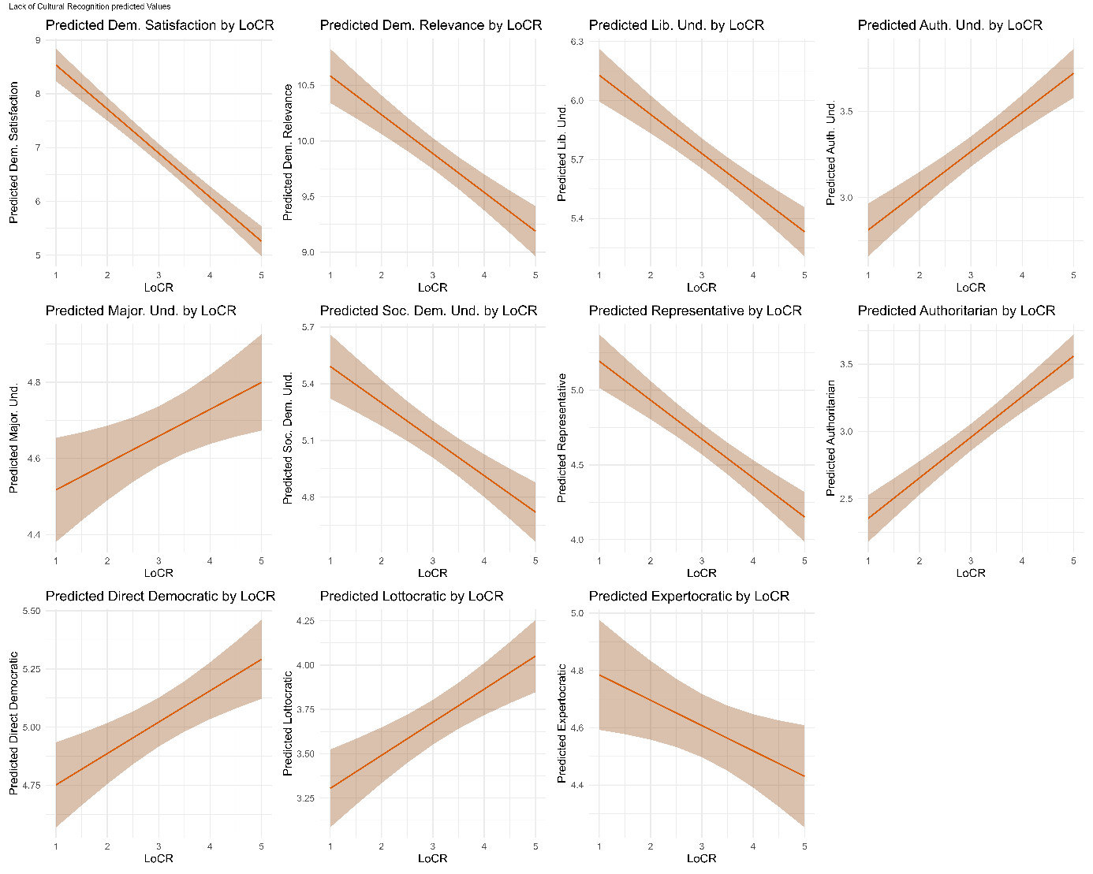

A7.2.2 Predicted values lack of economic recognition

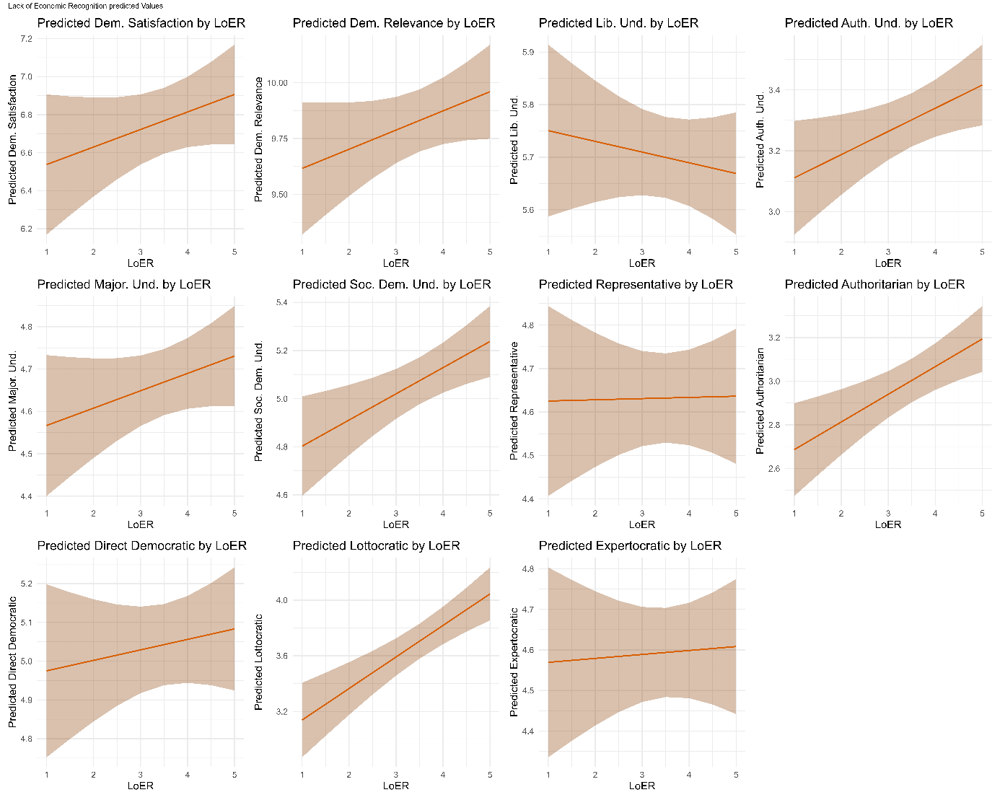

A7.2.2 Predicted values lack of political recognition
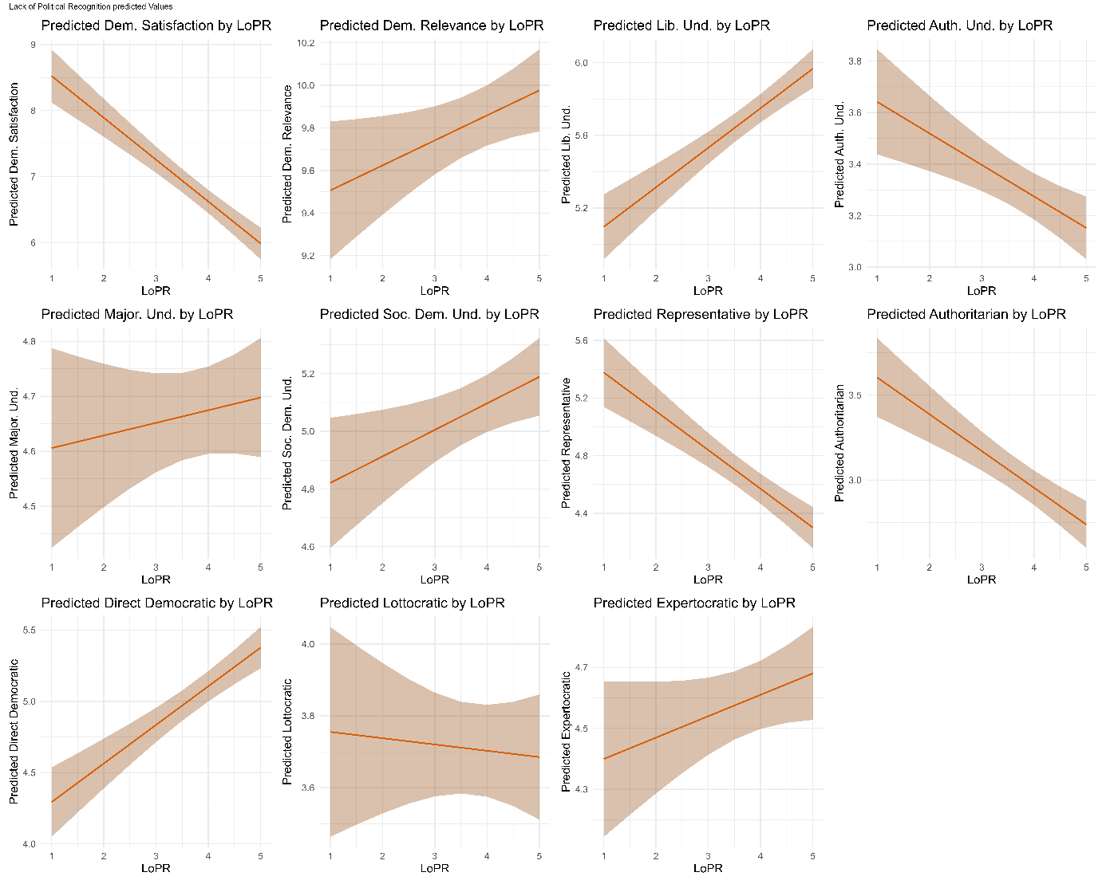

A8 VIF Values

The presented VIF values are based on the respective models presented in A5.
 | Democratic Satisfaction |  |  |  | Democratic Relevance
 | Model 3 |  | Model 5 |  | Model 3 |  |  | Model 5
 | GER | US | GER | US | GER |  | US | GER | US
LoCR | 1.69 | 1.71 | 1.70 | 1.72 | 1.69 |  | 1.71 | 1.70 | 1.72
LoER | 1.93 | 1.82 | 1.97 | 1.86 | 1.93 |  | 1.81 | 1.97 | 1.86
LoPR | 2.05 | 1.92 | 2.08 | 1.96 | 2.05 |  | 1.93 | 2.08 | 1.96
Worker | 1.15 | 1.12 | 1.20 | 1.17 | 1.15 |  | 1.12 | 1.20 | 1.17
Low Income | 1.12 | 1.10 | 1.30 | 1.17 | 1.12 |  | 1.10 | 1.30 | 1.17
Rural | 1.02 | 1.02 | 1.02 | 1.04 | 1.02 |  | 1.02 | 1.02 | 1.04
Deprived |  |  | 1.27 | 1.14 |  |  |  | 1.27 | 1.14
Working/Low Class |  |  | 1.62 | 1.46 |  |  |  | 1.62 | 1.45
Subj. Social Position |  |  | 1.74 | 1.48 |  |  |  | 1.74 | 1.47
Ideology (Left – Right) | 1.07 | 1.13 | 1.08 | 1.16 | 1.07 |  | 1.13 | 1.08 | 1.16
Eastern Germany (GER) / Rust Belt State (US) | 1.02 | 1.01 | 1.03 | 1.01 | 1.02 |  | 1.01 | 1.03 | 1.01
Low Education | 1.13 | 1.05 | 1.16 | 1.06 | 1.13 |  | 1.05 | 1.16 | 1.06
Male | 1.11 | 1.05 | 1.11 | 1.06 | 1.11 |  | 1.05 | 1.11 | 1.06
Age | 1.03 | 1.07 | 1.03 | 1.07 | 1.03 |  | 1.07 | 1.03 | 1.07
 | Liberal Understanding |  |  |  |  | Authoritarian Understanding
 | Model 3 |  | Model 5 |  | Model 3 |  |  | Model 5
 | GER | US | GER | US | GER |  | US | GER | US
LoCR | 1.68 | 1.71 | 1.69 | 1.72 | 1.68 |  | 1.70 | 1.69 | 1.72
LoER | 1.91 | 1.81 | 1.96 | 1.85 | 1.92 |  | 1.81 | 1.96 | 1.85
LoPR | 2.04 | 1.92 | 2.07 | 1.95 | 2.04 |  | 1.92 | 2.08 | 1.95
Worker | 1.15 | 1.12 | 1.20 | 1.17 | 1.16 |  | 1.12 | 1.20 | 1.17
Low Income | 1.12 | 1.10 | 1.30 | 1.17 | 1.12 |  | 1.10 | 1.30 | 1.17
Rural | 1.02 | 1.02 | 1.02 | 1.04 | 1.02 |  | 1.02 | 1.02 | 1.04
Deprived |  |  | 1.27 | 1.14 |  |  |  | 1.26 | 1.14
Working/Low Class |  |  | 1.64 | 1.46 |  |  |  | 1.62 | 1.46
Subj. Social Position |  |  | 1.74 | 1.48 |  |  |  | 1.74 | 1.48
Ideology (Left – Right) | 1.07 | 1.13 | 1.08 | 1.16 | 1.07 |  | 1.13 | 1.08 | 1.15
Eastern Germany (GER) / Rust Belt State (US) | 1.02 | 1.01 | 1.03 | 1.01 | 1.03 |  | 1.01 | 1.03 | 1.01
Low Education | 1.13 | 1.05 | 1.15 | 1.06 | 1.13 |  | 1.05 | 1.16 | 1.06
Male | 1.11 | 1.05 | 1.11 | 1.06 | 1.11 |  | 1.05 | 1.11 | 1.06
Age | 1.03 | 1.06 | 1.03 | 1.07 | 1.03 |  | 1.07 | 1.03 | 1.07
 | Majoritarian Understanding |  |  |  | Social Democratic Understanding
 | Model 3 |  | Model 5 |  | Model 3 |  |  | Model 5
 | GER | US | GER | US | GER |  | US | GER | US
LoCR | 1.68 | 1.71 | 1.69 | 1.72 | 1.69 |  | 1.71 | 1.69 | 1.72
LoER | 1.92 | 1.81 | 1.96 | 1.86 | 1.92 |  | 1.81 | 1.97 | 1.86
LoPR | 2.04 | 1.93 | 2.07 | 1.96 | 2.05 |  | 1.93 | 2.08 | 1.96
Worker | 1.16 | 1.12 | 1.20 | 1.17 | 1.15 |  | 1.12 | 1.20 | 1.17
Low Income | 1.12 | 1.09 | 1.30 | 1.17 | 1.12 |  | 1.10 | 1.30 | 1.17
Rural | 1.02 | 1.02 | 1.02 | 1.04 | 1.02 |  | 1.02 | 1.02 | 1.04
Deprived |  |  | 1.27 | 1.14 |  |  |  | 1.27 | 1.14
Working/Low Class |  |  | 1.63 | 1.46 |  |  |  | 1.62 | 1.46
Subj. Social Position |  |  | 1.74 | 1.48 |  |  |  | 1.73 | 1.47
Ideology (Left – Right) | 1.07 | 1.13 | 1.08 | 1.16 | 1.07 |  | 1.13 | 1.08 | 1.15
Eastern Germany (GER) / Rust Belt State (US) | 1.02 | 1.01 | 1.03 | 1.01 | 1.03 |  | 1.01 | 1.03 | 1.01
Low Education | 1.13 | 1.05 | 1.16 | 1.05 | 1.13 |  | 1.05 | 1.16 | 1.06
Male | 1.11 | 1.05 | 1.11 | 1.06 | 1.11 |  | 1.05 | 1.11 | 1.06
Age | 1.03 | 1.07 | 1.03 | 1.07 | 1.03 |  | 1.07 | 1.03 | 1.07
 | Representative Decision-Making |  |  |  | Authoritarian Decision-Making
 | Model 3 |  | Model 5 |  | Model 3 |  |  | Model 5
 | GER | US | GER | US | GER |  | US | GER | US
LoCR | 1.69 | 1.71 | 1.69 | 1.72 | 1.68 |  | 1.71 | 1.69 | 1.72
LoER | 1.92 | 1.81 | 1.97 | 1.86 | 1.92 |  | 1.81 | 1.97 | 1.86
LoPR | 2.05 | 1.93 | 2.08 | 1.96 | 2.04 |  | 1.92 | 2.08 | 1.95
Worker | 1.16 | 1.12 | 1.20 | 1.17 | 1.16 |  | 1.12 | 1.20 | 1.17
Low Income | 1.12 | 1.10 | 1.30 | 1.17 | 1.12 |  | 1.10 | 1.30 | 1.17
Rural | 1.02 | 1.02 | 1.02 | 1.04 | 1.02 |  | 1.02 | 1.02 | 1.04
Deprived |  |  | 1.27 | 1.14 |  |  |  | 1.27 | 1.14
Working/Low Class |  |  | 1.62 | 1.46 |  |  |  | 1.62 | 1.46
Subj. Social Position |  |  | 1.74 | 1.48 |  |  |  | 1.74 | 1.48
Ideology (Left – Right) | 1.07 | 1.13 | 1.08 | 1.15 | 1.07 |  | 1.13 | 1.08 | 1.15
Eastern Germany (GER) / Rust Belt State (US) | 1.02 | 1.01 | 1.03 | 1.01 | 1.03 |  | 1.01 | 1.03 | 1.01
Low Education | 1.13 | 1.05 | 1.16 | 1.06 | 1.14 |  | 1.05 | 1.16 | 1.06
Male | 1.11 | 1.05 | 1.11 | 1.06 | 1.11 |  | 1.05 | 1.11 | 1.06
Age | 1.03 | 1.07 | 1.03 | 1.07 | 1.03 |  | 1.07 | 1.03 | 1.07
 | Direct Democratic Decision-Making |  |  |  | Lottocratic Decision-Making
 | Model 3 |  | Model 5 |  | Model 3 |  |  | Model 5
 | GER | US | GER | US | GER |  | US | GER | US
LoCR | 1.69 | 1.71 | 1.69 | 1.72 | 1.69 |  | 1.71 | 1.69 | 1.72
LoER | 1.93 | 1.81 | 1.97 | 1.86 | 1.93 |  | 1.82 | 1.97 | 1.86
LoPR | 2.05 | 1.92 | 2.08 | 1.95 | 2.05 |  | 1.93 | 2.08 | 1.96
Worker | 1.16 | 1.12 | 1.20 | 1.17 | 1.16 |  | 1.12 | 1.20 | 1.17
Low Income | 1.12 | 1.10 | 1.30 | 1.17 | 1.12 |  | 1.09 | 1.30 | 1.17
Rural | 1.02 | 1.02 | 1.02 | 1.04 | 1.02 |  | 1.02 | 1.02 | 1.04
Deprived |  |  | 1.27 | 1.14 |  |  |  | 1.27 | 1.14
Working/Low Class |  |  | 1.62 | 1.46 |  |  |  | 1.62 | 1.46
Subj. Social Position |  |  | 1.74 | 1.47 |  |  |  | 1.74 | 1.48
Ideology (Left – Right) | 1.07 | 1.13 | 1.08 | 1.15 | 1.07 |  | 1.13 | 1.08 | 1.16
Eastern Germany (GER) / Rust Belt State (US) | 1.02 | 1.01 | 1.03 | 1.01 | 1.02 |  | 1.01 | 1.03 | 1.01
Low Education | 1.13 | 1.05 | 1.16 | 1.06 | 1.13 |  | 1.05 | 1.16 | 1.06
Male | 1.11 | 1.05 | 1.11 | 1.06 | 1.11 |  | 1.05 | 1.11 | 1.06
Age | 1.03 | 1.07 | 1.03 | 1.07 | 1.03 |  | 1.06 | 1.03 | 1.07
 | Technocratic Decision-Making
 | Model 3 |  | Model 5
 | GER | US | GER | US
LoCR | 1.69 | 1.71 | 1.69 | 1.72
LoER | 1.92 | 1.82 | 1.97 | 1.86
LoPR | 2.05 | 1.93 | 2.08 | 1.96
Worker | 1.16 | 1.12 | 1.20 | 1.17
Low Income | 1.12 | 1.09 | 1.30 | 1.17
Rural | 1.02 | 1.02 | 1.02 | 1.04
Deprived |  |  | 1.27 | 1.14
Working/Low Class |  |  | 1.62 | 1.46
Subj. Social Position |  |  | 1.74 | 1.48
Ideology (Left – Right) | 1.07 | 1.13 | 1.08 | 1.15
Eastern Germany (GER) / Rust Belt State (US) | 1.02 | 1.01 | 1.03 | 1.01
Low Education | 1.13 | 1.05 | 1.16 | 1.06
Male | 1.11 | 1.05 | 1.11 | 1.06
Age | 1.03 | 1.06 | 1.03 | 1.07
 | Military |  |  |  | Strong President
 | Model 3 |  | Model 5 |  | Model 3 |  |  | Model 5
 | GER | US | GER | US | GER |  | US | GER | US
LoCR | 1.69 | 1.71 | 1.69 | 1.72 | 1.69 |  | 1.71 | 1.69 | 1.72
LoER | 1.92 | 1.81 | 1.97 | 1.86 | 1.92 |  | 1.81 | 1.97 | 1.86
LoPR | 2.05 | 1.92 | 2.08 | 1.96 | 2.04 |  | 1.92 | 2.08 | 1.95
Worker | 1.15 | 1.12 | 1.20 | 1.17 | 1.16 |  | 1.12 | 1.20 | 1.17
Low Income | 1.12 | 1.10 | 1.30 | 1.17 | 1.12 |  | 1.10 | 1.30 | 1.17
Rural | 1.02 | 1.02 | 1.02 | 1.04 | 1.02 |  | 1.02 | 1.02 | 1.04
Deprived |  |  | 1.27 | 1.14 |  |  |  | 1.27 | 1.14
Working/Low Class |  |  | 1.62 | 1.46 |  |  |  | 1.62 | 1.46
Subj. Social Position |  |  | 1.74 | 1.48 |  |  |  | 1.74 | 1.48
Ideology (Left – Right) | 1.07 | 1.13 | 1.08 | 1.15 | 1.07 |  | 1.13 | 1.08 | 1.15
Eastern Germany (GER) / Rust Belt State (US) | 1.03 | 1.01 | 1.03 | 1.01 | 1.03 |  | 1.01 | 1.03 | 1.01
Low Education | 1.14 | 1.05 | 1.16 | 1.06 | 1.13 |  | 1.05 | 1.16 | 1.06
Male | 1.11 | 1.05 | 1.11 | 1.06 | 1.11 |  | 1.05 | 1.11 | 1.06
Age | 1.03 | 1.07 | 1.03 | 1.07 | 1.03 |  | 1.07 | 1.03 | 1.07

A9 Pooled Data Regression Analyses

 | Dependent variable:
 | Democratic Satisfaction | Democratic Relevance | Liberal Understanding
LoCR | -0.879*** | -0.341*** | -0.207***
 | (0.061) | (0.051) | (0.026)
LoER | 0.118 | 0.128* | -0.014
 | (0.069) | (0.058) | (0.029)
LoPR | -0.638*** | 0.111 | 0.221***
 | (0.070) | (0.059) | (0.030)
Worker | -0.435*** | -0.466*** | -0.114**
 | (0.089) | (0.075) | (0.038)
Low Income | -0.402*** | -0.711*** | -0.120**
 | (0.100) | (0.084) | (0.042)
Rural | -0.408*** | -0.067 | -0.107*
 | (0.108) | (0.091) | (0.046)
Ideology (Left-Right) | 0.037* | 0.005 | -0.009
 | (0.016) | (0.014) | (0.007)
Eastern Germany/Rust Belt | -0.263** | -0.273*** | -0.077*
 | (0.090) | (0.076) | (0.038)
Low Education | -0.033 | -0.644*** | -0.285***
 | (0.125) | (0.106) | (0.053)
Male | 0.413*** | 0.315*** | 0.178***
 | (0.077) | (0.065) | (0.033)
Age | 0.016*** | 0.038*** | 0.021***
 | (0.002) | (0.002) | (0.001)
LoCR:US | 0.748*** | 0.184* | 0.105**
 | (0.088) | (0.074) | (0.037)
LoER:US | 0.050 | -0.037 | 0.086*
 | (0.099) | (0.083) | (0.042)
LoPR:US | 0.122 | -0.007 | -0.021
 | (0.103) | (0.087) | (0.044)
Country (US) | -2.518*** | -0.802** | -0.559***
 | (0.314) | (0.265) | (0.133)
Constant | 10.430*** | 8.267*** | 4.654***
 | (0.249) | (0.210) | (0.106)
Observations | 4,907 | 4,912 | 4,880
R² | 0.174 | 0.129 | 0.128
Adjusted R² | 0.171 | 0.126 | 0.126
Residual Std. Error | 2.587 (df = 4891) | 2.183 (df = 4896) | 1.096 (df = 4864)
F Statistic | 68.666*** (df = 15; 4891) | 48.134*** (df = 15; 4896) | 47.694*** (df = 15; 4864)
Note: *p<0.05; **p<0.01; ***p<0.001

 | Dependent variable:
 | Authoritarian Understanding | Majoritarian Understanding | Social Democratic Understanding
LoCR | 0.212*** | 0.071* | -0.191***
 | (0.031) | (0.028) | (0.033)
LoER | 0.074* | 0.030 | 0.099**
 | (0.035) | (0.031) | (0.037)
LoPR | -0.113** | 0.037 | 0.111**
 | (0.035) | (0.032) | (0.038)
Worker | 0.114* | 0.069 | -0.008
 | (0.045) | (0.040) | (0.048)
Low Income | 0.024 | -0.109* | 0.139**
 | (0.051) | (0.045) | (0.054)
Rural | -0.139* | -0.134** | -0.114
 | (0.055) | (0.049) | (0.058)
Ideology (Left-Right) | 0.078*** | 0.053*** | -0.088***
 | (0.008) | (0.007) | (0.009)
Eastern Germany/Rust Belt | 0.100* | 0.030 | -0.040
 | (0.046) | (0.041) | (0.049)
Low Education | 0.209** | 0.095 | -0.135*
 | (0.064) | (0.057) | (0.068)
Male | 0.056 | 0.113** | 0.007
 | (0.039) | (0.035) | (0.041)
Age | -0.020*** | 0.006*** | 0.001
 | (0.001) | (0.001) | (0.001)
LoCR:US | 0.057 | 0.033 | -0.0004
 | (0.044) | (0.040) | (0.047)
LoER:US | 0.212*** | 0.154*** | 0.219***
 | (0.050) | (0.045) | (0.053)
LoPR:US | -0.071 | -0.083 | -0.036
 | (0.052) | (0.047) | (0.056)
Country (US) | -0.490** | -0.471*** | -0.828***
 | (0.160) | (0.143) | (0.170)
Constant | 3.304*** | 3.589*** | 5.349***
 | (0.127) | (0.114) | (0.135)
Observations | 4,883 | 4,890 | 4,892
R² | 0.154 | 0.054 | 0.068
Adjusted R² | 0.152 | 0.051 | 0.065
Residual Std. Error | 1.311 (df = 4867) | 1.175 (df = 4874) | 1.399 (df = 4876)
F Statistic | 59.287*** (df = 15; 4867) | 18.654*** (df = 15; 4874) | 23.634*** (df = 15; 4876)
Note: *p<0.05; **p<0.01; ***p<0.001

 | Dependent variable:
 | Representative | Authoritarian | Direct Democratic
LoCR | -0.304*** | 0.293*** | 0.157***
 | (0.036) | (0.035) | (0.035)
LoER | 0.009 | 0.122** | 0.030
 | (0.041) | (0.040) | (0.040)
LoPR | -0.251*** | -0.201*** | 0.272***
 | (0.041) | (0.040) | (0.040)
Worker | -0.202*** | 0.064 | -0.052
 | (0.052) | (0.051) | (0.052)
Low Income | -0.158** | 0.081 | -0.205***
 | (0.059) | (0.057) | (0.058)
Rural | -0.142* | -0.089 | 0.042
 | (0.063) | (0.062) | (0.063)
Ideology (Left-Right) | 0.029** | 0.107*** | 0.011
 | (0.009) | (0.009) | (0.009)
Eastern Germany/Rust Belt | -0.052 | 0.078 | 0.136**
 | (0.053) | (0.052) | (0.052)
Low Education | -0.082 | 0.305*** | -0.133
 | (0.074) | (0.072) | (0.073)
Male | 0.307*** | -0.127** | 0.059
 | (0.045) | (0.044) | (0.044)
Age | 0.010*** | -0.027*** | 0.005***
 | (0.001) | (0.001) | (0.001)
LoCR:US | 0.366*** | -0.156** | -0.129*
 | (0.052) | (0.051) | (0.051)
LoER:US | 0.034 | 0.127* | 0.040
 | (0.058) | (0.057) | (0.057)
LoPR:US | 0.097 | 0.021 | -0.117*
 | (0.061) | (0.059) | (0.060)
Country (US) | -1.650*** | 0.130 | 0.816***
 | (0.185) | (0.181) | (0.182)
Constant | 5.824*** | 3.016*** | 3.166***
 | (0.147) | (0.144) | (0.145)
Observations | 4,901 | 4,906 | 4,907
R² | 0.089 | 0.153 | 0.060
Adjusted R² | 0.086 | 0.150 | 0.057
Residual Std. Error | 1.524 (df = 4885) | 1.493 (df = 4890) | 1.502 (df = 4891)
F Statistic | 31.725*** (df = 15; 4885) | 58.788*** (df = 15; 4890) | 20.915*** (df = 15; 4891)
Note: *p<0.05; **p<0.01; ***p<0.001

 | Dependent variable:
 | Lottocratic | Technocratic
LoCR | 0.161*** | -0.117**
 | (0.043) | (0.039)
LoER | 0.225*** | 0.007
 | (0.049) | (0.044)
LoPR | 0.010 | 0.097*
 | (0.050) | (0.044)
Worker | 0.154* | -0.072
 | (0.063) | (0.056)
Low Income | 0.056 | -0.030
 | (0.071) | (0.063)
Rural | -0.054 | -0.221**
 | (0.077) | (0.068)
Ideology (Left-Right) | 0.071*** | 0.002
 | (0.011) | (0.010)
Eastern Germany/Rust Belt | 0.105 | 0.137*
 | (0.064) | (0.057)
Low Education | 0.227* | -0.171*
 | (0.089) | (0.080)
Male | -0.053 | -0.054
 | (0.054) | (0.049)
Age | -0.025*** | -0.014***
 | (0.002) | (0.002)
LoCR:US | -0.055 | 0.071
 | (0.062) | (0.056)
LoER:US | 0.119 | 0.186**
 | (0.070) | (0.063)
LoPR:US | -0.129 | -0.157*
 | (0.073) | (0.065)
Country (US) | 0.284 | -0.524**
 | (0.223) | (0.199)
Constant | 3.113*** | 5.186***
 | (0.177) | (0.158)
Observations | 4,902 | 4,905
R² | 0.100 | 0.031
Adjusted R² | 0.097 | 0.028
Residual Std. Error | 1.839 (df = 4886) | 1.643 (df = 4889)
F Statistic | 36.011*** (df = 15; 4886) | 10.439*** (df = 15; 4889)
Note: *p<0.05; **p<0.01; ***p<0.001

A10 Additional Regression Analyses
For some dimensions of lack of recognition, visual inspection suggested nonlinear relationships with a liberal understanding of politics. Therefore, additional regression analyses were conducted that included quadratic terms to explore these patterns. These analyses revealed significant nonlinear effects while the main effects remained robust. As this paper aims to provide an initial overview of the relationships between recognition and democracy-related variables, the main text only presents primary linear results. As mentioned in the discussion section, however, some of these relationships may not be strictly linear and require further investigation.
Germany
 | Dependent variable:
 | Liberal Understanding
LoCR | -0.195***
 | (0.026)
LoCR quadratic term | 0.172***
 | (0.017)
LoER | -0.013
 | (0.029)
LoPR | 0.229***
 | (0.029)
Worker | -0.061
 | (0.053)
Low Income | -0.041
 | (0.057)
Rural | -0.134*
 | (0.057)
Ideology (Left-Right) | -0.030**
 | (0.011)
Eastern Germany | -0.097
 | (0.062)
Low Education | -0.298***
 | (0.059)
Male | 0.178***
 | (0.046)
Age | 0.021***
 | (0.001)
Constant | 3.829***
 | (0.144)
Observations | 2,405
R² | 0.175
Adjusted R² | 0.171
Residual Std. Error | 1.081 (df = 2392)
F Statistic | 42.368*** (df = 12; 2392)
Note: | *p<0.05; **p<0.01; ***p<0.001

 | Dependent variable:
 | Liberal Understanding
LoPR | 0.317***
 | (0.031)
LoPR quadratic term | 0.159***
 | (0.017)
LoCR | -0.200***
 | (0.026)
LoER | -0.009
 | (0.029)
Worker | -0.056
 | (0.054)
Low Income | -0.039
 | (0.058)
Rural | -0.153**
 | (0.058)
Ideology (Left-Right) | -0.026*
 | (0.011)
Eastern Germany | -0.112
 | (0.062)
Low Education | -0.329***
 | (0.059)
Male | 0.167***
 | (0.047)
Age | 0.021***
 | (0.001)
Constant | 5.330***
 | (0.150)
Observations | 2,405
R² | 0.169
Adjusted R² | 0.164
Residual Std. Error | 1.086 (df = 2392)
F Statistic | 40.410*** (df = 12; 2392)
Note: | *p<0.05; **p<0.01; ***p<0.001

US
 | Dependent variable:
 | Liberal Understanding
LoCR | -0.065*
 | (0.028)
LoCR quadratic term | 0.161***
 | (0.017)
LoER | 0.081**
 | (0.030)
LoPR | 0.208***
 | (0.032)
Worker | -0.140**
 | (0.051)
Low Income | -0.244***
 | (0.061)
Rural | -0.030
 | (0.073)
Ideology (Left-Right) | -0.005
 | (0.008)
Rust Belt State | -0.075
 | (0.047)
Low Education | -0.307*
 | (0.121)
Male | 0.162***
 | (0.044)
Age | 0.018***
 | (0.001)
Constant | 3.630***
 | (0.150)
Observations | 2,475
R² | 0.154
Adjusted R² | 0.150
Residual Std. Error | 1.066 (df = 2462)
F Statistic | 37.289*** (df = 12; 2462)
Note: | *p<0.05; **p<0.01; ***p<0.001

 | Dependent variable:
 | Liberal Understanding
LoER | 0.132***
 | (0.031)
LoER quadratic term | 0.154***
 | (0.018)
LoCR | -0.104***
 | (0.027)
LoPR | 0.199***
 | (0.032)
Worker | -0.155**
 | (0.052)
Low Income | -0.240***
 | (0.061)
Rural | -0.026
 | (0.073)
Ideology (Left-Right) | 0.001
 | (0.008)
Rust Belt State | -0.063
 | (0.047)
Low Education | -0.297*
 | (0.122)
Male | 0.174***
 | (0.044)
Age | 0.019***
 | (0.001)
Constant | 4.277***
 | (0.140)
Observations | 2,475
R² | 0.148
Adjusted R² | 0.144
Residual Std. Error | 1.070 (df = 2462)
F Statistic | 35.645*** (df = 12; 2462)
Note: | *p<0.05; **p<0.01; ***p<0.001

 | Dependent variable:
 | Liberal Understanding
LoPR | 0.263***
 | (0.033)
LoPR quadratic term | 0.117***
 | (0.019)
LoCR | -0.102***
 | (0.028)
LoER | 0.068*
 | (0.030)
Worker | -0.150**
 | (0.052)
Low Income | -0.255***
 | (0.061)
Rural | -0.033
 | (0.074)
Ideology (Left-Right) | -0.002
 | (0.008)
Rust Belt State | -0.058
 | (0.047)
Low Education | -0.285*
 | (0.123)
Male | 0.172***
 | (0.044)
Age | 0.019***
 | (0.001)
Constant | 4.841***
 | (0.150)
Observations | 2,475
R² | 0.136
Adjusted R² | 0.132
Residual Std. Error | 1.077 (df = 2462)
F Statistic | 32.366*** (df = 12; 2462)
Note: | *p<0.05; **p<0.01; ***p<0.001

All regressions were additionally re-run using a dataset that included respondents who had been excluded from the main analyses based on speeding and straightlining checks post-survey. The results remained robust.

