Supplementary Materials

for

Second-Order Beliefs Among Citizens, Elected, and Unelected Political Elites: Insights from Norwegian Climate Policy

Ingrid Faleide, Department of Government, University of Bergen
Åsta Dyrnes Nordø, Department of Government, University of Bergen

Contents
Meat-free day as climate measure: Media attention and political relevance 2
Data and Analysis 5
Data 5
Party representativeness in the Panel of Elected Representatives 6
Regression specifications 7
Public Opinion 10
Pre-registration 12
References 13

Meat-free day as climate measure: Media attention and political relevance

Figure A1 shows the development in media attention to meat reduction as a climate change policy over the last decade. The article search was conducted in the online media database ATEKST with the following search string: (bovine meat OR beef OR *meat) AND (environment* OR sustainability* OR climate*). The query generated 69 776 news stories from all media sources (paper, web and TV/radio). We see that the issue of meat consumption when related to climate change has received increased attention in this period. However, the increase is gradual, only interrupted by a steep peak in 2019. This peak seems to be driven by three things; a report pointing at the necessity of drastic reductions in meat and dairy consumption received a lot of attention, 2019 being a local election year where climate policy was high on the political agenda and where the Green Party came to power in many municipalities, and last the introduction of a free, meat free meal once a week in the Oslo schools, orchestrated by the newly elected red-green city government. The fact that this is a type of policy local politicians have the power to implement as a means to reduce greenhouse gas emissions was an additional important factor for picking this specific survey item, given the survey samples at hand. The increased media attention linked to the 2019 local elections indicate that measures to reduce meat consumption is a politically relevant issue, particularly at the local government level.
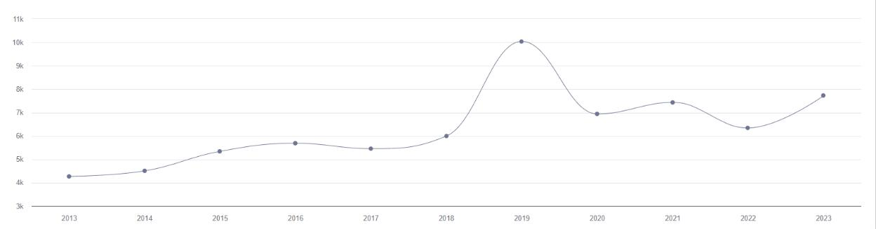

Figure A1: Press coverage of sustainable meat consumption in Norway 2013-2023. Data collected from ATEKST (N= 69 776).

Important to our study, Figure A1 signifies that 2023 is a year similar to previous years in terms of public debate on meat consumption in light of climate change. In other words, there seems to be nothing specific about the scope of media debate in 2023 that should reduce the representativeness of our results.

An example to illustrate the political relevance of meat reduction as a climate change mitigation measure from around the time of this data collection, is an interview with two of the most prominent Center Party (Sp) profiles before their 2023 national party convention (in March). Their attitudes toward meat-reduction was portrayed in national media under the headline ”- Meat-free dinner is not dinner” (Gilbrant and Solas Suvatne 2023). This was a response to the Conservative Party’s (H) “CO2 tax in agriculture” (Høyre 2022, 32), labelled a “climate tax on meat” by Sp.
A search through the Norwegian political parties’ national party manifestos resulted in the following findings concerning meat consumption and production specifically related to climate change and emissions:
- Socialist Left, Sosialistisk venstreparti (2021, 89): “Stimulate more cultivation of grains, fruits and vegetables, and gradually reduce meat production that is not based on Norwegian resources and climate-friendly farming methods.”
- Agrarian Center Party, Senterpartiet (2021, 15): “Norwegian grass and pasture resources must be better utilized, and Norwegian meat production from cattle and sheep is an important global contribution to more climate-friendly food production.”
- Green Party, Miljøpartiet De Grønne (2021, 9): “Have a long-term goal of halving Norwegian meat consumption, so that consumption does not exceed what we can produce ourselves on our own land and resources. Have a long-term goal of phasing out imports of concentrated feed and adapting meat production to the local resource base. (See also chapters 6 and 33.)”
- Liberal Party, Venstre (2021, 29-30): “We will shift a larger share of agricultural subsidies to green food production. To achieve national goals for food security, health and climate, we must produce more grain, potatoes, fruit and vegetables, and less meat based on imported feed. We will support measures to reduce meat consumption, while ensuring that the entire animal is utilized. We want consumer information about diet to place more emphasis on health, quality and food traditions, especially for children and young people. In international comparison, Norwegian agriculture is among those that use the least antibiotics. We will support measures that continue to promote safe and sustainable Norwegian agriculture.”
- Progress Party, Fremskrittspartiet (2021, 78): “The Progress Party will also oppose a policy that is based on harassing its own citizens with symbolic policies that have little or no impact on global emissions, but that make everyday life more difficult for most people. Examples of this include a ban on the sale of new gasoline and diesel cars by 2025, a tax on the production of red meat, creative aviation taxes, electrification of the continental shelf that will require massive development of new wind turbines on land, or environmental taxes with no effect that only bring money to the treasury. Nor is it a solution to impose taxes such as increased CO2 taxes before alternative technology is available. This will affect, among other things, the transport industry and the maritime sector.”

The Red Party, the Labor Party (Ap), the Christian Democrats (KrF) and the Conservative Party (H) did not mention meat specifically in their party manifestos. These extracts reflect the perceived resistance toward meat reduction as a measure to reduce emissions. The clearest position for meat reduction is presented by the Green Party, and the clearest opposition is presented by the Progress Party.

To exemplify how meat-free meals in canteens more specifically is a politically relevant issue, we can look at the Green Party’s local party manifestos in the two biggest cities in Norway:
- Miljøpartiet De Grønne Oslo (2023, 9): “Eating more varied and plant-based food is good for health, the environment and animals. Therefore, we will reduce meat consumption in Oslo Municipality's canteens and institutions by at least 50 percent. We will strengthen the expertise in good vegetarian food in municipal businesses and institutions. Vegetarian food should be the standard choice at municipal events. We will always offer a full vegan alternative. It should always be possible to choose vegetarian in Oslo.”
- Miljøpartiet De Grønne Bergen (2023, 8-9): “ We want to make it easier and more attractive to eat more plant-based and healthy food. We want to halve meat consumption in Bergen Municipality by 2027. (…) Bergen MDG will make organic and plant-based food the standard in municipal institutions and canteens.”

Data and Analysis

Data
Data from the Norwegian Citizen Panel is as close as we can get to an estimate of what Norwegians think. With its initial random sampling from the National Population Registry, and post-stratification survey weights, the Norwegian Citizen Panel follows the best practice for survey research. While the Norwegian Citizen Panel does have some common biases (particularly more highly educated respondents, but also less young respondents, and some regional skews), the initial random selection mitigates these biases to a greater extent compared to opt-in panels (Cornesse et al. 2020).

All elected representatives in Norway are invited to take part in The Panel of Elected Representatives. The retention rate has gradually declined across recruitment waves, with most drop-off occurring between the first and second wave of participation. Wave 9 achieved a response rate of 35.6% (Skjervheim, Grendal, et al. 2023, p. 5). It primarily consists of elected representatives at the local level, which is not in itself a bias, but a reflection of the fact that Norwegian elected officials are primarily chosen for local assemblies (Fimreite and Ivarsflaten 2022). However, the share of county, Sami and parliamentary representatives participating is lower than the share of participating municipal representatives (Skjervheim, Grendal, et al. 2023, p. 9). It is also worth noting that more than 90% of the respondents in this panel are part-time, and not full-time politicians. This is important to consider when comparing the results to elite surveys conducted on full-time politicians in other countries. Comparing the sample to registry data from Statistics Norway, similar biases as found in the Citizen Panel are present also in the Panel of Elected Representatives (men, older and higher educated are overrepresented in this sample compared to the actual population of elected representatives). These biases must be considered in the analyses, as survey weights are not calculated for this sample. Biases when it comes to regions and parties are rather small (Skjervheim, Grendal, et al. 2023, p. 9-11). It is also worth noting that with the Norwegian 4-year terms for elected representatives, most of the respondents in this panel were elected in the local elections of 2019. National and Sami elections were held in 2021.
Respondents in the Panel of Public Administrators are exclusively recruited from central level administration, resulting in a higher concentration of respondents living in the capital and other urban areas. This panel has the same representation issues as the two other panels compared to the population of public administrators (particularly older respondents are overrepresented, especially the oldest age group (62 years and older)). Although education level naturally should be higher in the Panel of Public Administrators, this sample also has an overrepresentation of respondents with the highest level of education compared to the population of public administrators (Skjervheim, Høgestøl, et al. 2023, p. 9-12). The gross sample of invited public administrators does not fully reflect the target population. Discrepancies between organizational employee numbers and those invited to participate exist, some intentionally (exclusion of organizations with large operational roles) and others unintentionally (difficulty obtaining email addresses). More details about this are provided by Skjervheim, Høgestøl, et al. (2023).

Party representativeness in the Panel of Elected Representatives
Norwegian municipal councils were dominated by representatives from the Labor (27.6 percent) and Center party (24.2 percent) in the election period 2019-2023. Figure A2 illustrates that the share of respondents in the panel from each party corresponds quite well to the actual share of representatives from each party in Norwegian municipalities.

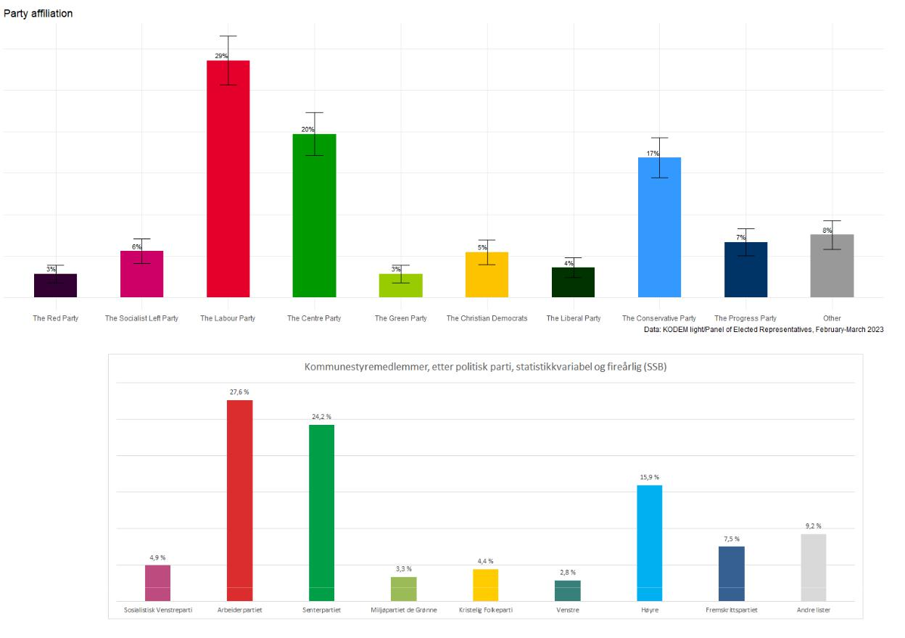

Figure A2: Comparison of party affiliation of respondents in the Panel of Elected Representatives and actual party affiliation in Norwegian municipalities 2019-2023.

Regression specifications
Gender is coded 1 for male and 2 for female. The generational classification is based on the four generational cohorts identified by Norris and Inglehart (2019, 35-37) to explain changes in social values. We put emphasis on the distinction between ”Generation X” and ”Millennials.” This division between generations is set at 1980, so those born in 1979 are included in the older age group and assigned the value 1, while those born in 1980 and later are assigned the value 0. Education is coded 0 for those with elementary and upper secondary school as highest level of completed education, and 1 for those with a university degree. The urban variable is based on the question ”Which description best fits the area you live in?” with the response options ”A city”, ”A suburb or the outskirts of a city”, ”A small or medium sized town”, ”A village”, and ”A sparsely inhabited area”. The variable has been rescaled to values ranging from 0 (most urban) to 1 (most rural).
The ideology measure is based on self-placement on the political left-right spectrum. This scale ranges from 0 to 10 in the questionnaire, but has been recoded to values between 0 and 1. The indicator of cultural liberalism/conservatism builds on Hooghe, Marks, and Wilson (2002). The index is composed of four “What is your opinion of the following proposals?”-elements: “Reserve more parental leave days for the father/co-mother”, ”Make more space for Christian cultural heritage in Norway”, ”Accept fewer asylum seekers”, and ”Increase the carbon tax on petrol and diesel”. It ranges from 0 to 1, where low values indicate cultural liberalism and higher values indicate cultural conservatism. The correlation between self-placement on the left-right axis and cultural liberalism-conservatism measures is 0.48 (Pearson’s R).

The party variable is based on voting intention for citizens and unelected elites, and which party the elected elites represent. Norway employs a proportional representation electoral system, fostering a diverse political landscape with representation from ten distinct parties in parliament. The nine largest parties represented in the national parliament are included in the analyses. According to the Chapel Hill Expert Survey (CHES) classification of political parties, the two main parties, Labor (Ap) and Conservative (H), are positioned along the classical left-to-right political axis. Four parties are placed at the culturally liberal end of the second dimension, these are the Socialist Left (SV), Red (R), Green (MDG) and Liberal (V). Three parties are placed toward the culturally conservative side, these are the Christian Democrats (KrF), Progress Party (Frp) and Agrarian Center Party (Sp) (Stein 2023). At the time of this data collection, the Conservative Party (H) had the largest number of observations, this is set as the reference category in the regression analyses.

Table A1: Logistic regression, first-order beliefs: Agreement with meat free day is coded as 1, and disagreement is coded as 0.

 | Model 1 | Model 2 | Model 3 | Model 4
(Intercept) | 0.29∗∗∗ | 1.18∗∗∗ | 4.10∗∗∗ | 3.61∗∗∗
 | (0.07) | (0.19) | (0.30) | (0.42)
Elected elites | −0.72∗∗∗ | −0.45∗∗∗ | −0.73∗∗∗ | −0.55∗∗∗
 | (0.13) | (0.15) | (0.17) | (0.18)
Unelected elites | 0.63∗∗∗ | 0.19 | −0.01 | −0.02
 | (0.11) | (0.14) | (0.16) | (0.16)
Female |  | 0.77∗∗∗ | 0.78∗∗∗ | 0.77∗∗∗
 |  | (0.11) | (0.12) | (0.12)
Age |  | −0.32∗∗∗ | −0.26∗∗∗ | −0.27∗∗∗
 |  | (0.04) | (0.05) | (0.05)
University |  | 0.46∗∗∗ | 0.22 | 0.15
 |  | (0.13) | (0.14) | (0.14)
Rural |  | −0.86∗∗∗ | −0.49∗∗ | −0.27
 |  | (0.18) | (0.20) | (0.21)
Ideology |  |  | −1.14∗∗∗ | −1.04∗∗
 |  |  | (0.29) | (0.45)
Cultural |  |  | −5.09∗∗∗ | −4.24∗∗∗
 |  |  | (0.43) | (0.46)
The Christian Democrats |  |  |  | 0.04
 |  |  |  | (0.31)
The Progress Party |  |  |  | −0.66∗∗
 |  |  |  | (0.31)
The Liberal Party |  |  |  | 0.25
 |  |  |  | (0.25)
The Socialist Left Party |  |  |  | 0.61∗∗
 |  |  |  | (0.31)
The Centre Party |  |  |  | −1.13∗∗∗
 |  |  |  | (0.27)
The Green Party |  |  |  | 1.82∗∗∗
 |  |  |  | (0.52)
The Labour Party |  |  |  | −0.17
 |  |  |  | (0.21)
The Red Party |  |  |  | −0.09
 |  |  |  | (0.34)
AIC | 2280.92 | 2107.28 | 1823.87 | 1774.16
BIC | 2297.50 | 2145.98 | 1873.62 | 1868.14
Log Likelihood | −1137.46 | −1046.64 | −902.94 | −870.08
Deviance | 2323.42 | 2142.78 | 1844.75 | 1781.30
Num. obs. | 1859 | 1859 | 1859 | 1859

∗∗∗ p < 0.01; ∗∗ p < 0.05; ∗ p < 0.1

Table A2: Logistic regression, second-order beliefs: Think a majority agree is coded as 1, think a minority agree is coded as 0.

 | Model 1 | Model 2 | Model 3 | Model 4
(Intercept) | −0.36∗∗∗ | −0.37∗ | 0.66∗∗ | 0.53
 | (0.07) | (0.18) | (0.25) | (0.35)
Elected elites | −0.71∗∗∗ | −0.58∗∗∗ | −0.69∗∗∗ | −0.57∗∗∗
 | (0.13) | (0.15) | (0.15) | (0.16)
Unelected elites | 0.21· | −0.15 | −0.26· | −0.27∗
 | (0.11) | (0.13) | (0.14) | (0.14)
Female |  | 0.70∗∗∗ | 0.64∗∗∗ | 0.62∗∗∗
 |  | (0.10) | (0.10) | (0.10)
Age |  | −0.08∗ | −0.06 | −0.06
 |  | (0.04) | (0.04) | (0.04)
University |  | 0.37∗∗ | 0.20 | 0.13
 |  | (0.13) | (0.13) | (0.13)
Rural |  | −0.52∗∗ | −0.38∗ | −0.21
 |  | (0.17) | (0.18) | (0.18)
Ideology |  |  | −0.57∗ | −0.73·
 |  |  | (0.25) | (0.39)
Cultural |  |  | −1.48∗∗∗ | −0.88∗
 |  |  | (0.34) | (0.37)
The Christian Democrats |  |  |  | −0.14
 |  |  |  | (0.30)
The Progress Party |  |  |  | −0.89∗∗
 |  |  |  | (0.30)
The Liberal Party |  |  |  | 0.19
 |  |  |  | (0.22)
The Socialist Left Party |  |  |  | 0.07
 |  |  |  | (0.24)
The Centre Party |  |  |  | −1.18∗∗∗
 |  |  |  | (0.30)
The Green Party |  |  |  | 0.50·
 |  |  |  | (0.26)
The Labour Party |  |  |  | −0.09
 |  |  |  | (0.19)
The Red Party |  |  |  | −0.46
 |  |  |  | (0.29)
AIC | 2334.91 | 2247.32 | 2213.71 | 2190.52
BIC | 2351.50 | 2286.04 | 2263.49 | 2284.56
Log Likelihood | −1164.45 | −1116.66 | −1097.85 | −1078.26
Deviance | 2358.16 | 2270.08 | 2231.16 | 2191.82
Num. obs. | 1866 | 1866 | 1866 | 1866

∗∗∗ p < 0.001; ∗∗ p < 0.01; ∗ p < 0.05; · p < 0.1

Public Opinion

Figure A3 illustrate the support for meat reduction among the Norwegian public, specifically for the purpose of reducing greenhouse gas emissions. Three different survey questions have been asked, and the third version has been recorded twice, making up a solid basis for evaluating second-order beliefs. The first point estimate is from a standard survey question with a 7-point Likert-scale, asked in spring 2022. The total share who reported one of the three ”agree” options is plotted. The second and third point estimates are from a survey experiment fielded in the same survey wave, where respondents were either asked about canteens offering meat-free meals or about canteens having a meat-free day once per week. Both survey experiment questions used a 4-point response scale. All three point estimates recorded in 2022 overlap, and none of the confidence intervals touch 50 percent, indicating that a scant majority of Norwegians support meat-reduction in order to reduce greenhouse gas emissions. This is true regardless of whether it was measured with a 7-or 4-point scale. The results are also robust in terms of three different formulations. The fourth point estimate is based on data collected eight months later, in 2023, as part of the coordinated study for the three groups. Here the support for meat reduction to reduce emissions has decreased. The 2023 estimate indicate that 52 percent of the Norwegian population support meat-free days in canteens.
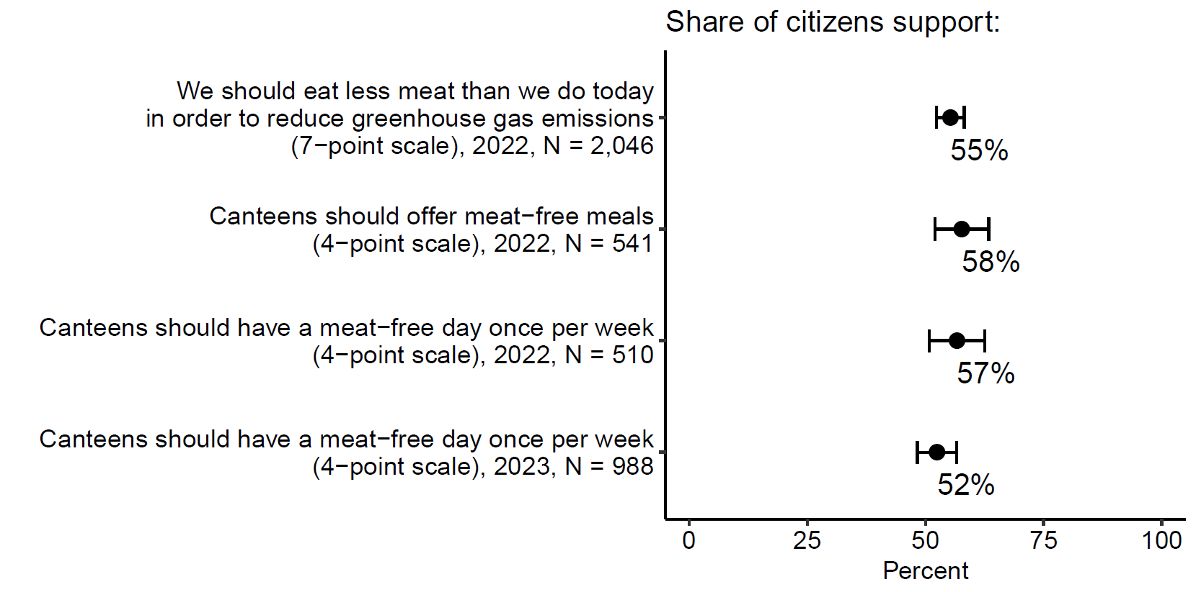
Figure A3: The four survey items were: ”We should eat less meat than we do today in order to reduce greenhouse gas emissions” (7-point Likert-scale), ”Canteens should [offer meat-free meals/have a meat-free day once per week] in order to reduce greenhouse gas emissions” (4-point scale; Agree - Somewhat agree - Somewhat disagree - Disagree), and ”Canteens should have a meat-free day once per week in order to reduce greenhouse gas emissions” (4-point scale; Strongly agree - Agree, Disagree - Strongly disagree). The first three were part of wave 24 (May/June 2022), the last was part of wave 26 and the coordinated study (February/March 2023).

In addition to measuring the public opinion signal in three different ways and across two different time estimates, we have done some robustness checks on the reported public opinion signal from 2023. First, if we restrict the sample to the respondents included in the regression analyses reported in the main paper, the results shift to 57% support in citizens’ first-order beliefs (N = 791). We chose to use the maximal N as the basis for our analysis. Second, rational choice theory would predict that politicians would rather seek to understand the people who turn out to vote’s opinions, and that understanding the general populations’ preferences should matter less to them. To take this into account, we re-ran our estimates for the general population’s preferences based on the respondents that have reported that they voted in the 2021 parliamentary elections. When running a weighted cross table analysis on this sample, the results show: Strongly agree: 17.7%, Agree: 36.4%, Disagree: 28.9%, and Strongly disagree: 16.9%. When those that to some extent agree are combined, we find that 54.2% (+/- 4.9 MOE) support meat-free days in canteens, well within the margins of our original measure.

Pre-registration

Two main questions were reported in the pre-registration: 1) whether the results from the Norwegian Citizen Panel would be replicated and 2) whether the same patterns are evident in the Panel of Elected Representatives and Panel of Public Administrators. The pre-registered methods for analyses were: ”To examine the main hypothesis I will compare the average results among citizens that are asked to state their own opinion against the average response among citizens, politicians and bureaucrats that are asked to assess what the majority thinks. Conventional 95 percent confidence intervals are set to assess whether the results are statistically significant or not. For further analyses gender, age, region, education, voting intention, left-right placement, and the battery of questions intended to measure the cultural dimension (liberal vs. conservative) will be controlled for.

The main (pre-registered) hypothesis for this study was:
H1: Norwegians underestimate the support for meat reduction for environmental concerns.

Specific sub-hypotheses for each group of actors were not pre-registered as this study marks the first attempt to directly compare the perspectives of elected and unelected elites with those of ordinary citizens on climate change issues. Unlike most of the research that this study builds on, this study delves into second-order beliefs across different groups of actors simultaneously. Without pre-registering specific sub-hypotheses for each group, the aim was to explore and analyze the discrepancies in first- and second-order beliefs regarding support for a specific climate policy.

References
Cornesse, Carina et al. (2020). “A review of conceptual approaches and empirical evidence on probability and nonprobability sample survey research”. In: Journal of Survey Statistics and Methodology 8.1, pp. 4–36.
Fimreite, Anne Lise and Elisabeth Ivarsflaten (2022). “Nye perspektiver på det norske demokratiets kjerneinstitusjoner”. In: Norsk statsvitenskapelig tidsskrift 4, pp. 129–136.
Fremskrittspartiet. (2021). Partiprogram 2021–2025.
https://www.frp.no/files/Partiprogram/2021-2025/Partiprogram-2021-2025.pdf
Gilbrant, Jørgen and Steinar Solas Suvatne (2023). “- Kjøttfri middag er ikke middag”. In: ˚ Dagbladet. Accessed: 7 June 2023.
Høyre. (2022). Alternativt statsbudsjett 2023.
https://res.cloudinary.com/hoyre/images/v1674568572/Nye%20hoyre.no/Hovedside/Alternativt-statsbudsjett-DIGITAL-3/Alternativt-statsbudsjett-DIGITAL-3.pdf?_i=AA
Miljøpartiet De Grønne. (2021). Arbeidsprogram 2021–2025 (bokmål).
https://mdg.no/_service/505809/download/id/1136375/name/Arbeidsprogram_2021-2025_bokmal.pdf
Miljøpartiet De Grønne Bergen. (2023). Lokalprogram 2023–2027.
https://bergen.mdg.no/wp/files/2023/03/Bergen-MDG-program.pdf
Miljøpartiet De Grønne Oslo. (2023). Oslo MDGs program for 2023–2027.
https://oslo.mdg.no/program/
Senterpartiet. (2021). Stortingsprogram 2021–2025.
https://www.senterpartiet.no/politikk/program-uttaler/program/Stortingsprogram-2021-2025
Sosialistisk Venstreparti. (2021). Arbeidsprogram 2021–2025.
https://www.sv.no/wp-content/uploads/2021/04/arbeidsprogram-for-korrektur.pdf
Stein, Jonas (2023). “Blir norsk politikk GAL? Grønn Alternativ Liberal (GAL)-Norske velgere
og partier sett gjennom et europeisk perspektiv”. In: Norsk statsvitenskapelig tidsskrift
1, pp. 41–49.
Venstre. (2021). Frihet og muligheter for alle: Stortingsvalgprogram 2021–2025.
https://www.venstre.no/assets/Venstres_Stortingsvalgprogram_2021-2025.pdf

While ten parties are represented in the national parliament during this term, Pasientfokus is excluded from the analysis due to its status as a single-issue party operating solely in one electoral district (Finnmark).
This study was pre-registered with AsPredicted, #121917. This study builds on a pre-trial carried out only in the Norwegian Citizen Panel eight months prior to the coordinated survey, also pre-registered with AsPredicted, #96139.

