# Appendix

## A Additional graphs and figures

### A.1 Effect of pension eligibility on own net labor force participation

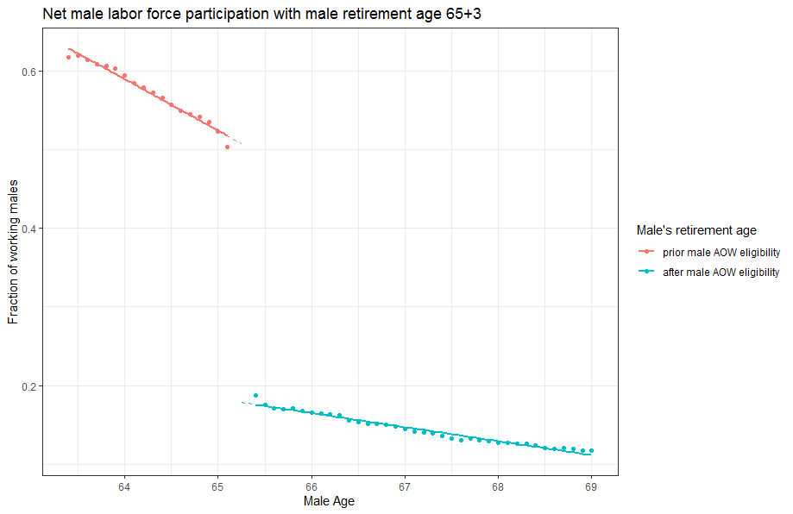

Figure 1 Average net labor force participation of the older male partner with male statutory retirement age of 65 years and 3 months. The red (blue) line indicates the average net labor force participation prior (after) the statutory retirement age.

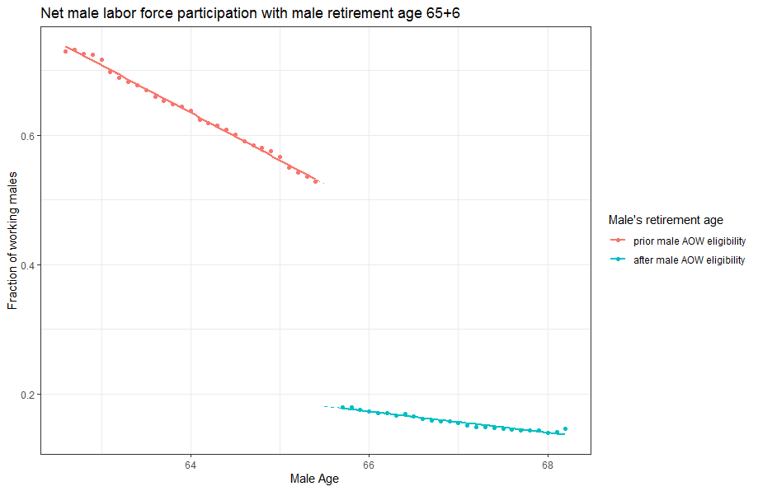

Figure 2 Average net labor force participation of the older male partner with male statutory retirement age of 65 years and 6 months. The red (blue) line indicates the average net labor force participation prior (after) the statutory retirement age.

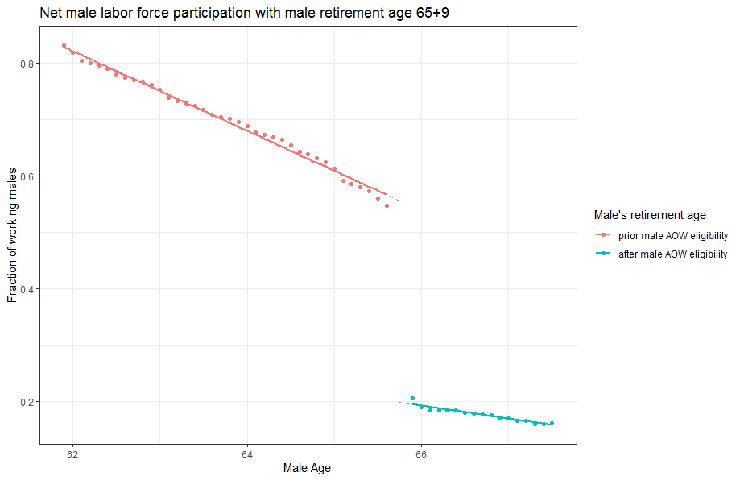

Figure 3 Average net labor force participation of the older male partner with male statutory retirement age of 65 years and 9 months. The red (blue) line indicates the average net labor force participation prior (after) the statutory retirement age.

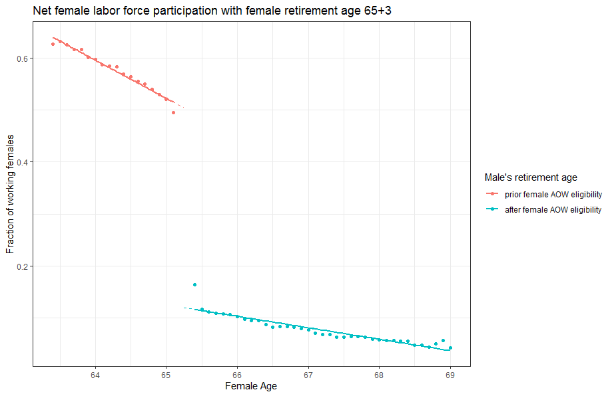

Figure 4 Average net labor force participation of the older female partner with female statutory retirement age of 65 years and 3 months. The red (blue) line indicates the average net labor force participation prior (after) the statutory retirement age.

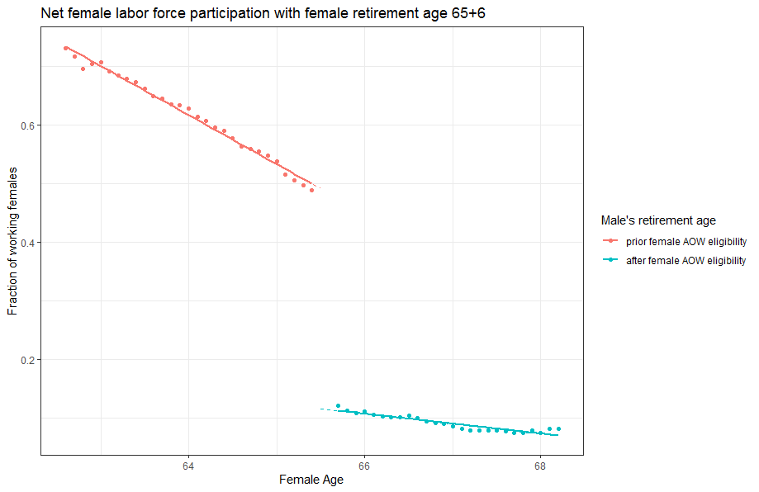

Figure 5 Average net labor force participation of the older female partner with female statutory retirement age of 65 years and 6 months. The red (blue) line indicates the average net labor force participation prior (after) the statutory retirement age.

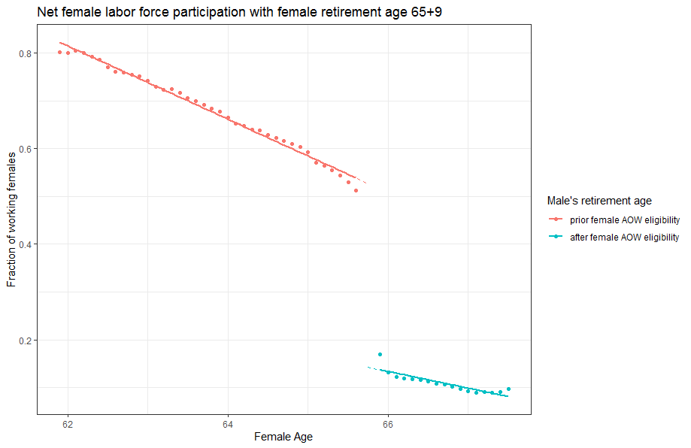

Figure 6 Average net labor force participation of the older female partner with female statutory retirement age of 65 years and 9 months. The red (blue) line indicates the average net labor force participation prior (after) the statutory retirement age.

### A.2 Part time factor

We plot the part-time factor of the youngest person in a couple before and after the oldest person reaches the statutory retirement age. More precisely, we plot the average part-time factor of the youngest partner 6 months prior and after the oldest partners reaches the statutory retirement age.

Figure 7 Average part-time factor of the younger male partner with female statutory retirement age of 65 years and 3 months. The red (blue) line indicates the average part-time factor of the younger male partner 6 months prior (after) the statutory retirement age of the older spouse.

Figure 8 Average part-time factor of the younger male partner with female statutory retirement age of 65 years and 6 months. The red (blue) line indicates the average part-time factor of the younger male partner 6 months prior (after) the statutory retirement age of the older spouse.

Figure 9 Average part-time factor of the younger male partner with female statutory retirement age of 65 years and 9 months. The red (blue) line indicates the average part-time factor of the male partner 6 months prior (after) the statutory retirement age of the older spouse.

Figure 10 Average part-time factor of the younger female partner with male statutory retirement age of 65 years and 3 months. The red (blue) line indicates the average part-time factor of the female partner 6 months prior (after) the statutory retirement age of the older spouse.

Figure 11 Average part-time factor of the younger female partner with male statutory retirement age of 65 years and 3 months. The red (blue) line indicates the average part-time factor of the female partner 6 months prior (after) the statutory retirement age of the older spouse.

Figure 12 Average part-time factor of the younger female partner with male statutory retirement age of 65 years and 9 months. The red (blue) line indicates the average part-time factor of the female partner 6 months prior (after) the statutory retirement age of the older spouse.

## B Additional regression output

In appendix B.1, we provide the regression output per regression cohort of equation (1). We provide the regression tables with clustered standard errors at the household level. In case we would change to robust standard errors, the results would not change (we omit them here to economize on space). The first tables provide the regression output with spousal labor supply of the youngest spouse as the dependent variable. In the upper left cell of each table we write down the gender of the oldest spouse as well as the pension cohort the oldest spouse belongs to. Cohort 1 refers to a pension eligibility age of 65 years and 3 months. Cohort 2 and cohort 3 refer to a pension eligibility age of 65 years and 6 months and 65 years and 9 months, respectively. The main variables we use from these tables are the coefficients for $R^{o}$ and $R^{y}.$

In appendix B.2, show the regression output with the net labor supply of the oldest spouse as the dependent variable. Here we use the coefficient of $R^{o}$ to calculate the ratios to determine whether joint retirement increases or decreases for different cohorts.

In appendix B.3, we show our regression results when we split the households into a low- and high wage income group. In appendix B.4 we show the regression results for the part-time factor of the younger spouse as the dependent variable. The references to the cohorts are the same as in appendix B1.

Lastly, in appendix B.5 we display the full regression output when we check for a social norm effect at the initial statutory retirement age of 65.

### B.1 Net labor force participation for the youngest spouse

|  |  |  |  |  |
| --- | --- | --- | --- | --- |
| Male = old in cohort 65+3 | (1) | (2) | (3) | (4) |
| $$α$$ | 0.278***  (0.005) | 0.274***  (0.005) | 0.247***  (0.014) | 0.352***  (0.051) |
| $$R^{y}$$ | -0.178***  (0.004) | -0.178***  (0.004) | -0.175***  (0.004) | -0.140***  (0.004) |
| $$R^{o}$$ | -0.020***  (0.002) | -0.020***  (0.002) | -0.011***  (0.001) | -0.009***  (0.001) |
| $$Age^{o}-Age(R^{o})$$ | -0.011***  (0.002) | -0.010***  (0.002) | -0.004  (0.006) | -0.009  (0.006) |
| $$Age^{y}-Age(R^{y})$$ | -0.033***  (0.001) | -0.034***  (0.001) | -0.034***  (0.001) | -0.021***  (0.003) |
| $$\left(Age^{y}-Age(R^{y})\right)*R^{y}$$ | 0.006***  (0.002) | 0.006***  (0.002) | 0.004**  (0.002) | 0.0185***  (0.003) |
| $$\left(Age^{o}-Age(R^{o})\right)*R^{o}$$ | 0.011***  (0.002) | 0.010***  (0.002) | 0.011***  (0.004) | 0.004  (0.004) |
| Controls | NO | YES | YES | YES |
| Year dummies | NO | NO | YES | YES |
| Cohort dummies | NO | NO | NO | YES |
| Adj. $R^{2}$ | 12.6% | 12.8% | 12.8% | 13.3% |
| Households | 21,148 | 21,148 | 21,148 | 21,148 |

Table 1 The effect of male pension eligibility (male = oldest spouse) on female net labor supply. Clustered standard errors at the household level are between parentheses. ***denotes significance at the 1%-level, ** denotes significance at the 5% level, and * denotes significance at the10% level.

|  |  |  |  |  |
| --- | --- | --- | --- | --- |
| Male = old in cohort 65+6 | (1) | (2) | (3) | (4) |
| $$α$$ | 0.293***  (0.005) | 0.293***  (0.005) | 0.286***  (0.011) | 0.354***  (0.044) |
| $$R^{y}$$ | -0.178***  (0.005) | -0.177***  (0.005) | -0.176***  (0.005) | -0.138***  (0.004) |
| $$R^{o}$$ | -0.014***  (0.002) | -0.014***  (0.002) | -0.010***  (0.001) | -0.008***  (0.001) |
| $$Age^{o}-Age(R^{o})$$ | -0.016***  (0.001) | -0.016***  (0.001) | -0.017***  (0.006) | -0.022***  (0.006) |
| $$Age^{y}-Age(R^{y})$$ | -0.030***  (0.0001) | -0.030***  (0.001) | -0.030***  (0.001) | -0.021***  (0.003) |
| $$\left(Age^{y}-Age(R^{y})\right)*R^{y}$$ | -0.023***  (0.004) | -0.023***  (0.004) | -0.024***  (0.004) | -0.0121**  (0.005) |
| $$\left(Age^{o}-Age(R^{o})\right)*R^{o}$$ | 0.012***  (0.003) | 0.012***  (0.002) | 0.015***  (0.004) | 0.009**  (0.004) |
| Controls | NO | YES | YES | YES |
| Year dummies | NO | NO | YES | YES |
| Cohort dummies | NO | NO | NO | YES |
| Adj. $R^{2}$ | 8.9% | 9.0% | 9.0% | 9.5% |
| Households | 20,224 | 20,224 | 20,224 | 20,224 |

Table 2 The effect of male pension eligibility (male = oldest spouse) on female net labor supply. Clustered standard errors at the household level are between parentheses. ***denotes significance at the 1%-level, ** denotes significance at the 5% level, and * denotes significance at the10% level.

|  |  |  |  |  |
| --- | --- | --- | --- | --- |
| Male = old in cohort 65+9 | (1) | (2) | (3) | (4) |
| $$α$$ | 0.32***  (0.005) | 0.315***  (0.005) | 0.315***  (0.003) | 0.4678***  (0.0368) |
| $$R^{y}$$ | -0.150***  (0.007) | -0.148***  (0.007) | -0.148***  (0.007) | -0.0904***  (0.006) |
| $$R^{o}$$ | -0.010***  (0.002) | -0.010***  (0.002) | -0.009***  (0.001) | -0.008***  (0.001) |
| $$Age^{o}-Age(R^{o})$$ | -0.012***  (0.001) | -0.011***  (0.001) | -0.006  (0.006) | -0.012**  (0.006) |
| $$Age^{y}-Age(R^{y})$$ | -0.028***  (0.001) | -0.029***  (0.001) | -0.029***  (0.001) | -0.015***  (0.004) |
| $$\left(Age^{y}-Age(R^{y})\right)*R^{y}$$ | -0.163***  (0.02) | -0.161***  (0.015) | -0.161***  (0.016) | -0.169***  (0.016) |
| $$\left(Age^{o}-Age(R^{o})\right)*R^{o}$$ | 0.001  (0.003) | 0.00001  (0.003) | -0.006  (0.004) | -0.012***  (0.004) |
| Controls | NO | YES | YES | YES |
| Year dummies | NO | NO | YES | YES |
| Cohort dummies | NO | NO | NO | YES |
| Adj. $R^{2}$ | 6.4% | 6.8% | 6.8% | 7.3% |
| Households | 19,665 | 19,665 | 19,665 | 19,665 |

Table 3 The effect of male pension eligibility (male = oldest spouse) on female net labor supply. Clustered standard errors at the household level are between parentheses. ***denotes significance at the 1%-level, ** denotes significance at the 5% level, and * denotes significance at the10% level.

|  |  |  |  |  |
| --- | --- | --- | --- | --- |
| Female = old in cohort 65+3 | (1) | (2) | (3) | (4) |
| $$α$$ | 0.464***  (0.013) | 0.466***  (0.013) | 0.410***  (0.037) | 0.475***  (0.118) |
| $$R^{y}$$ | -0.294***  (0.011) | -0.293***  (0.011) | -0.288***  (0.011) | -0.244***  (0.011) |
| $$R^{o}$$ | -0.021***  (0.006) | -0.020***  (0.006) | -0.007  (0.005) | -0.003  (0.005) |
| $$Age^{o}-Age(R^{o})$$ | -0.024***  (0.006) | -0.023***  (0.006) | -0.0002  (0.015) | -0.008  (0.016) |
| $$Age^{y}-Age(R^{y})$$ | -0.038***  (0.002) | -0.038***  (0.002) | -0.038***  (0.002) | -0.026***  (0.007) |
| $$\left(Age^{y}-Age(R^{y})\right)*R^{y}$$ | 0.006  (0.006) | 0.005  (0.006) | 0.001  (0.007) | 0.021***  (0.008) |
| $$\left(Age^{o}-Age(R^{o})\right)*R^{o}$$ | 0.0216**  (0.008) | 0.0216***  (0.008) | 0.014  (0.013) | 0.003  (0.013) |
| Controls | NO | YES | YES | YES |
| Year dummies | NO | NO | YES | YES |
| Cohort dummies | NO | NO | NO | YES |
| Adj. $R^{2}$ | 22.2% | 22.5% | 22.6% | 23.3% |
| Households | 2,663 | 2,663 | 2,663 | 2,663 |

Table 4 The effect of female pension eligibility (female = oldest spouse) on male net labor supply. Clustered standard errors at the household level are between parentheses. ***denotes significance at the 1%-level, ** denotes significance at the 5% level, and * denotes significance at the10% level.

|  |  |  |  |  |
| --- | --- | --- | --- | --- |
| Female = old in cohort 65+6 | (1) | (2) | (3) | (4) |
| $$α$$ | 0.493***  (0.014) | 0.493***  (0.014) | 0.484***  (0.030) | 0.599***  (0.137) |
| $$R^{y}$$ | -0.287***  (0.012) | -0.287***  (0.012) | -0.283***  (0.012) | -0.224***  (0.011) |
| $$R^{o}$$ | -0.031***  (0.006) | -0.031***  (0.006) | -0.022***  (0.005) | -0.017***  (0.005) |
| $$Age^{o}-Age(R^{o})$$ | -0.024***  (0.005) | -0.024***  (0.005) | -0.016  (0.0014) | -0.029*  (0.016) |
| $$Age^{y}-Age(R^{y})$$ | -0.032***  (0.0003) | -0.032***  (0.0003) | -0.032***  (0.003) | -0.011  (0.009) |
| $$\left(Age^{y}-Age(R^{y})\right)*R^{y}$$ | -0.049***  (0.011) | -0.049***  (0.011) | -0.052***  (0.011) | -0.024*  (0.012) |
| $$\left(Age^{o}-Age(R^{o})\right)*R^{o}$$ | 0.042***  (0.007) | 0.042***  (0.007) | 0.031***  (0.012) | 0.015  (0.013) |
| Controls | NO | YES | YES | YES |
| Year dummies | NO | NO | YES | YES |
| Cohort dummies | NO | NO | NO | YES |
| Adj. $R^{2}$ | 14.7% | 15.3% | 15.3% | 16.9% |
| Households | 2,526 | 2,526 | 2,526 | 2,526 |

Table 5 The effect of female pension eligibility (female = oldest spouse) on male net labor supply. Clustered standard errors at the household level are between parentheses. ***denotes significance at the 1%-level, ** denotes significance at the 5% level, and * denotes significance at the10% level.

|  |  |  |  |  |
| --- | --- | --- | --- | --- |
| Female = old in cohort 65+9 | (1) | (2) | (3) | (4) |
| $$α$$ | 0.515***  (0.013) | 0.513***  (0.014) | 0.497***  (0.020) | 0.618***  (0.104) |
| $$R^{y}$$ | -0.186***  (0.016) | -0.187***  (0.016) | -0.185***  (0.016) | -0.137***  (0.014) |
| $$R^{o}$$ | -0.026***  (0.007) | -0.026***  (0.007) | -0.020***  (0.005) | -0.017***  (0.005) |
| $$Age^{o}-Age(R^{o})$$ | -0.024***  (0.003) | -0.023***  (0.003) | -0.029**  (0.014) | -0.039***  (0.015) |
| $$Age^{y}-Age(R^{y})$$ | -0.030***  (0.002) | -0.030***  (0.002) | -0.030***  (0.002) | -0.014*  (0.007) |
| $$\left(Age^{y}-Age(R^{y})\right)*R^{y}$$ | -0.274***  (0.034) | -0.275***  (0.034) | -0.280***  (0.035) | -0.284***  (0.035) |
| $$\left(Age^{o}-Age(R^{o})\right)*R^{o}$$ | 0.006  (0.010) | 0.006  (0.010) | 0.021  (0.013) | 0.010  (0.014) |
| Controls | NO | YES | YES | YES |
| Year dummies | NO | NO | YES | YES |
| Cohort dummies | NO | NO | NO | YES |
| Adj. $R^{2}$ | 9.9% | 10.4% | 10.4% | 11.5% |
| Households | 2,473 | 2,473 | 2,473 | 2,473 |

Table 6 The effect of female pension eligibility (female = oldest spouse) on male net labor supply. Clustered standard errors at the household level are between parentheses. ***denotes significance at the 1%-level, ** denotes significance at the 5% level, and * denotes significance at the10% level.

### B.2 Labor supply of the oldest spouse

|  |  |  |  |  |
| --- | --- | --- | --- | --- |
| Male = old in cohort 65+3  (own labor supply) | (1) | (2) | (3) | (4) |
| $$α$$ | 0.469***  (0.005) | 0.468***  (0.005) | 0.451***  (0.011) | 0.433***  (0.036) |
| $$R^{y}$$ | 0.002  (0.004) | 0.0002  (0.004) | 0.005  (0.004) | 0.009***  (0.003) |
| $$R^{o}$$ | -0.301***  (0.003) | -0.301***  (0.003) | -0.267***  (0.003) | -0.267***  (0.003) |
| $$Age^{o}-Age(R^{o})$$ | -0.063***  (0.002) | -0.063***  (0.002) | -0.063***  (0.006) | -0.062***  (0.006) |
| $$Age^{y}-Age(R^{y})$$ | -0.008***  (0.001) | -0.006***  (0.001) | -0.006***  (0.001) | -0.007***  (0.002) |
| $$\left(Age^{y}-Age(R^{y})\right)*R^{y}$$ | 0.005*  (0.003) | 0.004  (0.003) | -0.003  (0.003) | 0.007**  (0.003) |
| $$\left(Age^{o}-Age(R^{o})\right)*R^{o}$$ | 0.040***  (0.002) | 0.040***  (0.002) | 0.037***  (0.006) | 0.035***  (0.006) |
| Controls | NO | YES | YES | YES |
| Year dummies | NO | NO | YES | YES |
| Cohort dummies | NO | NO | NO | YES |
| Adj. $R^{2}$ | 18.6% | 18.8% | 18.9% | 18.9% |
| Households | 21,148 | 21,148 | 21,148 | 21,148 |

Table 7 The effect of male pension eligibility (male = oldest spouse) on male net labor supply. Clustered standard errors at the household level are between parentheses. ***denotes significance at the 1%-level, ** denotes significance at the 5% level, and * denotes significance at the10% level.

|  |  |  |  |  |
| --- | --- | --- | --- | --- |
| Male = old in cohort 65+6  (own labor supply) | (1) | (2) | (3) | (4) |
| $$α$$ | 0.488***  (0.005) | 0.484***  (0.005) | 0.452***  (0.009) | 0.4865***  (0.032) |
| $$R^{y}$$ | 0.001  (0.005) | -0.001  (0.005) | 0.004  (0.005) | 0.019***  (0.005) |
| $$R^{o}$$ | -0.304***  (0.003) | -0.304***  (0.003) | -0.278***  (0.003) | -0.277***  (0.003) |
| $$Age^{o}-Age(R^{o})$$ | -0.064***  (0.001) | -0.065***  (0.001) | -0.083***  (0.005) | -0.084***  (0.006) |
| $$Age^{y}-Age(R^{y})$$ | -0.010***  (0.001) | -0.008***  (0.001) | -0.008***  (0.001) | -0.005**  (0.002) |
| $$\left(Age^{y}-Age(R^{y})\right)*R^{y}$$ | 0.00002  (0.005) | -0.001  (0.005) | -0.011**  (0.005) | -0.002  (0.006) |
| $$\left(Age^{o}-Age(R^{o})\right)*R^{o}$$ | 0.032***  (0.002) | 0.032***  (0.002) | 0.055***  (0.006) | 0.053***  (0.006) |
| Controls | NO | YES | YES | YES |
| Year dummies | NO | NO | YES | YES |
| Cohort dummies | NO | NO | NO | YES |
| Adj. $R^{2}$ | 22.3% | 22.5% | 22.6% | 22.6% |
| Households | 20,224 | 20,224 | 20,224 | 20,224 |

Table 8 The effect of male pension eligibility (male = oldest spouse) on male net labor supply. Clustered standard errors at the household level are between parentheses. ***denotes significance at the 1%-level, ** denotes significance at the 5% level, and * denotes significance at the 10% level.

|  |  |  |  |  |
| --- | --- | --- | --- | --- |
| Male = old in cohort 65+9  (own labor supply) | (1) | (2) | (3) | (4) |
| $$α$$ | 0.509***  (0.005) | 0.507***  (0.005) | 0.469***  (0.006) | 0.487***  (0.026) |
| $$R^{y}$$ | 0.004  (0.008) | -0.0003  (0.008) | 0.002  (0.008) | 0.016*  (0.009) |
| $$R^{o}$$ | -0.288***  (0.003) | -0.289***  (0.003) | -0.276***  (0.003) | -0.275***  (0.003) |
| $$Age^{o}-Age(R^{o})$$ | -0.061***  (0.001) | -0.062***  (0.001) | -0.076***  (0.005) | -0.077***  (0.001) |
| $$Age^{y}-Age(R^{y})$$ | -0.011***  (0.001) | -0.009***  (0.001) | -0.009***  (0.001) | -0.006***  (0.002) |
| $$\left(Age^{y}-Age(R^{y})\right)*R^{y}$$ | 0.030  (0.02) | 0.029  (0.019) | 0.018  (0.019) | 0.016  (0.019) |
| $$\left(Age^{o}-Age(R^{o})\right)*R^{o}$$ | -0.018***  (0.003) | -0.018***  (0.003) | 0.017***  (0.006) | 0.016***  (0.006) |
| Controls | NO | YES | YES | YES |
| Year dummies | NO | NO | YES | YES |
| Cohort dummies | NO | NO | NO | YES |
| Adj. $R^{2}$ | 21.6% | 21.9% | 21.9% | 22.0% |
| Households | 19,665 | 19,665 | 19,665 | 19,665 |

Table 9 The effect of male pension eligibility (male = oldest spouse) on male net labor supply. Clustered standard errors at the household level are between parentheses. ***denotes significance at the 1%-level, ** denotes significance at the 5% level, and * denotes significance at the10% level.

|  |  |  |  |  |
| --- | --- | --- | --- | --- |
| Female = old in cohort 65+3  (own labor supply) | (1) | (2) | (3) | (4) |
| $$α$$ | 0.505***  (0.012) | 0.498***  (0.012) | 0.482***  (0.025) | 0.388***  (0.112) |
| $$R^{y}$$ | -0.014***  (0.007) | -0.013*  (0.007) | -0.002  (0.007) | -0.010  (0.007) |
| $$R^{o}$$ | -0.346***  (0.009) | -0.346***  (0.009) | -0.298***  (0.008) | -0.298***  (0.008) |
| $$Age^{o}-Age(R^{o})$$ | -0.079***  (0.006) | -0.079***  (0.006) | -0.069***  (0.016) | -0.065***  (0.017) |
| $$Age^{y}-Age(R^{y})$$ | -0.0003  (0.002) | 0.0002  (0.002) | 0.0003  (0.002) | -0.005  (0.007) |
| $$\left(Age^{y}-Age(R^{y})\right)*R^{y}$$ | 0.020***  (0.005) | 0.020***  (0.005) | 0.008  (0.016) | 0.009  (0.006) |
| $$\left(Age^{o}-Age(R^{o})\right)*R^{o}$$ | 0.038***  (0.007) | 0.037***  (0.007) | 0.022  (0.023) | 0.023  (0.016) |
| Controls | NO | YES | YES | YES |
| Year dummies | NO | NO | YES | YES |
| Cohort dummies | NO | NO | NO | YES |
| Adj. $R^{2}$ | 27.7% | 27.9% | 28.1 | 28.2% |
| Households | 2,663 | 2,663 | 2,663 | 2,663 |

Table 10 The effect of female pension eligibility (female = oldest spouse) on female net labor supply. Clustered standard errors at the household level are between parentheses. ***denotes significance at the 1%-level, ** denotes significance at the 5% level, and * denotes significance at the10% level.

|  |  |  |  |  |
| --- | --- | --- | --- | --- |
| Female = old in cohort 65+6  (own labor supply) | (1) | (2) | (3) | (4) |
| $$α$$ | 0.492***  (0.012) | 0.484***  (0.013) | 0.427***  (0.021) | 0.362***  (0.115) |
| $$R^{y}$$ | -0.023**  (0.008) | -0.023**  (0.008) | -0.015*  (0.009) | -0.005  (0.009) |
| $$R^{o}$$ | -0.323***  (0.009) | -0.324***  (0.009) | -0.291***  (0.008) | -0.290***  (0.008) |
| $$Age^{o}-Age(R^{o})$$ | -0.086***  (0.004) | -0.084***  (0.004) | -0.066***  (0.015) | -0.066***  (0.016) |
| $$Age^{y}-Age(R^{y})$$ | -0.001**  (0.002) | -0.0005  (0.002) | -0.0004  (0.002) | -0.002  (0.008) |
| $$\left(Age^{y}-Age(R^{y})\right)*R^{y}$$ | 0.018**  (0.007) | 0.018**  (0.008) | 0.005  (0.008) | 0.016*  (0.009) |
| $$\left(Age^{o}-Age(R^{o})\right)*R^{o}$$ | 0.040***  (0.006) | 0.039***  (0.006) | 0.036**  (0.016) | 0.032**  (0.016) |
| Controls | NO | YES | YES | YES |
| Year dummies | NO | NO | YES | YES |
| Cohort dummies | NO | NO | NO | YES |
| Adj. $R^{2}$ | 27.5% | 28.0% | 28.1% | 28.2% |
| Households | 2,526 | 2,526 | 2,526 | 2,526 |

Table 11 The effect of female pension eligibility (female = oldest spouse) on female net labor supply. Clustered standard errors at the household level are between parentheses. ***denotes significance at the 1%-level, ** denotes significance at the 5% level, and * denotes significance at the10% level.

|  |  |  |  |  |
| --- | --- | --- | --- | --- |
| Female = old in cohort 65+9  (own labor supply) | (1) | (2) | (3) | (4) |
| $$α$$ | 0.522***  (0.012) | 0.516***  (0.013) | 0.471***  (0.016) | 0.596***  (0.019) |
| $$R^{y}$$ | -0.022*  (0.012) | -0.023*  (0.012) | -0.018  (0.012) | -0.004  (0.014) |
| $$R^{o}$$ | -0.301***  (0.009) | -0.302***  (0.009) | -0.284***  (0.008) | -0.284***  (0.008) |
| $$Age^{o}-Age(R^{o})$$ | -0.077***  (0.004) | -0.076***  (0.004) | -0.086***  (0.014) | -0.092***  (0.015) |
| $$Age^{y}-Age(R^{y})$$ | -0.003  (0.002) | -0.002  (0.002) | -0.002  (0.002) | 0.008  (0.007) |
| $$\left(Age^{y}-Age(R^{y})\right)*R^{y}$$ | 0.076***  (0.026) | 0.075***  (0.026) | 0.063**  (0.027) | 0.057**  (0.027) |
| $$\left(Age^{o}-Age(R^{o})\right)*R^{o}$$ | -0.038***  (0.008) | -0.038***  (0.008) | -0.006  (0.02) | -0.008  (0.017) |
| Controls | NO | YES | YES | YES |
| Year dummies | NO | NO | YES | YES |
| Cohort dummies | NO | NO | NO | YES |
| Adj. $R^{2}$ | 24.9% | 25.2% | 25.3% | 25.4% |
| Households | 2,473 | 2,473 | 2,473 | 2,473 |

Table 12 The effect of female pension eligibility (female = oldest spouse) on female net labor supply. Clustered standard errors at the household level are between parentheses. ***denotes significance at the 1%-level, ** denotes significance at the 5% level, and * denotes significance at the10% level.

### B.3 Regression tables for low wage and high wage income households

In the regression tables below, we run the same regression as equation (1) after splitting our data into rich and poor households for each pension cohort of the older spouse. To do so, we use the household wage income in January 2014. The results are presented below.

|  |  |  |
| --- | --- | --- |
| Male = old in cohort 65+3  (female labor supply) | Low wage income | High wage income |
| $$α$$ | 0.220***  (0.074) | 0.488***  (0.066) |
| $$R^{y}$$ | -0.094***  (0.004) | -0.221***  (0.007) |
| $$R^{o}$$ | -0.003*  (0.002) | -0.018***  (0.002) |
| $$Age^{o}-Age(R^{o})$$ | 0.002  (0.008) | -0.015*  (0.009) |
| $$Age^{y}-Age\left(R^{y}\right)$$ | -0.022***  (0.004) | -0.017***  (0.004) |
| $$\left(Age^{y}-Age\left(R^{y}\right)\right)*R^{y}$$ | 0.019***  (0.003) | 0.007  (0.005) |
| $$(Age^{o}-Age\left(R^{o}\right)*R^{o})$$ | -0.003  (0.005) | 0.011*  (0.006) |
| Controls | YES | YES |
| Year Dummies | YES | YES |
| Cohort dummies | YES | YES |
| Adj. $R^{2}$ | 9.2% | 17.2% |
| Households | 11,936 | 9,212 |

Table 13 The effect of male pension eligibility (male = oldest spouse) on female net labor supply for different wage income groups. Clustered standard errors at the household level are between parentheses. ***denotes significance at the 1%-level, ** denotes significance at the 5% level, and * denotes significance at the 10% level.

|  |  |  |
| --- | --- | --- |
| Male = old in cohort 65+6  (female labor supply) | Low wage income | High wage income |
| $$α$$ | 0.175**  (0.072) | 0.497***  (0.048) |
| $$R^{y}$$ | -0.097***  (0.005) | -0.205***  (0.007) |
| $$R^{o}$$ | -0.003*  (0.002) | -0.016***  (0.002) |
| $$Age^{o}-Age(R^{o})$$ | -0.004  (0.008) | -0.020**  (0.008) |
| $$Age^{y}-Age\left(R^{y}\right)$$ | -0.018***  (0.005) | -0.018***  (0.003) |
| $$\left(Age^{y}-Age\left(R^{y}\right)\right)*R^{y}$$ | -0.008  (0.006) | -0.025***  (0.009) |
| $$(Age^{o}-Age\left(R^{o}\right)*R^{o})$$ | 0.002  (0.005) | 0.010  (0.006) |
| Controls | YES | YES |
| Year Dummies | YES | YES |
| Cohort dummies | YES | YES |
| Adj. $R^{2}$ | 5.6% | 14.1% |
| Households | 11,036 | 9,188 |

Table 14 The effect of male pension eligibility (male = oldest spouse) on female net labor supply for different wage income groups. Clustered standard errors at the household level are between parentheses. ***denotes significance at the 1%-level, ** denotes significance at the 5% level, and * denotes significance at the10% level.

|  |  |  |
| --- | --- | --- |
| Male = old in cohort 65+9  (female labor supply) | Low wage income | High wage income |
| $$α$$ | 0.385***  (0.054) | 0.553***  (0.041) |
| $$R^{y}$$ | -0.059***  (0.007) | -0.143***  (0.011) |
| $$R^{o}$$ | -0.006***  (0.002) | -0.011***  (0.003) |
| $$Age^{o}-Age(R^{o})$$ | 0.002  (0.008) | -0.019**  (0.008) |
| $$Age^{y}-Age\left(R^{y}\right)$$ | -0.012***  (0.003) | -0.016***  (0.003) |
| $$\left(Age^{y}-Age\left(R^{y}\right)\right)*R^{y}$$ | -0.144***  (0.018) | -0.216***  (0.029) |
| $$(Age^{o}-Age\left(R^{o}\right)*R^{o})$$ | -0.013***  (0.005) | -0.014**  (0.007) |
| Controls | YES | YES |
| Year Dummies | YES | YES |
| Cohort dummies | YES | YES |
| Adj. $R^{2}$ | 4.8% | 10.8% |
| Households | 11,037 | 8,628 |

Table 15 The effect of male pension eligibility (male = oldest spouse) on female net labor supply for different wage income groups. Clustered standard errors at the household level are between parentheses. ***denotes significance at the 1%-level, ** denotes significance at the 5% level, and * denotes significance at the10% level.

|  |  |  |
| --- | --- | --- |
| Male = old in cohort 65+3  (male own labor supply) | Low wage income | High wage income |
| $$α$$ | 0.234***  (0.051) | 0.692***  (0.046) |
| $$R^{y}$$ | -0.000  (0.004) | -0.014***  (0.005) |
| $$R^{o}$$ | -0.138***  (0.003) | -0.436***  (0.005) |
| $$Age^{o}-Age(R^{o})$$ | -0.021**  (0.003) | -0.096***  (0.006) |
| $$Age^{y}-Age\left(R^{y}\right)$$ | -0.004  (0.003) | -0.005**  (0.003) |
| $$\left(Age^{y}-Age\left(R^{y}\right)\right)*R^{y}$$ | 0.005*  (0.003) | -0.009*  (0.005) |
| $$(Age^{o}-Age\left(R^{o}\right)*R^{o})$$ | 0.012*  (0.007) | 0.050***  (0.007) |
| Controls | YES | YES |
| Year Dummies | YES | YES |
| Cohort dummies | YES | YES |
| Adj. $R^{2}$ | 6.7% | 41.3% |
| Households | 11,936 | 9,212 |

Table 16 The effect of male pension eligibility (male = oldest spouse) on male net labor supply for different wage income groups. Clustered standard errors at the household level are between parentheses. ***denotes significance at the 1%-level, ** denotes significance at the 5% level, and * denotes significance at the10% level.

|  |  |  |
| --- | --- | --- |
| Male = old in cohort 65+6  (male own labor supply) | Low wage income | High wage income |
| $$α$$ | 0.376***  (0.053) | 0.593***  (0.037) |
| $$R^{y}$$ | 0.019***  (0.006) | -0.006  (0.007) |
| $$R^{o}$$ | -0.193***  (0.004) | -0.380***  (0.005) |
| $$Age^{o}-Age(R^{o})$$ | -0.061***  (0.008) | -0.078***  (0.005) |
| $$Age^{y}-Age\left(R^{y}\right)$$ | -0.004  (0.003) | -0.003  (0.002) |
| $$\left(Age^{y}-Age\left(R^{y}\right)\right)*R^{y}$$ | -0.003  (0.007) | -0.010  (0.008) |
| $$(Age^{o}-Age\left(R^{o}\right)*R^{o})$$ | 0.037***  (0.008) | 0.042***  (0.007) |
| Controls | YES | YES |
| Year Dummies | YES | YES |
| Cohort dummies | YES | YES |
| Adj. $R^{2}$ | 11.2% | 43.2% |
| Households | 11,036 | 9,188 |

Table 17 The effect of male pension eligibility (male = oldest spouse) on male net labor supply for different wage income groups. Clustered standard errors at the household level are between parentheses. ***denotes significance at the 1%-level, ** denotes significance at the 5% level, and * denotes significance at the10% level.

|  |  |  |
| --- | --- | --- |
| Male = old in cohort 65+9  (male own labor supply) | Low wage income | High wage income |
| $$α$$ | 0.408***  (0.040) | 0.570***  (0.029) |
| $$R^{y}$$ | 0.015  (0.011) | 0.002  (0.012) |
| $$R^{o}$$ | -0.240***  (0.004) | -0.322***  (0.005) |
| $$Age^{o}-Age(R^{o})$$ | -0.069***  (0.008) | -0.075***  (0.005) |
| $$Age^{y}-Age\left(R^{y}\right)$$ | -0.007***  (0.003) | -0.003*  (0.002) |
| $$\left(Age^{y}-Age\left(R^{y}\right)\right)*R^{y}$$ | 0.031  (0.025) | -0.010  (0.030) |
| $$(Age^{o}-Age\left(R^{o}\right)*R^{o})$$ | 0.016**  (0.008) | 0.004  (0.008) |
| Controls | YES | YES |
| Year Dummies | YES | YES |
| Cohort dummies | YES | YES |
| Adj. $R^{2}$ | 14.0% | 38.1% |
| Households | 11,037 | 8,628 |

Table 18 The effect of male pension eligibility (male = oldest spouse) on male net labor supply for different wage income groups. Clustered standard errors at the household level are between parentheses. ***denotes significance at the 1%-level, ** denotes significance at the 5% level, and * denotes significance at the10% level.

|  |  |  |
| --- | --- | --- |
| Female = old in cohort 65+3  (male labor supply) | Low wage income | High wage income |
| $$α$$ | 0.315  (0.201) | 0.775***  (0.100) |
| $$R^{y}$$ | -0.146***  (0.013) | -0.382***  (0.016) |
| $$R^{o}$$ | -0.002  (0.006) | -0.007  (0.008) |
| $$Age^{o}-Age(R^{o})$$ | 0.024  (0.023) | -0.045***  (0.012) |
| $$Age^{y}-Age\left(R^{y}\right)$$ | -0.034***  (0.012) | -0.008  (0.005) |
| $$\left(Age^{y}-Age\left(R^{y}\right)\right)*R^{y}$$ | 0.010  (0.010) | 0.002  (0.012) |
| $$(Age^{o}-Age\left(R^{o}\right)*R^{o})$$ | -0.014  (0.016) | 0.026  (0.018) |
| Controls | YES | YES |
| Year Dummies | YES | YES |
| Cohort dummies | YES | YES |
| Adj. $R^{2}$ | 15.2% | 38.4% |
| Households | 1,451 | 1,212 |

Table 19 The effect of female pension eligibility (female = oldest spouse) on male net labor supply for different wage income groups. Clustered standard errors at the household level are between parentheses. ***denotes significance at the 1%-level, ** denotes significance at the 5% level, and * denotes significance at the10% level.

|  |  |  |
| --- | --- | --- |
| Female = old in cohort 65+6  (male labor supply) | Low wage income | High wage income |
| $$α$$ | 0.435**  (0.199) | 0.509***  (0.133) |
| $$R^{y}$$ | -0.152***  (0.013) | -0.337***  (0.017) |
| $$R^{o}$$ | -0.013**  (0.006) | -0.023***  (0.008) |
| $$Age^{o}-Age(R^{o})$$ | -0.027  (0.023) | -0.024*  (0.014) |
| $$Age^{y}-Age\left(R^{y}\right)$$ | -0.013  (0.013) | -0.030***  (0.009) |
| $$\left(Age^{y}-Age\left(R^{y}\right)\right)*R^{y}$$ | 0.003  (0.016) | -0.074***  (0.018) |
| $$(Age^{o}-Age\left(R^{o}\right)*R^{o})$$ | 0.022  (0.016) | 0.016  (0.018) |
| Controls | YES | YES |
| Year Dummies | YES | YES |
| Cohort dummies | YES | YES |
| Adj. $R^{2}$ | 12.6% | 27.6% |
| Households | 1,374 | 1,152 |

Table 20 The effect of female pension eligibility (female = oldest spouse) on male net labor supply for different wage income groups. Clustered standard errors at the household level are between parentheses. ***denotes significance at the 1%-level, ** denotes significance at the 5% level, and * denotes significance at the10% level.

|  |  |  |
| --- | --- | --- |
| Female = old in cohort 65+9  (male labor supply) | Low wage income | High wage income |
| $$α$$ | 0.626***  (0.148) | 0.544***  (0.111) |
| $$R^{y}$$ | -0.085***  (0.018) | -0.212***  (0.020) |
| $$R^{o}$$ | -0.012*  (0.006) | -0.026***  (0.008) |
| $$Age^{o}-Age(R^{o})$$ | -0.008  (0.021) | -0.045***  (0.015) |
| $$Age^{y}-Age\left(R^{y}\right)$$ | -0.013  (0.010) | -0.020**  (0.008) |
| $$\left(Age^{y}-Age\left(R^{y}\right)\right)*R^{y}$$ | -0.244***  (0.049) | -0.344***  (0.051) |
| $$(Age^{o}-Age\left(R^{o}\right)*R^{o})$$ | -0.011  (0.017) | 0.025  (0.022) |
| Controls | YES | YES |
| Year Dummies | YES | YES |
| Cohort dummies | YES | YES |
| Adj. $R^{2}$ | 9.2% | 19.2% |
| Households | 1,339 | 1,134 |

Table 21 The effect of female pension eligibility (female = oldest spouse) on male net labor supply for different wage income groups. Clustered standard errors at the household level are between parentheses. ***denotes significance at the 1%-level, ** denotes significance at the 5% level, and * denotes significance at the10% level.

|  |  |  |
| --- | --- | --- |
| Female = old in cohort 65+3  (female own labor supply) | Low wage income | High wage income |
| $$α$$ | 0.395***  (0.130) | 0.449***  (0.169) |
| $$R^{y}$$ | -0.021**  (0.009) | -0.013  (0.011) |
| $$R^{o}$$ | -0.244***  (0.010) | -0.366***  (0.012) |
| $$Age^{o}-Age(R^{o})$$ | -0.050**  (0.023) | -0.091***  (0.023) |
| $$Age^{y}-Age\left(R^{y}\right)$$ | 0.006  (0.008) | -0.011  (0.010) |
| $$\left(Age^{y}-Age\left(R^{y}\right)\right)*R^{y}$$ | -0.005  (0.008) | 0.015  (0.010) |
| $$(Age^{o}-Age\left(R^{o}\right)*R^{o})$$ | 0.013  (0.021) | 0.039*  (0.023) |
| Controls | YES | YES |
| Year Dummies | YES | YES |
| Cohort dummies | YES | YES |
| Adj. $R^{2}$ | 21.9% | 37.4% |
| Households | 1,451 | 1,212 |

Table 22 The effect of female pension eligibility (female = oldest spouse) on female net labor supply for different wage income groups. Clustered standard errors at the household level are between parentheses. ***denotes significance at the 1%-level, ** denotes significance at the 5% level, and * denotes significance at the10% level.

|  |  |  |
| --- | --- | --- |
| Female = old in cohort 65+6  (female own labor supply) | Low wage income | High wage income |
| $$α$$ | 0.246*  (0.145) | 0.463***  (0.167) |
| $$R^{y}$$ | -0.007  (0.012) | -0.019  (0.014) |
| $$R^{o}$$ | -0.253***  (0.011) | -0.335***  (0.013) |
| $$Age^{o}-Age(R^{o})$$ | -0.046**  (0.023) | -0.088***  (0.022) |
| $$Age^{y}-Age\left(R^{y}\right)$$ | -0.009  (0.009) | 0.004  (0.011) |
| $$\left(Age^{y}-Age\left(R^{y}\right)\right)*R^{y}$$ | 0.011  (0.013) | 0.017  (0.014) |
| $$(Age^{o}-Age\left(R^{o}\right)*R^{o})$$ | 0.019  (0.022) | 0.051**  (0.022) |
| Controls | YES | YES |
| Year Dummies | YES | YES |
| Cohort dummies | YES | YES |
| Adj. $R^{2}$ | 22.1% | 37.0% |
| Households | 1,374 | 1,152 |

Table 23 The effect of female pension eligibility (female = oldest spouse) on female net labor supply for different wage income groups. Clustered standard errors at the household level are between parentheses. ***denotes significance at the 1%-level, ** denotes significance at the 5% level, and * denotes significance at the10% level.

|  |  |  |
| --- | --- | --- |
| Female = old in cohort 65+9  (female own labor supply) | Low wage income | High wage income |
| $$α$$ | 0.627***  (0.137) | 0.462***  (0.149) |
| $$R^{y}$$ | 0.005  (0.019) | -0.020  (0.019) |
| $$R^{o}$$ | -0.271***  (0.011) | -0.301***  (0.019) |
| $$Age^{o}-Age(R^{o})$$ | -0.099***  (0.022) | -0.057***  (0.020) |
| $$Age^{y}-Age\left(R^{y}\right)$$ | 0.013  (0.009) | -0.005  (0.011) |
| $$\left(Age^{y}-Age\left(R^{y}\right)\right)*R^{y}$$ | 0.044  (0.037) | 0.071*  (0.040) |
| $$(Age^{o}-Age\left(R^{o}\right)*R^{o})$$ | -0.007  (0.023) | -0.021  (0.023) |
| Controls | YES | YES |
| Year Dummies | YES | YES |
| Cohort dummies | YES | YES |
| Adj. $R^{2}$ | 20.9% | 33.0% |
| Households | 1,339 | 1,134 |

Table 24 The effect of female pension eligibility (female = oldest spouse) on female net labor supply for different wage income groups. Clustered standard errors at the household level are between parentheses. ***denotes significance at the 1%-level, ** denotes significance at the 5% level, and * denotes significance at the10% level.

### B.4 Part-time factor

|  |  |  |  |  |
| --- | --- | --- | --- | --- |
| Male = old in cohort 65+3 | (1) | (2) | (3) | (4) |
| $$α$$ | 0.139***  (0.004) | 0.136***  (0.003) | 0.122***  (0.010) | 0.200***  (0.040) |
| $$R^{y}$$ | -0.095***  (0.003) | -0.094***  (0.003) | -0.093***  (0.003) | -0.077***  (0.002) |
| $$R^{o}$$ | -0.010***  (0.001) | -0.010***  (0.001) | -0.006***  (0.001) | -0.005***  (0.001) |
| $$Age^{o}-Age(R^{o})$$ | -0.003**  (0.002) | -0.002*  (0.002) | 0.001  (0.004) | -0.003  (0.004) |
| $$Age^{y}-Age(R^{y})$$ | -0.026***  (0.001) | -0.026***  (0.001) | -0.026***  (0.001) | -0.018***  (0.002) |
| $$\left(Age^{y}-Age(R^{y})\right)*R^{y}$$ | 0.009***  (0.001) | 0.010***  (0.001) | 0.008***  (0.001) | 0.014***  (0.002) |
| $$\left(Age^{o}-Age(R^{o})\right)*R^{o}$$ | 0.004***  (0.001) | 0.004**  (0.001) | 0.005*  (0.003) | 0.002  (0.003) |
| Controls | NO | YES | YES | YES |
| Year dummies | NO | NO | YES | YES |
| Cohort dummies | NO | NO | NO | YES |
| Adj. $R^{2}$ | 13.4% | 13.5% | 13.5% | 13.8% |
| Households | 21,148 | 21,148 | 21,148 | 21,148 |

Table 25 The effect of male pension eligibility (male = oldest spouse) on female’s part-time factor. Clustered standard errors at the household level are between parentheses. ***denotes significance at the 1%-level, ** denotes significance at the 5% level, and * denotes significance at the10% level.

|  |  |  |  |  |
| --- | --- | --- | --- | --- |
| Male = old in cohort 65+6 | (1) | (2) | (3) | (4) |
| $$α$$ | 0.149***  (0.004) | 0.147***  (0.004) | 0.133***  (0.007) | 0.167***  (0.034) |
| $$R^{y}$$ | -0.092***  (0.003) | -0.091***  (0.003) | -0.090***  (0.003) | -0.071***  (0.003) |
| $$R^{o}$$ | -0.010***  (0.001) | -0.010***  (0.001) | -0.005***  (0.001) | -0.005***  (0.001) |
| $$Age^{o}-Age(R^{o})$$ | -0.005***  (0.001) | -0.005***  (0.001) | -0.002  (0.003) | -0.005***  (0.004) |
| $$Age^{y}-Age(R^{y})$$ | -0.024***  (0.001) | -0.025***  (0.001) | -0.024***  (0.001) | -0.019***  (0.002) |
| $$\left(Age^{y}-Age(R^{y})\right)*R^{y}$$ | -0.008***  (0.002) | -0.008***  (0.002) | -0.009***  (0.002) | -0.005***  (0.003) |
| $$\left(Age^{o}-Age(R^{o})\right)*R^{o}$$ | 0.004***  (0.001) | 0.004***  (0.001) | 0.007***  (0.003) | 0.004**  (0.003) |
| Controls | NO | YES | YES | YES |
| Year dummies | NO | NO | YES | YES |
| Cohort dummies | NO | NO | NO | YES |
| Adj. $R^{2}$ | 10.1% | 10.3% | 10.3% | 10.6% |
| Households | 20,224 | 20,224 | 20,224 | 20,224 |

Table 26 The effect of male pension eligibility (male = oldest spouse) female’s part-time factor. Clustered standard errors at the household level are between parentheses. ***denotes significance at the 1%-level, ** denotes significance at the 5% level, and * denotes significance at the10% level.

|  |  |  |  |  |
| --- | --- | --- | --- | --- |
| Male = old in cohort 65+9 | (1) | (2) | (3) | (4) |
| $$α$$ | 0.167***  (0.004) | 0.164***  (0.004) | 0.164***  (0.005) | 0.311***  (0.029) |
| $$R^{y}$$ | -0.072***  (0.005) | -0.071***  (0.005) | -0.071***  (0.005) | -0.040***  (0.004) |
| $$R^{o}$$ | -0.006***  (0.001) | -0.006***  (0.001) | -0.005***  (0.001) | -0.005***  (0.001) |
| $$Age^{o}-Age(R^{o})$$ | -0.004***  (0.001) | -0.003***  (0.001) | 0.0002  (0.004) | -0.005***  (0.004) |
| $$Age^{y}-Age(R^{y})$$ | -0.023***  (0.001) | -0.023***  (0.001) | -0.023***  (0.001) | -0.012***  (0.002) |
| $$\left(Age^{y}-Age(R^{y})\right)*R^{y}$$ | -0.103***  (0.009) | -0.101***  (0.009) | -0.100***  (0.010) | -0.108***  (0.010) |
| $$\left(Age^{o}-Age(R^{o})\right)*R^{o}$$ | -0.001  (0.002) | -0.002  (0.002) | -0.007***  (0.003) | -0.010***  (0.003) |
| Controls | NO | YES | YES | YES |
| Year dummies | NO | NO | YES | YES |
| Cohort dummies | NO | NO | NO | YES |
| Adj. $R^{2}$ | 7.3% | 7.5% | 7.5% | 8.0% |
| Households | 19,665 | 19,665 | 19,665 | 19,665 |

Table 27 The effect of male pension eligibility (male = oldest spouse) on female’s part-time factor. Clustered standard errors at the household level are between parentheses. ***denotes significance at the 1%-level, ** denotes significance at the 5% level, and * denotes significance at the10% level.

|  |  |  |  |  |
| --- | --- | --- | --- | --- |
| Female = old in cohort 65+3 | (1) | (2) | (3) | (4) |
| $$α$$ | 0.40***  (0.011) | 0.396***  (0.012) | 0.336***  (0.032) | 0.369***  (0.117) |
| $$R^{y}$$ | -0.279***  (0.010) | -0.278***  (0.010) | -0.273*  (0.010) | -0.230***  (0.010) |
| $$R^{o}$$ | -0.021***  (0.005) | -0.021***  (0.005) | -0.008*  (0.004) | -0.004  (0.004) |
| $$Age^{o}-Age(R^{o})$$ | -0.022***  (0.006) | -0.021***  (0.006) | 0.002  (0.015) | -0.005  (0.015) |
| $$Age^{y}-Age(R^{y})$$ | -0.040***  (0.002) | -0.040***  (0.002) | -0.040***  (0.002) | -0.030***  (0.007) |
| $$\left(Age^{y}-Age(R^{y})\right)*R^{y}$$ | 0.007  (0.007) | 0.006  (0.004) | 0.002  (0.004) | 0.023***  (0.007) |
| $$\left(Age^{o}-Age(R^{o})\right)*R^{o}$$ | 0.022***  (0.007) | 0.021***  (0.007) | 0.015**  (0.012) | 0.004  (0.012) |
| Controls | NO | YES | YES | YES |
| Year dummies | NO | NO | YES | YES |
| Cohort dummies | NO | NO | YES | YES |
| Adj. $R^{2}$ | 25.4% | 25.7% | 25.7% | 26.6% |
| Households | 2,663 | 2,663 | 2,663 | 2,663 |

Table 28 The effect of female pension eligibility (female = oldest spouse) on male’s part-time factor. Clustered standard errors at the household level are between parentheses. ***denotes significance at the 1%-level, ** denotes significance at the 5% level, and * denotes significance at the10% level.

|  |  |  |  |  |
| --- | --- | --- | --- | --- |
| Female = old in cohort 65+6 | (1) | (2) | (3) | (4) |
| $$α$$ | 0.418***  (0.013) | 0.412***  (0.013) | 0.393***  (0.027) | 0.476***  (0.136) |
| $$R^{y}$$ | -0.277***  (0.011) | -0.276***  (0.011) | -0.273***  (0.010) | -0.218***  (0.009) |
| $$R^{o}$$ | -0.026***  (0.005) | -0.026***  (0.005) | -0.018***  (0.004) | -0.013***  (0.004) |
| $$Age^{o}-Age(R^{o})$$ | -0.023***  (0.004) | -0.021***  (0.004) | -0.010  (0.014) | -0.022  (0.016) |
| $$Age^{y}-Age(R^{y})$$ | -0.034***  (0.003) | -0.034***  (0.003) | -0.034***  (0.003) | -0.015  (0.009) |
| $$\left(Age^{y}-Age(R^{y})\right)*R^{y}$$ | -0.041***  (0.007) | -0.041***  (0.007) | -0.044***  (0.007) | -0.017*  (0.009) |
| $$\left(Age^{o}-Age(R^{o})\right)*R^{o}$$ | 0.033***  (0.006) | 0.031***  (0.006) | 0.026**  (0.012) | 0.011  (0.012) |
| Controls | NO | YES | YES | YES |
| Year dummies | NO | NO | YES | YES |
| Cohort dummies | NO | NO | YES | YES |
| Adj. $R^{2}$ | 16.8% | 17.5% | 17.5% | 19.1% |
| Households | 2,526 | 2,526 | 2,526 | 2,526 |

Table 29 The effect of female pension eligibility (female = oldest spouse) on male’s part-time factor. Clustered standard errors at the household level are between parentheses. ***denotes significance at the 1%-level, ** denotes significance at the 5% level, and * denotes significance at the10% level.

|  |  |  |  |  |
| --- | --- | --- | --- | --- |
| Female = old in cohort 65+9 | (1) | (2) | (3) | (4) |
| $$α$$ | 0.441***  (0.013) | 0.439***  (0.013) | 0.417***  (0.018) | 0.521***  (0.108) |
| $$R^{y}$$ | -0.197***  (0.013) | -0.197***  (0.013) | -0.195***  (0.012) | -0.144***  (0.011) |
| $$R^{o}$$ | -0.027***  (0.006) | -0.027***  (0.006) | -0.020***  (0.005) | -0.016***  (0.005) |
| $$Age^{o}-Age(R^{o})$$ | -0.026***  (0.003) | -0.025***  (0.003) | -0.022  (0.013) | -0.031**  (0.015) |
| $$Age^{y}-Age(R^{y})$$ | -0.031***  (0.002) | -0.031***  (0.002) | -0.031***  (0.002) | -0.016**  (0.008) |
| $$\left(Age^{y}-Age(R^{y})\right)*R^{y}$$ | -0.230***  (0.025) | -0.232***  (0.025) | -0.238***  (0.026) | -0.241***  (0.027) |
| $$\left(Age^{o}-Age(R^{o})\right)*R^{o}$$ | 0.012  (0.009) | 0.012  (0.008) | 0.021  (0.013) | 0.010  (0.013) |
| Controls | NO | YES | YES | YES |
| Year dummies | NO | NO | YES | YES |
| Cohort dummies | NO | NO | YES | YES |
| Adj. $R^{2}$ | 11.2% | 11.5% | 11.5% | 12.7% |
| Households | 2,473 | 2,473 | 2,473 | 2,473 |

Table 30 The effect of female pension eligibility (female = oldest spouse) on male’s part-time factor. Clustered standard errors at the household level are between parentheses. ***denotes significance at the 1%-level, ** denotes significance at the 5% level, and * denotes significance at the10% level.

### B.5 Initial statutory retirement age of 65

We first examine whether there is any discontinuity at the age of 65. The reason for doing this is that the age of 65 has been the initial age at which older workers receive first pillar pension benefits. In line with Behaghel and Blau (2012), this point could still serve as a reference point for workers. To do so, we run the following regression:

$$Q^{y}=α+β_{1}R^{y}+β_{2}D^{y}65+β_{3}R^{o}+β_{4}D^{o}65+β_{5}\left(Age^{y}-Age\left(R^{y}\right)\right)+β_{6}\left(Age^{o}-65\right)+$$

$$β_{7}\left(Age^{y}-Age\left(R^{y}\right)\right)*R^{y}+β_{8}\left(Age^{y}-Age\left(R^{y}\right)\right)*D^{y}65+β_{9}\left(Age^{o}-65\right)*D^{o}65+β_{10}\left(Age^{o}-65\right)*R^{o}+β_{11}D^{y}65*R^{o}+β_{11}X+ϵ (3)$$

The regression results are displayed in Table 39 and Table 40. We observe that the coefficient $D^{y}65*R^{o}$ is insignificant for all cohorts except for the cohort with statutory retirement age 65+9 and the male is the oldest spouse (column 3 of Table). Therefore, we conclude that the age of 65 does not serve as a reference point for the younger partner to leave the labor force.

|  |  |  |  |
| --- | --- | --- | --- |
| Male = old / female = young | (1)  65+3 | (2)  65+6 | (3)  65+9 |
| $$α$$ | 0.370***  (0.051) | 0.383***  (0.045) | 0.493***  (0.039) |
| $$R^{y}$$ | -0.122***  (0.004) | -0.111***  (0.004) | -0.051***  (0.005) |
| $$D^{y}65$$ | -0.012  (0.049) | -0.041*  (0.022) | -0.010  (0.017) |
| $$R^{o}$$ | -0.012***  (0.002) | -0.013***  (0.003) | -0.002  (0.003) |
| $$D^{o}65$$ | -0.000  (0.001) | -0.001  (0.002) | -0.001  (0.001) |
| $$Age^{o}-65$$ | -0.009  (0.006) | -0.022***  (0.006) | -0.012**  (0.006) |
| $$Age^{y}-Age(R^{y})$$ | -0.021***  (0.003) | -0.019***  (0.003) | -0.014***  (0.002) |
| $$(Age^{y}-Age\left(R^{y})\right)*R^{y}$$ | -0.011  (0.007) | -0.039**  (0.008) | -0.196***  (0.018) |
| $$(Age^{y}-Age\left(R^{y})\right)*D^{y}65$$ | 0.025***  (0.006) | 0.023***  (0.006) | 0.022**  (0.008) |
| $$(Age^{o}-65)*D^{o}65$$ | -0.016**  (0.008) | -0.001  (0.004) | -0.001  (0.004) |
| $$(Age^{o}-65)*R^{o}$$ | 0.023***  (0.007) | 0.015***  (0.005) | -0.002  (0.005) |
| $$D^{y}65*R^{o}$$ | -0.023  (0.049) | -0.010  (0.022) | -0.060***  (0.015) |
| Controls | YES | YES | YES |
| Year dummies | YES | YES | YES |
| Cohort dummies | YES | YES | YES |
| Adj. $R^{2}$ | 13.4% | 9.6% | 7.4% |
| Households | 21,148 | 20,224 | 19,665 |

Table 31 The effect of spousal labor supply (male = old) when younger partner reaches the age of 65. Clustered standard errors at the household level are between parentheses. ***denotes significance at the 1%-level, ** denotes significance at the 5% level, and * denotes significance at the10% level.

|  |  |  |  |
| --- | --- | --- | --- |
| Female = old / male = young | 65+3 | 65+6 | 65+9 |
| $$α$$ | 0.511***  (0.117) | 0.650***  (0.140) | 0.696***  (0.109) |
| $$R^{y}$$ | -0.210***  (0.010) | -0.169***  (0.011) | -0.096***  (0.012) |
| $$D^{y}65$$ | -0.022  (0.083) | -0.080*  (0.040) | -0.099***  (0.032) |
| $$R^{o}$$ | -0.006  (0.006) | -0.011  (0.008) | -0.005  (0.012) |
| $$D^{o}65$$ | 0.003  (0.004) | 0.001  (0.005) | -0.004  (0.005) |
| $$Age^{o}-65$$ | -0.009  (0.016) | -0.031*  (0.016) | -0.038***  (0.015) |
| $$Age^{y}-Age(R^{y})$$ | -0.024***  (0.006) | -0.009  (0.009) | -0.011  (0.007) |
| $$(Age^{y}-Age\left(R^{y})\right)*R^{y}$$ | -0.027  (0.020) | -0.014  (0.021) | -0.295***  (0.041) |
| $$(Age^{y}-Age\left(R^{y})\right)*D^{y}65$$ | 0.040**  (0.017) | -0.018  (0.017) | 0.008  (0.019) |
| $$(Age^{o}-65)*D^{o}65$$ | -0.010  (0.023) | 0.021  (0.014) | 0.008  (0.011) |
| $$(Age^{o}-65)*R^{o}$$ | 0.019  (0.022) | -0.000  (0.017) | 0.001  (0.017) |
| $$D^{y}65*R^{o}$$ | -0.047  (0.082) | -0.026  (0.038) | 0.004  (0.028) |
| Controls | YES | YES | YES |
| Year dummies | YES | YES | YES |
| Cohort dummies | YES | YES | YES |
| Adj. $R^{2}$ | 23.4% | 17.8% | 11.7% |
| Households | 2,663 | 2,526 | 2,473 |

Table 32 The effect of spousal labor supply (female = old) when younger partner reaches the age of 65. Clustered standard errors at the household level are between parentheses. ***denotes significance at the 1%-level, ** denotes significance at the 5% level, and * denotes significance at the10% level.

### B.6 Sensitivity analysis

We still use regression $(1)$ as our baseline estimation for both the net labor force participation and the part-time factor of the younger partner as the dependent variable. In Table 11 and Table 12 we show how our main coefficients of interest, $R^{o}$ and $R^{y}$, change when we relax a number of assumptions. First,

For the baseline extended sample (column 1 of Table 41 and Table 42), we find that the $R^{o}$ coefficient does not change in terms of sign or significance when analyzing net labor supply as the dependent variable. This does not depend on the gender of the older spouse. Adding cohort dummies (column 2) does not have a major impact in terms of sign, magnitude, or significance on our variables of interest. Analyzing the part-time factor (column (3) and column (4)), we observe as well that not much is changing when we add self-employed workers and cohort dummies, respectively.

In addition to the above relaxation, we also change the month in which the net labor force participation of the younger partner may change. More precisely, a reduction in net labor force participation of the younger partner in the month when the older spouse reaches the pension eligibility age might be too restrictive. Therefore, we analyze in Table 43 and Table 44 the effect on the net labor force participation of the younger spouse when using the net labor supply at time $t+1, t+2,$ and $t+3$ as dependent variable. in regression (1). In case the size of the coefficient changes significantly, this may indicate that focusing on the month of retirement might be too restrictive.[1] We find that the coefficients remain relatively constant, indicating that the main reduction in net labor supply of the younger partner happens when the oldest spouse reaches the pension eligibility age.

|  |  |  |  |  |
| --- | --- | --- | --- | --- |
| %-point estimates | Net labor supply | | Part time factor | |
| *Male = old/ Female = young* | (1) | (2) | (3) | (4) |
| Cohort 65+3 |  | | | |
| $$R^{o}$$ | -1.1***  (0.1) | -1.0***  (0.1) | -0.6***  (0.1) | -0.5***  (0.1) |
| $$R^{y}$$ | -17.5***  (0.4) | -13.9***  (0.4) | -9.3***  (0.3) | -7.7***  (0.2) |
| Households | $$23,471$$ | | $$23,471$$ | |
| Cohort 65+6 |  | | | |
| $$R^{o}$$ | -0.9***  (0.1) | -0.8***  (0.1) | -0.5***  (0.1) | -0.4***  (0.1) |
| $$R^{y}$$ | -17.8***  (0.4) | -13.6***  (0.4) | -9.3***  (0.3) | -7.2***  (0.3) |
| Households | $$22,621$$ | | $$22,621$$ | |
| Cohort 65+9 |  | | | |
| $$R^{o}$$ | -0.9***  (0.1) | -0.8***  (0.1) | -0.5***  (0.1) | -0.5***  (0.1) |
| $$R^{y}$$ | -14.8***  (0.7) | -9.3***  (0.6) | -7.1***  (0.4) | -4.3***  (0.4) |
| Households | $$22,157$$ | | $$22,157$$ | |
| Controls | YES | YES | YES | YES |
| Year dummies | YES | YES | YES | YES |
| Cohort dummies | NO | YES | NO | YES |
| Including self-employed | YES | YES | YES | YES |

Table 33 Sensitivity analysis for net labor supply (column (1) and (2)) and the part-time factor (column (3) and (4) where the male is the older spouse. Clustered standard errors at the household level are between parentheses. * denotes significance level at 10%, ** denotes significance at 5%, and *** denotes significance at 1%. Note that we cannot calculate the percentage change at the moment of retirement as we only have yearly data for self-employment.

|  |  |  |  |  |
| --- | --- | --- | --- | --- |
| %-point estimates | Net labor supply | | Part time factor | |
| Female = old / male = young | (1) | (2) | (3) | (4) |
| Cohort 65+3 |  |  |  |  |
| $$R^{o}$$ | -0.5  (0.5) | -0.1  (0.5) | -0.7  (0.4) | -0.3  (0.4) |
| $$R^{y}$$ | -28.5***  (1.1) | -23.5***  (1.0) | -27.0***  (1.0) | -22.2***  (0.9) |
| Households | $$2,944$$ | | $$2,944$$ | |
| Cohort 65+6 |  | |  |  |
| $$R^{o}$$ | -1.9***  (0.5) | -1.4***  (0.5) | -1.6***  (0.4) | -1.2***  (0.4) |
| $$R^{y}$$ | -27.1***  (1.2) | -21.5***  (1.0) | -26.1***  (1.0) | -20.9***  (0.9) |
| Households | $$2,805$$ | | $$2,805$$ | |
| Cohort 65+9 |  |  |  |  |
| $$R^{o}$$ | -2.1***  (0.5) | -1.8***  (0.5) | -2.0***  (0.4) | -1.6***  (0.4) |
| $$R^{y}$$ | -18.6***  (1.5) | -14.1***  (1.3) | -19.3***  (1.2) | -14.6***  (1.1) |
| Households | $$2,763$$ | | $$2,763$$ | |
| Controls | YES | YES | YES | YES |
| Year dummies | YES | YES | YES | YES |
| Cohort dummies | NO | YES | NO | YES |
| Including self-employed | YES | YES | YES | YES |

Table 34 Sensitivity analysis for net labor supply (column (1) and (2)) and the part-time factor (column (3) and (4) where the male is the older spouse. Clustered standard errors at the household level are between parentheses. * denotes significance level at 10%, ** denotes significance at 5%, and *** denotes significance at 1%. Note that we cannot calculate the percentage change at the moment of retirement as we only have yearly data for self-employment.

We find that the coefficients remain relatively constant, indicating that the main reduction in net labor supply of the younger partner happens when the oldest spouse reaches the pension eligibility age.

|  |  |  |  |  |
| --- | --- | --- | --- | --- |
| $R^{o}$ coefficient per Pension cohort of the oldest spouse (male) / dependent variable | $$Q_{t}^{y}$$ | $$Q_{t+1}^{y}$$ | $$Q_{t+2}^{y}$$ | $$Q_{t+3}^{y}$$ |
| 65+3 | -0.9***  (0.1) | -1.0***  (0.1) | -1.0***  (0.1) | -1.0***  (0.1) |
| 65+6 | -0.8***  (0.1) | -0.9***  (0.1) | -0.8***  (0.1) | -0.8***  (0.1) |
| 65+9 | -0.8***  (0.1) | -0.9***  (0.2) | 0.9***  (0.2) | -0.8***  (0.2) |

Table 35 Sensitivity analysis for net labor supply for couples where the older spouse is male. The regression is given by equation (1) with a change of the dependent variable to $Q_{t+1}^{y}, Q_{t+2}^{y},$ and $Q_{t+3}^{y}$, respectively. We control for first- and second-generation immigrant status, the presence of children in the household, cohort dummies, and year effects. Column (1) represents the baseline estimate for the coefficient as shown in section V.A. * denotes significance level at 10%, ** denotes significance at 5%, and *** denotes significance at 1%.

|  |  |  |  |  |
| --- | --- | --- | --- | --- |
| $R^{o}$ coefficient per Pension cohort of the oldest spouse (female) / dependent variable | $$Q_{t}^{y}$$ | $$Q_{t+1}^{y}$$ | $$Q_{t+2}^{y}$$ | $$Q_{t+3}^{y}$$ |
| 65+3 | -0.3  (0.5) | -0.3  (0.5) | -0.2  (0.5) | -0.2  (0.5) |
| 65+6 | -1.7***  (0.5) | -1.8***  (0.5) | -1.7***  (0.5) | -1.8***  (0.5) |
| 65+9 | -1.7***  (0.5) | -1.8***  (0.5) | -1.6***  (0.5) | -1.5***  (0.6) |

Table 36 Sensitivity analysis for net labor supply for couples where the older spouse is female. The regression is given by equation (1) with a change of the dependent variable to $Q_{t+1}^{y}, Q_{t+2}^{y},$ and $Q_{t+3}^{y}$, respectively. We control for first- and second-generation immigrant status, the presence of children in the household, cohort dummies, and year effects. Column (1) represents the baseline estimate for the coefficient as shown in section V.A. * denotes significance level at 10%, ** denotes significance at 5%, and *** denotes significance at 1%.

1. Another interpretation of this sensitivity check is to analyze how the net labor force participation of the younger partner changes x month(s) after the oldest spouse reaches the pension eligibility age (where x equals 1, 2, or 3). It is possible to use regression (1) to calculate how the net labor force participation of the youngest spouse changes one month after pension eligibility of the oldest spouse. To do so, we use the coefficients on the following dependent variables: $R^{o}$, $Age-Age(R^{o})$, and $(Age-Age\left(R^{o}\right)*R^{o}$. In case x=1, $Age-Age\left(R^{o}\right)=\frac{1}{12}$. This implies that the effect of the last two terms on the net labor force participation of the younger spouse will be close to zero when one looks at the size of the coefficients. In other words, if the linear model fits the data well, we should not expect to see a large change in the $R^{o}$ coefficient once we shift the dependent variable by one month. A similar way of reasoning holds for shifting the net labor supply of the younger partner by two or three months.