Appendix A: Investment Returns and Assumed Rates of Return

Appendix Figure A.1: Average 1-Year Investment Returns and Average Assumed Rates of Return, 2001-20

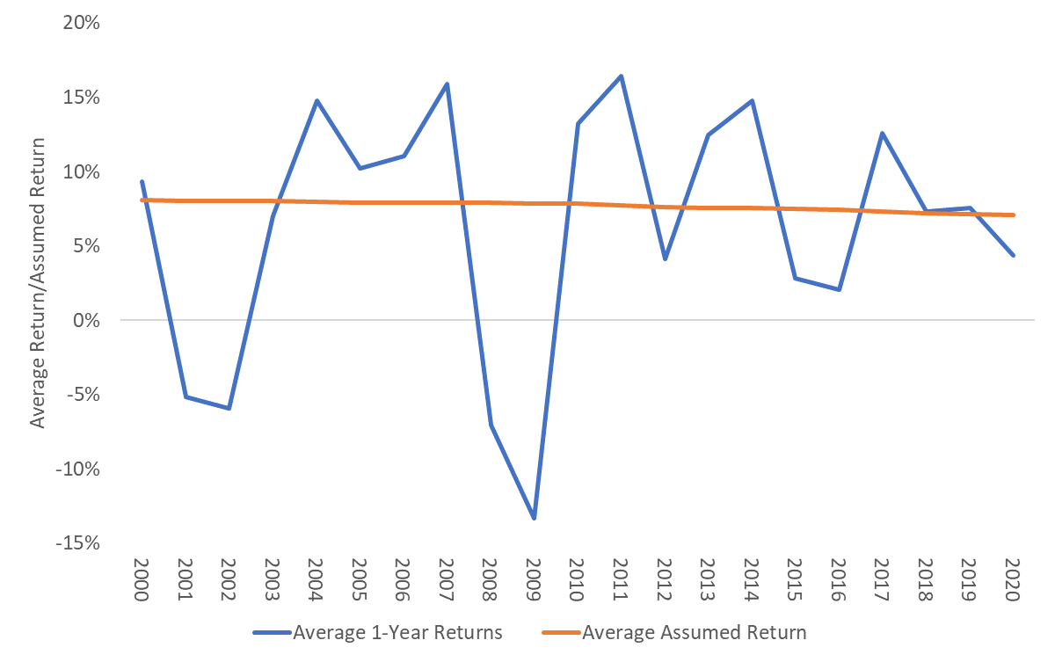

Appendix Figure A.2: Average 10-Year Investment Returns and Average Assumed Rates of Return, 2001-20
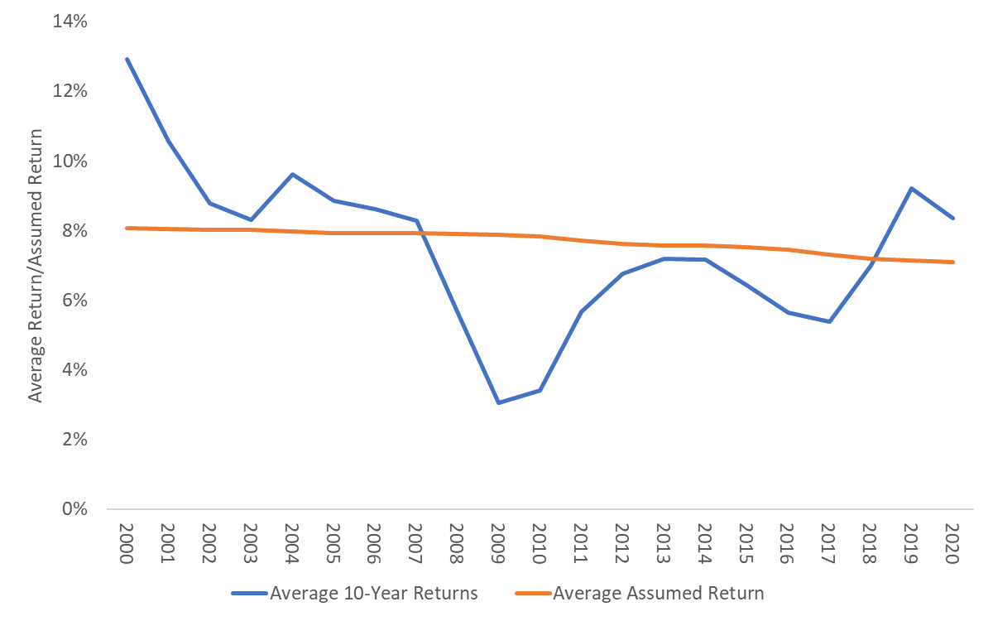

Appendix B: Selected Subcategories of Unfunded Liabilities from 2000 to 2020

Appendix Figure B.1: Demographic Experience
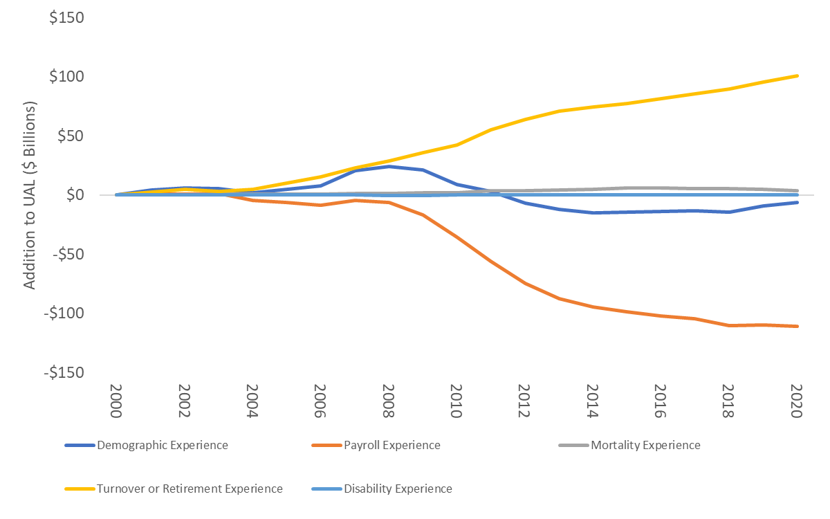
Notes: Authors’ tabulation of actuarial valuations and other financial reports for state-administered retirement systems using actuarial valuation of assets.

Appendix Figure B.2: Benefit Experience and Legislative Changes
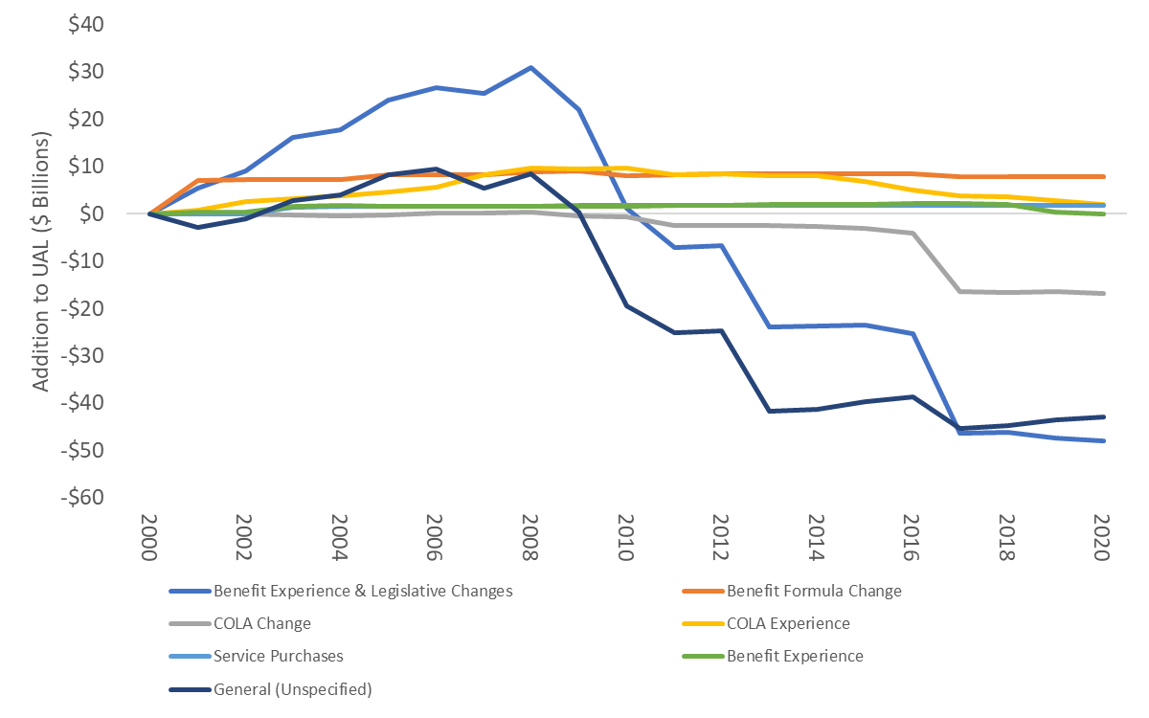
Notes: Authors’ tabulation of actuarial valuations and other financial reports for state-administered retirement systems using actuarial valuation of assets.

Appendix C: Non-Normalized Unfunded Liability Percent Changes

Appendix Figure C.1: Sources of Unfunded Liabilities as a Percent of Total from 2000 to 2020, Non-Normalized
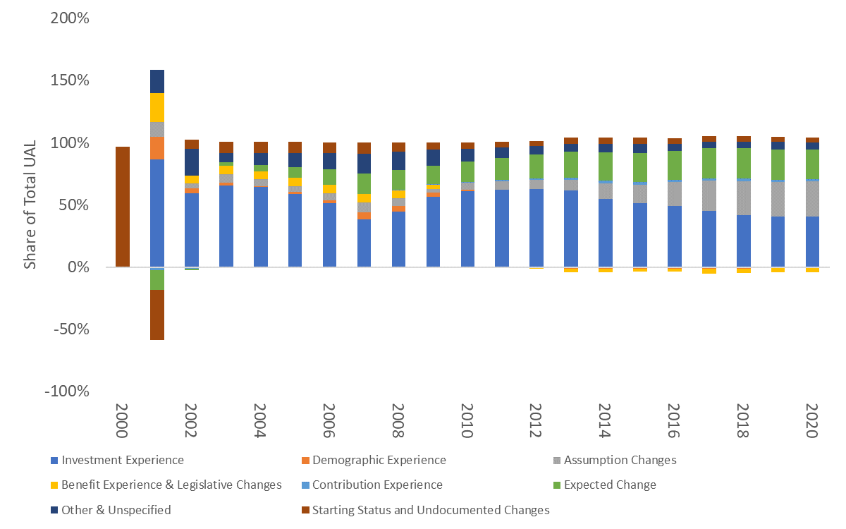
Notes: Authors’ tabulation of actuarial valuations and other financial reports for state-administered retirement systems using actuarial valuation of assets.

Appendix Figure C.2: Sources of Yearly Unfunded Liability Accrual from 2000 to 2020, Non-Normalized
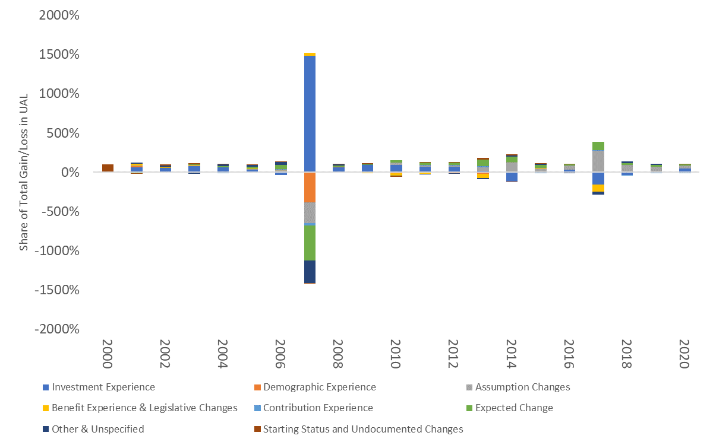
Notes: Authors’ tabulation of actuarial valuations and other financial reports for state-administered retirement systems using actuarial valuation of assets.

