Appendix

A1. Table of Total Issuance, Total Redemption and Total Public Debt Subject to Limit
Fiscal Year | Total Issues | Total Redemptions | Total Public Debt Subject to Limit
2000 | 17,128 | 17,110 | 5,568
2001 | 17,935 | 17,802 | 5,592
2002 | 21,313 | 20,893 | 5,733
2003 | 25,539 | 24,984 | 6,161
2004 | 39,445 | 38,849 | 6,738
2005 | 38,414 | 37,860 | 7,333
2006 | 36,485 | 35,911 | 7,871
2007 | 38,744 | 38,243 | 8,420
2008 | 43,137 | 42,120 | 8,921
2009 | 54,417 | 52,532 | 9,960
2010 | 65,432 | 63,781 | 11,853
2011 | 65,198 | 63,969 | 13,511
2012 | 68,683 | 67,407 | 14,747
2013 | 62,163 | 61,492 | 16,027
2014 | 69,814 | 68,728 | 16,699
2015 | 60,775 | 60,449 | 17,781
2016 | 95,649 | 94,226 | 18,113
2017 | 85,856 | 85,185 | 19,538
2018 | 100,238 | 98,966 | 20,209
2019 | 91,617 | 90,413 | 21,475
2020 | 121,649 | 117,424 | 22,687
Source: Author’s calculations based on U.S. Department of the Treasury information.
Note: Values are rounded in billions of US nominal dollars.

Fiscal Year | Issues |  | Total Issues | Redemptions |  | Total Redemptions | Total Public Debt Subject to Limit
 | Marketable | Nonmarketable |  | Marketable | Nonmarketable
2000 | 1,998 | 15,130 | 17,128 | 2,207 | 14,903 | 17,110 | 5,568
2001 | 2,477 | 15,459 | 17,935 | 2,570 | 15,232 | 17,802 | 5,592
2002 | 3,693 | 17,621 | 21,313 | 3,487 | 17,406 | 20,893 | 5,733
2003 | 4,139 | 21,399 | 25,539 | 3,815 | 21,168 | 24,984 | 6,161
2004 | 4,604 | 34,841 | 39,445 | 4,218 | 34,631 | 38,849 | 6,738
2005 | 4,480 | 33,934 | 38,414 | 4,241 | 33,619 | 37,860 | 7,333
2006 | 4,425 | 32,060 | 36,485 | 4,207 | 31,704 | 35,911 | 7,871
2007 | 4,434 | 34,310 | 38,744 | 4,289 | 33,954 | 38,243 | 8,420
2008 | 5,537 | 37,600 | 43,137 | 4,749 | 37,371 | 42,120 | 8,921
2009 | 8,855 | 45,562 | 54,417 | 7,081 | 45,451 | 52,532 | 9,960
2010 | 8,421 | 57,012 | 65,432 | 6,932 | 56,848 | 63,781 | 11,853
2011 | 7,851 | 57,346 | 65,198 | 6,725 | 57,244 | 63,969 | 13,511
2012 | 7,590 | 61,093 | 68,683 | 6,465 | 60,943 | 67,407 | 14,747
2013 | 8,028 | 54,135 | 62,163 | 7,182 | 54,310 | 61,492 | 16,027
2014 | 7,238 | 62,576 | 69,814 | 6,540 | 62,188 | 68,728 | 16,699
2015 | 6,946 | 53,829 | 60,775 | 6,386 | 54,062 | 60,449 | 17,781
2016 | 8,054 | 87,594 | 95,649 | 7,248 | 86,978 | 94,226 | 18,113
2017 | 8,646 | 77,210 | 85,856 | 8,107 | 77,078 | 85,185 | 19,538
2018 | 9,993 | 90,244 | 100,238 | 8,915 | 90,051 | 98,966 | 20,209
2019 | 11,734 | 79,882 | 91,617 | 10,665 | 79,748 | 90,413 | 21,475
2020 | 18,681 | 102,969 | 121,649 | 14,653 | 102,770 | 117,424 | 22,687
A2. Marketable and Nonmarketable Issues, Marketable and Nonmarketable Redemptions and Public Debt Subject to Limit
Source: Author’s calculations based on U.S. Department of the Treasury information.
Note: Values are rounded in billions of US nominal dollars.

Fiscal Year | Issues |  | Redemptions |  | Total Public Debt Subject to Limit
 | Marketable | Gov. Account Series (Issues) | Marketable | Gov. Account Series (Redemptions)
2000 | 1,998 | 15,086 | 2,207 | 14,837 | 5,568
2001 | 2,477 | 15,384 | 2,570 | 15,146 | 5,592
2002 | 3,693 | 17,518 | 3,487 | 17,303 | 5,733
2003 | 4,139 | 21,231 | 3,815 | 21,026 | 6,161
2004 | 4,604 | 34,675 | 4,218 | 34,457 | 6,738
2005 | 4,480 | 33,766 | 4,241 | 33,515 | 7,333
2006 | 4,425 | 31,955 | 4,207 | 31,613 | 7,871
2007 | 4,434 | 34,145 | 4,289 | 33,840 | 8,420
2008 | 5,537 | 37,493 | 4,749 | 37,222 | 8,921
2009 | 8,855 | 45,384 | 7,081 | 45,227 | 9,960
2010 | 8,421 | 56,763 | 6,932 | 56,572 | 11,853
2011 | 7,851 | 57,089 | 6,725 | 56,941 | 13,511
2012 | 7,590 | 60,747 | 6,465 | 60,601 | 14,747
2013 | 8,028 | 53,807 | 7,182 | 53,943 | 16,027
2014 | 7,238 | 62,250 | 6,540 | 61,841 | 16,699
2015 | 6,946 | 53,508 | 6,386 | 53,707 | 17,781
2016 | 8,054 | 87,218 | 7,248 | 86,627 | 18,113
2017 | 8,646 | 76,916 | 8,107 | 76,749 | 19,538
2018 | 9,993 | 89,968 | 8,915 | 89,761 | 20,209
2019 | 11,734 | 79,609 | 10,665 | 79,453 | 21,475
2020 | 18,681 | 102,430 | 14,653 | 102,367 | 22,687
A3. Marketable and Nonmarketable Issues, Marketable and Nonmarketable Redemptions and Public Debt Subject to Limit

Source: Author’s calculations based on U.S. Department of the Treasury information.
Note: Values are rounded in billions of US nominal dollars.

A4. Graphic illustration of the BP1 variable
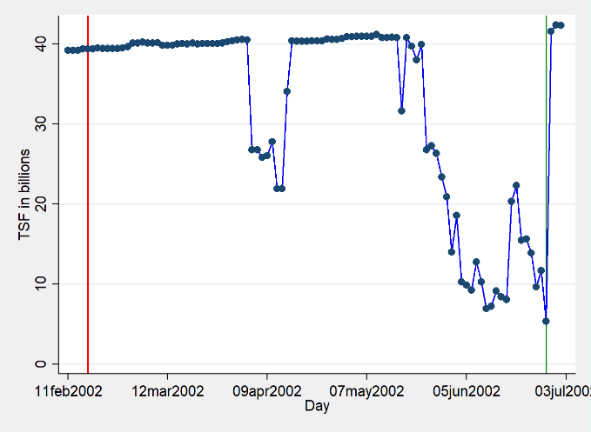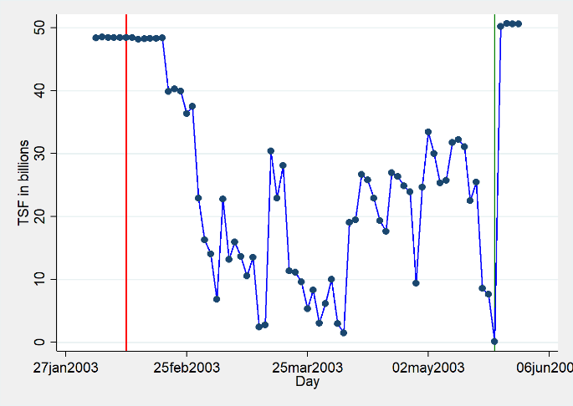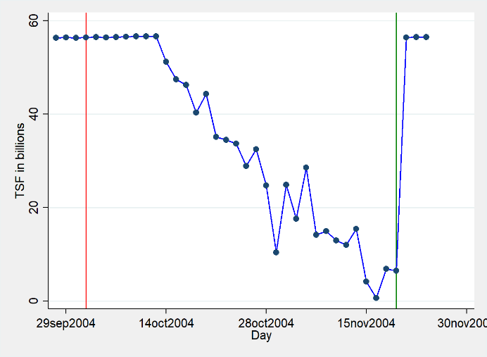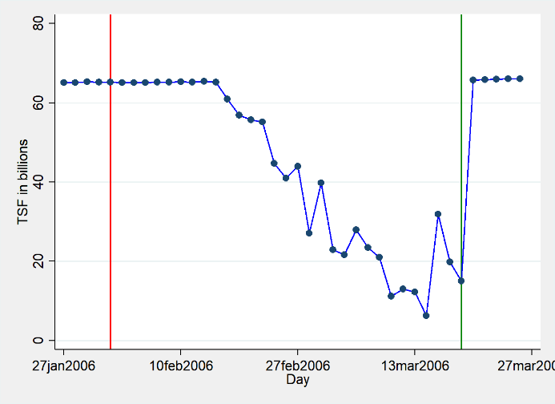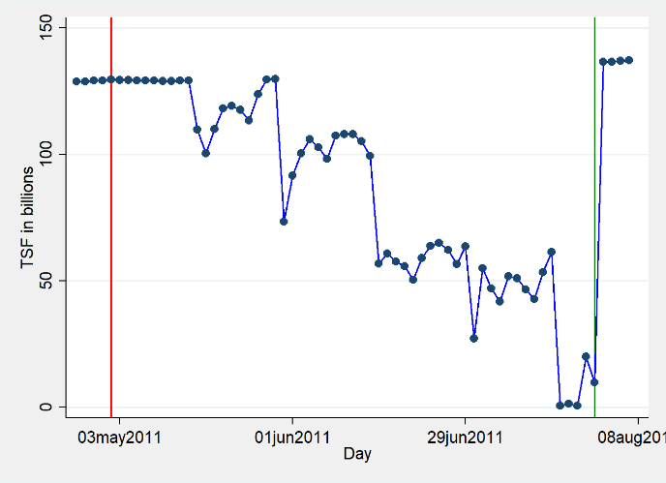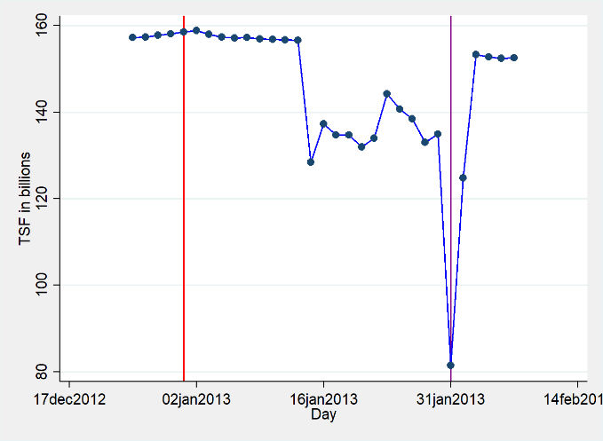
Event N°1
Event N°2
Event N°3
Event N°4
Event N°5
Event N°6

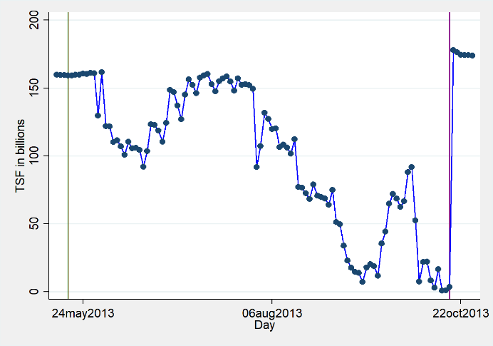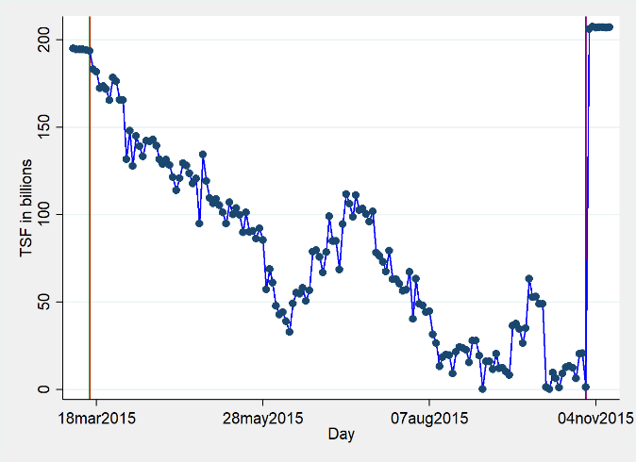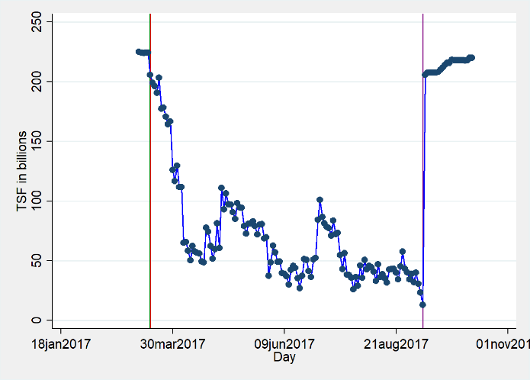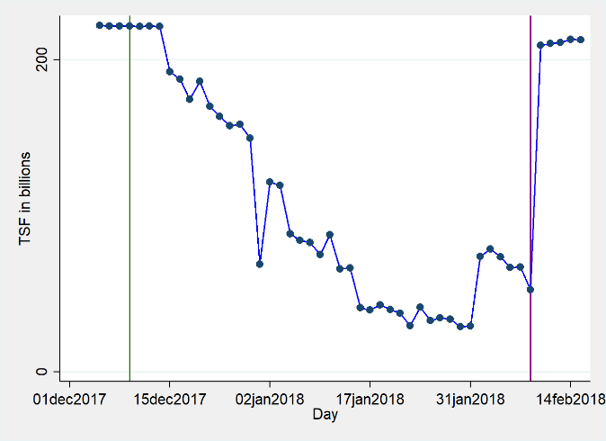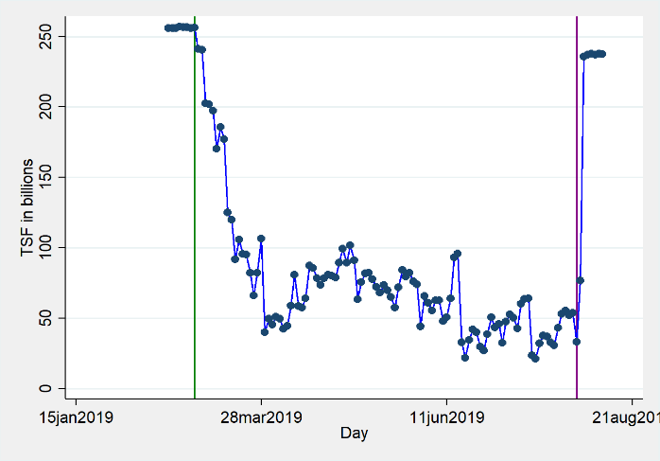
Event N°7
Event N°8
Event N°9
Event N°10
Event N°11
Source: Author’s calculations.

A5. Graphic illustration of the BP2 variable
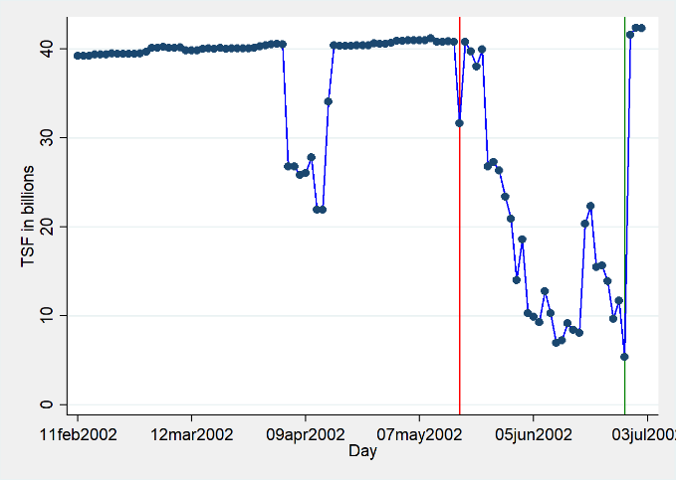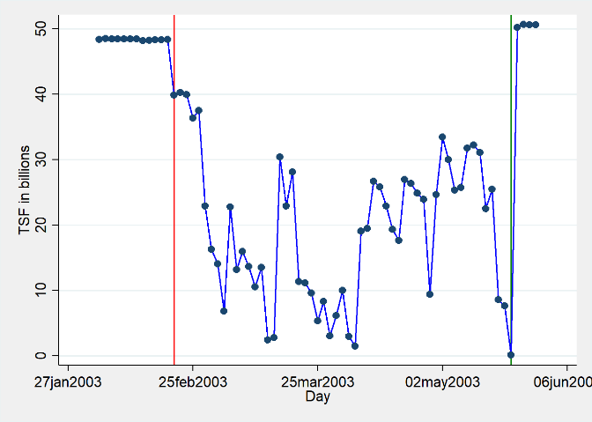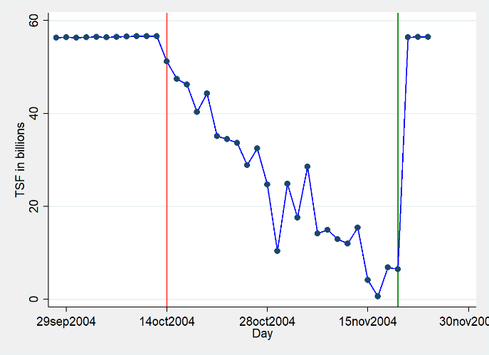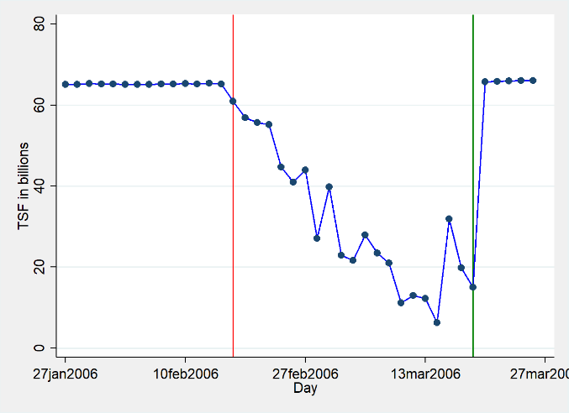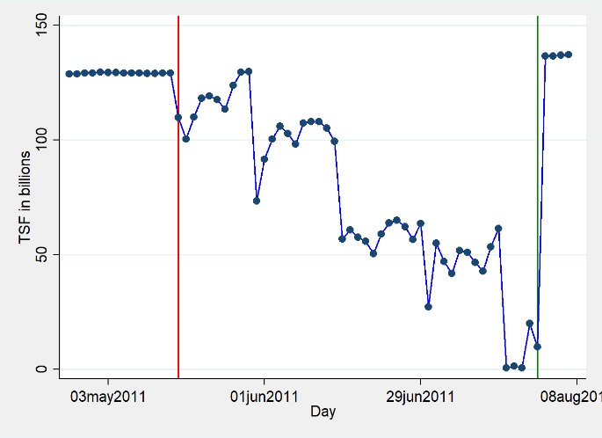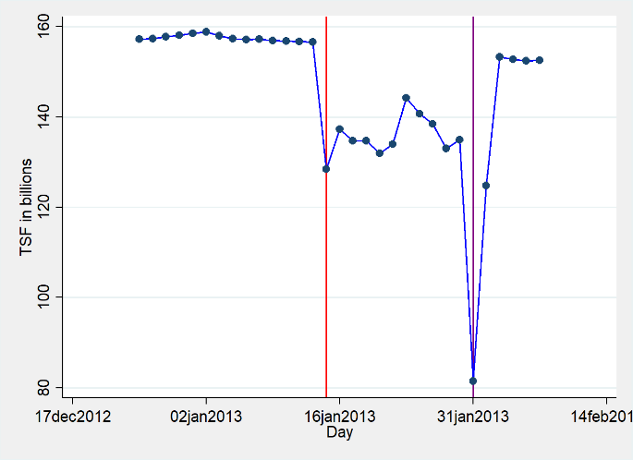
Event N°1
Event N°2
Event N°3
Event N°4
Event N°5
Event N°6

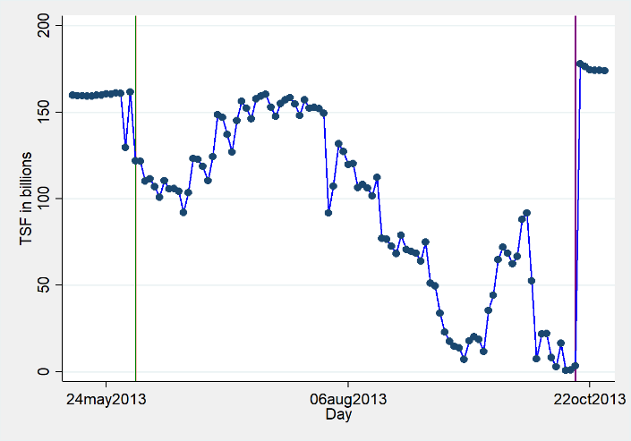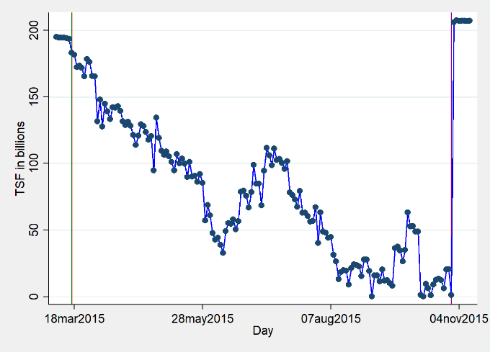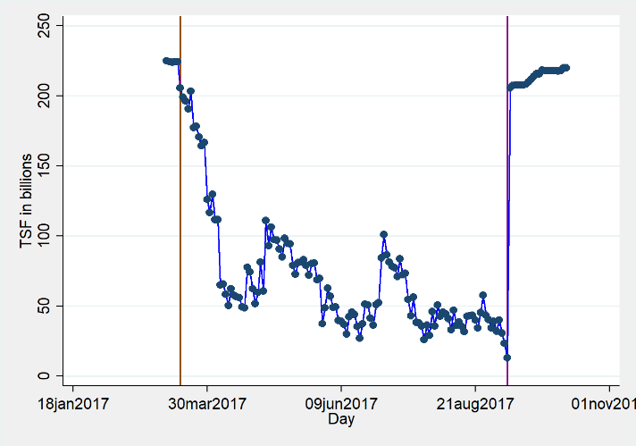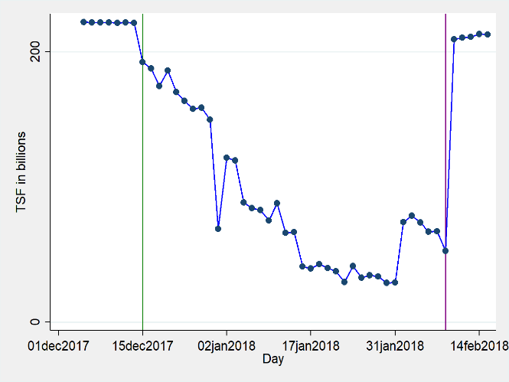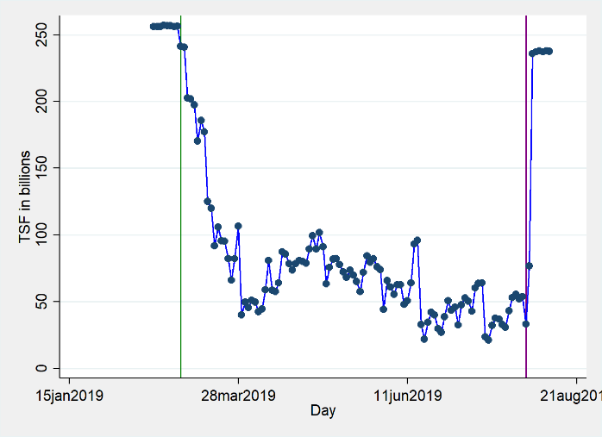
Event N°7
Event N°8
Event N°9
Event N°10
Event N°11
Source: Author’s calculations.

