Identifying Optimal Decision-Making Strategies and Determining Effective Messaging to Maximize the Expected Outcomes of Potential Human-Extraterrestrial Encounters
Supplementary Materials

Matrices alignment protocol
SERS computation requires identifying the cells that constitute players’ similar choices (Fischer, 2009). In symmetric games, i.e., games that provide each player with the same strategic problem (Kilgour & Fraser, 1988), the definition of similar choices is self-evident (see Figure S1a). In non-symmetric games, i.e., games that provide the players with strategic problems that are not fully identical, the distinction between alternatives that are more and less similar is reflected by the extent of similarity of the provided payoffs. In other words, by choosing similar alternatives in non-symmetric games, players obtain payoffs that are closer to each other than the payoffs they obtain by choosing dissimilar alternatives. To identify the cells that constitute the similarity diagonal—the diagonal comprising both similar choices—we test the extent to which both players face the same strategic problem under the two possibilities for defining the similarity diagonal.
For example, consider the symmetric matrix depicted in Figure S1a (showing the well-known Prisoner’s Dilemma game (Flood et al., 1950; Rapoport & Chammah, 1965). There are two possible options for defining the similarity diagonal: either i) Alice’s top alternative is similar to Bob’s left alternative, and Alice’s bottom alternative is similar to Bob’s right alternative (Figure S1b), or ii) Alice’s top alternative is similar to Bob’s right alternative, and Alice’s bottom alternative is similar to Bob’s left alternative (Figure S1c). The two cells in the matrix that represent the choice of the same alternative by both players define the similarity diagonal (shaded in Figures S1b and S1c).
To determine the appropriate similarity diagonal, we switch the roles of the players and test whether they are facing the same strategic problem. Switching the roles of the players in matrix S1b results in matrix S1d, and switching the roles of the players in matrix S1c results in matrix S1e. Switching the roles of the players in matrix b yields the same matrix. However, switching the roles of the players in matrix c does not yield the same matrix. Therefore, the similarity diagonal shown in matrix b - the top left and bottom right cells - is the appropriate similarity diagonal of matrix S1a.

a |  | Bob
 |  | Left | Right
Alice | Top | 3 , 3 | 1 , 4
 | Bottom | 4 , 1 | 2 , 2

b Bob  # @  Alice # 3 , 3 1 , 4  @ 4 , 1 2 , 2 | c Bob  @ #  Alice # 3 , 3 1 , 4  @ 4 , 1 2 , 2
d Alice  # @  Bob # 3 , 3 1 , 4  @ 4 , 1 2 , 2 | e Alice  @ #  Bob # 2 , 2 4 , 1  @ 1 , 4 3 , 3
Fig. S1. Example of a symmetric matrix (the Prisoners’ Dilemma game). Permutations of identical alternative labels (# and @) represent the tested configurations of similar alternatives.
In the case of a non-symmetric game, switching the players’ roles does not yield an identical matrix. Thus, to determine which diagonal best constitutes the similarity diagonal, we switch the roles of the players and separately correlate the payoffs of the original matrix and the switched matrix under each of the two configurations. The diagonal that yields a higher correlation is identified as the similarity diagonal.
For example, consider the matrix depicted in Figure S2a. The two possible options for defining the similar alternatives and the corresponding similarity diagonals are depicted by matrices b and c. Switching the roles of the players in matrix b results in matrix d, and switching the roles of the players in matrix c results in matrix e. The correlation between the row player’s (Alice) payoff set in matrix b (4,3,2,1) and the row player’s (Bob) payoff set in matrix d (1,3,2,4) is -0.8, while the correlation between the row player’s (Alice) payoff set in matrix c (4,3,2,1) and the row player’s (Bob) payoff set in matrix e (4,2,3,1) is 0.8. Hence, the similarity diagonal depicted in matrix c better constitutes the similarity diagonal of matrix S2a. Note that since matrices d and e are obtained by switching the roles of the players in matrices c and d, calculating the same correlations for the column player’s payoffs yields identical results.
This procedure applies to both symmetric and non-symmetric games. Clearly, in symmetric games the computed correlation for the appropriate similarity diagonal always equals 1.

a |  | Bob
 |  | Left | Right
Alice | Top | 4 , 1 | 3 , 2
 | Bottom | 2 , 3 | 1 , 4

b Bob  # @  Alice # 4 , 1 3 , 2  @ 2 , 3 1 , 4 | c Bob  @ #  Alice # 4 , 1 3 , 2  @ 2 , 3 1 , 4
d Alice  # @  Bob # 1 , 4 3 , 2  @ 2 , 3 4 ,1 | e Alice  @ #  Bob # 4 , 1 2 , 3  @ 3 , 2 1 , 4
Fig. S2. Example of a non-symmetric matrix. Permutations of identical alternative labels (# and @) represent the tested configurations of similar alternatives.
Another method of identifying the similarity diagonal is to calculate the differences between the two payoffs in each cell and select the diagonal with the minimal sum of differences. If the matrix is symmetric, the similarity diagonal contains two cells, each showing two identical payoffs, thus yielding a sum of differences equal to 0. If the matrix is non-symmetric, the minimum of the two sums of differences corresponds to the similarity diagonal with the better fit.
For example, consider again the matrix depicted in Figure S2a. The sum of differences for the shaded diagonal in matrix b is |4-1|+|1-4|=6, whereas the sum of differences in the shaded diagonal in matrix c is |3-2|+|2-3|=2. Since the minimal sum of differences is obtained in the shaded diagonal in panel c, it is identified as the similarity diagonal. Note that this method identifies the same similarity diagonal as the correlation method described above. This is indeed the case for about 70% of the simulated matrices. Moreover, the simulation results based on the sum of differences (Figure S3) closely resemble those based on the correlation method (see Figure 2 in the main text), both showing identical trends of the mean human payoffs.
a  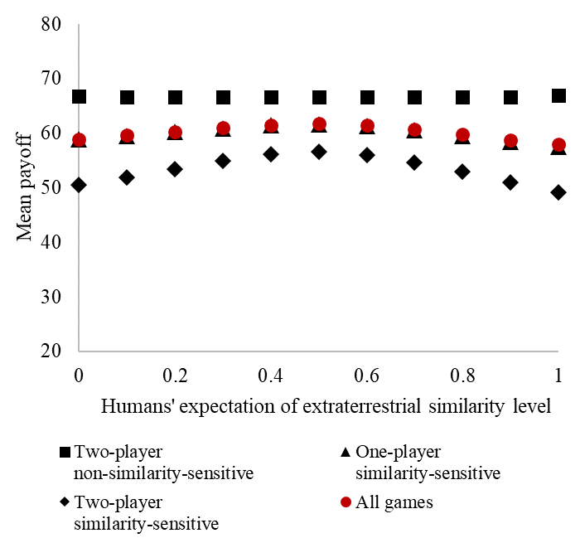 | b  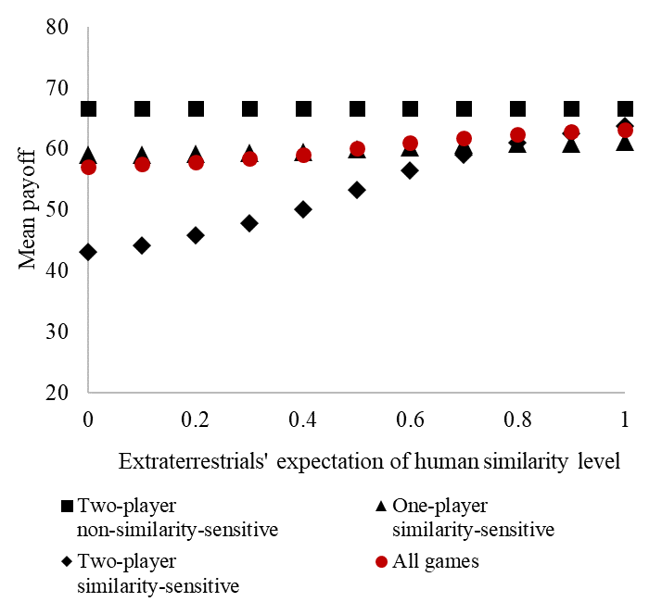
Fig. S3. Simulation results based on the sum of differences method. Panel a depicts average human payoffs across various human similarity levels, separately calculated for each game type. Panel b depicts average human payoffs across various extraterrestrial similarity levels, separately calculated for each game type.
Complete data
Link to files in OSF: https://osf.io/wev9p/?view_only=373250029af64e1291dd00b8f85365f1
Included files: (1) Full simulation, (2) Simulation results summary
References
Fischer, I. (2009). Friend or foe: Subjective expected relative similarity as a determinant of cooperation. Journal of Experimental Psychology: General, 138(3), 341–350. https://doi.org/10.1037/a0016073
Flood, M., Dresher, M., Tucker, A., & Device, F. (1950). Prisoner’s Dilemma: Game Theory. Experimental Economics.
Kilgour, D. M., & Fraser, N. M. (1988). A taxonomy of all ordinal 2 × 2 games. Theory and Decision, 24(2), 99–117. https://doi.org/10.1007/BF00132457/METRICS
Rapoport, A., & Chammah, A. M. (1965). Prisoner’s dilemma : a study in conflict and cooperation. University of Michigan Press.

