**Supplementary Material**

**Contents**

Table S1. Fixed-effects panel regression results predicting log assets with an interaction between time and connectedness

Figure S1. Results of synthetic control analysis

Table S2. Panel logistic regression results predicting having a political connection

Table S3. Results of additional panel logistic regressions

Table S4. Panel logistic regression results predicting having a political connection with year-specific effects

Table S5. Interactive effect of time and assets on having a political connection

**Table S1.** Fixed-effects panel regression results predicting log assets with an interaction between time and connectedness

|  |  |
| --- | --- |
|  | Estimate |
| Time | 1.30*** |
|  | (0.05) |
| Connection | 0.44*** |
|  | (0.12) |
| Time × Connection | −0.04 |
|  | (0.15) |
| Constant | 4.77*** |
|  | (0.03) |
| Observations | 3,501 |
| Groups | 997 |

*Note.* Standard errors in parentheses.

* *p* < 0.05, ** *p* < 0.01, *** *p* < 0.001

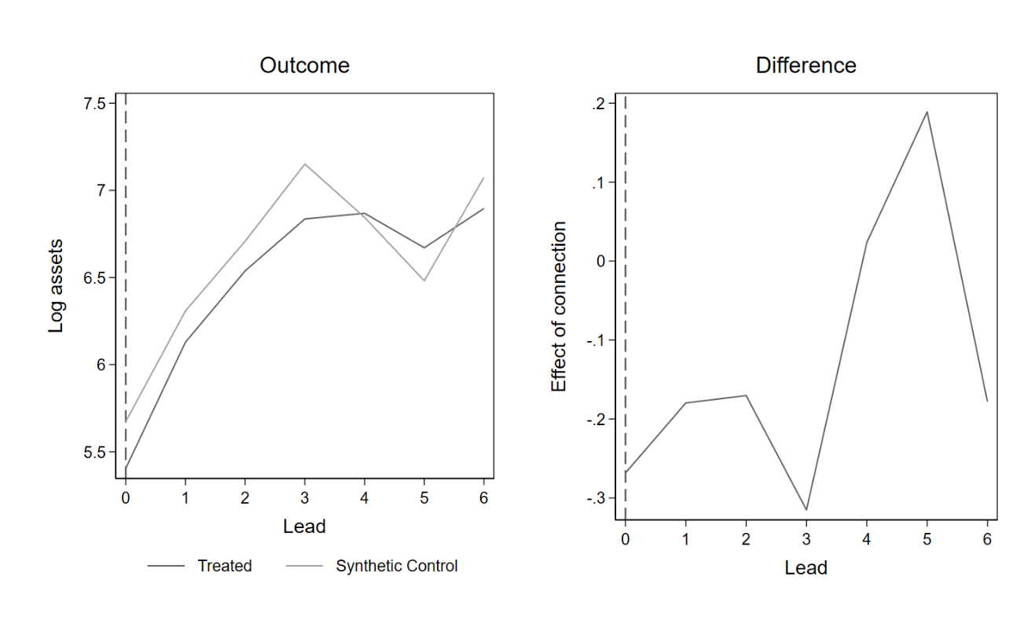

**Figure S1.** Results of synthetic control analysis

*Note.* Effect of connection not significant on the 95% confidence level in all time points.

**Table S2.** Full logistic regression results predicting having a political connection

|  |  |  |
| --- | --- | --- |
|  | Model 1 | Model 2 |
| Time trend | −2.17*** | −2.45** |
|  | (0.60) | (0.91) |
| Connection previous year | 9.19*** | 3.80*** |
|  | (0.93) | (0.65) |
| Log fortune | 1.65 | 3.69* |
|  | (1.18) | (1.56) |
| Industry (Finance = ref.) |  |  |
| Metallurgy | 1.15 |  |
|  | (0.73) |  |
| Retail | 0.09 |  |
|  | (0.67) |  |
| Construction | 0.51 |  |
|  | (0.69) |  |
| Food | −0.13 |  |
|  | (0.63) |  |
| Petroleum | 0.64 |  |
|  | (0.83) |  |
| Chemical | −0.19 |  |
|  | (0.91) |  |
| Communication | −1.11 |  |
|  | (1.29) |  |
| Transportation | 0.43 |  |
|  | (1.02) |  |
| Machinery | 1.90* |  |
|  | (0.90) |  |
| Agriculture | 1.85 |  |
|  | (1.15) |  |
| Energy | −0.06 |  |
|  | (1.13) |  |
| Other | 1.39 |  |
|  | (1.22) |  |

*Note.* Standard errors in parentheses.

* *p* < 0.05, ** *p* < 0.01, *** *p* < 0.001

**Table S3.** Results of additional panel logistic regressions

|  |  |  |
| --- | --- | --- |
|  | Model 1 | Model 2 |
| Time trend | −1.927** | −2.562*** |
|  | (0.593) | (0.754) |
| Connection previous year | 8.894*** | 9.328*** |
|  | (0.890) | (1.016) |
| Log fortune | 1.375 | 2.319 |
|  | (1.307) | (1.247) |
| Industry | included | included |
| *N* observations | 2,790 | 3,501 |
| *N* individuals | 771 | 997 |

*Note.* Model 1 includes only the first 400 observations for each year. Model 2 introduces indicator variables for years 2003, 2005, and 2008. Standard errors in parentheses.

* *p* < 0.05, ** *p* < 0.01, *** *p* < 0.001

**Table S4.** Year indicator variables’ effects on propensity to have a political connection

|  |  |
| --- | --- |
|  | Estimate |
| Year (2003 = ref.) |  |
| 2004 | 0.02 |
|  | (0.52) |
| 2005 | −0.12 |
|  | (0.48) |
| 2006 | −1.00* |
|  | (0.48) |
| 2007 | −1.30* |
|  | (0.63) |
| 2008 | −0.65 |
|  | (0.65) |
| 2009 | −1.99** |
|  | (0.69) |
| 2010 | −2.14** |
|  | (0.67) |
| Connection previous year | 9.32*** |
|  | (1.01) |
| Log fortune | 2.42 |
|  | (1.31) |
| Industry fixed effects | included |
| *N* observations | 3,501 |
| *N* individuals | 997 |

*Note.* Standard errors in parentheses.

* *p* < 0.05, ** *p* < 0.01, *** *p* < 0.001

**Table S5.** Interactive effect of time and assets on having a political connection

|  |  |
| --- | --- |
|  | Estimate |
| Time trend | −1.97*** |
|  | (0.58) |
| Log fortune | 3.31* |
|  | (1.67) |
| Fortune × Time | −3.92 |
|  | (3.10) |
| Connection previous year | 9.29*** |
|  | (0.96) |
| Industry fixed effects | included |
| *N* observations | 3,501 |
| *N* individuals | 997 |

*Note.* Standard errors in parentheses.

* *p* < 0.05, ** *p* < 0.01, *** *p* < 0.001