Local variation in musculoskeletal pain consultation rates in primary care: findings from an ecologic study in Staffordshire
SUPPLEMENTARY DATA

Contents
- SNOMED-CT codelists (pp2-13)

- List of covariates and sources, including questions from brief online GP practice questionnaire used in the current study (pp14-15)

- Technical appendix: Method for obtaining practice-specific modelled prevalence estimates of chronic pain and high impact chronic pain (p16)

- Data tables and scatterplots (pp17-28)
D1. Proportion of adults consulting for a MSK pain condition vs length of recruitment period
D2. Proportion of adults consulting for a MSK Pain Condition, by GP practice: North Staffordshire
& Stoke-on-Trent
D3. Relationships between proportion consulting for MSK pain condition and selected covariates
D4. Sensitivity analysis 1 – exclusion of consulting cases with a previous record of inflammatory
arthritis
D5. Sensitivity analysis 2 – Replacement of single annual prevalence estimate with 3-year average
annual prevalence estimate
D6. Sensitivity analysis 3 – Additional adjustment for recorded number of appointments per 1000
patients as a proxy for completeness of recording consultations
D7. Summary table of associations with covariates

- SNOMED-CT Codelists

Keele Core Set of SNOMED CT Concept IDs: MSK Pain/Injury (Adult). Version 1.0, 2021-10-14

SnomedCTConceptId | Preferred term | Body region
1003721002 | Pain of joint of knee | KNE
1003722009 | Pain of knee region | KNE
10085004 | Metatarsalgia | FOT
102556003 | Pain in upper limb | ARM
102570003 | Inguinal pain | HIP/LEG
103014001 | Cervical nerve root pain | NCK
10380004 | Crushing injury of finger | FTB
105606008 | Injury of musculoskeletal system | UNS
10601006 | Pain in lower limb | LEG
1088071000000108 | Pain in upper arm | ARM
11049006 | Cervical radiculitis | NCK
111222003 | Derangement of medial meniscus | KNE
111243002 | Bursitis of knee | KNE
111640008 | Closed fracture of radius | ARM
1126007 | Knee locking | KNE
11654001 | Achilles tendinitis | ANK/LEG
118952005 | Joint finding | UNS
122481008 | Hammer toe | TOE
123536004 | Sprain of upper extremity | ARM/SHD
12519004 | Sprain of sacroiliac ligament | BCK/HIP
125594001 | Injury of shoulder region | SHD
125596004 | Injury of elbow | ELB
125597008 | Injury of forearm | ARM
125598003 | Injury of wrist | WRT
125599006 | Injury of hand | HND
125600009 | Injury of hip region | HIP
125601008 | Injury of knee | KNE
125602001 | Injury of lower leg | LEG
125603006 | Injury of ankle | ANK
125604000 | Injury of foot | FOT
125605004 | Fracture of bone | UNS
125606003 | Fracture of cervical spine | NCK
125607007 | Fracture of thoracic spine | TXS
125608002 | Fracture of lumbar spine | BCK
12584003 | Bone pain | UNS
12676007 | Fracture of radius | WRT/ARM
127278005 | Injury of upper extremity | ARM
127279002 | Injury of lower extremity | HIP
129179000 | Piriformis syndrome | HIP/BCK
134407002 | Chronic back pain | BCK
135897006 | Salter-Harris type II | UNS
13695006 | Fracture of pubic rami | HIP
1539003 | Acquired trigger finger | FTB
157265008 | Dislocation of hip joint | HIP
157266009 | Dislocation of knee joint | KNE
16114001 | Fracture of ankle | ANK
161880003 | Stiff neck symptom | NCK
161882006 | Stiff neck | NCK
161891005 | Backache | BCK
161892003 | Backache with radiation | BCK
161894002 | Complaining of low back pain | BCK
161896000 | Complaining of upper back ache | TXS/BCK
162411004 | Complaining of stiffness | UNS
162429009 | Symptom: upper limb | ARM
16250001000004107 | Fracture of shoulder | SHD
164539000 | O/E - joint movement painful | UNS
17059001 | Prepatellar bursitis | KNE
17222009 | Closed fracture of distal end of radius | WRT
17883008 | Sprain of hip | HIP
18171007 | Fracture of phalanx of finger | FTB
18347007 | Spinal stenosis of lumbar region | BCK
18876004 | Pain in finger | FTB
19660004 | Disorder of soft tissue | UNS
201819000 | Degenerative joint disease involving multiple joints | MSW
201837004 | Localized primary osteoarthritis of the ankle and/or foot | ANK/FOT
202031002 | Generalised arthritis | MSW
202246002 | Recurrent dislocation of the patellofemoral joint | KNE
202336002 | Acetabular labrum tear | SHD
202381003 | Knee joint effusion | KNE
202472008 | Hand joint pain | HND
202479004 | Acromioclavicular joint pain | SHD
202480001 | Elbow joint pain | ELB
202482009 | Wrist joint pain | WRT
202487003 | Sacroiliac joint pain | BCK/HIP
202490009 | Ankle joint pain | ANK
202596000 | Clicking joint | UNS
202606004 | Clicking hip | HIP
202609006 | Clicking knee | KNE
202664003 | Cervical myelopathy | NCK
202683005 | Cervical spondylosis with radiculopathy | NCK
202693003 | Lumbosacral spondylosis with radiculopathy | BCK
202708005 | Prolapsed lumbar intervertebral disc | BCK
202732003 | Disc prolapse with radiculopathy | SPN
202733008 | Cervical disc prolapse with radiculopathy | NCK
202735001 | Lumbar disc prolapse with radiculopathy | BCK
202752002 | Lumbar discitis | BCK
202757008 | Cervical disc disorder with radiculopathy | NCK
202788007 | Degenerative lumbar spinal stenosis | BCK
202794004 | Lumbago with sciatica | BCK
202805003 | Sacroiliac disorder | BCK/HIP
202841003 | Supraspinatus tendinitis | SHD
202842005 | Partial thickness rotator cuff tear | SHD
202843000 | Full thickness rotator cuff tear | SHD
202849001 | Subacromial impingement | SHD
202855006 | Lateral epicondylitis | ELB
202856007 | Biceps tendinitis | ARM
202863007 | Adductor tendinitis | HIP
202881005 | Tibialis posterior tendinitis | LEG
202882003 | Plantar fasciitis | FOT
202888004 | Anterior shin splints | LEG
202900007 | Synovitis and tenosynovitis | UNS
202914007 | Extensor tenosynovitis of wrist | WRT
202916009 | Extensor tenosynovitis of thumb | FTB
202936005 | Ganglion and cyst of synovium, tendon and bursa | UNS
202942009 | Ganglion of wrist | WRT
203045001 | Dupuytren's disease of palm | HND
203082005 | Fibromyalgia | MSW
203095000 | Spasm of back muscles | BCK
203131005 | Tender heel pad | FOT
203509009 | Clavicle pain | SHD
203534009 | Acquired pes planus | FOT
203601000 | Acquired unequal leg length | LEG
203638000 | Kyphoscoliosis and scoliosis | TXS/BCK
203639008 | Idiopathic scoliosis | BCK
203645000 | Postural scoliosis | BCK
203681002 | Acquired spondylolisthesis | BCK
20511007 | Fracture of hand | HND
207940009 | Closed fracture thoracic vertebra wedge | TXS
207957008 | Closed fracture lumbar vertebra | BCK
207959006 | Closed fracture lumbar vertebra, wedge | BCK
208145002 | Fracture or disruption of pelvis | HIP
208165009 | Closed fracture pelvis single pubic ramus | HIP
208166005 | Closed fracture pelvis multiple pubic rami - stable | HIP
208240004 | Closed fracture proximal humerus, neck | ARM/SHD
208242007 | Closed fracture proximal humerus, greater tuberosity | ARM
208294009 | Closed fracture olecranon, extra-articular | ELB
208325003 | Closed fracture radial styloid | WRT
208388003 | Fracture at wrist and/or hand level | WRT/HND
208393000 | Fracture of metacarpal bone | WRT/HND
208394006 | Closed fracture of metacarpal bone | HND
208399001 | Closed fracture finger metacarpal neck | HND
208401007 | Closed fracture finger metacarpal | HND
208430000 | Closed fracture of one or more phalanges of hand | FTB
208444006 | Closed fracture finger proximal phalanx | FTB
208450001 | Closed fracture finger middle phalanx | FTB
208634001 | Closed fracture distal tibia | LEG
208687001 | Closed fracture metatarsal base | FOT
208710000 | Closed fracture proximal phalanx, toe | TOE
208712008 | Closed fracture distal phalanx, toe | TOE
208719004 | Fracture of great toe | TOE
2089002 | Paget's disease of bone | UNS
208916003 | Acute meniscal tear medial posterior horn | KNE
208921000 | Acute meniscal tear lateral | KNE
209238002 | Closed fracture dislocation shoulder joint | SHD
209354002 | Closed fracture dislocation foot | FOT
209409002 | Sprains and strains of joints and adjacent muscles | UNS
209436000 | Sprain of wrist and/or hand | WRT/HND
209520004 | Partial tear knee anterior cruciate ligament | KNE
209529003 | Sprain of ankle and/or foot | ANK/FOT
209532000 | Sprain, ankle joint, lateral | ANK
209557005 | Neck sprain | NCK
209565008 | Lumbar sprain | BCK
209574005 | Pulled back muscle | BCK
209629006 | Complete tear knee anterior cruciate ligament | KNE
209812006 | Sprain, symphysis pubis | HIP
21351003 | Fracture of phalanx of foot | TOE
21698002 | Open fracture of phalanx of finger | FTB
21794005 | Radial styloid tenosynovitis | WRT
221695002 | Achilles bursitis | ANK/FOT
22193007 | Degenerative joint disease of hand | HND
228158008 | Difficulty in walking | UNS
22817005 | Strain of Achilles tendon | ANK/LEG
22878006 | Contusion of knee | KNE
23056005 | Sciatica | BCK/LEG
23382007 | Stress fracture | UNS
23406007 | Fracture of upper limb | ARM
23482006 | Avulsion fracture | UNS
235231000119100 | Osteophyte of bone | UNS
23680005 | Enthesopathy | UNS
239720000 | Tear of meniscus of knee | KNE
239732001 | Disorder of patellofemoral joint | KNE
239733006 | Anterior knee pain | KNE
239863005 | Osteoarthritis of spinal facet joint | SPN
239865003 | Osteoarthritis of acromioclavicular joint | SHD
239866002 | Osteoarthritis of elbow | ELB
239867006 | Osteoarthritis of wrist | WRT
239868001 | Osteoarthritis of finger joint | FTB
239872002 | Osteoarthritis of hip | HIP
239873007 | Osteoarthritis of knee | KNE
239874001 | Osteoarthritis of ankle | ANK
239877008 | Osteoarthritis of first metatarsophalangeal joint | FOT/TOE
239878003 | Osteoarthritis of toe joint | TOE
239880009 | Lumbar spondylosis | BCK
239960007 | Impingement syndrome of shoulder | SHD
239961006 | Bursitis of shoulder | SHD
240003004 | Suprapatellar bursitis | KNE
240008008 | Synovial cyst of knee | KNE
240131006 | Rhabdomyolysis | UNS
240203005 | Rupture of Baker's cyst - knee | KNE
240205003 | Synovial cyst | UNS
240261009 | Generalised benign joint hypermobility | MSW
240631000000102 | Suspected fracture or dislocation | UNS
24424003 | Closed fracture of phalanx of finger | FTB
24693007 | Myofascial pain syndrome | MSW
247366003 | Acute back pain with sciatica | BCK
247369005 | Facet joint pain | SPN
247373008 | Ankle pain | ANK
248491001 | Swollen knee | KNE
250082003 | Hand cramps | HND
250102002 | Unstable knee | KNE
25415003 | Closed fracture of femur | LEG
25899002 | Closed bimalleolar fracture | ANK
262520005 | Thumb injury | FTB
262965006 | Strain of back muscle | BCK
262971000 | Tendon injury - hand | HND
262981001 | Rupture of gastrocnemius tendon | LEG
262992000 | Hamstring sprain | LEG
263021005 | Anterior dislocation of shoulder joint | SHD
263051004 | Subluxation of shoulder joint | SHD
263054007 | Subluxation of finger | FTB
263055008 | Subluxation of thumb | FTB
263058005 | Subluxation of knee joint | KNE
263084004 | Fracture dislocation of finger or thumb | FTB
263128001 | Sprain of ligament of elbow | ELB
263129009 | Sprain of ligament of finger | FTB
263130004 | Sprain of ligament of thumb | FTB
263133002 | Sprain of lateral ligament of ankle joint | ANK
263199001 | Fracture of distal end of radius | ARM/WRT
263225007 | Fracture of proximal end of femur | HIP
263233008 | Closed fracture of femur, distal end | LEG/KNE
263244000 | Bimalleolar fracture of ankle | ANK
263246003 | Fracture of talus | FOT
263247007 | Fracture of calcaneus | FOT
263251009 | Metatarsal bone fracture | FOT
26538006 | Degeneration of lumbar intervertebral disc | BCK
267039000 | Swollen ankle | ANK
267109007 | Symptom of ankle or foot | ANK/FOT
267889007 | Generalised osteoarthritis of the hand | HND
267949000 | Shoulder joint pain | SHD
267953003 | Arthralgia of the lower leg | LEG
267954009 | Arthralgia of the ankle and/or foot | ANK/FOT
267970006 | Cervical spondylosis without myelopathy | NCK
267981009 | Pain in thoracic spine | TXS
267982002 | Pain in lumbar spine | BCK
269062008 | Closed fracture of cervical spine | NCK
269080004 | Closed fracture of lower end of humerus | ARM/ELB
269083002 | Closed Colles' fracture | WRT
269105005 | Dislocation or subluxation of shoulder | SHD
269111008 | Dislocation or subluxation of finger or thumb | FTB
269112001 | Dislocation or subluxation of knee | KNE
269113006 | Acute meniscal tear medial | KNE
270476009 | Wry neck/torticollis | NCK
270887007 | Rupture of popliteal space synovial cyst | KNE
271587009 | Stiffness | UNS
271771009 | Joint swelling | UNS
27182002 | Sprain of acromioclavicular ligament | SHD
272009001 | Complaining of a back symptom | BCK
272014002 | Complaining of foot symptom | FOT
2733002 | Heel pain | FOT
274142002 | Dupuytren's contracture | HND
274160002 | Fracture of phalanx of thumb | FTB
274162005 | Thoracic back sprain | TXS
274179004 | Traumatic haematoma | UNS
2764000 | Joint crepitus | UNS
27741009 | Calcific tendinitis of shoulder | SHD
277890004 | Swollen toe | TOE
278860009 | Chronic low back pain | BCK
278862001 | Acute low back pain | BCK
279029001 | Pain in cervical spine | NCK
279035001 | Acute thoracic back pain | BCK
279038004 | Thoracic back pain | TXS
279039007 | Low back pain | BCK
279040009 | Mechanical low back pain | BCK
279043006 | Pain in buttock | HIP/BCK
279069000 | Musculoskeletal pain | UNS
281531008 | Fracture of medial malleolus | KNE
281535004 | Fracture of lateral malleolus | ANK
281543009 | Strain of tendon of medial thigh muscle | HIP/LEG
281598004 | Sprain of spinal ligament | BCK
281792000 | Swollen lower leg | LEG
281974002 | Weber type B fracture | ANK
281975001 | Weber type A fracture | ANK
282026002 | Soft tissue injury | UNS
282766005 | Lower back injury | BCK
282775007 | Calf injury | LEG
282776008 | Injury of toe | TOE
283858004 | Crush injury of thumb | FTB
285365001 | Pain in toe | TOE
285395009 | Strain of calf muscle | LEG
29210001 | Trochanteric tendinitis | HIP
297142003 | Swollen foot | FOT
297193007 | Ganglion of hand | HND
297194001 | Ganglion of foot | FOT
298382003 | Scoliosis deformity of spine | BCK
298494008 | Scoliosis of thoracic spine | TXS
298857005 | Shoulder joint painful on movement | SHD
299037003 | Swollen hand | HND
299060006 | Swelling of finger | FTB
299331007 | Bandy legged | LEG
30085007 | Morton metatarsalgia | TOE
300954003 | Pain in calf | LEG
300955002 | Pain in thumb | FTB
301813003 | Irritable hip | HIP
302222008 | Elbow fracture - closed | ELB
302941001 | Nonunion of fracture | UNS
30556007 | Recurrent dislocation of shoulder region | SHD
30760008 | Finger clubbing | FTB
308153009 | Closed fracture of distal fibula | ANK/LEG
309246000 | Osteoarthritis of foot joint | FOT
309567004 | Toe problem | TOE
30989003 | Knee pain | KNE
310483003 | Complaining of pain in toe | TOE
310484009 | Complaining of pain in hallux | TOE
311804006 | Prolapsed lumbar intervertebral disc with sciatica | BCK
311821002 | Closed fracture of great toe | TOE
312225001 | Musculoskeletal and connective tissue diseases | UNS
314916002 | Swollen thumb | FTB
31975004 | Fracture of navicular bone of wrist | WRT
31978002 | Fracture of tibia | LEG
3199001 | Sprain of shoulder | SHD
33173003 | Closed fracture of clavicle | SHD
33192001 | Closed fracture of lower end of radius AND ulna | ARM/WRT
33308003 | Disorder of back | BCK
342070009 | Closed fracture of foot | FOT
34268009 | Closed fracture of lateral malleolus | ANK
34789001 | Pain in the coccyx | BCK
34840004 | Tendinitis | UNS
35678005 | Multiple joint pain | MSW
359532006 | Rotator cuff impingement syndrome | SHD
359817006 | Closed fracture of hip | HIP
359820003 | Closed fracture of neck of femur | HIP
360450007 | Strain of neck muscle | NCK
36071006 | Chondromalacia of patella | KNE
36186002 | Polyarthropathy | MSW
36427004 | Intervertebral disc disorder | SPN
36924003 | Closed fracture of metatarsal bone | FOT
371081002 | Arthritis of knee | KNE
371598009 | Heberden node | FTB
37785001 | Patellar tendonitis | KNE
37895003 | Osteoarthrosis of the carpometacarpal joint of the thumb | FTB
387800004 | Cervical spondylosis | NCK
387802007 | Thoracic spondylosis | TXS
396275006 | Osteoarthritis | UNS
39848009 | Whiplash injury to neck | NCK
398878007 | Sprain of ligament | UNS
399114005 | Adhesive capsulitis of shoulder | SHD
399269003 | Arthropathy | UNS
399346004 | Supraspinatus tear | SHD
40144003 | Morning stiffness - joint | UNS
404098005 | Digital mucous cyst | FTB/TOE
4046000 | Degenerative spondylolisthesis | BCK
405817008 | Fracture of phalanx of hand | FTB
40799003 | Subacromial bursitis | SHD
4106009 | Rotator cuff syndrome | SHD
413428007 | Acquired kyphosis | TXS
413875004 | Closed fracture of head of humerus | SHD
414293001 | Fracture of tibia AND fibula | LEG
41511005 | Open fracture of distal phalanx of finger | FTB
415692008 | Swelling of first metatarsophalangeal joint of hallux | TOE
416189003 | Exostosis | UNS
416209007 | Synovitis | UNS
417076003 | Dislocation of shoulder joint | SHD
417109008 | Subluxation of radial head | ARM/ELB
417163006 | Traumatic AND/OR non-traumatic injury | UNS
417558002 | Dislocation of elbow joint | ELB
417746004 | Traumatic injury | UNS
418237007 | Pain in hallux | TOE
42188001 | Closed fracture of ankle | ANK
423849004 | Iliotibial band friction syndrome | LEG
424648000 | Closed fracture of base of fifth metatarsal bone | FOT
425940002 | Olecranon bursitis | ELB
42636007 | Closed fracture of upper end of humerus | ARM/SHD
42786005 | Snapping thumb syndrome | FTB
428151000 | Closed fracture of bone of knee joint | KNE
42818005 | Closed fracture of scaphoid bone of wrist | WRT
428257007 | Fracture of tibial plateau | KNE
428883008 | Rupture biceps tendon | ARM
429513001 | Rupture Achilles tendon | ANK/LEG
4308002 | Repetitive strain injury | UNS
432473000 | Femoral acetabular impingement | HIP
43295006 | Closed fracture of humerus | ARM
43422002 | Crushing injury of foot | FOT
442048005 | Tenosynovitis of wrist | WRT
442056008 | Torus fracture | UNS
442085002 | Greenstick fracture | UNS
442520000 | Inflammation of rotator cuff tendon | SHD
443700006 | Disorder of lumbar disc | BCK
443798008 | Arthritis of shoulder region joint | SHD
44465007 | Sprain of ankle | ANK
445008009 | Ganglion | UNS
447139008 | Closed fracture of tibia | LEG
447395005 | Closed fracture of fibula | LEG
448355005 | Greenstick fracture of distal radius | ARM/WRT
448394006 | Inflammation of joint of foot | FOT
448589005 | Arthritis of hand | HND
449917004 | Cramp in lower limb | LEG
450521003 | Osteoarthritis of patellofemoral joint | KNE
45231001 | Infrapatellar bursitis | KNE
45326000 | Shoulder pain | SHD
45352006 | Spasm of muscle | UNS
45613006 | Contusion of lower leg | LEG
46866001 | Fracture of lower limb | LEG
47933007 | Foot pain | FOT
481000119104 | Strain of hamstring muscle | LEG
48210000 | Lumbosacral spondylosis without myelopathy | BCK
48532005 | Muscle strain | UNS
49218002 | Hip pain | HIP
49388007 | Sprain of foot | FOT
51037009 | Fracture of patella | KNE
52011008 | Injury of finger | FTB
53057004 | Hand pain | HND
53208009 | Peroneal tendinitis | ANK/FOT
53226007 | Pes planus | FOT
53286005 | Medial epicondylitis of elbow joint | ELB
53627009 | Closed fracture of radius AND ulna | ARM/WRT
54556006 | Fracture of ulna | ARM/WRT
54888009 | Sprain of knee | KNE
55146009 | Sacroiliitis | BCK
55260003 | Calcaneal spur | FOT
55300003 | Cramp | UNS
56608008 | Pain in wrist | WRT
57406009 | Carpal tunnel syndrome | WRT/HND
57676002 | Joint pain | UNS
58150001 | Fracture of clavicle | SHD
58580000 | Closed supracondylar fracture of humerus | ARM/ELB
58781003 | Gluteal tendinitis | HIP
5913000 | Fracture of neck of femur | HIP
61007003 | Separation of symphysis pubis during delivery | HIP
62629000 | Divarication of recti | ABD
637091000000105 | Osteoarthritis NOS, of the lower leg | KNE
64217002 | Curvature of spine | TXS/BCK
64298006 | Mallet finger | FTB
64455005 | Fracture of acetabulum | HIP/SHD
64665009 | Closed fracture of calcaneus | FOT
65260001 | Cervical spondylosis with myelopathy | NCK
65358001 | Acquired hallux valgus | TOE
65966004 | Fracture of forearm | ARM
66308002 | Fracture of humerus | ARM
6654000 | Acquired hallux rigidus | TOE
6698000 | Closed trimalleolar fracture | ANK
67315001 | Degenerative joint disease of shoulder region | SHD
67801009 | Tenosynovitis | HND
68449006 | Arthritis of hip | HIP
6858004 | Capsulitis | UNS
68854005 | Closed fracture of head of radius | ARM/ELB
68962001 | Muscle pain | UNS
69195002 | Degeneration of cervical intervertebral disc | NCK
699062006 | Injury of shoulder and upper arm | SHD/ARM
699370008 | Symptom of foot | FOT
699462004 | Monoarthritis | UNS
70070008 | Torticollis | NCK
704213001 | Closed fracture of phalanx of thumb | FTB
70704007 | Sprain of wrist | WRT
712893003 | Traumatic and/or non-traumatic injury of back | BCK
71620000 | Fracture of femur | LEG
72047008 | Osgood Schlatter disease | KNE
721291009 | Disorder of patella, unspecified | KNE
73589001 | Intervertebral disc prolapse | SPN
74323005 | Pain in elbow | ELB
74779009 | Strain of rotator cuff capsule | SHD
74814004 | Contusion of foot | FOT
75308009 | Closed fracture of navicular bone of foot | FOT
75591007 | Fracture of fibula | LEG
75857000 | Fracture of radius AND ulna | ARM
76107001 | Spinal stenosis | BCK
7674000 | Greater trochanteric pain syndrome | HIP
76865005 | Closed fracture of distal phalanx of finger | FTB
771083005 | Pain in upper arm | ARM
77493009 | Fracture of pelvis | HIP
77547008 | Degeneration of intervertebral disc | SPN
78435003 | Ganglion of joint | UNS
78514002 | Thigh pain | LEG
788465007 | Repetitive motion disorder | UNS
789758005 | Strain of rotator cuff of shoulder | SHD
80068009 | Swelling of limb | LEG/ARM
80692000 | Late effect of tendon injury | UNS
80756009 | Closed fracture of patella | KNE
81498004 | Bursitis of hip | HIP
81576005 | Closed fracture of phalanx of foot | FOT/TOE
81680005 | Neck pain | NCK
81902001 | Sprain of medial collateral ligament of knee | KNE
82423001 | Chronic pain | UNS
82675004 | Baker's cyst | KNE
82991003 | Generalized aches and pains | MSW
83561009 | Spinal stenosis in cervical region | NCK
84017003 | Bursitis | UNS
84445001 | Joint stiffness | UNS
84869007 | Musculoskeletal symptoms | UNS
85551004 | Hypermobility syndrome | MSW
86380000 | Acquired claw toes | TOE
870206000 | Weber type A fracture | ANK
870207009 | Weber type B fracture | ANK
87778004 | Sprain of hand | HND
8847002 | Spondylosis | SPN
88998003 | Osteophyte | UNS
90460009 | Injury of neck | NCK
906591000006102 | Soft tissue injuries | UNS
90834002 | Pain in limb | ARM
91037003 | Closed fracture of pelvis | HIP
926335004 | Rupture of rotator cuff of shoulder | SHD
928000 | Disorder of musculoskeletal system | UNS
939761000006103 | Musculoskeletal pain mild | UNS
9468002 | Closed fracture of carpal bone | WRT/HND
95414005 | Calcific tendinitis | UNS
95854004 | Pulled elbow | ELB
9682006 | Fracture of scapula | SHD
9808005 | Closed fracture of cuboid bone of foot | FOT
1931871000006102 | Suspected fracture | UNS
ABD Abdomen; ANK Ankle; ARM Arm; BCK Back/lumbar spine; CHE Chest; ELB Elbow; FOT Foot; FTB Finger(s)/thumb; HIP Hip/pelvis; HND Hand; KNE Knee; LEG Leg; MSW Multiple-site/widespread; NCK Neck/cervical spine; SHD Shoulder; SKF Skull/head/face; SPN Spine; TNK Trunk, TOE Toe; TXS Thoracic spine; UNS Unspecified body region; WRT Wrist

Inflammatory exclusions codelist

- List of covariates and sources
Covariate | Source
Registered population characteristics
Female (%) | NHS Digital. Patients registered at a GP Practice, Nov 2021-Jun 2022
Aged 65+ years (%) | NHS Digital. Patients registered at a GP Practice, Nov 2021-Jun 2022
Aged 85+ years (%) | NHS Digital. Patients registered at a GP Practice, Nov 2021-Jun 2022
Black, Asian, Minority Ethnic background (%) | OHID. National General Practice Profiles
Practice weighted deprivation decile (1-10)† | OHID. National General Practice Profiles
Practice organisation and performance characteristics
Total population size (n) | NHS Digital. Patients registered at a GP Practice, Nov 2021-Jun 2022
Total clinical staff FTE per 10,000 | OHID. GP Profiles for Patients, Q4 2021-Q2 2022  NHS Digital. Primary Care Workforce - Quarterly Update; NHS Digital. General Practice Workforce;
QOF Overall achievement (max=635) | NHS Digital. Quality and Outcomes Framework, 2021-2022
Positive experience of care (%) | GP Patient Survey, 2022
CQC Overall Rating‡ | OHID. National General Practice Profiles (last available)
Number of selected services available/accessible to MSK patients (0-11) | Brief online questionnaire to practices (see below)
Number of types of MSK clinical decision support systems used (0-8) | Brief online questionnaire to practices (see below)
Need-related factors
Prevalence of self-reported long-term MSK problem (%) | GP Patient Survey, 2022
Prevalence of chronic pain (%) | PRELIM Survey, 2017; Lynch et al., 2023
Prevalence of high-impact chronic pain (%) | PRELIM Survey, 2017; Lynch et al., 2023
QOF Obesity prevalence (%) | NHS Digital. Quality and Outcomes Framework, 2021-2022
CQC Care Quality Commission; FTE Full Time Equivalent; QOF Quality and Outcomes Framework; OHID Office for Health Improvement & Disparities MSK Musculoskeletal

Questions from brief online GP practice questionnaire used in the current study
Which of the following options are available to your practice (or PCN) for your MSK patients?
- Access to a social prescribing team
- Access to specific healthy lifestyle support programmes, e.g. council run, voluntary or third sector organisations providing weight management programmes
- The “ESCAPE Pain” knee rehabilitation programme (or an equivalent exercise-based exercise programme)
- An annual health check to assess/review patients with long-term MSK problems (e.g. fibromyalgia)
- Access to generic mental health services
- Access to specific mental health care for MSK disorders such as a multidisciplinary pain clinic or psychologically informed treatment clinic for patients with complex needs
- Vocational support, e.g. via a vocational advisor or workplace assessor
- Access to MRI scans for patients with MSK disorders
- Access to MSK joint injections in primary care
- Access to Yoga for Healthy Lower Backs
- Direct access or self-referral to physiotherapy
Variable for analysis = simple count (0-11)

Do your clinicians use any of the following MSK clinical decision support systems (typically these are digital/online systems)?
- MSK red flag identification (e.g. software or online protocols to support local guidance and SOPs)
- Diagnostic decision support (e.g. Orthopathways or MSK Predict)
- MSK risk stratification (e.g. STarT Back Tool)
- MSK prescribing support (e.g. analgesic ladder protocol available online)
- MSK patient self-management (e.g. apps, leaflets, online support networks, or links to MSK websites)
- MSK referral optimisation to specialist MSK services (e.g. protocols for referral to ortho, neuro, or rheumatology)
- MSK online imaging protocols (e.g. iRefer)
- MSK shared decision-making tools (e.g. knee & hip surgery decision support tool from Versus Arthritis)
Variable for analysis = simple count (0-8)

- Technical Appendix: Method for obtaining practice-specific modelled prevalence estimates of chronic pain and high impact chronic pain
We derived practice-specific estimates of chronic pain and high impact chronic pain in adults aged 35+ years from previously published LSOA-specific modelled estimates that were based on the PRELIM survey conducted in 2017 (source: Lynch et al., 2023). We used GP-LSOA cross-mapping from NHS Digital GP Data Hub (January 2022 extract as being closest to the mid-point of MIDAS-GP recruitment) to derive the proportion of the total practice population resident in each LSOA. We then applied our modelled LSOA-specific prevalence estimates to these to yield weighted practice-specific estimates of chronic pain and high impact chronic pain in adults aged 35+ years. This assumed that the neighbourhood distribution of 35+ year-olds was the same as the total registered population (i.e. all ages). The registered practice populations for the 30 participating practices in MIDAS-GP resided in a total of 397 LSOAs, including all 298 LSOAs in North Staffordshire & Stoke-on-Trent. LSOA was unspecified for 33 patients registered with 17 practices. The median number of LSOAs covered by each practice was 97.5 (IQR: 53.25, 150.5; range 21 – 233). Of 258,287 total population (all ages), 6795 (2.6%) resided in out-of-area neighbourhoods, most commonly LSOAs in neighbouring areas in Stafford (N=4876), Cheshire East (N=1096), and Shropshire (N=648). Modelled LSOA-specific prevalence estimates were only available for LSOAs in North Staffordshire and Stoke-on-Trent. For out-of-area and missing LSOAs, we used the median LSOA-specific prevalence estimate.

- Data tables and scatterplots
D1. Proportion of adults consulting for a MSK pain condition vs length of recruitment period. Each marker represents a GP practice. Y-axis represents component+residual from regression analysis using fractional polynomials with days of recruitment and whether the practice was open for recruitment in December as independent variables. As expected the proportion of the registered adult population consulting is higher in practices with longer recruitment periods but there is up to two-fold variation among practices with similar lengths of recruitment period.
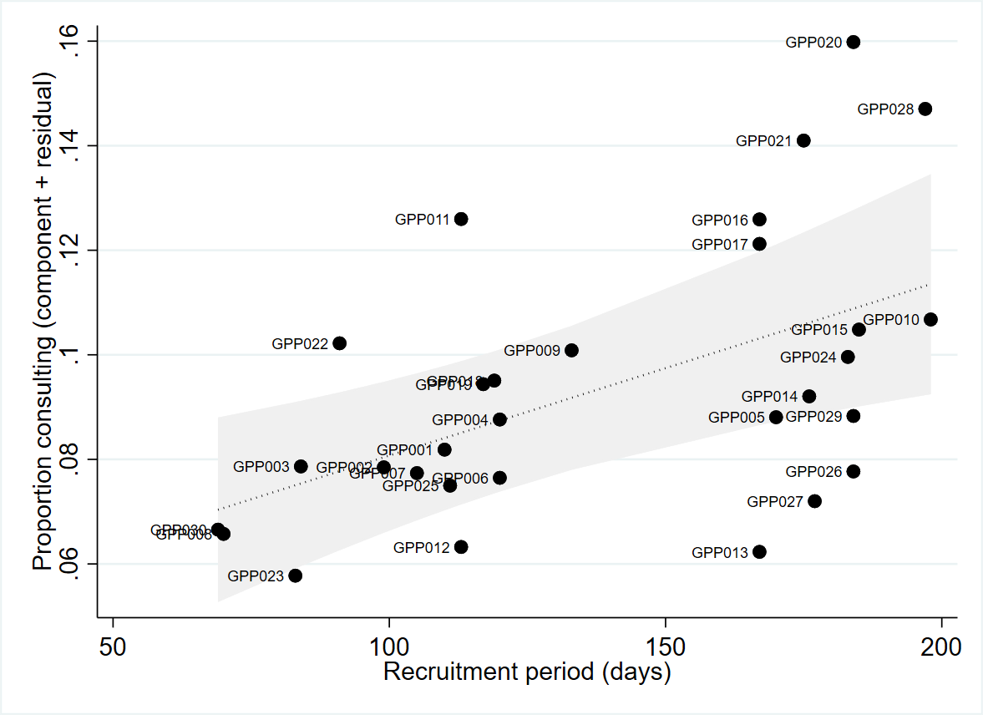

D2. Proportion of adults consulting for a MSK Pain Condition, by GP practice: North Staffordshire & Stoke-on-Trent
GP Practice | Recruitment period (days) | Total registered population 18+§ | Total† |  |  | After exclusions‡
 |  |  | n | Pr | 95%CI | n | Pr | 95%CI
GPP020 | 184 | 7,083 | 1,127 | 0.159 | 0.151, 0.168 | 357 | 0.050 | 0.046, 0.056
GPP028 | 197 | 3,007 | 440 | 0.146 | 0.134, 0.159 | 351 | 0.116 | 0.106, 0.129
GPP021 | 175 | 3,646 | 514 | 0.141 | 0.130, 0.153 | 473 | 0.130 | 0.119, 0.141
GPP011 | 113 | 11,105 | 1,391 | 0.125 | 0.119, 0.132 | 462 | 0.042 | 0.038, 0.045
GPP016 | 167 | 3,203 | 401 | 0.125 | 0.114, 0.137 | 353 | 0.110 | 0.010, 0.122
GPP017 | 167 | 2,508 | 304 | 0.121 | 0.109, 0.135 | 276 | 0.110 | 0.098, 0.123
GPP010 | 198 | 6,601 | 700 | 0.106 | 0.099, 0.114 | 455 | 0.069 | 0.063, 0.075
GPP015 | 185 | 4,351 | 453 | 0.104 | 0.094, 0.114 | 368 | 0.085 | 0.077, 0.093
GPP022 | 91 | 11,086 | 1,133 | 0.102 | 0.097, 0.108 | 1064 | 0.096 | 0.091, 0.102
GPP009 | 133 | 9,137 | 915 | 0.100 | 0.094, 0.106 | 598 | 0.065 | 0.061, 0.071
GPP024 | 183 | 3,843 | 380 | 0.099 | 0.090, 0.109 | 318 | 0.083 | 0.074, 0.092
GPP018 | 119 | 6,469 | 615 | 0.095 | 0.088, 0.102 | 561 | 0.087 | 0.080, 0.094
GPP019 | 117 | 5,658 | 530 | 0.094 | 0.086, 0.102 | 462 | 0.082 | 0.075, 0.089
GPP014 | 176 | 7,335 | 670 | 0.091 | 0.085, 0.098 | 451 | 0.061 | 0.056, 0.067
GPP004 | 120 | 7,635 | 669 | 0.088 | 0.081, 0.094 | 622 | 0.081 | 0.076, 0.088
GPP029 | 184 | 7,695 | 674 | 0.088 | 0.081, 0.094 | 462 | 0.060 | 0.055, 0.066
GPP005 | 170 | 5,495 | 480 | 0.087 | 0.080, 0.095 | 428 | 0.078 | 0.071, 0.085
GPP001 | 110 | 8,503 | 690 | 0.081 | 0.076, 0.087 | 478 | 0.056 | 0.052, 0.061
GPP003 | 84 | 6,167 | 485 | 0.079 | 0.072, 0.086 | 444 | 0.072 | 0.066, 0.079
GPP002 | 99 | 7,214 | 561 | 0.078 | 0.072, 0.084 | 448 | 0.062 | 0.057, 0.068
GPP007 | 105 | 8,401 | 650 | 0.077 | 0.072, 0.083 | 487 | 0.058 | 0.053, 0.063
GPP026 | 184 | 4,690 | 361 | 0.077 | 0.070, 0.085 | 257 | 0.055 | 0.049, 0.062
GPP006 | 120 | 9,623 | 729 | 0.076 | 0.071, 0.081 | 605 | 0.063 | 0.058, 0.068
GPP025 | 111 | 8,968 | 666 | 0.074 | 0.069, 0.080 | 554 | 0.062 | 0.057, 0.067
GPP027 | 177 | 4,625 | 333 | 0.072 | 0.065, 0.080 | 305 | 0.066 | 0.059, 0.073
GPP030 | 69 | 2,960 | 197 | 0.067 | 0.058, 0.076 | 186 | 0.063 | 0.055, 0.072
GPP008 | 70 | 8,321 | 547 | 0.066 | 0.061, 0.071 | 507 | 0.061 | 0.056, 0.066
GPP012 | 113 | 10,091 | 631 | 0.063 | 0.058, 0.067 | 563 | 0.056 | 0.051, 0.060
GPP013 | 167 | 10,544 | 657 | 0.062 | 0.058, 0.067 | 616 | 0.058 | 0.054, 0.063
GPP023 | 83 | 8,503 | 485 | 0.057 | 0.052, 0.062 | 450 | 0.053 | 0.048, 0.058
Median | 126.5 | 7,149 | 588 | 0.088 |  | 459 | 0.064
TOTAL | 4,171 | 204,467 | 18,388 | 0.090 | 0.089, 0.091 | 13,961 | 0.068 | 0.067, 0.069
† Unique individuals consulting with a Keele 500 MSK Pain code during the recruitment period at a participating practice
‡ Unique individuals consulting with a Keele 500 MSK Pain code during the recruitment period at a participating practice, excluding cases with a recorded code for inflammatory musculoskeletal disease in past 3 years
§ Registered population aged 18 years and over at the practice-specific mid-point of recruitment (data source: NHS Digital ‘Patients Registered at a GP Practice’ Patients registered at a GP practice - NHS Digital)

D3. Relationships between proportion consulting for MSK pain condition and selected covariates.
In all figures, y-axis represents predicted + residual values for dependent variable (proportion consulting) from regression analysis using fractional polynomials for independent variables and with adjustment for length of recruitment period, whether practice recruitment period included December, proportion of registered population female, proportion of registered population aged 65+ years.
vs registered population female | vs registered population aged 65+ years
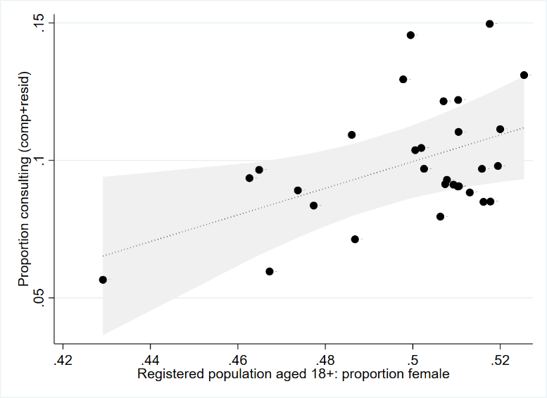 | 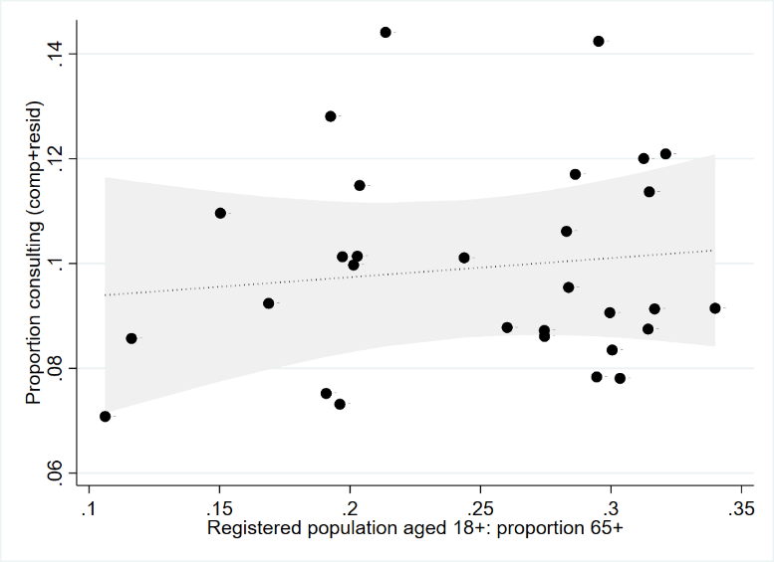
LR χ²(1)=5.87, p=0.0154 | LR χ²(1)=0.35, p=0.5569

vs registered population aged 85+ years | vs registered population Black, Asian, or Minority Ethnic background
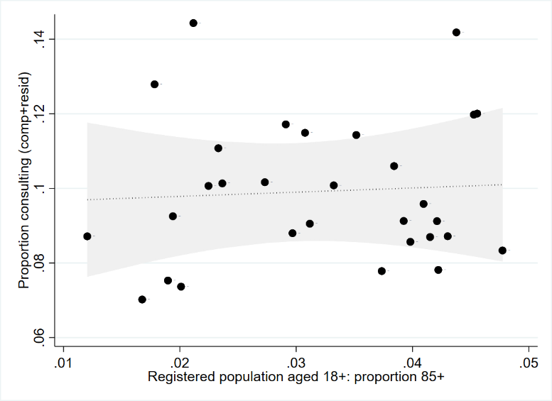 | 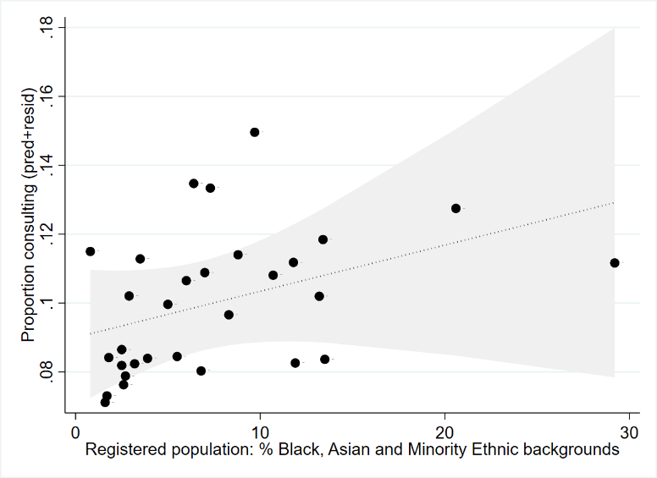
LR χ²(1)=0.07, p=0.7860 | LR χ²(1)=1.75, p=0.1863

vs practice weighted Index of Multiple Deprivation (1=most deprived) | vs size of registered population (all ages)
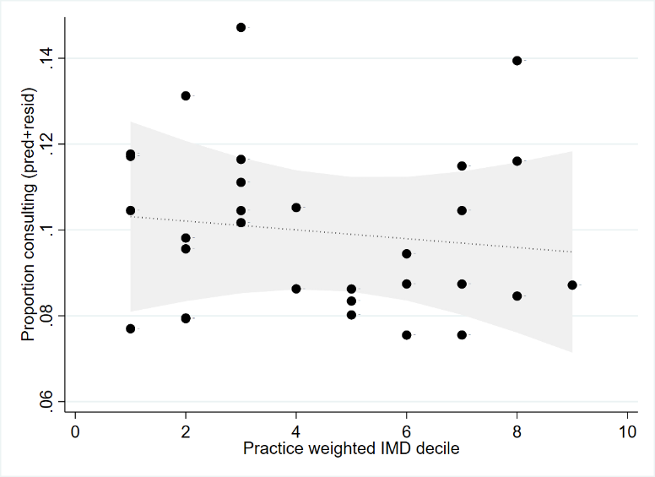 | 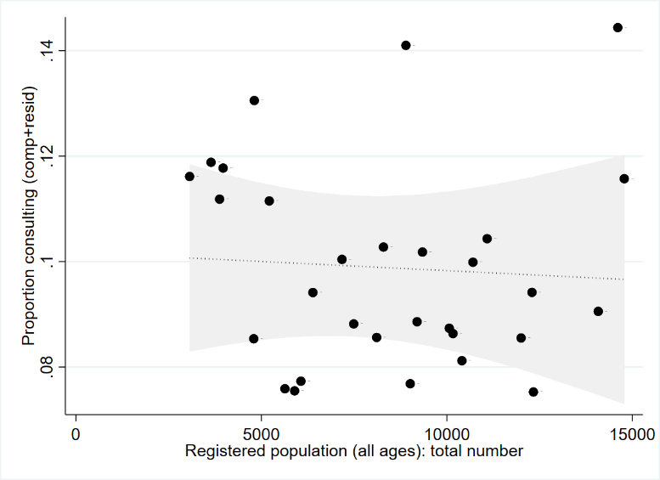
LR χ²(1)=0.24, p=0.6261 | LR χ²(1)=0.79, p=0.3750

vs Clinical staff FTE per 10,000 registered patients | vs Overall achievement points in Quality and Outcomes Framework
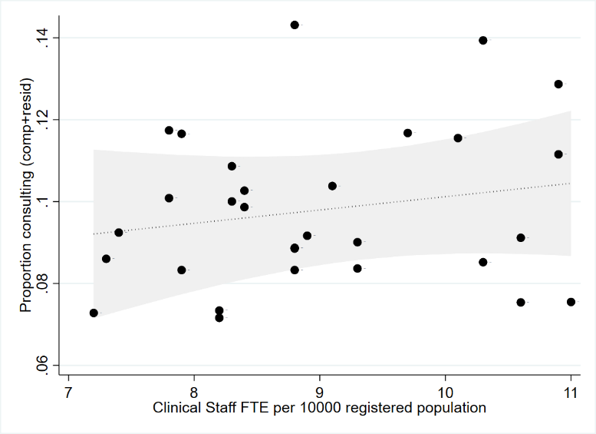 | 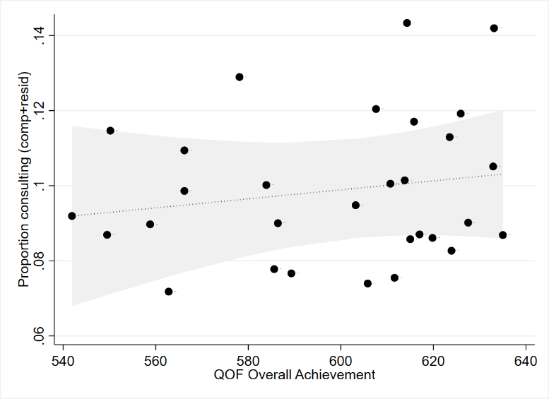
LR χ²(1)=0.94, p=0.3316 | LR χ²(1)=0.62, p=0.4295

vs Percentage of patients reporting positive experience | vs Prevalence of obesity in adults
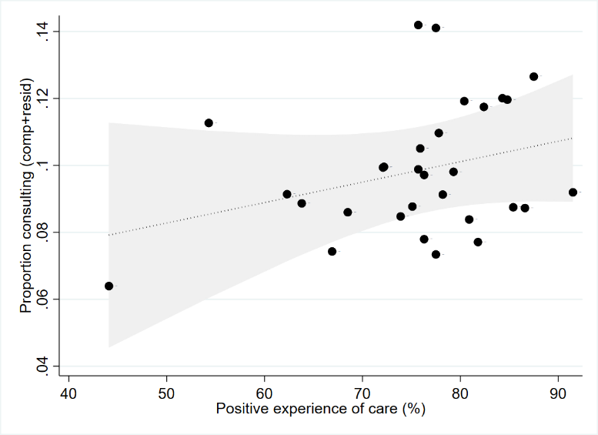 | 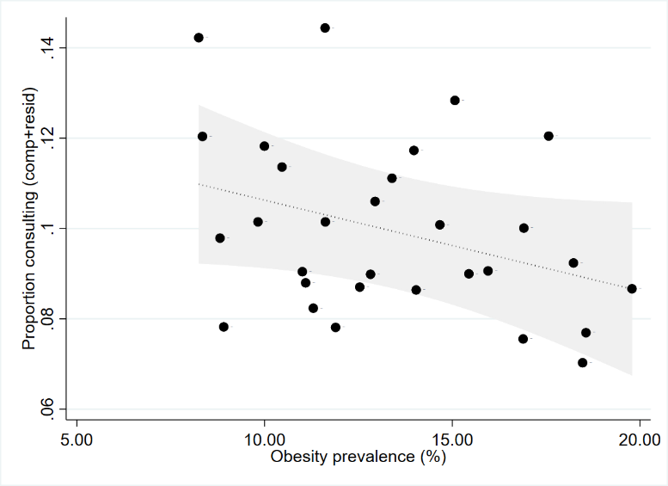
LR χ²(1)=1.94, p=0.1641 | LR χ²(1)=3.45, p=0.0633

vs opioid items per 1000 patients | vs available services
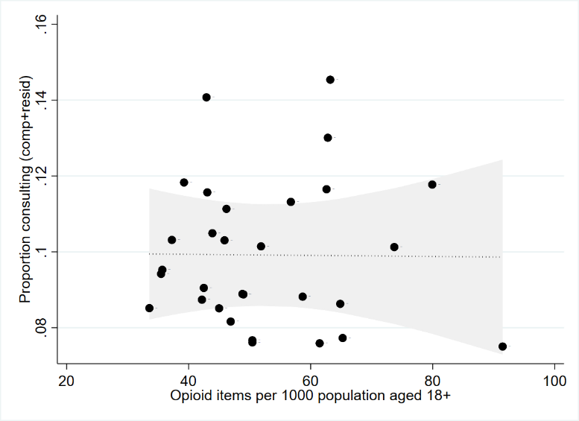 | 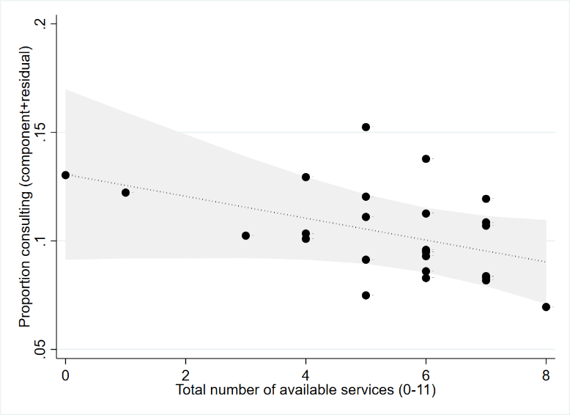
LR χ²(1)=0.00, p=0.9564 | LR χ²(1)=3.25, p=0.0715 (n=25 practices)

vs clinical decision support systems used
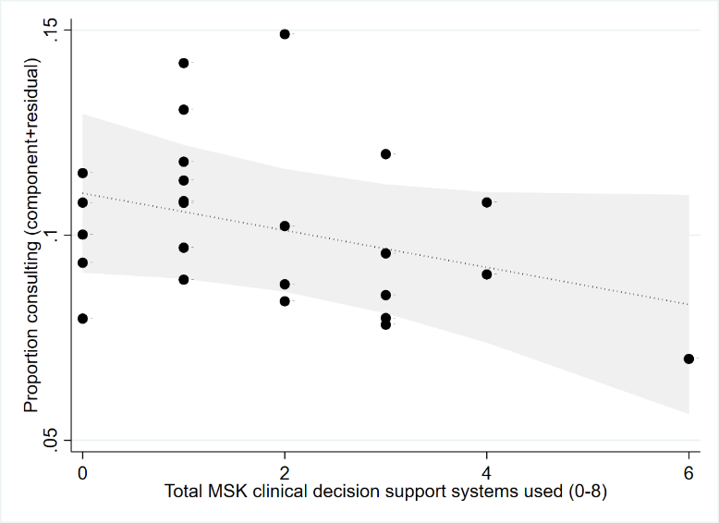
LR χ²(1)=2.95, p=0.0860

D4. Sensitivity analysis 1 – exclusion of consulting cases with a previous record of inflammatory arthritis
In all figures, y-axis represents component + residual values for dependent variable (proportion consulting) from regression analysis using fractional polynomials for independent variables and with adjustment for length of recruitment period, whether practice recruitment period included December, proportion of registered population female, proportion of registered population aged 65+ years.

vs prevalence of long-term MSK problem | vs prevalence of chronic pain
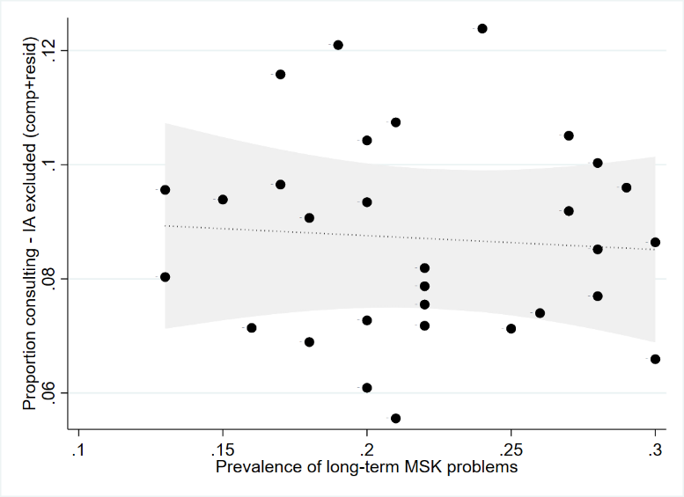 | 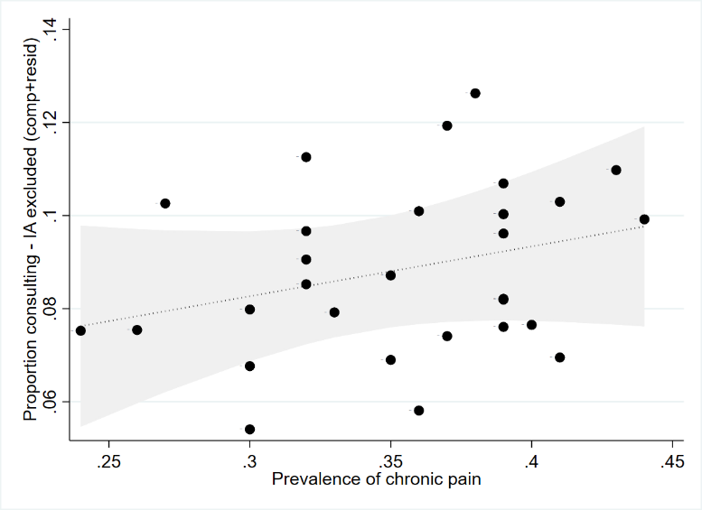
LR χ²(1)=0.14, p=0.7052 | LR χ²(1)=1.66, p=0.1977

vs prevalence of high-impact chronic pain
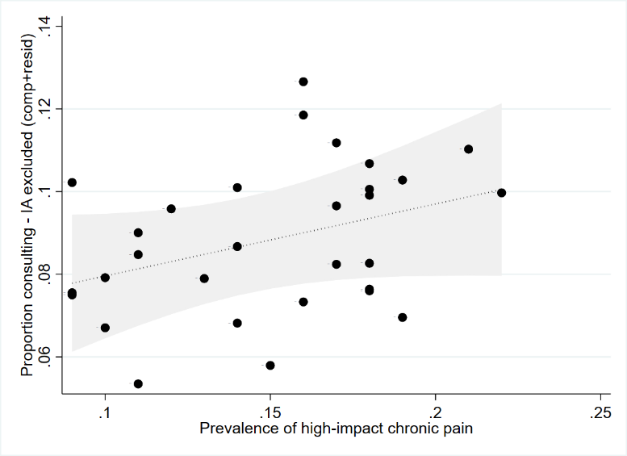
LR χ²(1)=2.79, p=0.0949

vs registered population female | vs registered population aged 65+ years
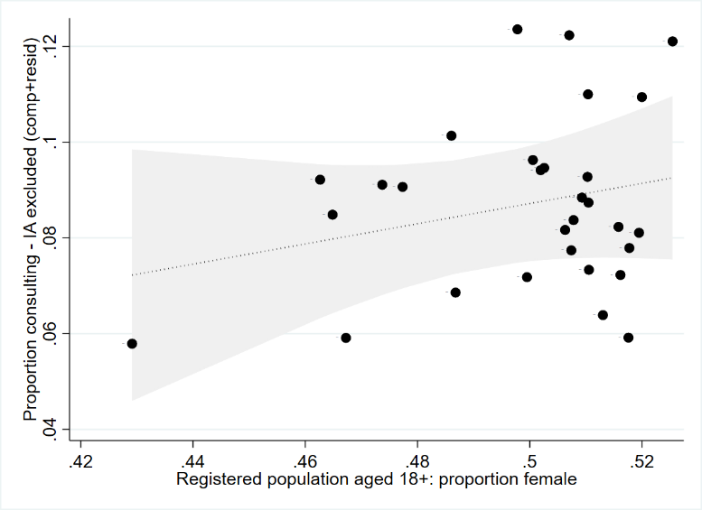 | 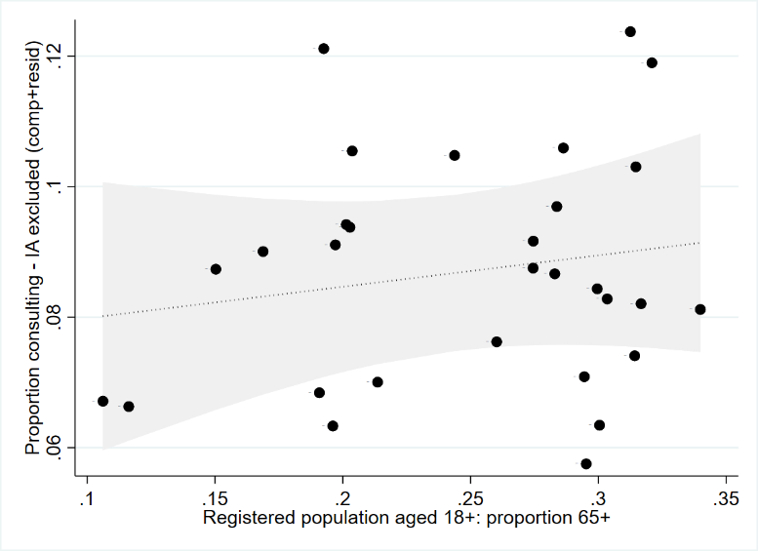
LR χ²(1)=1.44, p=0.2305 | LR χ²(1)=0.71, p=0.3978

vs registered population aged 85+ years | vs registered population Black, Asian, or Minority Ethnic background
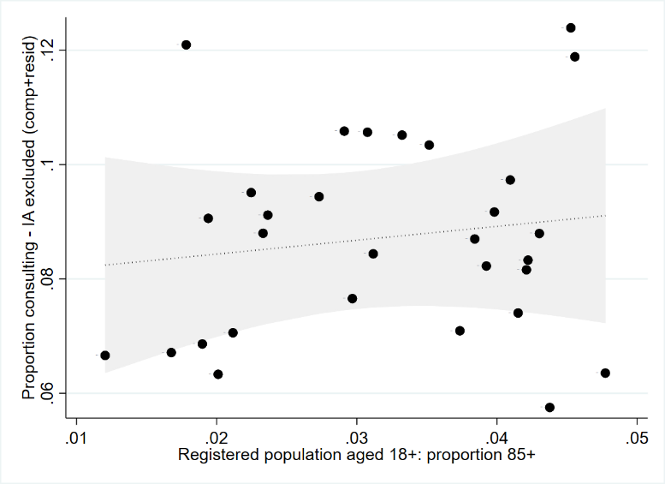 | 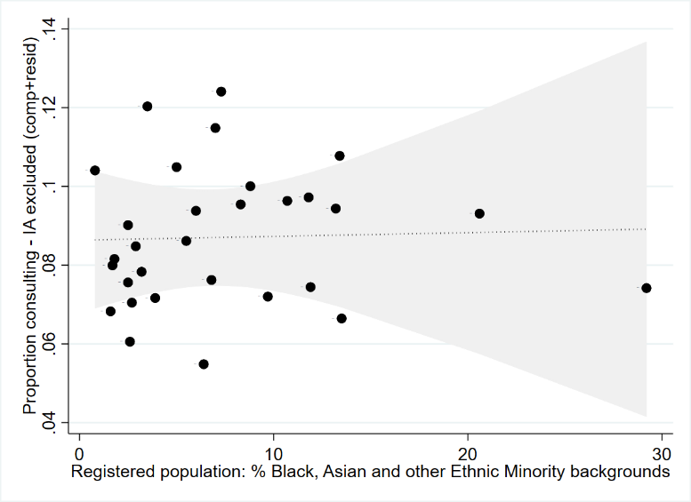
LR χ²(1)=0.41, p=0.5229 | LR χ²(1)=0.01, p=0.9190

vs practice weighted Index of Multiple Deprivation (1=most deprived) | vs size of registered population (all ages)
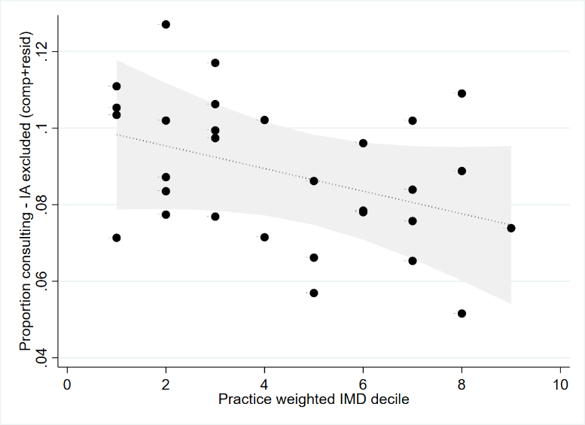 | 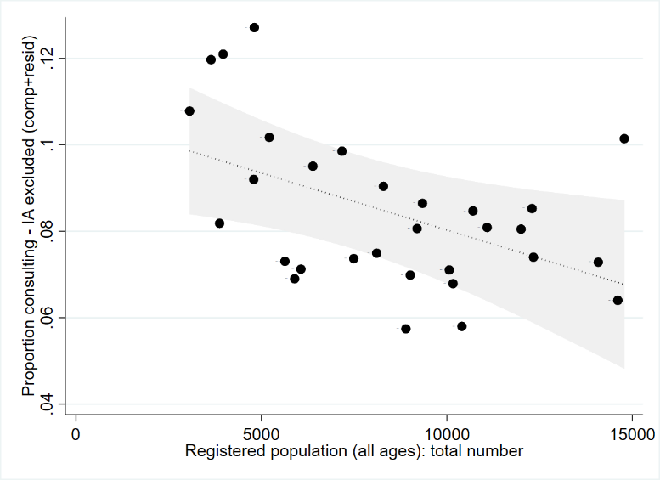
LR χ²(1)=2.43, p=0.1188 | LR χ²(1)=9.05, p=0.0026

vs Clinical staff FTE per 10,000 registered patients | vs Overall achievement points in Quality and Outcomes Framework
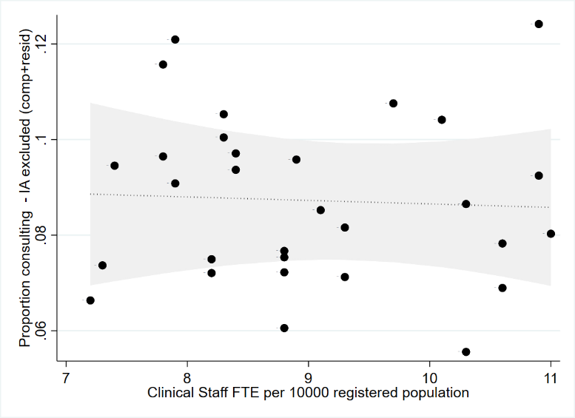
LR χ²(1)=0.06, p=0.8119 | LR χ²(1)=1.13, p=0.2877

vs Percentage of patients reporting positive experience | vs Prevalence of obesity in adults
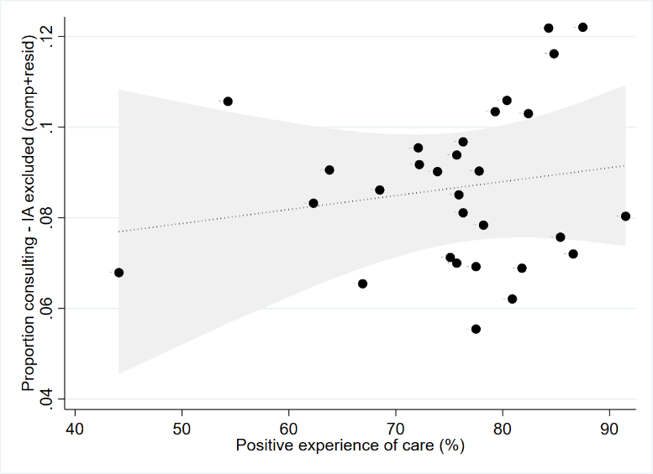 | 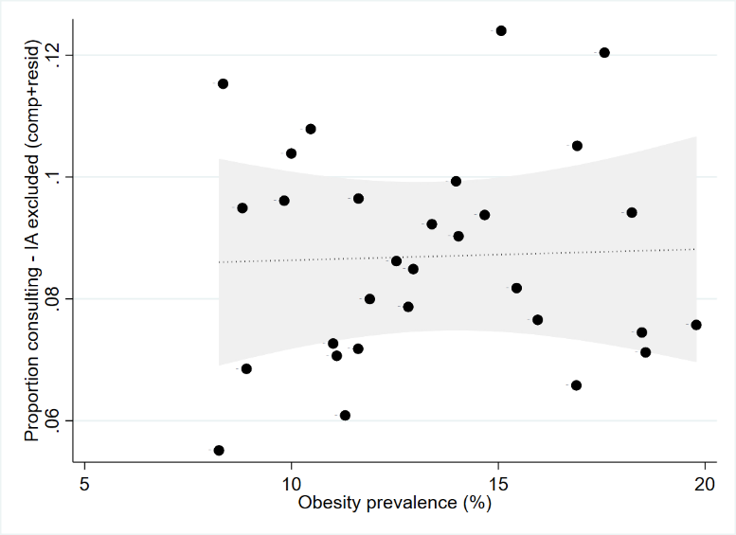
LR χ²(1)=0.58, p=0.4480 | LR χ²(1)=0.03, p=0.8572

vs opioid items per 1000 patients | vs available services
 | 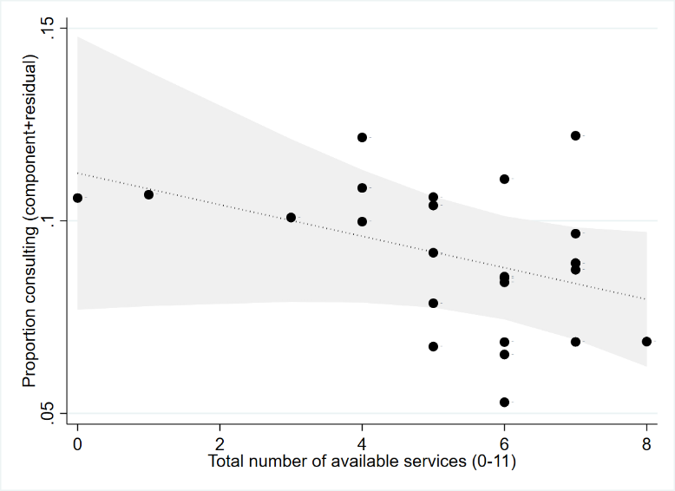
LR χ²(1)=0.09, p=0.7616 | LR χ²(1)=2.66, p=0.1030 (n=25 practices)

vs clinical decision support systems used
LR χ²(1)=2.24, p=0.1348

D5. Sensitivity analysis 2 – Replacement of single annual prevalence estimate with 3-year average annual prevalence estimate
Single annual prevalence estimate | Average of annual prevalence estimates over 3 years
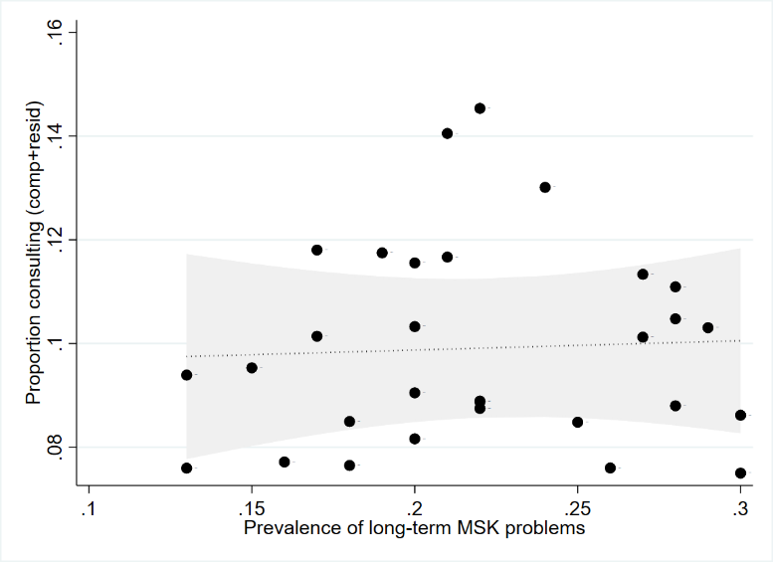 | 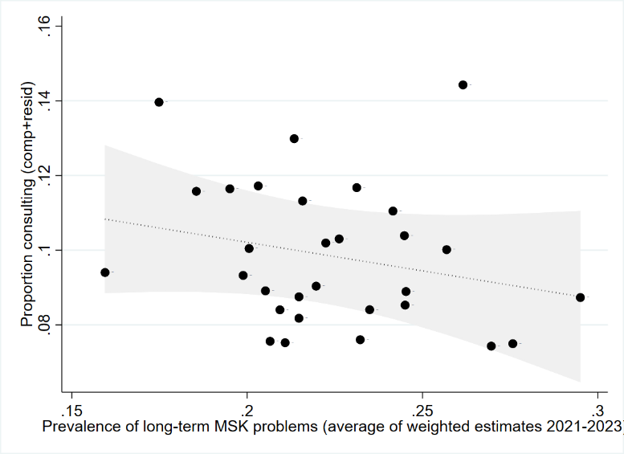
LR χ²(1)=0.09, p=0.7616 | LR χ²(1)=2.66, p=0.1030 (n=25 practices)

D6. Sensitivity analysis 3 – Additional adjustment for recorded number of appointments per 1000 patients as a proxy for completeness of recording consultations
Fig 1A | with additional adjustment
 | 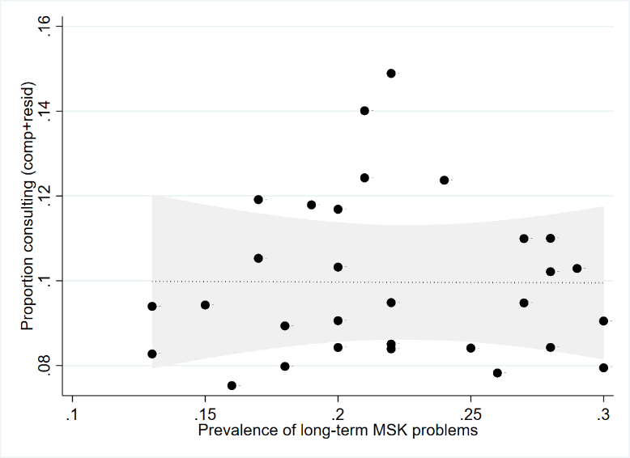

Fig 1B | with additional adjustment
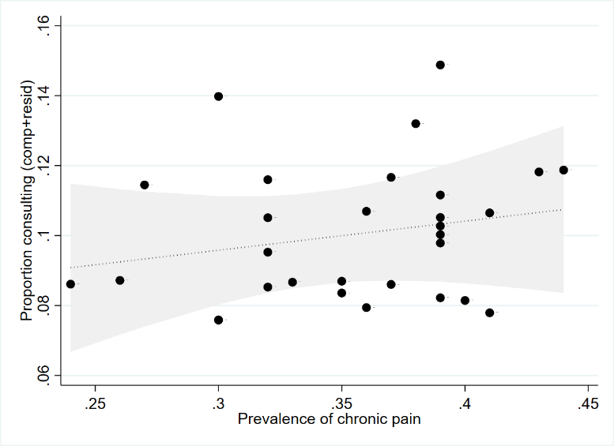 | 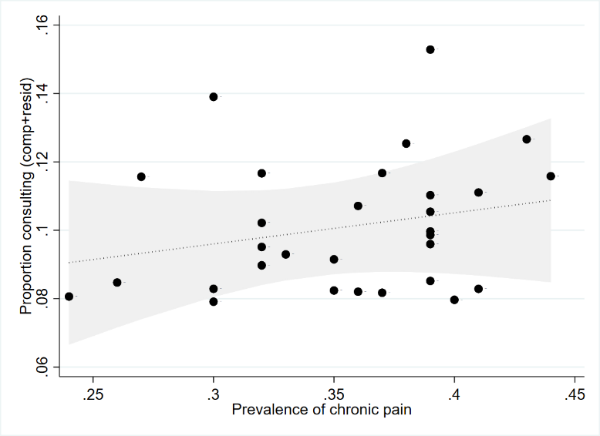

Fig 1C | with additional adjustment
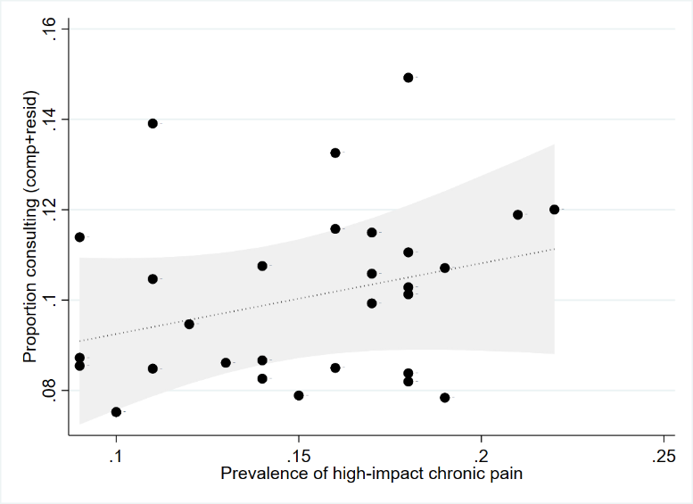 | 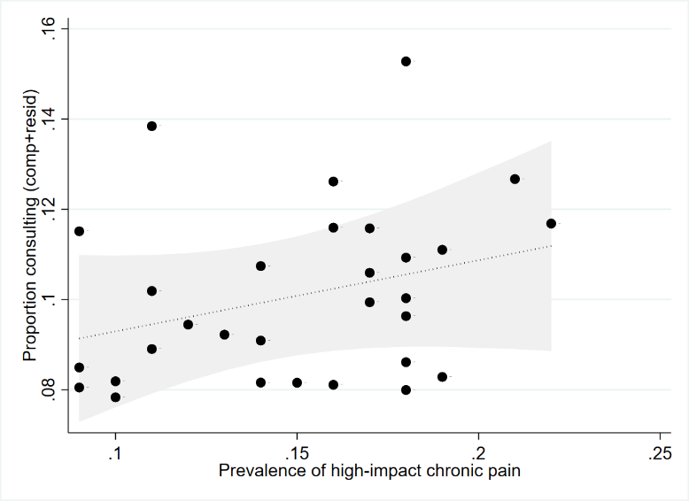

D7. Summary table of associations with covariates
 | Observed range | Dependent variable: Proportion consulting (Total) | Dependent variable: Proportion consulting (after excluding IA)
Registered population characteristics
Female (%)§ | 43-53 | LR χ²(1)=5.87, p=0.0154 | LR χ²(1)=1.44, p=0.2305
Aged 65+ years (%)§ | 11-34 | LR χ²(1)=0.35, p=0.5569 | LR χ²(1)=0.71, p=0.3978
Aged 85+ years (%)§ | 1-5 | LR χ²(1)=0.07, p=0.7860 | LR χ²(1)=0.41, p=0.5229
Black, Asian, Minority Ethnic background (%) | 1-29 | LR χ²(1)=1.75, p=0.1863 | LR χ²(1)=0.01, p=0.9190
Practice weighted deprivation decile (1-10)† | 1-9 | LR χ²(1)=0.24, p=0.6261 | LR χ²(1)=2.43, p=0.1188
Practice organisation and performance characteristics
Total population size (n) | 3065-14783 | LR χ²(1)=0.79, p=0.3750 | LR χ²(1)=9.05, p=0.0026
Total clinical staff FTE per 10,000 | 7-11 | LR χ²(1)=0.94, p=0.3316 | LR χ²(1)=0.06, p=0.8119
QOF Overall achievement (max=635) | 542-635 | LR χ²(1)=0.62, p=0.4295 | LR χ²(1)=1.13, p=0.2877
Positive experience (%) | 44-92 | LR χ²(1)=1.94, p=0.1641 | LR χ²(1)=0.58, p=0.4480
CQC Overall Rating‡ | RI-O | - | -
Available services (0-11)†† | 0-8 | LR χ²(1)=4.91, p=0.0267 | LR χ²(1)=0.78, p=0.3778
Clinical decision support systems used (0-8)†† | 0-6 | LR χ²(1)=2.68, p=0.1018 | LR χ²(1)=1.54, p=0.2153
Need/burden estimates
Prevalence of self-reported long-term MSK problem (%) | 13-30 | LR χ²(1)=0.06, p=0.7998 | LR χ²(1)=0.14, p=0.7052
Prevalence of chronic pain (%) | 24-44 | LR χ²(1)=0.82, p=0.3642 | LR χ²(1)=1.66, p=0.1977
Prevalence of high-impact chronic pain (%) | 9-22 | LR χ²(1)=1.85, p=0.1741 | LR χ²(1)=2.79, p=0.0949
QOF Obesity prevalence (%) | 8-20 | LR χ²(1)=3.45, p=0.0633 | LR χ²(1)=0.03, p=0.8572
Opioid items per 1000 patients | 34-91 | LR χ²(1)=0.00, p=0.9564 | LR χ²(1)=0.09, p=0.7616
CQC Care Quality Commission; FTE Full Time Equivalent; IA Inflammatory arthritis; LR Likelihood ratio; QOF Quality and Outcomes Framework; RI Requires Improvement; O Outstanding
All LR values are compared with model containing length of recruitment period, recruiting in December, proportion of registered population female, proportion of registered population aged 65+ years
† Based on Index of Multiple Deprivation where 1=Most deprived, 10=Least deprived
‡ 26 (87%) practices were rated as ‘good’, providing insufficient variation for further meaningful analysis
§ Denominator – registered population aged 18+ years
†† Based on 25 practices responding to practice questionnaire

