Article Title: Patients’ experiences of interprofessional collaborative practice in primary care: a constructivist grounded theory study

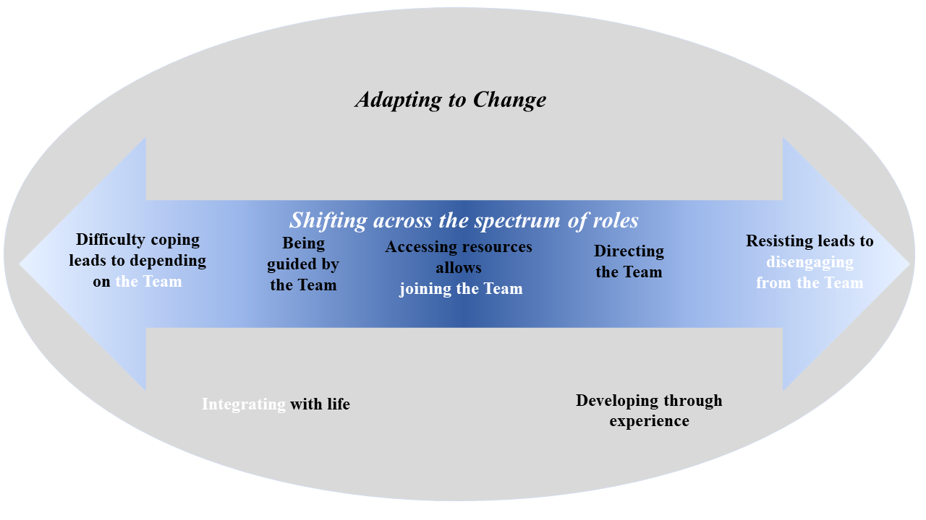
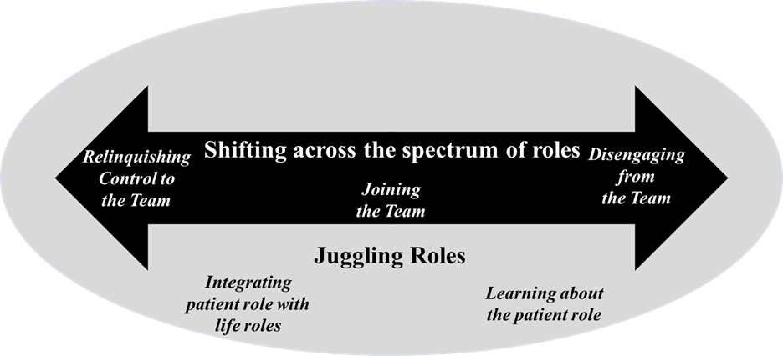

Patient advocate focus group study theoretical framework [1] Patients with chronic conditions interview study theoretical framework [2]
Figure 2: Comparison of patient advocate focus group study theoretical framework and adapted theoretical framework with results from patients with lived experience of living with a chronic condition.
[1] Davidson AR, Morgan M, Ball L, Reidlinger DP. Patient advocates' views of patient roles in interprofessional collaborative practice in primary care: A constructivist grounded theory study. Health Soc Care Community. 2022 Nov;30(6):e5775-e5785. doi: 10.1111/hsc.14009.
[2] Available on Figshare: 10.6084/m9.figshare.21588816

