**Amber Networks in Prehistory: North-Eastern Iberia as a Case Study**

**M. Murillo-Barroso, M. Navero Rosales, P. González-Marcén and M. Martinón-Torres**

**SUPPLEMENTARY MATERIAL**

**Supplementary Material S1: Archaeological Background of Amber Objects**

This supplementary material contains information on all later prehistoric archaeological sites with amber objects in north-eastern Iberia. It includes descriptions of their context, the number of individuals, the associated material culture and other data relevant to ascribing the sites to a chronological period. All amber objects are summarized in Table S1.

***Table S1.*** *Amber objects currently available related to exemplars previously published by Rovira i Port (1994).*

|  |  |  |  |  |
| --- | --- | --- | --- | --- |
| **Site** | **Description in Rovira i Port (1994)** | **Amber objects preserved** | **Proposed chronology1** | **Location** |
| Pedra Cabana | 2 small fragments | – | MBA/LBA |  |
| Cabana del Moro de Colomera | 5 fragments | 3 | MBA/LBA | Museo Diocesano de Solsona |
| Cova de Can Maurí | 1 bead | – |  |  |
| El Bosc de Correà | 19 beads | 17 | Chal.–LBA | Museo Diocesano de Solsona |
| Cal Rajolí | 1 bead or pendant | – |  |  |
| Bullons | 1 bead and 2 fragments of another bead | – | EBA/MBA |  |
| La Fossa del Gegant | 1 bead | 1 | CHal. or LBA | Museo Diocesano de Solsona |
| Can Cuca | 1 bead or moon-shaped pendant | – |  |  |
| Collet de Su | Some fragments | – | EBA? |  |
| La Pera | 1 thin bead or subcircular overlay | 1 | EBA–LBA | Museo Diocesano de Solsona |
| Cova de les Pixarelles | 1 spacer-bead of Kakovatos type | – | LBA |  |
| Cova del Frare | 1 bead | 1 | LN | Museo de Terrasa |
| Roca del Frare | 1 bead | – | LBA |  |
| El Garrofet | 1 bead | 1 | Chal.–EIA | Vinseum |
| Forat de la Conqueta | – | 2 | LN–LBA | Museu de Lleida |
| Cova de Muricecs | – | 135 | MBA | Museu de Valls |
| Cova del Gegant | – | 2 | LChal.–EIA |  |

1LN = Late Neolithic (3400–2700 bc); Chal = Chalcolithic (2700–2300 bc); EBA = Early Bronze Age (2300–2100 bc); MBA = Middle Bronze Age (2100–1550 bc); LBA = Late Bronze Age (1550–1250 bc); EIA = Early Iron Age (1250–750 bc)

**Archaeological sites**

*1. Pedra Cabana (El Vilar de Cabo, Organyà, Lleida)*

The tumular grave of Pedra Cabana is a dolmen featuring a small, subrectangular chamber covered by a mound of stones. It was excavated by Serra i Vilaró in the early twentieth century, who documented seven individuals (Serra i Vilaró, 1927). Both Serra i Vilaró (1927: 283–86) and Rovira i Port (1994: 70) mention ‘two small [amber] fragments that did not form any specific shape’ among the grave goods. The materials are stored at the Diocesan and Regional Museum of Solsona, though no amber fragments are recorded among them. To this day, the whereabouts of these amber fragments, which Rovira i Port (1994) analysed and identified as Baltic in origin, remain unknown. It is possible that the fragments were so small that they were entirely destroyed during analysis.

The typology and composition of the associated metal objects, with tubular beads and tin (Sn) contents ranging from 9% to 12.5% (Table S2), place the burial in the Middle or Late Bronze Age.

***Table S2.*** *XRF analysis of the metallic objects recovered with the amber beads at Pedra Cabana. Results in %wt. See Rovira et al., 1997 for further methodological questions.*

|  |  |  |  |  |  |  |  |  |  |  |  |  |
| --- | --- | --- | --- | --- | --- | --- | --- | --- | --- | --- | --- | --- |
| **Analysis** | **ID** | **Object** | **Fe** | **Ni** | **Cu** | **Zn** | **As** | **Ag** | **Sn** | **Sb** | **Pb** | **Reference** |
| PA7675 | 1895 | Tubular bead | 0,66 | nd | 86,7 | nd | tr | 0,10 | 11,3 | 0,15 | 1,09 | Rovira et al. 1997: 253 |
| PA7676 | 1895 | Tubular bead | 0,23 | nd | 85,9 | nd | nd | 0,13 | 12,5 | 0,17 | 1,09 | Rovira et al. 1997: 253 |
| PA7677 | 1894 | Bead | 0,13 | nd | 87,4 | nd | nd | 0,03 | 12 | 0,44 | nd | Rovira et al. 1997: 253 |
| PA7685 | 1892 | Boton | 0,21 | 0,15 | 90 | nd | nd | 0,07 | 9,1 | 0,10 | 0,48 | Rovira et al. 1997: 253 |

Nd = Not detected

*2. Cabana del Moro de Colomera (Organyà, Lleida)*

Published as Dolmen de Cabó by Vidal (1911: 5–6), this site is a rectangular dolmen measuring 1.8 ×1.3 m with a height of 0.95 m. The chamber is likely to have been covered by a large slab measuring 2.9 × 2.4 m, with a height of 0.95 m at its eastern end, tapering to a wedge shape at its western end (Vidal, 1911: 5). Within a 3-m radius south of the dolmen, five vertical stones were observed, which Vidal interpreted as the remnants of a cromlech but could have been the boundary of the mound covering the chamber. However, Serra i Vilaró (1927: 273), who did not see these stones, believed the mound’s boundary to be the natural terrain margin.

At this site, both Serra i Vilaró (1927: 274) and Rovira i Port (1994: 70) refer to five fragments of amber beads.

The materials are housed in the Diocesan and Regional Museum of Solsona, where five fragments classified as amber are kept. The fragments are in such a fragmented state that it is difficult to confirm whether they were originally beads or other objects, as clear traces of perforation are not evident. In three fragments (Figure S1: 2508a, 2508b, and 2508c), the translucent appearance characteristic of amber can be observed in fresh fractures, while the surfaces exhibit a more opaque degradation layer. Although we cannot confirm that these three fragments were part of the same object, Serra i Vilaró (1927: 274) noted that they were broken during excavation, a claim supported by the fresh nature of the fractures. Despite the fragmentation, the amber is in relatively good condition. The other two fragments (Figure S1: 2508d and 2508e) have a completely different appearance that does not match that of amber. These are amorphous fragments with reddish and yellowish veins, completely opaque. The five beads are described as follows:

2508a: A fragment measuring 12 mm in length, 8 mm in width, and 7 mm in maximum thickness. Its original shape cannot be determined; it has two rectilinear sides and a third that is more circular. The fresh fracture reveals the translucent appearance characteristic of amber and slight surface oxidation.

2508b: An amorphous fragment with two rectilinear sides and a third that is more circular, measuring 10 mm in length, 9 mm in width, and 7 mm in maximum thickness. The fresh fracture reveals the translucent appearance characteristic of amber and slight surface degradation. Together with the previous fragment, it could be part of the same object.

2508c: An amorphous fragment with a rounded tendency, measuring 7 mm in length, 7 mm in width, and 5.5 mm in maximum thickness. It shows slight surface oxidation but retains a glassy appearance.

2508d: A circular fragment measuring 6 × 6 × 6 mm. It has a reddish colour with yellowish veins and is opaque. Neither the translucent appearance nor the typical oxidation of amber is present.

2508e: A similar fragment to the previous one, but larger, measuring 15x10x7 mm. It has a reddish colour with yellowish veins and lacks the typical characteristics of amber.

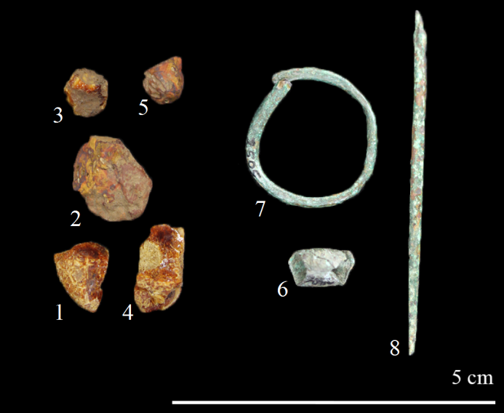

***Figure S1.*** *Amber and metal objects from Cabana del Moro de Colomera. 1. 2508a; 2. 2508e; 3. 2508c; 4. 2508b; 5. 2508d; 6. bead 2506; 7. ring 2505; 8. awl 2504 (image: M. Murillo-Barroso).*

Samples were taken from all five fragments to identify the raw material of pieces 2508d and e and to assess the homogeneity of fragments 2508 a, b, and c.

Among the grave goods, carinated ceramic vessels, flint blades, cores and flakes, a striated bone bead, and three metal objects were also documented: a square-section awl with a rounded tip (53 × 2 mm) (no. 2504), a ring made from a metal wire 2 mm thick with overlapping ends and an internal diameter of 18 mm (no. 2505), and a laminar bead folded onto itself measuring 10 × 6 mm and 0.5 mm in thickness (no. 2506) (Figure S1, nos. 6–8).

No absolute dating has been obtained for this site. Serra i Vilaró reported a large number of crushed bones, including three fragmented lower jaws and a total of 160 teeth, suggesting a Minimum Number of Individuals (MNI hereafter) of five (Serra i Vilaró, 1927: 273). The typology of the grave goods and the composition of the analysed metal objects (Table S3), with >10% tin, place it in the Middle or Late Bronze Age.

***Table S3.*** *XRF analysis of the metallic objects recovered with the amber beads at Cabana del Moro de Colomera. Results in %wt. See Rovira et al. (1997) for further methodological questions.*

|  |  |  |  |  |  |  |  |  |  |  |  |  |
| --- | --- | --- | --- | --- | --- | --- | --- | --- | --- | --- | --- | --- |
| **Analysis** | **ID** | **Object** | **Fe** | **Ni** | **Cu** | **Zn** | **As** | **Ag** | **Sn** | **Sb** | **Pb** | **Reference** |
| PA7678 | 2506 | Bead | 0.3 | Nd | 82.8 | nd | nd | 0.13 | 15.5 | nd | 1.2 | Rovira et al. 1997: 253 |
| PA7679 | 2504 | Awl | 0.32 | Nd | 85.4 | nd | tr | 0.10 | 13.6 | 0.23 | 0.27 | Rovira et al. 1997: 253 |
|  | 2505 | Ring |  |  | 86.7 |  |  |  | 12.1 |  |  | Serra i Vilaró, 1927: 274 |

Nd = Not detected

*3. Cova de Can Maurí (Berga, Barcelona)*

The Can Maurí cave, likely to have been used for both habitation and burial, has suffered from multiple unauthorized interventions and looting. In the early and mid-twentieth century, two archaeological excavations documented burials and abundant material spanning a broad chronology, including the Late Roman period (Cura i Morera, 1971–1972: 60; Serra i Vilaró, 1922). Rovira i Port (1994: 70) mentions that ‘a collaborator of the Berga Museum collected a spherical amber bead, approximately 10 mm in diameter, with axial perforation, on the slopes leading to the cave entrance.’ However, the Berga Museum, where the cave's materials are stored, has no record of any amber bead. Given the lack of archaeological context and the unfeasibility to study this bead, it will not be considered among the prehistoric amber materials.

*4. El Bosc de Correà Tumular Tomb I (Espunyola, Barcelona)*

The El Bosc de Correà Tumular Tomb I consists of a square chamber measuring 1.4 × 1.8 m at its widest point. It has a small entrance atrium just over 1.2 m wide, which retains only one slab on each side, suggesting that it may have originally been a longer corridor (Serra i Vilaró, 1927: 184). The anthropological remains were highly fragmented, but based on the 229 recovered teeth and molars, Serra i Vilaró estimated a MNI of eight (Serra i Vilaró, 1927: 185).

Regarding amber, Serra i Vilaró mentions twenty amber beads, including one made of glass paste (Rovira i Port, 1996a). However, in the accompanying figure, only 19 beads are depicted, including the glass paste bead (Serra i Vilaró, 1927: 187). Rovira i Port (1994: 71) reports ‘19 beads of various sizes and shapes (oval and flat shapes, barrel type, elongated beads, and faceted sections ranging from triangular to quadrangular or pentagonal, among others). [...] Their original lengths ranged from 10/11 to approximately 24 mm. All beads had a longitudinal cylindrical perforation.’

The Diocesan and Regional Museum of Solsona has eighteen beads or fragments, as after restoration one fragment was integrated into one of the beads. A detailed study of the pieces revealed that they are actually seventeen beads, as two fragments (1837_16 and 1837_17) are two halves of the same bead (Figure S2). Despite the fractures, the amber is in relatively good condition, and the characteristic glassy, translucent appearance of amber is still observable, regardless of slight surface oxidation. We did not have access to beads 1837_3, 1837_4, 1837_10, and 1837_11 as they were part of a travelling exhibition. The descriptions that follow include these four beads but are based on the museum’s documentation.

1837_1: A flattened barrel bead with a longitudinal perforation 2 mm in diameter. It has a maximum length of 18 mm, a maximum width of 17 mm at the centre, and 11 mm at the end, with a thickness of 6 mm.

1837_2: A flattened bead similar to the previous bead, with a longitudinal perforation 2 mm in diameter. It has a maximum length of 29 mm, a maximum width of 19 mm at the centre, and 13 mm at the end, with a thickness of 4 mm.

1837_3: A cylindrical bead with a longitudinal perforation. It has a maximum length of 18 mm and a maximum width of 9 mm.

1837_4: A cylindrical bead with a longitudinal perforation. It has a maximum length of 15 mm and a maximum width of 7 mm.

1837_5: A trapezoidal-section bead with a longitudinal perforation 2 mm in diameter and maximum dimensions of 11.5 × 8 × 5 mm.

1837_6: A triangular-section bead, with a width of 6 mm on each side. It has a longitudinal perforation 2 mm in diameter and a maximum length of 12 mm.

1837_7: A triangular-section bead similar to the previous bead, with a width of 6 mm on each side, a longitudinal perforation 2 mm in diameter, and a maximum length of 11 mm.

1837_8: A triangular-section bead similar to the previous bead, with a width of 7 mm on two sides and 5 mm on the third side, a longitudinal perforation 2 mm in diameter, and a maximum length of 11 mm.

1837_9: A triangular-section bead similar to the previous beads, although in slightly worse condition, with a width of 5 mm on each side, a longitudinal perforation 2 mm in diameter, and a length of 9 mm.

1837_10: A triangular-section bead similar to the previous beads, with a width of 5 mm, a longitudinal perforation, and a length of 10 mm.

1837_11: A triangular-section bead similar to the previous beads, with a width of 5 mm, a longitudinal perforation, and a length of 9 mm.

1837_12: A square-section bead with a longitudinal perforation 2 mm in diameter and dimensions of 11 × 6 ×5 mm.

1837_13: A fragment of a flattened bead similar to beads 1837_1 and 1837_2, with a longitudinal perforation 2 mm in diameter and extant maximum dimensions of 8 × 11 mm.

1837_14: A small triangular-section bead with a longitudinal perforation of 2 mm in diameter and dimensions of 7 × 8× 3 mm.

1837_15: The fragment originally catalogued as 1837_15 is now part of bead 1837_2.

1837_16 and 1837_17: Two halves of a triangular-section bead with a longitudinal perforation, a maximum length of 11 mm, and a width of 5 mm on each side.

1837_18: A half-bead of undetermined type. It retains its longitudinal perforation.

Samples were taken from the eleven beads we had access to in order to evaluate the internal variability of the set. For bead 1837_12, two samples were taken: one from the surface oxidation layer and one from the amber core to evaluate spectral alterations resulting from post-depositional degradation processes.

Except for the Muricecs cave (see below), where 135 amber beads were recovered, this is the site with the largest number of amber objects found in the north-eastern Iberian Peninsula.

Among the grave goods, Bell Beaker pottery, carinated vessels with applied buttons, flint blades, and a fragment of a flint leaf were recovered, as well as eight metal objects (Figure S2). These metal objects are:

1840: A square-section awl, with a thickness of 2.5 mm and a length of 81 mm..

1845: A ring made from a square-section wire measuring 3.5 × 2.5 mm in thickness, folded onto itself, with an internal diameter of 8x6 mm.

1841: A bracelet made from a 3.5 mm thick wire, folded onto itself without the ends touching, with an internal diameter of 33 × 30 mm.

1844: A three-turn spiral made from a circular-section wire measuring 1.5 mm in thickness and an internal diameter of 17 mm.

1842: A possible dagger, fragmented, with a maximum length of 29 mm, a maximum width of 19 mm, and a thickness of 2 mm. It seems to have some burring on the long sides.

1843: A square-section rivet measuring 3x4 mm in thickness and 17 mm in length.

1846: A small awl with a square section, 2 mm thick, and 16 mm long.

No number: A spiral bead, highly corroded.

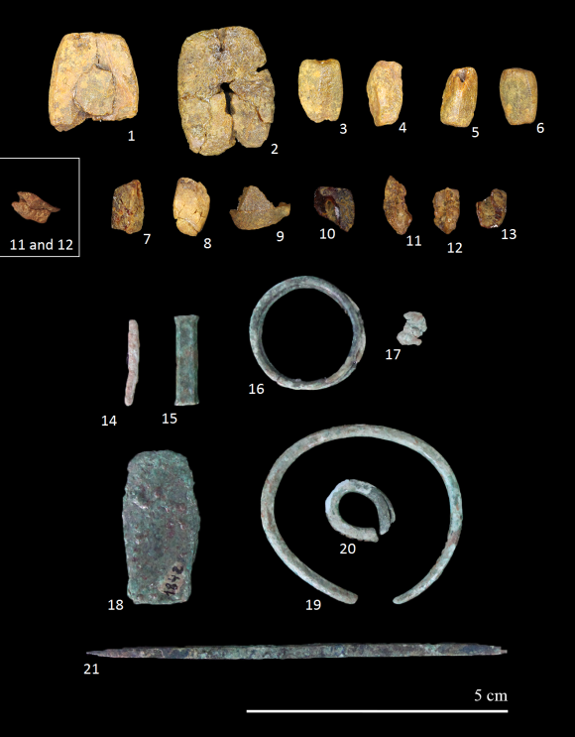

***Figure S2.*** *Amber and metal objects from El Bosc de Correà. 1. 1837_1; 2. 1837_2 and 1837_16; 3. 1837_15; 4. 1837_6; 5. 1837_7; 6. 1837_8; 7. 1837_9; 8. 1837_12; 9. 1837_13; 10. 1837_14; 11. 1837_16; 12. 1837_17; 13. 1837_18; 14. 1846; 15. 1843; 16. 1844; 17. spiral bead; 18. 1842; 19. 1841; 20. 1845; 21. 1840 (image: M. Murillo-Barroso).*

We do not have any absolute dating for this site, but the Bell Beaker material, the composition of the analysed dagger with 11.5% Sn (Table S4), and the Orientalizing typology of the glass paste bead suggest a monument with a broad temporal range, its use spanning from the Late Chalcolithic to the Late Bronze Age. We cannot definitively associate the amber beads with a specific period.

***Table S4.*** *XRF analysis of the dagger recovered with the amber beads. Results in %wt. See Rovira et al. (1997) for further methodological questions.*

|  |  |  |  |  |  |  |  |  |  |  |  |  |
| --- | --- | --- | --- | --- | --- | --- | --- | --- | --- | --- | --- | --- |
| **Analysis** | **ID** | **Object** | **Fe** | **Ni** | **Cu** | **Zn** | **As** | **Ag** | **Sn** | **Sb** | **Pb** | **Reference** |
| PA7665 | 1842 | Dagger | 0.29 | nd | 87.9 | nd | nd | 0.05 | 11.5 | 0.05 | 0.18 | Rovira et al. 1997: 115 |

Nd = Not detected

*5. La Pera (Solsona, Lleida)*

The dolmen of La Pera is a gallery dolmen measuring 4.8 m in length, 1.8 m in width, and 1.2 m in thickness, covered by a tumulus measuring 13 × 10 m with a maximum height of 1.5 m, excavated in the 1980s (Castany et al., 1989: 56). A flat amber bead (no. 3434) was documented: it is arched, almost circular, with an extant maximum diameter of 28 × 22 mm and 5 mm in thickness, featuring a central perforation 2 mm in diameter (Figure S3). It is broken at one end, but the amber's state of preservation is quite good. Despite slight surface oxidation, the characteristic translucent appearance of amber is observable.

We do not have absolute dates for this burial, nor are any anthropological remains mentioned. However, the excavators proposed a broad chronology between 2400 and 1500 bc for its use (Castany & Guerrero, 1983–1986: 37). Among the materials recovered, notable items include Bell Beaker vessels with incised decoration, ceramics with handles, pottery with impressed and fingernail-impressed decoration, and a notched flint arrowhead. Among the metal objects are a copper ring made from a 2 mm thick wire folded over itself with overlapping ends (no. 3436); a half-ring made from a circular-section wire of 2.5 mm thickness (no. 3475) which Castany et al. (1989: 56) describe as made of iron despite being a copper-based alloy; and three fragments of possibly highly corroded copper-based wires (no. 3475) (Figure S3).

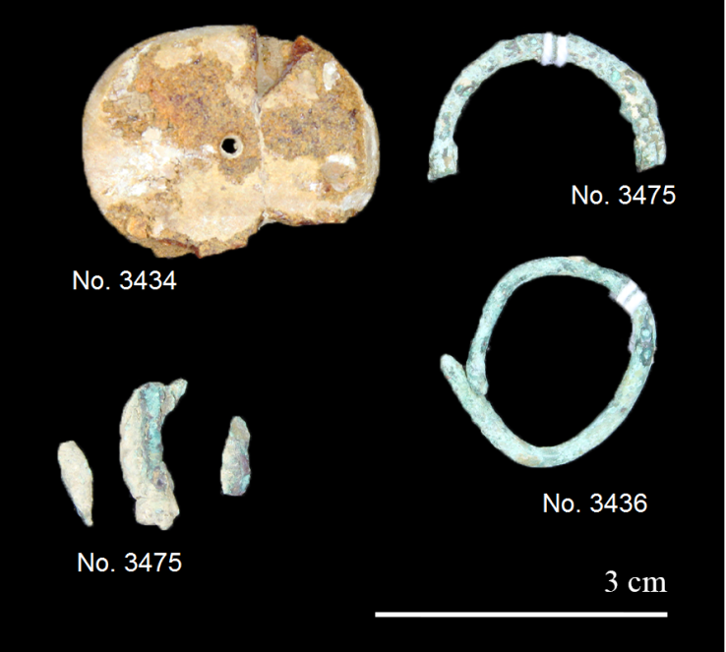

***Figure S3.*** *Amber and metal objects from La Pera (image: M. Murillo-Barroso).*

*6. Cal Rajolí (Solsona, Lleida)*

Rovira i Port (1994: 71) refers to seventeen beads found in the Neolithic inhumation cist of Cal Rajolí,, including ‘a fragmented amber bead or pendant in the shape of a truncated sub-cone, red in colour.’ Serra i Vilaró only mentions seven beads made of serpentine, magnesite, and steatite (Serra i Vilaró, 1927: 107), and seven beads are preserved in the Diocesan and Regional Museum of Solsona. The bead described by Rovira i Port exists in the museum's collections but is actually a coral bead (Figure S4).

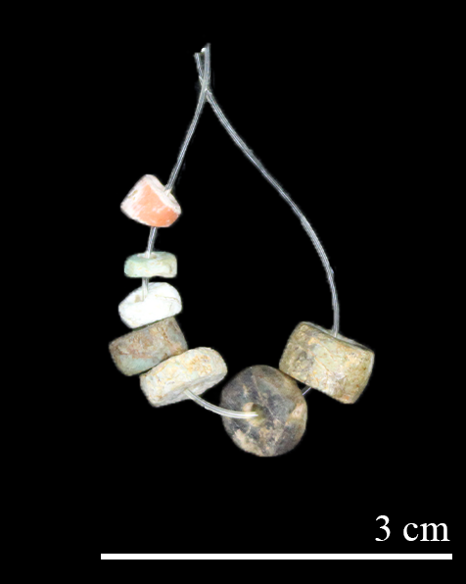

***Figure S4.*** *Beads from Cal Rajolí (image: M. Murillo-Barroso).*

*7. Bullons (Solsona, Lleida)*

This site is a trapezoidal chamber of 2 × 1.5 × 1.9 m covered by a tumulus excavated by Bosch Gimpera in the early twentieth century (Bosch Gimpera, 1923: 529–31). He indicated that the tumulus is heavily damaged and its diameter could not be established. Among the remains, several fragmented human bones including a cranium were recovered as well as some hand-made pottery and a carinated and polished vessel described as ‘clearly Argaric’ by Bosch Gimpera. A flattened, almost quadrangular bead measuring 17 × 16 × 16 mm with an axial perforation (Figure S5) and fragments of another bead were recovered. However, no amber pieces from this site exist in either the Diocesan and Regional Museum of Solsona or the Archaeology Museum of Catalonia in Barcelona.

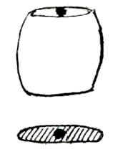

***Figure S5.*** *Amber bead (17 × 16 × 16 mm) from Bullons (after Bosch Gimpera, 1923: 529).*

*8. La Fossa del Gegant (Solsona, Lleida)*

La Fossa del Gegant consists of a rectangular chamber dolmen measuring approximately 1.65 × 2.15 m, with a pit excavated in the centre. The chamber is covered by a tumulus 1 0m in diameter (Serra i Vilaró, 1927: 204–05), and no human remains are mentioned. Among the finds, there are a spatulated handle, incised and fingernail-impressed pottery, flint, and a fragmented amber bead whose morphology is difficult to determine (Figure S6). However, the bead kept in the collections of the Diocesan and Regional Museum of Solsona associated with La Fossa del Gegant does not match the drawing by Serra i Vilaró, and resembles more the bead from Bullons, as it is a flattened barrel-shaped bead with a maximum length of 17 mm, a maximum width of 12 mm in the centre, and a maximum preserved width of 9 mm at the ends, featuring a longitudinal perforation 2 mm in diameter (Figure S6). In the fresh fracture, the characteristic translucent appearance of amber is observable, while the surface appears opaque. Despite being broken, the amber's state of preservation is good.

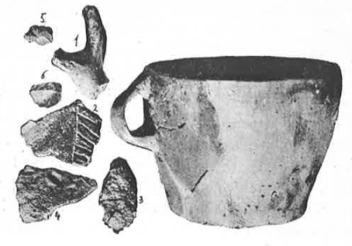 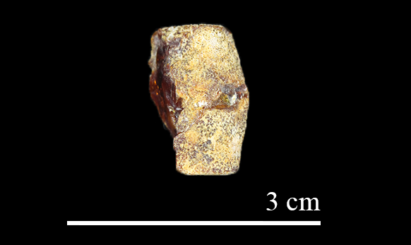

***Figure S6.*** *Left: Finds from La Fossa del Gegant after Serra i Vilaró, 1927: 206. 1–4 pottery; 5. amber bead; 6. flint. Right: Amber bead recorded as from La Fossa del Gegant at the Diocesan and Regional Museum of Solsona (image: M. Murillo-Barroso).*

We do not have absolute dates for the burial. The associated material (truncated conical vessels with handles, incised ceramics with fingernail-impressed decorations, and a flint flake) could correspond to a Chalcolithic phase. Notably, there is no metal.

*9. Can Cuca (Su, Lleida)*

Can Cuca is a rectangular chamber dolmen covered by a tumulus approximately 6 m in diameter, partially excavated in 1974 by J. Freixes and P. Casanovas. Later, in the 1980s, the tomb was cleared out and reconstructed, when most of the materials were recovered, including an amber bead (Cura i Morera, 1980; Turbón, 1980). Among the finds, carinated vessels as well as pottery with applied buttons and Merlés pottery were recovered, suggesting a broad chronology from the Neolithic to the Late Bronze Age. Rovira i Port (1994: 71) describes ‘a crescent-shaped bead or pendant measuring 11 mm in thickness by 26 mm in length,’ but the materials from this site are not in the collections of the Diocesan and Regional Museum of Solsona, nor is the bead or pendant deposited in the Archaeology Museum of Catalonia in Barcelona. Therefore, the whereabouts of this piece are unknown.

*10. Collet de Su (Pinòs, Lleida)*

The Collet de Su tomb is a gallery dolmen with a trapezoidal chamber measuring 2.9 × 1.9 × 2.2 m covered by a tumulus approximately 10 m in diameter, excavated in 1915 by Serra i Vilaró, and in 1983 by Bosch Gimpera and restored in 1986 by the Servei d’Arqueologia of the Generalitat de Catalunya (Bosch Gimpera, 1923; Guitart i Perarnau, 1986), in which eighteen crania were documented, one with a bronze arrowhead stuck in its parietal bone. Bosch Gimpera (1923: 528) also reports that one of the bronze arrowheads contained 19.34% Sn and 2.69% Pb but he does not mention the technique employed nor whether the analysis was conducted on the patina (which is likely, given the extremely high Sn levels). No amber beads are mentioned among the grave goods composed mostly by more than100 hand-made pottery sherds, including Bell Beaker, carinated, Copper Age pottery with incised decoration, and Neolithic pottery; flint flakes were also recovered (Guitart i Perarnau, 1986). According to Rovira i Port, 1994: 72), however, some amber fragments were recovered. These fragments are not in the collections of the Diocesan and Regional Museum of Solsona or the Archaeology Museum of Catalonia in Barcelona, and hence their whereabouts are unknown.

*11. Cova de Les Pixarelles (Tavertet, Barcelona)*

Excavations in the 1980s in Cova de Les Pixarelles documented an extensive stratigraphic sequence from the Late Neolithic to the fourth century ad. In stratum XIII, cord-impressed, incised ceramics, and an amber spacer-bead were documented (Rauret, 1987: 62), described by Rovira i Port (1994: 72) as ‘a rectangular, elongated spacer-bead with three vertical/transversal perforations, type Kakovatos.’ In the same stratum, Rovira i Port (1994: 72) refers to ‘a large discoidal and sub-annular bead perforated axially and with an elliptical section,’ but this is not mentioned by Rauret (1987). Additionally, in the same stratum, three bronze buttons and two truncated conical gold pieces were documented (Rovira i Port, 1996b).

The rectangular amber object appears to be, along with that of Forat de la Conqueta (see below), the only amber spacer-bead known in the Iberian Peninsula. Unfortunately, despite some finds from this site being deposited in the Episcopal Museum of Vic, the whereabouts of the amber pieces are unknown, and there are no drawings or photographs available.

From stratum XIII, we have two absolute dates on charcoal offering dates of 3150 ± 120 and 2980 ± 130 bp (Rauret, 1987: 66), which correspond to calibrated dates of 1693–1107 and 1502–857 bc, placing stratum XIII in the Late Bronze Age.

*12. Cova del Frare (Matadepera, Barcelona)*

The cave of Cova del Frare, extending over approximately 70 m, was excavated during the 1970s and 1980s. Five strata corresponding to five phases of occupation were identified within the cave (Martín Cólliga et al. 1981, 1985). In stratum C4, corresponding to the Late Neolithic, the remains of a significant number of individuals were documented: between eight and nine adults (six male and two female), one elderly individual, one or two youths, and three to five children. Among the grave goods, an amber bead and three variscite beads were recovered (Martín Cólliga et al. 1985: 97). The absolute dating obtained for stratum C4 gives a range from the late fourth to the early third millennium bc (4450±100 bp, 3371–2896 cal bc, at 94.9% confidence), suggesting that this may be the oldest amber piece found in the north-eastern Iberian Peninsula (Murillo-Barroso et al., 2023).

The amber bead is barrel-shaped, slightly flattened, measuring 14 mm in length and 12 mm in width, with a longitudinal perforation 4 mm in diameter. It is in excellent condition, showing minimal surface oxidation (Figure S7).

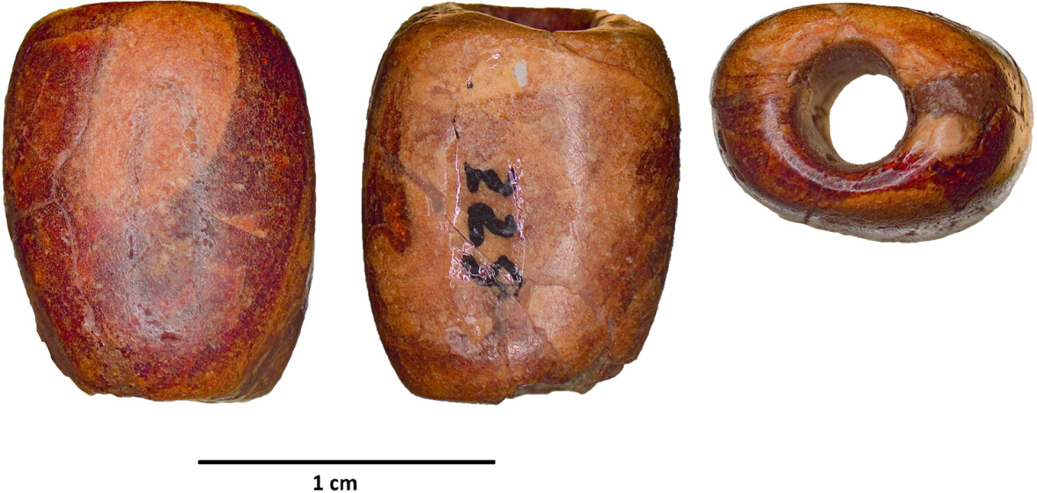

***Figure S7.*** *Amber bead from Cova del Frare (after Murillo-Barroso et al., 2023).*

*13. Cova de la Roca del Frare (La Llacuna, Barcelona)*

Cova de la Roca del Frare consists of an extensive network of galleries, including a burial chamber known as the ‘Hall of Skulls,’ excavated in 1956. In this chamber, the remains of at least twelve individuals were identified, accompanied by a vast array of grave goods, including 111 ceramic vessels, twelve flint blades (seven of them retouched), and a flint flake, a diorite axe, sixty-six shell beads and pendants, a bone tube, a variscite bead, six perforated shells, two bluish-green glass paste beads, and one highly fragmented red amber disk bead. This context is likely to date to 1700–1450 bc, based on the typology of the glass beads (Rafel, 1977–1978). Rovira i Port (1994: 73) describes the amber bead as ‘fragmented, disc-shaped, axially perforated, and oval in section.’

Today, the materials from the Cova de la Roca del Frare are housed in Vinseum in Vilafranca del Penedès, but the amber bead is not in their collections. The whereabouts of this bead remain unknown.

*14. Cova de El Garrofet (Querol, Tarragona)*

This extensive cave was excavated by Santacana and Vilaseca (1973), revealing a wide-ranging stratigraphy and a varied assemblage, including an iron buckle, a bronze ring, incised Bell Beaker pottery, lithic tools, bone awls, etc. A fragmented ribbed bronze blade was also recovered, out of archaeological context, possibly dating to the Late Bronze Age or Early Iron Age (Soriano, 2013). It composition reveals significant levels of Sn (Table S5).

Rovira i Port (1994: 73) mentions the presence of amber, but ‘details about its characteristics and recovery conditions are unclear’. However, this amber bead is kept in the Vinseum collections (G/333). It is a fragmented disc-shaped bead, with a maximum extant diameter of 18 mm and a thickness of 11 mm, of which only half remains, with a central perforation 6 mm in diameter (Figure S8). The bead exhibits a superficial layer of oxidation, but the translucent core characteristic of amber is still visible.

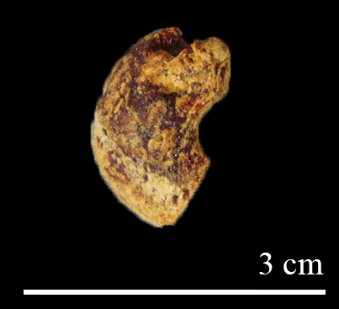

***Figure S8.*** *Amber bead from El Garrofet (image: M. Murillo-Barroso).*

***Table S5****. XRF analysis of the ribbed dagger or sword fragment from El Garrofet. Results in %wt. See Rovira et al., 1997 for further methodological questions.*

|  |  |  |  |  |  |  |  |  |  |  |  |
| --- | --- | --- | --- | --- | --- | --- | --- | --- | --- | --- | --- |
| **Analysis** | **Object** | **Fe** | **Ni** | **Cu** | **Zn** | **As** | **Ag** | **Sn** | **Sb** | **Pb** | **Reference** |
| PA7848 | Frag. blade | 0.05 | nd | 88.2 | nd | nd | 0.04 | 11.7 | nd | nd | Rovira et al. 1997: 366 |

Nd = Not detected

Additional amber finds were recovered from the following three sites after Rovira i Port's 1994 review:

*15. Cova de Muricecs (Llimiana, Lleida)*

Muricecs de Cellers is a karstic cave extending over 390 m, divided in several cavities. It features a large chamber measuring 3 × 4 m and a 28m-long gallery ending in a chamber called ‘Sala de Muricecs’, the largest one in the cave, measuring 25 × 18 × 9 m. This chamber is connected through various openings with an upper level, leading to other galleries (Gallart i Fernàndez, 2006).

A total of forty-one bronze artefacts have been recovered from the cave, and are currently deposited at the Museu de Valls, Alt Camp. Based on their typology and parallels in southern France, these have been dated to *c.* 1400–1200 bc (Gallart i Fernàndez, 2006). The bronze artefacts were associated to 135 amber beads, along with ten dentalium beads, two made of shell, and two of glass. Some of these beads show copper corrosion products on their surface. Most of the amber beads are flat, circular and small (between 0.5 and 1 cm in diameter), except for seven larger beads – six of which are rounded, and one quadrangular (Figure S9). These amber beads were studied by Murillo-Barroso and Martinón-Torres (2012).

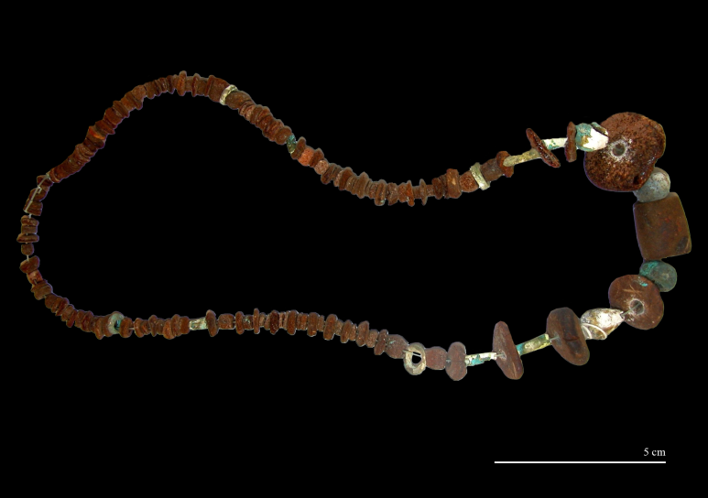

***Figure S9.*** *Amber beads from Cova de Muricecs (after Murillo-Barroso & Martinón-Torres, 2012).*

*16. Cova del Forat de Conqueta (Santa Linya, Lleida)*

The Cova del Forat de Conqueta is a natural cave used for burial purposes, excavated between 2005 and 2007 by the Autonomous University of Barcelona (González Marcén et al., 2010, 2011). A narrow opening (3 × 1.5 m) leads into a 5m-long passage that narrows to 0.35 m before opening into a larger cylindrical cavity (a doline) that served as a collective burial chamber. A second, broader entrance at the top of the rock leads directly into the burial chamber through a nearly vertical passage that was probably used to lower the dead (Garcia-Guixé et al., 2010; Garcia-Guixé, 2011). The excavations yielded commingled bones in various degrees of cremation and four partially articulated skeletons representing over forty burials of men, women, and children. According to eleven AMS dates from human dentine, these burials took place from the Late Neolithic to the Bronze Age (3400–1100 cal bc), which is consistent with the archaeological assemblage, mostly sherds, lithic and bone artefacts, as well as two bronze rings, shell, marble, bone, and amber beads (González Marcén et al., 2010, 2011; Mora Torcal et al., 2010).

One of the beads has a cylindrical shape commonly found in the Iberian Peninsula, while the second bead stands out for its typology (Figure S10). It is a quadrangular bead measuring 16 × 16 × 6 mm with several perforations, indicating that it is a spacer-bead that was reused after breaking (Martínez-Moreno, 2010; Núñez et al., 2022). These spacer-beads are not known in amber in Iberian prehistory, this bead being the only well-known example of a type that is frequently recovered in Northern and Central Europe up to France.

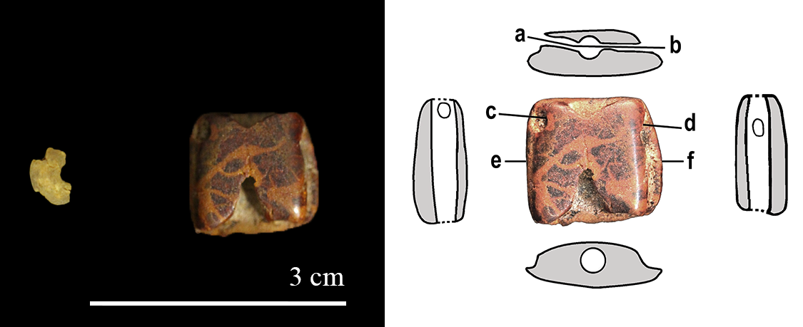

***Figure S10****. Amber beads from Forat de la Conqueta (after Nuñez et al., 2022).*

17. Cova del Gegant (Sitges, Barcelona)

Cova del Gegant is the largest cave in a subterranean network of galleries connected by narrow passages. It consists of a main chamber 22 m long and two side galleries. This cave was used from the Bronze Age to medieval times, primarily for funerary purposes during the Bronze Age, with a collective burial of at least nineteen individuals, three of whom have been radiocarbon-dated to 1600–1400 cal bc (Daura et al., 2010). The artefacts recovered include Late Bell Beaker pottery, four shell, three lignite-jet, and two amber beads (Figure S11), two gold tutuli (Daura et al., 2017), one coral, and one Cypraea fragment (Daura et al., 2010). The amber beads were analysed by Odriozola et al. (2019a), indicating a Sicilian provenance.

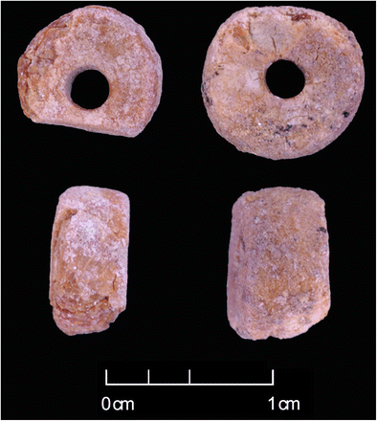

***Figure S11.*** *Amber beads from Cova del Gegant (after Odriozola et al., 2019a).*

**References**

Bosch Gimpera, P. 1923. Edat del Bronze. Sepulcres megalítics dels començos de l'Edat del bronze de la comarca de Solsona. L'excavació i les troballes. *Anuari de l'Institut d'Estudis Catalans*, 6: 527–31.

Castany, J. & Guerrero, L. 1983–1986. Algunes consideracions sobre la prehistòria i I’antropologia a les comarques del Bages, Berguedà i Solsonès. *Dovella*, 11–20: 35-41.

Castany, J., Alsina, F. & Guerrero, L. 1989. El megalitisme al Solsonès: resultats de les darreres excavacions (1984–1988). *Tribuna d'Arqueologia* 1988–1989: 51–62.

Cura i Morera, M. 1980. El sepulcre megalític de Can Cuca (Su, Solsonès) i consideracions sobre el megalitisme a l'interior de Catalunya. *Fonaments: Prehistòria i món antic als Països Catalans*, 2: 59-–68

Cura, i Morera, M. 1971–1972. El poblament prerromà en les comarques centrals de Catalunya. *Butlletí Arqueològic. Reial Societat Arqueològica Tarraconense*, 113–120: 55–67.

Daura, J., Sanz, M., Pike, A.W.G., Subirà, M.E., Fornós, J.J., Fullola, J.M. et al. 2010. Stratigraphic Context and Direct Dating of the Neandertal Mandible from Cova del Gegant (Sitges, Barcelona). *Journal of Human Evolution*, 59: 109–22. https://doi.org/10.1016/j.jhevol.2010.04.009

Daura, J., Sanz, M., Soriano, I., Pedro, M., Rubio, Á., Oliva, M. et al. 2017. Objetos de oro y epicampaniforme en la Cova del Gegant. Relaciones en la costa mediterránea de la Península Ibérica durante la Edad del Bronce. *Trabajos de Prehistoria*, 74: 149–67. https://doi.org/10.3989/tp.2017.12188

Gallart i Fernàndez, J.R. 2006. Notícia sobre un nou dipòsit de la cova dels Muricecs de Cellers (Llimiana, Pallars Jussà). *Cota Zero*, 21: 10–13.

García Guixé, E., González-Marcén, P., Lou, M., Martínez-Moreno, J., Mora, R., Pizarro, J. & Vega, S. 2010. Les ocupacions prehistòriques de la cavitat de Forat de Conqueta (Santa Linya, Lleida): metodologia d’excavació i seqüència arqueológica. *Treballs d’Arqueologia*, 16: 17–44. https://doi.org/10.5565/rev/tda.28

Garcia-Guixé, E. 2011. Estudi paleoantropològic i paleopatològic del sepulcre col·lectiu de Forat de Conqueta (Santa Linya, Lleida). *Treballs d’Arqueologia*, 17: 37–98. https://doi.org/10.5565/rev/tda.40

González-Marcén, P., Mora Torcal R., Roda Gilabert, X. eds. 2010. El jaciment de Forat de Conqueta: seqüència arqueològica i cultura material (*Treballs d’Arqueologia*, 16). Bellaterra: Centre d'Estudis del Patrimoni Arqueològic de la Prehistòria.

González-Marcén, P., Mora Torcal R., Roda Gilabert, X. eds. 2011. El jaciment de Forat de Conqueta: estudis paleobiològics (*Treballs d’Arqueologia*, 17). Bellaterra: Centre d'Estudis del Patrimoni Arqueològic de la Prehistòria.

Guitart i Perarnau, I. 1986. *Memòria de la intervenció al sepulcre megalític del Collet de Su (Pinós de Solsonès, Solsonès)*. Barcelona: Generalitat de Catalunya. [online] [accessed 9 April 2025]. Available at: https://calaix.gencat.cat/browse?type=jaciments&value=Galeria+Catalana+del+Collet+de+Su+%28Pin%C3%B3s%2C+Solson%C3%A8s%29

Martín Cólliga, A., Guilaine, J. & Thommeret, J. Y. 1981. Estratigrafía y dataciones C14 del yacimiento de la ‘Cova del Frare’ de St Llorenç del Munt (Matadepera, Barcelona). *Zephyrus* XXXII–XXXIII, 101–111.

Martín Cólliga, A., Biosca, A. & Albareda, M. J. 1985. Excavacions a la cova del Frare (Matadepera, Valles Occidental). Dinàmica ecològica, seqüència cultural i cronologia absoluta, *Tribuna d’Arqueologia*, Departament de Cultura de la Generalitat 1983–84, 91–103.

Martínez-Moreno, J. 2010. La indústria òssia i els objectes d’ornament al jaciment de Forat de Conqueta (Santa Linya, Lleida). *Treballs d’Arqueologia*, 16: 81–104. https://doi.org/10.5565/rev/tda.32

Mora Torcal, R., Pizarro, J., Lou, M., Jordá, J. & Benito-Calvo, A. 2010. El jaciment de Forat de Conqueta. Localització i característiques geològiques. *Treballs d’Arqueologia*, 16: 7–15. https://doi.org/10.5565/rev/tda.42

Murillo-Barroso, M. & Martinón-Torres, M. 2012. Amber Sources and Trade in the Prehistory of the Iberian Peninsula. *European Journal of Archaeology*, 15: 187–216. https://doi.org/10.1179/1461957112Y.0000000009

Murillo-Barroso, M., Martín, A. & Martinón-Torres, M. 2023. The Earliest Baltic Amber in Iberia. *Scientific Reports*, 13: 14250. https://doi.org/10.1038/s41598-023-41293-0

Núñez, M., García-Guixé, E., González-Marcén, P. & Mora Torcal, R. 2022. A Recycled Amber Spacer Bead from Forat de Conqueta, Catalonia, Spain. In: P. Halinen, V. Heyd & K. Mannermaa, eds. *Odes to Mika: Festschrift for Professor Mika Lavento on the Occasion of his 60th Birthday*. Helsinki: Archaeological Society of Finland, pp. 112–20.

Odriozola, C., Sousa, A.C., Mataloto, R., Boaventura, R., Andrade, M., Villalobos, R. et al. 2019. Amber, Beads and Social Interaction in the Late Prehistory of the Iberian Peninsula. *Archaeological and Anthropological Sciences*, 11: 567–95. https://doi.org/10.1007/s12520-017-0549-7

Rafel, N. 1977–1978. La cueva de «La Roca del Frare» en la Llacuna, comarca del Penedès. *Pyrenae*, 13–14: 43–60.

Rauret, A.M. 1987 La seqüència estratigràfica de la cova de les Pixarelles. *Tribuna d'Arqueologia*, 1986–1987: 59–68.

Rovira, S., Montero, I., Consuegra, S. 1997. *Las primeras etapas metalúrgicas en la península ibérica.* Madrid: Instituto Universitario Ortega y Gasset.

Rovira i Port, J. 1994. Ámbar y pasta vítrea. Elementos de prestigio entre el neolítico avanzado y el bronce final del nordeste de la península ibérica. *Quaderns de prehstòria de Castelló*, 16: 67–91.

Rovira i Port, J. 1996a. Una cuenta singular vitrificada de tipo Orientalizante entre los depósitos funerarios de un túmulo catalán del Bronce Medio: El Monumento I de El Bosc de Correà (L’Espunyola, Berguedà, Cataluña). *Trabajos de Prehistoria*, 53(1): 155-162.

Rovira i Port, J. 1996b. El conjunto de elementos en oro y bronce de la Cueva de Les Pixarelles (Tavertet, Cataluña): reflexiones sobre la producción y el comercio de objetos santuarios y ornamentales a lo largo de la Edad del Bronce en el Noreste de la Península Ibérica. *Complutum*, 1: 171–78.

Santacana, J. & Vilaseca, S. (1973): La Cueva del Garrofet (Querol, Tarragona). *XII Congreso Nacional de Arqueología.* Zaragoza: Universidad de Zaragoza.

Serra i Vilaró, J. 1922. *La cova de Can Mauri (Berga). Estació prehistòrica i megalits del coll de l'Orelle*r. Manresa: Imprenta i Enquadernacions de Sant Josep.

Serra i Vilaró, J. 1927. *Civilizacio megalitica a Catalunya. Contribució al seu estudi.* Solsona: Musaeum Archaeologicum Dioecesanum.

Soriano, I. 2013. *Metalurgia y sociedad en el nordeste de la Península Ibérica (finales del IV–II milenio cal ANE)* (British Archaeological Reports. International Series, 2502). Oxford: Archaeopress. https://doi.org/10.30861/9781407311180.

Turbón, D. 1980. Les restes humanes de Can Cuca. *Fonaments: Prehistòria i món antic als Països Catalans*, 2: 69–70.

Vidal, L.M. 1911. Otros monumentos megalíticos en Cataluña. *Memorias de la Real Academia de Artes y Ciencias de Barcelona*, 10; 3–12.