**The Use-Life of Ancestors: Neolithic Cranial Retention, Caching and Disposal at Masseria Candelaro, Italy**

**Jess E. Thompson, Sofia Panella, Silvia Soncin, Rowan McLaughlin, Italo Muntoni, Francesca Alhaique, Francesca Candilio, Alessandra Sperduti, Christopher J. Knüsel, Mary Anne Tafuri and John E. Robb**

**SUPPLEMENTARY MATERIAL**

**Supplementary Material 1: Deathways in Southern Italy**

***Table S1.*** *Typical funerary practices in Neolithic southern Italy, with examples for each.*

|  |  |  |
| --- | --- | --- |
| **Ritual practice** | **Key sites** | **References** |
| Primary burial in simple pit graves | Titolo; Passo di Corvo; La Torretta; Balsignano; Ripa Tetta | Tinè, 1983; Robb et al., 1991; Tozzi, 2002; Radina, 2006; Tunzi et al., 2014; Radina et al., 2020 |
| Primary burial near or under huts | Balsignano (T1); Carrara San Francesco (T2); Serra d’Alto Fondo Tataranni; Punta Rondinella (Strato L) | Rellini, 1925; Borgognini Tarli, 1978; Striccoli & Lopopolo, 2001; Radina, 2003; Radina et al., 2020 |
| Double or multiple burials | Masseria Candelaro (P12, P3/4); Madonna delle Grazie; Malerba II; Ripa Tetta (T3); Trasano (Silo 9); Masseria San Giovanni (T3); Masseria Cesario (T1); Cava Ripatetta; Matinelle di Malvezzi (S7); Serra d’Alto Fondo Lacopeta | Bianco, 1976; Lo Porto, 1989; Sublimi Saponetti et al., 2001; Radi, 2002; Tozzi, 2002; Venturo, 2002; Cassano & Manfredini, 2004; Radina et al., 2017; Radina et al., 2020; Oione et al., 2022 |
| Collective burials, sometimes with reduction of earlier depositions | Serra Cicora; Carpignano Salentino; Diga di Occhito; Cava Ripatetta; Contrada Galliano | Tunzi Sisto, 1999: 87; Fabbri et al., 2009; Fabbri & Lonoce, 2011; Venturo & D’Onghia, 2017; Oione et al., 2022 |
| Skeletons with bones removed, including skull/cranium | Madonna di Loreto; Serra Cicora; Masseria Candelaro; Passo di Corvo; Grotta Scaloria; Trasano; Cala Colombo | Pesce Delfino et al., 1977; Tunzi Sisto, 1999: 132; Radi, 2002; Cassano & Manfredini, 2004; Fabbri & Lonoce, 2011; Knüsel et al., 2016: 151; Mariotti et al., 2020 |
| Secondary deposition of bones | Masseria Bellavista; Scoglio del Tonno; Girifalco; Grotta Scaloria; Santa Tecchia; Cala Colombo; Masseria Candelaro; Grotta Latronico | Lucifero, 1901; Quagliati, 1906; Pesce Delfino et al., 1977; Mallegni, 1978; Salvadei & Macchiarelli, 1983; Cassano & Manfredini, 2004; Robb et al., 2015 |
| Secondary deposition or special treatment of crania | Balsignano; San Matteo-Chiantinelle; Masseria Bellavista; Scoglio del Tonno; Girifalco; Passo di Corvo; Cala Tramontana | Lucifero, 1901; Quagliati, 1906; Corrain & Scarpari, 1965; Radina, 2006; Tunzi Sisto & Sanseverino, 2008; Mariotti et al., 2020 |
| Cremation | Masseria Candelaro; Passo di Corvo; Le Macchie | Radina, 2002; Cassano & Manfredini, 2004; Mariotti et al., 2020 |

**Supplementary Material 2: Radiocarbon Dates**

***Table S2.*** *Newly obtained radiocarbon dates for Masseria Candelaro and associated isotope measurements. Radiocarbon dates calibrated with IntCal20 (Reimer et al., 2020) in OxCal version 4.4.4 (Bronk Ramsey, 2021).*

|  |  |  |  |  |  |  |
| --- | --- | --- | --- | --- | --- | --- |
| **Lab number** | **Radiocarbon age (bp)** | **Calibrated date** | **δ¹³C relative to VPDB** | **δ¹⁵N relative to air** | **C/N ratio (molar)** | **Context** |
| SUERC-103630 | 6212±24 | 5215–5073 cal bc (68.3%)  5296–5055 cal bc (95.4%) | -19.6 ‰ | 9.6 ‰ | 3.3 | Long bone fragment. Fossato F, T3 |
| SUERC-103631 | 6289±25 | 5307–5218 cal bc (68.3%)  5313–5214 cal bc (95.4%) | -19.5 ‰ | 8.8 ‰ | 3.3 | Rib fragments. 40D P3/4 B |
| SUERC-103632 | 6609±23 | 5612–5485 cal bc (68.3%)  5618–5482 cal bc (95.4%) | -19.2 ‰ | 9.5 ‰ | 3.3 | Cranial fragments. Cranium 6, Structure Q |
| SUERC-103633 | 6436±24 | 5472–5376 cal bc (68.3%)  5476–5335 cal bc (95.4%) | -19.3 ‰ | 8.9 ‰ | 3.4 | Parietal bone fragment. Cranium 1, Structure Q |
| SUERC-103634 | 6314±22 | 5315–5221 cal bc (68.3%)  5332–5214 cal bc (95.4%) | -19.0 ‰ | 8.9 ‰ | 3.5 | Long bone fragment. Pozzetto T1 |

***Table S3.*** *Previously published radiocarbon dates for Masseria Candelaro. Radiocarbon dates calibrated with IntCal20 (Reimer et al., 2020) in OxCal version 4.4.4 (Bronk Ramsey, 2021).*

|  |  |  |  |  |
| --- | --- | --- | --- | --- |
| **Lab number** | **Radiocarbon age (bp)** | **Calibrated date** | **Context** | **Reference** |
| OxA-3684 | 6640±95 | 5629–5782 cal bc (68.3%)  5726–5385 cal bc (95.4%) | Animal bone.  Structure Q, layer 4 | Cassano & Manfredini, 1993 |
| OxA-12062 | 6638±34 | 5621–5536 cal bc (68.3%)  5627–5483 cal bc (95.4%) | Animal bone.  Structure Q, pit P3 | Manfredini & Muntoni, 2004 |
| OxA-9988 | 6605±45 | 5614–5483 cal bc (68.3%)  5621–5479 cal bc (95.4%) | Seed.  Structure Q, layer 3 | Manfredini & Muntoni, 2004 |
| OxA-12063 | 6601±37 | 5612–5484 cal bc (68.3%)  5619–5479 cal bc (95.4%) | Human bone.  Pit P2, burial layer 8 | Manfredini & Muntoni, 2004 |
| OxA-9990 | 6555±45 | 5556–5476 cal bc (68.3%)  5619–5390 cal bc (95.4%) | Seed.  Ditch Ze, layer 5 | Manfredini & Muntoni, 2004 |
| OxA-3685 | 6510±95 | 5556–5374 cal bc (68.3%)  5627–5234 cal bc (95.4%) | Human bone; Ditch F, layer 6 | Cassano & Manfredini, 1993 |
| OxA-9989 | 6510±45 | 5523–5384 cal bc (68.3%)  5608–5372 cal bc (95.4%) | Seed. Pit P2, layer 8 | Manfredini & Muntoni, 2004 |
| OxA-12064 | 6501±37 | 5510–5383 cal bc (68.3%)  5536–5371 cal bc (95.4%) | Human bone. Cranium 2, Structure Q | Manfredini & Muntoni, 2004 |
| OxA-10013 | 6450±50 | 5474–5376 cal bc (68.3%)  5510–5313 cal bc (95.4%) | Human bone.  45C, burial T2 | Manfredini & Muntoni, 2004 |
| OxA-3683 | 6200±95 | 5300–5032 cal bc (68.3%)  5366–4856 cal bc (95.4%) | Human bone. Ditch F, burial T1 | Cassano & Manfredini, 1993 |

**Supplementary Material 3: Taphonomic Analysis**

When excavated (see Figure S1 for *in situ* excavation photograph), the fragments from the cranial cache in Structure Q were labelled approximately according to single individuals, with crania numbered from 1 to 9 (although three crania were numbered ‘6’ and throughout are designed as 6, 6(2) and 6(3)), and maxillae and mandibles were found between Crania 5–6 and 7–8.

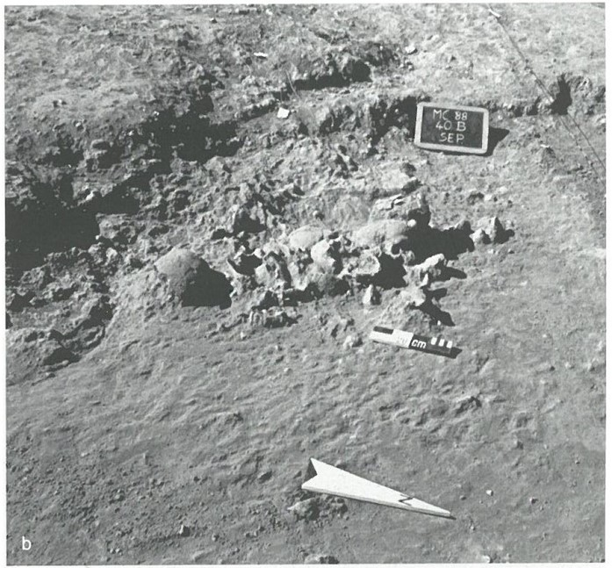

***Figure S1.*** *Masseria Candelaro Structure Q cranial cache during excavation (Marconi et al. 2004:71).*

Reproduced with permission of SABAP for the provinces of Barletta-Andria-Trani and Foggia.

Crania 1, 2, 6 and 8 were broken in a curved outline across the frontal bone, truncating approximately half of one orbital margin (Figure S2). Crania 3 and 6(2) were missing portions of bone from the superior aspect of the cranium which described semi-circular outlines (Figures S3 and S4). However, the endocranial surfaces of the fragments did not present any evidence of bevelling, which suggests that breakage was not peri-mortem. The presence of two refitting fragments forming a broken semicircle on the superior aspect of the right and left parietal bones of Cranium 8 suggests that fragmentation in this region could have been caused by *in situ* compaction and crushing (Figure S5). Alternatively, these fragments may have already been broken before deposition and retained or discarded elsewhere. The only indication of a potentially intentional post-mortem defect is an incomplete subcircular perforation in the superior aspect of the right and left parietal bones of Cranium 6(3) (Figure S6). The defect measures a maximum of 19.77 mm in diameter in an antero-posterior direction (and 31.69 mm from the sagittal suture to the right lateral margin). Fine cortical abrasion had eroded most of the surrounding authentic ectocranial cortex, but the cortex was not thinned in any region, as might be expected in the case of ante-mortem trepanation by scraping or cutting (Verano, 2016; Giuffra & Fornaciari, 2017), and there is no indication of osteoblastic activity. The shape of the defect and its internal margins are inconsistent with the root damage observed on other elements. A small portion of glue remaining on the internal surface of the defect may suggest that a refitting fragment was once present.

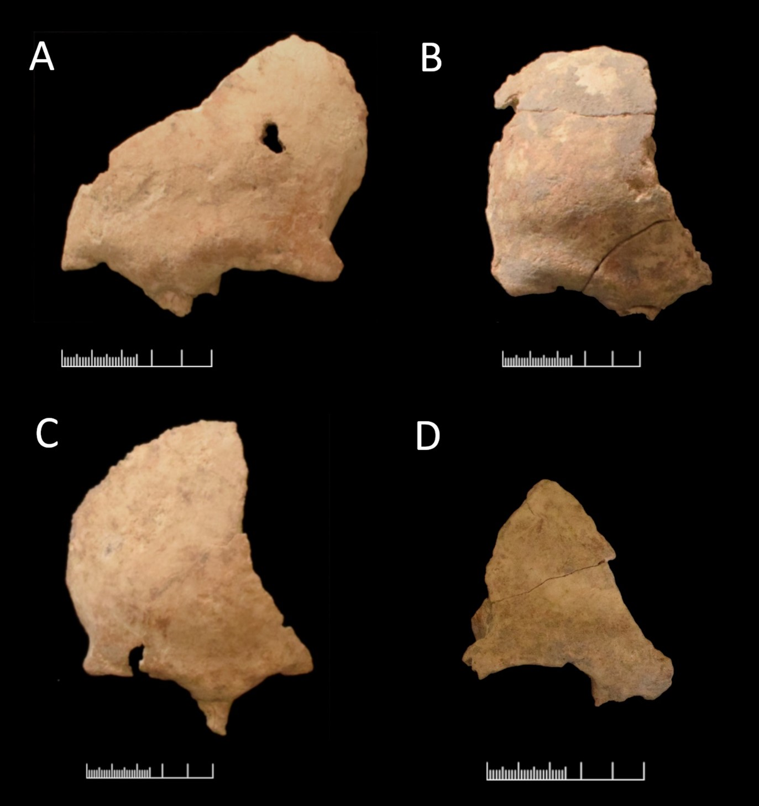

***Figure S2.*** *A) Anterior aspect of fragmentary frontal bone from Cranium 1 displaying post-mortem dry bone breakage in an interrupted curved outline, and full-thickness cortical erosion probably caused by root penetration. B) Anterior aspect of fragmentary frontal bone of Cranium 2, presenting post-mortem dry bone breakage, superficial cortical erosion, and concretion on the ectocranial surface. C) Anterior aspect of fragmentary frontal bone from Cranium 6 displaying post-mortem dry bone breakage in a curved outline and full-thickness cortical erosion. D) Anterior aspect of two glued fragments of the right portion of the frontal bone from Cranium 8, displaying post-mortem dry bone breakage in a curved outline. Scale: 5 cm.*

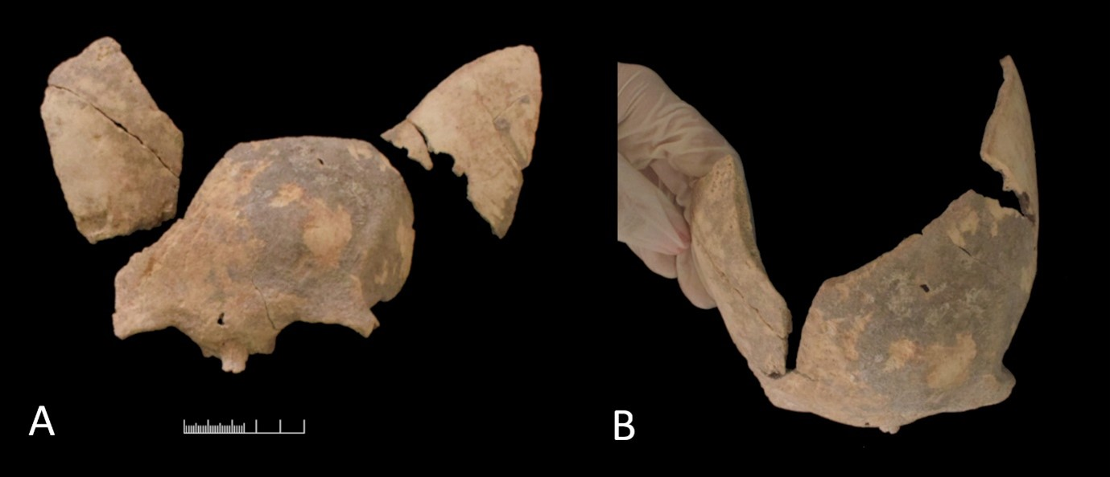

***Figure S3.*** *A) anterior aspect of fragments of frontal bone and parts of right and left parietal bones from Cranium 3. B) Fragments of frontal and parietal bones of Cranium 3 refitted in approximate position, showing curved breakage of the superior aspect of the calotte; all margins are characteristic of post-mortem breakage of dry bone. Scale: 5 cm.*

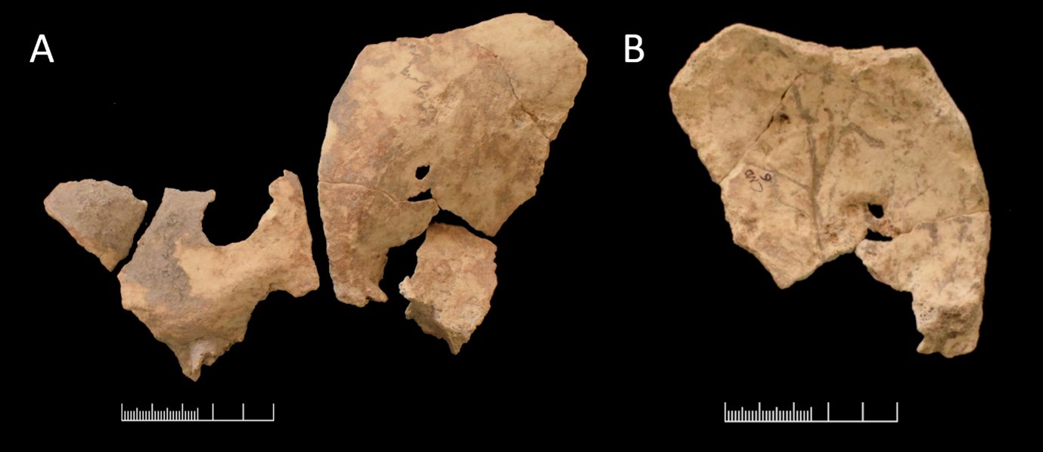

***Figure S4.*** *A) Anterior aspect of fragments of the frontal bone, and lateral aspect of the left parietal bone and sphenoid of Cranium 6(2) presenting irregular post-mortem dry bone breakage margins—including curved superior fragmentation margin—and full-thickness erosion. B) Endocranial aspect of fragment of left portion of frontal and left parietal bones, showing extensive cortical abrasion, concretion, and irregular, worn superior breakage margin with no evidence of bevelling. Scale: 5 cm.*

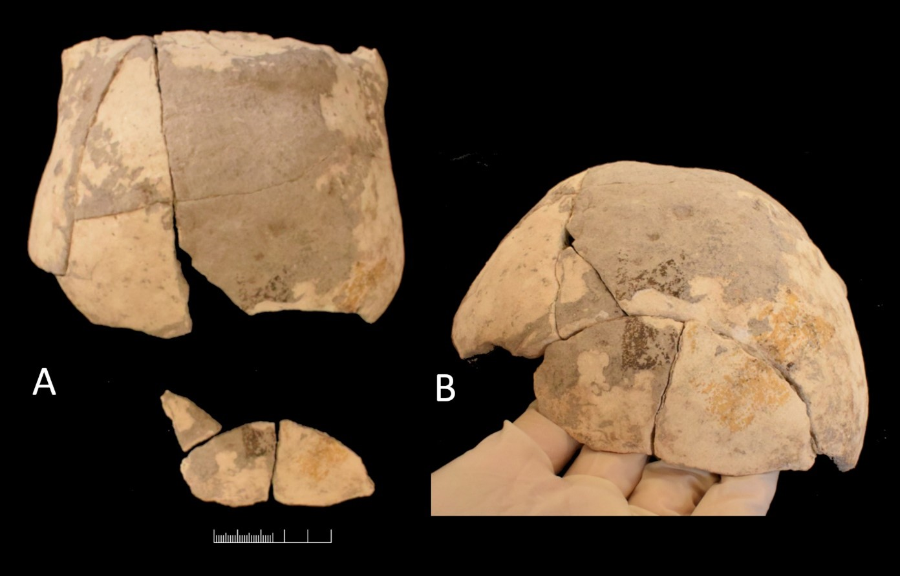

***Figure S5****. A) Supero-posterior aspect of Cranium 8 (with parts of right and left parietal bones, temporal bones, and occipital bone present), with three additional fragments broken off from the calotte, all displaying cortical abrasion and concretion. B) Antero-superior view of Cranium 8, with the three separate fragments refitted, demonstrating diagonal and curved post-mortem breakage to dry bone. Scale: 5 cm.*

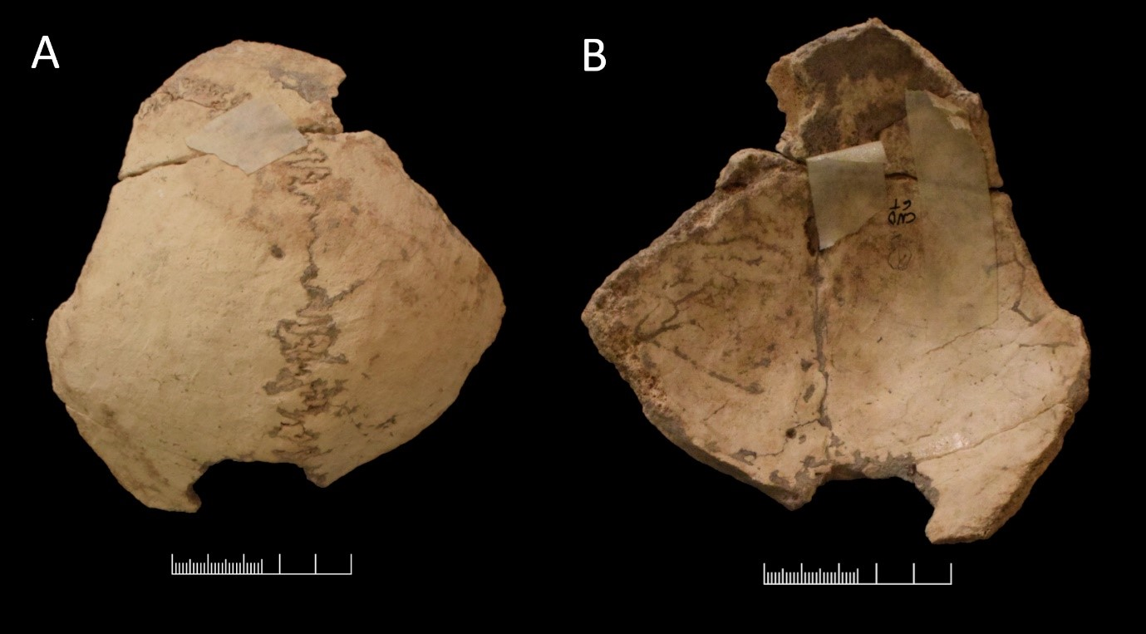

***Figure S6.*** *A) Superior aspect of the Cranium 6(3) calotte (with parts of right and left parietal bones and occipital bone present), presenting incomplete sub-circular breakage margin in the right parietal bone and extensive cortical abrasion. B) Endocranial aspect of the Cranium 6(3) calotte (occipital bone at top), showing concretion on internal aspect, sub-circular breakage margin, and absence of bevelling. Scale: 5 cm.*

The MNE (Minimum Number of Elements) was calculated by assessing the representation of each of the fifteen cranial and nine mandibular zones when they were more than 50% complete. Of these, the frontal bone was most numerous, represented four times on the left and five times on the right side. For the mandible, the right coronoid process was represented four times. This completeness threshold underrepresented the MNE, and the second zonation method was referred to (Kranioti, 2015). By graphically representing the approximate position of all cranial and mandibular fragments, it was possible to determine which zones were best represented (Figure S7). Nine individuals were represented by the central portion of the frontal bone and eight by the right frontal zygomatic process. The right and left maxillary processes, the sphenoid, the spheno-occipital synchondrosis, most of the palatal bones, and the inferior nasal conchae, lacrimal, vomer, and ethmoid bones were entirely absent. The facial skeleton was missing in most cases, with only several zygomata present, and eight small fragments of maxillary alveoli. Most fragments pertained to the cranial vault and the mandible, but refits often could not be made between cranial vault fragments in the same group. Several groups of elements demonstrated part repetition or morphological differences, which affected the hypothesis that each group represented one individual. A new MNI (Minimum Number of Individuals) was calculated for each group which accounted for element zonation, morphological characteristics, and age (Table S4). This increased the MNI to fifteen individuals, based on the hypothesis that all jaw fragments and dentitions originated from individuals whose crania are also present. A maximum possible NI (Number of Individuals), which hypothesises that all fragments which could not be re-fitted might have originated from a different individual, totals fifty-three, accounting for the lack of possible refits between many fragments in each group. The ‘true’ original number of individuals represented is likely to be in the lower end of this range.

***Table S4.*** *Minimum and maximum number of individuals estimated for each group of elements with comments describing how each estimate was reached; NI=Number of Individuals, MNI= Minimum Number of Individuals.*

|  |  |  |  |  |
| --- | --- | --- | --- | --- |
| **No**. | **MNI** | **MNI comments** | **Max. NI** | **Maximum NI comments** |
| 1 | 1 | This cranium was in layer 1, slightly separated from others. Male adult | 6 | No refits; all fragments could be of different individuals, but this is unlikely as they are morphologically and taphonomically consistent |
| 2 | 1 | M, 18–25 years (dental wear) | 6 | Frontal bone, R parietal, R zygoma, R maxilla, and R and L temporal could be from different individuals |
| 3 | 1 | Morphologically and taphonomically all fragments are similar. ?M, 25–35 years (dental wear) | 2 | The R maxilla and mandible appear to correspond, as well as the L mandibular condyle and L mandibular fossa; likely to be 1 individual. Occipital could be from a different individual |
| 4 | 1 | ?M adult | 3 | Frontal bone, R parietal and occipital could be different individuals |
| 5 | 2 | Cranium and mandible are 2 different ages. 5(1) is M adult calotte. 5(2) ?M adolescent mandible, 12–18 years | 2 | Cranial fragments consistent, mandible represents another individual |
| Mand. 5–6 | 0 | In this scenario, refits to Cranium 5 or 6. M, 45–60 years (dental wear and ante-mortem tooth loss) | 1 | Does not refit to another in this scenario |
| Mand. 6 | 0 | In this scenario, L orbit belongs to Cranium 6 and mandible to another cranium. At least two individuals present, M adult 35–45 years (dental wear) and another adult of not determinable sex | 4 | L orbit=1; mandible frags=1. Or, since it cannot be established whether L and R mandibular rami fragments are from the same individual, or if either belong to the mandibular corpus fragment and loose teeth=4 |
| 6 | 2 | L and R zygomata morphologically different (sex not determinable), calotte is ?M adult | 4 | Frontal bone and R zygoma=1 and L zygoma, R temporal and occipital all different individuals |
| 6(2) | 1 | ?M adult (could be an older adult; extant portions of coronal and lambdoid sutures are partly obliterated) | 5 | Frontal bone, L zygoma, R parietal, L parietal and L temporal all different individuals |
| 6(3) | 1 | ?M adult (could be an older adult; extant portion of sagittal suture closed) | 3 | Frontal fragments=1 and parietal/occipital and L? parietal different individuals |
| Max. 6 | 0 | In this scenario, refits with Cranium 6, 35–45 years (dental wear), sex not determinable | 3 | Fragments of mandibular condyle/coronoid processes=1 and maxilla and mandible=1; If L and R frags are different individuals=3 |
| 7 | 2 | 2 different ages, 7(1): M adult; 7(2): 12–­18 years, sex not determinable | 7 | If all elements of individual 1 are separate=5; if small and large fragments of individual 2 are separate=2 |
| Teeth 7–8 | 0 | Refits to another cranium in this scenario, 12–18 years, sex not determinable | 1 | Given that teeth ULM3 and LRM3 are both root 1/2 complete, the maxillary and mandibular fragments are likely from the same individual |
| 8 | 2 | Frontal + occipital=1; L + R temporals=1. A least two ages present, 8(1): M adult (could be an older adult, extant portion of lambdoid suture closed), 8(2): adult, sex not determinable | 4 | Frontal bone, occipital, L and R temporals all different individuals |
| 9 | 1 | Frontal and sphenoid=1, adult, sex not determinable | 2 | Frontal and sphenoid from different individuals |
| **TOTAL** | **15** |  | **53** |  |

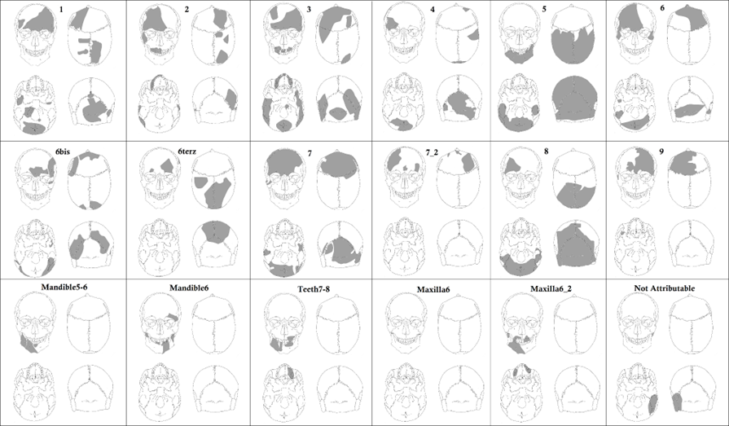

***Figure S7.*** *Digitized recording forms representing the approximate anatomical position of fragments from Structure Q. Graphic: S. Panella.*

**Supplementary Material 4: Isotopic Analyses**

**Methods of isotopic analysis**

Samples were processed using a modified Longin’s method (Longin, 1971). Briefly, bone fragments were mechanically cleaned using a dremel and then demineralized in 0.5 M HCl at 4 °C for several days. After being rinsed to neutral pH, the demineralized samples were gelatinized in pH 3 HCl for 48 hours at 75 °C. The solution was filtered using 5–8 μm Ezee filters to remove insoluble parts, frozen, and freeze-dried for 48 hours. Collagen samples were analysed at SUERC using a Delta V Advantage continuous-flow isotope ratio mass spectrometer coupled via a ConfloIV to an IsoLink elemental analyser (Thermo Scientific, Bremen) following Sayle et al. (2019). Here, two in-house standards (GS2, δ34SVCTD = –10.28 ± 0.18‰ and GAS2, δ34SVCTD = 18.56 ± 0.10‰) that are calibrated to the International Atomic Energy Agency (IAEA) reference materials IAEA-S-2 (silver sulfide, δ34SVCTD = 22.62 ± 0.08‰) and IAEA-S-3 (silver sulfide, δ34SVCTD = –32.49 ± 0.08‰) were used to normalize δ34S values. The normalization was checked using marine collagen USGS88 (δ34SVCTD = 17.10 ± 0.44‰), porcine collagen USGS89 (δ34SVCTD = 3.86 ± 0.56‰), and the Elemental Microanalysis IRMS fish gelatin standard B2215 (δ34SVCTD = 1.21 ± 0.24‰). Samples were run in two separate batches. For the first batch, to which the majority of samples belong, USGS88 gave δ34SVCTD = 17.34 ± 0.57‰ (n=6); USGS89 gave δ34SVCTD = 4.61 ± 0.41‰ (n=7); B2215 gave δ34SVCTD = 1.51 ± 0.11‰ (n=4). For the second batch, to which samples CND013, CND SUS10 and CND OVC3 belong, only USGS88 and B2215 were used to check normalization, and these gave values: USGS88, δ34SVCTD = 17.33 ± 0.57‰ (n=7); B2215, δ34SVCTD = 0.87 ± 0.32‰ (n=4). Four samples were run in duplicate (CND BOS 15, CND BOS 16, CND CAPR.2, CND SUS 12) and the highest standard deviation was 0.20‰. Stable isotope concentrations are measured as the ratio of the heavier isotope to the lighter isotope, reported as δ values per mil (‰) relative to the internationally accepted standard VCDT.

The quality of the measurements was assessed using C/N, C/S and N/S ratios and %C, %N and %S (Ambrose, 1990; Nehlich & Richards, 2009). Out of twenty-nine samples analysed (fourteen human and fifteen animal), five failed according to these parameters (Table S5). We did not exclude samples with C/S and N/S ratios slightly outside the suggested range since there is still debate around these limits (Nehlich, 2015). Two samples were re-analysed in conjunction with radiocarbon analysis at SUERC. One (CND 014, cr 1) failed from the original isotope analysis and therefore the results from the measurement associated with the radiocarbon dating are used instead. The second sample (CND 005, cr 6) re-analysed in conjunction with radiocarbon analysis reported a δ34S (‰) value slightly lower than that from the first run (Table S5). Nevertheless, both values are within the range of δ34S (‰) values from the animals, with no variation of the interpretations for this sample. R version 4.0.3 was used for statistical analysis and plotting.

Human bone samples were selected from the Structure Q cranial cache assemblage from discrete bone groups identified during excavation and prior analysis (Salvadei & Santandrea, 2004). Faunal bone samples were selected according to published species identifications (Curci et al., 2004). Descriptive statistics are reported in Table S6. The distribution of stable sulphur values of faunal and human remains is shown in Figure S8.

***Table S5.*** *Information and stable isotope composition of human and animal remains from Masseria Candelaro.*=Excluded*

|  |  |  |  |  |  |  |  |  |  |  |  |  |
| --- | --- | --- | --- | --- | --- | --- | --- | --- | --- | --- | --- | --- |
| **Sample ID** | **SUERC ID** | **Archaeo ID** | **Description** | **Context** | **Collagen yield (%)** | **δ³⁴S** | **%N** | **%C** | **%S** | **CNMolar** | **CSMolar** | **NSMolar** |
| CND 003 | GUsi12667 | Cr 7 | Cranium 7 | Cranial cache | 2.4 | 9.3 | 5.9 | 16.6 | 0.19 | 3.3 | 238.6 | 73.2 |
| CND 004 | GUsi12669 | Cr 8 | Cranium 8 | Cranial cache | 3.5 | 7.0 | 10.9 | 31.9 | 0.18 | 3.4 | 480.2 | 140.9 |
| CND 005 | GUsi12680 | Cr 6 | Cranium 6 | Cranial cache | 2.9 | 8.8 | 15.0 | 45.6 | 0.27 | 3.5 | 458.8 | 129.9 |
| CND 005* | SUERC-103632 (GU60074) | cr 6 | Cranium 6 | Cranial cache | 1.2 | 6.3 | 9.7 | 27.8 | 0.17 | 3.3 | 435.0 | 130.0 |
| CND 006 | GUsi12674 | Cr 6 bis | Cranium 6 (2) | Cranial cache | 1.8 | 9.2 | 7.5 | 22.8 | 0.30 | 3.5 | 203.0 | 57.3 |
| CND 007 | GUsi12688 | Cr 9 | Cranium 9 | Cranial cache | 4.8 | 9.2 | 10.2 | 28.3 | 0.20 | 3.3 | 378.5 | 116.4 |
| CND 008 | GUsi12668 | Cr 6 ter | Cranium 6 (3) | Cranial cache | 4.2 | 6.5 | 12.1 | 35.0 | 0.23 | 3.4 | 414.4 | 122.8 |
| CND 009 | GUsi12682 | Cr 5 | Cranium 5 | Cranial cache | 3.8 | 9.6 | 13.2 | 40.1 | 0.25 | 3.5 | 423.3 | 119.3 |
| CND 010 | GUsi12672 | Cr 4 | Cranium 4 | Cranial cache | 1.6 | 8.2 | 11.9 | 34.9 | 0.19 | 3.4 | 495.9 | 144.6 |
| CND 011 | GUsi12693 | Mand. 5 | Mandible 5 | Cranial cache | 1.7 | 10.2 | 14.4 | 43.4 | 0.21 | 3.5 | 542.9 | 154.3 |
| CND 013* | GUsi13721 | Mand. 5–6 | Mandible between crania 5–6 | Cranial cache | 0.6 | 9.5 | 2.6 | 9.8 | 0.18 | 4.5 | 143 | 32 |
| CND 012 | GUsi12689 | Cr 3 | Cranium 3 | Cranial cache | 2.3 | 8.1 | 4.4 | 12.2 | 0.16 | 3.2 | 208.4 | 65.0 |
| CND 014* | GUsi12679 | Cr 1 | Cranium 1 | Cranial cache | 1.1 | 8.3 | 1.0 | 2.7 | 0.25 | 3.2 | 28.9 | 9.1 |
| CND 014* | SUERC-103633 (GU60075) | Cr 1* | Cranium 1 | Cranial cache | 1.4 | 10.0 | 10.9 | 31.5 | 0.17 | 3.4 | 483.0 | 143.0 |
| CND 015 | GUsi12692 | Cr 2 | Cranium 2 | Cranial cache | 3.8 | 9.9 | 8.8 | 24.4 | 0.18 | 3.2 | 359.7 | 111.8 |
| CND 016 | GUsi12690 | Cr 7–8 | Maxilla between crania 7–8 | Cranial cache | 1.1 | 9.0 | 5.1 | 14.0 | 0.23 | 3.2 | 163.6 | 51.0 |
| CND BOS 13* | GUsi12677 | BOS 13 | I phalanx | Str Q 40 B/D 3 | 2.7 | 7.1 | 14.0 | 44.8 | 0.24 | 3.7 | 494.0 | 132.7 |
| CND BOS 14 | GUsi12685 | BOS 14 | Pelvis | Fa 8 | 7.8 | 11.3 | 13.5 | 39.4 | 0.20 | 3.4 | 518.2 | 151.8 |
| CND BOS 15** | GUsi12671 A and GUsi12671 B | BOS 15 | II phalanx | Str Q 40 B/D 4 | 4.0 | 5.6 | 12.6 | 38.6 | 0.20 | 3.6 | 513.4 | 143.3 |
| CND BOS 16** | GUsi12681 A and GUsi12681 B | BOS 16 | Radius (juvenile) | Str Q 40 B/D 4 | 5.2 | 10.7 | 11.8 | 33.6 | 0.25 | 3.3 | 365.3 | 109.8 |
| CND CAPR. 2** | GUsi12691 A and GUsi12691 B | CAPR. 2 | Mandible | Str Q 40 C/D 4 | 6.6 | 11.0 | 13.8 | 40.5 | 0.19 | 3.4 | 563.6 | 164.4 |
| CND OVC 3 | GUsi13779 | OVC 3 | Metatarsus | Str Q B/C 4 | 4.6 | 9.0 | 11.4 | 33.1 | 0.16 | 3.4 | 546.0 | 161.0 |
| CND OVIS 4* | GUsi12684 | OVIS 4 | Tibia | Str Q 40 B/D 4 | 0.7 | 13.1 |  | 2.0 | 0.28 |  | 19.7 |  |
| CND OVC 5 | GUsi12673 | OVC 5 | Scapula | Str Q 40 B/D 3 | 4.3 | 9.5 | 12.2 | 35.9 | 0.16 | 3.4 | 614.7 | 179.1 |
| CND OVC 6 | GUsi12683 | OVC 6 | Tibia | Fa 8 | 7.0 | 9.0 | 12.5 | 37.0 | 0.18 | 3.4 | 558.1 | 162.2 |
| CND SUS 7* | GUsi12675 | SUS 7 | Tibia | Str Q 40 B/D 3 | 0.1 | 10.5 | 1.6 | 9.9 | 0.28 | 7.1 | 93.0 | 13.0 |
| CND SUS 8 | GUsi12670 | SUS 8 | Pelvis | Str Q 40 C/D 4 | 6.2 | 7.2 | 12.9 | 37.0 | 0.18 | 3.3 | 558.5 | 166.8 |
| CND SUS 9 | GUsi12678 | SUS 9 | Fibula | Str Q 40 B/D 4 | 1.6 | 10.0 | 13.3 | 40.7 | 0.25 | 3.6 | 428.1 | 120.1 |
| CND SUS 10 | GUsi13722 | SUS 10 | Scapula | Str Q 40 C/D 4 | 1.5 | 9.5 | 10.4 | 30.4 | 0.22 | 3.4 | 372.0 | 109.0 |
| CND SUS 11 | GUsi12687 | SUS 11 | Pelvis | Srt Q A/C 4 | 8.1 | 7.7 | 13.0 | 39.0 | 0.16 | 3.5 | 633.1 | 181.6 |
| CND SUS 12** | GUsi12686 A and GUsi12686 B | SUS 12 | Pelvis | Srt Q A/C 4 | 6.0 | 5.5 | 13.9 | 40.7 | 0.17 | 3.4 | 639.0 | 187.1 |

***Table S6.*** *Descriptive statistics of δ34Svalues according to species.*

|  |  |  |  |  |  |  |
| --- | --- | --- | --- | --- | --- | --- |
|  | ***n*** | **Mean δ³⁴S** | **Median δ³⁴S** | **SD δ³⁴S** | **Min. δ³⁴S** | **Max. δ³⁴S** |
| **Humans** | 13 | 8.8 | 9.2 | 1.1 | 6.5 | 10.2 |
| ***Bos*** | 3 | 9.2 | 10.7 | 3.1 | 5.6 | 11.3 |
| ***Capreolus*** | 1 | 11.0 | 11.0 |  | 11.0 | 11.0 |
| ***Ovis* or *Capra*** | 3 | 9.2 | 9.0 | 0.3 | 9.0 | 9.5 |
| ***Sus*** | 5 | 8.0 | 7.7 | 1.8 | 5.5 | 10.0 |

***Figure S8.*** *Distribution of δ34Svalues according to species. Continuous lines represent the median or second quartile (Q2), the empty black circles represent the mean, the box limits represent the first (Q1) and third (Q3) quartiles and the whiskers represent Q1 - 1.5 * IQR (where IQR stands for interquartile range) and Q3 + 1.5*

**References**

Ambrose, S.H. 1990. Preparation and Characterization of Bone and Tooth Collagen for Isotopic Analysis. *Journal of Archaeological Science*, 17: 431–51. <https://doi.org/10.1016/0305-4403(90)90007-R>

Bianco, S. 1976. Matinelle di Malvezzi (Vetrina XXI). In: S.A. della Basilicata, ed. *Il Museo Nazionale Ridola di Matera*. Matera: Edizioni Meta, pp. 71–73.

Borgognini Tarli, S. 1978. I resti scheletrici del Neolitico materano dei Museo Ridola (nota preliminare). *Atti della XX Riunione Scientifica in Basilicata 16–20 Ottobre 1976.* Firenze: Istituto Italiano di Preistoria e Protostoria, pp. 241–59.

Bronk Ramsey, C. 2021. OxCal v.4.4.4 [software]. <https://c14.arch.ox.ac.uk/oxcal.html>

Cassano, S.M. & Manfredini, A. 1993. Tre nuove date C14 da Masseria Candelaro. *Origini*, 17: 246–47.

Cassano, S.M. & Manfredini, A. 2004. *Masseria Candelaro: Vita quotidiana e mondo ideologico in una comunità neolitica del Tavoliere*. Foggia: Claudio Grenzi.

Corrain, C. & Scarpari, G. 1965. I resti scheletrici umani rinvenuti in depositi neolitici delle Isole Tremiti. *Atti della X Riunione Scientifica in Verona 21–23 novembre 1965*. Firenze: Istituto Italiano di Preistoria e Protostoria, pp. 101–121.

Curci, A., Facciolo, A. & Tagliacozzo, A. 2004. I dati archeozoologici: un’economia di allevamento nel Neolitico dell'Italia meridionale. In: S.M. Cassano & A. Manfredini, eds. *Masseria Candelaro. Vita quotidiana e mondo ideologico in una comunità neolitica del Tavoliere*. Foggia: Claudio Grenzi, pp. 401–40.

Fabbri, P.F. & Lonoce, N. 2011. Gli aspetti funerari. Le sepolture. In: I. Tiberi, ed. *Serra Cicora tra VI e V millennio a.C*. Firenze: Istituto Italiano di Preistoria e Protostoria, pp. 187–233.

Fabbri, P.F., Pagliara, C. & Scarano, T. eds. 2009. *Prima di Carpignano. Documentazione e interpretazione di una sepoltura neolitica*. Lecce: Terra.

Giuffra, V. & Fornaciari, G. 2017. Trepanation in Italy: A Review. *International Journal of Osteoarchaeology*, 27: 745–67. <https://doi.org/10.1002/oa.2591>

Knüsel, C., Robb, J. & Tafuri, M.A. 2016. The Upper Cave: Taphonomic Analysis of the Treatment of the Dead. In: E.S. Elster, E. Isetti, J. Robb & A. Traverso, eds. *The Archaeology of Grotta Scaloria: Ritual in Neolithic Southeast Italy*. Los Angeles (CA): Cotsen Institute of Archaeology, pp. 145–91.

Kranioti, E.F. 2015. Forensic Investigation of Cranial Injuries Due to Blunt Force Trauma: Current Best Practice. *Research and Reports in Forensic Medical Science*, 5: 25–37. <https://doi.org/10.2147/RRFMS.S70423>

Longin, R. 1971. New Method of Collagen Extraction for Radiocarbon Dating. *Nature*, 230: 241–42. <https://doi.org/10.1038/230241a0>

Lo Porto, F. 1989. *L’insediamento neolitico di Serra d'Alto nel Materano*. Rome: Giorgio Bretschneider.

Lucifero, A. 1901. Mammalia calabra. Elenco dei mammiferi calabresi. *Rivista Italiana di Scienze Naturali*, 21: 115–20.

Mallegni, F. 1978. I resti scheletrici trovati nelle grotte n. 2 e n. 3 di Latronico. *Atti della XX Riunione Scientifica in Basilicata 16–20 ottobre 1976.* Firenze: Istituto Italiano di Preistoria e Protostoria, pp. 215–17.

Manfredini, A. & Muntoni, I.M. 2004. Datazioni radiometriche. In: S.M. Cassano & A. Manfredini, eds. *Masseria Candelaro: vita quotidiana e mondo ideologico in una comunità neolitica del Tavoliere*. Foggia: Claudio Grenzi, pp. 463–65.

Marconi, N., Muntoni, I.M., Cassano, S.M., Manfredini, A., Carboni, G. & Curci, A. 2004. Lo scavo. In: S.M. Cassano & A. Manfredini, eds. *Masseria Candelaro: vita quotidiana e mondo ideologico in una comunita neolitica del Tavoliere*. Foggia: Claudio Grenzi, pp. 49–85.

Mariotti, V., Muntoni, I.M. & Belcastro, M.G. 2020. New Insights into the Funerary Rituals of the Neolithic Site of Passo di Corvo (Apulia, Italy): The Study of the Human Remains. *Journal of Archaeological Science: Reports*, 34: 102643. <https://doi.org/10.1016/j.jasrep.2020.102643>

Nehlich, O. 2015. The Application of Sulphur Isotope Analyses in Archaeological Research: A Review. *Earth-Science Reviews*, 142: 1–17. [ttps://doi.org/10.1016/j.earscirev.2014.12.002](https://doi.org/10.1016/j.earscirev.2014.12.002)

Nehlich, O. & Richards, M.P. 2009. Establishing Collagen Quality Criteria for Sulphur Isotope Analysis of Archaeological Bone Collagen. *Archaeological and Anthropological Sciences,* 1: 5975. <https://doi.org/10.1007/s12520-009-0003-6>

Oione, D., Muntoni, I.M., Quero, T., Modesto, R. & D'Ardes, A*.* 2022. La necropoli di tombe a grotticella del Neolitico finale di Cava Ripatetta (Lucera – FG). Risultati preliminari. In: N. Negroni Catacchio, C. Metta, V. Gallo & M. Aspesi, eds. *Preistoria e Protostoria in Etruria. Atti del Quindicesimo Incontro di Studi. Ipogei: La vita, la morte, i culti nei mondi sotterranei. Ricerche e scavi*. Milano: Centro Studi di Preistoria e Archeologia, pp. 467–79.

Pesce Delfino, V., Scattarella, V., de Lucia, A., Ferri, D. & Giove, C. 1977. Antropologia della comunità neolitica di Cala Colombo. In: A. de Lucia, ed. *La comunità neolitica di Cala Colombo presso Torre a Mare, Bari*. Bari: Società per lo Studio di Storia Patria per la Puglia, pp. 96–178.

Quagliati, Q. 1906. Tombe neolitiche in Taranto e nel suo territorio. *Bullettino di Paletnologia Italiana*, 32: 17–49.

Radi, G. 2002. Trasano. In: M.A. Fugazzola Delpino, A. Pessina & V. Tiné, eds. *Le ceramiche impresse nel Neolitico Antico. Italia e Mediterraneo*. Roma: Istituto Poligrafico e Zecca dello Stato, pp. 695–706.

Radina, F. 2002. Per un progetto di salvaguardia del Neolitico antico sulle Murge pugliesi. In: F. Radina, ed. *La preistoria della Puglia. Paesaggi, uomini e tradizioni di 8000 anni fa*. Bari: Adda, pp. 1–18.

Radina, F. 2003. Le ricerche archeologiche. In: I. Muntoni, ed. *Modellare l’argilla: Vasai del Neolitico antico e medio nelle Murge pugliesi*. Firenze: Istituto Italiano di Preistoria e Protostoria, pp. 81–96.

Radina, F. 2006. Le sepolture 2 e 3 di Balsignano (Modugno, Bari) e la sepoltura di Masseria Masselli (Lama Balice, Bari). In: F. Martini, ed. *La cultura del morire nelle società preistoriche e protostoriche italiane. Studio interdisciplinare dei dati e loro trattamento informatico: dal Paleolitico all’età del Rame*. Firenze: Istituto Italiano di Preistoria, pp. 111–22.

Radina, F., Sicolo, M. & Sivilli, S. 2017. Il contesto rituale del Neolitico finale di Madonna delle Grazie (Rutigliano-Bari) nella Bassa Murgia Barese. In: F. Radina, ed. *Preistoria e Protostoria della Puglia*. Firenze: Istituto Italiano Preistoria e Protostoria (XLII Riunione Scientifica), pp. 277–83.

Radina, F., Aprile, G., D’Onghia, P., Russo, G., Sicolo, M., Sivilli, S. & Tiberi, I. 2020. Società neolitiche del sud-est italiano tra VI e V millennio a.C. Simboli e modelli di circolazione mediterranea nella documentazione funeraria. *Rivista di Scienze Preistoriche*, 70: 109–24. https://doi.org/10.32097/1119

Reimer P.J., Austin, W.E.N., Bard, E., Bayliss, A., Blackwell, P.G., Bronk Ramsey, C. et al. 2020. The IntCal20 Northern Hemisphere Radiocarbon Age Calibration Curve (0–55 cal kbp). *Radiocarbon*, 62:725–57. <https://doi.org/10.1017/RDC.2020.41>

Rellini, U. 1925. Scavi preistorici a Serra d’Alto. *Notizie di Scavi*, 1: 257–95.

Robb, J., Mallegni, F. & Ronco, D. 1991. New skeletal material from the Southern Italian Neolithic. *Rivista di Antropologia*, 69: 125–44.

Robb, J., Elster, E.S., Isetti, E., Knüsel, C.J. Tafuri, M.A. & Traverso A. 2015. Cleaning the Dead: Neolithic Ritual Processing of Human Bone at Scaloria Cave, Italy. *Antiquity*, 89: 39–54. <https://doi.org/10.15184/aqy.2014.35>

Salvadei, L. & Macchiarelli, R. 1983. Studi antropologici. In: S. Cassano & A. Manfredini, eds. *Studi sul Neolitico del Tavoliere della Puglia* (BAR International Series, 160). Oxford: British Archaeological Reports, pp. 253–264.

Salvadei, L. & Santandrea, E. 2004. I resti scheletrici umani: studio paleobiologico. In: S.M. Cassano & A. Manfredini, eds. *Masseria Candelaro: Vita quotidiana e mondo ideologico in una comunita neolitica del Tavoliere*. Foggia: Claudio Grenzi, pp. 379–91.

Sayle, K.L., Brodie, C.R., Cook, G.T. & Hamilton, W.D. 2019. Sequential Measurement of δ15N, δ13C and δ34S Values in Archaeological Bone Collagen at the Scottish Universities Environmental Research Centre (SUERC): A New Analytical Frontier. *Rapid Communications in Mass Spectrometry*, 33: 1258–66. <https://doi.org/10.1002/rcm.8462>

Striccoli, R. & Lopopolo, L. 2001. Il sito neolitico di Carrara San Francesco presso Bisceglie (Bari) e i suoi riscontri culturali con l’area balcanico-mediterranea. *Studia Antiqua et Archeologica*, 8: 11–26.

Sublimi Saponetti, S., Scattarella, V., Laraspata, L., Giove, C., Simone, O. & Venturo, D. 2001. Il villaggio neolitico trincerato di Malerba (Altamura): studio antropologico della tomba 2 e osservazioni sui reperti faunistici. *Altamura. Rivista storica. Bollettino dell’Archivio Biblioteca Museo Civico*, 42: 9–40.

Tinè, S. 1983. *Passo di Corvo e la civiltà neolitica del Tavoliere*. Genova: Sagep.

Tozzi, C. 2002. Ripa Tetta, Puglia. In: M.A. Fugazzola Delpino, A. Pessina & V. Tinè, eds. *Le ceramiche impresse nel Neolitico antico. Italia e Mediterraneo*. Roma: Istituto Poligrafico e Zecca dello Stato, pp. 579–88.

Tunzi, A.M., Sanseverino, R. & Rizzi, G. 2014. L’area necropolare di La Torretta (Poggio Imperiale – FG). Analisi delle più recenti evidenze funerarie neolitiche nella Puglia settentrionale: rituali, mondo ideologico e riflessioni antropologiche. In: A. Gravina, ed. *34 Convegno Nazionale sulla Preistoria - Protostoria - Storia della Daunia San Severo 16–17 novembre 2013*. Foggia: Centro Grafico, pp. 99–129.

Tunzi Sisto, A.M. 1999. *Ipogei della Daunia: preistoria di un territorio*. Foggia: Claudio Grenzi.

Tunzi Sisto, A.M. & Sanseverino, R. 2008. Nota preliminare sull’insediamento neolitico di C.no S. Matteo–Chiantinelle (Serracapriola – FG). In: A. Gravina, ed. *Atti 28° Convegno Nazionale di Preistoria, Protostoria, Storia della Daunia. San Severo 25–26 novembre 2007*. Foggia: Centro Grafico, pp. 87–98.

Venturo, D. 2002. Altamura (Bari), Masseria San Giovanni. *Taras. Notiziario della attività di tutela.*, 22: 27–28.

Venturo, D. & D’Onghia, P. 2017. La necropoli neolitica di Contrada Galliano, Palagiano (Taranto). In: F. Radina, ed. *Preistoria e Protostoria della Puglia. Studi di Preistoria e Protostoria*. Firenze: Istituto Italiano di Preistoria e Protostoria, pp. 297–305.

Verano, J.W. 2016. Differential Diagnosis: Trepanation. *International Journal of Paleopathology*, 14: 1–9. <https://doi.org/10.1016/j.ijpp.2016.04.001>