SUPPLEMENTARY MATERIAL
Transport Costs and Economic Change in Roman Britain

Scott Ortman¹, Olivia Bulik¹, Rob Wiseman², José Lobo³, Luis Bettencourt⁴ and Lisa Lodwick†
¹ Department of Anthropology, University of Colorado Boulder, USA
² McDonald Institute of Archaeological Research, University of Cambridge, UK
³ School of Sustainability, Arizona State University, USA
⁴ Mansueto Institute for Urban Innovation, University of Chicago, USA
† Died 3 November 2022, formerly of All Souls College, University of Oxford, UK

Materials and Methods
To compile the data analysed, we began by combining the Rural Settlement of Roman Britain and Defended Small Towns of Roman Britain datasets, both of which are available through the Archaeology Data Service, into a single relational database (Allen et al., 2018; Fulford et al., 2018). This database was used to identify records of excavations associated with quantified assemblages of at least 500 sherds or 4 kilograms of pottery, as reflected in the summary information for pottery in the source record, and to identify the associated publications and grey literature relating to these excavations. We obtained these reports through searches of the Archaeology Data Service Library, the online journals of county-level archaeological and historical societies, and libraries at the Universities of Cambridge and Colorado. We focused on pottery fabrics and wares that were quantified by count and/or weight and entered this information from summary tabulations in each report.
We reviewed the pottery reports for each source and entered the total count and/or weight of pottery by fabric, using the fabric classification scheme in each report, in data tables created for this project. To harmonize the various methods of quantification, we prioritized weight and translated other forms of quantification into estimated weights. If weights were absent but counts were available, we multiplied counts by the average sherd weight across the dataset (15g) to convert these into estimated weights. And if only estimated vessel equivalents (EVE) were available, we treated these as counts and converted them to estimated weights too. We entered data for each context group available in the excavation report. In some cases, these were based on spatial subdivisions and in others on contexts dated to specific chronological intervals. The sources we consulted are listed in the references and grey literature reports associated with individual excavations in the online datasets (Allen et al., 2018; Fulford et al., 2018). We also added comparable information from excavations in seven primary towns (Caerwent, Cirencester, Colchester, Exeter, Leicester, Silchester, and Wroxeter) working from the literature, and we integrated the data for seventy sites in Allen and Fulford’s (1996) dataset that also featured in our database. Table S1 summarizes the sources we consulted to obtain the data for primary towns. Overall, we compiled data for 1408 pottery groups, and 21,691 quantified fabric entries across these groups, for 775 excavations in 690 distinct settlements.
We encountered over 6,000 fabric codes in the source data—an unworkable number, and far more than the actual number of industries. This profusion of codes is a legacy of the historic development of Roman pottery analysis in Britain. Some fabric classification schemes (such as the Colchester Fabric Type Series) originated in major excavation reports and have been adopted by subsequent projects; others derive from county councils, municipalities, or county-based research units (Gloucester City Fabric Type Series, Museum of London Archaeology Fabric Codes, etc.); in still other cases analysts devised site-specific fabric type series. In the late 1990s, a National Roman Fabric Reference Collection (NRFRC, Tomber & Dore, 1998) was developed, but it is still by no means universally employed and has become outdated as more pottery industries have been identified in the last twenty years. Many reports include fabric code descriptions and/or correspondences with NRFRC codes with the data or in an appendix, but many others simply present the codes, with or without a reference to the type series used or publication in which they are defined. Fabric descriptions in certain reports are also misleading. For example, some coarse ware fabrics were referred to as 'fine grey ware' or 'fine sandy ware' despite being coarse wares. Finally, there are many cases where the same code refers to a different fabric (and industry) depending on the fabric type series used.
Due to these complications, it was not possible to group the original fabric codes into a shorter list of industries. Instead, we had to re-translate each row in the dataset. The shorter list of fabrics we developed is based on a combination of the NRFRC, Paul Tyers’ landmark Roman Pottery in Britain (Tyers, 2003) and his Potsherd website (Tyers, 2022), the Study Group of Roman Pottery’s gazetteer of Roman kilns (SGRP, 2022), and a major list of fabrics produced by the Museum of London Archaeology (MoLA, 2019) for use in Greater London and neighbouring counties. The resulting list includes 162 pottery fabrics, including ninety that could be assigned to a specific industry, twenty-nine imported Continental fabrics, and forty-three more generic, unsourced fabrics. We also determined the pottery class (samian, coarse ware, fine ware, mortaria, flagon, amphora, and storage vessel) for each entry, following the classification developed by Tyers (2003), whenever possible. The fabrics assigned to specific industries (see Figure S1) group together all wares produced at a given source. So, for example, all wares produced at Verulamium (coarse white slipped, fine white slipped, mica dusted, mortaria, and marbled ware) were given a single industry code. In total, just under forty per cent of sherds by weight in our database could be assigned to identifiable British and Continental fabrics: most of the remainder reflects the output of small-scale local production, or represent various indeterminate, unknown, or other categories. Table S2 presents the fabric list, dates of production for each fabric, and the total amount of pottery assigned to each fabric. The production dates are something of a compromise between the pottery resources listed above, which differ in some specifics.
Of the ninety industries in our list, we identified forty-nine where the production sites were well located, working from information compiled by Tyers (2003), Tomber and Dore (1998), and Swan (1984), and updated online by the Study Group for Roman pottery (SGRP, 2022). For those industries that have multiple production sites, we took the mean coordinate of these sites as the location of the production centre. In the following analysis, we calculated the distance from each production centre to each excavated site as a straight line. We explored the possibility of measuring distances using the Roman road network, but this produced a much wider dispersal of data and an average distance that was c. 50 km longer than straight line distances—implausible given that even the major industries transported ninety-five per cent of their pottery over distances shorter than 200 km. These differences between road and straight-line distances are probably owed to the locations of many secondary roads, which provided shorter routes to many locations, being lost.

Apportioning pottery assemblages to periods
An important issue in examining changes in the spatial distribution of pottery over time is isolating assemblages that can be assigned to specific date ranges. This is a special problem because most of the material recovered from excavations derives from contexts of mixed or redeposited material; even contexts that are well-defined or sealed, such as pits, trenches, and subfloor deposits often contain significant quantities of residual and intrusive pottery. Recent attempts at synthesizing Romano-British pottery records (e.g. Perring & Pitts, 2013; Rippon, 2018) have either taken pains to select only precisely-dated assemblages representing short periods of time or have treated the entire Roman period as a single group. The latter approach cannot be used to analyse change over time; while the former approach requires systematic evaluation of each excavation, resulting in a much lower sample density, and smaller sample sizes, without necessarily eliminating sampling error. An alternative approach is to carry forward the judgements and decisions in individual reports, which often attempt to phase the material recovered. Unfortunately, this does not solve the problem, because the date ranges of these groups are usually tailored to the results of each excavation, and they incorporate differing spans of time, and differing rates of residuality and intrusiveness.
In this study, we take a different, somewhat simpler approach. Rather than selecting and grouping subsets of the data based on stratigraphic or other contextual information, we assign fractions of excavated assemblages to periods based on the production span of each fabric in the assemblage. We use a technique known as Uniform Probability Density Analysis, developed for the study of ancestral Pueblo sites in the US Southwest (Roberts et al., 2012; Ortman, 2016; Mills et al., 2018), and using an approach generalized by Matthew Peeples (2008), to accomplish this. The approach is related to summed probability density approaches that have become widespread in the interpretation of radiocarbon dates (Rick, 1987; Shennan et al., 2013; Downey et al., 2014; Robinson et al., 2021; Bird et al., 2022). In our case, each piece of pottery plays the role of a radiocarbon date, but the chronological information is represented as a uniform distribution across the production span of that industry. Essentially, the probability that the sherd was deposited at the site during each year of its production span is one over the number of years of production, and for each year outside the production span it is zero. Although the output of a pottery industry was probably not uniform across its production span, the data required to establish more informative production intensity curves (time-series measures of output from kilns associated with each industry) are not yet available. In addition, the loss of information from using uniform distributions can be expected to be modest when working with many different varieties and broad chronological periods, as we do here.
The allocation procedure begins by multiplying the quantity of pottery of a given fabric by its corresponding uniform distribution, and these weighted distributions are then summed and divided by the total assemblage size to create a summed probability density distribution where the area under the curve equals one, and the height of the curve represents the probability that a gram of pottery was deposited during each time step. The procedure then uses Bayes’ Theorem to adjust the shape of this curve based on the likelihood of obtaining the observed mixture of fabrics if the site had been inhabited during each time step. Then, the procedure establishes beginning and ending dates for the assemblage by trimming away time steps for which the posterior probability is below a pre-selected threshold, and it reapportions the removed probability for each fabric within the resulting occupation span. Essentially, the procedure squeezes the uniform distributions of more vaguely dated fabrics based on the occupation span suggested by the more precisely dated fabrics, with the amount of squeezing being set by a tuneable threshold. Finally, these figures are summed across groups of years to create sub-assemblages consisting of quantities of pottery of each fabric that were deposited at a given site during each period of occupation. We aggregated the results into three periods: Early Roman (c. 50 bc–ad 150), Middle Roman (ad 150-–50) and Late Roman (ad 250–400). These periods roughly capture the start and end dates of production of key industries, including imported samian ware, Lower Nene Valley ware, Oxfordshire ware, New Forest ware, and South-East Dorset black burnished ware.
For our analysis, we computed summed probability distributions using 25-year time steps and set the minimum threshold indicating occupation at thirty per cent of the most probable period in the posterior distribution. We chose this threshold for several reasons. First, Romano-British sites clearly had varied occupation spans, but about seventy per cent of Roman pottery can be dated only to the Roman period overall. So, when a low threshold is used, posterior distributions suggest occupation across the Roman period at nearly every site. This is clearly unrealistic. Second, we found that, as we increased the threshold, the modelled occupation spans of sites stabilize at around thirty per cent, and it takes a substantial increase to change them appreciably from that point. Finally, a threshold at this level does not unduly restrict the occupation spans of sites with evidence for a lengthy occupation because the area under each posterior probability distribution is by definition equal to one. Because of this, the actual probability level represented by the threshold works out to be larger when the distribution is strongly peaked, suggesting a short occupation span, and smaller when the distribution is flatter, indicating a long occupation span. We found that a threshold of thirty per cent provided the most realistic overall interpretation of the data. Further studies could investigate more formal evaluation methods for this specific detail of uniform probability density analysis.
Table S3 presents ordinary least squares fits for the relationship between the log-proportion of each tracked industry and distance from the production location after implementing the procedure above to assign portions of each assemblage to each time period.

Exponential Decay of Pottery Consumption with Distance
In quantitative geography, two kinds of decay patterns with distance from a source are typically observed empirically: exponential decay and power law decay. Power law decay with distance is often observed in commuting patterns in cities, as well as transportation and migration flows (Fotheringham & Webber, 1980; Batty, 2013; Bettencourt, 2021: chapter 8). Exponential decay is more general and is observed in a variety of other situations, both dealing with human activities and with dispersal processes in ecology (Haynes, 1974). Here, we describe the derivation and significance of exponential decay, as observed in our data, for pottery consumption away from their production centres.
In the main article, we argue that the probability of consumption of a specific variety of pottery should exhibit exponential decay with distance from the production location, based on the following chain of reasoning: 1) consumption of a given variety of a manufactured good is proportional to the price (whether mediated through money or barter) of that variety in the local market relative to other varieties; 2) the increase in the price of a good with distance from its source is equivalent to the total transport cost; 3) transport costs accumulate in a linear fashion with distance; and 4) linear transport costs lead to a consistent fractional decline in the probability of consumption as distance increases, following the same mechanism seen with respect to time in survival analysis in demography. We discuss each link in this chain below.
First, consumption choices in any given location should follow from differences in price. The proportion of pottery from a given industry in an archaeological assemblage represents the fraction of pottery consumption represented by products from that industry, the remaining consumption being of pottery from other industries. According to the theory of consumer choice in economics (Krugman & Wells, 2009: 271–302), individuals have finite (or limited) resources to allocate to obtaining goods. Given this ‘budget constraint’, there are a range of combinations of related goods that can be obtained, given their relative prices. As the price of one variety increases relative to others, consumers will purchase fewer of that variety, on average, so that they can continue to consume the desired quantity and variety of goods. This view does not presume that all varieties of pottery were equivalent. Indeed, due to differences in quality, functionality, durability, and appearance, certain varieties of pottery were surely more desirable than others. It merely suggests that, in a context where consumers had limited resources to allocate to obtaining pottery, one would expect the probability of consumption of any given variety of pottery to decline as its price increased relative to that other varieties.
Second, the ‘price’ of a good for a consumer will increase as the cost of transporting that good from where it is produced to where it is consumed increases. The basic idea is that distributors must recoup the costs of bringing a pot from its production site to a local market for it to be worth their while. The total cost of bringing a good to a consumer is the sum of the production costs and the transport costs. The production cost will be the same regardless of where the product is consumed, but the transport cost will vary, with the total transport cost being the product of the distance travelled and the cost per unit to transport it over that distance.
Third, transport costs increase proportionately with distance. This is the standard approach in economics, where transport costs are typically modelled in the ‘iceberg’ form (Samuelson, 1954; Krugman, 1991). In this formulation, transport costs accumulate in a linear fashion and are ‘paid’ through a reduction in the amount that reaches a given distance. In our context, transport costs will increase the price of a pot as the transport distance increases. And as the price increases, the probability of consumption will decrease.
Finally, the cost of transport per unit distance has an effect on spatial patterns of pottery consumption that is analogous to the effect of the hazard rate for mortality patterns in demography. Survival analysis (in demography and engineering) focuses on the fraction of an initial amount that persists over time (Lee & Wang, 2003), but the same reasoning can be applied to decay over distance. Consider a location which produces a certain quantity of pottery. Its products will be moved over some distance from production to consumption sites, thus reducing the portion that is carried further, and so on. The question is thus what fraction of the original product “remains” to be consumed with each additional increment of distance. This is equivalent to the probability that a product from that source will be consumed at a given distance. We can write this probability of consumption at distance $x$as $P_{x}$. This probability is analogous to the fraction of a birth cohort surviving at age $x$, or the probability of survival to age $x$, in the survival function.
The decay in the fraction of pottery $P_{x}$ that remains as distance increases is written in terms of a hazard or failure rate, $μ,$describing the probability of loss at distance $x,$defined as
$\frac{dP_{x}/dx}{P_{x}}=-μ.$ (S.1)
This prescription is general because $μ$ can assume different dependences on $x.$ However, the simplest model has $μ$ as a constant in $x$, resulting in
$\frac{dP_{x}/dx}{P_{x}}=\frac{d}{dx}\log{P_{x}}=-μ → \log{P_{x}}=\log{P_{0}}-\int_{0}^{x}{μ}dx^{'}=\log{P_{0}}- μx,$ (S.2)
leading to $P_{x}=P_{0} e^{-μx},$ with $μ$ interpreted as the hazard rate, that is, the per cent decay in the remainder of the original product with each additional unit of distance. We can further interpret the parameter $μ$ as a cost of transport per unit length travelled, divided by some total energy allocated to transport, through the concept of ‘iceberg’ transport costs, which is common in economic geography. In this approach, transport costs accumulate in a linear fashion with distance, and they are ‘paid’ by subtraction from the initial amount. With each additional increment of distance, an amount equivalent to the cost of transport over that distance is removed from the remaining amount. In this reading, the cost of transport per unit distance is analogous to the momentary hazard rate, such that a constant fraction of the remaining product is consumed with each additional unit of distance travelled. Essentially, transport costs have the effect of ‘melting’ a fraction of the remaining product with each additional unit of distance, with the rate of melting being equivalent to the transport cost per unit distance, $μ$. Put simply, transport costs increase the price of a pot as the transport distance increases, leading to a decrease in the fraction that is transported over each new increment of distance, and a corresponding decrease in the probability of consumption with each new increment of distance.
Iceberg transport costs were proposed long ago by Paul Samuelson (1954) and are commonly used in models of economic geography, such as Krugman’s influential core-periphery model (Krugman, 1991) for urbanization and regional trade, which matches industrial production to residential consumers across space. Finally, let us note that, insofar as the cost of moving pottery per unit distance travelled may decrease over time (for example because of improved transport technology and/or infrastructure), the mean distance travelled by pottery $\overline{x}=μ^{-1}$ for a given cost will be proportionally greater. We could also consider hazard rates that depend on the direction of travel from the source, for example along better roads, or upstream vs downstream along navigable water courses, or that are specific to different sources, but this is not attempted here. Other methods in quantitative geography, including origin-destination trip generation models under maximum entropy estimation (Wilson, 2013), also generate exponential decay of travel from a source with distance, expressing the same essential ideas but using more complex derivation strategies.

Transport, Agglomeration, and Diversity in Pottery Assemblages
In the main article, we note that transport costs and agglomeration both affect diversity in pottery assemblages. As the frictional effect of distance declines, the total cost of pottery at a given distance from the production location will also decline, leading to reductions in price too. As a result, the area over which a product can be effectively distributed will expand, and this will expand the potential market for the product. This will in turn stimulate an expansion in the scale and specialization of production (Arrow, 1994; Kelly, 1997; Smith, 2007). Hence, reductions in transport costs will result in an increase in the specialization of production, or a decrease in the diversity of production, as production focuses on fewer, more intensively produced and generally higher-quality varieties. In addition, reduced transport costs would have had consequences not just for individual industries, but would also have allowed competing industries to have easier access to local markets. Even sites where pottery was produced would have been increasingly open to competitors’ wares. As a result, the proportion of locally produced wares should decrease at their production sites (where the distance x = 0) as transport costs decrease and competing wares became increasingly available.
In addition to transport costs, the distribution of people in space also affects production and consumption patterns. Populations that are more concentrated in space will interact more frequently with more people of different kinds, and this will increase the connectivity of, and information available to, an individual (Ortman & Lobo, 2020). Thus, at any given time, individuals who live in more populous settlements will integrate more information about the choices available to them, including their consumption activities, than individuals who live in less populous settlements (Hanson & Ortman, 2020). Individuals in agglomerated populations also typically become more productive as a result of learning and sharing skills (Ortman & Lobo, 2020). This increase in individual-level productivity can in turn support increases in consumption.
Transport costs and agglomeration thus have seemingly opposed effects on patterns of pottery consumption, with increasing agglomeration promoting greater diversity in consumption, and declining transport costs leading to greater specialization in production. These two effects are connected via the increase in demand for all goods that a reduction in transport costs creates. The analytical framework known as Settlement Scaling Theory integrates both forces. Previous work (Bettencourt, 2013; Bettencourt et al., 2014; Hanson et al., 2017; Lobo et al., 2020) has shown that the expected number of social connections experienced by an individual in his or her daily activities at time $t$can be captured by a simple power function:
$k\left(N_{t}\right)=k_{0_{t}}{N_{t}}^{δ}$, (S.3)
where $k(N_{t})$ is the connectivity of the individual (their degree, or number of links to others, in network theory terms) in a settlement with population $N$ at time $t$, $k_{0_{t}}$ is the baseline connectivity of individuals at time $t$ (e.g. the number of connections maintained by an individual in an isolated farmstead), and the exponent $δ$ captures the network effects of concentrating people in space. Previous theoretical work has derived an expected value of $δ=1/6$ for this exponent, and this has also been observed empirically (Bettencourt, 2013; Andris & Bettencourt, 2014; Schläpfer et al., 2014). This formulation implies that the diversity of an individual’s consumption activities will also be proportional to the number of connections, and will therefore increase with the size of an individual’s local social network in the same way:
$d\left(N_{t}\right)=d_{0_{t}}{N_{t}}^{δ}$. (S.4)
However, the baseline diversity of an individual’s consumption activities, $d_{0_{t}}$, will be subject to the levels of specialization in production, and this should in turn be inversely proportional to the baseline connectivity, $k_{0_{t}}$. In other words, as the baseline connectivity of individuals increases over time, individuals can satisfy more of their needs through their social connections, and as a result their own productive activities can become less diverse, or increasingly specialized. Since baseline connectivity would be expected to increase as transport costs decrease, $d_{0_{t}}$ should be proportional to transport costs. Equation (S.4) can be converted to a linear function by taking the logarithm of both sides:
$\ln\left[d\left(N_{t}\right)\right]=δ\left[\ln{N_{t}}\right]+\ln\left[d_{0_{t}}\right]$. (S.5)
Now, a good measure of diversity is the Shannon Diversity Index ($H$), defined as:
$H=-\sum{\left(p_{i}*\ln{p_{i}}\right)=-\ln\left(\prod{{p_{i}}^{p_{i}}}\right)}$, (S.6)
where $p_{i}$ represents the proportion of an assemblage produced at source $i$. It is a measure of the amount of information integrated by an individual through their consumption choices. This would have included information from others in an individual’s social network regarding the range of products available, their functional and aesthetic qualities; their prices in previous exchanges; and their relative status appeal. Because the Shannon Diversity Index is a logarithmic diversity measure ($H=\ln{d}$), it can be substituted directly into Equation (S.5), yielding:
$H\left(N_{t}\right)=δ\left[\ln{N_{t}}\right]+H_{0_{t}}$. (S.7)
Equation (S.7) can be tested directly by fitting a linear function to the logarithm of a population proxy and the Shannon Diversity Index of the associated pottery assemblage for data from a variety of settlements dating from different times. This analysis is presented in the main article.

Additional Factors that May Have Influenced Pottery Distributions
In the main article, we emphasize that distance from production locations was merely one of many factors that contributed to patterns of pottery consumption in each location. This raises the question of whether evidence of these other factors might be visible in the data. We consider several possibilities below.
Figure S2 summarizes standardized residuals from a pooled (all periods) regression of the relationship between log-proportion and distance, with the residuals sorted according to the size of the settlement from which the excavated pottery sample derives. This analysis allows one to assess the extent to which the size of the local market affected pottery consumption, after taking distance into account. For example, if distributors could fetch higher prices for pottery in larger markets, one might expect these residuals to be more strongly positive for larger settlements, or more strongly negative for smaller settlements. The results suggest that any such effects were minor. For all settlement size classes, the ninety-five per cent confidence interval of the mean includes zero. This result is consistent with other studies which have found that primary towns did not exert a strong influence on pottery distributions (Fulford, 2017: 360).
Figure S3 compares these residuals by region. Several studies have argued that different regions of Britannia participated to differing degrees in the imperial economy. Studies have shown, for example, that British-style round houses persisted longer in the north and west than in the south-east, that Roman coins are generally more common in the south-east, and that military activity was more prominent in the north and west (Millett, 1990; Mattingly, 2006; Walton & Moorhead, 2015; Allen et al., 2017). Based on these findings, one might expect the distributions of residuals to be more negative in regions of Britannia that were less integrated into the provincial economy. Figure S3 shows that, for the most part, this is not the case. Settlements in the south-west and Wales, however, do have a positive bias to their residuals, potentially suggesting that pottery supply was influenced by military activity in these regions. However, our dataset contains relatively few settlements from these regions. Overall, these results suggest that our sampling of settlements and regions has not introduced any systematic biases to the data. They also suggest that transport costs were factored into the distribution of pottery even in regions where exchanges were not mediated by coins.
One might also ask whether changes in pottery vessels themselves could have contributed to the observed changes in distance-decay relationships. For example, if Early Roman industries produced primarily heavy, high-capacity jars used for transporting goods but Late Roman industries primarily tableware, including open forms that could be stacked for transport, these changes could have affected the slope of distance-decay relationships simply because of a change in the size and weight of the average vessel over time. We have attempted to control for this possibility in several ways. First, we excluded amphorae from our attributions to remove obvious transport pottery from the analysis. Second, we included samian and other continental imports because they were used in the same ways as other tablewares. These imports were common during the Early and Middle Roman periods but declined during the Late Roman period; hence, the increase in the slope of the distance-decay relationships from the Early to Middle Roman period cannot be attributed to this factor, nor can the increase from the Middle to Late Roman period. Third, we included all wares and vessel forms from each industry in the analysis in an effort to remove any associations between time, industry, and vessel form. When this is done, samples for most of the major industries, including Verulamium, Colchester, Hadham, Oxfordshire, New Forest, and Lower Nene, include large quantities of both fine and coarse wares. In addition, major industries that span multiple periods and include only coarse wares (Alice Holt, Dales, Dorset Black Burnished, Horningsea, and Savernake) each show decreases in the slopes of their distance-decay relationships over time (see Figure S1). In sum, there is no evidence that changes in the slopes of the distance-decay relationships are a by-product of changes in the types of vessels that were produced and distributed.
Finally, we considered whether factors unrelated to transport could have been responsible for changes over time in the slope of the distance-decay relationships. While there was sophisticated pottery production in Late Iron Age Britain (Sutton, 2020), the idea of an ‘industry’ appears to have been an entirely Roman concept. The residents of Roman Gaul had practised ‘impersonal’ trade before arriving in Britain (Pitts, 2019), and it is not at all obvious that native Britons would have always applied kin- or clan-based rules when obtaining Roman-manufactured objects. Rippon (2018: 197) notes that some Early Roman industries developed in liminal locations near the borders of Iron Age ‘tribal’ territories, and he also found that the distributions of certain wares—including London Essex stamped, pink grog-tempered, Horningsea, Wattisfield, Packenham, Nar Valley, and Icenian rusticated wares—were partly constrained within socially embedded zones established during the Iron Age. It seems quite plausible that certain minor wares become associated with local ethnic identities, leading to marked boundaries in their distributions. Ethnoarchaeological studies suggest that in kin-based trade with overland animal transport, pottery from local workshops is distributed no more than twenty to thirty kilometres from its source (Vossen, 1984: 376). Some of the territories identified by Rippon, based on the correspondence of minor wares with geophysical boundaries, are of this scale; but most of the major Romano-British pottery industries were distributed over a hundred kilometres or more, as is apparent from Figure S1 and Figure 4 in the main article. This is far larger than is plausible for an ethnic or tribal territory. Moreover, finds of major industries are clustered along roads and rivers more frequently than are contained within geophysical boundaries. We highlight this in Figure S4, a close-up map of the distribution of Early Roman pottery from Verulamium, which plainly clusters around the road system, which highlights that there were no obvious kin-based restrictions in its distribution. We conclude that the distributions of some minor wares (such as Horningsea Ware, see Figure 4c) may well have corresponded to ethnic areas, but even these had to be distributed across space, and would have required transport from production sites to producers. Therefore, while ethnic boundaries might have affected the spatial extent of some distributions, they should not have affected the distance-decay relationships within these spatial extents.

Considerations on Data Synthesis
Some archaeologists appear to conceptualize data synthesis as the compilation of many individual data points, each accurate enough to stand on its own. This approach was followed, for example, in Pitts and Perring’s study of pottery consumption in Early Roman Essex (Pitts & Perring, 2006; Perring & Pitts, 2013). This approach is feasible, but here we promote a different conception, which makes it possible to estimate the parameters of aggregate patterns across a region even when there are obvious errors in individual data points. Indeed, aiming for consistently precise and accurate individual data points is often unrealistic. Even if one had access to perfect archaeological data—consistently dated assemblages of short duration analysed using a single methodology—there would still be errors in estimates of statistical population parameters for individual sites simply because of taphonomic, site formation, and sampling issues. So, ‘ideal’ datasets are not realistically obtainable. In our view, it is more reasonable to assume that inaccuracy and imprecision in the data from individual sites is unavoidable, and hence it is better to include data from as many sites as possible, such that all these sources of error ‘come out in the wash’ when estimating aggregate properties of the dataset. In other words, the issue is not error per se, but biased errors, and we have found that the best way to eliminate such bias is to include as many data points as possible and focus on estimating average relationships across these data points.
When faced with large quantities of intractable data, there are essentially two approaches one can take: 1) retain the level of detail but reduce the scale to a manageable level; or 2) retain the scale but simplify the data. One is not better than the other, but in this study, there are pragmatic reasons to choose option 2. First, our interest is in the transport of goods across the entirety of Roman Britain, not smaller areas. There is no way to extrapolate upwards from regional results studies to an overall picture, which would have defeated the purpose of our research. Second, some of the most important pottery industries distributed their wares across large parts of Britannia; a regional study could not have captured these, and excluding them would have biased our results, which rely on a comprehensive analysis of all the major pottery industries. Third, the goal of this project was to assess the contribution of a single factor—transport—and its development over time. The goal was not to deal with the full complexity of pottery distribution and supply. Finally, since our focus is on transport, our goal was to create a method which could be applied to the distribution of many materials. Focusing narrowly on the specifics of pottery distribution and supply would have limited its transferability to other domains.

Table S1. Pottery data from excavations in primary towns: sources consulted.
Site (excavations) | References
Caerwent (Time Team) | Wessex Archaeology, 2009
Cirencester (St. Michaels and Town Centre, Beeches Road) | McWhirr, 1986; Holbrook 1998
Colchester (Fortress, Boudiccan, Roman) | Crummy 1984, 1992; Symonds & Wade 1999; Gascoyne & Radford, 2013
Exeter (Cathedral Close, 1971–79) | Bidwell, 1979; Rippon & Holbrook, 2021a, 2021b
Leicester (Causeway Lane) | Connor & Buckley 1999
Silchester (Defences, Insula IX, mapping) | Fulford, 1984; Fulford, et al., 2006; Creighton & Fry 2016
Wroxeter (Fortress, Baths, Basilica, Insula X, lining holes) | Barker et al., 1997; Ellis, 2000; Webster, 2002; White et al., 2013

Table S2. Total estimated weight of pottery assigned to each industry in the dataset. All dates are ad unless specified.
Fabric (industry) | Start date | End date | Total weight (g)
Alice Holt-Farnham* | 43 | 410 | 643915
Alice Holt-Farnham, Early* | 40 | 160 | 937
Alice Holt-Farnham, Late* | 250 | 410 | 24333
Argonne (eastern Gaul) | 150 | 200 | 570
Argonne colour-coated ware | 150 | 200 | 146
Belgic (Aylesford-Swarling) | 50 bc | 80 | 767508
Bourne-Greetham shelly ware | 150 | 250 | 1185
Caerleon | 100 | 200 | 2184
Canterbury | 80 | 150 | 7204
Central Gaul | 40 | 200 | 197199
Central Gaul (Rhenish) | 40 | 200 | 11731
Céramique à l'éponge marbled ware (southern Gaul) | 200 | 400 | 233
Colchester | 43 | 250 | 140145
Colchester Samian | 150 | 200 | 1965
Cologne (Germany) | 80 | 250 | 2379
Continental | 43 | 260 | 15917
Continental (colour coat) | 43 | 260 | 137
Continental (eggshell) | 43 | 260 | 21
Continental Samian | 43 | 260 | 248481
Corfe Mullen | 43 | 300 | 1921
Crambeck | 300 | 410 | 18372
Dales | 200 | 375 | 33808
Derbyshire | 140 | 350 | 41028
Dorset black-burnished ware | 150 | 400 | 956115
East Anglian | 100 | 200 | 54776
Eastern Gaul | 120 | 260 | 48478
Eastern Gaul (Rhineland) | 120 | 260 | 6535
Fortress wares (Devon) | 55 | 80 | 21612
Gabbroic (South-west) | 50 bc | 410 | 165732
Gallo-Belgic | 50 bc | 100 | 2516
Gaul | 20 bc | 70 | 13047
Gloucestershire, Early* | 43 | 200 | 1039
Gloucestershire, Late* | 150 | 400 | 22367
Hadham | 200 | 410 | 195353
Hampshire | 270 | 400 | 2640
Harrold shelly ware | 260 | 410 | 81781
Heiligenberg (Germany) | 43 | 260 | 15
Highgate Wood | 70 | 160 | 5232
Holme on Spalding Moor | 200 | 400 | 19359
Hoo island ware | 43 | 100 | 971
Horningsea | 60 | 370 | 467324
Huntcliffe | 300 | 400 | 17992
Imitation black burnished ware | 150 | 410 | 71810
Imitation black burnished ware 1 | 150 | 410 | 29178
Imitation Gallo-Belgic | 50 bc | 100 | 23
Imitation Oxfordshire ware | 250 | 410 | 8716
Imitation Samian | 43 | 260 | 3796
Imitation Severn Valley | 40 | 410 | 36228
Imitation Terra nigra | 20 bc | 70 | 10748
Imitation Terra rubra | 0 bc | 70 | 531
Imitation Wiltshire Samian | 43 | 80 | 3
Kent | 100 | 300 | 252
Knapton | 200 | 400 | 2760
La Graufesenque (southern Gaul) | 40 | 120 | 9596
Late Roman (S. Midlands) shelly ware | 300 | 410 | 64024
Les Matres-de-Veyre (central Gaul) | 40 | 200 | 4361
Lezoux (central Gaul) | 40 | 200 | 79846
Lincoln | 100 | 200 | 11746
London (city) | 70 | 160 | 3195
London-Essex stamped wares | 100 | 200 | 3950
London-type ware | 70 | 160 | 6449
Lower Nene Valley | 150 | 410 | 744782
Lyon (southern Gaul) | 40 | 70 | 5899
Malvernian (Severn Basin) | 100 | 200 | 359908
Mancetter/Hartshill (Midlands) | 200 | 400 | 110114
Mayen (Germany) | 300 | 410 | 17787
Montans Samian | 50 | 180 | 72
Mortaria, not further specified | 50 bc | 410 | 278785
Moselkeramik (Germany) | 180 | 250 | 526
Nar Valley (Norfolk) | 150 | 300 | 20588
Native | 50 bc | 100 | 34044
New Forest | 260 | 370 | 56257
Normandy Gauloise | 50 | 300 | 1576
North Africa | 140 | 400 | 819
North African | 70 | 410 | 116
North Fitzwarren (Devon) | 43 | 410 | 7233
North Kent | 43 | 200 | 63172
Northern Gaul | 70 | 300 | 16261
Northern Gaul Samian | 70 | 300 | 68
Overwey (South-east) | 300 | 410 | 44363
Oxfordshire | 250 | 410 | 1168898
Pakenham (Suffolk) | 100 | 300 | 1549
Patch Grove (Kent) | 43 | 200 | 101077
Pink (Midlands) | 160 | 410 | 94237
Pompeian red ware | 43 | 200 | 3254
Pulborough (Sussex) | 120 | 150 | 160
Rettendon (Essex) | 50 | 400 | 114232
Rheinzabern (Germany) | 120 | 260 | 891
Rossington | 135 | 190 | 1686
Rowlands Castle | 80 | 320 | 4096
Rusticated wares (Midlands) | 43 | 120 | 140
Savernake (Wiltshire) | 40 | 300 | 278482
SE England glazed ware | 70 | 120 | 7410
Severn Valley | 40 | 120 | 47956
Severn Valley | 40 | 410 | 2363022
Shepton Mallet (Somerset) | 100 | 200 | 1124
Silchester (Hampshire) | 50 bc | 80 | 77138
Soller Nordrhein-Westfalen (Germany) | 150 | 220 | 1157
South Carlton (Lincolnshire) | 100 | 200 | 1200
South Gaulish | 40 | 250 | 1019
South Gaulish Samian | 40 | 120 | 59945
South-western | 100 | 300 | 258059
South Yorkshire ware | 100 | 200 | 76834
Southern British | 70 | 120 | 248007
Storage jar fabrics | 50 bc | 410 | 2386956
Swanpool (Lincolnshire) | 250 | 410 | 6039
Terra nigra | 20 bc | 70 | 13928
Terra rubra | 20 bc | 60 | 9404
Thameside Kent | 110 | 250 | 102933
Unsourced | 50 bc | 410 | 461114
Unsourced BB1 | 150 | 410 | 741756
Unsourced BB2 | 150 | 410 | 148597
Unsourced black burnished ware | 150 | 410 | 583203
Unsourced black slipped ware | 50 bc | 410 | 992775
Unsourced calcareous temper | 50 bc | 410 | 333801
Unsourced chalk temper | 50 bc | 410 | 7269
Unsourced clay pellet temper | 50 bc | 410 | 2849
Unsourced coarse wares | 50 bc | 410 | 1691060
Unsourced colour coat ware | 150 | 410 | 138799
Unsourced Early Roman ware | 43 | 250 | 11598
Unsourced eggshell ware | 50 bc | 410 | 334
Unsourced flint temper | 50 bc | 410 | 50130
Unsourced glazed | 43 | 200 | 2922
Unsourced grog and organic temper | 50 bc | 410 | 6892
Unsourced grog and shell temper | 50 bc | 410 | 660
Unsourced grog temper | 50 bc | 410 | 2896360
Unsourced grog temper | 43 | 120 | 2760
Unsourced iron temper | 50 bc | 410 | 475
Unsourced Late Roman ware | 250 | 410 | 1980
Unsourced limestone temper | 50 bc | 410 | 10001
Unsourced micaceous | 50 bc | 410 | 338609
Unsourced micaceous | 43 | 120 | 1003
Unsourced micaceous and calcite gritted | 50 bc | 410 | 1321
Unsourced micaceous and sand tempered | 50 bc | 410 | 10768
Unsourced mica-dusted | 80 | 120 | 11949
Unsourced Middle Roman | 150 | 250 | 559
Unsourced mixed temper | 50 bc | 410 | 115698
Unsourced organic temper | 50 bc | 410 | 22737
Unsourced oxidised fabric | 43 | 410 | 1726727
Unsourced parchment ware | 260 | 410 | 17207
Unsourced red slipped | 50 bc | 410 | 4358
Unsourced red ware | 50 bc | 410 | 52830
Unsourced reduced fabric | 50 bc | 410 | 6654093
Unsourced rock temper | 50 bc | 410 | 9203
Unsourced Samian | 40 | 250 | 111443
Unsourced sand temper | 50 bc | 410 | 2733831
Unsourced sand temper | 43 | 120 | 19578
Unsourced shell temper | 50 bc | 120 | 45101
Unsourced shell temper | 50 bc | 410 | 1745677
Unsourced vesicular fabric | 50 bc | 410 | 814
Unsourced white slipped | 50 bc | 410 | 192839
Unsourced whiteware | 50 bc | 410 | 311510
Upchurch (Kent) | 43 | 250 | 54052
Upper Nene Valley | 150 | 410 | 20263
Verulamium (Hertfordshire) | 43 | 200 | 449123
Wattisfield reduced ware | 100 | 400 | 167
West Stow-Essex-London | 70 | 120 | 84451
Wiggonholt (Sussex) | 43 | 400 | 5378
Wilderspool (Cheshire) | 110 | 190 | 217622
Wiltshire | 80 | 200 | 284503
Wroxeter | 100 | 170 | 22362
York | 75 | 250 | 11688
*These industries were pooled into single industries following attribution.

Table S3. Regressions for each industry and period.
Type | Period | N Sites | Intercept | SE | Slope | SE | r² | F-Statistic | P-Value
Alice Holt-Farnham | ERP | 30 | 0.317 | 0.396 | -0.058 | 0.007 | 0.692 | 62.881 | .0000
Alice Holt-Farnham | MRP | 36 | -0.333 | 0.450 | -0.050 | 0.006 | 0.617 | 54.833 | .0000
Alice Holt-Farnham | LRP | 54 | -0.245 | 0.441 | -0.052 | 0.006 | 0.502 | 52.475 | .0000
Bourne-Greetham shelly ware | MRP | 3 | 0.222 | 2.494 | -0.090 | 0.036 | 0.758 | 3.127 | .3277
Caerleon | ERP | 2 | 0.936 | NA | -0.158 | NA | 1.000 | NA | NA
Caerleon | MRP | 6 | -2.087 | 1.538 | -0.092 | 0.035 | 0.534 | 4.580 | .0991
Canterbury | ERP | 9 | -0.669 | 1.496 | -0.065 | 0.057 | 0.195 | 1.692 | .2345
Colchester | ERP | 51 | -3.887 | 0.436 | -0.019 | 0.005 | 0.241 | 15.559 | .0003
Colchester | MRP | 68 | -4.003 | 0.472 | -0.015 | 0.005 | 0.129 | 9.786 | .0026
Colchester Samian | MRP | 3 | -4.665 | 0.084 | -0.098 | 0.002 | 0.999 | 769.001 | .0229
Corfe Mullen | ERP | 1 | -3.225 | NA | NA | NA | 0.000 | NA | NA
Corfe Mullen | MRP | 5 | -5.835 | 3.835 | -0.022 | 0.144 | 0.010 | 0.030 | .8733
Corfe Mullen | LRP | 4 | -4.266 | 1.668 | -0.176 | 0.068 | 0.709 | 4.873 | .1580
Crambeck | LRP | 10 | -1.977 | 0.988 | -0.033 | 0.018 | 0.206 | 2.075 | .1877
Dales | MRP | 49 | -3.111 | 0.478 | -0.029 | 0.007 | 0.190 | 11.015 | .0018
Dales | LRP | 54 | -2.995 | 0.377 | -0.023 | 0.006 | 0.157 | 9.668 | .0030
Derbyshire | MRP | 16 | -0.538 | 0.730 | -0.102 | 0.014 | 0.706 | 33.544 | .0000
Derbyshire | LRP | 15 | -0.648 | 0.746 | -0.102 | 0.016 | 0.671 | 26.456 | .0002
Dorset black burnished ware | MRP | 139 | 0.351 | 0.297 | -0.024 | 0.003 | 0.352 | 74.523 | .0000
Dorset black burnished ware | LRP | 164 | 0.002 | 0.299 | -0.022 | 0.003 | 0.248 | 53.355 | .0000
East Anglian | ERP | 5 | 1.123 | 0.634 | -0.062 | 0.017 | 0.695 | 6.832 | .0794
East Anglian | MRP | 7 | -1.174 | 1.384 | -0.041 | 0.020 | 0.436 | 3.858 | .1067
Gloucestershire | ERP | 2 | 108.500 | NA | -6.424 | NA | 1.000 | NA | NA
Gloucestershire | MRP | 17 | -3.178 | 1.205 | -0.084 | 0.065 | 0.165 | 2.971 | .1053
Gloucestershire | LRP | 14 | -2.157 | 1.230 | -0.113 | 0.065 | 0.280 | 4.671 | .0516
Hadham | MRP | 88 | -3.988 | 0.476 | -0.030 | 0.008 | 0.188 | 19.859 | .0000
Hadham | LRP | 105 | -3.331 | 0.418 | -0.026 | 0.007 | 0.153 | 18.570 | .0000
Harrold shelly ware | LRP | 37 | -1.687 | 0.645 | -0.029 | 0.009 | 0.173 | 7.304 | .0105
Highgate Wood | ERP | 12 | -5.620 | 1.584 | -0.006 | 0.033 | 0.004 | 0.042 | .8411
Holme on Spalding Moor | MRP | 1 | -2.400 | NA | NA | NA | 0.000 | NA | NA
Holme on Spalding Moor | LRP | 3 | -1.398 | 0.516 | -0.019 | 0.013 | 0.490 | 0.961 | .5063
Hoo island ware | ERP | 3 | 4.083 | 3.886 | -0.284 | 0.158 | 0.616 | 1.607 | .4252
Horningsea | ERP | 19 | -0.016 | 0.458 | -0.096 | 0.026 | 0.596 | 25.113 | .0001
Horningsea | MRP | 40 | -0.433 | 0.346 | -0.092 | 0.017 | 0.542 | 45.056 | .0000
Horningsea | LRP | 49 | -0.844 | 0.315 | -0.069 | 0.013 | 0.456 | 39.446 | .0000
Huntcliffe | LRP | 4 | -0.316 | 0.820 | -0.036 | 0.008 | 0.780 | 7.101 | .1167
Lincoln | ERP | 7 | -1.581 | 1.416 | -0.076 | 0.045 | 0.307 | 2.217 | .1967
Lincoln | MRP | 25 | -4.003 | 0.472 | -0.029 | 0.006 | 0.267 | 8.392 | .0081
London (city) | ERP | 12 | -8.915 | 2.229 | 0.038 | 0.035 | 0.122 | 1.384 | .2667
Lower Nene Valley | MRP | 246 | -1.462 | 0.163 | -0.034 | 0.002 | 0.522 | 266.648 | .0000
Lower Nene Valley | LRP | 288 | -1.514 | 0.158 | -0.032 | 0.002 | 0.453 | 236.572 | .0000
Mancetter/Hartshill (Midlands) | MRP | 91 | -4.349 | 0.611 | -0.020 | 0.007 | 0.143 | 14.838 | .0002
Mancetter/Hartshill (Midlands) | LRP | 98 | -3.811 | 0.505 | -0.015 | 0.006 | 0.104 | 11.197 | .0012
Nar Valley (Norfolk) | MRP | 14 | -2.289 | 1.431 | -0.041 | 0.039 | 0.146 | 2.056 | .1771
Nar Valley (Norfolk) | LRP | 13 | -3.230 | 1.592 | -0.040 | 0.042 | 0.123 | 1.549 | .2391
New Forest | LRP | 115 | -2.160 | 0.417 | -0.035 | 0.006 | 0.311 | 50.996 | .0000
North Fitzwarren (Devon) | MRP | 1 | -3.436 | NA | NA | NA | 0.000 | NA | NA
North Fitzwarren (Devon) | LRP | 1 | -3.307 | NA | NA | NA | 0.000 | NA | NA
Overwey (South-east) | LRP | 33 | -4.882 | 0.566 | -0.007 | 0.008 | 0.042 | 1.352 | .2537
Oxfordshire | LRP | 341 | -1.771 | 0.200 | -0.024 | 0.002 | 0.246 | 110.446 | .0000
Pakenham (Suffolk) | ERP | 3 | -2.425 | 1.308 | -0.208 | 0.110 | 0.641 | 1.785 | .4091
Pakenham (Suffolk) | MRP | 14 | -5.342 | 0.570 | -0.012 | 0.010 | 0.030 | 0.372 | .5536
Pakenham (Suffolk) | LRP | 13 | -5.910 | 0.534 | -0.019 | 0.009 | 0.072 | 0.858 | .3743
Pulborough (Sussex) | ERP | 3 | -5.324 | 0.994 | -0.025 | 0.032 | 0.238 | 0.312 | .6758
Rettendon (Essex) | ERP | 5 | -2.833 | 3.553 | -0.074 | 0.166 | 0.057 | 0.180 | .7002
Rettendon (Essex) | MRP | 7 | -1.628 | 2.518 | -0.118 | 0.103 | 0.189 | 1.167 | .3294
Rettendon (Essex) | LRP | 7 | -1.691 | 2.504 | -0.111 | 0.102 | 0.173 | 1.046 | .3534
Rossington | ERP | 3 | -3.197 | 0.338 | -0.372 | 0.085 | 0.906 | 9.614 | .1986
Rossington | MRP | 4 | -4.747 | 0.437 | 0.048 | 0.014 | 0.638 | 3.527 | .2011
Rowlands Castle | ERP | 2 | -4.507 | NA | 0.092 | NA | 1.000 | NA | NA
Rowlands Castle | MRP | 5 | -4.472 | 0.763 | 0.064 | 0.022 | 0.638 | 5.297 | .1048
Rowlands Castle | LRP | 5 | -5.266 | 0.582 | 0.079 | 0.020 | 0.698 | 6.948 | .0779
Savernake (Wiltshire) | ERP | 48 | -0.458 | 0.436 | -0.052 | 0.010 | 0.396 | 30.189 | .0000
Savernake (Wiltshire) | MRP | 60 | -0.843 | 0.437 | -0.044 | 0.009 | 0.329 | 28.498 | .0000
Savernake (Wiltshire) | LRP | 66 | -2.020 | 0.569 | -0.046 | 0.010 | 0.213 | 17.291 | .0001
Severn Valley | ERP | 91 | -0.410 | 0.338 | -0.052 | 0.009 | 0.329 | 43.691 | .0000
Severn Valley | MRP | 116 | 0.179 | 0.295 | -0.055 | 0.006 | 0.388 | 72.185 | .0000
Severn Valley | LRP | 120 | 0.750 | 0.321 | -0.063 | 0.007 | 0.435 | 90.769 | .0000
Shepton Mallet (Somerset) | ERP | 2 | 1.909 | NA | -0.257 | NA | 1.000 | NA | NA
Shepton Mallet (Somerset) | MRP | 4 | -5.070 | 2.111 | 0.034 | 0.082 | 0.062 | 0.132 | .7513
Silchester (Hampshire) | ERP | 7 | 0.284 | 0.547 | -0.227 | 0.035 | 0.768 | 16.594 | .0096
South-western | ERP | 40 | -0.564 | 0.996 | -0.060 | 0.010 | 0.416 | 27.119 | .0000
South-western | MRP | 62 | -1.786 | 0.622 | -0.037 | 0.007 | 0.306 | 26.417 | .0000
South-western | LRP | 59 | -2.258 | 0.748 | -0.042 | 0.009 | 0.304 | 24.869 | .0000
Southern British | ERP | 28 | -1.933 | 1.568 | -0.017 | 0.020 | 0.020 | 0.523 | .4760
Swanpool (Lincolnshire) | LRP | 24 | -4.127 | 0.450 | -0.025 | 0.009 | 0.227 | 6.453 | .0186
Upchurch (Kent) | ERP | 15 | -1.418 | 0.412 | -0.038 | 0.006 | 0.647 | 23.810 | .0003
Upchurch (Kent) | MRP | 14 | -1.751 | 0.526 | -0.022 | 0.010 | 0.346 | 6.342 | .0270
Upper Nene Valley | MRP | 6 | -3.346 | 2.041 | -0.009 | 0.027 | 0.008 | 0.031 | .8683
Upper Nene Valley | LRP | 6 | -3.222 | 2.032 | -0.009 | 0.027 | 0.009 | 0.036 | .8583
Verulamium (Hertfordshire) | ERP | 90 | -2.048 | 0.377 | -0.024 | 0.005 | 0.210 | 23.426 | .0000
Verulamium (Hertfordshire) | MRP | 112 | -2.426 | 0.312 | -0.024 | 0.004 | 0.266 | 39.932 | .0000
Wattisfield reduced ware | MRP | 5 | -2.394 | 2.226 | -0.062 | 0.023 | 0.358 | 1.676 | .2861
Wattisfield reduced ware | LRP | 5 | -2.473 | 2.240 | -0.061 | 0.023 | 0.349 | 1.609 | .2941
Wiggonholt (Sussex) | ERP | 4 | 3.326 | 0.863 | -0.205 | 0.012 | 0.961 | 49.513 | .0196
Wiggonholt (Sussex) | MRP | 5 | 1.995 | 1.322 | -0.177 | 0.020 | 0.835 | 15.168 | .0300
Wiggonholt (Sussex) | LRP | 5 | 1.943 | 1.325 | -0.175 | 0.021 | 0.833 | 14.945 | .0306
Wilderspool (Cheshire) | ERP | 3 | -0.398 | 0.130 | 0.008 | 0.005 | 0.517 | 1.072 | .4890
Wilderspool (Cheshire) | MRP | 4 | -0.458 | 0.217 | -0.017 | 0.002 | 0.920 | 23.033 | .0408
Wiltshire | ERP | 31 | -1.797 | 0.585 | -0.050 | 0.010 | 0.306 | 12.781 | .0013
Wiltshire | MRP | 37 | -2.194 | 0.561 | -0.053 | 0.009 | 0.325 | 16.843 | .0002
Wroxeter | ERP | 5 | -2.201 | 0.579 | -0.019 | 0.009 | 0.615 | 4.783 | .1166
Wroxeter | MRP | 6 | -3.343 | 0.272 | -0.016 | 0.006 | 0.647 | 7.335 | .0536
York | ERP | 1 | -1.984 | NA | NA | NA | 0.000 | NA | NA
York | MRP | 4 | -6.337 | 2.529 | 0.049 | 0.049 | 0.192 | 0.474 | .5624

Figure captions

Figure S1. Scatterplots illustrating relationships between consumption (log-proportions) and distance (up to 200 km) for specific industries over time.
Figure S2. Distribution of standardized residuals from pooled regression analysis, grouped by settlement size. The solid line represents the mean residual for each group, and the dashed lines represent the ninety-five per cent confidence interval of the mean. The confidence interval includes zero for all settlement size classes, indicating that there is no statistical evidence for a bias in distance-decay relationships related to settlement size.
Figure S3. Distribution of standardized residuals from pooled regression analysis, grouped by region. The solid line represents the mean residual for each group, and the dashed lines represent the ninety-five per cent confidence interval of the mean. The confidence interval includes zero for most regions, except for the south-west and Wales. This may reflect military activity in these regions. Fortunately, the sample sizes from these regions are also small, so they are unlikely to introduce substantial bias to distance-decay relationships.
Figure S4. Distribution of Early Roman pottery made at Verulamium. Note the correspondence between the distribution and the road system, indicating transport primarily by road, and with no obvious barriers to distribution.

References
Allen, J.R.L. & Fulford, M.G. 1996. The Distribution of South-East Dorset Black Burnished Category I Pottery in South-West Britain. Britannia 27: 223–81.
Allen, M., Lodwick, L., Brindle, T., Fulford, M. & Smith, A. 2017. New Visions of the Countryside of Roman Britain, Volume II: The Rural Economy of Roman Britain (Britannia Monograph Series, 30). London: Society for the Promotion of Roman Studies.
Allen, M., Blick, N., Brindle, T., Evans, T., Fulford, N., Holbrook, N. et al. 2018. The Rural Settlement of Roman Britain: An Online Resource [dataset]. York: Archaeology Data Service [online] [accessed 22 November 2022]. Available at: <https://doi.org/10.5284/1030449>
Andris, C. & Bettencourt, L.M.A. 2014. Development, Information and Social Connectivity in Cote d'Ivoire. Infrastructure Complexity, 1: 1. https://doi.org/10.1186/s40551-014-0001-4
Arrow, K.J. 1994. The Division of Labor in the Economy, the Polity, and Society. In: M. Buchanan & Y.J. Yoon, eds. The Return to Increasing Returns. Ann Arbor (MI): University of Michigan Press, pp. 69–84.
Barker, P., White, R., Pretty, K., Burd, H. & Corbishley, M. 1997. The Baths Basilica Wroxeter: Excavations 1966–90. London: English Heritage.
Batty, M. 2013. The New Science of Cities. Cambridge (MA): The MIT Press.
Bettencourt, L.M.A. 2013. The Origins of Scaling in Cities. Science, 340: 1438–41.
Bettencourt, L.M.A. 2021. Introduction to Urban Science: Evidence and Theory for Cities as Complex Systems. Cambridge (MA): The MIT Press.
Bettencourt, L.M.A., Samaniego, H. & Youn, H. 2014. Professional Diversity and the Productivity of Cities. Scientific Reports, 4: 5393. https://doi.org/10.1038/srep05393
Bidwell, P.T. 1979. The Legionary Bath-House and Basilica and Forum at Exeter (Exeter Archaeological Reports 1). Exeter: Exeter City Council.
Bird, D., Miranda, L. Vander Linden, M., Robinson, E., Bocinsky, R.K., Nicholson, C.et al. 2022. p3k14c: A Synthetic Global Database of Archaeological Radiocarbon Dates. Scientific Data, 9: 27. https://doi.org/10.1038/s41597-022-01118-7
Connor, A. & Buckley, R. 1999. Roman and Medieval Occupation in Causeway Lane, Leicester. Leicester: University of Leicester Archaeological Services.
Creighton, J. & Fry, R. 2016. Silchester: Changing Visions of a Roman Town (Britannia Monograph Series, 28). London: Society for the Promotion of Roman Studies.
Crummy, P. 1984. Excavations at Lion Walk, Balkerne Lane, and Middleborough, Colchester, Essex (Colchester Archaeological Reports, 3). Colchester: Colchester Archaeological Trust.
Crummy, P. 1992. Excavations at Culver Street, the Gilberd School, and Other Sites in Colchester 1971–1985 (Colchester Archaeological Reports, 6). Colchester: Colchester Archaeological Trust.
Downey, S.S., Bocaege, E., Kerig, T., Edinborough, K. & Shennan, S. 2014. The Neolithic Demographic Transition in Europe: Correlation with Juvenility Index Supports Interpretation of the Summed Calibrated Radiocarbon Date Probability Distribution (SCDPD) as a Valid Demographic Proxy. PLoS ONE, 9: e105730. https://doi.org/10.1371/journal.pone.0105730
Ellis, P. 2000. The Roman Baths and Macellum at Wroxeter: Excavations by Graham Webster, 1955–85 (Archaeological Reports, 9). London: English Heritage.
Fotheringham, A.S. & Webber, M.J. 1980. Spatial Structure and the Parameters of Spatial Interaction Models. Geographical Analysis, 12: 33–46.
Fulford, M.G. 1984. Silchester: Excavations on the Defences 1974–1980 (Britannia Monograph, 5). London: Society for the Promotion of Roman Studies.
Fulford, M.G. 2017. Conclusions. In: M. Allen, L. Lodwick, T. Brindle, M. Fulford & A. Smith, eds. New Visions of the Countryside of Roman Britain, Volume 2: The Rural Economy of Roman Britain. London: Society for the Promotion of Roman Studies, pp. 358–63.
Fulford, M.G., Clarke, A. & Echkhardt, H. 2006. Life and Labour in Late Roman Silchester: Excavations in Insula IX since 1997 (Britannia Monograph, 22). London: Society for the Promotion of Roman Studies.
Fulford, M.G., Lodwick, L. & Smith, A. 2018. Defended Small Towns of Roman Britain [online dataset] [accessed 25 November 2022]. York: Archaeology Data Service. Available at: https://doi.org/10.5284/1046751
Gascoyne A. & Radford, D. 2013. Colchester, Fortress of the War God: An Archaeological Assessment. Oxford: Oxbow.
Hanson, J.W. & Ortman, S.G. 2020. Reassessing the Capacities of Entertainment Structures in the Roman Empire. American Journal of Archaeology 124: 417–40.
Hanson, J.W., Ortman, S.G. & Lobo, J. 2017. Urbanisation and the division of labour in the Roman Empire. Journal of the Royal Society Interface, 14: 1–12.
Haynes, R.M. 1974. Application of Exponential Distance Decay to Human and Animal Activities. Geografiska Annaler. Series B, Human Geography 56: 90–104.
Holbrook, N. 1998. Cirencester: The Roman Town Defences, Public Buildings and Shops (Cirencester Excavations, 5). Cirencester: Cotswold Archaeological Trust.
Kelly, M. 1997. The Dynamics of Smithian Growth. The Quarterly Journal of Economics, 112: 939–64.
Krugman, P. 1991. Increasing Returns and Economic Geography. Journal of Political Economy 99: 483–99.
Krugman, P. & Wells, R. 2009. Economics. 2nd ed. New York: Worth.
Lee, T. & Wang, J.W. 2003 Statistical Methods for Survival Data Analysis. New York: Wiley & Sons.
Lobo, J., Bettencourt, L.M.A., Ortman, S.G. & Smith, M.E. 2020. Settlement Scaling Theory: Bridging the Study of Ancient and Contemporary Urban Systems Urban Studies 57: 731–47.
Mattingly, D. 2006. An Imperial Possession: Britain in the Roman Empire. London: Penguin.
McWhirr, A. 1986. Houses in Roman Cirencester (Cirencester Excavations, 3). Cirencester: Cirencester Excavation Committee.
Millett, M. 1990. The Romanization of Britain: An essay in Archaeological Interpretation. Cambridge: Cambridge University Press.
Mills, B.J., Peeples, M.A., Aragon, L.D., Bellorado, B.A., Clark, J.J., Giomi, E. & Windes, T.C. 2018. Evaluating Chaco Migration Scenarios Using Dynamic Social Network Analysis. Antiquity, 92: 922–39.
Museum of London Archaeology (MoLA). 2019. Roman Pottery Codes [online resource] [accessed 25 November 2022]. Available at: https://www.mola.org.uk/roman-pottery-codes
Ortman, S.G. 2016. Uniform Probability Density Analysis and Population History in the Northern Rio Grande. Journal of Archaeological Method and Theory, 23: 95–126.
Ortman, S.G. & Lobo, J. 2020. Smithian Growth in a Nonindustrial Society. Science Advances, 6: eaba5694. https://doi.org/10.1126/sciadv.aba5694
Peeples, M. 2008. Uniform Probability Density Analysis [online resource] [accessed 25 November 2022]. Available at: <https://github.com/mpeeples2008/UniformProbabilityDensityAnalysis>
Perring, D. & Pitts, M. 2013. Alien Cities: Consumption and the origins of urbanism in Roman Britain (SpoilHeap Monograph, 7). Portslade: SpoilHeap Publications.
Pitts, M. 2019. The Roman Object Revolution: Objectscapes and Intra-Cultural Connectivity in Northwest Europe. Amsterdam: Amsterdam University Press.
Pitts, M. & Perring, D. 2006. The Making of Britain's First Urban Landscapes: The Case of Late Iron Age and Roman Essex. Britannia, 37: 189–212.
Rick, J.W. 1987 Dates as Data: An Examination of the Peruvian Precereamic Radiocarbon Record. American Antiquity, 52: 55–73.
Rippon, S. 2018. Kingdom, Civitas and County: The Evolution of Territorial Identity in the English Landscape. Oxford: Oxford University Press.
Rippon, S. & Holbrook, N. 2021a. Roman and Medieval Exeter and their Hinterlands: From Isca to Excester. Oxford: Oxbow.
Rippon, S. & Holbrook, N. 2021b. Studies in the Roman and Medieval Archaeology of Exeter: Exeter, A Place in Time Volume 2. Oxford: Oxbow.
Roberts, J.M., Mills, B.J., Clark, J.J., Haas, W.R., Huntley, D.L. & Trowbridge, M.A. 2012. A Method for Chronological Apportioning of Ceramic Assemblages. Journal of Archaeological Science, 39: 1513–20. https://doi.org/10.1016/j.jas.2011.12.022
Robinson, E., Bocinsky, R.K., Bird, D., Freeman, J. & Kelly, R.L. 2021. Dendrochronological Dates Confirm a Late Prehistoric Population Decline in the American Southwest Derived from Radiocarbon Dates. Philosophical Transactions of the Royal Society B: Biological Sciences, 376: 20190718. https://doi.org/10.1098/rstb.2019.0718
Samuelson, P.A. 1954. The Transfer Problem and Transport Costs, II: Analysis of Effects of Trade Impediments. The Economic Journal, 64: 264–89.
Schläpfer, M., Bettencourt, J.M.A., Grauwin, S., Raschke, M., Claxton, R., Smoreda, Z. et al. 2014. The Scaling of Human Interactions with City Size. Journal of the Royal Society Interface, 11: 20130789. http://doi.org/10.1098/rsif.2013.0789
Shennan, S., Downey, S.S., Timpson, A., Edinborough, K., Colledge, S., Kerig, T. et al. 2013 Regional Population Collapse Followed Initial Agriculture Booms in Mid-Holocene Europe. Nature Communications, 4: 2486. https://doi.org/10.1038/ncomms3486
Smith, A. 2007. An Inquiry into the Nature and Causes of the Wealth of Nations. Amsterdam: MetaLibri Digital Library.
Study Group for Roman Pottery (SGRP). 2022. The Pottery Kilns of Roman Britain by Vivien Swan [online] [accessed 21 November 2022]. Available at: <https://romankilns.net/about/>
Sutton, A. 2020. Revolutions: The Introduction of the Potter’s Wheel to Southern Britain, and its Implications for Understanding Late Iron Age Societies. Archaeological Journal, 177: 214–55.
Swan, V. 1984. The Pottery Kilns of Roman Britain (RCHME Supplementary Series, 5.) London: HMSO.
Symonds, R.P. & Wade, S. 1999. Roman Pottery from excavations in Colchester, 1971–86 (Colchester Archaeological Reports, 10). Colchester: Colchester Archaeological Trust.
Tomber, R. & Dore, J. 1998. The National Roman Fabric Reference Collection: A Handbook. London: Museum of London Archaeology Service.
Tyers, P. 2003. Roman Pottery in Britain. London: Routledge.
Tyers, P. 2022. Potsherd: Atlas of Roman Pottery [online] [accessed 25 November 2022]. Available at: https://potsherd.net/home/
Vossen, R.1984. Towards Building Models of Traditional Trade in Ceramics: Case Studies from Spain and Morocco. In: S.E. Van der Leeuw & A.C. Pritchard, eds. The Many Dimensions of Pottery. Amsterdam: University of Amsterdam, pp.339–406.
Walton, P. & Moorhead, S. 2015. Coinage and the Economy. In: M. Millett, L. Revell & A. Moore, eds. The Oxford Handbook of Roman Britain. Oxford: Oxford University Press, pp. 834–49.
Webster, G. 2002. The Legionary Fortress at Wroxeter: Excavations by Graham Webster, 1955–85 (Archaeological Report, 19). London: English Heritage.
Wessex Archaeology. 2009. Caerwent Roman Town, Monmouthshire, South Wales. Archaeological Evaluation and Assessment of Results (Wessex Archaeology Report 68736.01). Salisbury: Wessex Archaeology.
White, R.H., Gaffney, C. & Gaffney, V.L. 2013. Wroxeter, the Cornovii and the Urban Process: Final Report on the Wroxeter Hinterland Project 1994–1997. Volume 2: Characterizing the City. Oxford: Archaeopress.
Wilson, A.G. 2013. Entropy in Urban and Regional Modelling. London: Routledge.

Figure S1a.
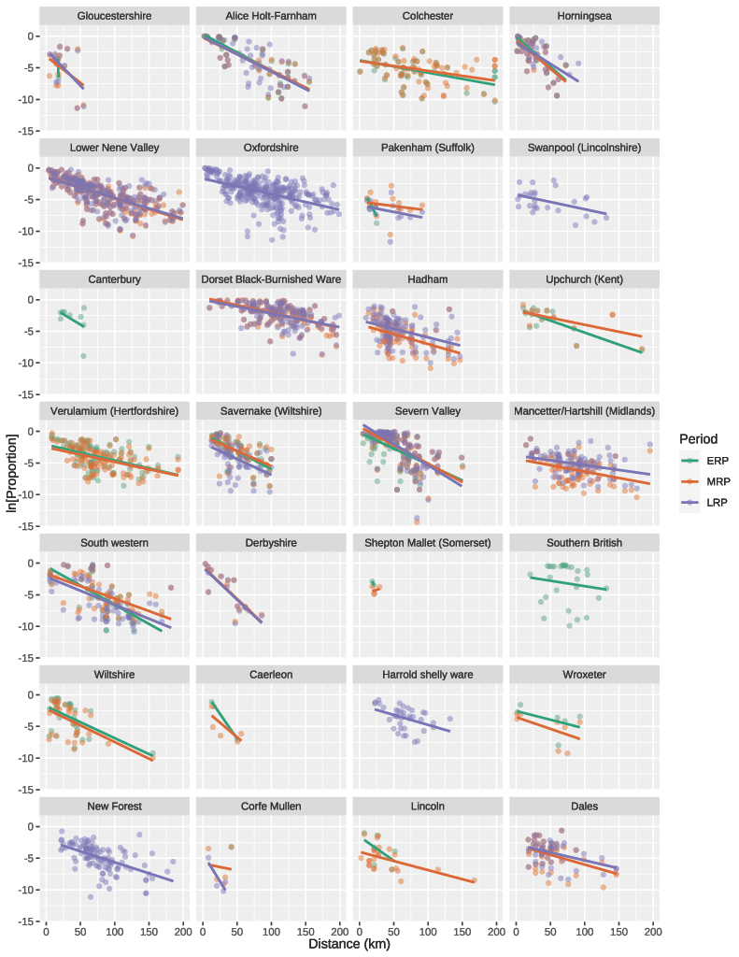

Figure S1b.
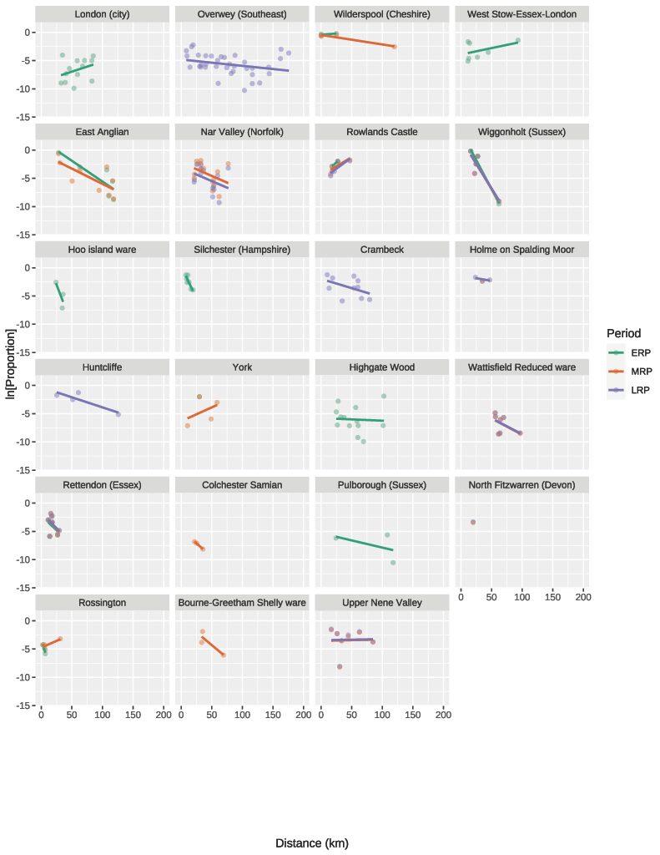

Figure S2.
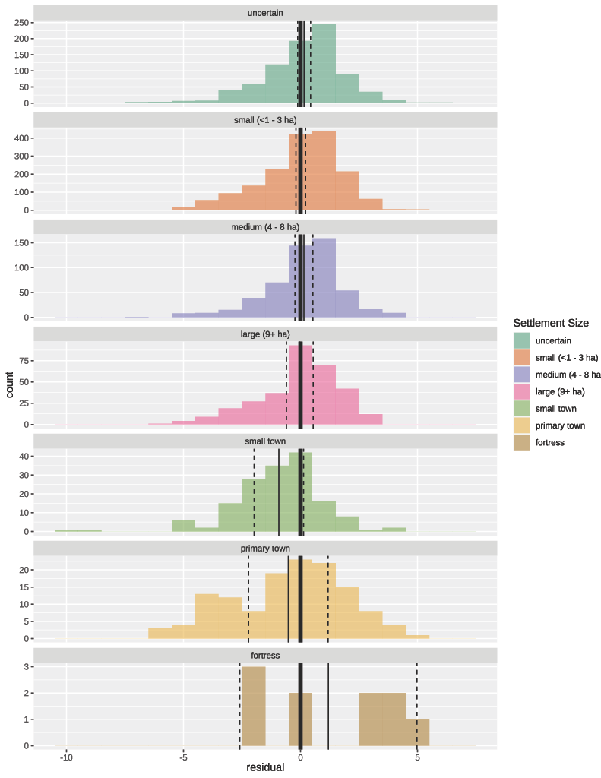

Figure S3.
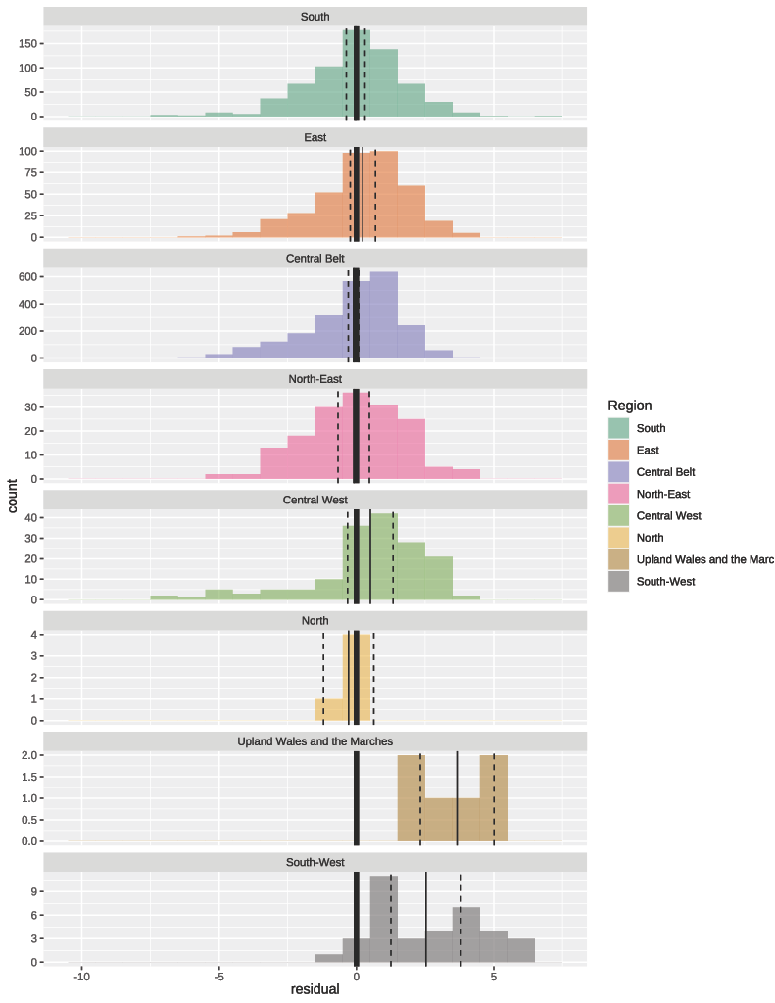

Figure S4.

