Supplementary materials

The supplementary materials includes the content analysis notes that the primary author used during the process. A key is included below for clarity.

Key

Yellow= less inclusive

Green = more inclusive

**Radiotherapy for Brain Tumours** 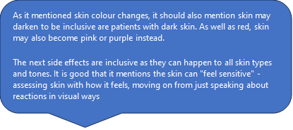

“Skin reaction

Your scalp may become irritated by the radiotherapy. It may become red, dry and itchy and feel sensitive. You can wash your hair or scalp gently with tepid water and a mild shampoo. If you shave your head use an electric razor, do not wet shave. If any areas become sore and uncomfortable we can advise you on a suitable cream to use. You should keep your head covered when out in the sun as the skin will be extra sensitive and can easily burn.”

**Radiotherapy for cancer of the bowel or anal canal** 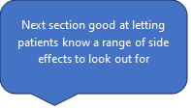

“Skin In the treated area your skin will become inflamed by the radiotherapy, For rectal cancer the skin reaction is minimal, For anal cancer : • The skin will start to look pink and then red • + only giving advice suitable for light skin

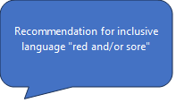 Some people find that their skin tender, sore or itchy • Small areas may become moist and peel. This is most likely to happen where the skin folds and creases such as the groins • The radiographers will look at your skin each day and advise on the use of creams or dressings to keep it as comfortable as possible. [+ only giving advice suitable for light skin]

Please check with the radiographers before using any creams yourself. The skin reaction will carry on developing for about a week after your treatment has finished. This means that your skin may become more red and sore during this time.

 Continue with your skin care advice until the reaction has settled. Most people find that by six weeks from the end of treatment their skin feels normal again. If your skin reaction changes and you are not sure what to do please telephone radiotherapy information and support for advice on 0115 962 7976. If the radiographers and doctors feel your skin reaction is more severe than expected then your treatment may be suspended for one to two weeks to let it recover. In rare cases the treatment may be stopped completely. As your skin may be more sensitive during treatment we suggest that you care for it in the following ways: • Wash gently with warm water • Use a mild, perfume-free soap • Pat skin dry with a soft towel • Take special care in skin folds or creases • Wear loose, soft clothing that won’t rub your skin • Avoid direct sunshine on the treated area • Do not scratch, rub or massage the area 4 If your skin becomes red or feels sore ask the radiographer treating you for advice. These side effects should begin to settle down about two weeks after you treatment has finished.”

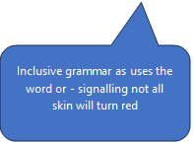

**Radiotherapy for Cancer of the mouth or throat**

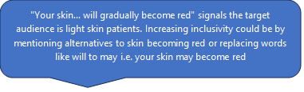

“Sore skin:Your skin in the treated area will gradually become red and may feel dry and itchy.

+ only giving advice suitable for light skin

To care for your skin from the start of your treatment: • Wash gently with soap and warm water • Pat dry with a soft towel • Moisturise regularly with an emollient cream • Wear loose, soft clothing that does not rub the skin • If you need to shave, try to use an electric razor. After two to three weeks the beard will stop growing in the treated area • Avoid direct sunshine on the treated area. Continue to protect from sun for at least a year following treatment Towards the end of your course of treatment some areas of skin may crack or peel. We may need to dress these areas to make you more comfortable.

Skin: Your skin will recover well from your treatment but a few people may notice tiny blood vessels visible under the skin in the treated area. This is called telangiectasia.

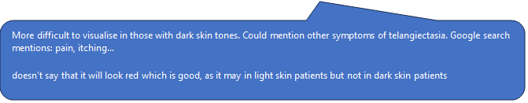

**Radiotherapy for localised breast cancer**

“Skin changes Skin care advice is given on the first day of treatment. Changes in the skin will begin to appear



+

after the first one or two weeks of treatment. It develops gradually.

+ Only giving advice suitable for light skin

 • The skin of the breast can start to look pink and may become red.



• Some people find that it feels tender, sore or itchy.

^ Is the sentence structure and order of ideas in the brochure organised in a way biased to light skin? [?mention effects that everyone can get, then mention colour?]

• Small areas may become moist and peel. This is most likely to happen under your breast. The radiographers will look at your skin each day and give advice as needed.

+

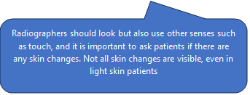

You will also have review appointments in a clinic. • The skin reaction will carry on developing for about one to two weeks after treatment has finished. After this time it will usually settle down quite quickly and by four to six weeks after radiotherapy most of the skin reactions will have settled. Your skin will recover well from the radiotherapy, but you may notice tiny blood vessels under the skin on small areas of the treated breast. This is called telangiectasia. It is harmless and nothing to worry about.

You will be given a follow-up appointment after completion of radiotherapy to check that the radiotherapy reactions have settled down. This is usually four to eight weeks after completing your radiotherapy treatment. If you are concerned about your skin reaction before that appointment please contact the information and support radiographers on 0115 962 7976. After this appointment you will be discharged back to the care of the team in the breast institute or the team at KMH.”

**Radiotherapy for localised cancer of the Larynx**

“Sore skin Your skin in the treated area will gradually become red authors comments = "may gradually become pink, red, or other colour changes such as skin darkening

^

and may feel

+

dry and itchy. Towards the end of your course of treatment some areas of skin may crack or peel.

+

The radiographers treating you will advise you how to look after your skin during treatment.

Skin Your skin will recover well from your treatment but a few people may notice tiny blood vessels visible under the skin in the treated area. This is called telangiectasia.”

**Radiotherapy for oesophagus cancer**

“Skin Some people develop a skin reaction in the treatment area but an emollient cream is usually enough to soothe it.” Authors comment = inclusive language

+

**Radiotherapy for skin cancer**

“As radiotherapy is a localised form of treatment any side effects you might experience depend on the area being treated. The most common side effect is some redness and soreness of the skin.

+

This gradually settles over the six to eight weeks after the radiotherapy has finished. Skin changes then occur over a longer period of months or years. In the majority of patients the area of skin that has been treated will be a little lighter

+

than the surrounding skin and tiny blood vessels may be visible.”

**Radiotherapy information for patients**

“Will my skin get sore? You may have a skin reaction during the course of your radiotherapy. Whether or not you have a reaction depends on the dose you are given, the area treated and your individual sensitivity. You may get a reaction on the other side of your body to the treatment area. For example treatment to the front of the shoulder can make the skin red

+

on the back of the shoulder. Many people have no skin reaction at all. We will tell you what to expect from your treatment. If you have a skin reaction it will develop gradually. It will start to look pink and then red.

+

 It may feel tender, sore or itchy.

^

Towards the end of treatment a few people may find some areas are moist and peeling.

^

This is most likely to happen in skin folds and creases. Radiographers look

+

at your skin each day and give you advice to keep it as comfortable as possible. Skin care advice is given to you on your first day of treatment. Skin reactions usually settle down two to four weeks after the treatment has finished. A few people may find that the skin in the treated area always looks slightly darker than the surrounding area.”

+

**Radiotherapy to the chest**

“Skin: Most people don’t have any skin reaction during and after treatment to the chest, but a few experience some reddening

+

and itchiness

+

in the treated area. A mild moisturiser is usually enough to soothe it.”

**Radiotherapy to the pelvis for bladder cancer**

“Skin You may

+

 see some reddening

+

 of the skin in the treatment area. This is unlikely to be troublesome but you can use a moisturising cream in the treatment area. Please check with the radiographers before using any creams yourself.”

**Radiotherapy to the pelvis for prostate cancer (same as radiotherapy to the pelvis for bladder cancer leaflet)**

[“Skin You may see some reddening of the skin in the treatment area. This is unlikely to be troublesome. If the skin becomes uncomfortable keeping the skin moisturised can help. Please check with the radiographers before using anything.”]

**Radiotherapy to the pelvis for gynecological cancers**

“Skin and pubic hair Generally, radiotherapy to the pelvis does not cause a skin reaction. However, if the treatment area includes skin folds or creases such as in the groin, labia or between the buttocks, then these areas are likely to become sore.

+

It is possible that pubic hair will fall out during treatment but it should return after treatment. It is important not to use any methods of hair removal in the pelvic area as this will irritate the skin. To minimise skin reactions wash the area gently with unperfumed soap and lukewarm water and pat dry with a soft towel. If your skin becomes uncomfortable,

+

 ask the radiographers for advice, as gels and dressings can be used if required.”

**TSET for mycosis fungoides (skin lymphoma)**

“Skin changes Your skin in the treated area will become inflamed

+

by the radiotherapy: • It will start to look pink and then red •

+

 Some people find that it feels tender, sore or itchy •

+

 Some areas may become moist and peel. The radiographers will look Authors comment = Should feel, ask questions as some reactions hard to visualise

+

at your skin each day and provide skin care advice. The skin reaction will carry on developing for about a week after your treatment has finished. This means that your skin may become more red

+

and sore during this time. Continue with your skin care advice until the reaction has settled. Most people find that by six weeks from the end of treatment their reaction has settled down. It takes longer for the skin to heal in areas most affected by the mycosis fungoides. If your skin reaction changes and you are not sure what to do please telephone for advice. 6 Skin care during treatment As your skin may be more sensitive during treatment. We suggest that you care for it in the following way: • Wash gently with warm water • Use a mild, unperfumed soap • Pat dry with a soft towel • Take special care in skin folds or creases • Smooth on an emollient cream, or any of your normal creams if they have been approved by the doctor • Wear loose, soft cotton clothing that won’t rub your skin • If you need to shave try to use an electric razor. After two to three weeks the hair will stop growing in the treated area • Avoid direct sunshine on the treated area • Do not scratch, rub or massage the area

Delayed side effects These may occur months or years after the radiotherapy treatment: • Generalised dry skin • Decreased secretion of sweat and oil from much of the skin • Skin pigmentation changes

+ Author comments = skin pigmentation is good phrase. Skin pigmentation instead of red/pink etc

and the appearance of tiny blood vessels under the skin. This is called telangiectasia • It is possible that your hair may not grow back very well, if the head is treated • Finger and toe nails may not grow back properly, unless they are shielded during treatment”