Supplemental Figure 1: CONSORT Flow Diagram
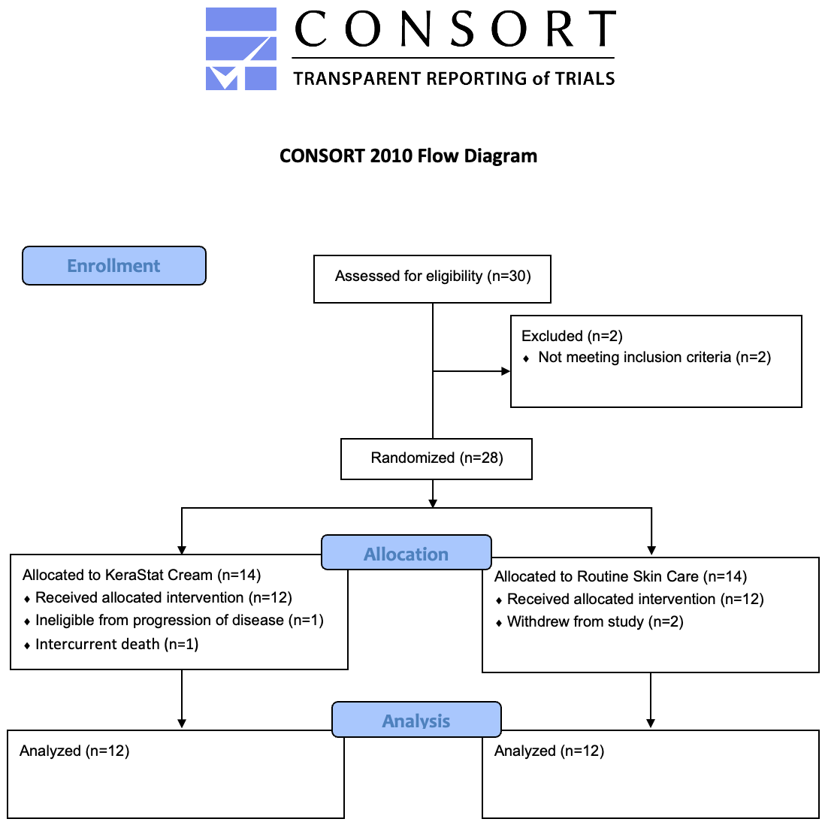
Supplemental Table 1: Options for topical agents utilized in the standard of care group
Petroleum-based ointments (Aquaphor®, Balmex®, EltaMD®)
Eucerin®
Lubriderm®
Aveeno®
Calendula-containing creams or gels
Cetaphil®
CeraVe®

Supplemental Table 2: Agreement between the CTCAE and PRO-CTCAE measures of radiation dermatitis. Data are presented as count (percent of total).
CTCAE Radiation Dermatitis Grade | PRO-CTCAE Radiation Skin Reaction Grade
 | 0 | 1 | 2 | 3 | 4 | Total
0 | 59 (33.3) | 13 (7.3) | 6 (3.4) | 1 (0.6) | 0 (0) | 79 (44.6)
1 | 26 (14.7) | 22 (12.4) | 17 (9.6) | 2 (1.1) | 0 (0) | 67 (37.9)
2 | 2 (1.1) | 8 (4.5) | 10 (5.7) | 4 (2.3) | 4 (2.3) | 28 (15.8)
3 | 0 (0) | 0 (0) | 1 (0.6) | 1 (0.6) | 1 (0.6) | 3 (1.7)
4 | 0 (0) | 0 (0) | 0 (0) | 0 (0) | 0 (0) | 0 (0)
Total | 87 (49.1) | 43 (24.3) | 34 (19.2) | 8 (4.5) | 5 (2.8) | 177 (100)

