Online Appendix
- Categorization Task and Judges’ Agreement
To validate our musical categories, we asked six independent judges (3 for each treatment) to classify each of the 200 music tracks into one of the four music categories or an additional “Other” category if they could not place it. No learning was possible since judges did not receive feedback on their performance. Judges were randomly drawn from the same subject pool.
The column labeled “% matching” in the table below reports the proportion of tracks judges classified in line with our intended categories.
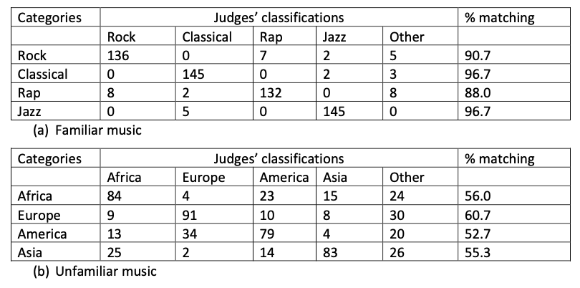
Panel (a) shows the familiar music categories (Rock, Classical, Rap, Jazz) were highly consistent with judges’ perceptions, with correct classification rates above 88% for all styles and reaching as high as 96.7% for Classical and Jazz. This supports the idea that these styles form distinct, well-recognized choice options for participants in the familiar treatment.
Panel (b) shows a lower degree of classification agreement for the unfamiliar music styles (Africa, Europe, America, Asia), with correct matching rates between 52% and 61%. This suggests these musical styles were recognized with greater imprecision which in turn creates richer opportunities for subjects’ preference discovery in the experiment.

II. Instructions
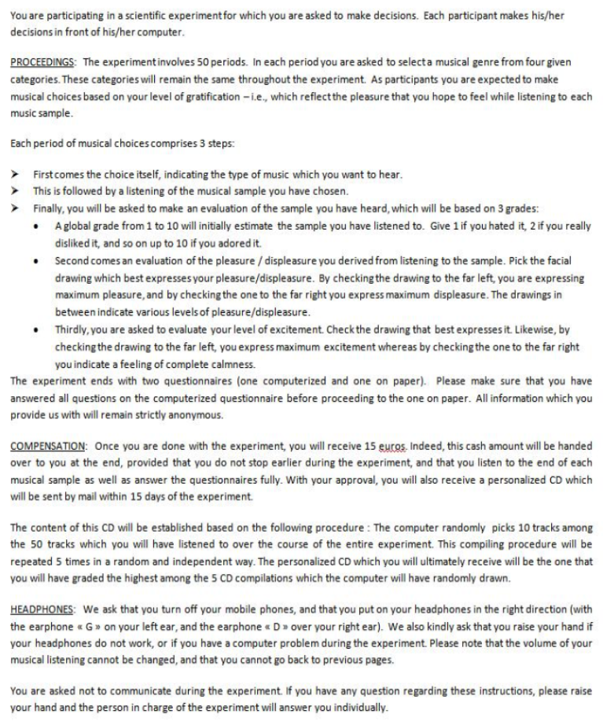
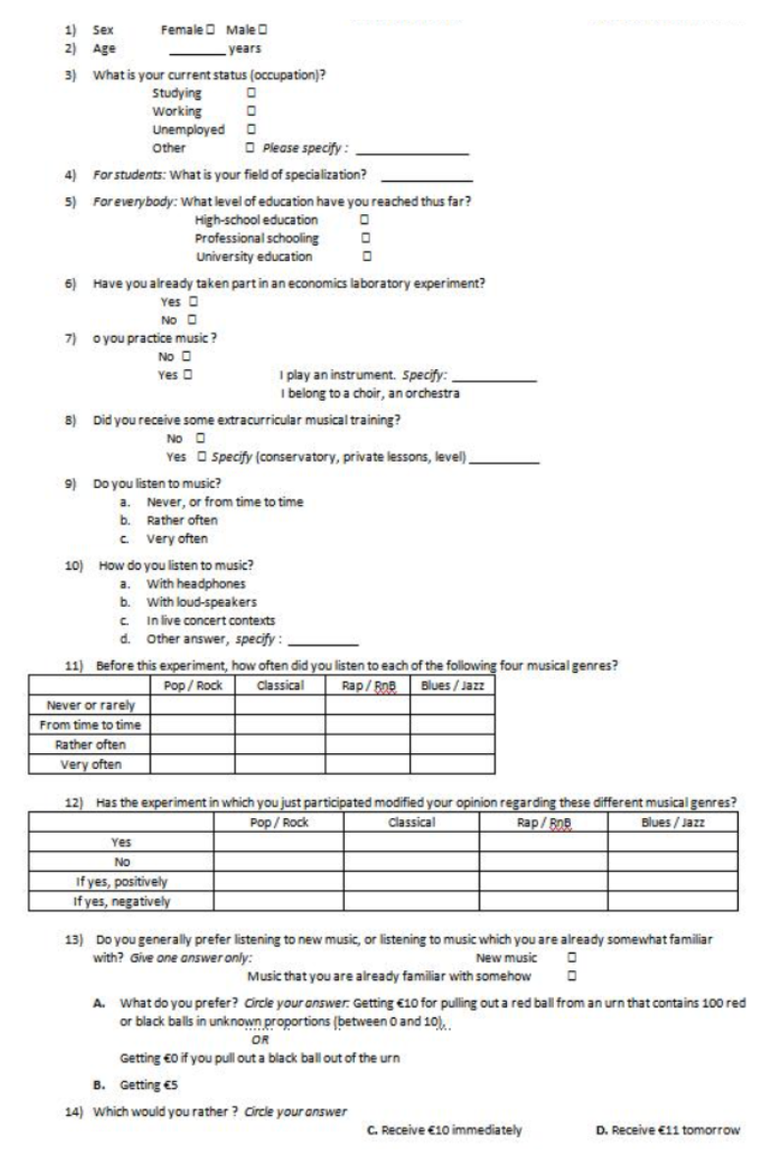

III. Derivation of equation (2): Recurrence and reduced forms
- We assume that the taste of a randomly drawn product of style $j$ is normally distributed:
$$v_{ijt}\sim N\left(μ_{ij},h_{j}\right)$$
where $h_{j}$ is known by the subject, while $μ_{ij}$ is unknown. The initial belief distribution about $μ_{ij}$ is also assumed to be normal with known (for the subject) mean and variance ($μ_{ij0},k_{ij0}$). The agent predicts he will have taste $μ_{ij0}$ for variety j at round 1.
After consuming a product from variety $j$ (i.e., $x_{ij1}=1)$, the subject $i$ updates his prior. The posterior belief is also normally distributed with mean and variance ($μ_{ij1},k_{ij1}$) (see DeGroot 1970, Chapter 9) where
$$μ_{ij1}=\frac{1}{\frac{1}{k_{ij0}}+\frac{1}{h_{j}}}\left(\frac{μ_{ij0}}{k_{ij0}}+\frac{v_{ij1}}{h_{j}}\right)$$
$$k_{ij1}=\frac{1}{\frac{1}{k_{ij0}}+\frac{1}{h_{j}}}$$

Developing the above expressions of $μ_{ij1}$ and $k_{ij1}$, we get:
$$μ_{ij1}=\frac{h_{j}}{k_{ij0}+h_{j}}μ_{ij0}+\frac{k_{ij0}}{k_{ij0}+h_{j}}v_{ij1}$$
$$k_{ij1}=\frac{k_{ij0}h_{j}}{k_{ij0}+h_{j}}$$
If we define $ρ_{ij1}=\frac{k_{ij1}}{h_{j}}$, we obtain the set of equations (2) for $t=1$ under the assumption that variety $j$ was selected. Finally, we obtain the general expression of equations (2) which allows variety $j$ to be selected if $x_{ij1}=1$, or not selected if $x_{ij1}=0$, by defining $ρ_{ij1}=x_{ij1}\frac{k_{ij1}}{h_{j}}$.
In the same way, at date $t$, with the prior belief ($μ_{ijt-1},k_{ijt-1}$) about variety $j$, consuming a product from $j$ leads the agent to update his belief. The posterior distribution is normal with mean and variance ($μ_{ijt},k_{ijt}$), with
$$μ_{ijt}=\frac{1}{\frac{1}{k_{ijt-1}}+\frac{1}{h_{j}}}\left(\frac{μ_{ijt-1}}{k_{ijt-1}}+\frac{v_{ijt}}{h_{j}}\right)$$
$$k_{ijt}=\frac{1}{\frac{1}{k_{ijt-1}}+\frac{1}{h_{j}}}$$
If we define $ρ_{ijt}=x_{ijt}\frac{k_{ijt}}{h_{j}}$, we obtain the set of equations (2) for all values of $t≥1$.

- Now, equations (2) can be used to write $μ_{ijt}$, $k_{ijt}$ and $ρ_{ijt}$ as functions of the parameters of the model:
$$k_{ijt}=\frac{1}{\frac{1}{k_{ij0}}+\frac{n_{ijt}}{h_{j}}}$$
$$ρ_{jt}=\frac{\frac{x_{ijt}}{h_{j}}}{\frac{1}{k_{ij0}}+\frac{n_{ijt}}{h_{j}}}$$
$$μ_{ijt}=\frac{1}{\frac{1}{k_{ij0}}+\frac{n_{ijt}}{h_{j}}}\left(\frac{μ_{ij0}}{k_{ij0}}+\frac{V_{ijt}}{h_{j}}\right)$$
with $n_{ijt}=\left(\sum_{θ=1}^{t}{x_{ijθ}}\right)$, the number of times $j$ has been chosen, $V_{ijt}=\left(\sum_{θ=1}^{t}{x_{ijθ}v_{ijθ}}\right)$ the total taste derived from those choices, and where $v_{ijt}=u_{ijt}-\frac{α_{j}}{1+n_{ijt}}$ is the taste for variety $j$ after consuming $n_{ijt}$ products from variety $j$ until round $t$.
This is simply the posterior hyperparameters of a normal with known variance, estimated from all consumptions of variety $j$ until $t$.

