Supplementary Information

Table S1
Correlations among outcome variables (Experiment 1)
 | PD | DG | PGG | TG | TG | UG | UG
 |  |  |  | (sender) | (receiver) | (proposer) | (responder)
PD | 1 | .15*** | .11*** | .05 | .09* | .02 | .04
DG |  | 1 | .34*** | .32*** | .40*** | .43*** | -.02
PGG |  |  | 1 | .46*** | .38*** | .36*** | -.06
TG (sender) |  |  |  | 1 | NA | .38*** | .00
TG (receiver) |  |  |  |  | 1 | .38*** | .01
UG (proposer) |  |  |  |  |  | 1 | NA
UG (responder) |  |  |  |  |  |  | 1
Note. This table presents Pearson correlation coefficients with pairwise deletion. PD = Prisoner’s Dilemma, DG = Dictator Game, PGG = Public Goods Game, TG = Trust Game, UG = Ultimatum Game.
* p<.05, ** p<.01, *** p<.001

Table S2
Results from exploratory regression analyses of back-transfers in the Trust Game when the sender transfers maximum amount possible (Experiment 1)
 | Beta  (SE) | Beta  (SE)
Condition
Hypothetical (ref: Random) | 1.4  (2.01) | 1.5  (2.03)
Full (ref: Random) | -0.72  (1.97) | -0.39  (1.99)
Full (ref: Hypothetical) | -2.1  (1.80) | -1.9  (1.82)
Age |  | -0.01  (0.070)
Gender
Female (ref: Male) |  | -2.3  (1.59)
N | 750 | 738
R² | 0.002 | 0.004

Table S3
Results from regression analyses of behavior in the games, excluding participants who failed the attention check (Experiment 1)
 | Composite score |  | Dictator game |  | Public goods game |  | Trust game (sender) |  | Trust game (receiver) |  | Ultimatum game (proposer) |  | Ultimatum game (responder) |  | Prisoner's dilemma
 | Beta (SE) | Beta  (SE) | Beta  (SE) | Beta  (SE) | Beta  (SE) | Beta  (SE) | Beta  (SE) | Beta  (SE) | Beta  (SE) | Beta  (SE) | Beta  (SE) | Beta  (SE) | Beta  (SE) | Beta  (SE) | OR  (SE) | OR  (SE)
Condition
Hypothetical (ref: Random) | 0.00 (0.039) | 0.01 (0.040) | -0.92 (1.54) | -0.80 (1.56) | 0.50 (2.06) | 1.6  (2.06) | -1.5 (3.04) | 0.32  (2.99) | 1.4 (1.81) | 1.5 (1.83) | -2.6 (1.80) | -2.1 (1.81) | -0.31 (2.01) | -0.16  (1.99) | 1.12 (0.136) | 1.13 (0.138)
Full (ref: Random) | -0.02 (0.040) | -0.01 (0.040) | -3.0 (1.51) | -2.7  (1.52) | 2.5 (2.05) | 2.9  (2.07) | -3.6 (3.08) | -3.3  (3.09) | 0.02 (1.79) | 0.35 (1.81) | -0.63 (1.72) | -0.55 (1.73) | -2.1 (1.96) | -2.1  (1.97) | 0.98 (0.135) | 1.00 (0.138)
Full (ref: Hypothetical) | -0.01 (0.039) | -0.02 (0.040) | -2.0 (1.52) | -1.9  (1.55) | 2.0 (2.07) | 1.3  (2.08) | -2.1 (3.14) | -3.6  (3.16) | -1.4 (1.65) | -1.1 (1.67) | 1.9 (1.82) | 1.6 (1.84) | -1.8 (1.96) | -1.9  (1.94) | 0.87 (0.135) | 0.88 (0.138)
Age |  | 0.00 (0.001) |  | 0.16 (0.058)** |  | 0.06 (0.080) |  | 0.00 (0.125) |  | 0.00 (0.066) |  | 0.01 (0.062) |  | 0.31 (0.074)*** |  | 1.02 (0.006)***
Gender
Female (ref: Male) |  | -0.04 (0.032) |  | 2.3  (1.26) |  | -7.6 (1.68)*** |  | -14 (2.49)*** |  | -1.8 (1.44) |  | -2.7 (1.46) |  | -6.0 (1.61)*** |  | 1.36 (0.114)**
N | 1,405 | 1,375 | 1,405 | 1,375 | 1,405 | 1,375 | 696 | 678 | 709 | 697 | 709 | 696 | 603 | 588 | 1,405 | 1,375
R² | 0.000 | 0.003 | 0.003 | 0.010 | 0.001 | 0.016 | 0.002 | 0.046 | 0.001 | 0.003 | 0.003 | 0.007 | 0.002 | 0.043
AIC |  |  |  |  |  |  |  |  |  |  |  |  |  |  | 1,863 | 1,803
Notes. This table shows results from regression analyses of behavior in the games (logistic regression for the Prisoner’s Dilemma; OLS regressions for all other games and the composite measure; robust standard errors in parentheses). The first two rows show estimates from models with the Random incentive scheme as reference condition and the third row shows estimates from a model with Hypothetical as the reference condition. OR = Odds ratio. In the Dictator Game, the dependent variable (DV) is the participant’s contribution to the other player (% of the endowment). In the Public Goods Game, the DV is the participant’s contribution to the group account (% of the endowment). For Trust Game senders, the DV is an ordinal variable indicating the % of the endowment transferred to the receiver (with possible values 0%, 33%, 67%, or 100%). For Trust Game receivers, the DV is the % of the total possible back-transfer that the participant transferred to the sender (i.e., across all possible non-zero transfers from the sender). For Ultimatum Game proposers, the DV is the amount offered to the responder (% of the endowment). For Ultimatum Game responders, the DV is the minimum acceptable offer from the proposer (i.e., the switching point; % of the proposer’s endowment). In the Prisoner’s Dilemma, the DV is a binary variable, coded as 1 if the participant chose A (cooperate) and 0 if they chose B (defect). For the composite measure of prosocial behavior, each DV was standardized into a z-score and averaged. Hypothetical is the no-payment (hypothetical) incentive scheme; full is the full-payment incentive scheme; both variables are coded as binary variables with the random-payment incentive scheme as the reference category. Age is the participant’s age in years. Female is a gender dummy.
* p < .05, ** p < .01, *** p < .001

Table S4
Results from equivalence tests (Experiment 1)
 | Equivalence bound (Cohen’s D) | No-payment –Random-payment | Random-payment – Full-payment | No-payment – Full-payment
Composite prosociality | 0 +- 0.2 | Equivalence  True MD = [-0.12 SD, 0.12 SD] | Equivalence  True MD = [-0.12 SD, 0.12 SD] | Equivalence  True MD = [-0.12 SD, 0.12 SD]
DG | 0 +- 0.2 | Equivalence  True MD = [-4.74 %, 4.74 %] | Inconclusive | Equivalence  True MD = [-4.68 %, 4.68 %]
PGG | 0 +- 0.2 | Equivalence  True MD = [-6.30 %, 6.30 %] | Equivalence  True MD = [-6.26 %, 6.26 %] | Equivalence  True MD = [-6.31 %, 6.31 %]
TG sender | 0 +- 0.3 | Equivalence  True MD = [-9.99%, 9.99%] | Equivalence  True MD = [-9.96%, 9.96%] | Equivalence  True MD = [-9.94%, 9.94%]
TG receiver | 0 +- 0.3 | Equivalence  True MD = [-6.08%, 6.08%] | Equivalence  True MD = [-5.97%, 5.97%] | Equivalence  True MD = [-5.60%, 5.60%]
UG proposer | 0 +- 0.3 | Equivalence  True MD = [-6.12%, 6.12%] | Equivalence  True MD = [-5.78%, 5.78%] | Equivalence  True MD = [-6.11%, 6.11%]
UG responder | 0 +- 0.3 | Equivalence  True MD = [-5.89, 5.89] | Equivalence  True MD = [-5.91, 5.91] | Equivalence  True MD = [-5.84, 5.84]

Table S5
p-values from tests of first-order stochastic dominance (FOSD; Experiment 1)
 | DG | PGG | TG sender | TG receiver | UG proposer | UG responder
Random FOSD no  No FOSD random | .680  .339 | .642  .813 | .395  .416 | .100  .344 | .855  .078 | .532  .610
Full FOSD random  Random FOSD full | .102  .919 | .638  .035 | .234  .648 | .427  .368 | .367  .906 | .175  .836
Full FOSD no  No FOSD full | .178  .812 | .765  .033 | .560  .769 | .196  .864 | .786  .127 | .149  .843
Notes. H0: cannot reject dominance. p-value < a, we reject that variable_1 can dominate variable_2 at the level a (see Barrett & Donald, 2003).

Table S6
Correlations among outcome variables (Experiment 2)
 | PD | DG | PGG | TG | TG | UG | UG
 |  |  |  | (sender) | (receiver) | (proposer) | (responder)
PD | 1 | .18*** | .07 | .01 | .17** | .10 | .00
DG |  | 1 | .31*** | .15** | .39*** | .29*** | -.08
PGG |  |  | 1 | .39*** | .40*** | .33*** | -.07
TG (sender) |  |  |  | 1 | NA | .30*** | -.06
TG (receiver) |  |  |  |  | 1 | .35*** | .03
UG (proposer) |  |  |  |  |  | 1 | NA
UG (responder) |  |  |  |  |  |  | 1
Note. This table presents Pearson correlation coefficients with pairwise deletion. PD = Prisoner’s Dilemma, DG = Dictator Game, PGG = Public Goods Game, TG = Trust Game, UG = Ultimatum Game.
* p<.05, ** p<.01, *** p<.001

Table S7
Results from regression analyses of behavior in the games, excluding participants who failed the attention check (Experiment 2)
 | Composite  score |  | Dictator Game |  | Public Goods Game |  | Trust Game  (sender) |  | Trust Game  (receiver) |  | Ultimatum Game  (proposer) |  | Ultimatum Game  (responder) |  | Prisoner’s dilemma
 | Beta  (SE) | Beta  (SE) | Beta  (SE) | Beta  (SE) | Beta  (SE) | Beta  (SE) | Beta  (SE) | Beta  (SE) | Beta  (SE) | Beta  (SE) | Beta  (SE) | Beta  (SE) | Beta  (SE) | Beta  (SE) | OR  (SE) | OR  (SE)
Condition
Hypothetical (ref: Random) | 0.03 (0.056) | 0.04 (0.057) | 0.51 (2.06) | 0.58 (2.09) | 8.1 (2.55)** | 7.9 (2.57)** | 6.9 (3.72) | 7.5 (3.73)* | -0.19 (2.21) | -0.25 (2.23) | -0.33 (2.05) | -0.37 (2.17) | 0.98 (0.270)*** | 1.0 (0.277)*** | 0.94 (0.192) | 0.97 (0.195)
Full (ref: Random) | 0.17 (0.051)*** | 0.17 (0.052)*** | 2.9 (1.82) | 3.0 (1.86) | 6.9 (2.41)** | 6.4 (2.42)** | 5.6 (3.48) | 5.4 (3.48) | 2.9 (2.28) | 2.8 (2.31) | 1.7 (1.96) | 1.6  (2.08) | -0.44 (0.248) | -0.44 (0.250) | 1.39 (0.197) | 1.42 (0.201)
Full (ref: Hypothetical) | 0.14 (0.055)* | 0.14 (0.056)* | 2.4 (2.00) | 2.4 (2.03) | -1.2 (2.65) | -1.4 (2.67) | -1.2 (3.71) | -2.1 (3.75) | 3.1 (2.44) | 3.0 (2.46) | 2.0 (2.16) | 2.0  (2.19) | -1.4 (0.272)*** | -1.5 (0.276)*** | 1.49  (0.197)* | 1.46  (0.200)
Age |  | 0.00 (0.002) |  | 0.08 (0.077) |  | 0.06 (0.099) |  | -0.27 (0.143) |  | 0.12 (0.090) |  | 0.12 (0.081) |  | 0.00 (0.011) |  | 1.01 (0.008)
Gender
Female (ref: Male) |  | -0.06 (0.045) |  | -0.40 (1.65) |  | -6.9 (2.11)** |  | -7.9 (2.99)** |  | -2.7 (1.96) |  | -1.5  (1.80) |  | -0.25 (0.222) |  | 1.49 (0.162)*
N | 702 | 691 | 702 | 691 | 702 | 691 | 356 | 350 | 346 | 341 | 352 | 343 | 297 | 295 | 702 | 691
R² | 0.017 | 0.021 | 0.004 | 0.005 | 0.017 | 0.032 | 0.011 | 0.040 | 0.006 | 0.016 | 0.003 | 0.012 | 0.093 | 0.099
AIC |  |  |  |  |  |  |  |  |  |  |  |  |  |  | 911 | 895
Notes. This table shows results from regression analyses of behavior in the games (logistic regression for the Prisoner’s Dilemma; OLS regressions for all other games and the composite measure; robust standard errors in parentheses). The first two rows show estimates from models with the Random incentive scheme as reference condition and the third row shows estimates from a model with Hypothetical as the reference condition. OR = Odds ratio. In the Dictator Game, the dependent variable (DV) is the participant’s contribution to the other player (% of the endowment). In the Public Goods Game, the DV is the participant’s contribution to the group account (% of the endowment). For Trust Game senders, the DV is an ordinal variable indicating the % of the endowment transferred to the receiver (with possible values 0%, 33%, 67%, or 100%). For Trust Game receivers, the DV is the % of the total possible back-transfer that the participant transferred to the sender (i.e., across all possible non-zero transfers from the sender). For Ultimatum Game proposers, the DV is the amount offered to the responder (% of the endowment). For Ultimatum Game responders, the DV is the minimum acceptable offer from the proposer (i.e., the switching point; % of the proposer’s endowment). In the Prisoner’s Dilemma, the DV is a binary variable, coded as 1 if the participant chose A (cooperate) and 0 if they chose B (defect). For the composite measure of prosocial behavior, each DV was standardized into a z-score and averaged. Hypothetical is the no-payment (hypothetical) incentive scheme; full is the full-payment incentive scheme; both variables are coded as binary variables with the random-payment incentive scheme as the reference category. Age is the participant’s age in years. Female is a gender dummy.
* p < .05, ** p < .01, *** p < .001.
Table S8
Results from exploratory regression analyses of backtransfers in the Trust Game when the sender transfers maximum amount possible (Experiment 2)
 | Beta  (SE) | Beta  (SE)
Condition
Hypothetical (ref: Random) | -0.62  (2.19) | -0.68  (2.21)
Full (ref: Random) | 4.7  (2.29)* | 4.5  (2.33)
Full (ref: Hypothetical) | 5.3  (2.46)* | 5.2  (2.48)*
Age |  | 0.07  (0.090)
Gender
Female (ref: Male) |  | -0.15  (0.145)
N | 372 | 367
R² | 0.016 | 0.020
* p < .05, ** p < .01, *** p < .001

Table S9
Results from equivalence tests (Experiment 2)
 | Equivalence bound (Cohen’s D) | No-payment –  Random-payment | Random-payment –  Full-payment | No-payment –  Full-payment
Composite prosociality | 0 +- 0.3 | Equivalence  True MD = [-0.18SD, 0.18SD] | No equivalence | No equivalence
DG | 0 +- 0.3 | Equivalence  True MD = [-6.61%, 6.61%] | Equivalence  True MD = [-5.85%, 5.85%] | Equivalence  True MD = [-6.44%, 6.44%]
PGG | 0 +- 0.3 | No equivalence | No equivalence | Equivalence  True MD = [-8.44%, 8.44%]
TG sender | 0 +- 0.4 | Inconclusive | Inconclusive | Equivalence  True MD = [-11.39%, 11.39%]
TG receiver | 0 +- 0.4 | Equivalence  True MD = [-6.67%, 6.67%] | Inconclusive | Equivalence  True MD = [-7.24%, 7.24%]
UG proposer | 0 +- 0.4 | Equivalence  True MD = [-6.38%, 6.38%] | Equivalence  True MD = [-5.95%, 5.95%] | Equivalence  True MD = [-6.78%, 6.78%]
UG responder | 0 +- 0.4 | No equivalence | No equivalence | No equivalence

Table S10
p-values from tests of first-order stochastic dominance (FOSD; Experiment 2)
 | DG | PGG | TG sender | TG receiver | UG proposer | UG responder
Random FOSD no  No FOSD random | .415  .29 | .002  .792 | .049  .793 | .677  .346 | .082  .288 | .002  .878
Full FOSD random  Random FOSD full | .747  .018 | .919  .007 | .813  .009 | .758  .016 | .805  .191 | .036  .710
Full FOSD no  No FOSD full | .395  .037 | .336  .345 | .179  .462 | .768  .007 | .245  .142 | <.001  .906
Notes. H0: cannot reject dominance. p-value < a, we reject that variable_1 can dominate variable_2 at the level a (see Barrett & Donald, 2003).

Table S11
Number of participants contributing 0%, 50%, and 100% in the Dictator Game
Experiment | Condition | No-payment | Random-payment | Full-payment | χ²(df) | p
1 | 0% | 96 | 93 | 119 | 3.94(2) | .139
1 | 50% | 217 | 236 | 229 | 0.81(2) | .666
1 | 100% | 14 | 9 | 2 | 8.72(2) | .013
2 | 0% | 45 | 33 | 24 | 6.53(2) | .038
2 | 50% | 113 | 106 | 133 | 3.35(2) | .188
2 | 100% | 10 | 2 | 3 | 7.6(2) | .022

Table S12
Results from regression analyses of composite measure without Ultimatum Game responder behavior
 | Experiment 1 |  | Experiment 2
 | Composite score (without UG responders) |  | Composite score (without UG responders)
 | Beta (SE) | Beta  (SE) | Beta  (SE) | Beta  (SE)
Condition
Hypothetical (ref: Random) | 0.00  (0.041) | 0.01  (0.042) | 0.09  (0.058) | 0.10  (0.059)
Full (ref: Random) | -0.03  (0.041) | -0.02  (0.041) | 0.17 (0.053)** | 0.17  (0.054)**
Full (ref: Hypothetical) | -0.03  (0.041) | -0.03  (0.042) | 0.08  (0.058) | 0.07  (0.058)
Age |  | 0.00  (0.001)** |  | 0.00  (0.002)
Gender
Female (ref: Male) |  | -0.08  (0.034)* |  | -0.07  (0.047)
N | 1,501 | 1,471 | 750 | 739
R² | 0.000 | 0.007 | 0.013 | 0.017
* p < .05, ** p < .01, *** p < .001

Table S13
Number of failed attention checks, inconsistent Ultimatum Game (UG) responses, previous experience, and duration of experiment across conditions
 |  | Full sample | By Condition
Experiment | Variable / Level |  | Hypothetical | Random | Full | p
1 | Attention check fails | 96 (6.4%) | 27 (5.4%) | 39 (7.8%) | 30 (6.0%) | 0.27
 | Inconsistent UG responders | 106 (14%) | 33 (14%) | 45 (17%) | 28 (11%) | 0.15
 | Previous experience |  |  |  |  | 0.72
 | No | 353 (24%) | 121 (24%) | 115 (23%) | 117 (23%)
 | Unsure/Don't know | 167 (11%) | 63 (13%) | 53 (11%) | 51 (10%)
 | Yes | 981 (65%) | 317 (63%) | 332 (66%) | 332 (66%)
 | Median duration in sec (IQR) | 395 (289, 552) | 385 (286, 545) | 388 (284, 530) | 411 (299, 571) | 0.06
2 | Attention check fails | 48 (6.4%) | 19 (7.6%) | 15 (6.0%) | 14 (5.6%) | 0.63
 | Inconsistent UG responders | 59 (16%) | 22 (17%) | 14 (11%) | 23 (19%) | 0.16
 | Previous experience |  |  |  |  | 0.38
 | No | 179 (24%) | 61 (24%) | 52 (21%) | 66 (26%)
 | Unsure/Don't know | 108 (14%) | 42 (17%) | 34 (14%) | 32 (13%)
 | Yes | 463 (62%) | 147 (59%) | 164 (66%) | 152 (61%)
 | Median duration in sec (IQR) | 422 (294, 568) | 404 (290, 552) | 444 (319, 577) | 416 (292, 580) | 0.28
Notes. p-values refer to tests of differences between conditions. Duration (in seconds) was tested using the Kruskal–Wallis test; all other variables were tested using Pearson’s chi-squared test.

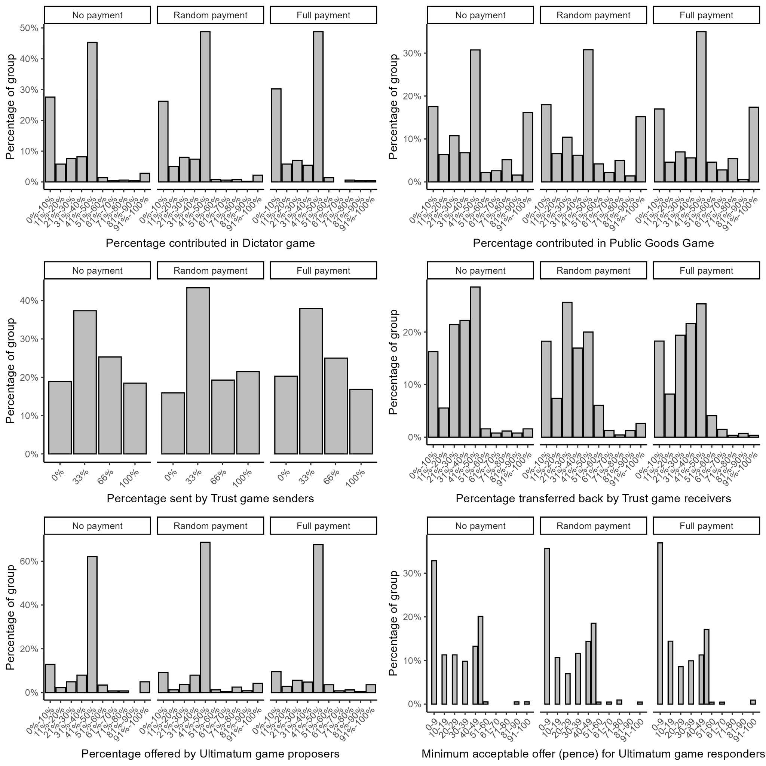
Fig. S1 Distribution of responses in each game and condition (Experiment 1). For the Dictator Game, Public Goods Game, Trust Game receivers, and Ultimatum Game proposers, participants could type in any amount; however, to improve readability of the graphs we have binned their answers into categories in this figure.
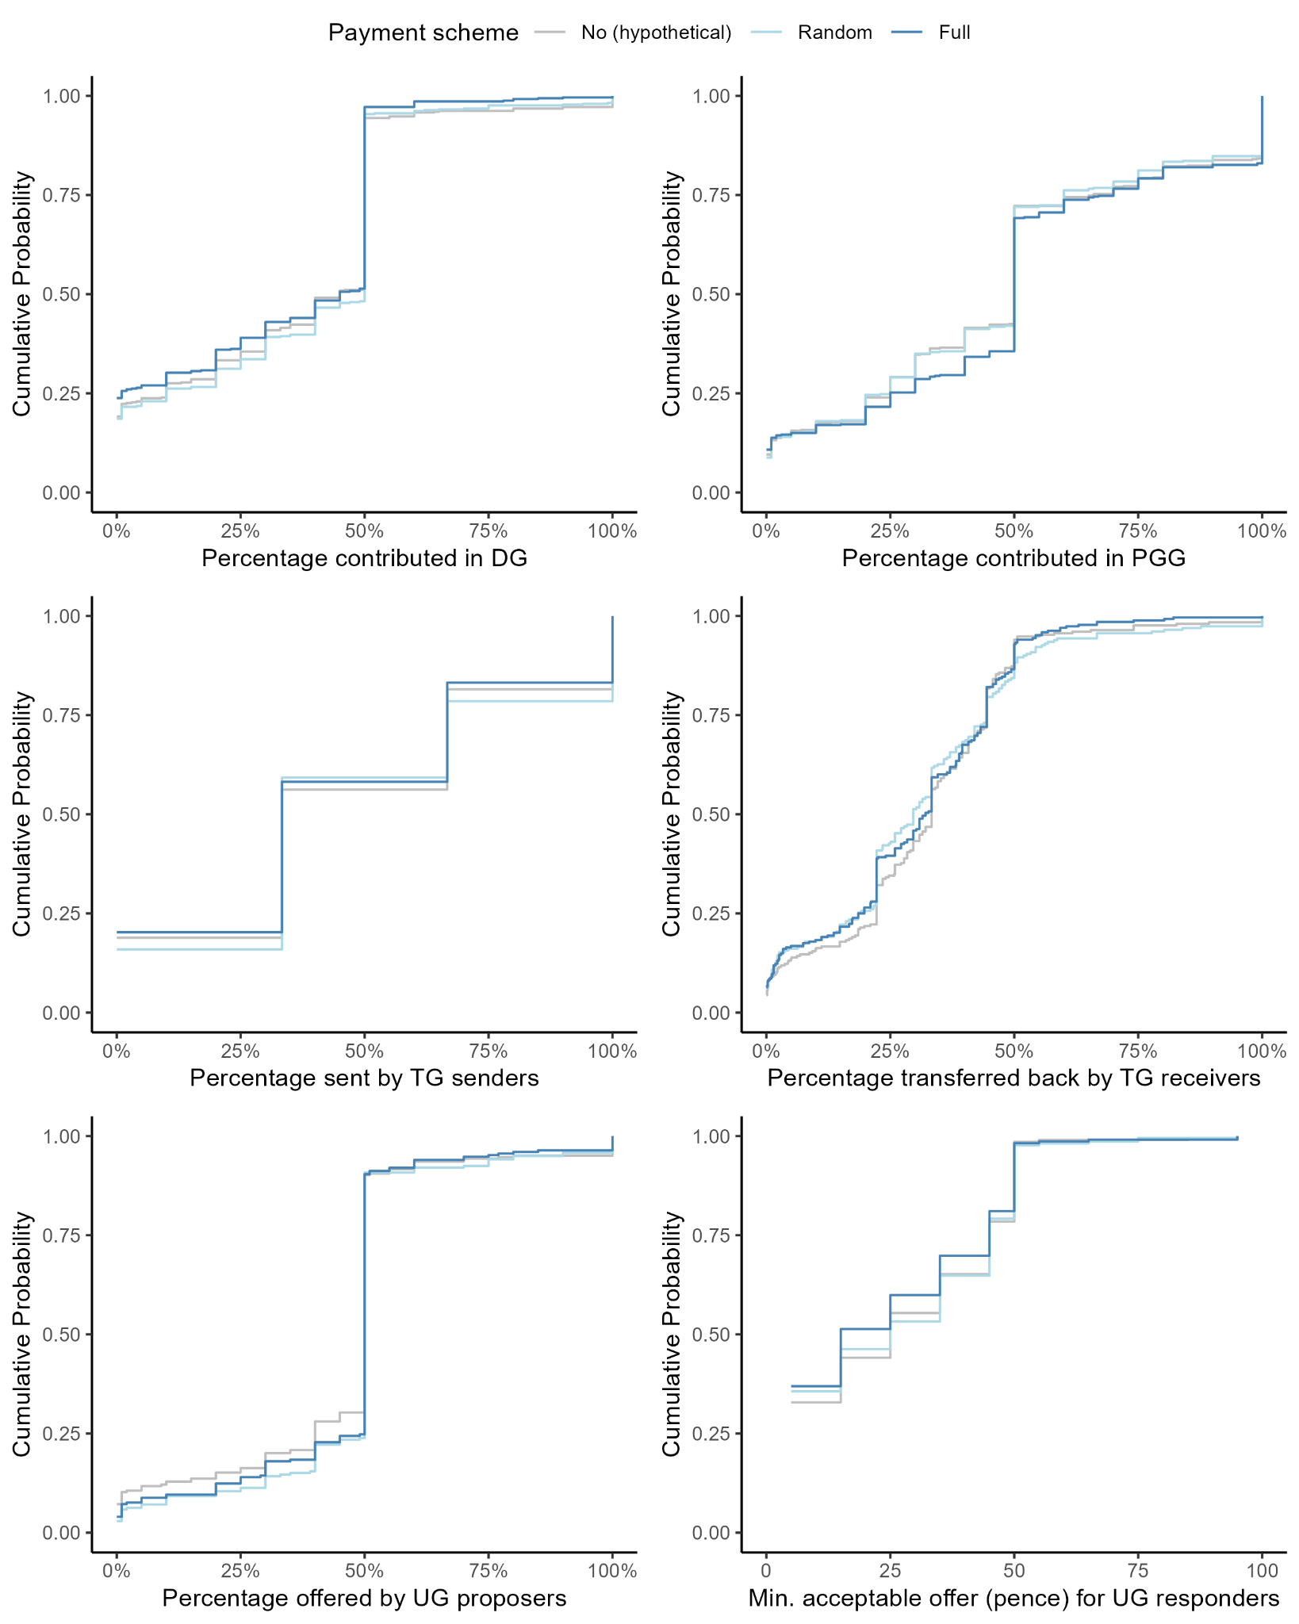
Fig. S2 Empirical cumulative distribution functions for games with continuous outcome variables in Experiment 1. DG = Dictator Game, PGG = Public Goods Game, TG = Trust Game, UG = Ultimatum Game.

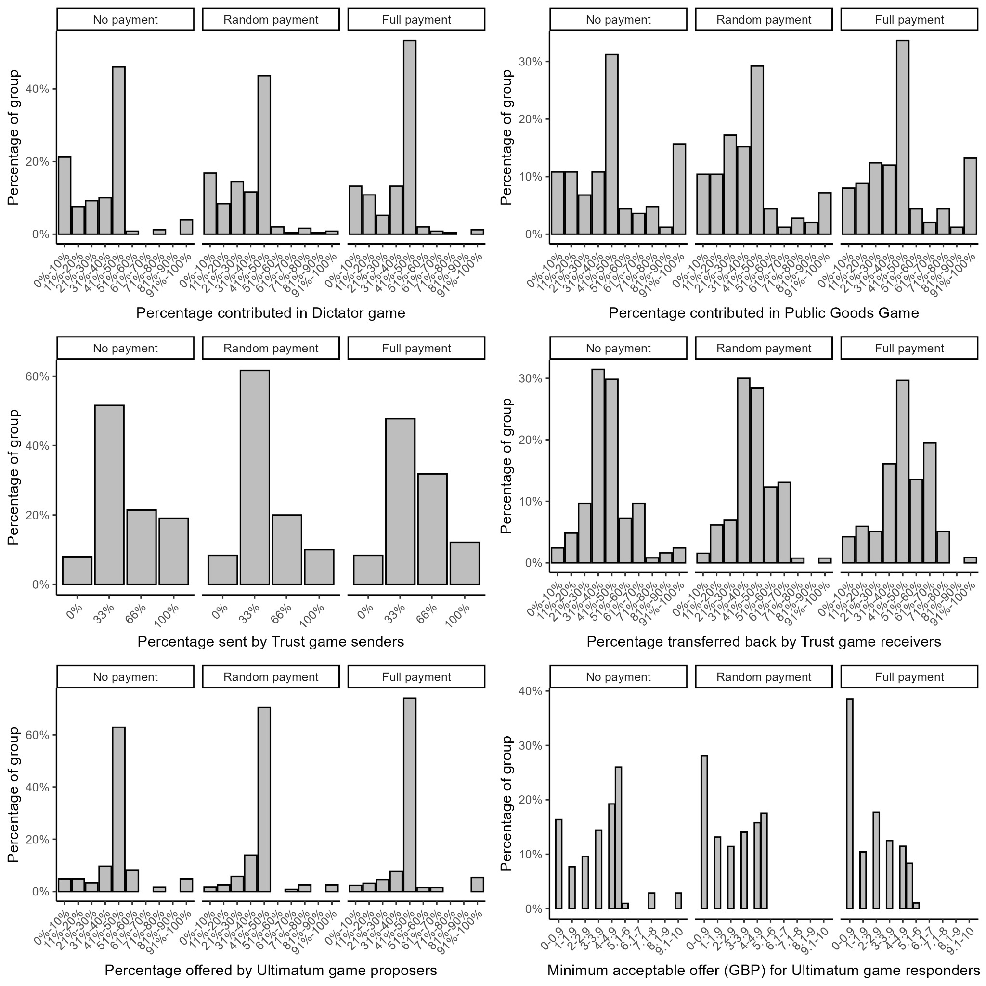Fig. S3 Distribution of responses in each game and condition (Experiment 2). For the Dictator Game, Public Goods Game, Trust Game receivers, and Ultimatum Game proposers, participants could type in any amount; however, to improve readability of the graphs we have binned their answers into categories in this figure.
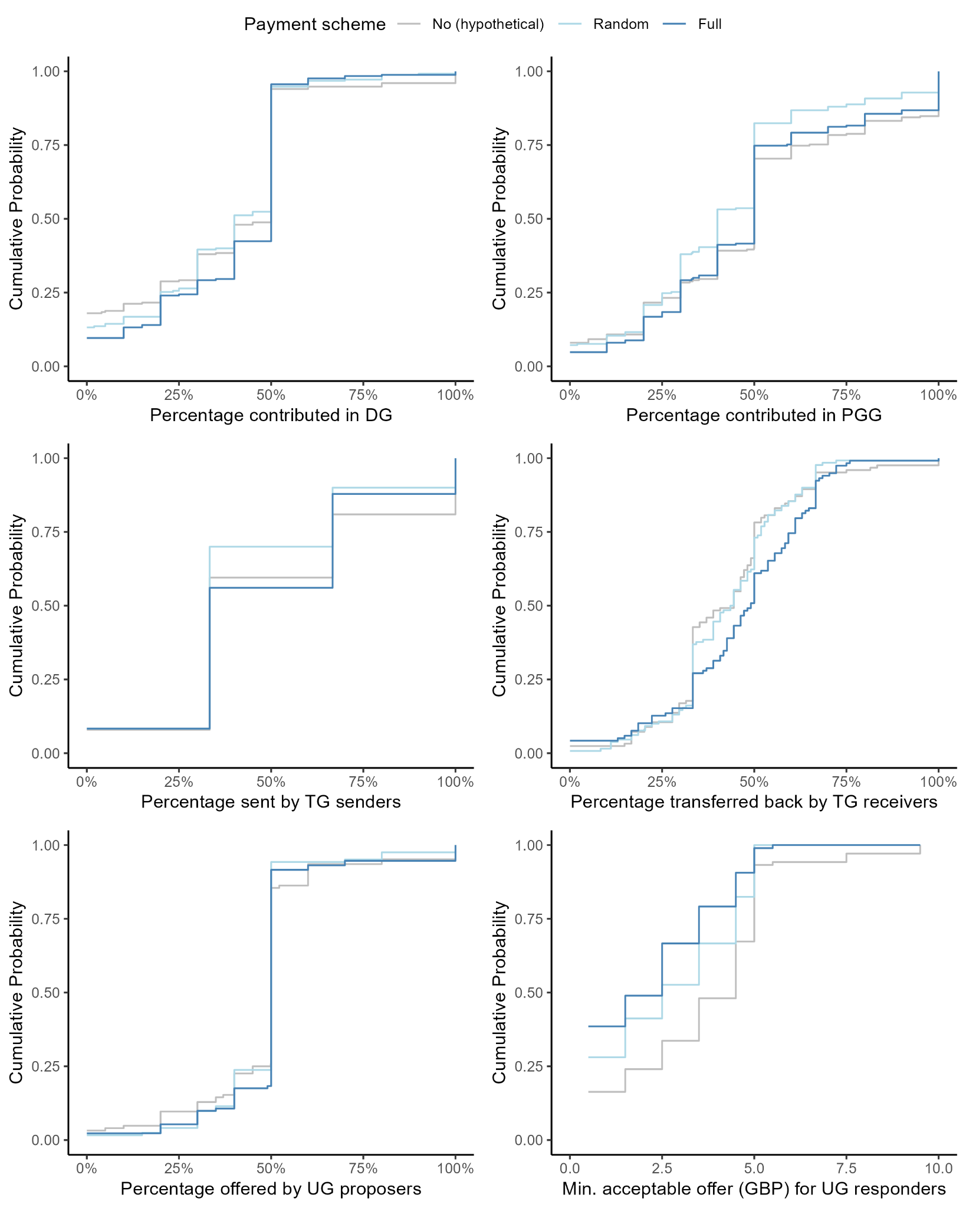
Fig. S4 Empirical cumulative distribution functions for games with continuous outcome variables in Experiment 2. DG = Dictator Game, PGG = Public Goods Game, TG = Trust Game, UG = Ultimatum Game.
Instructions to participants (Experiment 1)

[Consent]

We would like to include you as a participant in a research study. If you agree to participate in this study, we will ask you to make a number of decisions about how to allocate money between yourself and one or more other participants (whose identities will remain unknown to you). Your answers will be treated confidentially, and the results of the survey will be evaluated and presented in an anonymous, summarized form. Participation in this study is voluntary and you can always choose to cancel.
By clicking in "I voluntarily participate in this study" below, you consent to your answers being used, anonymously, as data for our study. We appreciate your participation!

Do you consent to participating in this study? (If you do not consent, simply click forward)
- I voluntarily participate in this study

[Page break]

[For participants assigned to the no-payment (hypothetical) incentive scheme:]

In this study, you are going to complete a series of tasks, in which you will be asked to distribute money between yourself and other people. In each of these tasks, we want you to imagine that you influence the payment of money to yourself and other participants in the experiment.
You will receive £1.50 for completing the entire study.
Please enter your Prolific ID, if it is not already entered automatically:

[For participants assigned to the random-payment incentive scheme:]

In this study, you are going to complete a series of tasks, in which you will be asked to distribute money between yourself and other people. In each of these tasks, we want you to be aware that you influence the payment of money to yourself and other participants in the experiment. You will receive a bonus payment based on the monetary allocations made in one, randomly drawn, task.
You will receive £1.50 for completing the entire study, in addition, you will receive a bonus sum based on one of the tasks.
Please enter your Prolific ID, if it is not already entered automatically:

[For participants assigned to the full-payment incentive scheme:]

In this study, you are going to complete a series of tasks, in which you will be asked to distribute money between yourself and other people. In each of these tasks, we want you to be aware that you influence the payment of money to yourself and other participants in the experiment. You will receive a bonus payment based on the monetary allocations made in all tasks.
You will receive £1.50 for completing the entire study, in addition, you will receive a bonus based on your decisions in each of these tasks.
Please enter your Prolific ID, if it is not already entered automatically:

[Page break]

[The games and an attention check are displayed in random order, each on a separate page.]

[Dictator Game]

[For participants assigned to the hypothetical incentive scheme:] Remember: In each task, we want you to imagine that you influence the payment of money to yourself and other participants in the experiment.

[For participants assigned to the random-payment incentive scheme:] Remember: In each task, we want you to be aware that you influence the payment of money to yourself and other participants in the experiment. You will receive a bonus payment based on the monetary allocations made in one, randomly drawn, task.

[For participants assigned to the full-payment incentive scheme:] Remember: In each task, we want you to be aware that you influence the payment of money to yourself and other participants in the experiment. You will receive a bonus payment based on the monetary allocations made in all tasks.

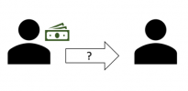
Task A
In this task, you will be randomly paired with one other person.
You are endowed with £1, the other person is endowed with £0.
You will decide how much of your £1 endowment to transfer to the other person. You can choose any amount between £0 and £1. The other person receives the amount that you decide to transfer to him/her. You will receive the amount that you decide not to transfer and thus to keep.

How much of your £1 endowment do you want to transfer to the other person? Please type the amount in pence (between 0-100):

[Page break]
[Public Goods Game]

[For participants assigned to the hypothetical incentive scheme:] Remember: In each task, we want you to imagine that you influence the payment of money to yourself and other participants in the experiment.

[For participants assigned to the random-payment incentive scheme:] Remember: In each task, we want you to be aware that you influence the payment of money to yourself and other participants in the experiment. You will receive a bonus payment based on the monetary allocations made in one, randomly drawn, task.

[For participants assigned to the full-payment incentive scheme:] Remember: In each task, we want you to be aware that you influence the payment of money to yourself and other participants in the experiment. You will receive a bonus payment based on the monetary allocations made in all tasks.

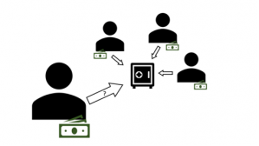
Task B

In this task, you will be randomly assigned to a group with three other people. All of you receive this same set of instructions.
Each group member is endowed with £1.
You are asked to decide how much of your endowment you want to keep for yourself and how much you want to contribute to a group account. You can choose to contribute any amount between £0 and £1.
Your choice influences your own and the other group members’ payment. Likewise, the group members’ choices influence your payment. That is:
- The amount you keep simply remains in your possession: For every 1 pence you keep, you will receive 1 pence in payment.
- The amount you and the other group members contribute to the group account is summed up to a total amount. This total amount is doubled (by the experimenter) and then equally split among all group members, including you. Thus, for every 2 pence contributed to the group account by any one group member, all four group members (including you) receive 1 pence.

Your payment is the sum of
- the amount you keep
- + 0.5 * the total amount contributed to the group account

How much of your £1 endowment do you want to contribute to the group account? Please type the amount in pence (between 0-100):

[Page break]
[Prisoner’s Dilemma]

[For participants assigned to the hypothetical incentive scheme:] Remember: In each task, we want you to imagine that you influence the payment of money to yourself and other participants in the experiment.

[For participants assigned to the random-payment incentive scheme:] Remember: In each task, we want you to be aware that you influence the payment of money to yourself and other participants in the experiment. You will receive a bonus payment based on the monetary allocations made in one, randomly drawn, task.

[For participants assigned to the full-payment incentive scheme:] Remember: In each task, we want you to be aware that you influence the payment of money to yourself and other participants in the experiment. You will receive a bonus payment based on the monetary allocations made in all tasks.

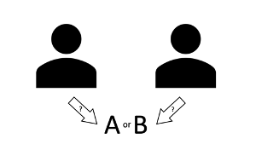
Task C
In this task, you will be randomly paired with one other person.
You and the other person are both asked to choose between two options, option A and option B. You choose independently of each other, that is, without knowing the other’s choice. Your own and the other’s potential payment depends on the combination of your choices as follows:
- If both of you choose option A, you both get £1.
- If you choose option A and the other person chooses option B, you get £0 and the other person gets £1.5.
- If you choose option B and the other person chooses option A, you get £1.5 and the other person gets £0. If both of you choose option B, you both get £0.5.
The following table provides a summary of the payment you and the other receives depending on the combination of your choices. Your payment is printed in bold-face; the other’s payment is printed in italics.
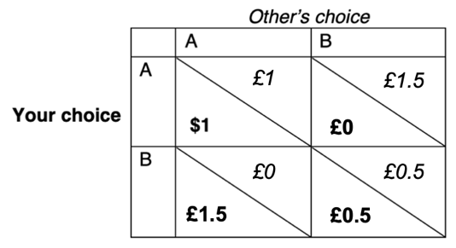
Which option do you choose:
- Option A
- Option B

[Page break]
[Ultimatum Game]

[For participants assigned to the hypothetical incentive scheme:] Remember: In each task, we want you to imagine that you influence the payment of money to yourself and other participants in the experiment.

[For participants assigned to the random-payment incentive scheme:] Remember: In each task, we want you to be aware that you influence the payment of money to yourself and other participants in the experiment. You will receive a bonus payment based on the monetary allocations made in one, randomly drawn, task.

[For participants assigned to the full-payment incentive scheme:] Remember: In each task, we want you to be aware that you influence the payment of money to yourself and other participants in the experiment. You will receive a bonus payment based on the monetary allocations made in all tasks.

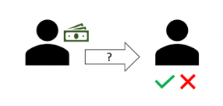
Task D
In this task, you will be randomly paired with one other person.
One of you will be assigned the role of the "proposer". The other will be assigned the role of the "responder".
The proposer is endowed with £1, the responder is endowed with £0.
The proposer makes a proposal on how to divide his/her endowment between the two players. That is, they decide how much to transfer to the responder and how much to keep. This is their offer to the responder. The responder then decides whether to accept or reject that offer. The final payment for both depends on the responder's decision:
- If the responder accepts, the allocation is realized as proposed in the offer. That is, the proposer and the responder receive the amounts that was allocated to both.
- If the responder rejects, neither the proposer nor the responder receives any money; that is, both get £0.

[For participants assigned to the role of proposer:]

You have randomly been assigned the role of the proposer
How much of your £1 endowment do you want to offer the responder? Please type the amount in pence (between 0-100):

[For participants assigned to the role of responder:]

You have randomly been assigned the role of the responder.

For each of the following offers, please indicate your choice:
The proposer offers 0–9 pence. Do you:
- Accept
- Reject

The proposer offers 10–19 pence. Do you:
- Accept
- Reject

The proposer offers 20–29 pence. Do you:
- Accept
- Reject

The proposer offers 30–39 pence. Do you:
- Accept
- Reject

The proposer offers 40–49 pence. Do you:
- Accept
- Reject

The proposer offers 50 pence. Do you:
- Accept
- Reject

The proposer offers 51–60 pence. Do you:
- Accept
- Reject

The proposer offers 61–70 pence. Do you:
- Accept
- Reject

The proposer offers 71–80 pence. Do you:
- Accept
- Reject

The proposer offers 81–90 pence. Do you:
- Accept
- Reject

The proposer offers 91–100 pence. Do you:
- Accept
- Reject

[Page break]
[Trust Game]

[For participants assigned to the hypothetical incentive scheme:] Remember: In each task, we want you to imagine that you influence the payment of money to yourself and other participants in the experiment.

[For participants assigned to the random-payment incentive scheme:] Remember: In each task, we want you to be aware that you influence the payment of money to yourself and other participants in the experiment. You will receive a bonus payment based on the monetary allocations made in one, randomly drawn, task.

[For participants assigned to the full-payment incentive scheme:] Remember: In each task, we want you to be aware that you influence the payment of money to yourself and other participants in the experiment. You will receive a bonus payment based on the monetary allocations made in all tasks.

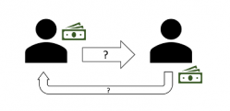
Task E
In this task, you will be randomly paired with one other person.
One of you will be assigned the role of the "sender". The other will be assigned the role of the "receiver".
The sender and the receiver are both endowed with £0.9.
The sender first decides how much of their endowment to transfer to the receiver. They can transfer £0, £0.3, £0.6 or £0.9. The amount they transfer is tripled (by the experimenter) before being received by the receiver. The amount they keep is not tripled and simply remains in their possession. The receiver then decides how much of the tripled transfer to return to the sender. They can choose any amount between £0 and the tripled amount the sender sent. The amount the receiver returns is not tripled.
The sender’s final payment is the sum of:
- the amount of the £0.9 endowment he/she keeps
- + the amount the receiver returns from the tripled transfer (in case anything is transferred)

The receiver’s final payment is the sum of:
- his/her £0.9 endowment
- + the amount the receiver keeps from the tripled transfer (in case anything is transferred)

[For participants assigned to the role of sender:]

You have been randomly assigned the role of the sender.
How much of your £0.9 endowment do you want to transfer to the receiver? Please type the amount in pence (between 0-90):

[For participants assigned to the role of receiver:]

You have been randomly assigned the role of the receiver.
For each of the following transfers from the sender, please indicate how much you want to return to the sender.
The sender transfers £0.3 to you. This amount is tripled, so you now have £0.9 in addition to your initial £0.9 endowment. How much do you return to the sender? Please type the amount in pence (between 0-180):

The sender transfers £0.6 to you. This amount is tripled, so you now have £1.8 in addition to your initial £0.9 endowment. How much do you return to the sender? Please type the amount in pence (between 0-270):

The sender transfers £0.9 to you. This amount is tripled, so you now have £2.7 in addition to your initial £0.9 endowment. How much do you return to the sender? Please type the amount in pence (between 0-360):

[Page break]

[Attention check]

Based on the text below, what would you say is your favorite drink?

This is a question to make sure that you are reading the instructions carefully. Please select milk to show that you are reading the instructions.

- Water
- Whiskey
- Coke
- Milk
- Beer
- Diet coke

[Page break]

[Demographics]

Thank you for your answers! Before completing the study, we want you to answer a few questions about yourself:

How would you describe yourself?
- Female
- Male
- Non-binary / third gender
- Prefer not to say

Please state your age (in years):

Please state your annual family income:
- Less than £10,000
- £10,000 - £19,999
- £20,000 - £29,999
- £30,000 - £39,000
- £40,000 - £49,999
- £50,000 - £59,999
- £60,000 - £69,999
- £70,000 - £79,999
- £80,000 - £99,999
- £100,000 - £119,999
- £120,000 - £149,999
- £150,000 - £199,999
- £200,000 - £249,999
- £250,000 - £349,999
- £350,000 - £499,999
- £500,000 or more
- Prefer not to say

Please state the highest level of education you have completed:
- No High school
- High school graduate
- Some college
- 2-year college
- 4-year college
- Post-grad

Have you participated in studies like this one before? (i.e., where you choose how much money to keep for yourself versus contribute to benefit others)
- Yes
- No
- Unsure/Don't know

[Page break]

[For participants assigned to the random-payment or full-payment incentive scheme:]

Thank you for your participation!
Please click forward to be redirected back to Prolific and register that you have completed the study.
Your bonus will be payed out within the next two weeks.

[For participants assigned to the hypothetical incentive scheme:]

Thank you for your participation!
Please click forward to be redirected back to Prolific and register that you have completed the study.

Instructions to participants (Experiment 2)

[Consent]

We would like to include you as a participant in a research study. If you agree to participate in this study, we will ask you to make a number of decisions about how to allocate money between yourself and one or more other participants (whose identities will remain unknown to you). Your answers will be treated confidentially, and the results of the survey will be evaluated and presented in an anonymous, summarized form. Participation in this study is voluntary and you can always choose to cancel.
By clicking in "I voluntarily participate in this study" below, you consent to your answers being used, anonymously, as data for our study. We appreciate your participation!

Do you consent to participating in this study? (If you do not consent, simply click forward)
- I voluntarily participate in this study

[Page break]

[For participants assigned to the no-payment (hypothetical) incentive scheme:]

In this study, you are going to complete a series of tasks, in which you will be asked to distribute money between yourself and other people. In each of these tasks, we want you to imagine that you influence the payment of money to yourself and other participants in the experiment.
You will receive £1.50 for completing the entire study.
Please enter your Prolific ID, if it is not already entered automatically:

[For participants assigned to the random-payment incentive scheme:]

In this study, you are going to complete a series of tasks, in which you will be asked to distribute money between yourself and other people. In each of these tasks, we want you to be aware that you influence the payment of money to yourself and other participants in the experiment. You will receive a bonus payment based on the monetary allocations made in one, randomly drawn, task.
You will receive £1.50 for completing the entire study, in addition, you will receive a bonus sum based on one of the tasks.
Please enter your Prolific ID, if it is not already entered automatically:

[For participants assigned to the full-payment incentive scheme:]

In this study, you are going to complete a series of tasks, in which you will be asked to distribute money between yourself and other people. In each of these tasks, we want you to be aware that you influence the payment of money to yourself and other participants in the experiment. You will receive a bonus payment based on the monetary allocations made in all tasks.
You will receive £1.50 for completing the entire study, in addition, you will receive a bonus based on your decisions in each of these tasks.
Please enter your Prolific ID, if it is not already entered automatically:

[Page break]

[The games and an attention check are displayed in random order, each on a separate page.]

[Dictator Game]

[For participants assigned to the hypothetical incentive scheme:] Remember: In each task, we want you to imagine that you influence the payment of money to yourself and other participants in the experiment.

[For participants assigned to the random-payment incentive scheme:] Remember: In each task, we want you to be aware that you influence the payment of money to yourself and other participants in the experiment. You will receive a bonus payment based on the monetary allocations made in one, randomly drawn, task.

[For participants assigned to the full-payment incentive scheme:] Remember: In each task, we want you to be aware that you influence the payment of money to yourself and other participants in the experiment. You will receive a bonus payment based on the monetary allocations made in all tasks.

Task A
In this task, you will be randomly paired with one other person.
You are endowed with £10, the other person is endowed with £0.
You will decide how much of your £10 endowment to transfer to the other person. You can choose any amount between £0 and £10. The other person receives the amount that you decide to transfer to him/her. You will receive the amount that you decide not to transfer and thus to keep.

How much of your £10 endowment do you want to transfer to the other person? Please type the amount in pounds (between 0-10, with up to 2 decimals):

[Page break]
[Public Goods Game]

[For participants assigned to the hypothetical incentive scheme:] Remember: In each task, we want you to imagine that you influence the payment of money to yourself and other participants in the experiment.

[For participants assigned to the random-payment incentive scheme:] Remember: In each task, we want you to be aware that you influence the payment of money to yourself and other participants in the experiment. You will receive a bonus payment based on the monetary allocations made in one, randomly drawn, task.

[For participants assigned to the full-payment incentive scheme:] Remember: In each task, we want you to be aware that you influence the payment of money to yourself and other participants in the experiment. You will receive a bonus payment based on the monetary allocations made in all tasks.

Task B

In this task, you will be randomly assigned to a group with three other people. All of you receive this same set of instructions.
Each group member is endowed with £10.
You are asked to decide how much of your endowment you want to keep for yourself and how much you want to contribute to a group account. You can choose to contribute any amount between £0 and £10.
Your choice influences your own and the other group members’ payment. Likewise, the group members’ choices influence your payment. That is:
- The amount you keep simply remains in your possession: For every 1 pence you keep, you will receive 1 pence in payment.
- The amount you and the other group members contribute to the group account is summed up to a total amount. This total amount is doubled (by the experimenter) and then equally split among all group members, including you. Thus, for every 2 pence contributed to the group account by any one group member, all four group members (including you) receive 1 pence.

Your payment is the sum of
- the amount you keep
- + 0.5 * the total amount contributed to the group account

How much of your £10 endowment do you want to contribute to the group account? Please type the amount in pounds (between 0-10, with up to 2 decimals):

[Page break]
[Prisoner’s Dilemma]

[For participants assigned to the hypothetical incentive scheme:] Remember: In each task, we want you to imagine that you influence the payment of money to yourself and other participants in the experiment.

[For participants assigned to the random-payment incentive scheme:] Remember: In each task, we want you to be aware that you influence the payment of money to yourself and other participants in the experiment. You will receive a bonus payment based on the monetary allocations made in one, randomly drawn, task.

[For participants assigned to the full-payment incentive scheme:] Remember: In each task, we want you to be aware that you influence the payment of money to yourself and other participants in the experiment. You will receive a bonus payment based on the monetary allocations made in all tasks.

Task C
In this task, you will be randomly paired with one other person.
You and the other person are both asked to choose between two options, option A and option B. You choose independently of each other, that is, without knowing the other’s choice. Your own and the other’s potential payment depends on the combination of your choices as follows:
- If both of you choose option A, you both get £10.
- If you choose option A and the other person chooses option B, you get £0 and the other person gets £15.
- If you choose option B and the other person chooses option A, you get £15 and the other person gets £0. If both of you choose option B, you both get £5.
The following table provides a summary of the payment you and the other receives depending on the combination of your choices. Your payment is printed in bold-face; the other’s payment is printed in italics.
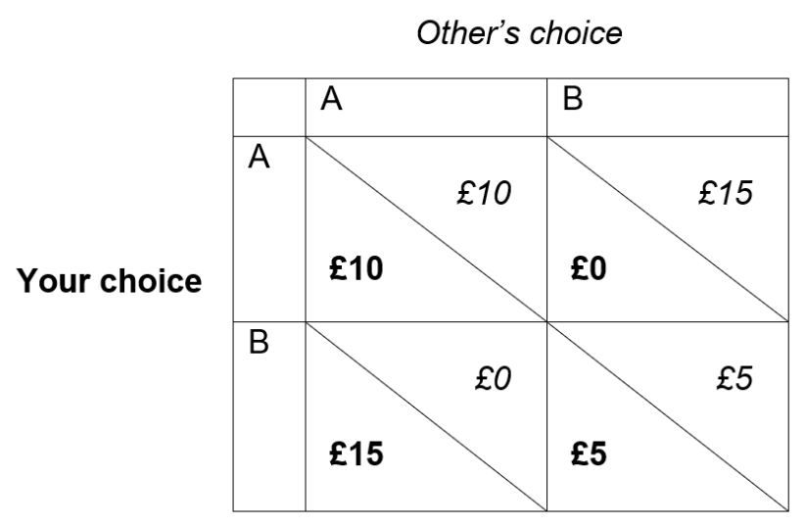

Which option do you choose:
- Option A
- Option B
[Page break]

[Ultimatum Game]

[For participants assigned to the hypothetical incentive scheme:] Remember: In each task, we want you to imagine that you influence the payment of money to yourself and other participants in the experiment.

[For participants assigned to the random-payment incentive scheme:] Remember: In each task, we want you to be aware that you influence the payment of money to yourself and other participants in the experiment. You will receive a bonus payment based on the monetary allocations made in one, randomly drawn, task.

[For participants assigned to the full-payment incentive scheme:] Remember: In each task, we want you to be aware that you influence the payment of money to yourself and other participants in the experiment. You will receive a bonus payment based on the monetary allocations made in all tasks.

Task D
In this task, you will be randomly paired with one other person.
One of you will be assigned the role of the "proposer". The other will be assigned the role of the "responder".
The proposer is endowed with £10, the responder is endowed with £0.
The proposer makes a proposal on how to divide his/her endowment between the two players. That is, they decide how much to transfer to the responder and how much to keep. This is their offer to the responder. The responder then decides whether to accept or reject that offer. The final payment for both depends on the responder's decision:
- If the responder accepts, the allocation is realized as proposed in the offer. That is, the proposer and the responder receive the amounts that was allocated to both.
- If the responder rejects, neither the proposer nor the responder receives any money; that is, both get £0.

[For participants assigned to the role of proposer:]

You have randomly been assigned the role of the proposer
How much of your £10 endowment do you want to offer the responder? Please type the amount in pounds (between 0-10, with up to 2 decimals):

[For participants assigned to the role of responder:]

You have randomly been assigned the role of the responder.

For each of the following offers, please indicate your choice:
The proposer offers 0–0.99 pounds. Do you:
- Accept
- Reject

The proposer offers 1.00–1.99 pounds. Do you:
- Accept
- Reject

The proposer offers 2.00–2.99 pounds. Do you:
- Accept
- Reject

The proposer offers 3.00–3.99 pounds. Do you:
- Accept
- Reject

The proposer offers 4.00–4.99 pounds. Do you:
- Accept
- Reject

The proposer offers 5.00 pounds. Do you:
- Accept
- Reject

The proposer offers 5.01–6.00 pounds. Do you:
- Accept
- Reject

The proposer offers 6.01–7.00 pounds. Do you:
- Accept
- Reject

The proposer offers 7.01–8.00 pounds. Do you:
- Accept
- Reject

The proposer offers 8.01–9.00 pounds. Do you:
- Accept
- Reject

The proposer offers 9.01–10 pounds. Do you:
- Accept
- Reject

[Page break]

[Trust Game]

[For participants assigned to the hypothetical incentive scheme:] Remember: In each task, we want you to imagine that you influence the payment of money to yourself and other participants in the experiment.

[For participants assigned to the random-payment incentive scheme:] Remember: In each task, we want you to be aware that you influence the payment of money to yourself and other participants in the experiment. You will receive a bonus payment based on the monetary allocations made in one, randomly drawn, task.

[For participants assigned to the full-payment incentive scheme:] Remember: In each task, we want you to be aware that you influence the payment of money to yourself and other participants in the experiment. You will receive a bonus payment based on the monetary allocations made in all tasks.

Task E
In this task, you will be randomly paired with one other person.
One of you will be assigned the role of the "sender". The other will be assigned the role of the "receiver".
The sender and the receiver are both endowed with £9.
The sender first decides how much of their endowment to transfer to the receiver. They can transfer £0, £3, £6 or £9. The amount they transfer is tripled (by the experimenter) before being received by the receiver. The amount they keep is not tripled and simply remains in their possession. The receiver then decides how much of the tripled transfer to return to the sender. They can choose any amount between £0 and the tripled amount the sender sent. The amount the receiver returns is not tripled.
The sender’s final payment is the sum of:
- the amount of the £9 endowment he/she keeps
- + the amount the receiver returns from the tripled transfer (in case anything is transferred)

The receiver’s final payment is the sum of:
- his/her £9 endowment
- + the amount the receiver keeps from the tripled transfer (in case anything is transferred)

[For participants assigned to the role of sender:]

You have been randomly assigned the role of the sender.
How much of your £9 endowment do you want to transfer to the receiver? Please type the amount in pounds (between 0-9, with up to 2 decimals):

[For participants assigned to the role of receiver:]

You have been randomly assigned the role of the receiver.
For each of the following transfers from the sender, please indicate how much you want to return to the sender.
The sender transfers £3 to you. This amount is tripled, so you now have £9 in addition to your initial £9 endowment. How much do you return to the sender? Please type the amount in pounds (between 0-9, with up to 2 decimals):

The sender transfers £6 to you. This amount is tripled, so you now have £18 in addition to your initial £9 endowment. How much do you return to the sender? Please type the amount in pounds (between 0-18, with up to 2 decimals):

The sender transfers £9 to you. This amount is tripled, so you now have £27 in addition to your initial £9 endowment. How much do you return to the sender? Please type the amount in pounds (between 0-27, with up to 2 decimals):

[Page break]

[Attention check]

Based on the text below, what would you say is your favorite drink?

This is a question to make sure that you are reading the instructions carefully. Please select milk to show that you are reading the instructions.

- Water
- Whiskey
- Coke
- Milk
- Beer
- Diet coke

[Page break]

[Demographics]

Thank you for your answers! Before completing the study, we want you to answer a few questions about yourself:

How would you describe yourself?
- Female
- Male
- Non-binary / third gender
- Prefer not to say

Please state your age (in years):

Please state your annual family income:
- Less than £10,000
- £10,000 - £19,999
- £20,000 - £29,999
- £30,000 - £39,999
- £40,000 - £49,999
- £50,000 - £59,999
- £60,000 - £69,999
- £70,000 - £79,999
- £80,000 - £99,999
- £100,000 - £119,999
- £120,000 - £149,999
- £150,000 - £199,999
- £200,000 - £249,999
- £250,000 - £349,999
- £350,000 - £499,999
- £500,000 or more
- Prefer not to say

Please state the highest level of education you have completed:
- No High school
- High school graduate
- Some college
- 2-year college
- 4-year college
- Post-grad

Have you participated in studies like this one before? (i.e., where you choose how much money to keep for yourself versus contribute to benefit others)
- Yes
- No
- Unsure/Don't know

[Page break]

[For participants assigned to the random-payment or full-payment incentive scheme:]

Thank you for your participation!
Please click forward to be redirected back to Prolific and register that you have completed the study.
Your bonus will be payed out within the next two weeks.

[For participants assigned to the hypothetical incentive scheme:]

Thank you for your participation!
Please click forward to be redirected back to Prolific and register that you have completed the study.

