Supplementary material 5: Knowledge and perceptions regarding intermittent fasting diets

Table S5.1. Awareness of intermittent fasting diet
Question | Yes (%) | No (%)
Have you heard of intermittent fasting before? | 88.3 | 11.7

Table S5.2. Previous use of intermittent fasting
Question | Yes (%) | No (%)
Have you followed any type of intermittent fasting before? | 49 | 51

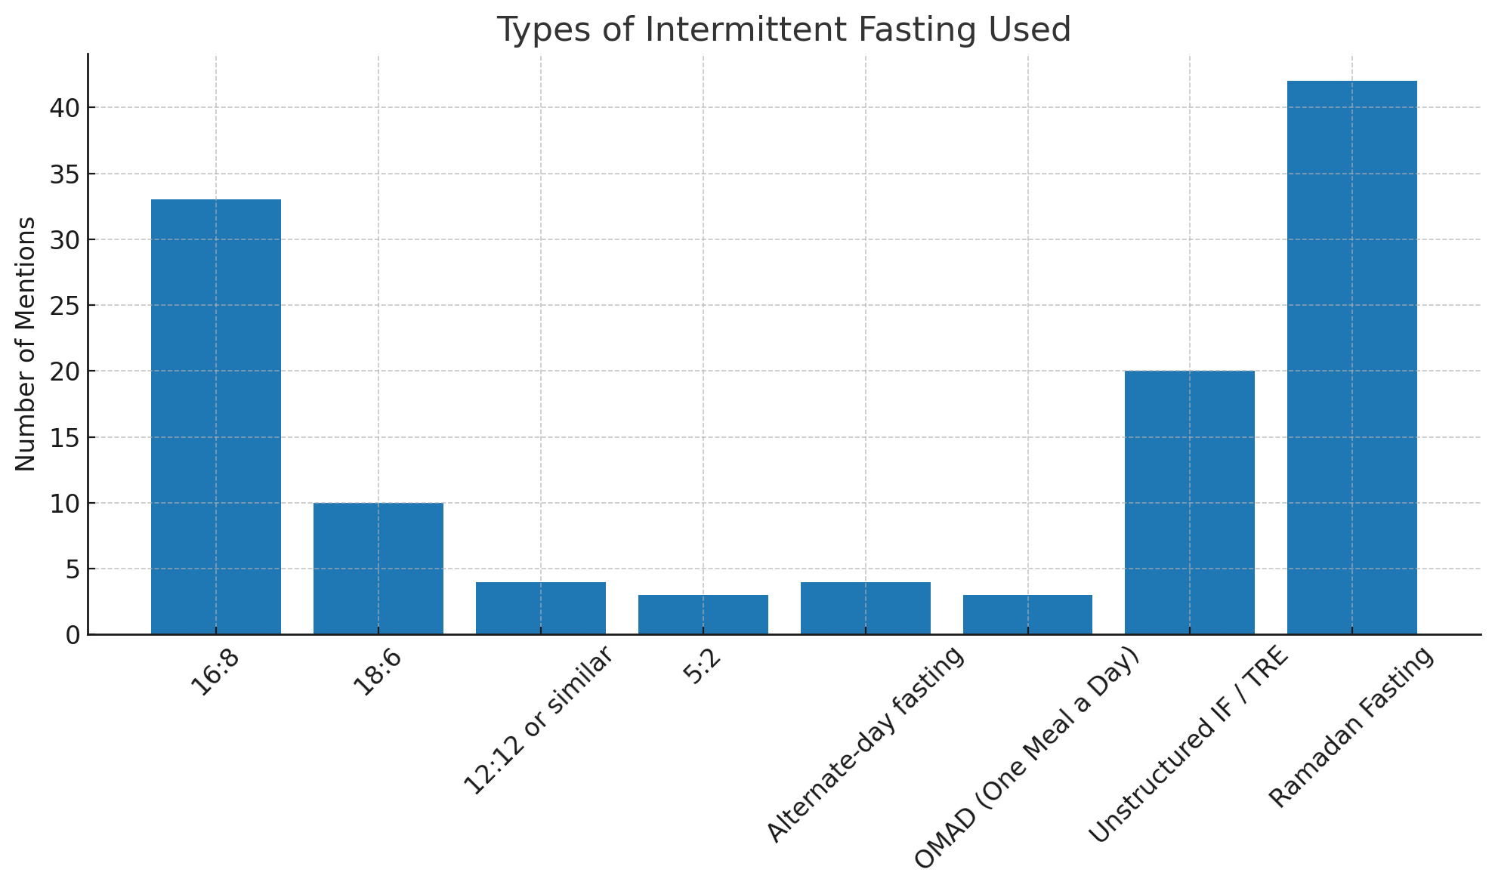
Figure S5.1. Types of intermittent fasting diets followed by participants
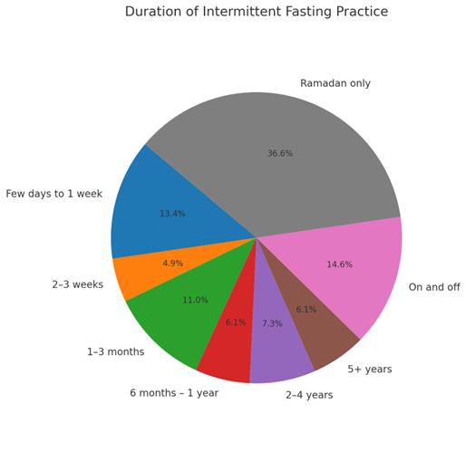
Figure S5.2. Duration of intermittent fasting practice followed by participants

Table S5.3. Perceived ability to follow intermittent fasting (n=207).
Question | Yes, if that helps prevent or manage diabetes (%) | No (%)
If you haven’t followed one yet, based on the definitions of the different types of intermittent diet listed previously, do you feel this is a diet you might be able to follow? | 76.8 | 23.2

Figure S5.3. Reasons that would stop participants from following an intermittent fasting diet
Note: Percentages may not sum to 100% where participants could select more than one response (if applicable) or due to rounding.

