Supplementary Material - Figures

Figure S1: Clustering based on responses

Panel A: Dendrogram derived from the hierarchical clustering analysis. The horizontal line shows where the dendrogram was cut to obtain 5 clusters.

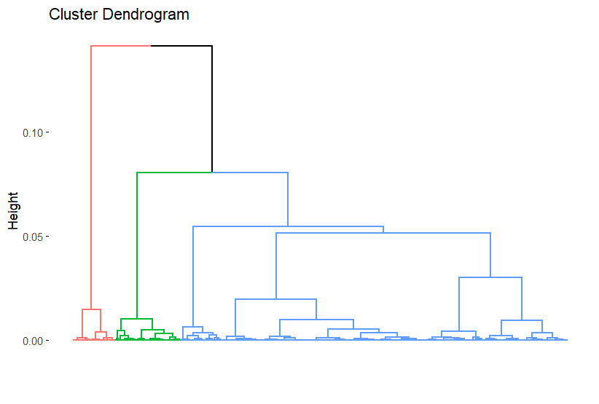

panel B: Representation of respondents along the first three principal components (three dimensions) extracted from the MCA applied to the responses to fibre-related questions. Colours identify the 5 patterns (or clusters) of responses obtained thanks to the hierarchical clustering analysis (1: blue/green: ‘sceptical consumers’; 2: orange: informed consumers; 3: blue: resistant consumers; 4: pink: committed consumers; 5: green: helpless consumers)

B
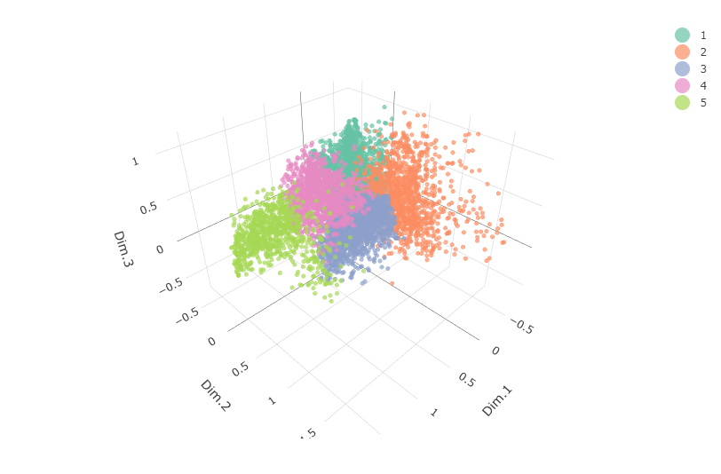

Figure S2: Clustering based on sociodemographic data
Panel A: Dendrogram derived from the hierarchical clustering analysis. The horizontal line shows where the dendrogram was cut to obtain 5 clusters.

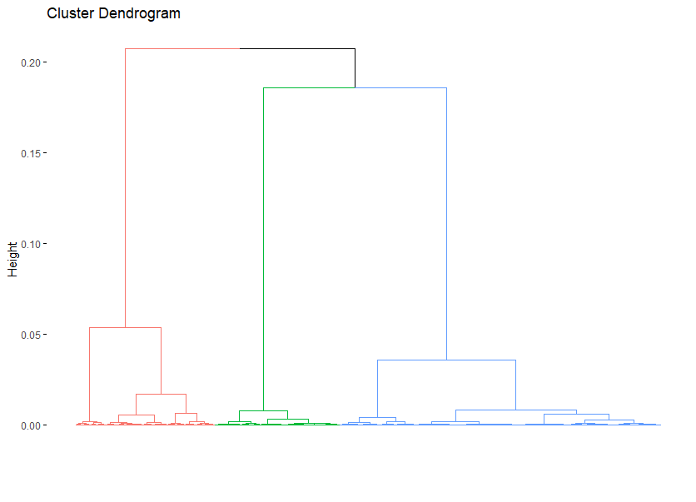

Panel B: Representation of respondents along the first two principal components (two dimensions) extracted from the MCA applied to the sociodemographic data. Colours identify the 5 patterns (or groups) obtained thanks to the hierarchical clustering analysis (1: orange: senior; 2: green: blue collar; 3: blue/green: white collar; 4: blue: inactive; 5: red: millenial).
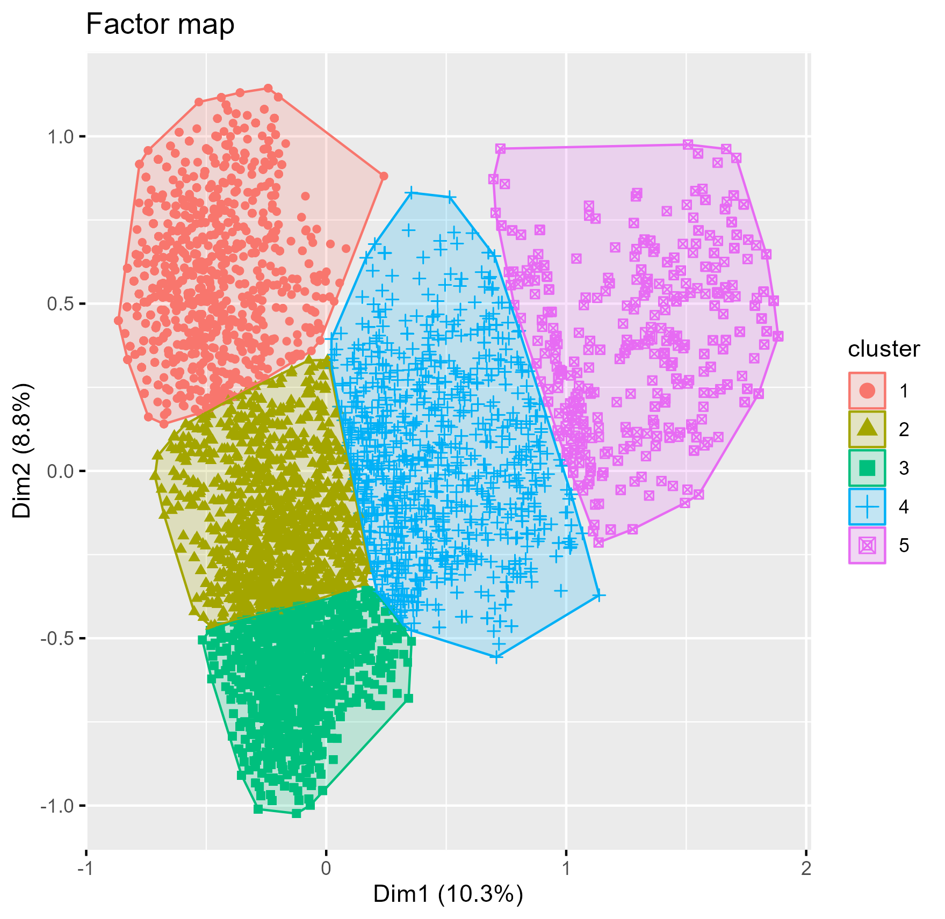

Figure S3: MCA using the following variables: sociodemographic groups (purple colour), score of nutritional concern (from 0 to 5; blue colour), health as a major criterion in food purchases (yes/no; grey colour), plus, in orange colour: knowledge of types of fibre (panel A), knowledge of health benefits of fibre (panel B),.See details of the questionnaire (Supplementary Table S1) for the possible responses.

Panel A

Panel B

