Appendix A
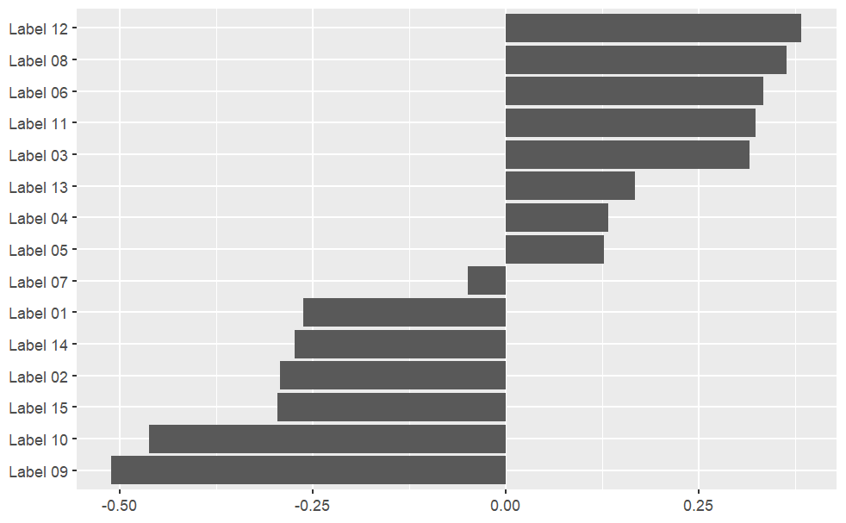
Figure A1. Preference orders of labels by count approach.

