Supplementary Data

Supplementary Table 1. List of 269 unique species identified.

Abalone
Akee apples
Alfalfa
Alfonsino
Almond, Almonds
Amberjack
Anchovies
Anise seed
Apples
Apricots
Arctic char
Asian rice
Asparagus
Atlantic halibut
Atlantic mackerel
Atlantic pomfret
Atlantic salmon
Aubergine
Avocado
Bamboo
Barley
Barnacle
Basil
Beets, chards
Black eyed peas
Blackberry
Blackcurrant
Blue shark
Blue whiting
Blueberries
Bonito
Borage
Brazil nuts
Breadfruits
Broad beans
Buckwheat
Buffalo
Burr gherkin
Butternut squashes
Button mushrooms
Caper
Cardamon Fruit
Carobs
Carrots
Cashew nut
Cassava
Celeriac, celery
Chayote fruits
Cherimoya
Chestnuts
Chicken
Chickling vetches
Chickpea
Chili peppers
Chinese cabbages, turnip
Chive
Cinnamon bark
Cloudberry
Coalfish
Cockles
Cocoa bean
Coconut
Cod
Coffee bean
Common banana, plantain
Common beans
Common dab
Common mussel
Common nettle
Common peaches
Common periwinkle
Common shrimps
Common skate
Common wheat, spelt
Coriander leaves
Courgette, pumpkin, squash
Cow
Cowberries, lingonberries
Cranberries
Cucumber, gherkin
Cumin Seeds
Curly endives
Cuttlefishes
Date
Dill
Duck
Durum wheat
Edible crab
European conger
European eel
European freshwater bream
European freshwater crayfish
European moose
European oyster
European perch
European plaice
European sardine
European spider crab
European sprat
Fennel
Fig
Flounders
Gages
Garden snail
Garfish
Garlic
Giant tiger prawn
Gilthead seabream
Ginger
Globe artichoke, cardoon
Goat
Gojiberry
Goose
Gooseberry
Grapefruits
Grapes
Groupers
Guava
Haddock
Hakes
Hare
Hazelnut
Head cabbages
Head lettuces
Hemp seeds
Herrings
Hibiscus infusion flowers
Hijiki
Horse
Horse mackerel
Horseradish root
Jerusalem artichoke
Kaki
Kiwi
Kumquats
Leek
Lemon
Lentil
Lime
Ling
Linseed
Litchis
Loquats
Lumpfish
Macadamias
Maize
Mandarins, clementine
Mango
Marble goby
Marjoram Fruit
Medlar
Megrims
Melons
Mints
Monkfish, anglerfish
Mulberries (black and white)
Mullets
Mung beans
Mustard seeds
Nectarines
Northern pike
Northern prawn
Norway pout
Norwegian lobster
Nutmeg seed
Oat
Octopuses
Oil palms
Okra
Olive
Onions
Oranges
Oregano
Pangas catfishes
Papayas
Parsley
Parsnip root
Partridge fresh meat
Passionfruit
Peanut
Pear
Pearl millet
Peas
Pecan
Peppercorn
Pheasant
Pig, boar
Pigeon
Pike-perch
Pine nuts
Pineapple
Pistachio
Plum
Pollock
Pomegranate
Poppy seeds
Potato
Prickly pear
Ptarmigan
Purple urchin
Quail
Quinces
Quinoa grain
Rabbit
Radicchio, Belgian endives
Radish, daikon
Raspberries
Razor clam
Red mustard leaves
Redcurrant
Rhubarb
Rockweed
Roe deer
Roman rocket and similar-
Rose hips
Rosemary
Rye
Safflower seeds
Saffron
Sage
Sago plant
Salsify leaves
Sapodillas
Scallops, pectens
Scorpion fish
Sea bass
Sea bream
Sea catfish
Sea lettuce
Sesame
Shea nuts
Sheep
Smelt
Smooth hounds
Snappers
Sole
Soybean
Spinach
Spiny dogfish
Squids
Strawberry
Sturgeon
Sunflower
Swede, rapeseed
Sweet cherry
Sweet corn
Sweet pepper
Sweet potato
Swordfish
Tamarind
Tarragon
Tea leaves
Thyme
Tomatoes
Trout
Tuna
Turbot
Turkey
Walnut
Watercress
Watermelon
Whelks
White lupine
Whitefish, Coregonus
Whiting
Witloofs
Wolffish
Yam
Yeast cultures
*Those species highlighted in orange were identified in the EPIC cohort's food list (See Hanley-Cook et al. 2021) but were not identified across the NDNS food and drink products.

Supplementary Figure 1. Median Dietary Species Richness (DSR) across composite dishes (A), seasoning, sauces, and condiments (B), and grains and grain-based products (C).
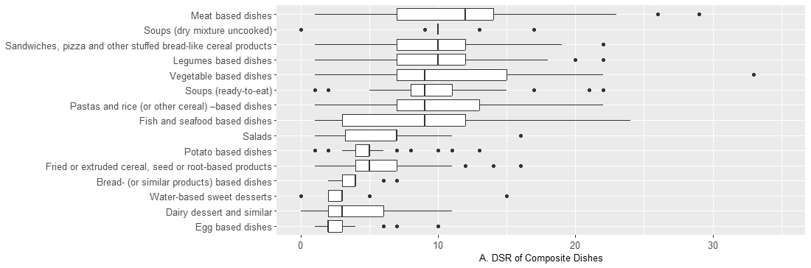
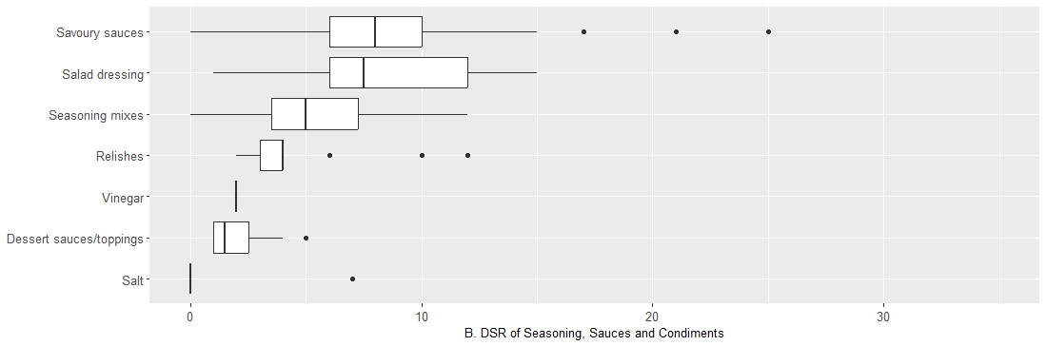
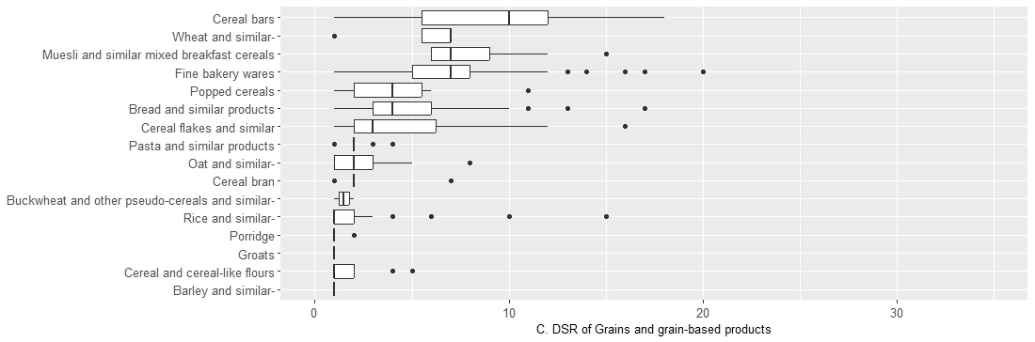

Supplementary Table 2. Differences in median Dietary Species Richness (DSR) across sociodemographic characteristics.
 |  | Median DSR (IQR)
 |  | Day
 |  | 1 | 2 | 3 | 4
Sex | Women | 29.5 (12) | 9 (7) | 6 (6) | 4 (4) | 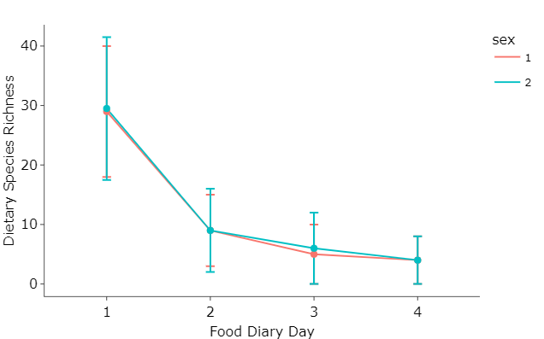
 | Men | 29 (11) | 9 (6) | 5 (5) | 4 (4)
 |  | p=0.438
Age | Children | 31 (10) | 9 (6) | 5 (5) | 4 (4) | 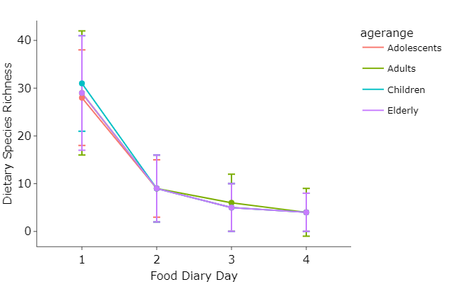
 | Adolescents | 28 (10) | 9 (7) | 6 (6) | 4 (4)
 | Adults | 29 (13) | 9 (7) | 5 (5) | 4 (5)
 | Elders | 29 (12) | 9 (7) | 5 (5) | 4 (4)
 |  | p <0.001
Household income | Lowest income tertile | 27 (10.5) | 8 (7) | 5 (5) | 4 (4) | 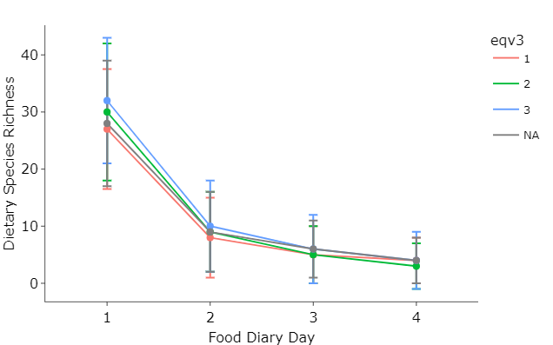
 | Middle income tertile | 30 (12) | 9 (7) | 5 (5) | 3 (4)
 | Highest income tertile | 32 (11) | 10 (8) | 6 (6) | 4 (5)
 | NA | 28 (10.5) | 9 (7) | 5 (5) | 4 (4)
 |  | P <0.001
IMD | 1 | 28 (11) | 8 (7) | 5 (5) | 3 (4) | 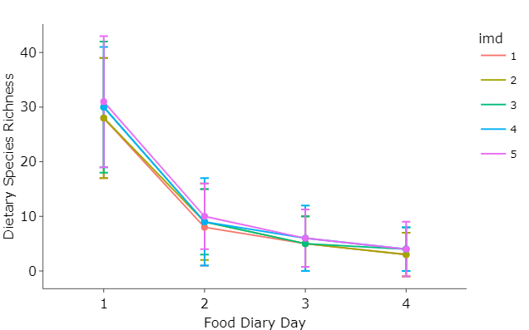
 | 2 | 28 (12) | 9 (7) | 5 (5) | 3 (4)
 | 3 | 30 (11) | 9 (6) | 5 (5) | 4 (4)
 | 4 | 30 (11) | 9 (8) | 6 (6) | 4 (4)
 | 5 | 31 (12) | 10 (6) | 6 (5.5) | 4 (5)
 |  | P <0.001
Ethnic group | White | 29 (11) | 9 (7) | 5 (5) | 4 (4) | 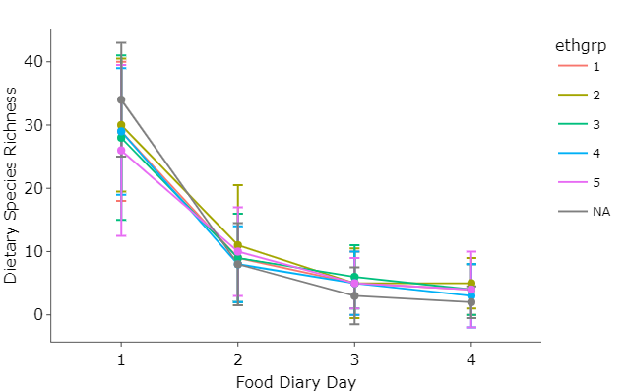
 | Mixed ethnic group | 30 (10.5) | 11 (9.5) | 5 (5.5) | 5 (4)
 | Black or Black British | 28 (13) | 9 (7) | 5 (5) | 4 (4)
 | Asian or Asian British | 29 (10) | 8 (6) | 6 (6) | 3 (5)
 | Any other group | 26 (13.5) | 10 (7) | 5 (4) | 4 (6)
 | NA | 34 (10) | 8 (5) | 3 (4) | 2 (3)
 |  | p=0.123
Marital status | Single | 28 (12) | 9 (7) | 5 (5) | 4 (4) | 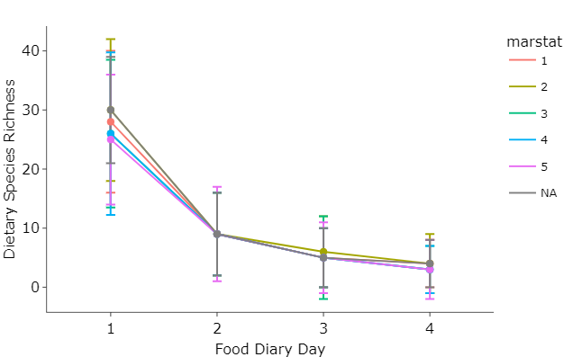
 | Married | 30 (12) | 9 (7) | 6 (6) | 4 (5)
 | Civil partnership | 26 (12.5) | 9 (7) | 5 (7) | 3 (4)
 | Separated/  divorced | 26 (13.75) | 9 (7) | 5 (5) | 3 (4)
 | Widow | 25 (11) | 9 (8) | 5 (6) | 3 (5)
 | NA | 30 (12) | 9 (7) | 5 (7) | 3 (4)
 |  | p<0.001
BMI | Underweight | 30 (11) | 7 (10) | 5 (5) | 3 (5) | 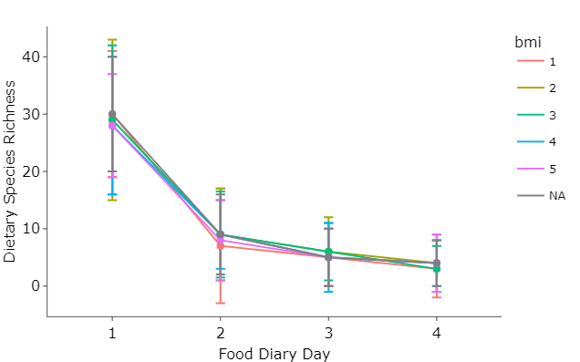
 | Normal weight | 29 (14) | 9 (8) | 6 (6) | 4 (5)
 | Overweight | 29 (13) | 9 (7.5) | 6 (5) | 3 (4)
 | Obesity | 28 (12) | 9 (6) | 5 (6) | 4 (4)
 | Morbid Obesity | 28 (9) | 8 (7) | 5 (5) | 4 (5)
 | NA | 30 (11) | 9 (10) | 5 (5) | 4 (5)
 |  | p=0.382

Supplementary Table 3. Differences in median Dietary Species Richness (DSR) across dietary quality categories
Variables |  | Median DSR (IQR) |  |  |  |  | Graph
 |  | Day
 |  | 1 |  | 2 | 3 | 4
Saturated fat consumption | Consuming more than 11% of total energy from saturated fats | 30 (11) |  | 9 (7) | 5 (5) | 4 (4) | 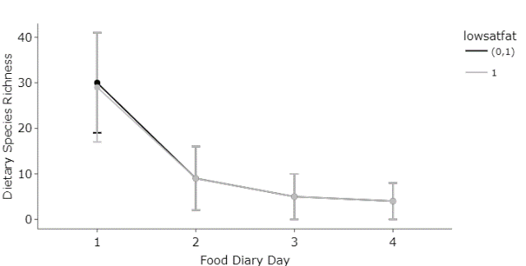
 | Consuming less than 11% of total energy from saturated fats | 29 (12) |  | 9 (7) | 5 (5) | 4 (4)
 |  | p=0.151
Free sugar consumption | Consuming more than 5% of total energy from free sugars | 30 (12) |  | 9 (7) | 6 (5) | 4 (4) | 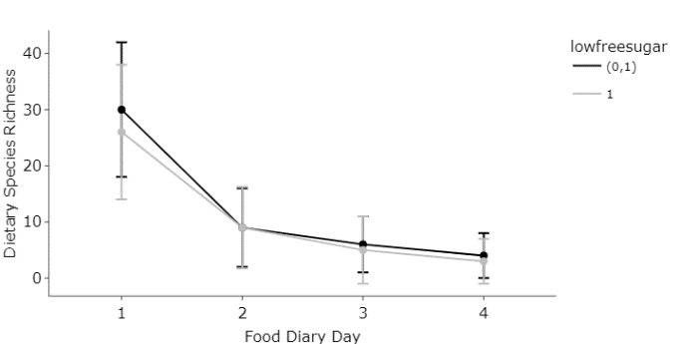
 | Consuming less than 5% of total energy from free sugars | 26 (12) |  | 9 (7) | 5 (6) | 3 (4)
 |  | p<0.000
Processed and ultra-processed food consumption | Consuming more than 60% of total energy from processed and ultra-processed food | 30 (11) |  | 9 (7) | 6 (5) | 4 (4) | 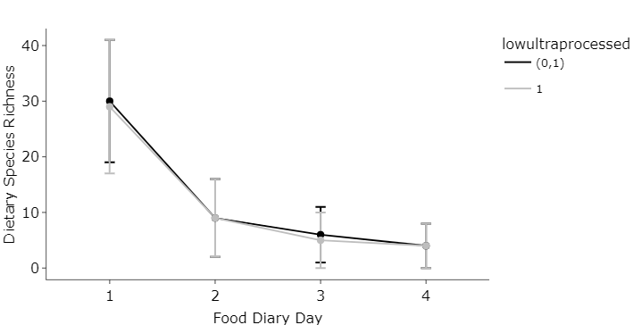
 | Consuming less than 60% of total energy from processed and ultra-processed food | 29 (12) |  | 9 (7) | 5 (5) | 4 (4)
 |  | p<0.002
Red meat consumption | Consuming more than 280g of red meat across four days. | 29 (11) |  | 9 (7) | 5 (5) | 4 (4) | 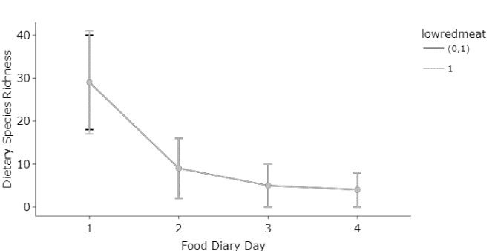
 | Consuming less than 280g of red meat across four days. | 29 (12) |  | 9 (7) | 5 (5) | 4 (4)
 |  | p=0.363
Salt consumption | Consuming more than 24g of salt across four days. | 32 (11) |  | 9 (7) | 6 (5) | 4 (4) | 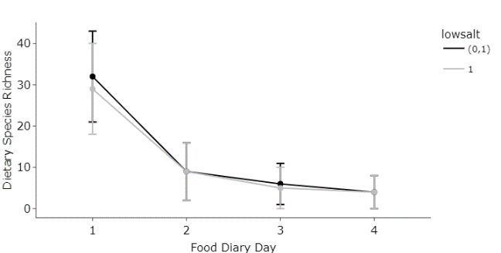
 | Consuming less than 24g of salt across four days. | 29 (11) |  | 9 (7) | 5 (5) | 4 (4)
 |  | p<0.000
Fibre consumption | Consuming less than 120 g of fibre across four days. | 27 (10) |  | 9 (7) | 5 (5) | 4 (4) | 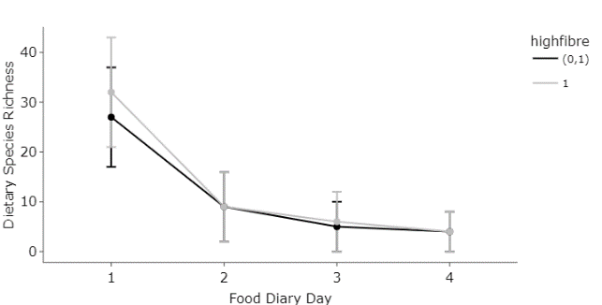
 | Consuming more than 120 g of fibre across four days. | 32 (11) |  | 9 (7) | 6 (6) | 4 (4)
 |  | p<0.000
Fruit and vegetable consumption | Consuming less than 1600 g of fruit and vegetables across four days. | 29 (11) |  | 9 (7) | 5 (5) | 4 (4) | 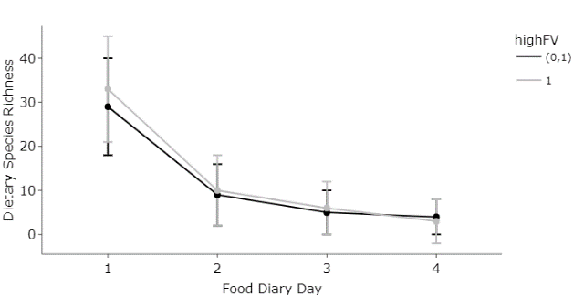
 | Consuming more than 1600 g of fruit and vegetables across four days. | 33 (12) |  | 10 (8) | 6 (6) | 3 (5)
 |  | p<0.000
Fish consumption | Consuming less than 160g of fish across four days. | 29 (11) |  | 9 (7) | 5 (5) | 4 (4) | 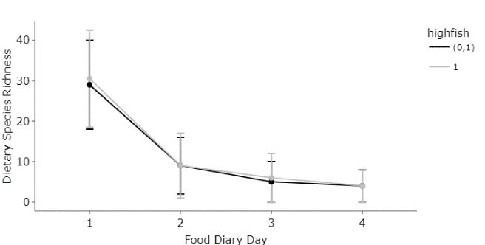
 | Consuming more than 160g of fish across four days. | 30.5 (12) |  | 9 (8) | 6 (6) | 4 (4)
 |  |  | p=0.049
Following all the above-enlisted guidelines. | Not meeting one or more guidelines. | 29 (11) |  | 9 (7) | 5 (5) | 4 (4) | 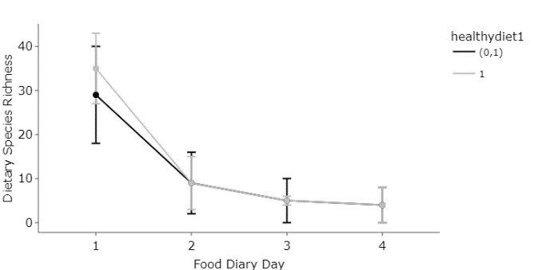
 | Meeting all guidelines. | 35 (8) |  | 9 (6) | 5 (5) | 4 (5)
 |  |  | p=0.288

Supplementary Figure 2. Regression analysis to evaluate the association of DSR with the nutritional quality (measured through NRF 8.3 as a proxy) of individual diets
