Additional file 2: Food Literacy scale generated from step 1

Food literacy questions
These questions explore how you plan and prepare food for you and/or your family.
This is not a test! There are no wrong answers. Just think about how you usually do things.
How often have you done the following actions in the last month? Please tick or circle in the box that provides the best answer for each question.

      - Planning and management
What is your opinion on the following?
Assessment question |  | Likert scale
1 | What I eat has an impact on my health and wellbeing | 1: Strongly Disagree | 2: Somewhat disagree | 3: Somewhat agree | 4: Strongly Agree
2 | How often do you think about health when deciding on what to eat | 1: Never | 2: Rarely | 3: Sometimes | 4: Always

3 | Which of following food groups do you consider as a typical balanced meal | 1:  Matooke,  Rice,  Chicken,  One banana | 2:  Matooke, Rice,  Beans,  One banana | 3:  Matooke,  Rice,  Greens (amaranth/ managu),  One banana | 4:  Matooke,  Beans or chicken,  Greens (amaranth/ managu),  One banana | 5:  Not sure
4 | How often do you plan meals ahead of time? | 1: Never | 2: Rarely |  | 3: Sometimes | 4: Always
5 | Do you normally have a weekly menu? | 1: Never | 2: Rarely |  | 3: Sometimes | 4: Always
6 | How often do you plan the meals to include all food groups? | 1: Never | 2: Rarely |  | 3: Sometimes | 4: Always
7 | How easy is it for you to plan a meal including atleast one food from each of the food groups on a limited budget | 1: Very difficult | 2: Somehow difficult |  | 3: Somehow easy | 4: Always easy
8 | How often do you think about vegetables when deciding what to eat? | 1: Never | 2: Rarely |  | 3: Sometimes | 4: Always
9 | How often do you think about fruits when deciding what to eat? | 1: Never | 2: Rarely |  | 3: Sometimes | 4: Always
      - Questions about selection
10 | How often do you make a food shopping list before going to shop? |  | 1: Never | 2: Rarely | 3: Sometimes | 4: Always
11 | How often do you purchase vegetables even if you have limited money? |  | 1: Never | 2: Rarely | 3: Sometimes | 4: Always
12 | How often do you purchase fruits, even if you have limited money? |  | 1: Never | 2: Rarely | 3: Sometimes | 4: Always
13 | On average how long do you stock up on the following food items
13a | Leafy vegetables | 1: Do not stock (buy for immediate consumption) | 2: Daily | 3: two days | 4: three days | 5: four to five days | 6: weekly
13b | Other vegetables (carrots, cucumbers, ovacado, tomatoes, eggplants etc) | 1: Do not stock (buy for immediate consumption) | 2: Daily | 3: two days | 4: three days | 5: four – five days | 6: weekly
13c | Fruits | 1: Do not stock (buy for immediate consumption) | 2: Daily | 3: two days | 4: three days | 5: four– five days | 6: weekly
14 | How do you normally store your fruits and vegetables (multiple choices are possible)
 | 1: In a fridge | 2: On a floor in the house | 3: In a basket | 4: on the shelves | 5: Others specify  ……………………………………………

      - Questions about preparation
15 | How often do you cook meals at home? | 1: Never | 2: Rarely | 3: Sometimes | 4: Always
16 | How often do you prepare vegetables at each main meal (e.g. pasted vegetables? a side dish) | 1: Never | 2: Rarely | 3: Sometimes | 4: Always
17 | Vegetable preparation is too much work? | 1: Strongly agree | 2: Somehow agree | 3.Somehow disagree | 4: Strongly disagree
18 | How confident do you feel about cooking a variety of healthy and tasty vegetables? | 1: Not confident | 2: Low | 3: Moderate | 4: High
19 | How would you rate your ability to cook vegetables in at least three different ways? e.g. steaming, stir frying, pasting or in different dishes | 1: Not confident l | 2: Low | 3: Moderate | 4: High
20 | How often do you try out new vegetable recipes? | 1: Never | 2: Rarely | 3: Sometimes | 4: Always
21 | Rate your confidence in changing recipes (written or unwritten) to make them healthier. | 1: Not confident | 2: Low | 3: Moderate | 4: High
22 | How confident are you about the hygiene of home prepared vegetables? | 1: Not confident | 2: Low | 3: Moderate | 4: High
23 | How confident are you that vegetables prepared at home don’t contain pesticide residues | 1: Not confident | 2: Low | 3: Moderate | 4: High
24 | How confident are you about the hygiene of home prepared fruits? | 1: Not confident | 2: Low | 3: Moderate | 4: High
25 | How confident are you that fruits prepared at home don’t contain pesticide residues | 1: Not confident | 2: Low | 3: Moderate | 4: High

      - Eating behaviours
26 | How many portions of vegetables is ministry of health and world health organisation is recommending people to eat? (a portion = 3 heaped table spoons or 1 handful) | 1: two or more portions a day | 2: one portion a day | 3: five portions a week | 4: three portions a week | 5: one portion a week | 6: Not sure
27 | How many portions of fruits ministry of health and world health organisation is recommending people to eat? (1 portion of fruit is equal to 1 medium piece of banana, orange, mango or a slice of watermelon or pineapple) | 1: two or more portions a day | 2: one portion a day | 3: five portions a week | 4: three portions a week | 5: one portion a week | 6: Not sure

28: Please indicate how often you consume at least one portion of fruits
1 portion of fruit is equal to 1 banana , orange, mango or a slice of watermelon or pineapple | 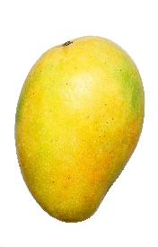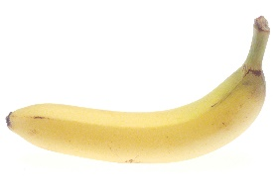  What is a portion – 1 banana mango

1: Once in a month | 2: one time a week | 3: two times a week | 4: three times a week | 5: four times a week | 6: five times a week | 7: six times a week | 8: one time a day | 9: two or more times a day

29: Please indicate how often you consume at least one portion of leafy vegetables
Four heaped tablespoons (one handful) of cooked green leafy veggies like cabbage, Sukuma wiki, spinach, | 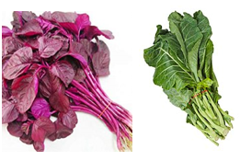  What is a portion – 4 heaped table spoons or 1 handful

1: Once in a month | 2: one time a week | 3: two times a week | 4: three times a week | 5: four times a week | 6: five times a week | 7: six times a week | 8: one time a day | 9: two or more times a day

30: Please indicate how often you consume at least one portion of vegetables other than leafy vegetables
Three heaped tablespoons (one handful) of vegetables like sliced carrots, cucumber, green pepper, eggplant, mixed vegetables | 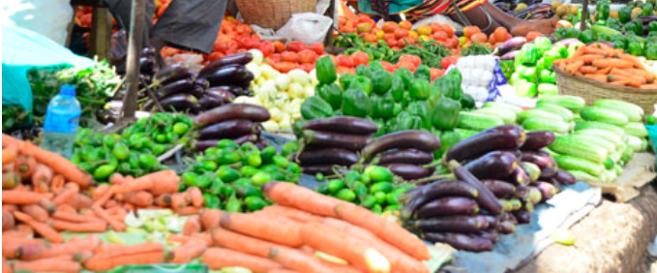  What is a portion – 3 heaped table spoons or 1 handful

1: Once in a month | 2: one time a week | 3: two times a week | 4: three times a week | 5: four times a week | 6: five times a week | 7: six times a week | 8: one time a day | 9: two or more times a day

31 | How easy is it for you to eat fruits and vegetables when you find yourself in the following situations
31a | When at work | 1: Very difficult | 2: Somewhat difficult | 3: Somewhat easy | 4: Always easy
31b | When traveling | 1: Very difficult | 2: Somewhat difficult | 3: Somewhat easy | 4: Always easy
31c | When you experience time pressure | 1: Very difficult | 2: Somewhat difficult | 3: Somewhat easy | 4: Always easy
32 | How often do you pack fruits when going to work? | 1: Never | 2: Rarely | 3: Sometimes | 4: Always
33 | How often do you pack vegetables when going to work? | 1: Never | 2: Rarely | 3: Sometimes | 4: Always
34 | How often do you eat vegetables as snacks (between meals)? e.g. avocado, carrots, tomatoes, cucumbers | 1: Never | 2: Rarely | 3: Sometimes | 4: Always
35 | How often do you eat fruits as a snack (in between meals)? | 1: Never | 2: Rarely | 3: Sometimes | 4: Always

      - Nutrition information
36 | When you have questions on what food to eat for better health, do you know where to ﬁnd this information? | 1: Never | 2: Rarely | 3: Sometimes | 4: Always
37 | There is a lot of information available on healthy eating today. How well do you manage to choose the information relevant to you? | 1: Very difficult | 2: Somewhat difficult | 3: Somewhat easy | 4: Always easy
38 | In general, how often do you use (listen and value) the sources of nutritional information below?
38a | Nutrition advice from family members | 1: Never | 2: Rarely | 3: Sometimes | 4: Always
38b | Nutrition advice from friends and peers | 1: Never | 2: Rarely | 3: Sometimes | 4: Always
38c | TV or radio program on nutrition | 1: Never | 2: Rarely | 3: Sometimes | 4: Always
38d | Self -proclaimed nutrition experts on streets | 1: Never | 2: Rarely | 3: Sometimes | 4: Always
38e | Health workers (doctors) | 1: Never | 2: Rarely | 3: Sometimes | 4: Always
38f | Nutritionists | 1: Never | 2: Rarely | 3: Sometimes | 4: Always
38g | Social media (WhatsApp, face book, you tube) | 1: Never | 2: Rarely | 3: Sometimes | 4: Always
39 | How easy is it for you to judge if healthy eating information shared on various platforms can be trusted? | 1: Very difficult | 2: Somewhat difficult | 3: Somewhat easy | 4: Always easy

