SUPPLEMENTARY MATERIAL

Supplementary Table 1. Characteristics¹ of men and women aged 25-64 years with spot urine samples in the HUNT Study: HUNT3 (2006-08, n=499) and HUNT4 (2017-19, n=500). Median values
 |  | Men |  | p value² |  | Women |  | P value²
 |  | HUNT3 | HUNT4 |  |  | HUNT3 | HUNT4
Age |  | 45.1 | 45.0 | 0.92 |  | 44.7 | 45.1 | 0.75
BMI |  | 27.6 | 27.1 | 0.17 |  | 25.0 | 25.6 | 0.24
Na (mmol/l) |  | 121.3 | 114.4 | 0.20 |  | 86.2 | 82.3 | 0.67
K (mmol/l) |  | 65.9 | 69.6 | 0.33 |  | 56.1 | 55.9 | 0.88
Na/K ratio |  | 1.85 | 1.66 | 0.11 |  | 1.67 | 1.48 | 0.07
Creatinine |  | 11.3 | 11.5 | 0.70 |  | 7.9 | 7.2 | 0.45
Calculated NaCl (g/24h) |  | 11.10 | 10.83 | 0.14 |  | 7.58 | 7.59 | 0.92
¹ BMI, body mass index. Na, urinary sodium concentration. K, urinary potassium concentration. Na/K ratio, ratio of urinary sodium to potassium concentrations. NaCl, salt.
² p-values estimated by quantile regression (Stata function ‘qreg’)

Supplementary Table 2. Median spot urinary sodium (Na), potassium (K), sodium to potassium ratio (Na/K ratio), creatinine and estimated 24-hour salt intake by age groups in men and women participating in HUNT4 (n=750).
 | N | Na  (mmol/l) | K  (mmol/l) | Na/K  ratio | Calculated NaCl  (g/24h)² | Creatinine (mmol/l)
Men
25-44 years | 125 | 118.5 | 62.4 | 1.99 | 10.6 | 11.5
45-64 years  70-79 years | 125  125 | 107.3  102.3 | 80.6  68.2 | 1.41  1.54 | 11.0  11.2 | 11.6  10.5
p-value¹ |  | 0.10 | 0.24 | 0.003 | 0.017 | 0.35
Women
25-44 years | 95 | 105.8 | 61.8 | 1.65 | 8.0 | 9.1
45-64 years  70-79 years³ | 155  125 | 65.9  85.0 | 51.0  61.5 | 1.24  1.35 | 7.3  5.9 | 6.5  6.8
p-value¹ |  | 0.027 | 0.74 | 0.043 | <0.001 | 0.06

¹ Age group entered as a continuous variable in quantile regression (Stata function ‘qreg’)
² Estimated using the INTERSALT equation with sex-specific coefficients for the Northern European region (see Supplementary Figure 1)
³ Three women aged 70-79 years had missing values for BMI and thereby calculated NaCl
P-values <0.05 bolded.

Supplementary Table 3. Age-standardized median sodium (Na), potassium (K), sodium to potassium ratio (Na/K ratio) and estimated 24-hour salt intake by educational attainment in men and women aged 25-64 years participating in HUNT4.
Education¹ | N | Na  (mmol/l) | K  (mmol/l) | Na/K  ratio | Calculated NaCl  (g/24h)³
Men
Primary | 38 | 121.1 | 70.6 | 1.84 | 11.1
Secondary  Tertiary, short (<4 yrs) | 110  59 | 115.0  108.9 | 68.4  79.5 | 1.82  1.76 | 10.8  10.4
Tertiary, long (≥4 yrs) | 42 | 99.2 | 61.8 | 1.50 | 10.7
p-value² |  | 0.22 | 0.82 | 0.048 | 0.19
Women
Primary | 39 | 84.6 | 69.3 | 1.54 | 7.8
Secondary | 67 | 100.4 | 53.2 | 1.81 | 8.0
Tertiary, short (<4 yrs) | 72 | 76.1 | 54.9 | 1.37 | 7.5
Tertiary, long (≥4 yrs) | 71 | 81.2 | 55.7 | 1.34 | 7.5
p-value² |  | 0.38 | 0.43 | 0.020 | 0.007

¹ Attained educational level in four categories. Primary education: Completed primary school or 1-2 years of high school/vocational school; secondary education: Completed high school or certificate of apprenticeship; tertiary short: University or other post-secondary education less than 4 years; tertiary long: University/college education of 4 years or more.
² Education level entered as a continuous variable in quantile regression (Stata function ‘qreg’)
³ Estimated using the INTERSALT equation with sex-specific coefficients for the Northern European region (see Supplementary Figure 1)
P-values <0.05 bolded.

Supplementary Figure 1. The INTERSALT equation with coefficients for the Northern European region for estimating 24-hour sodium excretion (mmol/24h) from spot urine^{1,2}
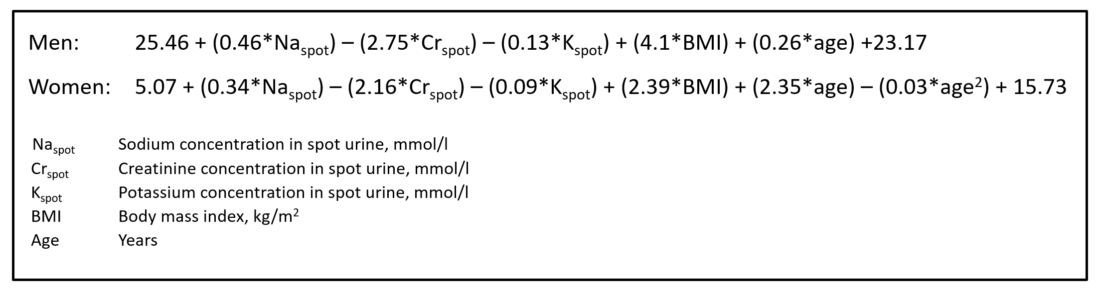
¹ Brown IJ, Dyer AR, Chan Q, Cogswell ME, Ueshima H, Stamler J, et al. Estimating 24-hour urinary sodium excretion from casual urinary sodium concentrations in Western populations: the INTERSALT study. Am J Epidemiol 2013;177(11):1180-92
² To convert to g Na/24h, results are multiplied by a factor of 0.023, then multiplied by 2.54 to obtain the corresponding g NaCl/24h.

