Supplemental Table S1 References values for macronutrients, vitamins and minerals
Nutrient | Unit | Minimum Daily Recommended Intake
 |  | 1-3 yo | 4-6 yo | 7-10 yo | 11-14 yo | 15-17 yo
Carbohydrates | % EI | 40-50 | 40-55 | 40-55 | 40-55 | 40-55
Fats | % EI | 45-50 | 35-40 | 35-40 | 35-40 | 35-40
Proteins | % EI | 6 | 6 | 7 | 9 | 10
Fibers | g | 10 | 14 | 16 | 19 | 21
LA | % EI | 2.7 | 4 | 4 | 4 | 4
ALA | % EI | 0.45 | 1 | 1 | 1 | 1
DHA | mg | 70 | 125 | 125 | 250 | 250
Calcium | mg | 450 | 800 | 800 | 1150 | 1150
Iron | mg | 5 | 4 | 6 | Boys : 11  Girls : 13 | Boys : 11  Girls : 13
Zinc | mg | 4.3 | 5.5 | 7.4 | 10.7 | Boys : 14.2  Girls : 11.9
Copper | mg | 0.8 | 1 | 1.2 | 1.3 | Boys : 1.5  Girls :1.1
Iodin | µg | 90 | 90 | 90 | 120 | 130
Selenium | µg | 15 | 20 | 35 | 55 | 70
Magnesium | mg | 180 | 210 | 240 | 265 | Boys : 295  Girls : 225
Potassium | mg | 800 | 1100 | 1800 | 2700 | 3500
Phosphorus | mg | 250 | 440 | 440 | 640 | 640
Vitamin A | RE | 250 | 300 | 400 | 600 | Boys : 750  Girls : 650
Vitamin B1 | mg/MJ | 0.0 | 0.072 | 0.072 | 0.072 | 0.72
Vitamin B2 | mg | 0.6 | 0.7 | 1 | 1.4 | 1.6
Vitamin B3 | mg/MJ | 1.3 | 1.3 | 1.3 | 1.3 | 1.3
Vitamin B5 | mg | 4 | 4.5 | 5 | 6 | 6
Vitamin B5 | mg | 4 | 4.5 | 5 | 6 | 5
Vitamin B6 | mg | 0.6 | 0.7 | 1 | 1.4 | 1.7
Vitamin B6 | mg | 0.6 | 0.7 | 1 | 1.5 | 1.6
Vitamin B9 | µg | 120 | 140 | 200 | 270 | 330
Vitamin B12 | µg | 1.5 | 1.5 | 1.5 | 2.5 | 2.5
Vitamin C | mg | 20 | 30 | 45 | 70 | 100
Vitamin D | µg | 15 | 15 | 15 | 15 | 15
Vitamin E | mg | 7 | 7 | 9 | 10 | Boys : 10  Girls : 8
Nutrient | Unit | Maximum Daily Recommended Intake
Free sugars | % EI | 10 | 10 | 10 | 10 | 10
SFAs | % EI | 12 | 12 | 12 | 12 | 12
Sodium | mg | 800 | 1000 | 1200 | 1200 | 1500

Supplemental Table S2. Nutritional composition per 100 g of the no-added sugar fruit puree added in the simulation (INCA3¹)
Energy (kcal) | 57.4 | Vitamin A (RE eq.) | 59,2 | Magnesium (mg) | 6.10
Proteins (g) | 0.43 | Vitamin B1 (µg) | 0.07 | Potassium (mg) | 140
Carbohydrates (g) | 12.8 | Vitamin B2 (mg) | 0.01 | Calcium (mg) | 8.1
Sugars (g) | 11.6 | Vitamin B3 (mg) | 0.24 | Iron (mg) | 0.14
Free and added sugars (g) | 0.00 | Vitamin B6 (mg) | 0.033 | Cupper (mg) | 0.05
Fibers (g) | 1.68 | Vitamin B9 (µg) | 7.48 | Zinc (mg) | 0.025
Fats (g) | 0.34 | Vitamin C (mg) | 12.2 | Selenium (µg) | 25
SFA (g) | 0.082 | Vitamin E (mg) | 0.66 | Iodine (µg) | 10
Sodium (mg) | 2.38
¹French Agency for Food Environmental and Occupational Health & Safety (Anses) (2017) Opinion of the French Agency for Food, Environmental and Occupational Health & Safety on "the Third Individual and National Survey on Food Consumption (INCA3 survey). Maison-Alfort, France
Supplemental Table S3 Standard servings per age and eating occasion for the fruit puree added in the simulation and the replaceable items
Age rank | Eating occasion | Standard serving (g)
 |  | Fruit puree | Soft drinks | 100% fruit juice | Pastries
1-3 years old | Breakfast | 90 | 152 | 104 | 30
 | Lunch | 100 | 121 | 146 | 46
 | Snack | 90 | 147 | 135 | 30
 | Dinner | 100 | 139 | 78.0 | 36
4-6 years old | Breakfast | 90 | 126 | 146 | 40
 | Lunch | 90 | 150 | 125 | 55
 | Snack | 90 | 161 | 208 | 42
 | Dinner | 100 | 149 | 156 | 50
7-10 years old | Breakfast | 90 | 152 | 146 | 50
 | Lunch | 100 | 192 | 125 | 68
 | Snack | 90 | 200 | 208 | 50
 | Dinner | 100 | 192 | 166 | 79
11-14 years old | Breakfast | 100 | 200 | 156 | 63
 | Lunch | 100 | 228 | 156 | 81
 | Snack | 90 | 207 | 208 | 64
 | Dinner | 100 | 224 | 149 | 87
15-17 years old | Breakfast | 100 | 250 | 218 | 65
 | Lunch | 100 | 264 | 125 | 90
 | Snack | 100 | 244 | 218 | 70
 | Dinner | 100 | 264 | 189 | 90
Age rank | Eating occasion | Standard serving (g)
 |  | Biscuits | Dairy desserts | Ice Cream | Chocolate confectionery
1-3 years old | Breakfast | 13 | 100 |  | 9.00
 | Lunch | 10 | 100 | 40.2 | 10.0
 | Snack | 14 | 100 | 39.1 | 12.0
 | Dinner | 18 | 100 | 36.5 | 7.25
4-6 years old | Breakfast | 26 | 108 |  | 13.9
 | Lunch | 18 | 100 | 40.2 | 10.0
 | Snack | 28 | 89.8 | 43.5 | 16.4
 | Dinner | 29 | 100 | 40.2 | 13.0
7-10 years old | Breakfast | 35 | 85.0 | 25.6 | 20.4
 | Lunch | 20 | 100 | 44.2 | 10.8
 | Snack | 35 | 100 | 52.2 | 19.0
 | Dinner | 20 | 100 | 44.2 | 13.0
11-14years old | Breakfast | 40 | 125 |  | 22.0
 | Lunch | 18 | 100 | 52.2 | 14.5
 | Snack | 39 | 100 | 70.0 | 21.0
 | Dinner | 24 | 100 | 59.6 | 17.5
15-17 years old | Breakfast | 42 | 100 |  | 20.7
 | Lunch | 23 | 100 | 62.3 | 16.5
 | Snack | 40 | 125 | 66.7 | 24.0
 | Dinner | 32 | 100 | 64.3 | 19.5

Supplemental Figure S4 Different kind of simulations among all the studied recalls. No simulations : the serving size of fruit puree was already reached. No substitution : No replaceable items, only addition. Partial substitution : the quantity of fruit puree was greater than 0 but lower than the serving size. Full substitution : the quantity of fruit puree was equal to 0.
1-3 years old | 4-6 years old
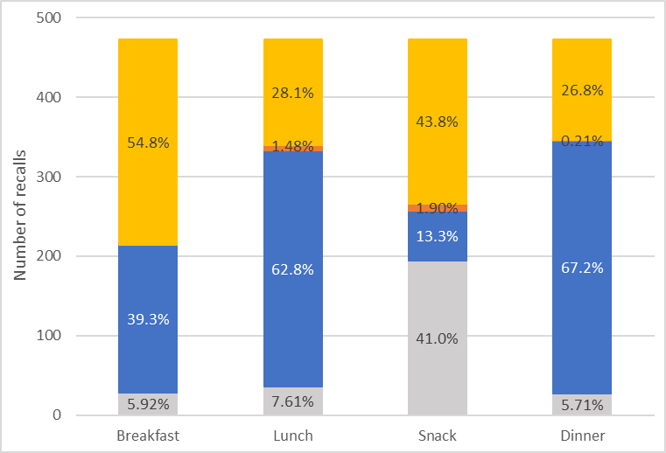 | 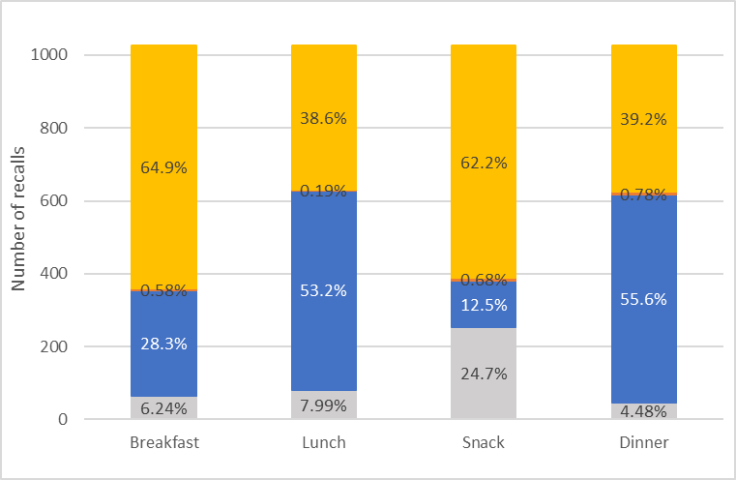
7-10 years old | 11-14 years old
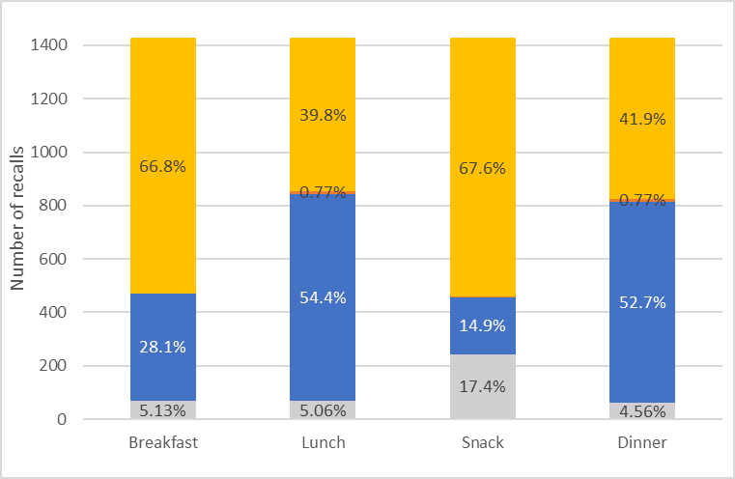 | 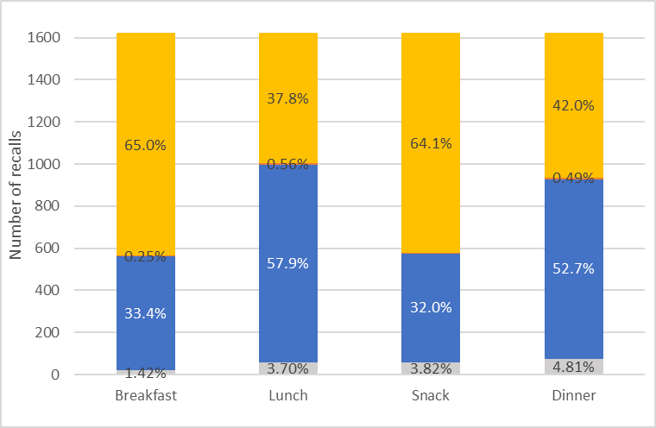
15-17 years old
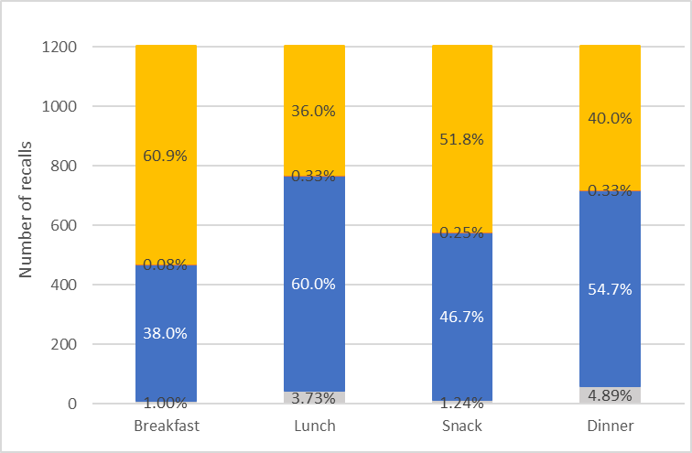

Supplemental Figure S5A Percentage of consumers fulfilling nutritional requirements (per age rank and for all age ranks combined) before and after ADDITION. detailed per age rank
1-3 (n=159) | 4-6 (n=345)
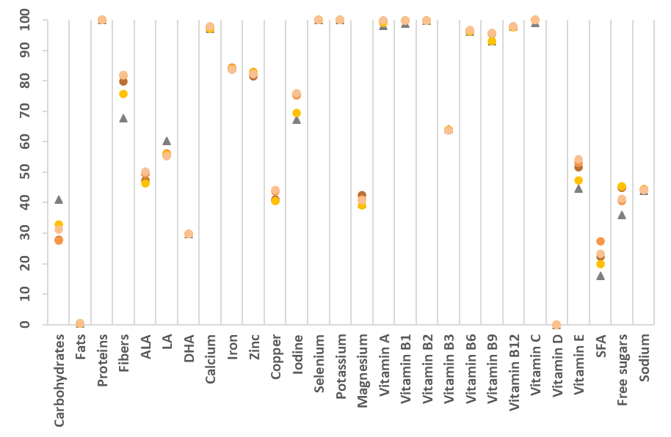 | 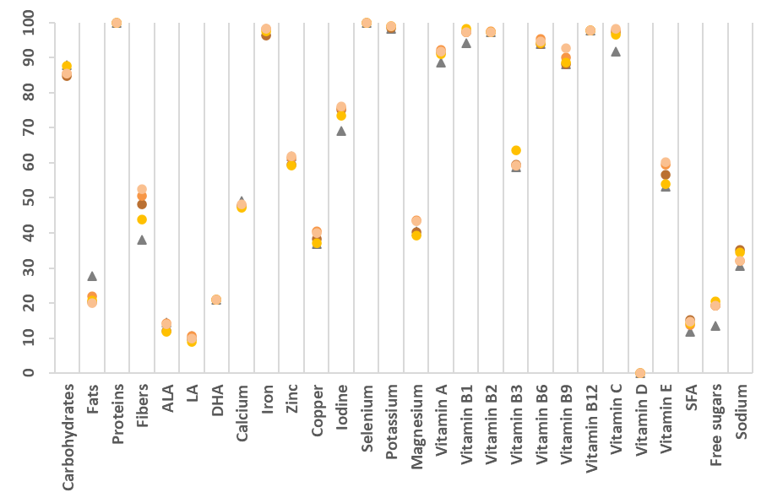
7-10 (n=481) | 11-17 (n=543)
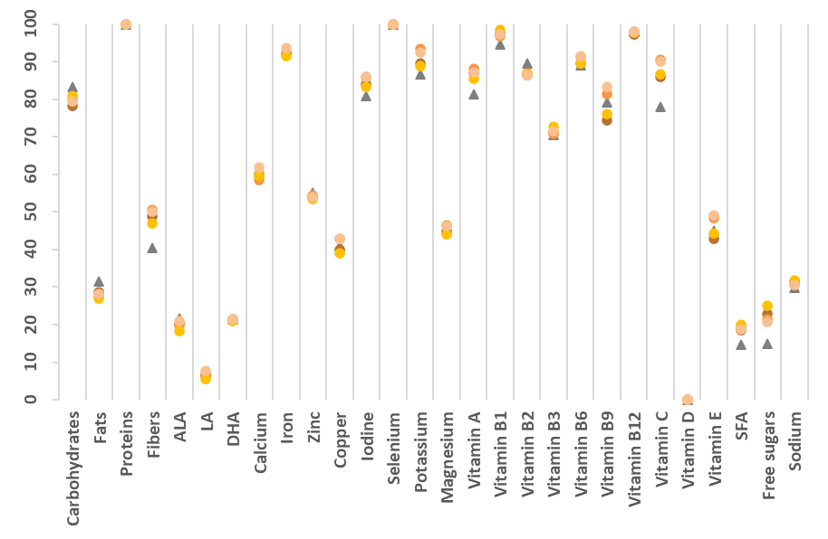 | 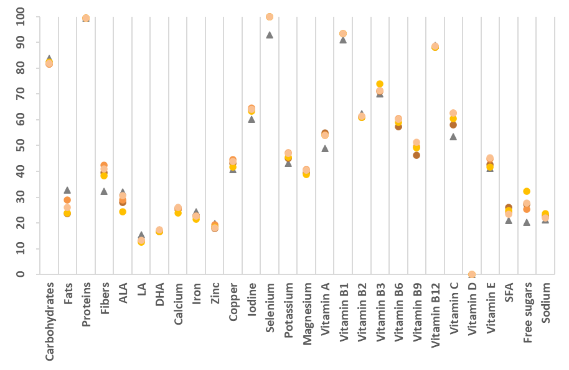
15-17 (n=406)
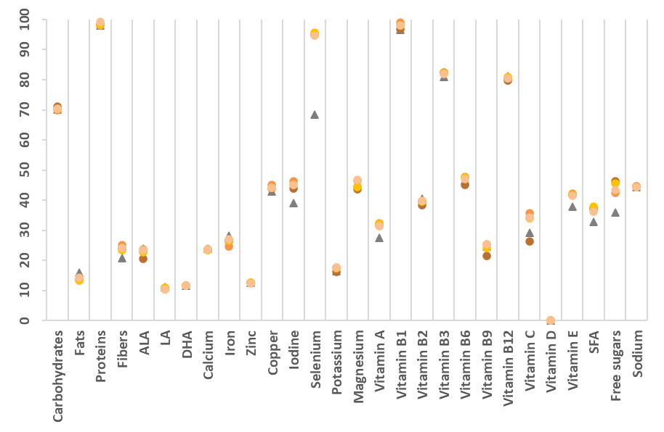

Supplemental Figure S5B Percentage of consumers fulfilling nutritional requirements (per age rank and for all age ranks combined) before and after ISOPORTION SUBSTITUTION. detailed per age rank
1-3 (n=159) | 4-6 (n=345)
7-10 (n=481) | 11-17 (n=543)
15-17 (n=406)

