Supplementary Material
Supplementary Table 1. Foods and beverages included in each food group component, by dietary quality index
Food Group Components | Planetary Health Index | Global Burden of Disease Index | Mexican Dietary Guidelines
High-fiber cereals (fiber/carbohydrates >0.1) | Tortilla, corn, whole grain bread, popcorn | Tortilla, corn, whole grain bread, popcorn, whole grain breakfast cereals | -
Cereals | - | - | Rice, sweet potato, breakfast cereal, corn, cookies, all types of bread, wheat pasta, wheat or corn flour, instant soup, all types of tortilla
Vegetables | Broccoli, cauliflower, zucchini, chayote, poblano peppers, cabbage, green beans, leafy greens, tomato, lettuce, nopal, cucumber, carrot, peas, onion, mushrooms, leak, jicama, canned or frozen vegetables
Fruits | Peach, strawberry, guava, mango, apple, pear, melon, watermelon, orange, papaya, pineapple, banana, grapefruit, grapes, capulín, plum, other fruits as ingredients of preparations included in the food frequency questionnaire (FFQ) | Peach, strawberry, guava, mango, apple, pear, melon, watermelon, orange, papaya, pineapple, banana, grapefruit, grapes | Peach, strawberry, guava, mango, apple, pear, melon, watermelon, orange, papaya, pineapple, banana, grapefruit, grapes, capulín, plum, other fruits as ingredients of preparations included in the FFQ
Legumes | Beans, lentils, broad beans, chickpeas
Nuts and seeds | Peanuts, fava beans, pepitas, almonds from ingredients of preparations included in the FFQ |  | -
Unsaturated oils | Corn, sunflower, and canola oils as ingredients of preparations included in the FFQ | - | -
Tubers | Potato, sweet potato | - | -
Dairy | Whole, skim, or semi-skim milk, fresh/white cheese, cured/mature cheeses, whole or low-fat plain or flavored yogurt | - | -
Milk | - | Whole, skim, or semi-skim milk | -
Low-fat dairy | - | - | Skim or semi-skim milk, fresh/white cheese and low-fat yogurt
Chicken/poultry | Any piece of chicken or other poultry | - | -
Eggs | Boiled, fried, or scrambled egg | - | -
Fish and shellfish | Fresh or dried fish, tuna, sardines, any other seafood | - | -
Red meats | Beef, pork | Beef, pork | -
Processed meats | - | Ham, sausage | -
Low-fat animal-based foods | - | - | Seafood (shrimp, oysters, etc.), tuna and sardines (in tomato, water, or oil), lean poultry, pork, beef or dried beef, fresh or dried fish
High-fat animal-based foods | - | - | Egg, semi-fatty or fatty chicken, pork, beef, sausage
Saturated fats | Butter, lard, bacon, milk cream | -
Foods rich in fats | - | - | Vegetable oils, avocado, butter, lard, bacon, milk cream, mayonnaise, vegetable shortening
Added sugars | Sweeteners added to milk, tea, coffee, or desserts, condensed milk, sugars from sodas or other industrialized beverages, natural or industrialized juices, candies, etc. | - | Sweeteners added to milk, tea, coffee, or desserts, condensed milk, sugars from sodas or other industrialized beverages, natural or industrialized juices, candies, etc.
Water | - | - | Plain water
Sugar-sweetened beverages | - | Industrialized juices, sodas, carbonated beverages, fruit drinks, etc. | -

Supplementary Figure 2. Scoring by component dimension
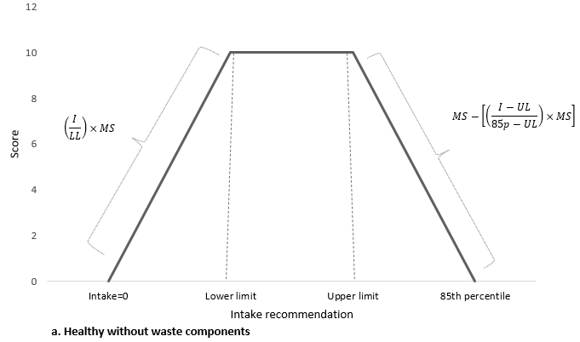 | 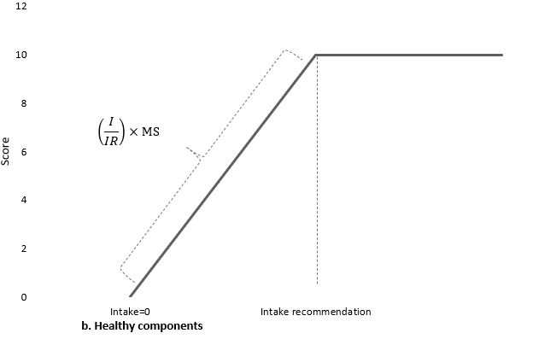
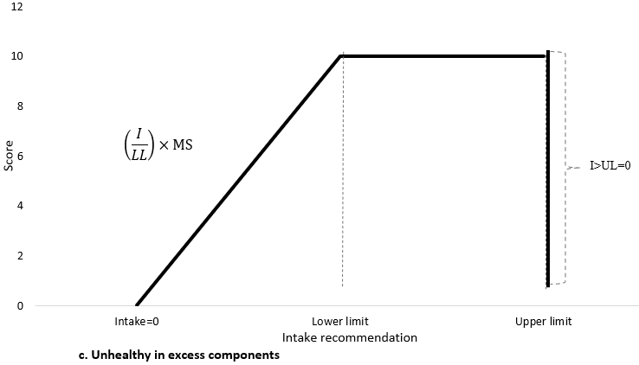 | 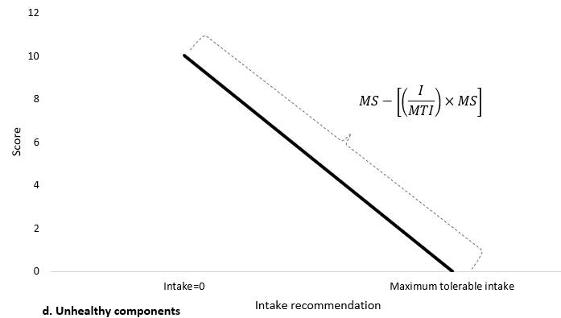
Where: I=Intake, LL=Lower limit of intake recommendation, UL= Upper limit of intake recommendation, 85p=85th percentile between UL and maximum intake registered in sample, MS=Maximum score, IR=Intake recommendation, MTI=Maximum tolerable intake.

Supplementary Table 2. Bonferroni correction used in statistical analysis, p values for significance and confidence levels.
Analysis | p value for significance | Confidence level
Trends in dietary quality (Figure 1) | 0.05/3 = 0.017 | 98.33%
Trends in dietary quality by Planetary Health Index components (Figure 2a) | 0.05/14 = 0.0036 | 99.64%
Trends in dietary quality by Global Burden of Disease Index components (Figure 2b) | 0.05/15 = 0.0033 | 99.67%
Trends in dietary quality by Mexican Dietary Guidelines Index components (Figure 2c) | 0.05/10 = 0.005 | 99.50%
Trends by sex, dwelling area and student status (Figure 3a, 3b, 3c) | 0.05/2=0.025 | 97.50%
Trends by region and household assets strata (Figure 3a, 3b,3c) | 0.05/3 = 0.017 | 98.33%

Supplementary Table 3. Distribution of the Mexican adolescent population according to component intake recommendation of the Planetary Health Index, by survey year
Intake vs. Recommendation Category | 2006 |  | 2012 |  | 2016 |  | 2018
 | % | CI95% | % | CI95% | % | CI95% | % | CI95%
High-Fiber Cereals
No intake | 1.2 | 0.9, 1.6 | 2.4 | 1.7, 3.5 | 0.8 | 0.4, 1.5 | 0.6 | 0.4, 1
Intake<recommendation | 46.9 | 44.6, 49.2 | 56.4 | 53.2, 59.6 | 46.4 | 42.6, 50.2 | 49.5 | 47.2, 51.8
Intake=recommendation | 0.2 | 0.1, 0.4 | 0.3 | 0.1, 0.8 | 0.4 | 0.2, 1.1 | 0.3 | 0.1, 0.6
Intake>recommendation | 44.3 | 42.2, 46.3 | 34.9 | 32, 37.9 | 45.7 | 42, 49.5 | 42 | 39.8, 44.3
Intake>85th p* | 7.5 | 6.5, 8.6 | 6 | 4.7, 7.6 | 6.7 | 5.2, 8.7 | 7.6 | 6.5, 8.8
Vegetables
No intake | 0.1 | 0, 0.2 | 0 | 0, 0 | 0 | 0, 0 | 0 | 0, 0.2
Intake<recommendation | 82.5 | 81, 83.8 | 66.9 | 63.9, 69.8 | 65.8 | 62.7, 68.9 | 78.2 | 76.3, 80.1
Intake=recommendation | 16.5 | 15.2, 17.9 | 31.9 | 29.1, 34.9 | 32 | 28.9, 35.2 | 20.1 | 18.3, 22
Intake>recommendation | 0.8 | 0.5, 1.3 | 0.9 | 0.5, 1.6 | 2.1 | 1.3, 3.2 | 1.4 | 0.9, 2.1
Intake>85th p* | 0.1 | 0, 0.4 | 0.3 | 0.1, 1.1 | 0.2 | 0.1, 0.4 | 0.3 | 0.1, 0.7
Fruits
No intake | 6.4 | 5.5, 7.4 | 5.7 | 4.4, 7.5 | 3.5 | 2.3, 5.1 | 4.1 | 3.3, 4.9
Intake<recommendation | 31.2 | 29.4, 33 | 27.2 | 24.6, 29.9 | 29.2 | 26.6, 32 | 36.4 | 34.3, 38.6
Intake=recommendation | 37 | 35.1, 38.9 | 38.1 | 35.1, 41.3 | 41.6 | 38.4, 44.9 | 39.9 | 37.7, 42.2
Intake>recommendation | 22 | 20.4, 23.6 | 24.3 | 21.6, 27.3 | 22.3 | 19.6, 25.3 | 17.1 | 15.5, 18.9
Intake>85th p* | 3.5 | 2.9, 4.1 | 4.7 | 3.4, 6.3 | 3.4 | 2.3, 5 | 2.4 | 1.9, 3.1
Legumes
No intake | 3.7 | 3, 4.6 | 4.3 | 3.2, 5.7 | 3.4 | 2.4, 5 | 2.8 | 2.1, 3.6
Intake<recommendation | 89.2 | 88, 90.3 | 81.3 | 79, 83.4 | 83.4 | 80.6, 85.8 | 88.7 | 87.2, 90
Intake=recommendation | 6.9 | 6.1, 7.9 | 13.7 | 11.8, 15.8 | 12.4 | 10.3, 14.9 | 8 | 6.9, 9.2
Intake>recommendation | 0.1 | 0.1, 0.2 | 0.6 | 0.4, 1.1 | 0.8 | 0.4, 1.7 | 0.4 | 0.2, 0.8
Intake>85th p* | 0 | 0, 0.1 | 0.1 | 0, 0.4 | 0 | 0, 0.2 | 0.1 | 0, 0.5
Nuts and Seeds
No intake | 73.6 | 71.8, 75.2 | 72.5 | 69.6, 75.3 | 75.3 | 72, 78.3 | 69 | 66.9, 71.1
Intake<recommendation | 25.8 | 24.2, 27.5 | 26.5 | 23.8, 29.5 | 23.5 | 20.6, 26.7 | 30.2 | 28.2, 32.4
Intake=recommendation | 0.6 | 0.4, 0.8 | 0.9 | 0.4, 2 | 1.2 | 0.6, 2.1 | 0.7 | 0.4, 1.1
Intake>recommendation | 0 | 0, 0 | 0 | 0, 0 | 0 | 0, 0 | 0 | 0, 0.2
Intake>85th p* | 0 | 0, 0.1 | 0 | 0, 0 | 0 | 0, 0.1 | 0.1 | 0, 0.5
Unsaturated oils
No intake | 0.1 | 0, 0.2 | 0.1 | 0, 0.4 | 0 | 0, 0.1 | 0.1 | 0, 0.5
Intake<recommendation | 97.3 | 96.7, 97.9 | 97.9 | 96.9, 98.6 | 95.3 | 93, 96.9 | 96 | 94.8, 96.9
Intake=recommendation | 2.6 | 2, 3.2 | 2.1 | 1.4, 3 | 4.6 | 3.1, 7 | 3.9 | 3, 5.1
Intake>recommendation | 0 | 0, 0.1 | 0 | 0, 0 |  |  | 0 | 0, 0
Intake>85th p* | 0 | 0, 0.1 | 0 | 0, 0 |  |  | 0 | 0, 0
Tubers
No intake | 20.9 | 19.5, 22.4 | 22.4 | 20.1, 25 | 16.4 | 14, 19.2 | 13.8 | 12.4, 15.4
Intake<recommendation | 64.1 | 62.3, 65.8 | 59.2 | 56.1, 62.4 | 68.3 | 64.7, 71.6 | 70 | 68, 72
Intake=recommendation | 14.5 | 13.2, 15.8 | 17.6 | 15.3, 20 | 14.3 | 11.8, 17.2 | 15.3 | 13.7, 17.1
Intake>recommendation | 0.6 | 0.4, 0.9 | 0.8 | 0.4, 1.5 | 1 | 0.6, 1.7 | 0.8 | 0.5, 1.4
Dairy
No intake | 1.6 | 1.2, 2.1 | 1 | 0.5, 1.9 | 1 | 0.5, 1.9 | 0.7 | 0.5, 1
Intake<recommendation | 30.7 | 28.9, 32.6 | 24.7 | 22.4, 27.1 | 32.1 | 28.9, 35.4 | 32.5 | 30.4, 34.7
Intake=recommendation | 42.8 | 41.1, 44.4 | 50.1 | 46.8, 53.4 | 45.5 | 42.5, 48.5 | 50.7 | 48.5, 53
Intake>recommendation | 24.9 | 23.2, 26.7 | 24.2 | 21.4, 27.2 | 21.5 | 18.6, 24.6 | 16 | 14.5, 17.7
Chicken/Poultry
No intake | 10.9 | 9.9, 12 | 16.6 | 14.6, 18.9 | 11 | 9, 13.5 | 6.3 | 5.4, 7.3
Intake<recommendation | 23.3 | 21.8, 24.8 | 35.5 | 32.3, 38.8 | 31.1 | 28.1, 34.2 | 25.4 | 23.5, 27.5
Intake=recommendation | 50.8 | 49, 52.6 | 34.3 | 31.3, 37.5 | 41.6 | 38.1, 45.1 | 44.7 | 42.5, 46.9
Intake>recommendation | 15 | 13.6, 16.5 | 13.5 | 11.5, 15.8 | 16.3 | 13.6, 19.5 | 23.6 | 21.6, 25.7
Egg
No intake | 4.7 | 4, 5.5 | 3.9 | 3, 4.9 | 2.7 | 2, 3.7 | 2.6 | 2.1, 3.4
Intake<recommendation | 20.7 | 19.3, 22.1 | 22.7 | 20, 25.6 | 20.1 | 17.5, 23.1 | 19.7 | 18, 21.6
Intake=recommendation | 21.2 | 19.6, 23 | 21.4 | 18.9, 24.1 | 24.7 | 21.8, 27.9 | 22.2 | 20.4, 24.1
Intake>recommendation | 53.4 | 51.6, 55.2 | 52.1 | 48.9, 55.2 | 52.4 | 48.9, 55.9 | 55.5 | 53.1, 57.8
Fish and Shellfish
No intake | 21.2 | 19.8, 22.7 | 19.7 | 17.4, 22.2 | 19.7 | 16.8, 22.9 | 12.7 | 11.4, 14.2
Intake<recommendation | 60.6 | 58.8, 62.4 | 62.8 | 59.6, 66 | 62.8 | 58.8, 66.6 | 69.5 | 67.2, 71.7
Intake=recommendation | 17.5 | 16.1, 19.1 | 16.9 | 14.5, 19.6 | 15.6 | 13, 18.7 | 16.9 | 15.2, 18.8
Intake>recommendation | 0.6 | 0.4, 0.9 | 0.5 | 0.3, 1.1 | 2 | 1, 3.7 | 0.8 | 0.5, 1.2
Red Meat
No intake=recommendation | 0 |  | 0 |  | 0 |  | 0
Intake<MTI† | 44 | 42.2, 45.8 | 41.3 | 38.2, 44.4 | 49.9 | 46.3, 53.5 | 37.9 | 35.7, 40.2
Intake>MTI† | 56 | 54.2, 57.8 | 58.7 | 55.6, 61.8 | 50.1 | 46.5, 53.7 | 62.1 | 59.8, 64.3
Saturated Fats
No intake=recommendation | 0 |  | 0 |  | 0 |  | 0
Intake<MTI† | 85.4 | 84, 86.7 | 81.1 | 78.3, 83.6 | 81.5 | 78.8, 83.9 | 80.7 | 78.8, 82.4
Intake>MTI† | 14.6 | 13.3, 16 | 18.9 | 16.4, 21.7 | 18.5 | 16.1, 21.2 | 19.3 | 17.6, 21.2
Added Sugars
No intake=recommendation | 0 |  | 0 |  | 0 |  | 0
Intake<MTI† | 2.3 | 1.8, 2.9 | 2.2 | 1.5, 3.1 | 2.3 | 1.5, 3.6 | 1.9 | 1.4, 2.6
Intake>MTI† | 97.7 | 97.1, 98.2 | 97.8 | 96.9, 98.5 | 97.7 | 96.4, 98.5 | 98.1 | 97.4, 98.6
*85th percentile between upper limit of intake recommendation and maximum intake in sample
†Maximum tolerable intake

Supplementary Table 4. Distribution of the Mexican adolescent population according to component intake recommendation of the Global Burden of Disease Index, by survey year
Intake vs. Recommendation Category | 2006 |  | 2012 |  | 2016 |  | 2018
 | % | CI95% | % | CI95% | % | CI95% | % | CI95%
Fruits
No intake | 12.2 | 11.1, 13.4 | 8.7 | 7.1, 10.8 | 5.1 | 3.7, 6.9 | 8.9 | 7.8, 10.2
Intake<recommendation | 70.0 | 68.3, 71.6 | 66.9 | 63.8, 69.8 | 70.2 | 67.1, 73.1 | 76.3 | 74.4, 78.2
Intake≥recommendation | 17.8 | 16.3, 19.4 | 24.4 | 21.8, 27.2 | 24.7 | 22, 27.6 | 14.7 | 13.2, 16.4
Vegetables
No intake | 0.1 | 0.1, 0.2 | 0 | 0, 0 | 0 | 0, 0 | 0.1 | 0, 0.2
Intake<recommendation | 98.6 | 98, 99 | 96.2 | 94.7, 97.3 | 92.5 | 90.1, 94.3 | 96.6 | 95.6, 97.4
Intake≥recommendation | 1.3 | 0.9, 1.9 | 3.8 | 2.7, 5.3 | 7.5 | 5.7, 9.8 | 3.3 | 2.6, 4.3
Legumes
No intake | 4.2 | 3.5, 5.2 | 4.2 | 3.1, 5.6 | 3.2 | 2.2, 4.6 | 2.8 | 2.1, 3.7
Intake<recommendation | 95.7 | 94.7, 96.5 | 94.3 | 92.7, 95.5 | 94.2 | 92.5, 95.6 | 95.9 | 94.9, 96.7
Intake≥recommendation | 0.1 | 0, 0.2 | 1.6 | 1, 2.4 | 2.6 | 1.7, 3.9 | 1.3 | 0.9, 1.9
High-Fiber Cereals
No intake | 1.7 | 1.4, 2.2 | 2.8 | 2, 3.9 | 1.0 | 0.5, 1.8 | 1.0 | 0.6, 1.5
Intake<recommendation | 38.0 | 35.7, 40.2 | 41.8 | 38.7, 45 | 28.8 | 25.7, 32 | 36.3 | 34.1, 38.5
Intake≥recommendation | 60.3 | 58, 62.6 | 55.3 | 52.1, 58.5 | 70.3 | 67, 73.4 | 62.7 | 60.5, 64.9
Nuts and Seeds
No intake | 73.6 | 71.8, 75.2 | 72.5 | 69.6, 75.3 | 75.3 | 72, 78.3 | 69 | 66.9, 71.1
Intake<recommendation | 25.3 | 23.6, 27 | 25.1 | 22.5, 27.9 | 22.8 | 19.9, 26 | 29.5 | 27.5, 31.7
Intake≥recommendation | 1.2 | 0.9, 1.5 | 2.4 | 1.3, 4.1 | 1.9 | 1.1, 3.3 | 1.4 | 1, 2
Milk
No intake | 19.4 | 18, 20.8 | 20 | 17.5, 22.6 | 16.8 | 14.3, 19.7 | 13.9 | 12.4, 15.6
Intake<recommendation | 74.1 | 72.5, 75.6 | 71.4 | 68.2, 74.3 | 74.0 | 70.9, 76.9 | 82.0 | 80.2, 83.6
Intake≥recommendation | 6.6 | 5.7, 7.6 | 8.7 | 6.8, 11 | 9.2 | 7.2, 11.6 | 4.1 | 3.5, 4.9
Fiber
No intake | 0 | - | 0 | - | 0 | - | 0 | -
Intake<recommendation | 68 | 66.1, 69.8 | 59.9 | 56.8, 62.9 | 52.1 | 48.6, 55.6 | 61.6 | 59.3, 63.9
Intake≥recommendation | 32 | 30.2, 33.9 | 40.1 | 37.1, 43.2 | 47.9 | 44.4, 51.4 | 38.4 | 36.1, 40.7
Calcium
No intake | 0 | - | 0 | - | 0 | - | 0 | -
Intake<recommendation | 84.3 | 82.5, 86 | 76.5 | 73.7, 79.1 | 71.2 | 68, 74.1 | 79.7 | 77.8, 81.6
Intake≥recommendation | 15.7 | 14, 17.5 | 23.5 | 20.9, 26.3 | 28.8 | 25.9, 32 | 20.3 | 18.4, 22.2
Omega-3 Fatty Acids
No intake
Intake<recommendation | 92.6 | 91.5, 93.5 | 93.9 | 92.2, 95.2 | 89.5 | 86.8, 91.8 | 90.8 | 89.3, 92
Intake≥recommendation | 7.4 | 6.5, 8.5 | 6.1 | 4.8, 7.8 | 10.5 | 8.2, 13.2 | 9.2 | 8, 10.7
Omega-6 Fatty Acids
No intake |  | - | 0 | - | 0 | - | 0 | -
Intake<recommendation | 100 | 99.9, 100 | 100 | 0, 0 | 100 | 99.9, 100 | 99.9 | 99.7, 100
Intake≥recommendation | 0 | 0, 0.1 | 0 | 0, 0 | 0 | 0, 0.1 | 0.1 | 0, 0.3
Red Meat
No intake | 10.2 | 9.1, 11.3 | 7.2 | 5.9, 8.9 | 8.6 | 7, 10.6 | 5.7 | 4.8, 6.8
Intake<recommendation | 34.9 | 33.2, 36.5 | 30.9 | 28, 33.9 | 35.7 | 32.3, 39.3 | 30.6 | 28.6, 32.6
Intake=recommendation | 11.3 | 10.1, 12.6 | 10.8 | 8.9, 13.1 | 13.1 | 11, 15.4 | 13.1 | 11.7, 14.6
Intake>recommendation | 43.7 | 41.7, 45.7 | 51.0 | 47.8, 54.3 | 42.6 | 39.2, 46.1 | 50.6 | 48.4, 52.9
Processed Meats
No intake=recommendation | 0 | - | 0 | - | 0 | - | 0 | -
Intake<MTI† | 33.0 | 31, 35 | 20.9 | 18.5, 23.4 | 23.3 | 20.4, 26.5 | 19.0 | 17.2, 21.0
Intake>MTI† | 67.0 | 65, 69 | 79.1 | 76.6, 81.5 | 76.7 | 73.5, 79.6 | 81.0 | 79.0, 82.8
Sugar-Sweetened Beverages
No intake=recommendation | 0 | - | 0 | - | 0 | - | 0 | -
Intake<MTI† | 8.4 | 7.5, 9.5 | 7.0 | 5.4, 9.1 | 4.3 | 3.1, 6 | 3.2 | 2.5, 4.1
Intake>MTI† | 91.6 | 90.5, 92.5 | 93 | 90.9, 94.6 | 95.7 | 94, 96.9 | 96.8 | 95.9, 97.5
Trans Fatty Acids
No intake=recommendation | 0 | - | 0 | - | 0 | - | 0 | -
Intake<MTI† | 59.9 | 57.8, 62 | 51.7 | 48.4, 54.9 | 59.2 | 56.1, 62.2 | 60.6 | 58.2, 62.9
Intake>MTI† | 40.1 | 38, 42.2 | 48.3 | 45.1, 51.6 | 40.8 | 37.8, 43.9 | 39.4 | 37.1, 41.8
Sodium
No intake=recommendation | 0 | - | 0 | - | 0 | - | 0 | -
Intake<MTI† | 83.3 | 81.8, 84.8 | 71.2 | 68.1, 74.1 | 76.1 | 73, 78.8 | 79.7 | 77.7, 81.5
Intake>MTI† | 16.7 | 15.2, 18.2 | 28.8 | 25.9, 31.9 | 23.9 | 21.2, 27 | 20.3 | 18.5, 22.3
†Maximum tolerable intake

Supplementary Table 5. Distribution of the Mexican adolescent population according to component intake recommendation of the Mexican Dietary Guidelines Index, by survey year
Intake vs. Recommendation Category | 2006 |  | 2012 |  | 2016 |  | 2018
 | % | CI95% | % | CI95% | % | CI95% | % | CI95%
Vegetables
No intake | 0.1 | 0, 0.2 | 0 | 0, 0 | 0 | 0, 0 | 0 | 0, 0.2
Intake<recommendation | 94.2 | 93.2, 95.1 | 92.5 | 90.4, 94.2 | 90.8 | 88.6, 92.6 | 94.2 | 92.8, 95.3
Intake≥recommendation | 5.7 | 4.8, 6.7 | 7.5 | 5.8, 9.6 | 9.2 | 7.3, 11.4 | 5.8 | 4.7, 7.1
Fruits
No intake | 7.8 | 6.8, 8.9 | 6.7 | 5.2, 8.6 | 3.6 | 2.5, 5.3 | 4.5 | 3.7, 5.5
Intake<recommendation | 75.7 | 74, 77.3 | 69.7 | 66.6, 72.7 | 75.6 | 72.9, 78.2 | 78 | 76.1, 79.8
Intake≥recommendation | 16.5 | 15.1, 18.1 | 23.5 | 20.8, 26.5 | 20.7 | 18.3, 23.3 | 17.5 | 15.8, 19.3
Cereals
No intake | 0 | - | 0 | - | 0 | -- | 0
Intake<recommendation | 28.8 | 26.9, 30.8 | 37.7 | 34.6, 40.8 | 32.8 | 29.5, 36.4 | 41.4 | 39.1, 43.7
Intake≥recommendation | 71.2 | 69.2, 73.1 | 62.3 | 59.2, 65.4 | 67.2 | 63.6, 70.5 | 58.6 | 56.3, 60.9
Legumes
No intake | 3.8 | 3.1, 4.8 | 4 | 2.9, 5.4 | 2.9 | 1.9, 4.3 | 2.4 | 1.8, 3.3
Intake<recommendation | 96.2 | 95.2, 96.9 | 96 | 94.6, 97.1 | 97.1 | 95.7, 98.1 | 97.5 | 96.7, 98.1
Intake≥recommendation | 0 | - | 0 | - | 0 | - | 0 | 0, 0.2
Low-Fat Dairy
No intake | 10.7 | 9.6, 11.9 | 13.2 | 11.3, 15.4 | 14.2 | 11.8, 17.1 | 8.5 | 7.3, 9.9
Intake<recommendation | 74.9 | 73.2, 76.6 | 74.1 | 71.3, 76.8 | 72.7 | 69.3, 75.9 | 81 | 79.1, 82.7
Intake≥recommendation | 14.4 | 12.8, 16.2 | 12.6 | 10.6, 15 | 13 | 10.7, 15.8 | 10.5 | 9.2, 12
Low-Fat Animal-Based Foods
No intake | 3.8 | 3.1, 4.6 | 2.9 | 2.1, 4.1 | 1.9 | 1.2, 3.2 | 2.1 | 1.5, 2.8
Intake<recommendation | 88.4 | 87.3, 89.5 | 90.3 | 88.1, 92.1 | 87.4 | 84.9, 89.6 | 83 | 81.1, 84.8
Intake≥recommendation | 7.8 | 6.9, 8.8 | 6.8 | 5.3, 8.8 | 10.6 | 8.6, 13 | 14.9 | 13.2, 16.8
Plain Water
No intake | 6 | 5, 7.1 | 12.7 | 10.4, 15.5 | 3 | 2.3, 4.1 | 3.8 | 3, 4.8
Intake<recommendation | 82.1 | 80.6, 83.5 | 72.8 | 69.5, 75.8 | 76.1 | 73.3, 78.7 | 75.3 | 73.3, 77.2
Intake≥recommendation | 11.9 | 10.8, 13.1 | 14.5 | 12.4, 16.9 | 20.8 | 18.4, 23.6 | 20.9 | 19.2, 22.8
High-Fat Animal-Based Foods
No intake=recommendation | 0 | - | 0 | - | 0 | - | 0 | -
Intake<MTI† | 49.4 | 47.5, 51.4 | 41.5 | 38.4, 44.7 | 51.8 | 47.9, 55.6 | 41.7 | 39.6, 43.9
Intake>MTI† | 50.6 | 48.6, 52.5 | 58.5 | 55.3, 61.6 | 48.2 | 44.4, 52.1 | 58.3 | 56.1, 60.4
Added Sugars
No intake=recommendation | 0 | - | 0 | - | 0 | - | 0 | -
Intake<MTI† | 18.5 | 17.1, 20.1 | 11.9 | 9.8, 14.4 | 18 | 15.7, 20.5 | 12.4 | 11, 14
Intake>MTI† | 81.5 | 79.9, 82.9 | 88.1 | 85.6, 90.2 | 82 | 79.5, 84.3 | 87.6 | 86, 89
Foods rich in fats
No intake=recommendation | 0 | - | 0 | - | 0 | - | 0 | -
Intake<MTI† | 75.8 | 74.1, 77.4 | 71.3 | 68.3, 74.2 | 72.2 | 69.2, 75.1 | 61.7 | 59.4, 63.9
Intake>MTI† | 24.2 | 22.6, 25.9 | 28.7 | 25.8, 31.7 | 27.8 | 24.9, 30.8 | 38.3 | 36.1, 40.6
†Maximum tolerable intake

