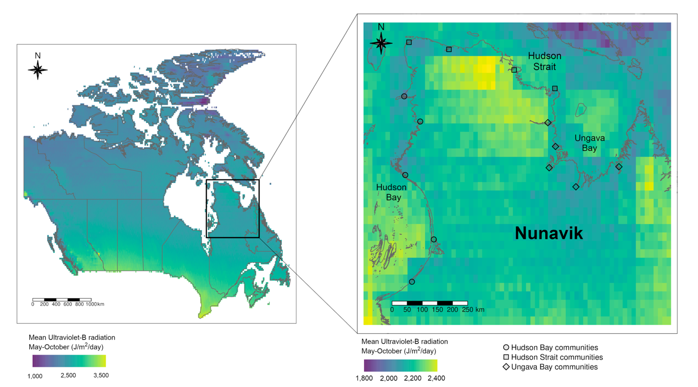
Supplementary Figure 1: Mean Ultraviolet-B radiation (J/m²/day) for the May - October period for Canada (left) and Nunavik (right). Inferred UV-B values extracted from the glUV dataset (15 arc-minute resolution) from: Beckmann, M., Václavík, T., Manceur, A. M., Šprtová, L., von Wehrden, H., Welk, E., & Cord, A. F. (2014). gl UV: a global UV‐B radiation data set for macroecological studies. Methods in Ecology and Evolution, 5(4), 372-383.

