Supplementary files
Supplementary Table S1: Unique barcode products for ready-to-drink non-alcoholic beverages over the five years of NielsenIQ Homescan data
Year | 2015 | 2016 | 2017 | 2018 | 2019
Sugar-sweetened beverages
Soft drinks | 495 (25.1) | 508 (25.8) | 531 (26.1) | 530 (26.0) | 545 (26.2)
Electrolyte drinks, energy drinks, and flavoured waters | 189 (9.6) | 193 (9.8) | 173 (8.5) | 206 (10.1) | 212 (10.2)
Dairy milks | 106 (5.4) | 111 (5.6) | 121 (5.9) | 147 (7.2) | 120 (5.8)
Plant based milks | 64 (3.2) | 68 (3.5) | 73 (3.6) | 70 (3.4) | 75 (3.6)
Fruit and vegetable juices and drinks | 652 (33.0) | 622 (31.6) | 638 (31.3) | 561 (27.5) | 549 (26.4)
Total | 1506 (76.3) | 1502 (76.2) | 1536 (75.4) | 1514 (74.3) | 1501 (72.2)
Artificially sweetened beverages
Soft drinks | 47 (2.4) | 89 (4.5) | 120 (5.9) | 120 (5.9) | 143 (6.9)
Electrolyte drinks, energy drinks, and flavoured waters | 93 (4.7) | 47 (2.4) | 44 (2.2) | 65 (3.2) | 87 (4.2)
Total | 140 (7.1) | 136 (6.9) | 164 (8.1) | 185 (9.1) | 230 (11.1)
Unsweetened beverages
Plain bottled waters | 134 (6.8) | 147 (7.5) | 145 (7.1) | 145 (7.1) | 149 (7.2)
Dairy milks | 186 (9.4) | 175 (8.9) | 175 (8.6) | 174 (8.5) | 178 (8.6)
Plant-based milks | 9 (0.5) | 11 (0.6) | 16 (0.8) | 21 (1.0) | 22 (1.1)
Total | 329 (16.7) | 333 (16.9) | 336 (16.5) | 340 (16.7) | 349 (16.8)
ALL BEVERAGES | 1975 (100.0) | 1971 (100.0) | 2036 (100.0) | 2039 (100.0) | 2080 (100.0)
*NielsenIQ Homescan panel data for the 52 weeks to the 8th October each year.
**Number of unique barcodes scanned by households each year. Data are reported as n (%).

Supplementary Figure S1. Mean annual household purchase volumes of all products in major and minor beverage categories * in 2019 (n=1,800)
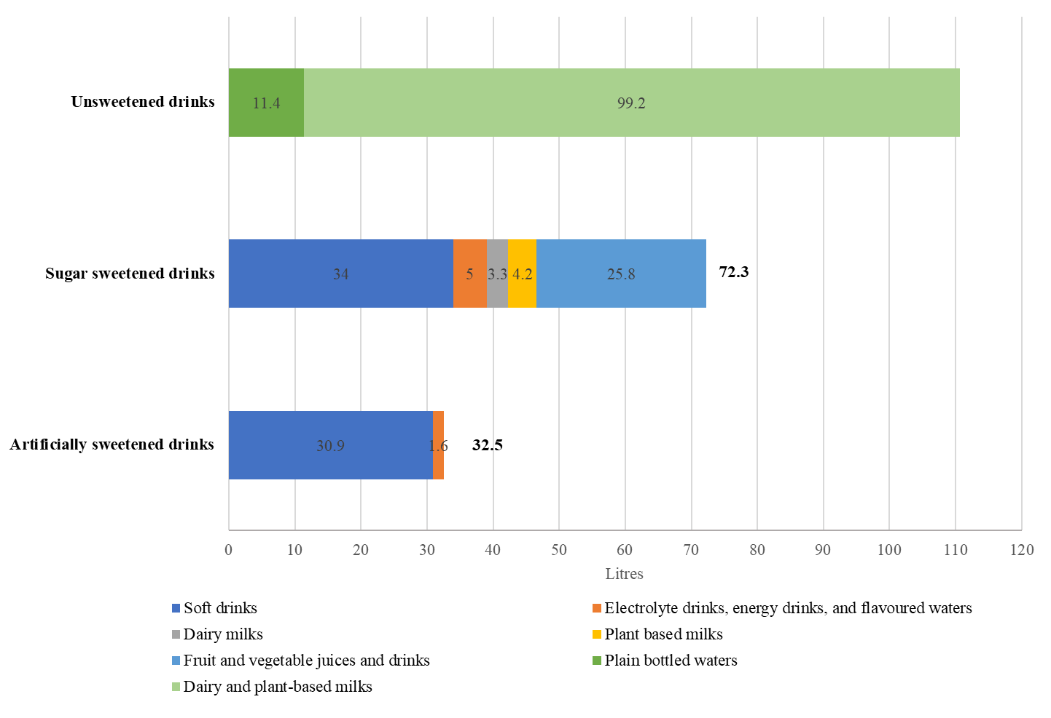
112.5
*NielsenIQ Homescan® panel. Data for the 52 weeks to the 8th October 2019.

