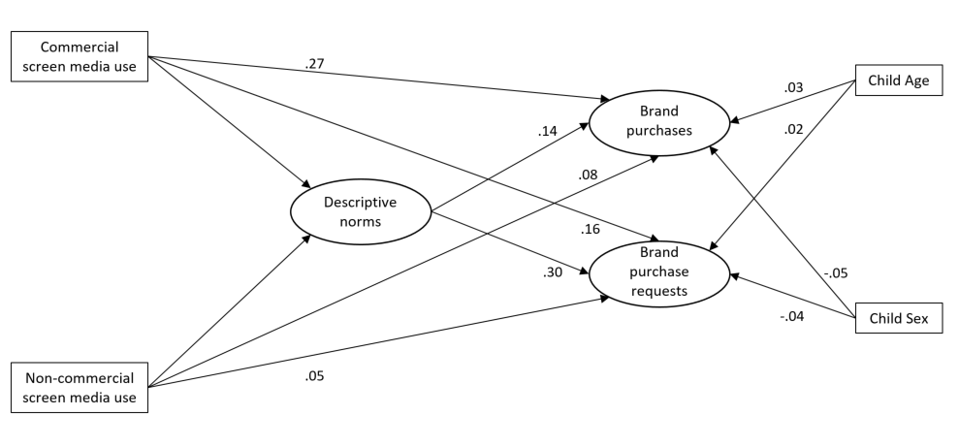
Figure S1: Model using descriptive norms

