Supplementary files

Supplementary table S1: Combining of items from the SMILE-FFQ (n = 25 into 8) prior to statistical analysis, based on similarities in food type and free sugars content
Original food items, combined prior to statistical analysis | Revised food items
- Yoghurt: plain  - Yoghurt: plain (reduced fat)  - Yoghurt alternatives: Plain (all fat) | - Yoghurt and alternatives, plain
- Yoghurt: children's (all fat)  - Yoghurt: fruit flavours  - Yoghurt: fruit flavours (reduced fat)  - Yoghurt: dessert and other flavours  - Yoghurt: dessert and other flavours (reduced fat)  - Yoghurt alternatives: flavoured  - Yoghurt alternatives: flavoured (reduced fat) | - Yoghurt and alternatives, flavoured
- Tinned fruit in syrup, drained  - Tinned fruit in syrup, undrained  - Tinned fruit in half syrup, drained  - Tinned fruit in half syrup, undrained | - Tinned fruit in syrup
- Tinned fruit in juice, drained  - Tinned fruit in juice, undrained | - Tinned fruit in juice
- Ice-cream and frozen yoghurt  - Ice-cream alternatives | - Ice-cream, frozen yoghurt, and non-dairy alternatives
- Water: plain, still  - Water: plain, carbonated | - Water, unflavoured, sparkling or still
- Biscuit, savoury, plain  - Biscuit, savoury, flavoured  - Snackfoods: savoury | - Savoury biscuits and snack foods
- Lollies that last a long time  - Lollies: regular (not sugarfree) | - Lollies: regular (not sugarfree)

Supplementary table S2: Summary of variance in consumption of SMILE-FFQ items in complete-case sample (n = 885, 2 years; n = 652, 5 years), including near-zero variance items removed prior to regularised regression-based prediction modelling
FoodID | Description | 2Y |  |  |  | 5Y
 |  | Frequency Ratio | Percent Unique | Zero Variance | Near-Zero Variance | Frequency Ratio | Percent Unique | Zero Variance | Near-Zero Variance
F1_1 | Condensed milk | 291.7 | 0.9 | No | YES | 141.4 | 0.8 | No | YES
F1_2 | Evaporated milk | 0.0 | 0.1 | YES | YES | 0.0 | 0.1 | YES | YES
F2_1 | Milk: flavoured | 24.4 | 2.4 | No | YES | 9.7 | 2.9 | No | No
F2_2 | Milk: plain | 0.0 | 0.1 | YES | YES | 0.0 | 0.1 | YES | YES
F2_3 | Milk alternatives: flavoured | 75.0 | 1.9 | No | YES | 43.7 | 2.1 | No | YES
F2_4 | Milk alternatives: plain | 35.7 | 3.2 | No | YES | 24.2 | 2.8 | No | YES
F2_5 | Infant formula and toddler milk | 23.0 | 2.4 | No | YES | 140.6 | 1.3 | No | YES
F3_1 | Cheese: cream or ricotta | 0.0 | 0.1 | YES | YES | 0.0 | 0.1 | YES | YES
F3_2 | Cheese: soft, other | 0.0 | 0.1 | YES | YES | 0.0 | 0.1 | YES | YES
F3_3 | Cheese: hard | 0.0 | 0.1 | YES | YES | 0.0 | 0.1 | YES | YES
F3_4 | Cheese alternatives | 76.5 | 1.7 | No | YES | 67.7 | 1.8 | No | YES
F4_5 | Probiotic drink | 73.1 | 1.8 | No | YES | 38.5 | 2.5 | No | YES
F5_1 | Sour cream or cream (unsweetened) | 0.0 | 0.1 | YES | YES | 0.0 | 0.1 | YES | YES
F5_2 | Custard: infant and toddler | 21.6 | 1.8 | No | YES | 15.2 | 2.1 | No | No
F5_3 | Custard: plain or vanilla | 13.3 | 1.9 | No | No | 24.0 | 2.0 | No | YES
F5_4 | Desserts: custard, mousse and sweet cream based | 30.6 | 1.7 | No | YES | 29.1 | 2.2 | No | YES
F5_5 | Other milk-based desserts | 29.7 | 1.5 | No | YES | 51.2 | 1.4 | No | YES
F6_2 | Icy-poles and sorbet | 5.9 | 1.7 | No | No | 3.5 | 2.1 | No | No
G1_1 | Fresh fruit | 0.0 | 0.1 | YES | YES | 0.0 | 0.1 | YES | YES
G2_1 | Dried fruit: coated | 36.7 | 1.2 | No | YES | 47.7 | 1.4 | No | YES
G2_2 | Dried fruit: plain | 0.0 | 0.1 | YES | YES | 0.0 | 0.1 | YES | YES
G4_1 | Fruit puree: toddler or infant | 0.0 | 0.1 | YES | YES | - | - | - | -
G4_2 | Vegetable puree: toddler or infant | 0.0 | 0.1 | YES | YES | - | - | - | -
G4_3 | Fruit puree: regular (commercial) | 48.5 | 1.8 | No | YES | 137.8 | 2.0 | No | YES
G4_4 | Fruit puree: home-made (unsweetened) | 0.0 | 0.1 | YES | YES | 0.0 | 0.1 | YES | YES
H1_1 | Nuts: coated | 37.9 | 1.5 | No | YES | 31.6 | 1.8 | No | YES
H1_2 | Nuts: plain | 0.0 | 0.1 | YES | YES | 0.0 | 0.1 | YES | YES
H2_1 | Nut paste | 7.8 | 2.7 | No | No | 7.4 | 3.2 | No | No
H2_2 | Chocolate, choc-nut or carob spreads | 21.5 | 2.3 | No | YES | 14.0 | 3.2 | No | No
H2_3 | Jam, marmalade and other fruit spreads | 5.8 | 2.5 | No | No | 5.3 | 3.2 | No | No
H2_4 | Honey | 9.2 | 2.1 | No | No | 5.4 | 3.5 | Vo | No
I1_1 | Porridge or other hot cereal | 0.0 | 0.1 | YES | YES | 0.0 | 0.1 | YES | YES
I1_2 | Wheat biscuits: plain | 2.0 | 2.3 | No | No | 3.5 | 2.9 | No | No
I1_3 | Puffed, unflavoured cereal | 0.0 | 0.1 | YES | YES | 0.0 | 0.1 | YES | YES
I1_4 | Muesli: toasted | 92.4 | 1.7 | No | YES | 47.4 | 1.5 | No | YES
I1_5 | Muesli: untoasted | 91.6 | 1.6 | No | YES | 51.5 | 1.8 | No | YES
I1_6 | Cereal flakes | 10.5 | 2.0 | No | No | 9.3 | 2.4 | No | No
I1_7 | Flavoured breakfast cereals | 10.2 | 1.9 | No | No | 5.5 | 2.9 | No | No
J1_1 | Sweet biscuits: plain | 1.1 | 2.7 | No | No | 1.1 | 3.2 | No | No
J1_2 | Sweet biscuits: not plain | 9.9 | 2.1 | No | No | 4.8 | 3.4 | No | No
J1_3 | Meringue or honeycomb | 174.6 | 0.6 | No | YES | 234.0 | 1.4 | No | YES
J2_1 | Snack foods: sweet, cereal based | 40.6 | 1.1 | No | YES | 22.2 | 2.7 | No | YES
J2_2 | Muesli and cake-type bars | 11.6 | 2.3 | No | No | 5.8 | 3.2 | No | No
J2_3 | Snack foods: fruit-flavoured | 0.0 | 0.1 | YES | YES | 0.0 | 0.1 | YES | YES
J3_1 | Cakes and puddings | 1.7 | 1.5 | No | No | 1.1 | 2.1 | No | No
J4_1 | Sweet breads and pancakes | 7.0 | 1.8 | No | No | 4.0 | 2.1 | No | No
J4_2 | Sweet pastry | 21.7 | 1.1 | No | YES | 11.3 | 1.8 | No | No
L1_10 | Soft drink: regular (not sugarfree) | 29.9 | 1.2 | No | YES | 16.9 | 2.1 | No | No
L1_11 | Frozen drinks | 77.2 | 1.2 | No | YES | 33.9 | 2.1 | No | YES
L1_12 | Tea: leaf | 0.0 | 0.1 | YES | YES | 0.0 | 0.1 | YES | YES
L1_13 | Tea: Powder or syrup | 218.8 | 0.7 | No | YES | 175.8 | 1.3 | No | YES
L1_14 | Coffee | - | - | - | - | 0.0 | 0.1 | YES | YES
L1_3 | Water: lightly flavoured | 83.3 | 1.8 | No | YES | 99.1 | 1.3 | No | YES
L1_4 | Juice: infant or toddler | 30.2 | 2.6 | No | YES | 29.0 | 2.2 | No | YES
L1_5 | Juice: fruit drink | 23.9 | 2.5 | No | YES | 17.1 | 2.8 | No | No
L1_5a | Juice: fruit (no added sugar/100% fruit juice) | 13.0 | 2.7 | No | No | 13.2 | 2.8 | No | No
L1_6 | Juice: vegetable | 57.4 | 2.0 | No | YES | 55.4 | 2.2 | No | YES
L1_7 | Cordial: sugarfree | 83.9 | 1.6 | No | YES | 136.4 | 2.2 | No | YES
L1_8 | Cordial: regular (not sugarfree) | 48.7 | 2.3 | No | YES | 53.0 | 2.8 | No | YES
L1_9 | Soft drink: sugarfree | 0.0 | 0.1 | YES | YES | 0.0 | 0.1 | YES | YES
L5_1 | Milo or Ovaltine in milk drinks | 32.3 | 2.3 | No | YES | 15.6 | 3.5 | No | No
L5_2 | Drinking chocolate in milk drinks | 30.3 | 1.8 | No | YES | 25.1 | 2.8 | No | YES
M1_1 | Sauce: tomato or barbecue | 3.2 | 2.8 | No | No | 1.3 | 4.5 | No | No
M1_2 | Sauce and marinade: sweet style | 12.6 | 2.0 | No | No | 17.4 | 2.5 | No | No
M1_3 | Mayonnaise: low fat | 23.0 | 1.6 | No | YES | 29.0 | 2.4 | No | YES
M1_4 | Mayonnaise: regular (not low fat) | 28.6 | 1.6 | No | YES | 17.9 | 2.1 | No | No
M1_5 | Chutney or relish | 69.9 | 1.4 | No | YES | 98.0 | 1.3 | No | YES
M1_6 | Dessert toppings | 30.7 | 1.5 | No | YES | 20.7 | 2.5 | No | YES
N1_1 | Sugar: regular (not sugarfree) | 17.9 | 1.8 | No | No | 14.9 | 2.7 | No | No
N1_2 | Sugar syrups | 35.7 | 1.7 | No | YES | 13.9 | 2.5 | No | No
N1_3 | Sweeteners | 145.8 | 0.7 | No | YES | 356.5 | 0.4 | No | YES
O1_1 | Jelly: sugarfree | 0.0 | 0.1 | YES | YES | 0.0 | 0.1 | YES | YES
O1_2 | Jelly: regular (not sugarfree) | 20.7 | 1.9 | No | YES | 20.3 | 2.2 | No | YES
O2_1 | Chocolate or carob | 2.0 | 1.8 | No | No | 1.5 | 2.7 | No | No
O2_2 | Lollies: sugarfree | 0.0 | 0.1 | YES | YES | 0.0 | 0.1 | YES | YES
X1_1 | Ice-cream, frozen yoghurt, and non-dairy alternatives | 2.8 | 4.6 | No | No | 1.2 | 6.1 | No | No
X1_2 | Yoghurt and alternatives: plain | 142.3 | 1.6 | No | YES | 139.0 | 1.8 | No | YES
X1_3 | Yoghurt and alternatives: flavoured | 4.2 | 32.9 | No | No | 5.8 | 33.9 | No | No
X1_4 | Water: unflavoured | 0.0 | 0.1 | YES | YES | 0.0 | 0.1 | YES | YES
X1_5 | Savoury biscuits and snack foods | 1.6 | 44.4 | No | No | 1.7 | 54.1 | No | No
X1_6 | Lollies: regular (not sugarfree) | 5.8 | 3.2 | No | No | 2.6 | 5.4 | No | No
X1_7 | Tinned fruit in syrup | 168.2 | 2.9 | No | YES | 136.6 | 2.9 | No | YES
X1_8 | Tinned fruit in juice | 33.6 | 3.1 | No | YES | 56.7 | 3.5 | No | YES
Frequency Ratio: ratio of frequencies for the most common value over the second most common value; Percent Unique: percentage of unique data points; Zero Variance: i.e., only one distinct value; Near-Zero Variance: <10% unique values or ratio of most common value is >19

Supplementary table S3: Characteristics of mother-child dyads in the samples with complete data (included) at 2 (n = 885) and 5 (n = 652) years versus participants excluded (n = 158, 2 years; n = 64, 5 years)ª
 | 2 Years |  |  |  |  |  | 5 Years
Characteristic | Included |  | Excluded |  | P-value |  | Included |  | Excluded |  | P-value
Child Characteristics
Child's age: Mean (SD) | 2.1 (0.1) |  | 2.2 (0.2) |  | 0.03* |  | 5.3 (0.4) |  | 5.2 (0.4) |  | 0.004*
Child's sex |  |  |  |  | 0.69 |  |  |  |  |  | 0.41
Male | 469 (53.0) |  | 87 (55.1) |  |  |  | 357 (54.8) |  | 39 (60.9)
Female | 416 (47.0) |  | 71 (44.9) |  |  |  | 295 (45.2) |  | 25 (39.1)
Child_BMI category^{b} |  |  |  |  | 0.25 |  |  |  |  |  | -
Missing | 118 (13.3) |  | 20 (12.7) |  |  |  | 0 (0.0) |  | 64 (100.0)
Healthy weight | 673 (76.1) |  | 126 (79.8) |  |  |  | 448 (68.7) |  | 0 (0.0)
Overweight | 71 (8.0) |  | 11 (7.0) |  |  |  | 143 (21.9) |  | 0 (0.0)
Obesity | 23 (2.6) |  | 1 (0.6) |  |  |  | 61 (9.4) |  | 0 (0.0)
Maternal and Household Characteristics
Mother's age: Mean (SD) | 30.5 (5.0) |  | 30.8 (4.7) |  | 0.41 |  | 30.8 (5.1) |  | 31.1 (4.4) |  | 0.58
Mother's BMI category^{b} |  |  |  |  | 0.01* |  |  |  |  |  | 0.68
Missing | 59 (6.7) |  | 9 (5.7) |  |  |  | 125 (19.2) |  | 18 (28.1)
<25kg/m2 | 476 (53.8) |  | 88 (55.7) |  |  |  | 315 (48.3) |  | 27 (42.2)
25-29.9kg/m2 | 176 (19.9) |  | 43 (27.2) |  |  |  | 122 (18.7) |  | 9 (14.1)
≥30kg/m2 | 174 (19.7) |  | 18 (11.4) |  |  |  | 90 (13.8) |  | 10 (15.6)
Mother's country of birth |  |  |  |  | 0.006* |  |  |  |  |  | 1
Missing | 8 (0.9) |  | 0 (0.0) |  |  |  | 7 (1.1) |  | 1 (1.6)
AU/NZ/UK | 686 (77.5) |  | 107 (67.7) |  |  |  | 480 (73.6) |  | 47 (73.4)
Others | 191 (21.6) |  | 51 (32.3) |  |  |  | 165 (25.3) |  | 16 (25.0)
Mother's education attainment |  |  |  | 0.48 |  |  |  |  |  | 0.04*
Missing | 0 (0.0) |  | 0 (0.0) |  |  |  | 0 (0.0) |  | 0 (0.0)
School/vocational | 379 (42.8) |  | 73 (46.2) |  |  |  | 254 (39.0) |  | 16 (25.0)
Some university and above | 506 (57.2) |  | 85 (53.8) |  |  |  | 398 (61.0) |  | 48 (75.0)
Annual household income, $AUD |  |  |  | 0.2 |  |  |  |  |  | 0.77
Missing | 7 (0.8) |  | 1 (0.6) |  |  |  | 7 (1.1) |  | 0 (0.0)
≤40K | 97 (11.0) |  | 19 (12.0) |  |  |  | 65 (10.0) |  | 7 (10.9)
40.1-80K | 267 (30.2) |  | 52 (32.9) |  |  |  | 208 (31.9) |  | 19 (29.7)
80.1-120K | 269 (30.4) |  | 55 (34.8) |  |  |  | 216 (33.1) |  | 19 (29.7)
>120K | 245 (27.7) |  | 31 (19.6) |  |  |  | 156 (23.9) |  | 19 (29.7)
Index of Relative Socio-Economic Advantage and Disadvantage |  |  |  | 0.11 |  |  |  |  |  | 0.53
Missing | 7 (0.8) |  | 0 (0.0) |  |  |  | 5 (0.8) |  | 3 (4.7)
Deciles 1-2 | 203 (22.9) |  | 52 (32.9) |  |  |  | 146 (22.4) |  | 11 (17.2)
Deciles 3-4 | 231 (26.1) |  | 38 (24.1) |  |  |  | 161 (24.7) |  | 12 (18.8)
Deciles 5-6 | 151 (17.1) |  | 26 (16.5) |  |  |  | 120 (18.4) |  | 14 (21.9)
Deciles 7-8 | 220 (24.9) |  | 32 (20.3) |  |  |  | 166 (25.5) |  | 16 (25.0)
Deciles 9-10 | 73 (8.2) |  | 10 (6.3) |  |  |  | 54 (8.3) |  | 8 (12.5)
Number of children at home |  |  |  | 0.62 |  |  |  |  |  | 0.88
Missing | 25 (2.8) |  | 5 (3.2) |  |  |  | 19 (2.9) |  | 4 (6.2)
1 | 413 (46.7) |  | 67 (42.4) |  |  |  | 317 (48.6) |  | 32 (50.0)
2 | 310 (35.0) |  | 59 (37.3) |  |  |  | 232 (35.6) |  | 21 (32.8)
≥3 | 137 (15.5) |  | 27 (17.1) |  |  |  | 84 (12.9) |  | 7 (10.9)
Two parent household |  |  |  |  | 1 |  |  |  |  |  | 0.54
Missing | 4 (0.5) |  | 0 (0.0) |  |  |  | 5 (0.8) |  | 1 (1.6)
Single parent household | 47 (5.3) |  | 8 (5.1) |  |  |  | 31 (4.8) |  | 4 (6.2)
Two-parent household | 834 (94.2) |  | 150 (94.9) |  |  |  | 616 (94.5) |  | 59 (92.2)
Abbreviations: BMI, Body Mass Index; NZ, New Zealand; UK, United Kingdom;
ªExcluded participants refers to those with complete and plausible dietary data but incomplete sociodemographic data. Data presented as N (%) unless otherwise stated
^{b} Weight status categories equivalent to body mass index (BMI) (kg/m2); Healthy weight <25kg/m2, Overweight 25–29.9 kg/m2, Obesity ≥30 kg/m2.
*denotes statistical significance, p<0.05

Supplementary table S4: Model coefficients including child height and weight after variable shrinkage across 10 cross-validation runs of the regularised regression-based prediction model, using the training sample (n = 622) at 2 yearsª
Description | R1 | R2 | R3 | R4 | R5 | R6 | R7 | R8 | R9 | R10
(Intercept) | -2.789 | -3.7 | -7.271 | -9.401 | -13.239 | 1.407 | -2.902 | -0.277 | 1.523 | 1.319
Child factors
Child age (at 2 years) | 5.777 | 7.123 | 5.505 | 7.621 | 7.707 | 2.343 | 3.868 | 2.217 | 2.228 | 2.94
Child sex | -1.258 | -0.817 | -0.788 | -0.888 | 0 | 0 | 0 | -0.001 | -0.002 | -0.565
Child height | -0.057 | -0.084 | 0 | 0 | 0 | 0 | -0.009 | 0 | 0 | 0
Child weight | 0 | 0.111 | 0.075 | 0 | 0.15 | 0 | 0 | -0.031 | 0 | -0.064
Food frequency items
Custard: plain or vanilla | 1.446 | 1.242 | 1.22 | 0.776 | 0.854 | 0.972 | 0.957 | 0.775 | 0.819 | 0.734
Icy-poles and sorbet | 1.798 | 1.545 | 1.774 | 1.505 | 2.031 | 1.58 | 1.725 | 1.568 | 1.68 | 0.929
Nut paste | 6.431 | 0.187 | 5.766 | 0 | 6.273 | 6.141 | 1.915 | 4.721 | 4.745 | 0
Jam, marmalade and other fruit spreads | 1.07 | 0.688 | 0.793 | 0.83 | 1.117 | 0.979 | 1.346 | 0.585 | 0.907 | 1.012
Honey | 0.656 | 0.876 | 0.879 | 0.784 | 0.826 | 0.29 | 0.918 | 0.859 | 0.407 | 0.597
Wheat biscuits: plain | 0.057 | 0.699 | 0 | 0 | 1.272 | 0.428 | 1.262 | 2.124 | 0.439 | 0
Cereal flakes | 2.603 | 2.411 | 3.31 | 1.799 | 1.873 | 2.619 | 2.688 | 2.39 | 2.743 | 2.391
Flavoured breakfast cereals | 1.005 | 0.912 | 0.465 | 1.048 | 0.915 | 0.74 | 0.7 | 0.898 | 0.598 | 0.973
Sweet biscuits: plain | 0.602 | 0.622 | 0.48 | 0.559 | 0.63 | 0.76 | 0.658 | 0.619 | 0.323 | 0.689
Sweet biscuits: not plain | 2.145 | 2.009 | 2.344 | 2.664 | 2.182 | 2.354 | 2.105 | 1.775 | 2.508 | 2.259
Muesli and cake-type bars | 1.071 | 0.874 | 0.996 | 0.922 | 0.987 | 0.891 | 0.819 | 0.938 | 1.04 | 0.841
Cakes and puddings | 1.197 | 1.236 | 1.134 | 1.079 | 1.186 | 1.036 | 1.104 | 1.112 | 1.091 | 1.058
Sweet breads and pancakes | 0.542 | 0.792 | 0.704 | 0.687 | 0.702 | 0.599 | 0.869 | 1.058 | 0.819 | 1.083
Juice: fruit (no added sugar/100% fruit juice) | 0.92 | 0.87 | 0.819 | 0.712 | 0.809 | 0.756 | 0.893 | 0.777 | 0.757 | 0.72
Sauce: tomato or barbecue | 1.723 | 0.876 | 1.443 | 1.163 | 0.966 | 0.578 | 1.329 | 0.86 | 1.181 | 0.925
Sauce and marinade: sweet style | 0 | 0 | -0.274 | 0 | 0 | 0 | -0.005 | 0.014 | 0 | 0
Sugar: regular table sugar | 2.277 | 2.898 | 2.055 | 2.15 | 2.173 | 3.117 | 3.089 | 3.31 | 2.363 | 1.923
Jelly: regular (not sugarfree) | 2.684 | 1.105 | 0.94 | 1.893 | 1.55 | 1.101 | 1.271 | 2.257 | 1.013 | 2.074
Chocolate or carob | 1.19 | 1.355 | 1.41 | 1.189 | 1.169 | 1.424 | 1.223 | 1.478 | 1.138 | 1.45
Ice-cream, frozen yoghurt, and non-dairy alternatives | 1.939 | 1.506 | 1.192 | 1.475 | 1.689 | 1.087 | 0.81 | 1.369 | 1.731 | 1.624
Yoghurt and alternatives, flavoured | 1.159 | 1.236 | 1.233 | 1.168 | 1.185 | 1.117 | 1.251 | 1.289 | 1.166 | 1.094
Savoury biscuits and snack foods | -0.088 | 0.238 | 0 | 0 | 0 | 0.038 | 0.446 | 0.483 | 0.186 | 0.627
Lollies: regular (not sugarfree) | 1.687 | 1.441 | 1.731 | 1.847 | 1.4 | 1.643 | 1.974 | 1.71 | 1.752 | 1.244
ªBold values indicate coefficients for best model with minimum Root Mean Square Error difference between training (2245.92) and testing (2238.71) data
Supplementary table S5: Model coefficients excluding child height and weight after variable shrinkage across 10 cross-validation runs of the regularised regression-based prediction model, using the training sample (n = 460) at 5 yearsª
Description | R1 | R2 | R3 | R4 | R5 | R6 | R7 | R8 | R9 | R10
(Intercept) | 7.271 | 7.139 | 7.203 | 6.639 | 6.846 | 7.792 | 6.84 | 6.786 | 6.776 | 6.906
Child factors
Child age (at 5 years) | 0 | 0 | 0 | 0 | 0 | 0 | 0 | 0 | 0 | 0
Child sex | 0 | 0 | 0 | 0 | 0 | 0 | 0 | 0 | 0 | 0
Food frequency items
Milk: flavoured | 0.982 | 0.989 | 1.444 | 1.694 | 1.41 | 0.875 | 1.398 | 1.383 | 1.236 | 0.772
Custard: infant and toddler | 0.757 | 1.02 | 0 | 1.142 | 0.747 | 0 | 0.89 | 1.046 | 0.727 | 0.754
Icy-poles and sorbet | 1.003 | 1.075 | 1.049 | 1.048 | 1.017 | 1.157 | 0.78 | 0.975 | 1.163 | 0.982
Nut paste | 0.372 | 0.009 | 0.277 | 0 | 0.141 | 0.004 | 0.402 | 0 | 0 | 0
Chocolate, choc-nut or carob spreads | 0.799 | 0.496 | 0.842 | 0.776 | 0.786 | 1.099 | 0.976 | 0.914 | 0.968 | 0.978
Jam, marmalade and other fruit spreads | 0.915 | 1.045 | 1.157 | 1.098 | 1.014 | 0.914 | 1 | 0.813 | 0.927 | 0.927
Honey | 0.807 | 0.74 | 0.694 | 0.76 | 0.785 | 0.761 | 0.814 | 0.79 | 0.78 | 0.776
Wheat biscuits: plain | 0 | 0 | 0 | 0 | 0 | 0 | 0 | 0 | 0 | 0
Cereal flakes | 0 | 0 | 0 | 0 | 0 | 0 | 0 | 0 | 0 | 0
Flavoured breakfast cereals | 0.772 | 0.943 | 0.843 | 0.994 | 0.922 | 0.721 | 0.913 | 0.813 | 0.728 | 0.836
Sweet biscuits: plain | 0.86 | 1.142 | 1.041 | 1.236 | 0.939 | 0.886 | 1.039 | 1.122 | 0.935 | 0.946
Sweet biscuits: not plain | 1.033 | 1.067 | 0.989 | 0.96 | 1.172 | 1.138 | 1.157 | 1.119 | 0.944 | 0.97
Muesli and cake-type bars | 0.869 | 0.761 | 0.537 | 0.786 | 0.818 | 0.847 | 0.848 | 0.662 | 0.705 | 1.038
Cakes and puddings | 0.803 | 0.869 | 0.987 | 0.925 | 0.839 | 0.93 | 0.925 | 0.914 | 0.942 | 1.001
Sweet breads and pancakes | 0.656 | 0.848 | 0.4 | 0.514 | 0.628 | 0.641 | 0.561 | 0.632 | 0.713 | 0.5
Sweet pastry | 1.134 | 0.937 | 1.254 | 0.851 | 1.16 | 0.729 | 0.991 | 1.079 | 1.924 | 1.663
Soft drink: regular (not sugarfree) | 1.113 | 0.841 | 0.698 | 1.179 | 0.701 | 0.931 | 1.084 | 0.633 | 0.804 | 0.62
Juice: fruit drink | 1.11 | 1.097 | 1.128 | 1.241 | 1.324 | 1.109 | 1.105 | 1.125 | 1.165 | 0.933
Juice: fruit (no added sugar/100% fruit juice) | 0.842 | 0.873 | 0.835 | 0.882 | 0.872 | 0.836 | 0.754 | 0.855 | 0.827 | 0.802
Milo or Ovaltine in milk drinks | 0.413 | 0 | 0.367 | 0.212 | 0.139 | 0.579 | 0.094 | 0 | 0.35 | 0.551
Sauce: tomato or barbecue | 1.233 | 0.878 | 0.842 | 0.889 | 0.825 | 1.077 | 1.141 | 0.842 | 0.945 | 1.07
Sauce and marinade: sweet style | 1.073 | 0.62 | 1.92 | 1.131 | 1.164 | 0.925 | 1.424 | 1.836 | 1.506 | 1.994
Mayonnaise: regular | 0 | 0 | 0 | 0 | 0 | 0 | 0 | 0 | 0.016 | 0
Sugar: regular table sugar | 1.293 | 0.874 | 0.909 | 0.848 | 0.916 | 0.808 | 0.904 | 1.598 | 1.377 | 0.893
Sugar syrups | 0.342 | 0.588 | 0.9 | 0.617 | 0.577 | 0.35 | 0.583 | 0.272 | 0.417 | 0.553
Chocolate or carob | 0.853 | 0.989 | 0.821 | 0.8 | 0.792 | 0.908 | 0.778 | 0.765 | 0.803 | 0.817
Ice-cream, frozen yoghurt, and non-dairy alternatives | 1.281 | 1.124 | 1.232 | 1.042 | 1.221 | 1.247 | 1.085 | 1.203 | 1.174 | 1.444
Yoghurt and alternatives, flavoured | 1.088 | 1.15 | 1.048 | 1.132 | 1.102 | 0.999 | 1.206 | 1.085 | 1.012 | 0.999
Savoury biscuits and snackfoods | 2.428 | 2.134 | 2.782 | 2.263 | 3.049 | 0.704 | 2.655 | 3.581 | 3.098 | 2.468
Lollies: regular (not sugarfree) | 1.169 | 1.041 | 1.324 | 1.184 | 1.311 | 1.294 | 1.224 | 1.255 | 1.209 | 1.24
ªBold values indicate coefficients for best model with minimum Root Mean Square Error difference between training (2192.71) and testing (2203.75) data
2 years
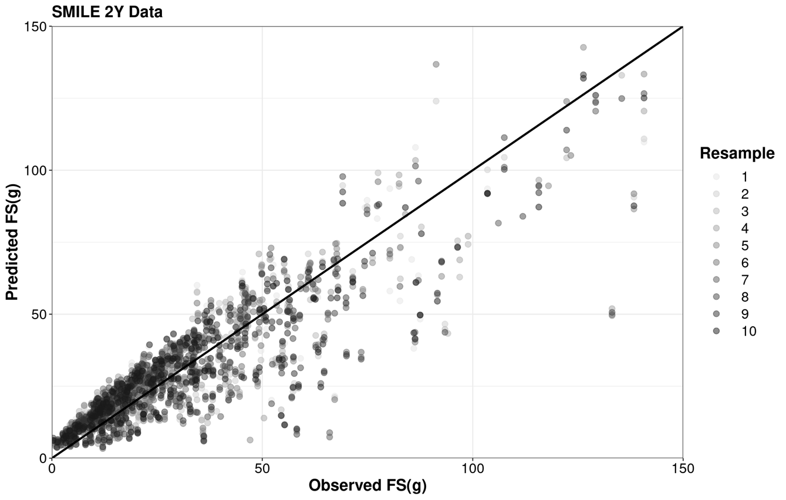
Measured FSg
<10%EFS

5 years
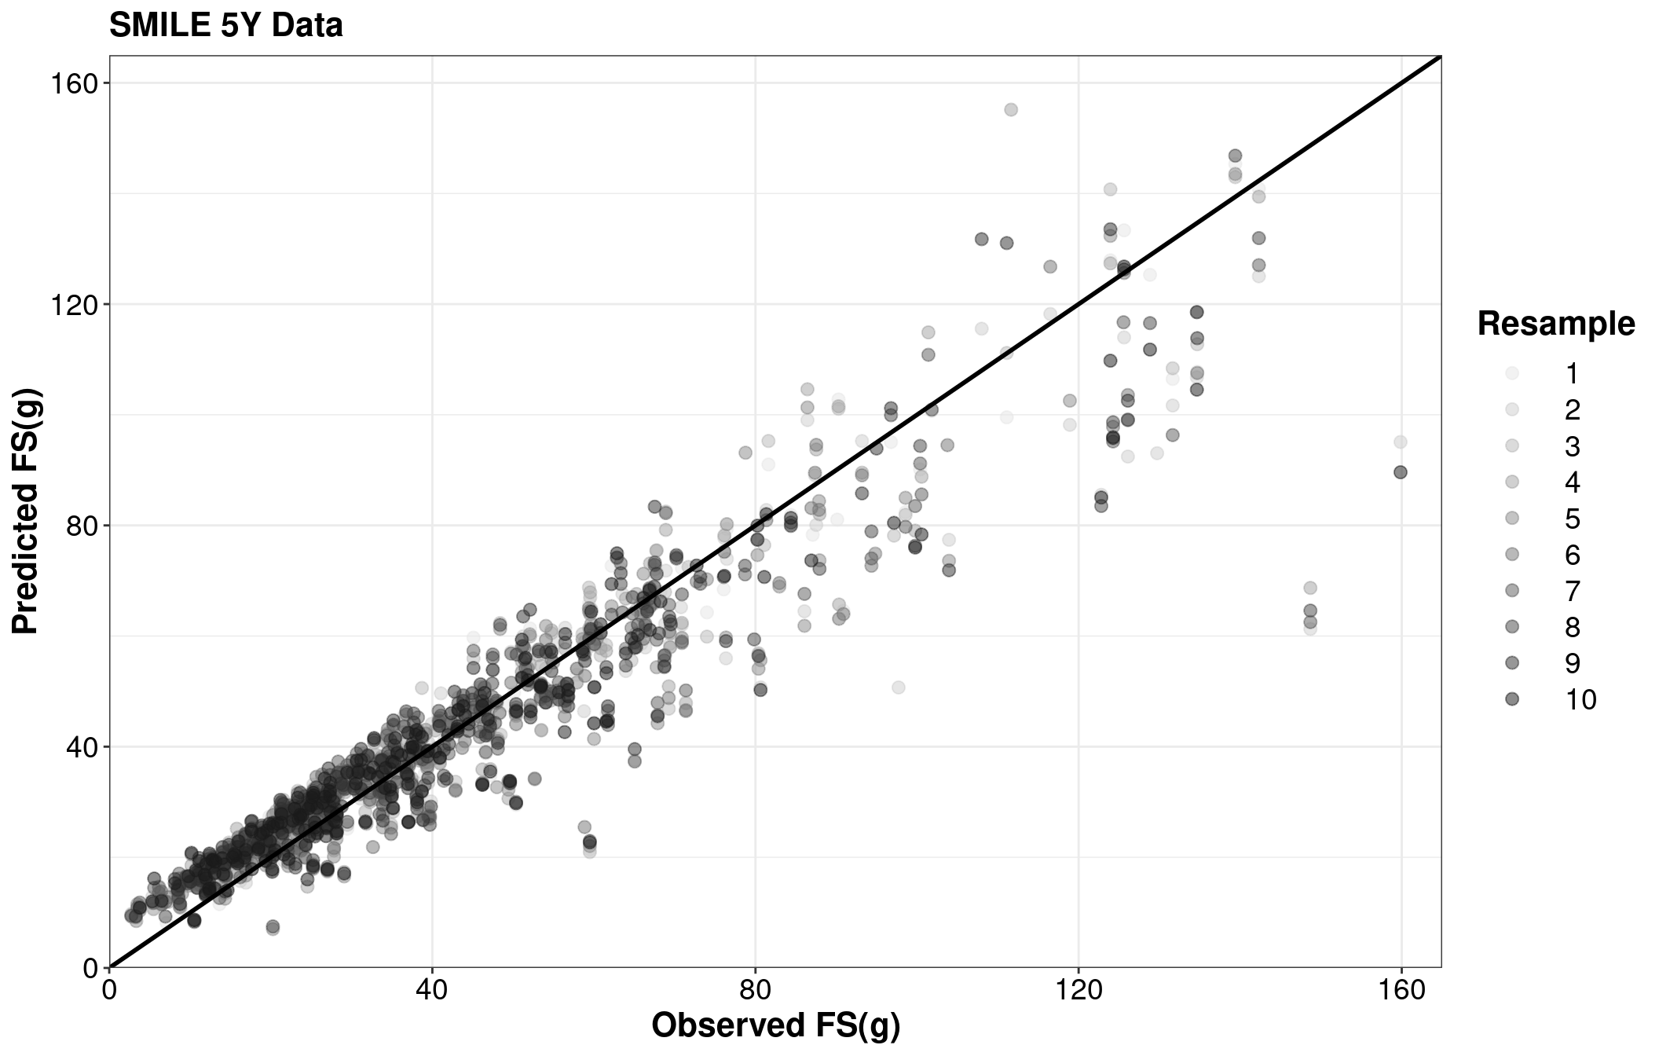
Measured FSg
<10%EFS

Supplementary Figure S3: Scatter plot of measured and predicted Free Sugars intake in grams (FSg) with the unity line (representing perfect calibration), using the testing sample (n = 263 at 2 years; n = 192 at 5 years).

Supplementary Table S6: Cross-classification table of measured and predicted WHO free sugars percentage categoriesª, using the testing sample (n = 263 at 2 years; n = 192 at 5 years) ^{b o}
Age group | Predicted category | Measured category
 |  | 1 | 2 | 3
2 years | 1 | 60 (22.8%) | 10 (3.8%) | 1 (0.4%)
 | 2 | 19 (7.2%) | 55 (20.9%) | 14 (5.3%)
 | 3 | 0 (0%) | 22 (8.4%) | 82 (31.2%)
 |  | 30.0% | 33.0% | 36.9% | 100%
5 years | 1 | 22 (11.4%) | 3 (1.6%) | 0 (0%)
 | 2 | 17 (8.8%) | 68 (35.4%) | 8 (4.2%)
 | 3 | 0 (0%) | 6 (3.1%) | 68 (35.4%)
 |  | 20.3% | 40.1% | 39.6% | 100%
ªWHO categories: (1) <5%EFS, (2) 5-<10%EFS, (3) ≥10%EFS
^{b}column-wise percentages in the diagonal equal the proportion of the participants in the whole sample correctly predicted to be in a given category

