Supplementary Material
Table of Contents
1. Economic sectors 2
2. Price regression model construction 3
2.1. Multiple linear regression for data variables including the outliers 4
2.1.1. Without the intercept 4
2.1.2. With the intercept 5
2.2. Multiple linear regression for data variables excluding the outliers 5
2.2.1. Without the intercept 5
2.2.2. With the intercept 6
2.3. Weighted multiple linear regression for data variables including the outliers 6
2.3.1. Daily dietary intake as the weighting variable 6
2.3.2. Square root of daily dietary intake as the weighting variable 7
2.3.3. Energy intake as the weighting variable 8
2.3.4. Square root of energy intake as the weighting variables 8
2.4. Weighted multiple linear regression for data variables excluding the outliers 9
2.4.1. Daily dietary intake as the weighting variable 9
2.4.2. Square root of daily dietary intake as the weighting variable 10
2.4.3. Energy intake as the weighting variable 11
2.4.4. Square root of energy intake as the weighting variables 12
3. Sector-wise analysis 14
3.1. Contribution to environmental and economic indicators calculated using the input-output technique 14
3.2. Sector-wise contribution to dietary intake for diets rich in UPFs (>95% of energy from NOVA 4), NOVA 2 and 3 (>95% of energy from NOVA 2 and 3), and NOVA 1 (>95% of energy from NOVA 1) 15
3.3. Sector-wise contribution to diets rich in UPFs (>95% of energy from NOVA 4), NOVA 2 and 3 (>95% of energy from NOVA 2 and 3), and NOVA 1 (>95% of 17

Economic sectors
Supplemental Table 1- Economic sectors in the supply-use table of Australia used in the calculation of dietary environmental and economic indicators using environmentally extended input-output analysis
No | Sector
1 | Sheep and goats
2 | Beef
3 | Poultry
4 | Pigs
5 | Other livestock and meat
6 | Sheep meat
7 | Beef meat
8 | Poultry meat
9 | Pork
10 | Fish
11 | Crustacean and molluscs
12 | Dairy products
13 | Eggs
14 | Jams, marmalade and honey
15 | Other animal products
16 | Plant nurseries
17 | Vegetables
18 | Nuts
19 | Fruit
20 | Coffee, tea and spices
21 | Wheat
22 | Cereal grains
23 | Wheat flour
24 | Grain flours and products
25 | Soybeans, ground nuts, copra, seeds
26 | Sugar
27 | Other roots and fibres and extracts
28 | Animal-based oils and fats
29 | Plant-based oils and fats
30 | Meat products
31 | Fish products
32 | Crustacean and mollusc products
33 | Sugar products
34 | Cocoa and chocolate
35 | Cereal products
36 | Vegetable products
37 | Fruit products
38 | Extracts and ice cream
39 | Waters and soft drinks
40 | Alcoholic beverages
41 | Animal food
42 | Tobacco
43 | Other manufacturing
44 | Restaurants
45 | Catering
46 | Other services
47 | Exports*
*All imports and exports are represented as a one-row item. Therefore, impacts associated with the goods or services imported to Australia are accounted for in the input-output calculation. However, there is no country-wise differentiation based on the origin of the good or service.

Price regression model construction
Export data for 6357 economic sectors of Harmonized commodity description and coding system (HSCPC) for the year 2015 was obtained from the United Nations International Trade Statistics Database (UN COMTRADE). The export price (USD per kg) for 6357 economic sectors was calculated for 221 partnering countries for the reporting country, Australia. Row median for a HSCPC sector indicates the price paid by the consumer in Australia, for a 1kg of product in the HSCPC sector produced in Australia. For example, the row median for the beef sector gives the price per 1kg of beef produced in Australia. Thus, it was assumed that all the food items consumed in Australia are produced within Australia itself. The HSCPC sectors were linked with the nutrients and NOVA categories of foods in the AUSNUT database by way of a concordance matrix between HSCPC sectors and AUSNUT foods.
At first, the linearity between the median export price and NOVA categories, the percentage of energy obtained from macronutrients (protein, carbohydrate, and fat) were tested using scatter plots (Supplementary Figure 1).
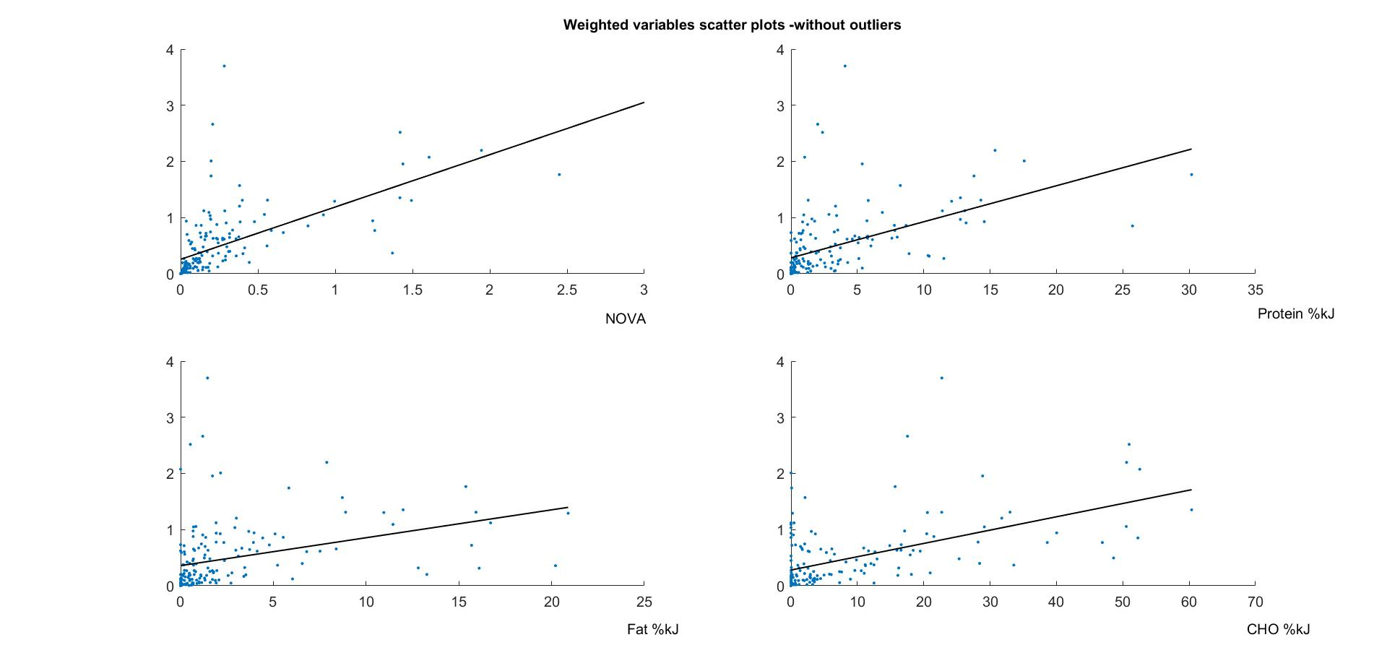
Price
Price
Price
Price
Supplementary Figure 1 – Scatter plots between median export price and NOVA categories, percentage of energy obtained from macronutrients (protein, carbohydrate, and fat)
Then, multiple linear regression analysis was performed to model the relationship between the NOVA categories, the percentage of energy obtained from macronutrients (protein, carbohydrate, and fat), and the median export price, where the median export price was considered as the response variable and NOVA categories and percentage of energy from macronutrients were considered as explanatory variables at different scenarios as follows:
- Including outliers (The data points situated more than 1.5 interquartile ranges above the upper quartile (75%) or below the lower quartile (25%) were considered as outliers)
  - No weighing variable – with and without intercept
  - Daily dietary intake as the weighting variable – with and without intercept
  - Square root of daily dietary intake as the weighting variable – with and without intercept
  - Energy intake as the weighting variable – with and without intercept
  - Square root of energy intake as the weighting variables – with and without intercept
- Excluding outliers
  - No weighing variable – with and without intercept
  - Daily dietary intake as the weighting variable – with and without intercept
  - Square root of daily dietary intake as the weighting variable – with and without intercept
  - Energy intake as the weighting variable – with and without intercept
  - Square root of energy intake as the weighting variables – with and without intercept
After that, the statistical significance of the model was tested using t-tests. If the t-statistical value is greater than the t-critical value (table S1), it was concluded that there is statistical evidence of a linear relationship between the response variable and explanatory variable at that level of a confidence interval.
Confidence interval | t-critical values
 | Degrees of freedom = 162 | Degrees of freedom = 266
90% | 1.654314 | 1.650559 | *
95% | 1.974716 | 1.968855 | **
99% | 2.606518 | 2.594298 | ***
99.90% | 3.351595 | 3.327198 | ****
Supplemental Table 2 - t-critical values at different confidence intervals
All the regression analysis and associated statistical analysis were performed using MATLAB R2018b software. The resultant models and associated statistical values are as follows:

Multiple linear regression for data variables including the outliers

Without the intercept
Linear regression model:
y = x1 + x2 + x3 + x4

y= Median export price (AUD/kg)
x1= NOVA
x2 = Protein (%kJ)
x3 = Fat (%kJ)
x4 = CHO (%kJ)

Estimated Coefficients:
 | Estimate | Standard deviation | t-statistical value | p value
x1 | 10.838 | 13.974 | 0.77556 | 0.4387
x2 | 0.99273* | 0.56574 | 1.7547 | 0.080455
x3 | -0.18602 | 0.53057 | -0.35061 | 0.72616
x4 | -0.33365 | 0.41917 | -0.79597 | 0.42676

Number of observations: 270, Error degrees of freedom: 266
Root Mean Squared Error: 257
R-squared: 0.0140
R-squared adjusted: 0.0029

With the intercept
Linear regression model:
y = 1 + x1 + x2 + x3 + x4

y= Median export price (AUD/kg)
x1= NOVA
x2 = Protein (%kJ)
x3 = Fat (%kJ)
x4 = CHO (%kJ)

Estimated Coefficients:
 | Estimate | Standard deviation | t-statistical value | p value
Intercept | 0 | 0 | NaN | NaN
x1 | 10.838 | 13.974 | 0.77556 | 0.4387
x2 | 0.99273* | 0.56574 | 1.7547 | 0.080455
x3 | -0.18602 | 0.53057 | -0.35061 | 0.72616
x4 | -0.33365 | 0.41917 | -0.79597 | 0.42676

Number of observations: 270, Error degrees of freedom: 266
Root Mean Squared Error: 257
R-squared: 0.014
Adjusted R-Squared: 0.0029
F-statistic vs. constant model: 1.26, p-value = 0.288

Multiple linear regression for data variables excluding the outliers

Without the intercept
Linear regression model:
y = x1 + x2 + x3 + x4

y= Median export price (AUD/kg)
x1= NOVA
x2 = Protein (%kJ)
x3 = Fat (%kJ)
x4 = CHO (%kJ)

Estimated Coefficients:
 | Estimate | Standard deviation | t-statistical value | p value
x1 | 0.013553 | 0.23032 | 0.058844 | 0.95315
x2 | 0.043882**** | 0.010738 | 4.0864 | 6.8766e-05
x3 | 0.059296**** | 0.008387 | 7.0699 | 4.3876e-11
x4 | 0.032947**** | 0.0058982 | 5.586 | 9.6205e-08

Number of observations: 166, Error degrees of freedom: 162
Root Mean Squared Error: 3.06
R-squared: 0.0685
R-squared adjusted: 0.0513

With the intercept
Linear regression model:
y = 1 + x1 + x2 + x3 + x4

y= Median export price (AUD/kg)
x1= NOVA
x2 = Protein (%kJ)
x3 = Fat (%kJ)
x4 = CHO (%kJ)

Estimated Coefficients:
 | Estimate | Standard deviation | t-statistical value | p value
Intercept | 0 | 0 | NaN | NaN
x1 | 0.013553 | 0.23032 | 0.058844 | 0.95315
x2 | 0.043882**** | 0.010738 | 4.0864 | 6.8766e-05
x3 | 0.059296**** | 0.008387 | 7.0699 | 4.3876e-11
x4 | 0.032947**** | 0.0058982 | 5.586 | 9.6205e-08

Number of observations: 166, Error degrees of freedom: 162
Root Mean Squared Error: 3.06
R-squared: 0.0685
Adjusted R-Squared: 0.0513
F-statistic vs. constant model: 3.97, p-value = 0.00915

Weighted multiple linear regression for data variables including the outliers

Daily dietary intake as the weighting variable

With the intercept
Linear regression model:
y = 1 + x1 + x2 + x3 + x4

y= Median export price (AUD/kg)
x1= NOVA
x2 = Protein (%kJ)
x3 = Fat (%kJ)
x4 = CHO (%kJ)

Estimated Coefficients:
 | Estimate | Standard deviation | t-statistical value | p value
Intercept | 4473.3 | 3903.3 | 1.146 | 0.25282
x1 | 0.71725 | 1.9013 | 0.37724 | 0.7063
x2 | 0.028811 | 0.17984 | 0.1602 | 0.87284
x3 | 0.044856 | 0.14296 | 0.31376 | 0.75395
x4 | -0.010193 | 0.079548 | -0.12813 | 0.89814

Number of observations: 270, Error degrees of freedom: 265
Root Mean Squared Error: 5.76e+04
R-squared: 0.0175,
Adjusted R-Squared: 0.00268
F-statistic vs. constant model: 1.18, p-value = 0.32

Without the intercept
Linear regression model:
y = x1 + x2 + x3 + x4

y= Median export price (AUD/kg)
x1= NOVA
x2 = Protein (%kJ)
x3 = Fat (%kJ)
x4 = CHO (%kJ)

Estimated Coefficients:
 | Estimate | Standard deviation | t-statistical value | p value
x1 | 0.26302 | 1.8606 | 0.14136 | 0.88769
x2 | 0.053577 | 0.17864 | 0.29991 | 0.76448
x3 | 0.072632 | 0.14098 | 0.51521 | 0.60683
x4 | 0.0099572 | 0.077626 | 0.12827 | 0.89803

Number of observations: 270, Error degrees of freedom: 266
Root Mean Squared Error: 5.77e+04

Square root of daily dietary intake as the weighting variable

With the intercept
Linear regression model:
y = 1 + x1 + x2 + x3 + x4

y= Median export price (AUD/kg)
x1= NOVA
x2 = Protein (%kJ)
x3 = Fat (%kJ)
x4 = CHO (%kJ)

Estimated Coefficients:
 | Estimate | Standard deviation | t-statistical value | p value
Intercept | 282.48 | 335.1 | 0.84299 | 0.4
x1 | 5.3946 | 7.9236 | 0.68083 | 0.49657
x2 | 0.56843 | 0.53437 | 1.0637 | 0.28841
x3 | -0.34183 | 0.47245 | -0.72353 | 0.46999
x4 | -0.25262 | 0.31511 | -0.80168 | 0.42345
Number of observations: 270, Error degrees of freedom: 265
Root Mean Squared Error: 3.83e+03
R-squared: 0.00759,
Adjusted R-Squared: -0.00739
F-statistic vs. constant model: 0.507, p-value = 0.731

Without the intercept
Linear regression model:
y = x1 + x2 + x3 + x4

y= Median export price (AUD/kg)
x1= NOVA
x2 = Protein (%kJ)
x3 = Fat (%kJ)
x4 = CHO (%kJ)

Estimated Coefficients:
 | Estimate | Standard deviation | t-statistical value | p value
x1 | 3.3682 | 7.5461 | 0.44635 | 0.65571
x2 | 0.72334 | 0.50151 | 1.4423 | 0.15039
x3 | -0.21864 | 0.44903 | -0.48691 | 0.62672
x4 | -0.14233 | 0.28651 | -0.49678 | 0.61975

Number of observations: 270, Error degrees of freedom: 266
Root Mean Squared Error: 3.83e+03

Energy intake as the weighting variable

With the intercept
Linear regression model:
y = 1 + x1 + x2 + x3 + x4

y= Median export price (AUD/kg)
x1= NOVA
x2 = Protein (%kJ)
x3 = Fat (%kJ)
x4 = CHO (%kJ)

Estimated Coefficients:
 | Estimate | Standard deviation | t-statistical value | p value
Intercept | 13311 | 20694 | 0.64321 | 0.52064
x1 | -2.0824 | 1.3806 | -1.5083 | 0.13267
x2 | 0.086249 | 0.058897 | 1.4644 | 0.14427
x3 | 0.13228** | 0.052705 | 2.5097 | 0.01268
x4 | 0.14447 | 0.065967 | 2.19 | 0.029398

Number of observations: 270, Error degrees of freedom: 265
Root Mean Squared Error: 3.15e+05
R-squared: 0.266,
Adjusted R-Squared: 0.254
F-statistic vs. constant model: 24, p-value = 6.31e-17

Without the intercept
Linear regression model:
y = x1 + x2 + x3 + x4

y= Median export price (AUD/kg)
x1= NOVA
x2 = Protein (%kJ)
x3 = Fat (%kJ)
x4 = CHO (%kJ)

Estimated Coefficients:
 | Estimate | Standard deviation | t-statistical value | p value
x1 | -2.2221 | 1.3619 | -1.6316 | 0.10394
x2 | 0.090436 | 0.058471 | 1.5467 | 0.12313
x3 | 0.13901*** | 0.051599 | 2.6939 | 0.00075103
x4 | 0.15082*** | 0.065153 | 2.3148 | 0.021385

Number of observations: 270, Error degrees of freedom: 266
Root Mean Squared Error: 3.15e+05

Square root of energy intake as the weighting variables

With the intercept
Linear regression model:
y = 1 + x1 + x2 + x3 + x4

y= Median export price (AUD/kg)
x1= NOVA
x2 = Protein (%kJ)
x3 = Fat (%kJ)
x4 = CHO (%kJ)

Estimated Coefficients:
 | Estimate | Standard deviation | t-statistical value | p value
Intercept | 977.72 | 826.58 | 1.1828 | 0.23793
x1 | 4.4788 | 6.5377 | 0.68507 | 0.4939
x2 | 0.24003 | 0.34611 | 0.69351 | 0.4886
x3 | -0.1457 | 0.25561 | -0.57 | 0.56916
x4 | -0.23901 | 0.31684 | -0.75436 | 0.4513

Number of observations: 270, Error degrees of freedom: 265
Root Mean Squared Error: 8.87e+03
R-squared: 0.00556,
Adjusted R-Squared: -0.00945
F-statistic vs. constant model: 0.37, p-value = 0.83

Without the intercept
Linear regression model:
y = x1 + x2 + x3 + x4

y= Median export price (AUD/kg)
x1= NOVA
x2 = Protein (%kJ)
x3 = Fat (%kJ)
x4 = CHO (%kJ)

Estimated Coefficients:
 | Estimate | Standard deviation | t-statistical value | p value
x1 | 0.92676 | 5.8116 | 0.15947 | 0.87342
x2 | 0.40828 | 0.31577 | 1.293 | 0.19715
x3 | -0.0003689 | 0.22431 | -0.0016447 | 0.99869
x4 | -0.034433 | 0.26567 | -0.12961 | 0.89698

Number of observations: 270, Error degrees of freedom: 266
Root Mean Squared Error: 8.88e+03

Weighted multiple linear regression for data variables excluding the outliers

Daily dietary intake as the weighting variable

With the intercept
Linear regression model:
y = 1 + x1 + x2 + x3 + x4

y= Median export price (AUD/kg)
x1= NOVA
x2 = Protein (%kJ)
x3 = Fat (%kJ)
x4 = CHO (%kJ)

Estimated Coefficients:
 | Estimate | Standard deviation | t-statistical value | p value
Intercept | 154.28**** | 41.796 | 3.6912 | 0.00030508
x1 | 0.42271*** | 0.15025 | 2.8134 | 0.0055138
x2 | 0.033256**** | 0.0090281 | 3.6837 | 0.00031356
x3 | 0.0086235 | 0.010181 | 0.84702 | 0.39824
x4 | 0.010532*** | 0.0038973 | 2.7023 | 0.0076248

Number of observations: 166, Error degrees of freedom: 161
Root Mean Squared Error: 404
R-squared: 0.461,
Adjusted R-Squared: 0.447
F-statistic vs. constant model: 34.4, p-value = 1.01e-20

Without the intercept
Linear regression model:
y = x1 + x2 + x3 + x4

y= Median export price (AUD/kg)
x1= NOVA
x2 = Protein (%kJ)
x3 = Fat (%kJ)
x4 = CHO (%kJ)

Estimated Coefficients:
 | Estimate | Standard deviation | t-statistical value | p value
x1 | 0.3813*** | 0.15556 | 2.4511 | 0.015303
x2 | 0.039866**** | 0.0091871 | 4.3393 | 2.5073e-0.5
x3 | 0.018482* | 0.0102 | 1.8119 | 0.071852
x4 | 0.01489**** | 0.0038562 | 3.8612 | 0.00016276

Number of observations: 166, Error degrees of freedom: 162
Root Mean Squared Error: 420
R-squared: 0.5378
R-squared adjusted: 0.4790

Square root of daily dietary intake as the weighting variable

With the intercept
Linear regression model:
y = 1+ x1 + x2 + x3 + x4

y= Median export price (AUD/kg)
x1= NOVA
x2 = Protein (%kJ)
x3 = Fat (%kJ)
x4 = CHO (%kJ)

Estimated Coefficients:
 | Estimate | Standard deviation | t-statistical value | p value
Intercept | 14.555*** | 4.3366 | 3.3564 | 0.00098531
x1 | 0.37891* | 0.20661 | 1.8339 | 0.068508
x2 | 0.042774**** | 0.0096934 | 4.4128 | 1.862e-05
x3 | 0.016251 | 0.011484 | 1.4151 | 0.15898
x4 | 0.0081558 | 0.0057274 | 1.424 | 0.15639

Number of observations: 166, Error degrees of freedom: 161
Root Mean Squared Error: 30.6
R-squared: 0.243,
Adjusted R-Squared: 0.224
F-statistic vs. constant model: 12.9, p-value = 3.88e-09

Without the intercept
Linear regression model:
y = x1 + x2 + x3 + x4

y= Median export price (AUD/kg)
x1= NOVA
x2 = Protein (%kJ)
x3 = Fat (%kJ)
x4 = CHO (%kJ)

Estimated Coefficients:
 | Estimate | Standard deviation | t-statistical value | p value
x1 | 0.35395* | 0.21292 | 1.6624 | 0.098366
x2 | 0.05388**** | 0.0093953 | 5.7348 | 4.6647e-0.8
x3 | 0.032691*** | 0.010712 | 3.0519 | 0.0026585
x4 | 0.017386*** | 0.0051807 | 3.356 | 0.0009852

Number of observations: 166, Error degrees of freedom: 162
Root Mean Squared Error: 31.6
R-squared: 0.3639
R-squared adjusted: 0.3521

Energy intake as the weighting variable

With the intercept
Linear regression model:
y = 1+ x1 + x2 + x3 + x4

y= Median export price (AUD/kg)
x1= NOVA
x2 = Protein (%kJ)
x3 = Fat (%kJ)
x4 = CHO (%kJ)

Estimated Coefficients:
 | Estimate | Standard deviation | t-statistical value | p value
Intercept | 1153.2 | 811.88 | 1.4204 | 0.15744
x1 | 0.10924 | 0.23474 | 0.46537 | 0.6423
x2 | 0.026315 | 0.016621 | 1.5833 | 0.11532
x3 | 0.055338**** | 0.0079928 | 6.9235 | 9.9471e-11
x4 | 0.02741*** | 0.0090469 | 3.0298 | 0.0028521

Number of observations: 166, Error degrees of freedom: 161
Root Mean Squared Error: 6.71e+03
R-squared: 0.452,
Adjusted R-Squared: 0.438
F-statistic vs. constant model: 33.2, p-value = 3.49e-20

Without the intercept
Linear regression model:
y = x1 + x2 + x3 + x4

y= Median export price (AUD/kg)
x1= NOVA
x2 = Protein (%kJ)
x3 = Fat (%kJ)
x4 = CHO (%kJ)

Estimated Coefficients:
 | Estimate | Standard deviation | t-statistical value | p value
x1 | 0.045638 | 0.23115 | 0.19744 | 0.84373
x2 | 0.034174** | 0.015722 | 2.1737 | 0.031183
x3 | 0.059753**** | 0.0073866 | 8.0893 | 1.3358e-13
x4 | 0.033417**** | 0.0080225 | 4.1654 | 5.0404e-05

Number of observations: 166, Error degrees of freedom: 162
Root Mean Squared Error: 6.74e+03
R-squared: 0.4885
R-squared adjusted: 0.4790

Square root of energy intake as the weighting variables

With the intercept
Linear regression model:
y = 1+ x1 + x2 + x3 + x4

y= Median export price (AUD/kg)
x1= NOVA
x2 = Protein (%kJ)
x3 = Fat (%kJ)
x4 = CHO (%kJ)

Estimated Coefficients:
 | Estimate | Standard deviation | t-statistical value | p value
Intercept | 36.337 | 27.401 | 1.3261 | 0.18668
x1 | 0.095181 | 0.26014 | 0.36588 | 0.71493
x2 | 0.033105* | 0.017709 | 1.8694 | 0.063384
x3 | 0.055124**** | 0.0097768 | 5.6382 | 7.5338e-08
x4 | 0.023827** | 0.010875 | 2.1909 | 0.029894
Number of observations: 166, Error degrees of freedom: 161
Root Mean Squared Error: 141
R-squared: 0.268,
Adjusted R-Squared: 0.25
F-statistic vs. constant model: 14.8, p-value = 2.72e-10

Without the intercept
Linear regression model:
y = x1 + x2 + x3 + x4

y= Median export price (AUD/kg)
x1= NOVA
x2 = Protein (%kJ)
x3 = Fat (%kJ)
x4 = CHO (%kJ)

Estimated Coefficients:
 | Estimate | Standard deviation | t-statistical value | p value
x1 | 0.027869 | 0.25574 | 0.10897 | 0.91336
x2 | 0.047419*** | 0.014073 | 3.3696 | 0.0009409
x3 | 0.062186**** | 0.008218 | 7.5671 | 2.7153e-12
x4 | 0.034001**** | 0.0077268 | 4.4004 | 1.9527e-05

Number of observations: 166, Error degrees of freedom: 162
Root Mean Squared Error: 142
R-squared: 0.3111
R-squared adjusted: 0.2984

Based on the statistical significance and the R-square adjusted values, the model derived under sub heading 2.4.1.2. was chosen among all the models to estimate the price of the AUSNUT foods.
The equation below shows the derived regression model:
$$Price = 0.3813*NOVA+0.039866*Protein\%kJ+ 0.018482*Fat\%kJ+ 0.01489*CHO\%kJ$$
The percentage of energy from macronutrients from each food item in AUSNUT food database and NOVA category of each food items weighted with the daily dietary intake of the food item were substituted to the above model one food at a time to calculate the price per kg of each food items. Then, the gram value of dietary intake each food items were converted to dollar values using the estimated price and the dietary intake per each respondent in the survey was calculated after the conversion.

Sector-wise analysis

Contribution to environmental and economic indicators calculated using the input-output technique
Supplemental Table 2 – Contribution to total GHG emissions, Material flow, Energy use, Water use, Employment, and Income by food-related sectors (The food-related sectors were separated from 46 economic sectors and similar sectors were aggregated into one sector. The original sector numbers (as numbered in Supplemental Table 2) are indicated in brackets)
Food related sectors | GHG emissions (kg-CO2e) | Material flow (kg) | Energy use (MJ) | Water use (L) | Employment (FTE-min) | Income (AUD)
Beverages (Non-alcoholic/alcoholic) (39,40) | 5138 | 43323 | 252947 | 2089 | 81715 | 30509
Dairy (12) | 7895 | 5459 | 52003 | 3176 | 19464 | 4991
Cereals and cereal-based products (21-24, 35) | 561 | 6051 | 43415 | 259 | 13199 | 4867
Confectionary (26,33, 34, 38) | 275 | 3217 | 10045 | 202 | 2981 | 1673
Other plant-based products (14, 20, 29, 36, 37) | 160 | 4028 | 10593 | 158 | 4283 | 1150
Vegetables (17, 25, 27) | 1524 | 12254 | 41992 | 2761 | 19030 | 600
Fruits and nuts (18, 19) | 774 | 9109 | 32299 | 3383 | 15662 | 462
Meat (Poultry, Beef, Lamb, pork and other livestock meat) (1-9) | 12125 | 3542 | 16691 | 529 | 9510 | 353
Other animal-based products (13, 15, 28, 30) | 462 | 426 | 1792 | 30 | 937 | 287
Seafoods (10, 11, 31, 32) | 84 | 781 | 2343 | 215 | 667 | 71

Sector-wise contribution to dietary intake for diets rich in UPFs (>95% of energy from NOVA 4), NOVA 2 and 3 (>95% of energy from NOVA 2 and 3), and NOVA 1 (>95% of energy from NOVA 1)
Supplemental Figure 3 - Sector-wise analysis of dietary intake of diets rich in NOVA 1 foods

Supplemental Figure 4 - Sector-wise analysis of dietary intake of diets rich in UPF (NOVA 4 foods)

Supplemental Figure 5 - Sector-wise analysis of dietary intake of diets rich in NOVA 2 and 3 foods

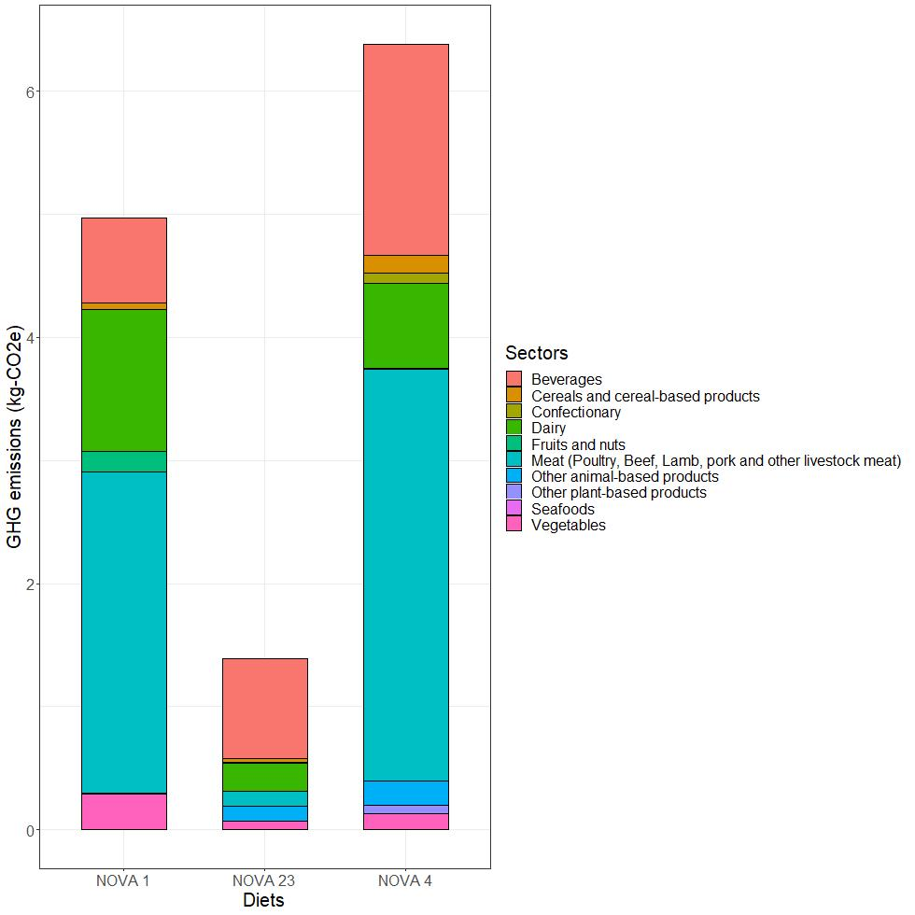
Sector-wise contribution to diets rich in UPFs (>95% of energy from NOVA 4), NOVA 2 and 3 (>95% of energy from NOVA 2 and 3), and NOVA 1 (>95% of
Supplemental Figure 6 - Sector-wise contribution to GHG emissions for diets rich in NOVA 1 (>95% energy from NOVA 1), NOVA 23 (>95% energy from NOVA 2 and 3), and NOVA 4 (>95% energy from NOVA 4)

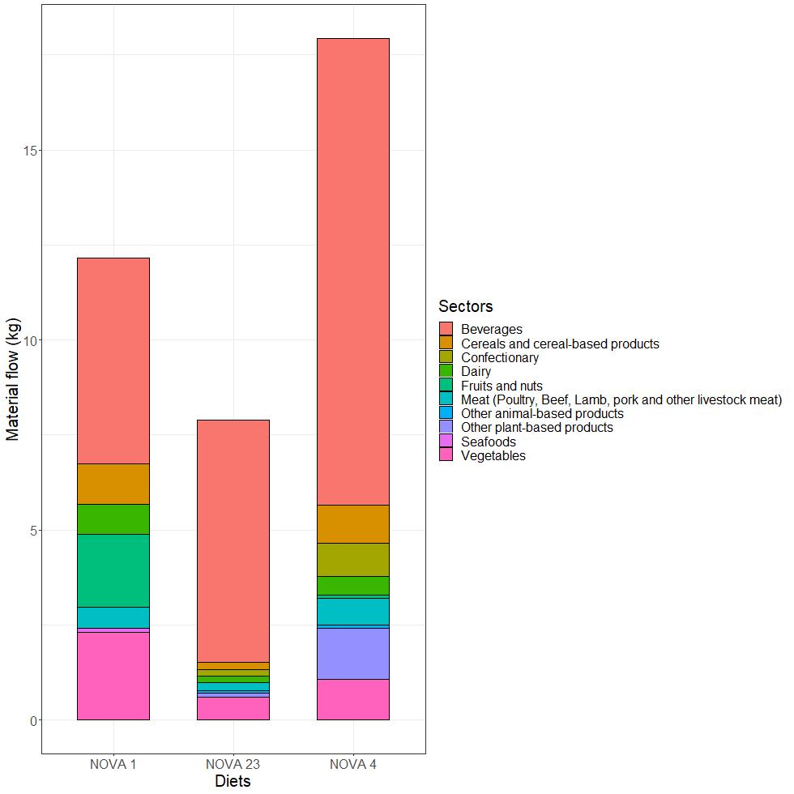
Supplemental Figure 7 - Sector-wise contribution to material flow for diets rich in NOVA 1 (>95% energy from NOVA 1), NOVA 23 (>95% energy from NOVA 2 and 3), and NOVA 4 (>95% energy from NOVA 4)

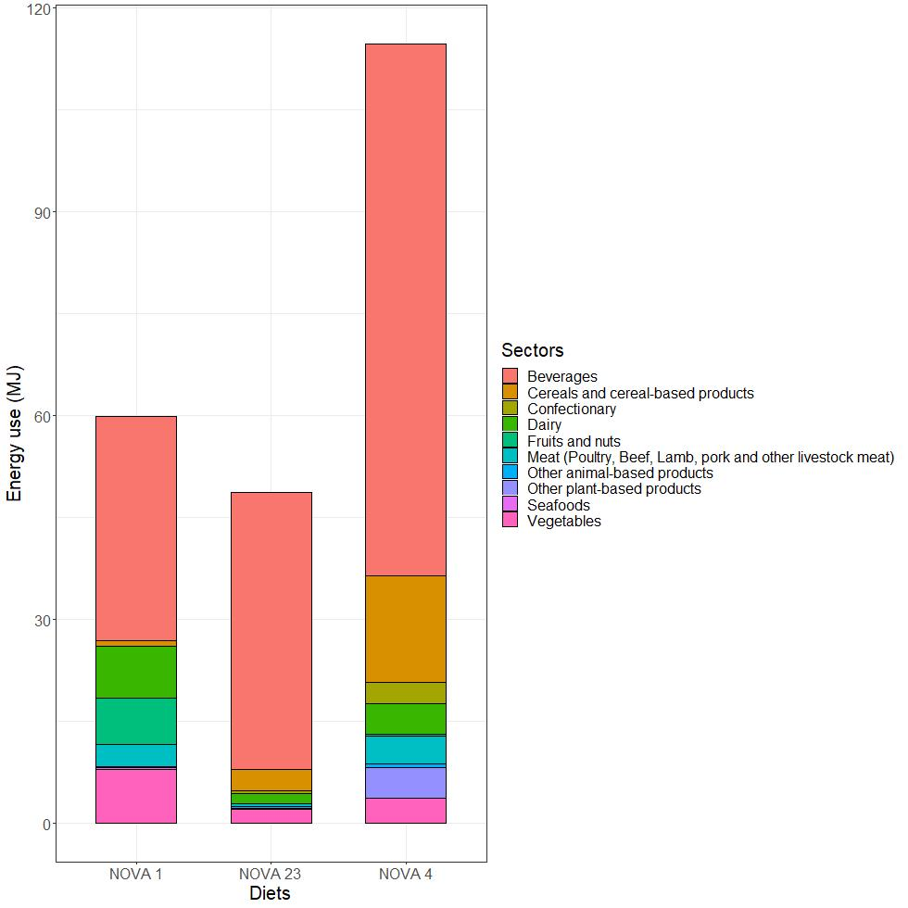
Supplemental Figure 8 - Sector-wise contribution to energy use for diets rich in NOVA 1 (>95% energy from NOVA 1), NOVA 23 (>95% energy from NOVA 2 and 3), and NOVA 4 (>95% energy from NOVA 4)

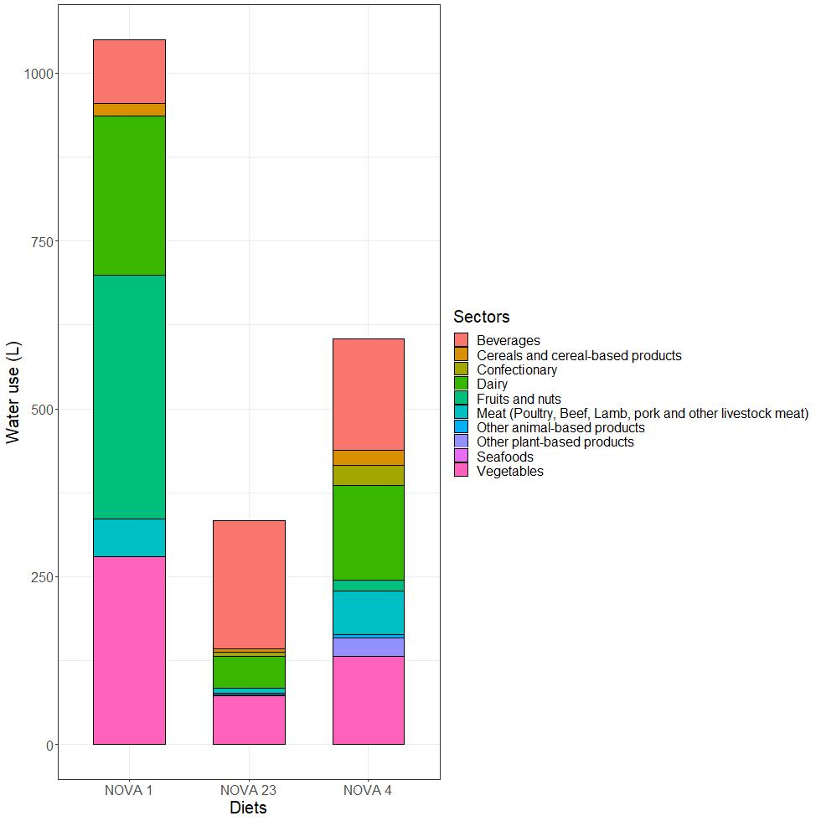
Supplemental Figure 9 - Sector-wise contribution to water use for diets rich in NOVA 1 (>95% energy from NOVA 1), NOVA 23 (>95% energy from NOVA 2 and 3), and NOVA 4 (>95% energy from NOVA 4)

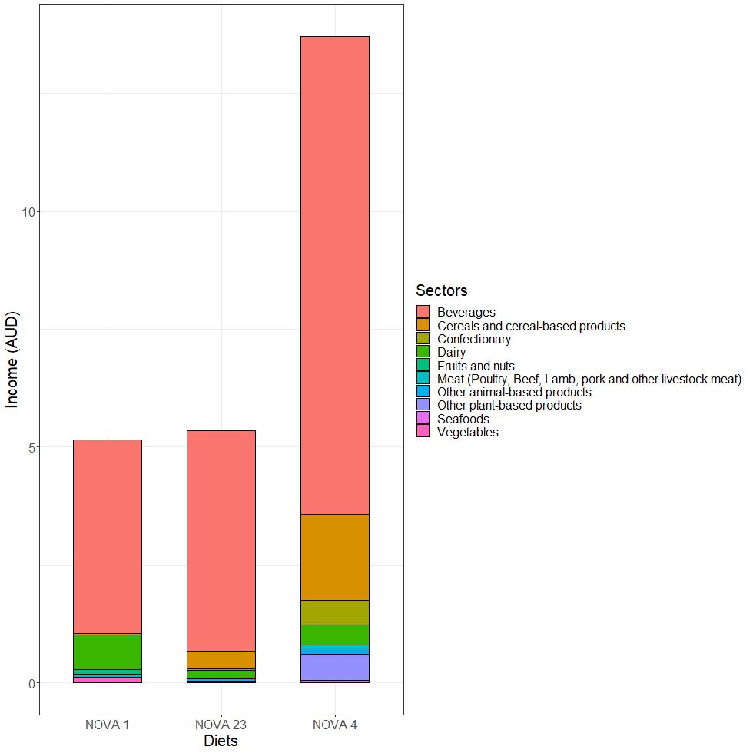
Supplemental Figure 10 - Sector-wise contribution to income for diets rich in NOVA 1 (>95% energy from NOVA 1), NOVA 23 (>95% energy from NOVA 2 and 3), and NOVA 4 (>95% energy from NOVA 4)

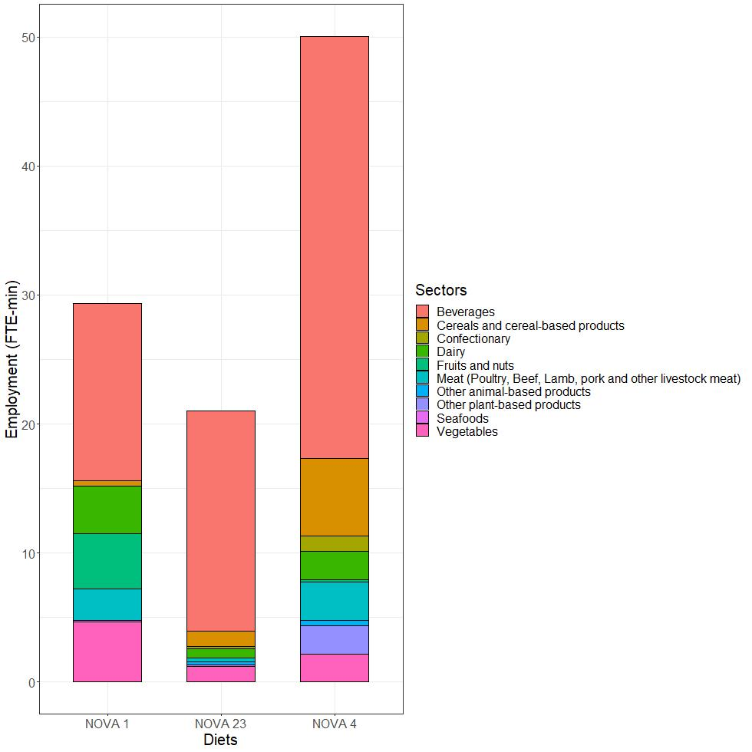
Supplemental Figure 11 - Sector-wise contribution to employment for diets rich in NOVA 1 (>95% energy from NOVA 1), NOVA 23 (>95% energy from NOVA 2 and 3), and NOVA 4 (>95% energy from NOVA 4)

