Appendix. Additional Tables and Figures.

Model assessing Cued Naming Condition and Simon effect for Swedish-only trials in the L2 sample:

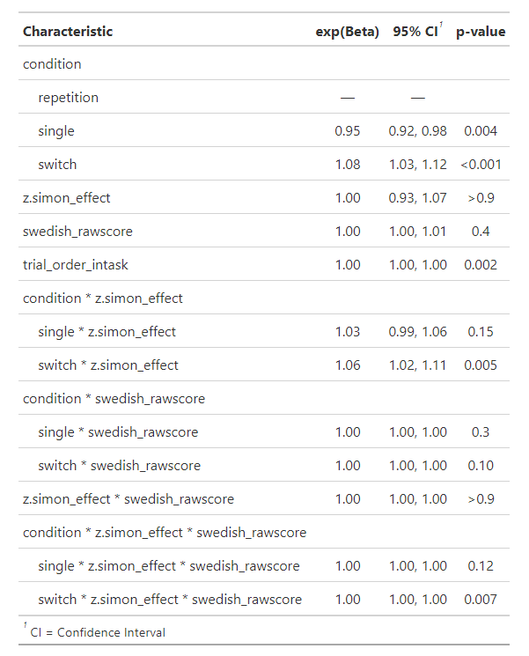Table A1

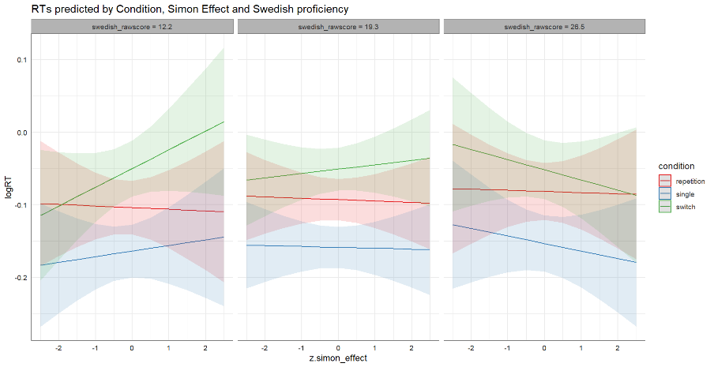 Figure A1

*Note:* The baseline level for the predictor Condition was *repetition*.

Model assessing Cued Naming Condition and Simon effect for Finnish-only trials in the L2 sample:

Table A2

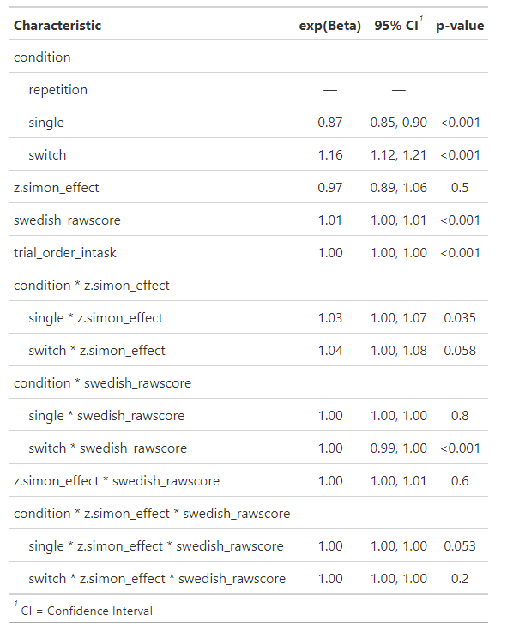Figure A2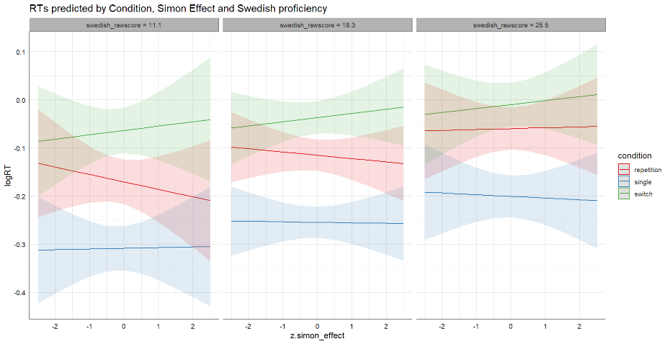

*Note:* The baseline level for the predictor Condition was *repetition*.

Model assessing Cued Naming Condition and Simon effect for Swedish-only trials in the Low proficiency sample:

Table 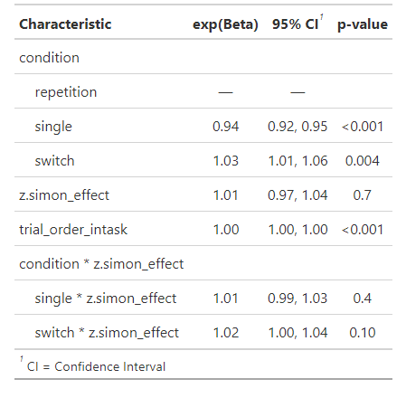A3

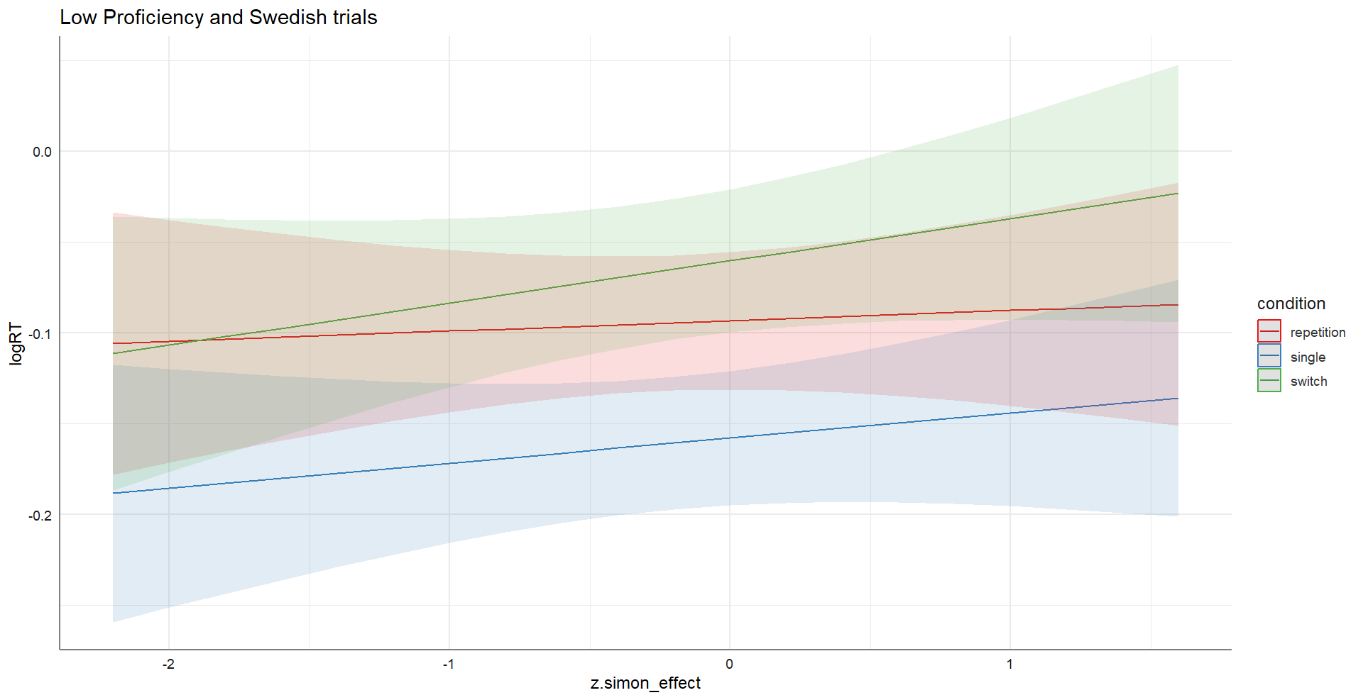Figure A3

*Note:* The baseline level for the predictor Condition was *repetition*.

Model assessing Cued Naming Condition and Simon effect for Finnish-only trials in the Low proficiency sample:

Table A4

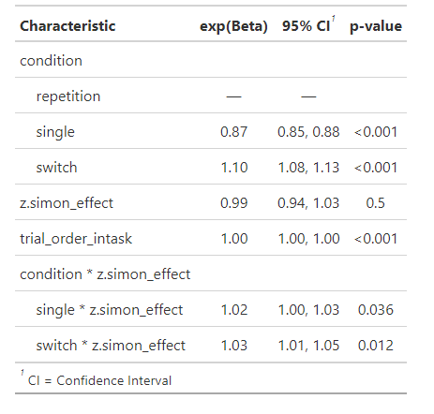

Figure A4

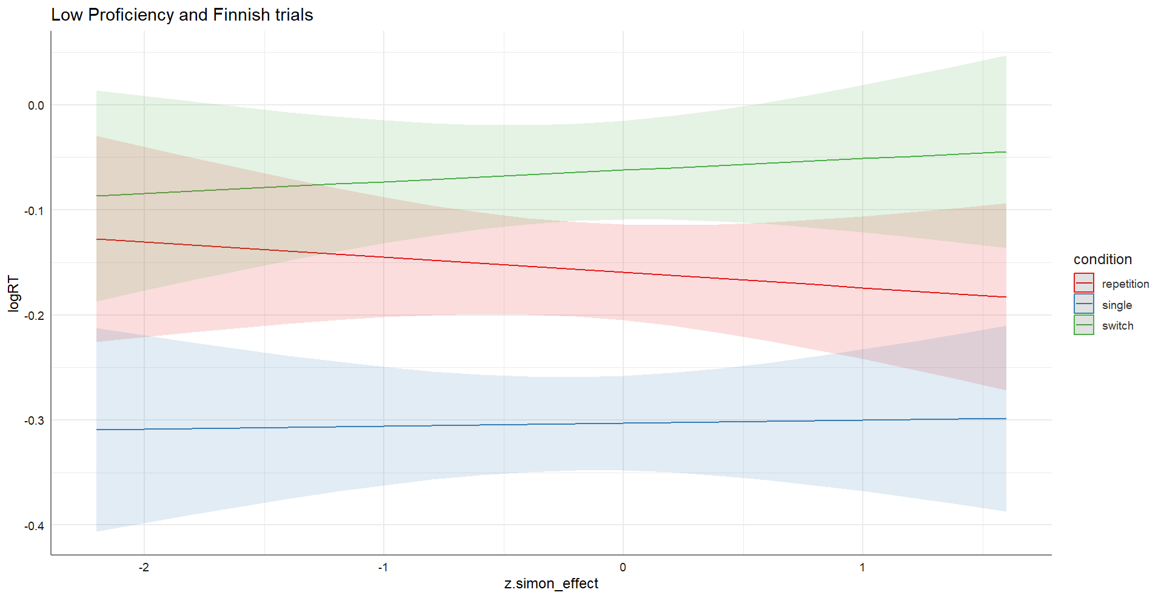

*Note:* The baseline level for the predictor Condition was *repetition*.

Tables and plots with Swedish Vocabulary score centered

Table A5

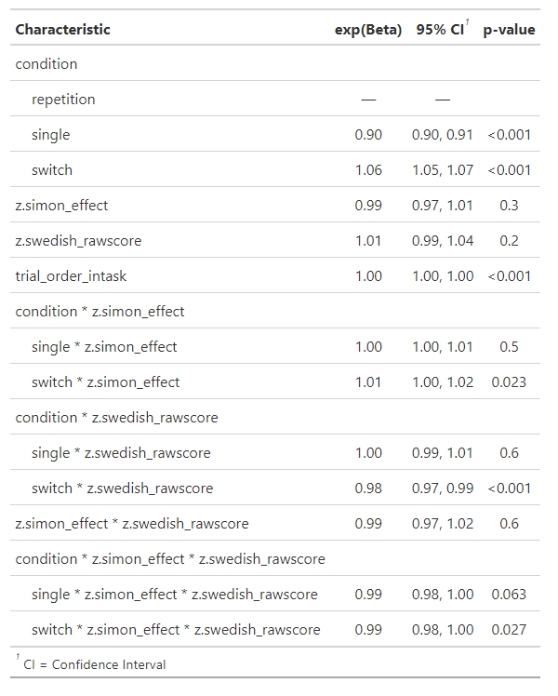

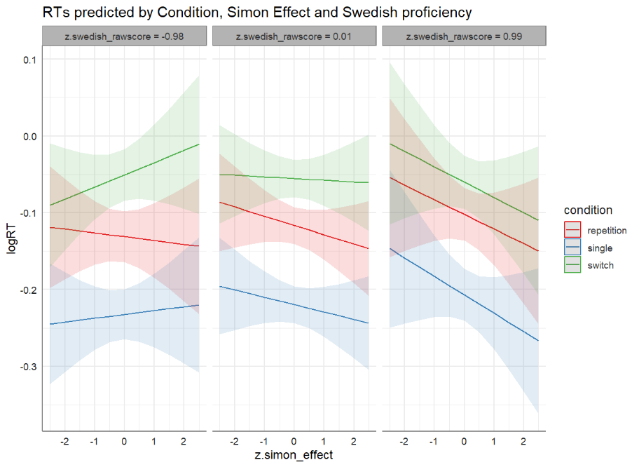Figure A5

*Note:* The baseline level for the predictor Condition was *repetition*.

Table A6. Mean RTs in ms (SD in parenthesis) of correct trials for the Cued Naming (CN) task for each group per condition and language. Error rates (%) for each group per condition and language for the CN task

|  |  |  |  |  |
| --- | --- | --- | --- | --- |
| Measure | Language | EB | HP | LP |
| Mean RT CN (ms) task | Both | 850 (16.5) | 890 (15.5) | 860 (15.7) |
| Error rate CN task(%) | 19.21 (13.8) | 26.97 (12.8) | 28.84 (15.5) |
| Mean RT CN (ms) | Swedish | 834 (15.4) | 902 (14.6) | 886 (14.3) |
| Mean RT CN single (ms) | 783 (14.4) | 863 (14.0) | 852 (13.8) |
| Mean RT CN repetition (ms) | 859 (14.5) | 920 (14.4) | 899 (13.8) |
| Mean RT CN switch (ms) | 899 (15.3) | 957 (14.0) | 941 (14.3) |
| Error rate CN task(%) | 19.66 | 26.90 | 41.04 |
| Error rate CN single(%) | 12.81 | 19.22 | 34.11 |
| Error rate CN repetition(%) | 19.62 | 28.00 | 41.46 |
| Error rate CN switch(%) | 30.76 | 38.47 | 51.42 |
| Mean RT CN (ms) | Finnish | 845 (16.0) | 892 (16.9) | 827 (16.8) |
| Mean RT CN single (ms) | 793 (15.2) | 826 (15.9) | 751 (15.1) |
| Mean RT CN repetition (ms) | 879 (15.3) | 932 (15.9) | 860 (15.1) |
| Mean RT CN switch (ms) | 916 (14.8) | 984 (14.7) | 943 (14.9) |
| Error rate CN task(%) | 19.28 | 26.59 | 22.56 |
| Error rate CN single(%) | 11.71 | 12.33 | 12.5 |
| Error rate CN repetition(%) | 21.15 | 32.96 | 23.29 |
| Error rate CN switch(%) | 39.24 | 40.82 | 37.65 |

*Note.* EB = early bilinguals; CN = cued naming; HP = high-proficiency late bilinguals; LP = low-proficiency late bilinguals