**Appendix**

**Tables and figures for additional reaction time analysis of the cued naming (CN), Flanker and Color-Shape (CS) tasks**

**Figure A1.** Models assessing the different (z-transformed) EF measures in interaction with cued naming condition.

A1a) Flanker

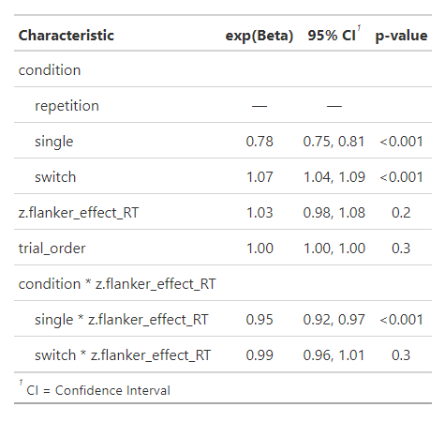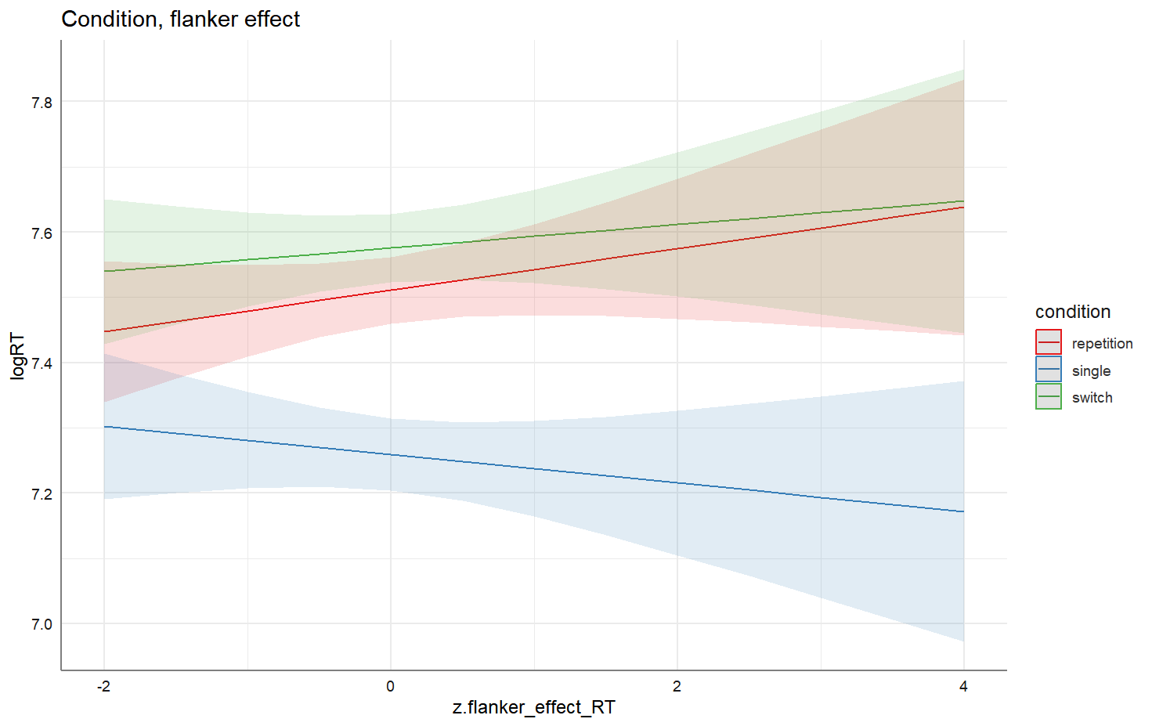

A1b) Color-shape switch cost

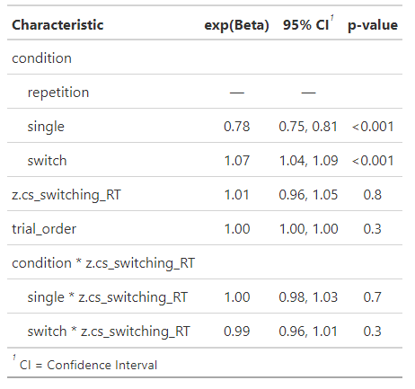

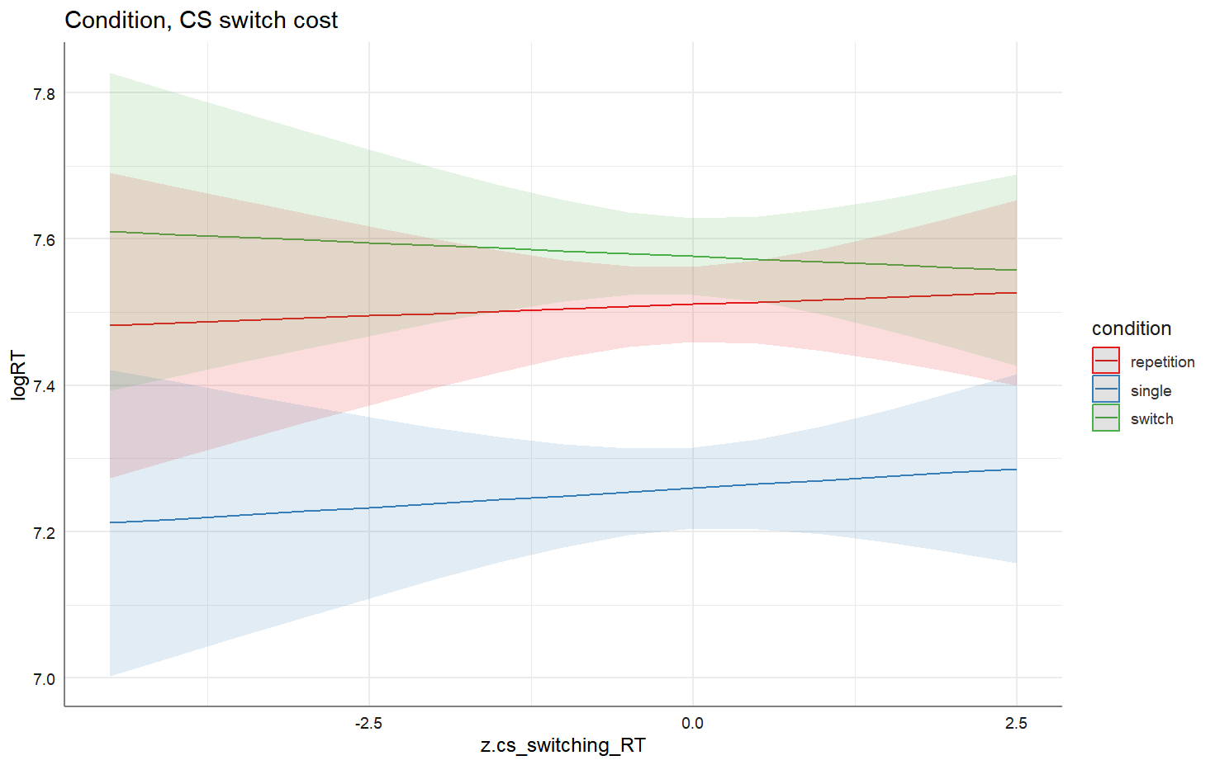

A1c) Color-shape mixing cost

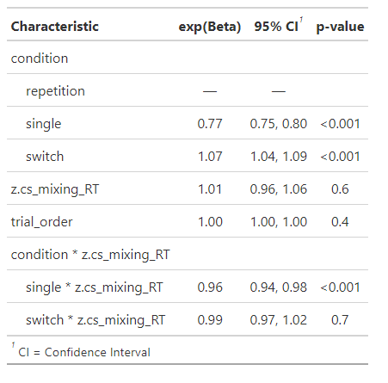

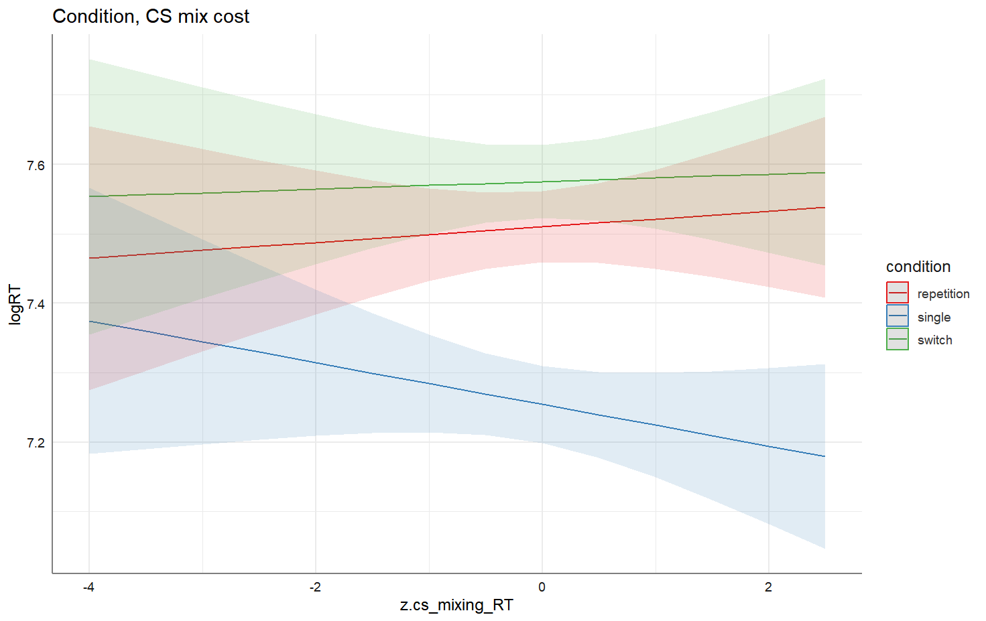

**Table A2.** Summary of the primary accuracy analysis and secondary reaction time analysis for all EF interaction effects with CN Condition, including non-significant ones in the CN task. Each line represents which EF measure each model analyzed. No reaction time analyses were performed for the Stroop and DCCS tasks.

|  |  |  |  |  |  |  |  |
| --- | --- | --- | --- | --- | --- | --- | --- |
|  |  | **Accuracy** | | | **Reaction Times** | | |
| **Models** | Predictor | CN Switching cost | CN Mixing cost | | CN Switching cost | | CN Mixing cost |
| **EF model 1** | Flanker | * | | - | | - | *** |
| **EF model 2** | Stroop | - | | - | | NA | NA |
| **EF model 3** | CS switching cost | - | | *** | | - | *** |
| **EF model 4** | CS mixing cost | - | | - | | - | - |
| **EF model 5** | DCCS | - | | - | | NA | NA |

*: *p* < .05; ***: *p* < .001. Note: CN = Cued Naming task, CS = Color-Shape task