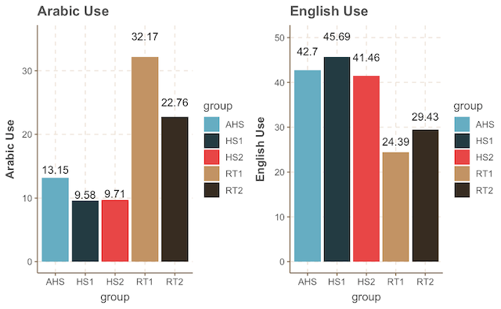
Figure. English and Arabic use measured by the BLP across groups.

Groups |  | Child Returnees RT1 | Adolescent Returnees  RT2 | Child Heritage Speakers  HS1 | Adolescent Heritage Speakers  HS2 | Adult Heritage Speakers  AHS
English VST (PPVT) | Mean (SD)  Range | 170.60 (17.75)  134-203 | 195.62 (12.27)  179-218 | 147.26 (25.64)  96-189 | 193.28 (17.03)  162-218 | 207.05(10.72)  183-220
Arabic VST | Mean (SD)  Range | 95.60 (8.89)  77-108 | 94.04(16.70)  54-115 | 37.19 (26.82)  4-87 | 43.71 (25.88)  1-97 | 35.10 (28.36)  10-112
Table. English and Arabic Vocabulary Size Task across groups

Table. Descriptive Statistics of the Gap-filling Task
Groups |  | Child Returnees  RT1 | Adolescent Returnees  RT2 | Child HSs  HS1 | Adolescent HSs  HS2 | Adult HSs  AHS
Gap Accuracy Total Mean | Mean (SD)  Range | 0.83 (0.37)  0-1 | 0.94 (0.23)  0-1 | 0.89 (0.30)  0-1 | 0.95 (0.21)  0-1 | 0.96 (0.17)  0-1
Arabic-English Accuracy Total Mean | Mean (SD)  Range | 0.79(0.40)  0-1 | 0.91(0.27)  0-1 | 0.89 (0.30)  0-1 | 0.94 (0.23)  0-1 | 0.95 (0.20)  0-1
English-only Accuracy Total Mean | Mean (SD)  Range | 0.87(0.33)  0-1 | 0.96(0.18)  0-1 | 0.89(0.30)  0-1 | 0.95(0.19)  0-1 | 0.98(0.13)  0-1

Table. Descriptive Statistics of the Acceptability Judgement Task
Groups |  | Child Returnees RT1 | Adolescent Returnees  RT2 | Child HSs  HS1 | Adolescent HSs  HS2 | Adult HSs  AHS
LDT Accuracy Total Mean | Mean (SD)  Range | 0.78(0.40)  0-1 | 0.82(0.37)  0-1 | 0.87(0.33)  0-1 | 0.88(0.31)  0-1 | 0.92(0.27)  0-1
Arabic-English Accuracy Total Mean | Mean (SD)  Range | 0.93(0.24)  0-1 | 0.95(0.21)  0-1 | 0.92(0.25)  0-1 | 0.95(0.20)  0-1 | 0.98(0.13)  0-1
English-only Accuracy Total Mean | Mean (SD)  Range | 0.93(0.24)  0-1 | 0.96(0.18)  0-1 | 0.91(0.27)  0-1 | 0.95(0.20)  0-1 | 0.98(0.13)  0-1
Arabic-only Accuracy Total Mean | Mean (SD)  Range | 0.57(0.49)  0-1 | 0.64(0.47)  0-1 | 0.80(0.39)  0-1 | 0.79(0.40)  0-1 | 0.79(0.40)  0-1
Baseline Accuracy Total Mean | Mean (SD)  Range | 0.70(0.45)  0-1 | 0.75(0.43)  0-1 | 0.82(0.37)  0-1 | 0.85(0.35)  0-1 | 0.92(0.26)  0-1
RT total mean | Mean (SD)  Range | 1.86(1.09)  0.03-6.95 | 1.54(0.97)  0.44-6.66 | 2.59(1.24)  0.09-6.88 | 2.08(1.05)  0.32-6.46 | 1.38(0.83)  0.46-6.67
Arabic-English RT total mean | Mean (SD)  Range | 1.66(0.87)  0.54-4.91 | 1.36(0.84)  0.44-6.39 | 2.53(1.16)  0.28-6.83 | 1.94(0.96)  0.50-6.26 | 1.268(0.76)  0.46-4.47
English-only total mean | Mean (SD)  Range | 1.51(0.86)  0.30-6.80 | 1.22(0.74)  0.45-6.37 | 2.42(1.11)  0.09-6.58 | 1.86(0.94)  0.41-6.19 | 1.22(0.72)  0.46-4.83
Arabic-only RT total mean | Mean (SD)  Range | 2.66(1.39)  0.71-6.95 | 2.14(1.13)  0.72-6.66 | 2.88(1.42)  0.42-6.83 | 2.39(1.20)  0.57-6.35 | 1.66(1.01)  0.56-6.67
Baseline RT total mean | Mean (SD)  Range | 1.94(1.00)  0.03-6.06 | 1.67(1.00)  0.67-6.61 | 2.58(1.23)  0.15-6.88 | 2.19(1.05)  0.32-6.46 | 1.43(0.78)  0.54-5.18

(see R Markdown file https://github.com/HadilAlraddadi/LDT.git).
(see R Markdown file https://github.com/HadilAlraddadi/GapfillingTask.git).

