Supporting Information-S1

All test resources can be found on the open science platform, L2 Speech Tools, as detailed by Mora-Plaza et al., 2022 at http://sla-speech-tools.com/. Demo versions of the tests can be accessed via https://app.gorilla.sc/openmaterials/663422.

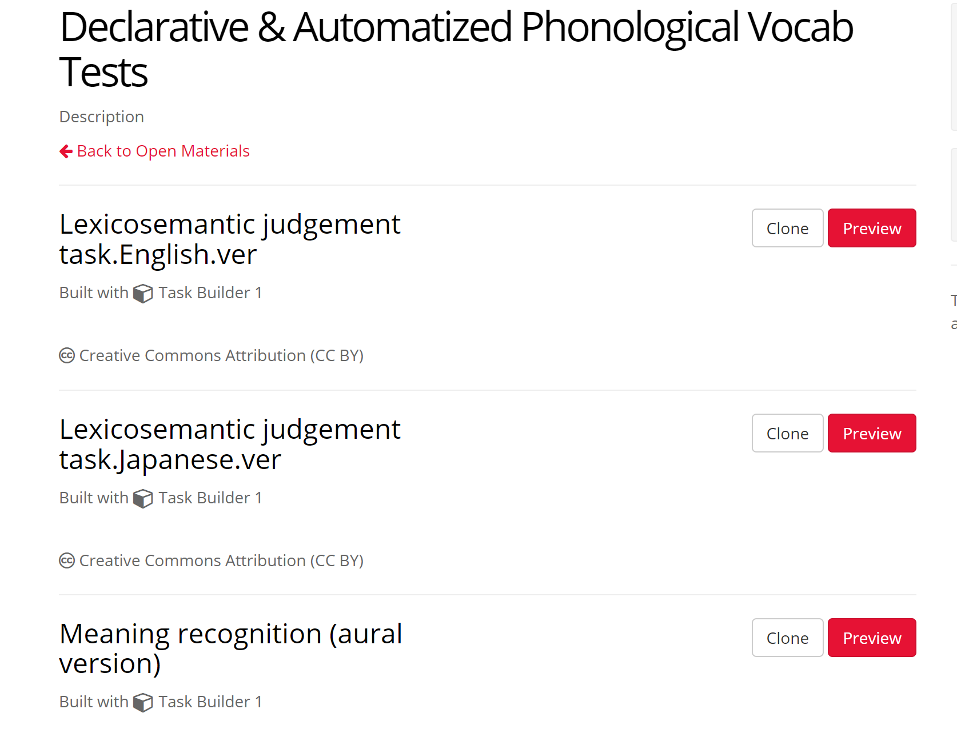
Figure S1
Phonological Vocabulary Tests (Meaning Recognition, Lexicosemantic Judgement)

Supporting Information-S2

The R scripts used in the current analyses are summarized as follows:

Relationships between experience, aptitude, and phonological vocabulary accuracy
# Load necessary packages
if (!require("readxl")) install.packages("readxl")
if (!require("lme4")) install.packages("lme4")
if (!require("performance")) install.packages("performance")

library(readxl)
library(lme4)
library(performance)

#Create MODEL1_acc
# Set a file path
file_path <- "submitted_data_accyracy.cvs"

# Import the data
data <- read.csv(file_path)

# Convert 'ID' and 'Test' to a factor
data$ID <- as.factor(data$ID)
data$Test <- as.factor(data$Test)

# Convert 'abroad' to a factor
data$abroad <- as.factor(data$abroad)

# Relevel 'Test' with '1' as the reference level
data$Test <- relevel(data$Test, ref = "1")

MODEL1_acc <- lmer(DV ~ age_of_learning*Test + total_past*Test + listening*Test + reading*Test + abroad*Test + AP*Test + WM*Test + (1|ID), data = data)

# Print the summary of the model
summary(MODEL1_acc)

# Print R squared
performance::r2(MODEL1_acc)

# Subset data for Test 1 and Test 2
data_test1 <- subset(data, Test == "1")
data_test2 <- subset(data, Test == "2")

# Post-hoc Pearson correlation for age_of_learning at Test 1 and Test 2
cor_test1_age_pearson <- cor.test(data_test1$age_of_learning, data_test1$DV, method = "pearson")
cor_test2_age_pearson <- cor.test(data_test2$age_of_learning, data_test2$DV, method = "pearson")
print(cor_test1_age_pearson)
print(cor_test2_age_pearson)

# Post-hoc Pearson correlation for total_past at Test 1 and Test 2
cor_test1_total_past_pearson <- cor.test(data_test1$total_past, data_test1$DV, method = "pearson")
cor_test2_total_past_pearson <- cor.test(data_test2$total_past, data_test2$DV, method = "pearson")
print(cor_test1_total_past_pearson)
print(cor_test2_total_past_pearson)

# Post-hoc Pearson correlation for listening at Test 1 and Test 2
cor_test1_listening_pearson <- cor.test(data_test1$listening, data_test1$DV, method = "pearson")
cor_test2_listening_pearson <- cor.test(data_test2$listening, data_test2$DV, method = "pearson")
print(cor_test1_listening_pearson)
print(cor_test2_listening_pearson)

# Post-hoc Pearson correlation for WM at Test 1 and Test 2
cor_test1_WM_pearson <- cor.test(data_test1$WM, data_test1$DV, method = "pearson")
cor_test2_WM_pearson <- cor.test(data_test2$WM, data_test2$DV, method = "pearson")
print(cor_test1_WM_pearson)
print(cor_test2_WM_pearson)

# Subset data for 'abroad' categories for Test 1 and Test 2
data_test1_abroad1 <- subset(data_test1, abroad == 1)
data_test1_abroad2 <- subset(data_test1, abroad == 2)
data_test2_abroad1 <- subset(data_test2, abroad == 1)
data_test2_abroad2 <- subset(data_test2, abroad == 2)

# Independent t-tests for 'abroad' at Test 1 and Test 2
t_test1_abroad <- t.test(DV ~ abroad, data = data_test1)
t_test2_abroad <- t.test(DV ~ abroad, data = data_test2)

# Print t-test results
print(t_test1_abroad)
print(t_test2_abroad)

