**Appendix A**

Word-Object Pairs by Order and Condition

A1. Low Variability Condition

Order A OrderB

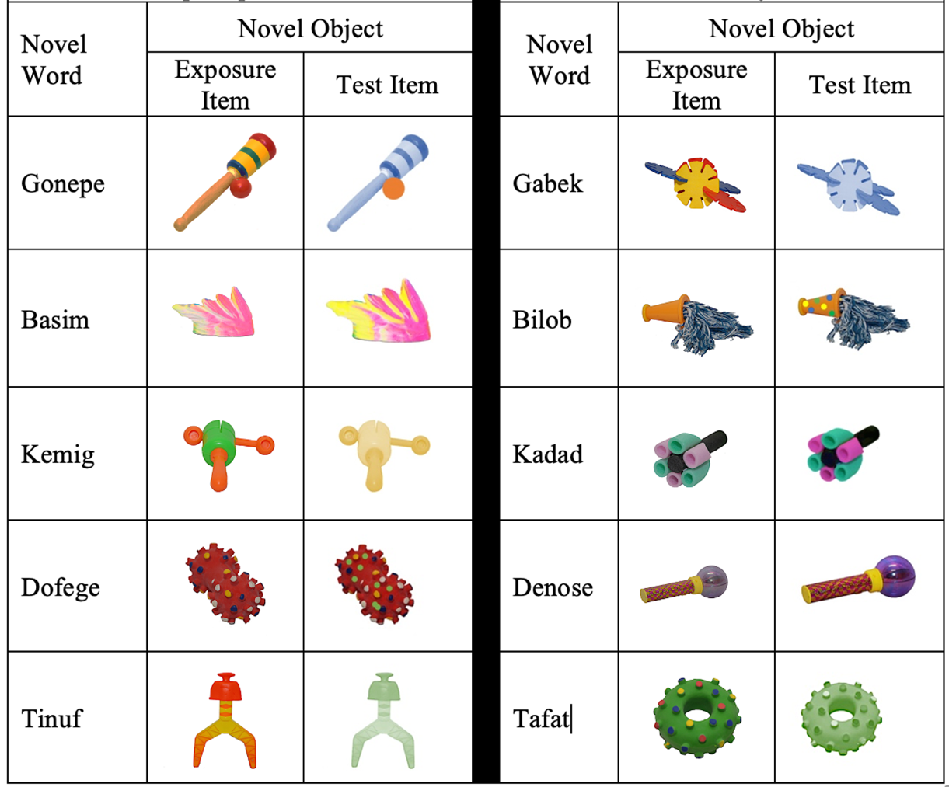

A2. High Variability Condition

Order A

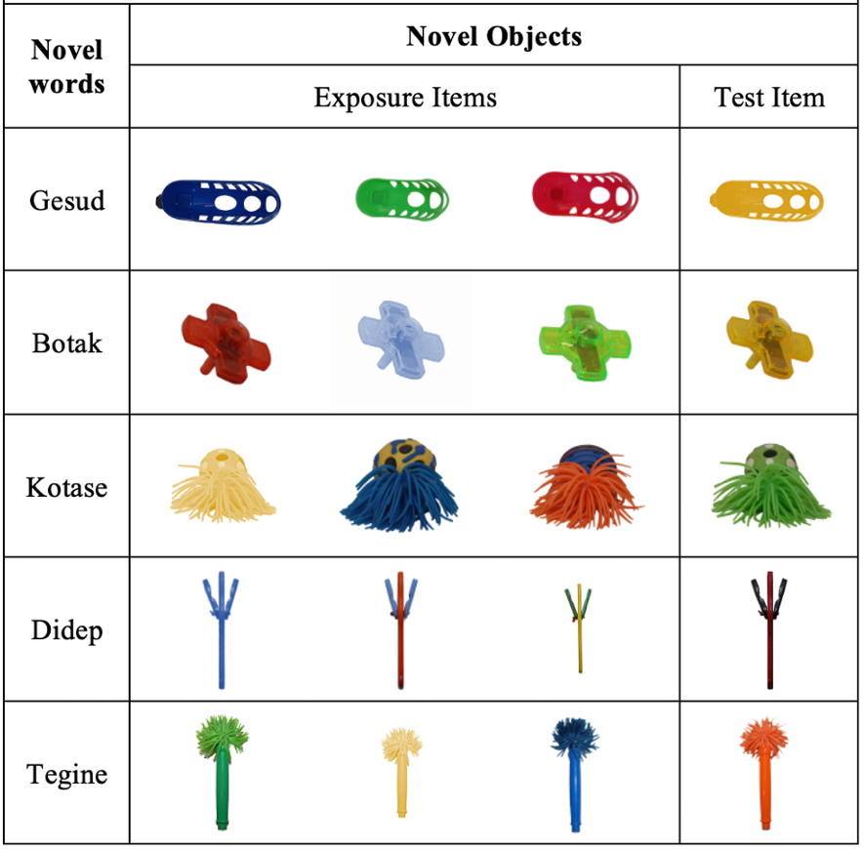

Order B

