**Figure 5**

Mediation Model 1

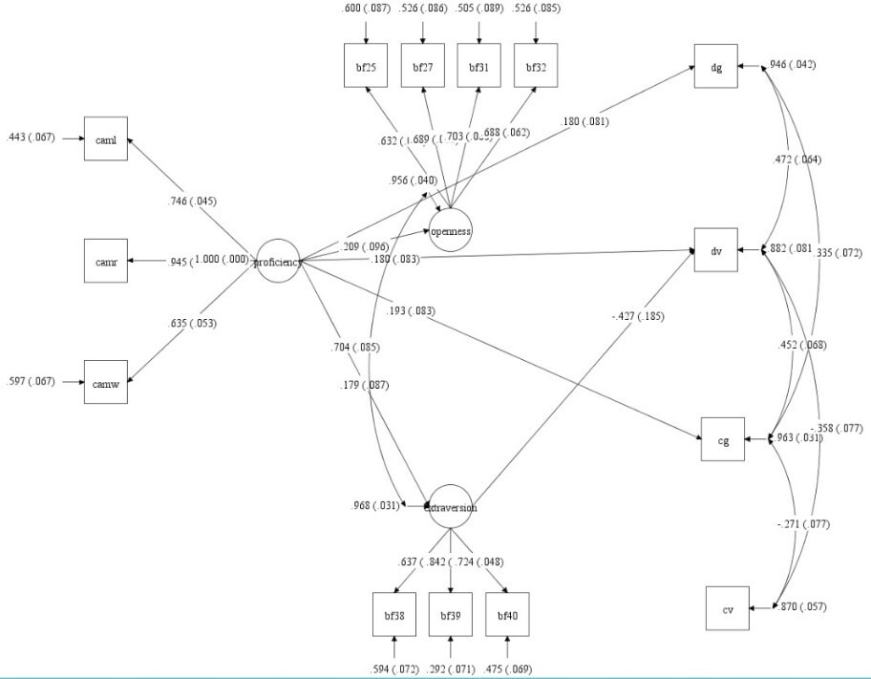

**Figure 6**

Mediation Model 2

