Supplementary material
Suppl. Table 1. Mean (and standard deviation) response times in the Language Switching task per condition for all older and young bilingual participants. Note that there was a significant difference between the overall (regardless of age group) average RT of L1 stay and L2 stay trials (t(188) = 10.07, p <.001) as well as L1 and L2 switch trials (t(188) = 10.76, p <.001), whereas the L1 and L2 single language trials did not differ (t(188) = -1.01m p > .05). Further, there was a significant difference between the overall (regardless of age group) average RT of L1 switch and L1 stay trials (t(188) = 24.03, p <.001), as well as L2 switch and L2 stay trials (t(188) = 24.61, p <.001). This means that the language switching task worked as expected.
 | L1 switch | L1 stay | L2 switch | L2 stay | L1 single language | L2 single language
Older | 1311.90 (211.04) | 1138.18 (205.39) | 1241.72 (211.09) | 1066.03 (186.92) | 956.65 (123.81) | 977.08 (125.10)
Young | 1080.65 (169.14) | 933.19 (136.71) | 1019.93 (153.59) | 872.87 (122.56) | 885.06 (105.52) | 867.34 (107.14)
Total | 1225.02 (225.79) | 1061.18 (207.66) | 1158.40 (219.35) | 993.47 (190.09) | 929.76 (122.04) | 935.85 (129.82)

In line with Costa et al. (2008) we carried out a three-way mixed ANOVA with the following factors: age group (older vs young), language status (bilinguals vs. monolinguals), and trial type (overall switch vs. overall stay). There was a main effect of trial type, F(1,148) = 27.79, p < .001 revealing that transformed proportion RTs on switch trials were longer than on stay trials. However, neither the interaction between age group and trial type (p = .99), nor language status and trial type were significant (p = 90). Further, in order to examine the effect of age group, language status and the difficulty of switching (easy switch: incongruent into incongruent vs. congruent into incongruent; and hard switch trial type: congruent into congruent vs. incongruent into congruent) on the transformed proportion RTs, we carried out additional ANOVAs. For the easy switch trial type (i.e. factors included: age group, language status, and easy switch trials: incongruent into incongruent trials vs. congruent into incongruent trials), the analysis revealed no significant effect of trial type (p = .81) and no significant interactions, neither between age group and trial type (p = .44), nor between language status and trial type (p = .87). For the hard switch trial type (i.e. factors included: age group, language status, and hard switch trials: congruent into congruent trials vs. incongruent into congruent trials), the analysis revealed a significant main effect of trial type F(1,148) = 80.44, p < .001 revealing that transformed proportion RTs on switch trials (into congruent) were longer than on congruent stay trials. Findings are illustrated in Suppl. Figure 1.

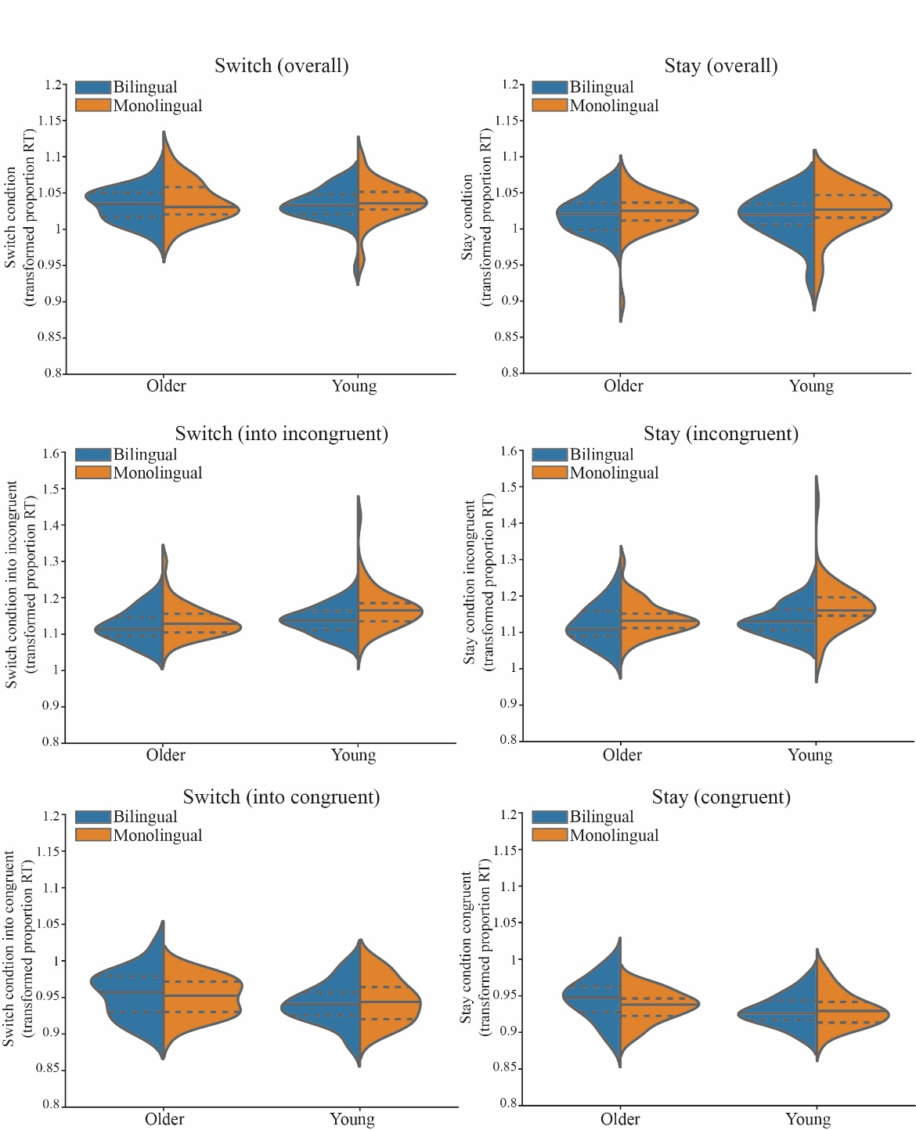
Suppl. Figure 1. Distributions and means of transformed proportion RTs of switch trials (left) and stay trials (right) from the ANT task per age group (older vs. younger) and language status (bilingual in blue, and monolingual in orange). The switch trials are further divided into easy (switch into incongruent) and hard (switch into congruent), the stay trials are also further divided into stay incongruent and stay congruent. The solid lines within the violin plots represent the average transformed proportion RT, the dashed lines represent the quartiles of the distribution. Note that there was a main effect of trial type in the overall switch vs. overall stay trials as well as the hard switch (switch into congruent vs. stay congruent trials), but not the easy switch (switch into incongruent vs. stay incongruent trials). There were no significant age-related or language status-related group differences.

