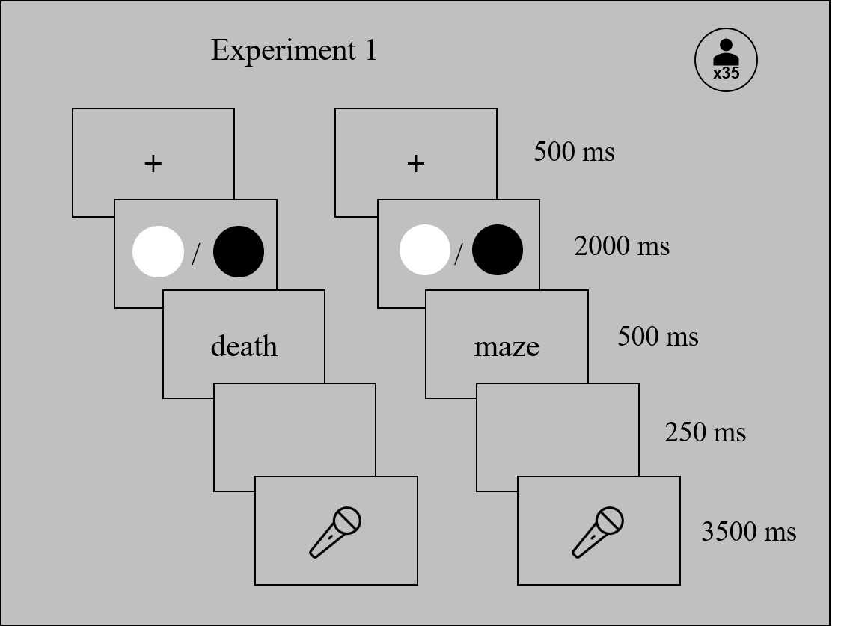
Supplementary Figure 1. Schematic visualisation of the experimental procedure in Experiment 1 (neutral context). Task (orally translate vs. read aloud) was colour coded and task-colour assignment was counterbalanced across participants.
Supplementary Figure 2. Mean reaction times when translating or reading aloud English and Polish (left panel) and negative and neutral (right panel) words (Experiment 1). Error bars represent 95% confidence intervals (CI).
Supplementary Figure 3. Mean accuracy when translating or reading aloud English and Polish (left panel) and negative and neutral (right panel) words (Experiment 1). Error bars represent 95% confidence intervals (CI).

Supplementary Figure 4. EPN elicited by negative and neutral words (Experiment 1). Waveforms illustrate brain potential variations computed via linear derivation from ten parieto–occipital electrodes (O1, PO3, P3, P5, P7, O2, PO4, P4, P6, and P8). Time 0 coincides with word presentation onset. The topographic map represents the difference in EPN amplitude between negative and neutral words in the 200–300 ms window. The line plot represents mean EPN amplitude averaged over the electrodes of interest in the 200–300 window. Shaded areas (ERP plot) and error bars (line plot) depict 95% confidence intervals (CI).

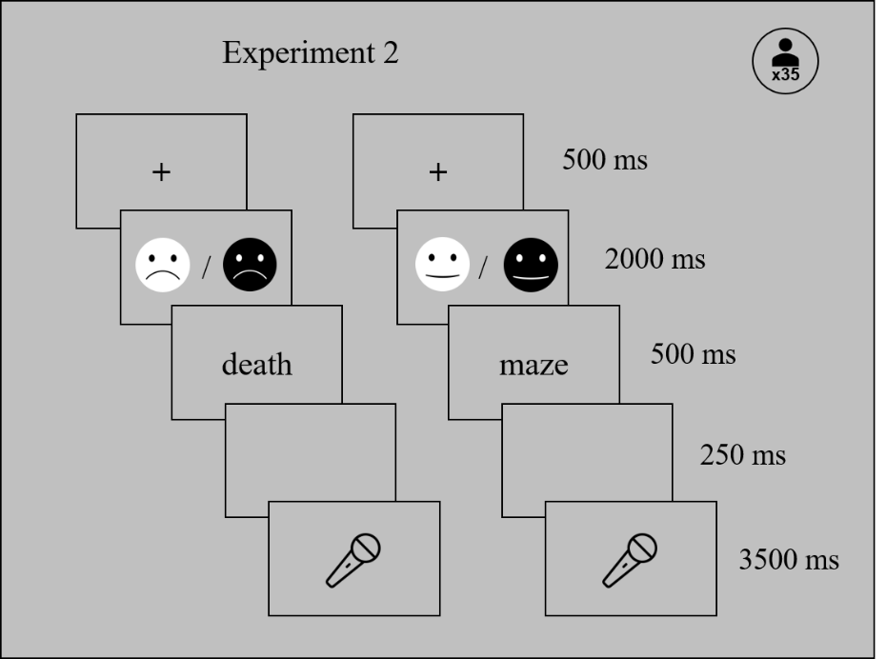
Supplementary Figure 5. Schematic visualisation of the experimental procedure in Experiment 2 (emotional context). Task (orally translate vs. read aloud) was colour coded and task-colour assignment was counterbalanced across participants.
Supplementary Figure 6. Mean reaction times when translating or reading aloud English and Polish (left panel) and negative and neutral (right panel) words (Experiment 2). Error bars represent 95% confidence intervals (CI).
Supplementary Figure 7. Mean accuracy to negative and neutral (right panel) words (Experiment 2). Error bars represent 95% confidence intervals (CI).
Supplementary Figure 8. EPN elicited by English and Polish words (Experiment 2). Waveforms illustrate brain potential variations computed via linear derivation from ten parieto–occipital electrodes (O1, PO3, P3, P5, P7, O2, PO4, P4, P6, and P8). Time 0 coincides with word presentation onset. The topographic map represents the difference in EPN amplitude between negative and neutral words in the 200–300 ms window. The line plot represents mean EPN amplitude averaged over the electrodes of interest in the 200–300 window. Shaded areas (ERP plot) and error bars (line plot) depict 95% confidence intervals (CI).

