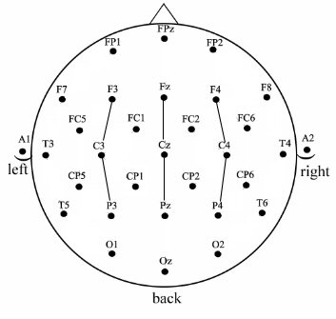
Supplementary Figure 1. Electrode montage and nine analysis sites (sites connected with lines)
Supplementary Figure 2. Top) ERPs to non-iconic ASL signs before learning at the 9 electrode sites used in the ANOVAs. Bottom) Voltage maps formed by subtracting no-match trial ERPs from match trial ERPs in the four latency ranges. Results: There were no significant main effects (all ps > .41) from 400-600ms, 600-800ms, or 800-1000ms. There were also no significant interactions (all ps > .23) in the time-windows 400-600ms or 600-800ms. There was a significant interaction between Match and Anteriority between 800-1000ms (F(2,62) = 6.3, p = .0126, η_{p}² = .0025). In the 1000-1400ms time-window there was a main effect of Match (F(1,31) = 13.2, p = .001, η_{p}² = .0222) as well as a significant interaction between Match and Laterality (F(2,62) = 3.82, p = .0331, η_{p}² = .0005).
D’ results
There was a significant main effect of Learning (F(1,31) = 122.95, p < .001, ηp2 = .2955); main effect of Matching (F(1,31) = 32.3, p < .001, ηp2 = .0476); main effect of Iconicity (F(1,31) = 131.6, p < .001, ηp2 = .0758). As well as significant interactions between Learning and Matching (F(1,31) = 11.55, p = .0019, ηp2 = .031); between Learning and Iconicity (F(1,31) = 131.6, p < .001, ηp2 = .0758); between Matching and Iconicity (F(1,31) = 23.82, p < .001, ηp2 = .0212); and between Learning, Matching and Iconicity (F(1,31) = 23.82, p < .001, ηp2 .0212).

