Supplementary Materials
Table S1. Effects of Language Entropy, Accuracy, and Information Access on Test Performance Controlling for L3 Exposure.
 | B | SE | z | p
(Intercept) | 1.936 | 0.237 | 8.175 | < .001
L3 exposure | 0.022 | 0.024 | 0.943 | .346
Age | 0.018 | 0.233 | 0.079 | .937
Language entropy | 1.591 | 0.967 | 1.645 | .100
Accuracy ª | –2.322 | 0.300 | –7.746 | < .001
Information access ^{b} | –1.612 | 0.290 | –5.560 | < .001
Language entropy × Accuracy ª | –1.171 | 1.305 | –0.897 | .370
Language entropy × Information access ^{b} | –2.993 | 1.247 | –2.400 | .016
Accuracy ª × Information access ^{b} | 2.200 | 0.386 | 5.696 | < .001
Language entropy × Accuracy ª × Information access ^{b} | 3.826 | 1.729 | 2.213 | .027
Note. N = 140. L3 = third language.
ª Accurate = 0, inaccurate = 1. ^{b} Informed = 0, uninformed = 1.

Table S2. Predicting Test Performance by Accuracy, Information Access, and Digit-Span Score.
 | B | SE | z | p
(Intercept) | 1.863 | 0.234 | 7.960 | < .001
Age | –0.025 | 0.253 | –0.099 | .921
Digit-span score | 0.109 | 0.161 | 0.678 | .498
Accuracy ª | –2.259 | 0.302 | –7.478 | < .001
Information access ^{b} | –1.521 | 0.292 | –5.209 | < .001
Digit-span score × Accuracy ª | –0.212 | 0.213 | –0.992 | .321
Digit-span score × Information access ^{b} | –0.081 | 0.213 | –0.381 | .703
Accuracy ª × Information access ^{b} | 2.108 | 0.396 | 5.325 | < .001
Digit-span score × Accuracy ª × Information access ^{b} | 0.202 | 0.280 | 0.720 | .472
Note. N = 139.
ª Accurate = 0, inaccurate = 1. ^{b} Informed = 0, uninformed = 1.

Table S3. Predicting Test Performance by Accuracy, Information Access, and Day-Night Score.
 | B | SE | z | p
(Intercept) | 1.867 | 0.219 | 8.522 | < .001
Age | –0.115 | 0.231 | –0.497 | .619
Day-night score | 0.118 | 0.069 | 1.695 | .090
Accuracy ª | –2.220 | 0.273 | –8.141 | < .001
Information access ^{b} | –1.538 | 0.277 | –5.544 | < .001
Day-night score × Accuracy ª | –0.090 | 0.099 | –0.913 | .361
Day-night score × Information access ^{b} | –0.013 | 0.086 | –0.151 | .880
Accuracy ª × Information access ^{b} | 2.093 | 0.369 | 5.678 | < .001
Day-night score × Accuracy ª × Information access ^{b} | 0.086 | 0.129 | 0.668 | .504
Note. N = 138.
ª Accurate = 0, inaccurate = 1. ^{b} Informed = 0, uninformed = 1.

Table S4. Effects of Language Entropy, Accuracy, and Information Access on Test Performance Controlling for Digit-Span Score.
 | B | SE | z | p
(Intercept) | 1.952 | 0.240 | 8.146 | < .001
Age | 0.011 | 0.246 | 0.043 | .966
Digit-span score | 0.002 | 0.069 | 0.032 | .974
Language entropy | 1.589 | 0.977 | 1.626 | .104
Accuracy ª | –2.336 | 0.305 | –7.669 | < .001
Information access ^{b} | –1.626 | 0.294 | –5.535 | < .001
Language entropy × Accuracy ª | –1.135 | 1.318 | –0.861 | .389
Language entropy × Information access ^{b} | –2.969 | 1.262 | –2.353 | .019
Accuracy ª × Information access ^{b} | 2.174 | 0.395 | 5.503 | < .001
Language entropy × Accuracy ª × Information access ^{b} | 3.981 | 1.790 | 2.224 | .026
Note. N = 139.
ª Accurate = 0, inaccurate = 1. ^{b} Informed = 0, uninformed = 1.

Table S5. Effects of Language Group, Accuracy, and Information Access on Test Performance Controlling for Day-Night Score.
 | B | SE | z | p
(Intercept) | 1.953 | 0.233 | 8.387 | < .001
Age | –0.073 | 0.233 | –0.316 | .752
Day-night score | 0.087 | 0.032 | 2.723 | .006
Language entropy | 1.516 | 0.947 | 1.601 | .109
Accuracy ª | –2.347 | 0.294 | –7.993 | < .001
Information access ^{b} | –1.663 | 0.286 | –5.823 | < .001
Language entropy × Accuracy ª | –1.179 | 1.273 | –0.926 | .354
Language entropy × Information access ^{b} | –2.922 | 1.221 | –2.393 | .017
Accuracy ª × Information access ^{b} | 2.227 | 0.380 | 5.865 | < .001
Language entropy × Accuracy ª × Information access ^{b} | 4.102 | 1.728 | 2.374 | .018
Note. N = 138.
ª Accurate = 0, inaccurate = 1. ^{b} Informed = 0, uninformed = 1.

Figure S1. A Picture Used in Exploratory Post-Test Question on Children’s Beliefs About the Uninformed Experimenter’s Perspective.
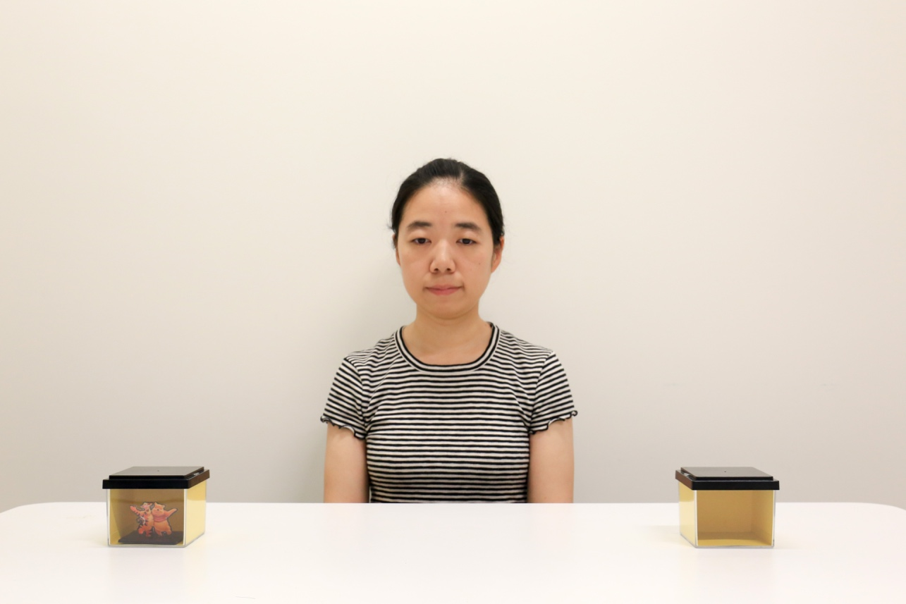
Note. In the uninformed condition, at the end of the study, children were presented with this picture and asked by the confederate whether they believe that the experimenter could or could not have seen the hidden sticker during the history phase.

