**Criteria for TBI severity.**

TBI diagnosis and severity were determined by physicians at the trauma centers according to provincial guidelines (1), based on the World Health Organization definition of traumatic brain injury (TBI) (2, 3): (a) alteration or loss of consciousness (mild TBI: < 30 minutes; moderate: < 24 hours; severe: > 6 hours); (b) posttraumatic amnesia (mild: < 24 hours; moderate: generally 1-14 days; severe: several weeks); (c) any transitory neurological sign such as any focal neurological sign, convulsion, or intracranial lesion (mild: positive or negative brain imaging results, possible neurological signs; moderate: generally positive brain imaging results, presence of focal neurological signs; severe: positive brain imaging results and presence of focal neurological signs); and (d) the initial score on the Glasgow Coma Scale (GCS)(4) (mild: 13-15; moderate: 9-12; severe: 3-8).

1. Ministère de la santé et des services sociaux, Société de l’assurance automobile du Québec. Orientations ministérielles pour le traumatisme craniocérébral léger 2005-2010 [Ministerial guidelines for mild traumatic brain injury 2005-2010]. Québec, QC, Canada: Bibliothèque nationale du Québec,; 2005. Available from: <https://publications.msss.gouv.qc.ca/msss/fichiers/2006/orientations_traumatisme.pdf>.

2. Carroll LJ, Cassidy JD, Peloso PM, Borg J, von Holst H, Holm L, et al. Prognosis for mild traumatic brain injury: Results of the WHO Collaborating Centre Task Force on Mild Traumatic Brain Injury. Journal of rehabilitation medicine. 2004(43 Suppl):84-105.

3. von Holst H, Cassidy JD. Best evidence synthesis on mild traumatic brain injury: Results of the WHO Collaborating Center for Neurotrauma, Prevention, Management and Rehabilitation Task Force on Mild Traumatic Brain Injury [Special issue]. Journal of rehabilitation medicine. 2004;43(Suppl):144 p.

4. Teasdale G, Jennett B. Assessment of coma and impaired consciousness. A practical scale. Lancet. 1974;304(7872):81-4.

**Table. Characteristics of participants at baseline (N = 222)**

|  |  |  |
| --- | --- | --- |
|  | **M ± SD (range)** | |
| Age (years) | 41.36 ± 15.17 (18-65) | |
| Education (years) | 12.68 ± 2.66 (6-20) | |
| Length of stay in trauma center (days) | 14.10 ± 11.82 (1-68) | |
|  | *n* | % |
| Sex (women) | 63 | 28% |
| Severity of TBI |  |  |
| Mild | 145 | 65% |
| Moderate | 47 | 21% |
| Severe | 29 | 13% |
| Mechanism of injury |  |  |
| Motor vehicle/traffic | 127 | 57% |
| Fall | 60 | 27% |
| Other (struck by/against, sport injury) | 33 | 15% |
| Concomitant injuries to body parts other than head |  |  |
| Neck | 30 | 14% |
| Upper limb | 83 | 38% |
| Lower limb | 91 | 41% |
| Trunk | 91 | 41% |
| Any of the four previous categories | 164 | 75% |

**Figure. Participants flow from CHU de Québec-Université Laval, Québec and McGill University Health Centre, Montréal, QC, Canada (level I trauma centers) between December 2013, and October 2016**

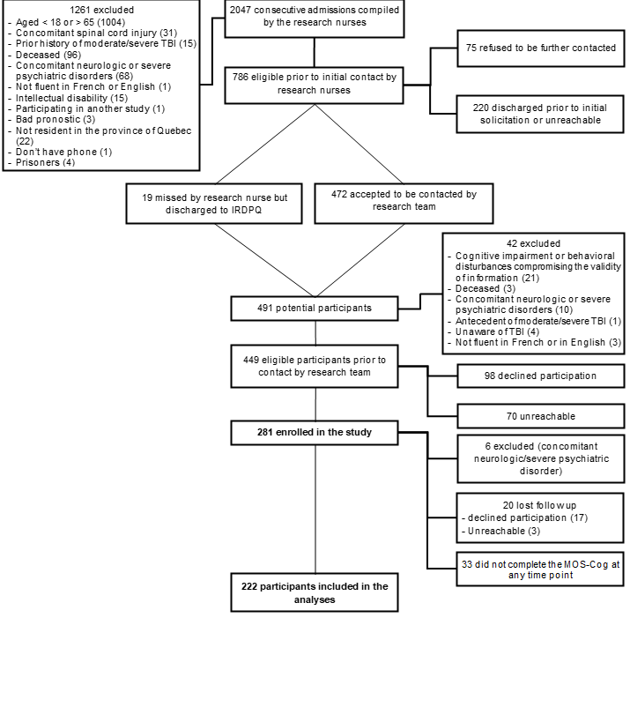

**Missing data and loss to follow-up**

To address missing data and loss to follow-up, the following subgroups were compared using t-tests for age, education, and length of stay at the trauma center, and using chi-square tests for sex, severity of TBI, and mechanism of injury.

1. First, the study sample of 222 participants was compared to the 33 individuals who participated in the parent study but did not complete the MOS-COG at any assessment. Individuals who were not included in the current study were significantly younger (34.6 ± 12.01years vs 41.4 ± 15.2 years) and less educated (11.3 ± 2.3 years vs 12.7 ± 2.7 years) compared to individuals who were included, *t*(252) = -2.47, *p* = .01 (age), *t*(236) = -2.57, *p* = .01 (education). The two subgroups did not differ on length of stay at the trauma center, sex, TBI severity, or TBI mechanism.
2. Second, among the 222 participants of this study, the 189 participants who completed the MOS-COG at 4 months were compared to the 33 who did not (but were still included because they completed the MOS-COG at least once in the next five assessments). Individuals with missing data at 4 months were more likely to have sustained a moderate-severe TBI (52%) compared to individuals who completed the 4-month assessment (31%), *X*2 (1, *N* = 221) = 5.04, *p* = .03. The two subgroups did not differ on age, education, length of stay at the trauma center, sex, or TBI mechanism.
3. Third, among the 189 with data at 4 months, the 84 with data at all six follow-ups were compared to the 105 with at least one missing data. Individuals with at least one incomplete assessment were significantly younger (39.5 ± 14.69 years) compared to individuals who completed all assessments (44.1 ± 15.53 years), *t*(186) = -2.08, *p* = .04. The two subgroups did not differ on education, length of stay at the trauma center, sex, TBI severity, or TBI mechanism.