**Supplementary Materials**

Supplementary Table 1. CUFF Model Comparisons in Response to Heywood Case

|  |  |  |  |  |  |
| --- | --- | --- | --- | --- | --- |
| **Model** | **χ2 (*df*)** | **∆χ2** | **CFI** | **∆CFI** | **RMSEA** |
| 1. Variances fixed to 0 | 203.70(60)** |  | 0.99 |  | 0.04 |
| 2. Equated variance estimates | 198.54(59)** | -5.16* | 0.99 | 0 | 0.04 |
| 3. Constraining variances to be positive | 192.02(56)** | -6.52 | 0.99 | 0 | 0.04 |
| 4. Final model | 195.44(57)** | 3.42 | 0.99 | 0 | 0.04 |

*Note.* Robust fit statistics are reported. ∆χ2 = change in χ2.CFI = comparative fit index. ∆CFI = change in CFI. RMSEA = root mean-square error of approximation. Model testing done specifically in response to Heywood case (i.e., negative wave 0 EF factor variance). Letter fluency and Trail making test part B values are standardized in all models. Model 1: Executive function factor variances are fixed to 0 at each wave. Model 2: Executive function factor variances are constrained to be equal across waves. Model 3: Executive function factor variance at wave 0 is constrained to be positive. Model 4: Executive function factor variance at wave 0 is fixed to 0.

\**p* < .05. \*\**p* < .001.

Supplementary Table 2. Robustness Check Comparisons

|  |  |  |
| --- | --- | --- |
| **Model** | **Intercept** | **Slope** |
| 1. Raw NPS | 0.049** | 0.013** |
| 2. Winsorized NPS | 0.052** | 0.013** |
| 3. Quantiles |  |  |
| Low | -0.101 | -0.054 |
| Medium | -0.394** | -0.103** |
| High | -0.463** | -0.122** |

*Note.* All values are unstandardized estimates. NPS = neuropsychiatric symptoms. Model 1: final predicted curve of factors model using raw NPS severity as predictor. Model 2: Total NPS severity values that were greater than 3 standard deviations above the mean were Winsorized to the next highest value. Model 3: Total NPS severity values were divided into quantiles. Three dummy codes were created for the low, medium, and high severity groups with the absent group as the reference category.

\**p* < .05. \*\**p* < .001.

Supplementary Figure 1. Participant Selection Diagram

Participants with data during UDS v.3-v3.2

Total Potentials: (n = 25,752)

**Selection from longitudinal NACC sample**

Total Excluded (n = 21,982) with overlap from:

* Initial visit was not during UDS v3-v3.2 (n = 10,039)
* Age ≤ 49 (n = 494)
* No data during waves 1-3 UDS v3-v3.2 (n = 11,453)

**Sample Eligibility Criteria: Demographic and Visit Data**

**Sample Eligibility Criteria: Participant and Cognitive Data**

Total Potentials: (n = 3,770)

Total Excluded based on cognitive data (n = 2,145):

* Clinician diagnosis of “Normal Cognition” at all waves (n = 1,844)
* Clinician determined participant data was invalid (n = 8)
* Cognitively impaired due to non-neurodegenerative etiology (n = 293)

Total Participants: (n = 1,625)

Supplementary Figure 2. Path Diagram of Executive Function Strict Invariance Model

*Note.* Executive function subtest scores (manifest variables) are represented by squares. Latent executive function variables are represented by circles. Factor loadings, intercepts, and residual variances are represented as invariant over time. Not depicted: covariances among latent variables, covariances among manifest variables at adjacent time points, and intercepts of latent and manifest variables. TMT-B = Trail Making Test Part B. W0=wave 0, W1=wave 1, W2=wave 2, W3=wave 3. EF=executive functioning. @ represents fixed parameters. λ represents factor loadings.

Supplementary Figure 3. Path Diagram of Executive Function Decline (CUFF Model)

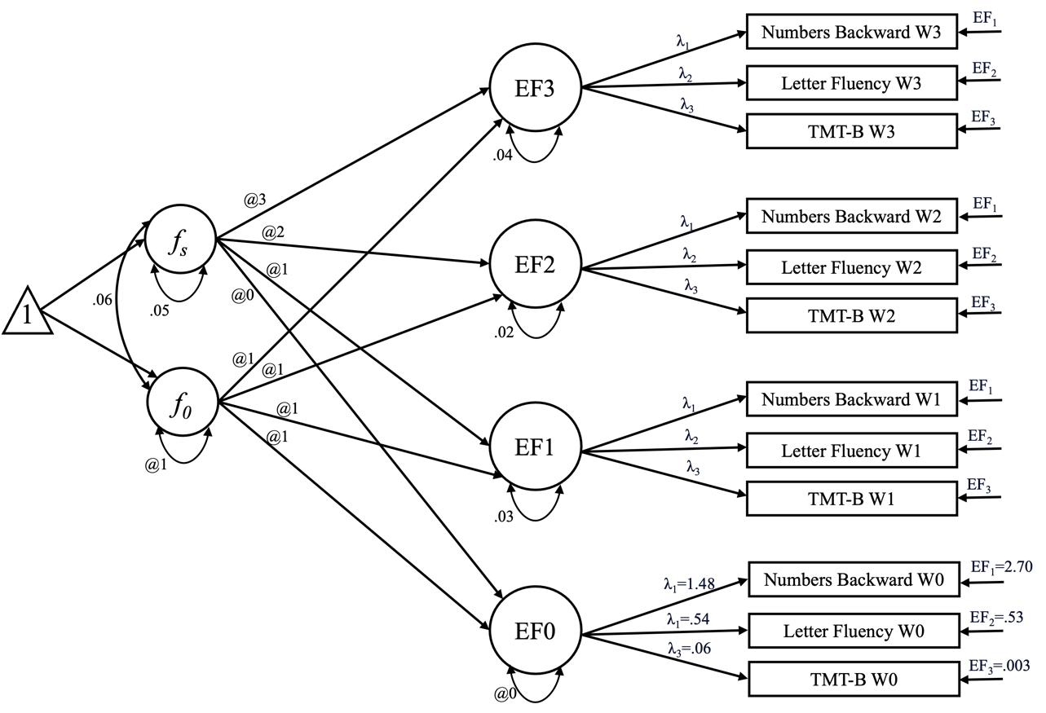

*Note.* An extension of the strict model, whereby longitudinal change is estimated using a curve of factors (CUFF) model. The triangle represents a constant to estimate means and intercepts. Covariance (rather than standardized correlation) between slope and intercept latent variables is represented. Not depicted: intercepts of manifest variables, covariances among manifest variables at adjacent time points. *f0* represents the intercept factor. *fs* represents the slope factor.

Supplementary Figure 4. Path Diagram of Executive Function Decline Predicted by W0 NPS

*Note.* An extension of the CUFF model, where latent change is predicted by W0 NPS severity. Covariance (rather than standardized correlation) between slope and intercept latent variables is represented. Not depicted: intercepts of manifest variables, covariances among manifest variables at adjacent time points. NPS = neuropsychiatric symptoms.

Supplementary Figure 5. Screenshot of Web Application Showing Differential EF Trajectories Based on NPS

