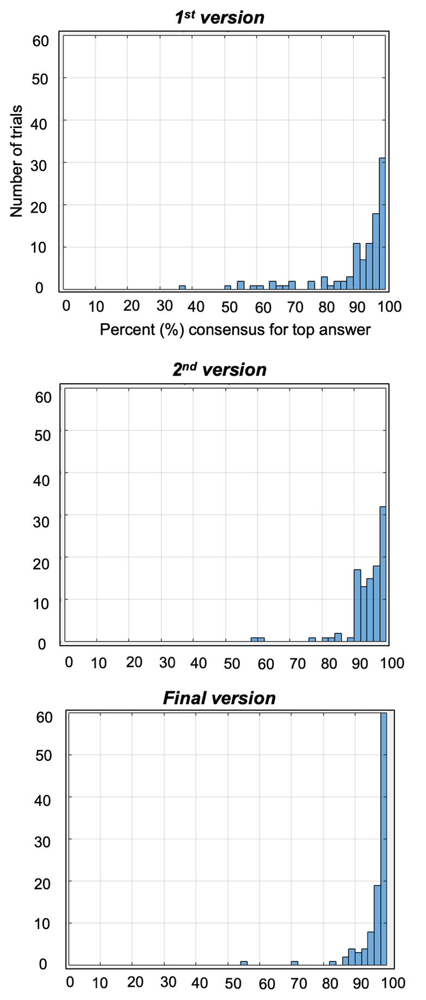

Supplemental Figure 1. ViSAT refinement process. Percent consensus (PCons) distributions of all 100 trials (and 3 practice trials) from the earlier versions (top and middle) and the final version (bottom), showing general increase in percent consensus.
PWE ID # | Etiology | Lateralization/ localization | Temporal involved in SOZ | Seizure Frequency | Age of Onset (y) | Duration of epilepsy (y) | # ASMs | # prior ASMs
1 | Focal | L frontotemporal | Yes | Yearly | 31 | 10 | 2 | 4
2 | Primary generalized | Primary generalized | No | Weekly | 12 | 14 | 2 | 4
3 | Focal | L mesial temporal | Yes | Yearly | 25 | 8 | 1 | 0
4 | Focal | Bilateral frontotemporal | Yes | Weekly | 18 | 7 | 3 | 3
5 | Focal | L frontotemporal and/or medial temporal | Yes | Weekly | 68 | 5 | 1 | 1
6 | Primary generalized | Primary generalized | No | Daily-weekly | 0 | 29 | 4 | 0
7 | Focal | L frontal | No | Monthly | 14 | 13 | 2 | 5
8 | Focal | R posterior temporal | Yes | Monthly | 13 | 11 | 3 | 1
9 | Focal | R frontocentral/ frontotemporal | Yes | Weekly-monthly | 13 | 13 | 3 | 2
10 | Focal | L mesial temporal | Yes | Weekly-monthly | 19 | 3 | 3 | 3
11 | Focal | R mesial temporal | Yes | Daily | 20 | 36 | 2 | 3
12 | Focal | L temporal | Yes | Monthly | 27 | 2 | 2 | 1
13 | Primary generalized | Primary generalized | No | Daily | 15 | 4 | 2 | 2
14 | Focal | Bilateral temporal | Yes | Weekly | 39 | 2 | 1 | 6
15 | Focal | L frontotemporal | Yes | Monthly | 57 | 2 | 2 | 1
16 | Focal | Bilateral temporal (suspected) | Yes | Daily-weekly | 34 | 15 | 3 | 1
17 | Focal | L frontocentral | No | Monthly | 20 | 2 | 2 | 1
18 | Focal | L basal temporal | Yes | Daily | 25 | 6 | 3 | 0
19 | Focal | R anterior temporal | Yes | Monthly | 52 | 3 | 1 | 2
20 | Focal | Bilateral mesial temporal | Yes | Monthly | 21 | 3 | 3 | 3
21 | Focal | Bilateral medial frontal/cingulate | No | Weekly | 27 | 16 | 1 | 4
22 | Focal | R frontotemporal | Yes | Weekly | 15 | 18 | 2 | 4
23 | Focal | Bilateral medial temporal | Yes | Daily | 39 | 24 | 4 | 9

Supplemental Table 1. Individual-level demographic and clinical information for PWE. Abbreviations: PWE, patients with epilepsy, y, year; R, right, L, left.

