Table of Contents

Supplementary Methods 2
Supplementary Tables 5
Table S1. Participant count per cohort across different age categories. 5
Table S2. Summary results of the optimal Beta GAMLSS. 6
Table S3. Diagnostic accuracies corresponding to the optimal cutoff for NC vs Dementia 7
Supplementary Figures 8
FigureS1. Flow chart of the exclusion criteria of our study. 8
FigureS2. Histogram distribution of the raw A-IADL-Q T-score in the cognitively normal sample. 9
FigureS3. Plot of A-IADL-Q performance over age, split by educational attainment. 10
FigureS4. Plot of the fitted terms for the normative model. 11
FigureS5. Worm plot of the normative model. 12
FigureS6. Density plot showing the distribution of the demographically adjusted norm scores of the A-IADL-Q in the different diagnostic groups. 13
FigureS7. Receiver Operating Curves for CN versus dementia, and other diagnostic contrasts. 14

Supplementary Methods
Participant selection criteria
Cognitively normal sample
Eligibility criteria for the CN sample were: (1) the absence of a self- or clinician-reported diagnosis of mild cognitive impairment (MCI) or dementia, (2) the availability of an assessment of the A-IADL-Q completed by a proxy (e.g., partner, adult child, sibling, or friend of the participant), (3) availability of age, sex and educational attainment data, and (4) normal cognitive performance.
To elaborate on the latter, participants from the Dutch Brain Research Registry[1] sample were excluded when they had a Cognitive Online Self-Test Amsterdam (COST-A) [2] score ≥1.5 standard deviations below the sample average, and participants from the EMIF-AD 90+ study [3] sample were excluded when they had a Clinical Dementia Rating scale (CDR) global score > 0. Those from EPAD-LCS [4] were excluded when they were amyloid positive (as measured in cerebrospinal fluid), or when they scored < 26 on MMSE [5], or > 1 on CDR sum of boxes [6]. Additionally, the proportion of items learned from the Repeatable Battery for the Assessment of Neuropsychological Status (RBANS) [7] was calculated by dividing the participant’s total score by 40. Individuals scoring below the 80th percentile (=0.825) of the proportions of items learned from RBANS were removed.

Memory clinic sample
Eligibility criteria for the memory clinic sample were: (1) the availability of an assessment of the A-IADL-Q as completed by a proxy, and (2) availability of age, sex and educational attainment data. Individuals who were diagnosed with a diagnosis other than SCD, MCI or dementia (either Alzheimer’s disease (AD) or non-AD) were excluded.

Sample characteristics per cognitively normal sample
The cognitively normal (CN) sample, used to calculate demographically adjusted norm scores, comprised 1,064 CN individuals (mean age = 61.8 ± 11 years, 69.5% female, 69.3% highly educated) recruited through the Dutch Brain Research Registry [1] between August and December 2018, as well as 63 CN individuals (mean age = 92.1 ± 2 years, 52.4% female, 42.9% highly educated) from the European Medical Information Framework – Alzheimer’s Disease (EMIF-AD) 90+ study[3], and 247 CN individuals from the European Prevention of Alzheimer’s Dementia Longitudinal Cohort Study (EPAD-LCS)[4].

Generalizability of the normative model
K-folds cross validation was conducted using k=10 folds, which were defined from the normative sample by random sampling with replacement. That is to say, the normative model was tested in each of the ten folds of the normative sample, after being trained in all the remaining folds. To assess generalizability of the normative model, its cross-validated global deviance (i.e., the average global deviance across the ten folds) was compared with its original global deviance, where a smaller difference in global deviance indicates higher generalizability.

Computation of norm scores
Norm scores (i.e., Z-scores, or normalized quantile residuals) were obtained for each individual in the joint study sample as follows:
- Predicting the outcome (i.e., transformed A-IADL-Q score), as well as the mu and sigma parameters for each individual, based on the normative model.
- Computing the probability of the observed outcome being below the predicted outcome, following the Beta distribution with mu and sigma values as predicted in (1).
- Applying the inverse cumulative distribution function (CDF) of the standard normal distribution on the probabilities computed in (2).

References
1. Zwan MD, van der Flier WM, Cleutjens S, et al. Dutch Brain Research Registry for study participant recruitment: Design and first results. Alzheimer's & dementia (New York, N. Y.) 2021;7(1):e12132 doi: 10.1002/trc2.12132 [published Online First: 20210214].
2. Visser LNC, Dubbelman MA, Verrijp M, et al. The Cognitive Online Self-Test Amsterdam (COST-A): Establishing norm scores in a community-dwelling population. Alzheimer's & dementia (Amsterdam, Netherlands) 2021;13(1):e12234 doi: 10.1002/dad2.12234 [published Online First: 2021/09/21].
3. Legdeur N, Badissi M, Carter SF, et al. Resilience to cognitive impairment in the oldest-old: design of the EMIF-AD 90+ study. BMC Geriatr 2018;18(1):289 doi: 10.1186/s12877-018-0984-z [published Online First: 2018/11/28].
4. Ritchie CW, Molinuevo JL, Truyen L, Satlin A, Van der Geyten S, Lovestone S. Development of interventions for the secondary prevention of Alzheimer's dementia: the European Prevention of Alzheimer's Dementia (EPAD) project. The lancet. Psychiatry 2016;3(2):179-86 doi: 10.1016/s2215-0366(15)00454-x [published Online First: 2015/12/20].
5. Folstein MF, Folstein SE, McHugh PR. "Mini-mental state". A practical method for grading the cognitive state of patients for the clinician. Journal of psychiatric research 1975;12(3):189-98 doi: 10.1016/0022-3956(75)90026-6 [published Online First: 1975/11/01].
6. Morris JC. The Clinical Dementia Rating (CDR): current version and scoring rules. Neurology 1993;43(11):2412-4 doi: 10.1212/wnl.43.11.2412-a.
7. Randolph C, Tierney MC, Mohr E, Chase TN. The Repeatable Battery for the Assessment of Neuropsychological Status (RBANS): preliminary clinical validity. Journal of clinical and experimental neuropsychology 1998;20(3):310-9 doi: 10.1076/jcen.20.3.310.823 [published Online First: 1998/12/09].

Supplementary Tables

Table S1. Participant count per cohort across different age categories.
Sample | Cohort | Age category (years) | N
Normative sample | Dutch Brain Research Registry | (17,60] | 416
Normative sample | Dutch Brain Research Registry | (60,70] | 452
Normative sample | Dutch Brain Research Registry | (70,80] | 171
Normative sample | Dutch Brain Research Registry | (80,90] | 23
Normative sample | Dutch Brain Research Registry | (90,100] | 2
Normative sample | EPAD-LCS | (17,60] | 104
Normative sample | EPAD-LCS | (60,70] | 108
Normative sample | EPAD-LCS | (70,80] | 33
Normative sample | EPAD-LCS | (80,90] | 2
Normative sample | EMIF-AD 90+ | (80,90] | 2
Normative sample | EMIF-AD 90+ | (90,100] | 61
Memory clinic sample | ADC | (17,60] | 665
Memory clinic sample | ADC | (60,70] | 964
Memory clinic sample | ADC | (70,80] | 512
Memory clinic sample | ADC | (80,90] | 14

Table S2. Summary results of the optimal Beta GAMLSS.
 | Estimate | Std. Error | t value | Pr(>|t|)
Mu coefficients
(Intercept) | 1.001243 | 0.0281083 | 35.621 | < 2e-16
cs(Age, by = as.factor(Education_dich)) | -0.005507 | 0.0004054 | -13.585 | < 2e-16
as.factor(Education_dich)1 | 0.044658 | 0.0105636 | 4.228 | 2.52E-05
Sigma coefficients
(Intercept) | -2.38299 | 0.02062 | -115.6 | <2e-16
Note: Given that the Beta distribution is a two parameter distribution, where mu equals the mean and sigma equals the scale parameter, the nu and tau coefficients were not estimated (and are therefore equal to 1).

Table S3. Diagnostic accuracies corresponding to the optimal cutoff for NC vs Dementia
contrast | N | cutpoint | sensivity | specificity | AUC (95% CI)
NC vs Dementia | 2618 | -1.85 | 0.9043 | 0.9381 | 0.97 (0.96-0.98)
NC vs MCI | 1693 | -1.85 | 0.6897 | 0.9389 | 0.9 (0.88-0.92)
SCD vs MCI | 911 | -1.85 | 0.6897 | 0.4916 | 0.63 (0.6-0.66)
SCD vs Dementia | 1836 | -1.85 | 0.9043 | 0.4916 | 0.84 (0.82-0.86)
MCI vs Dementia | 1563 | -1.85 | 0.9043 | 0.3103 | 0.75 (0.73-0.78)
SCD = subjective cognitive decline; MCI = mild cognitive impairment; N = sample size; AUC = area under the curve

Supplementary Figures
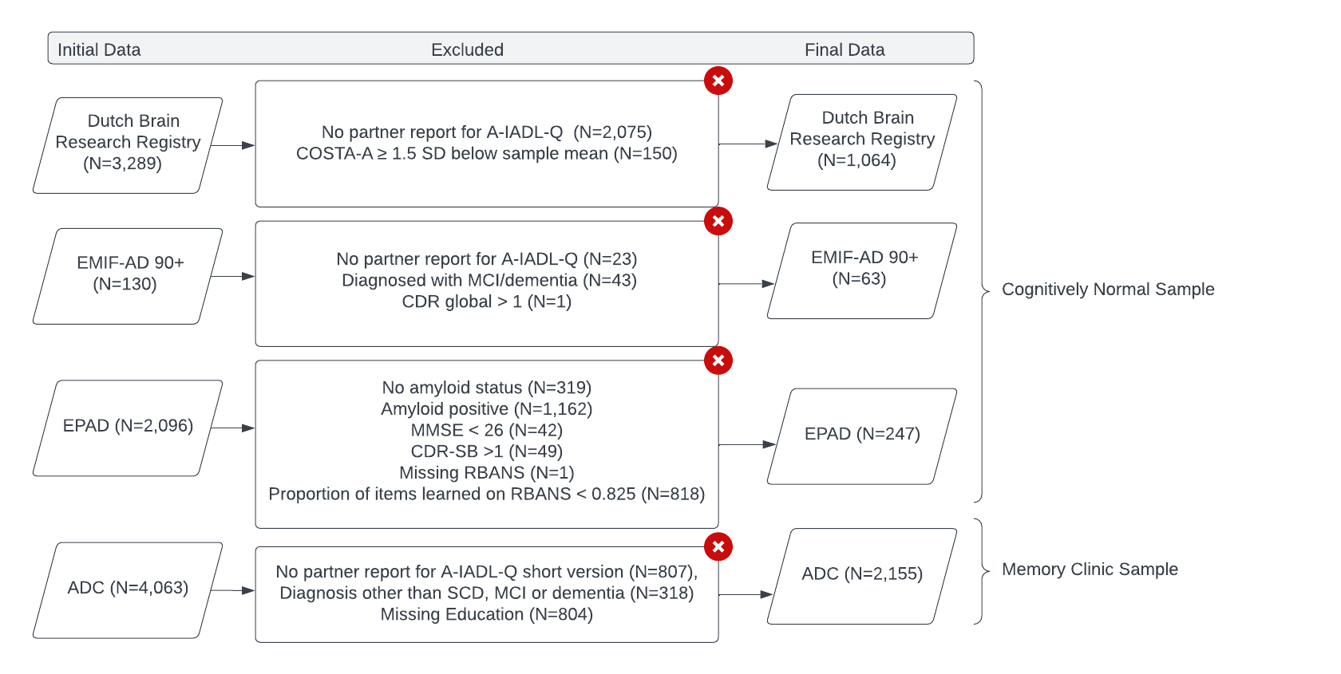

FigureS1. Flow chart of the exclusion criteria of our study.

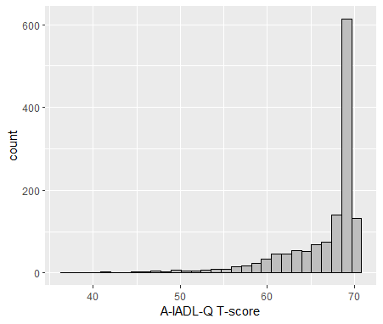

FigureS2. Histogram distribution of the raw A-IADL-Q T-score in the cognitively normal sample.
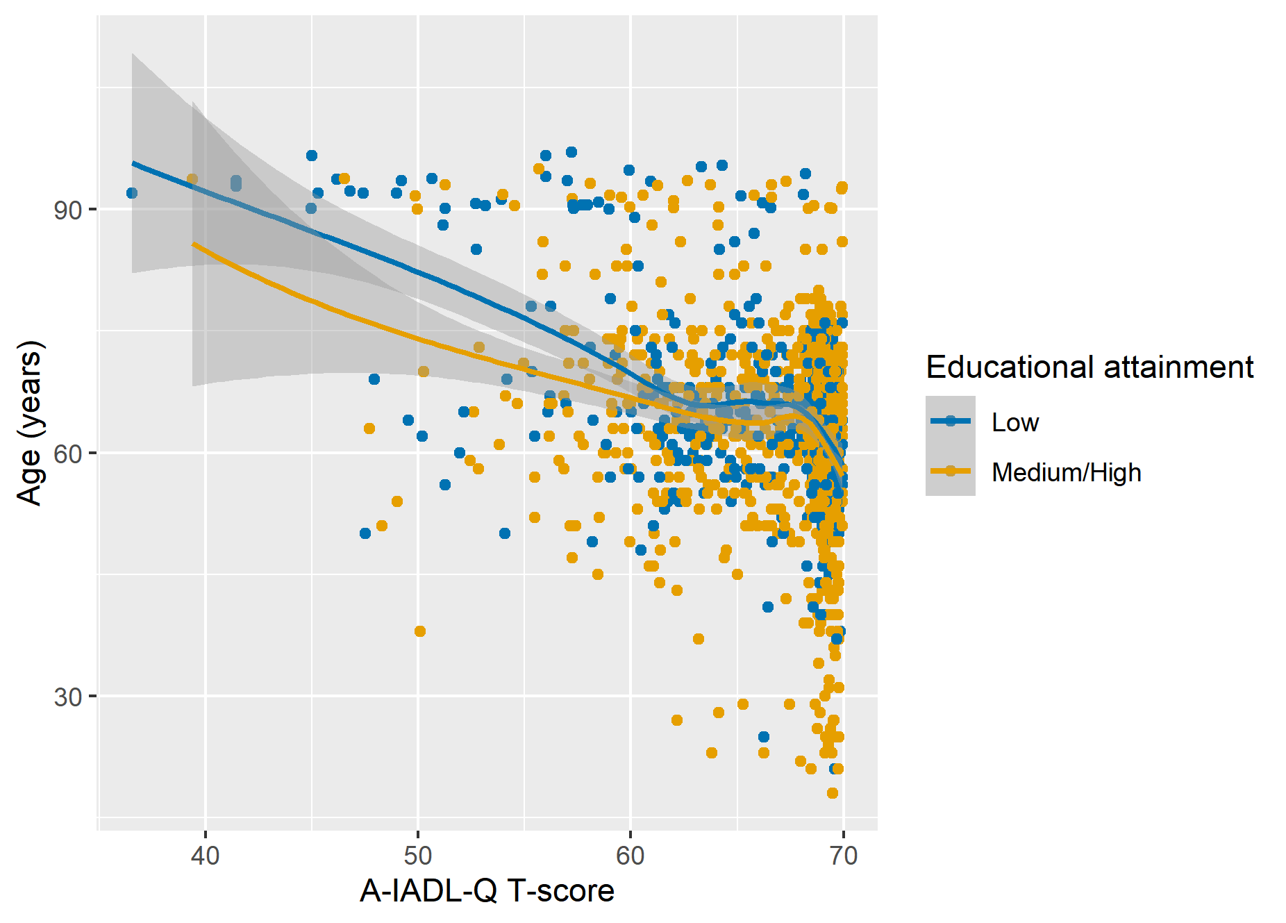

FigureS3. Plot of A-IADL-Q performance over age, split by educational attainment.
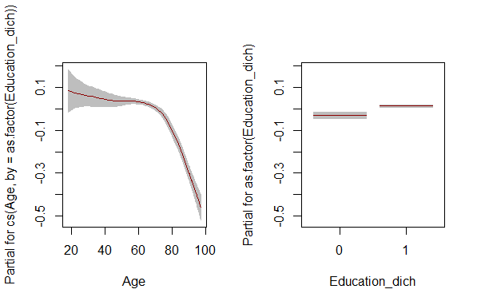

FigureS4. Plot of the fitted terms for the normative model.
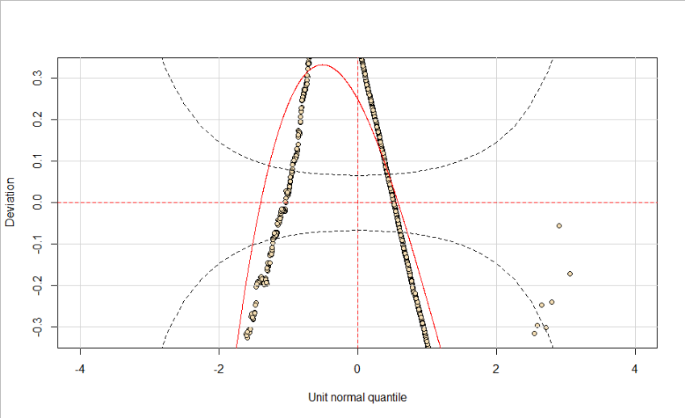

FigureS5. Worm plot of the normative model.
The majority of data points, which form a worm-like string, do not fall within the 95% confidence interval (dotted black lines), which define the area wherein the worm ideally should be. Thus, the shape of the worm, which should be flat, indicates that our data differs from the Beta distribution.

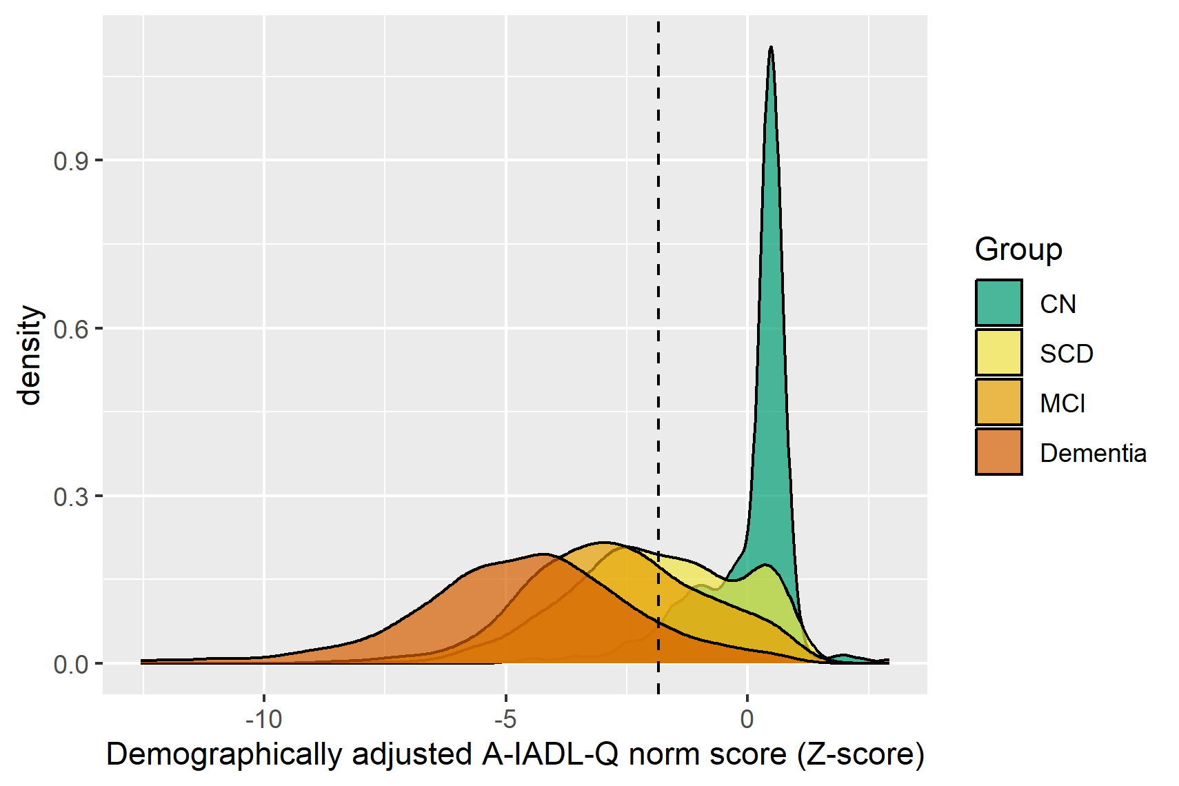

FigureS6. Density plot showing the distribution of the demographically adjusted norm scores of the A-IADL-Q in the different diagnostic groups.
The dashed vertical line marks the optimal cutoff to distinguish CN from dementia. CN = cognitively normal; SCD = subjective cognitive decline; MCI = mild cognitive impairment

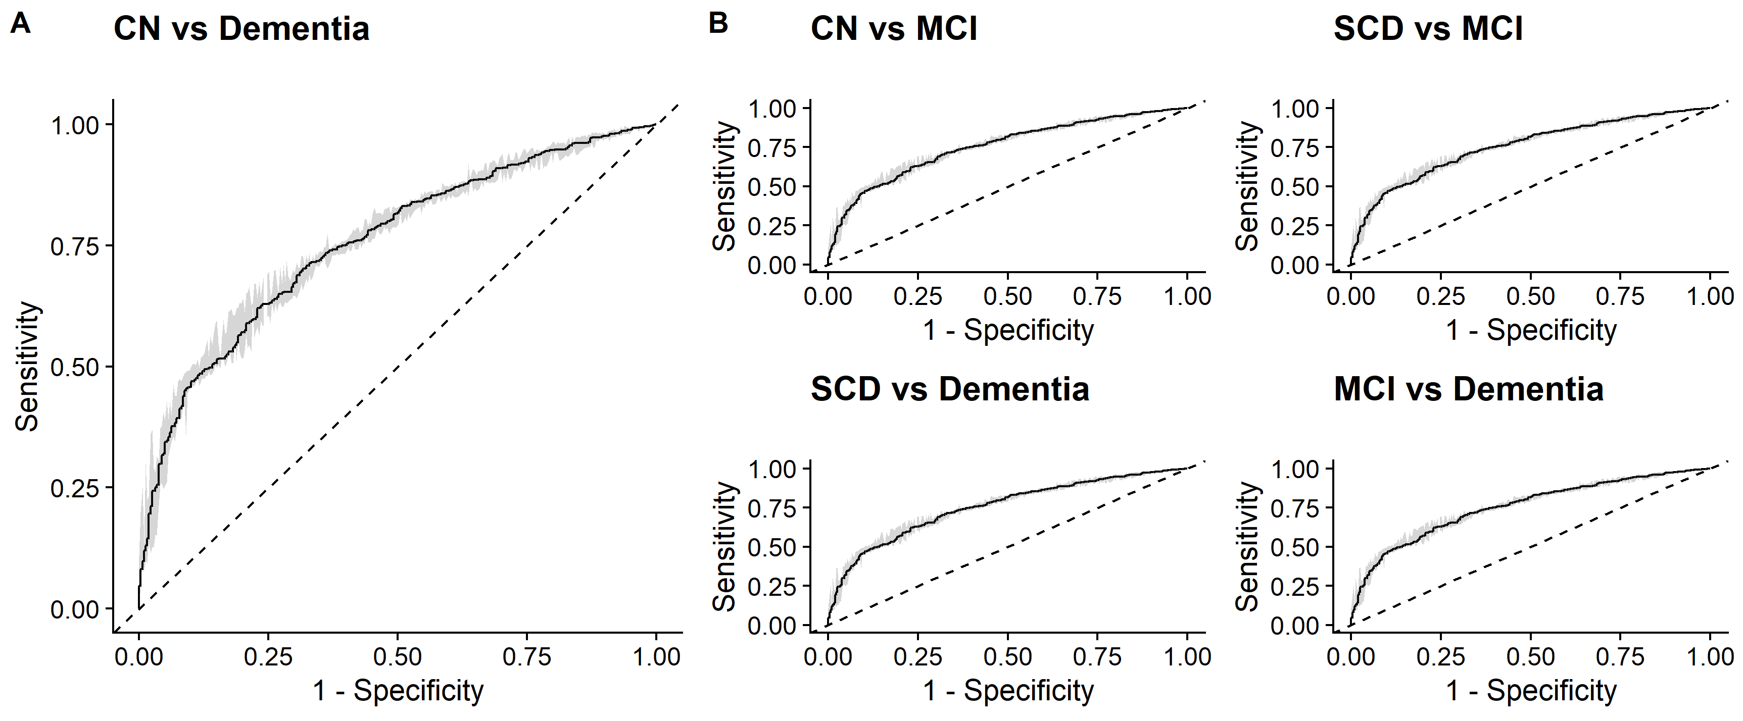
FigureS7. Receiver Operating Curves for (A) CN versus dementia, and (B) other diagnostic contrasts. All plots correspond to the cutoff value of -1.85, which we established to be the optimal cutoff to distinguish CN from dementia. CN = cognitively normal; SCD = subjective cognitive decline; MCI = mild cognitive impairment.

