Supplemental Material

Table 1
Subjective feedback from the usability survey (n=53).
Questions | 18-54 y/o | 55-78y/o | p-value
N | 40 | 13
How often do you use your computer in your daily life?  Everyday  More than two days per week  Less than once in a week  Rarely  Never | 33  6  1  0  0 | 12  1  0  0  0 | 0.0659
How do you rate the following items (0 being the lowest and 100 being the highest)?  Tasks accessibility (M/SD)  Task difficulty (M/SD)  Instructions clarity (MD/SD) | 94.5/7.6  44.18/24.87  89.43/20.57 | 88.3/19.2  59.42/34.65  82.08/23.51 | 0.098  0.098  0.285
How comfortable are you using a computer, including emails and the Internet (0 being the lowest and 100 being the highest)?" (M/SD) | 92.98/10.22 | 83.92/21.34 | 0.04
How did you feel during the tests?  Good  Stressed, anxious  Distracted  Confused  Proud  Other | 24  9  5  0  2  0 | 9  2  0  0  2  0 | 0.334
What did you think about the duration of the test battery?  Too short  Appropriate  Long  Too long | 0  19  18  3 | 0  10  3  0 | 0.156
In your opinion, could the addition of verbal instructions have facilitated your understanding of task instructions?  Yes  No | 7  32 | 3  10 | 0.685
Did you encounter any issues during the tests? (e.g., technical problems or difficulty understanding the task)  Yes  No | 35  5 | 7  6 | 0.009
How many times did you take a break during the tasks?  None  Once or twice  More than twice | 32  8  0 | 13  0  0 | 0.08
How many times were you interrupted during the tasks?  None  Once or twice  More than twice | 23  13  4 | 9  4  0 | 0.465

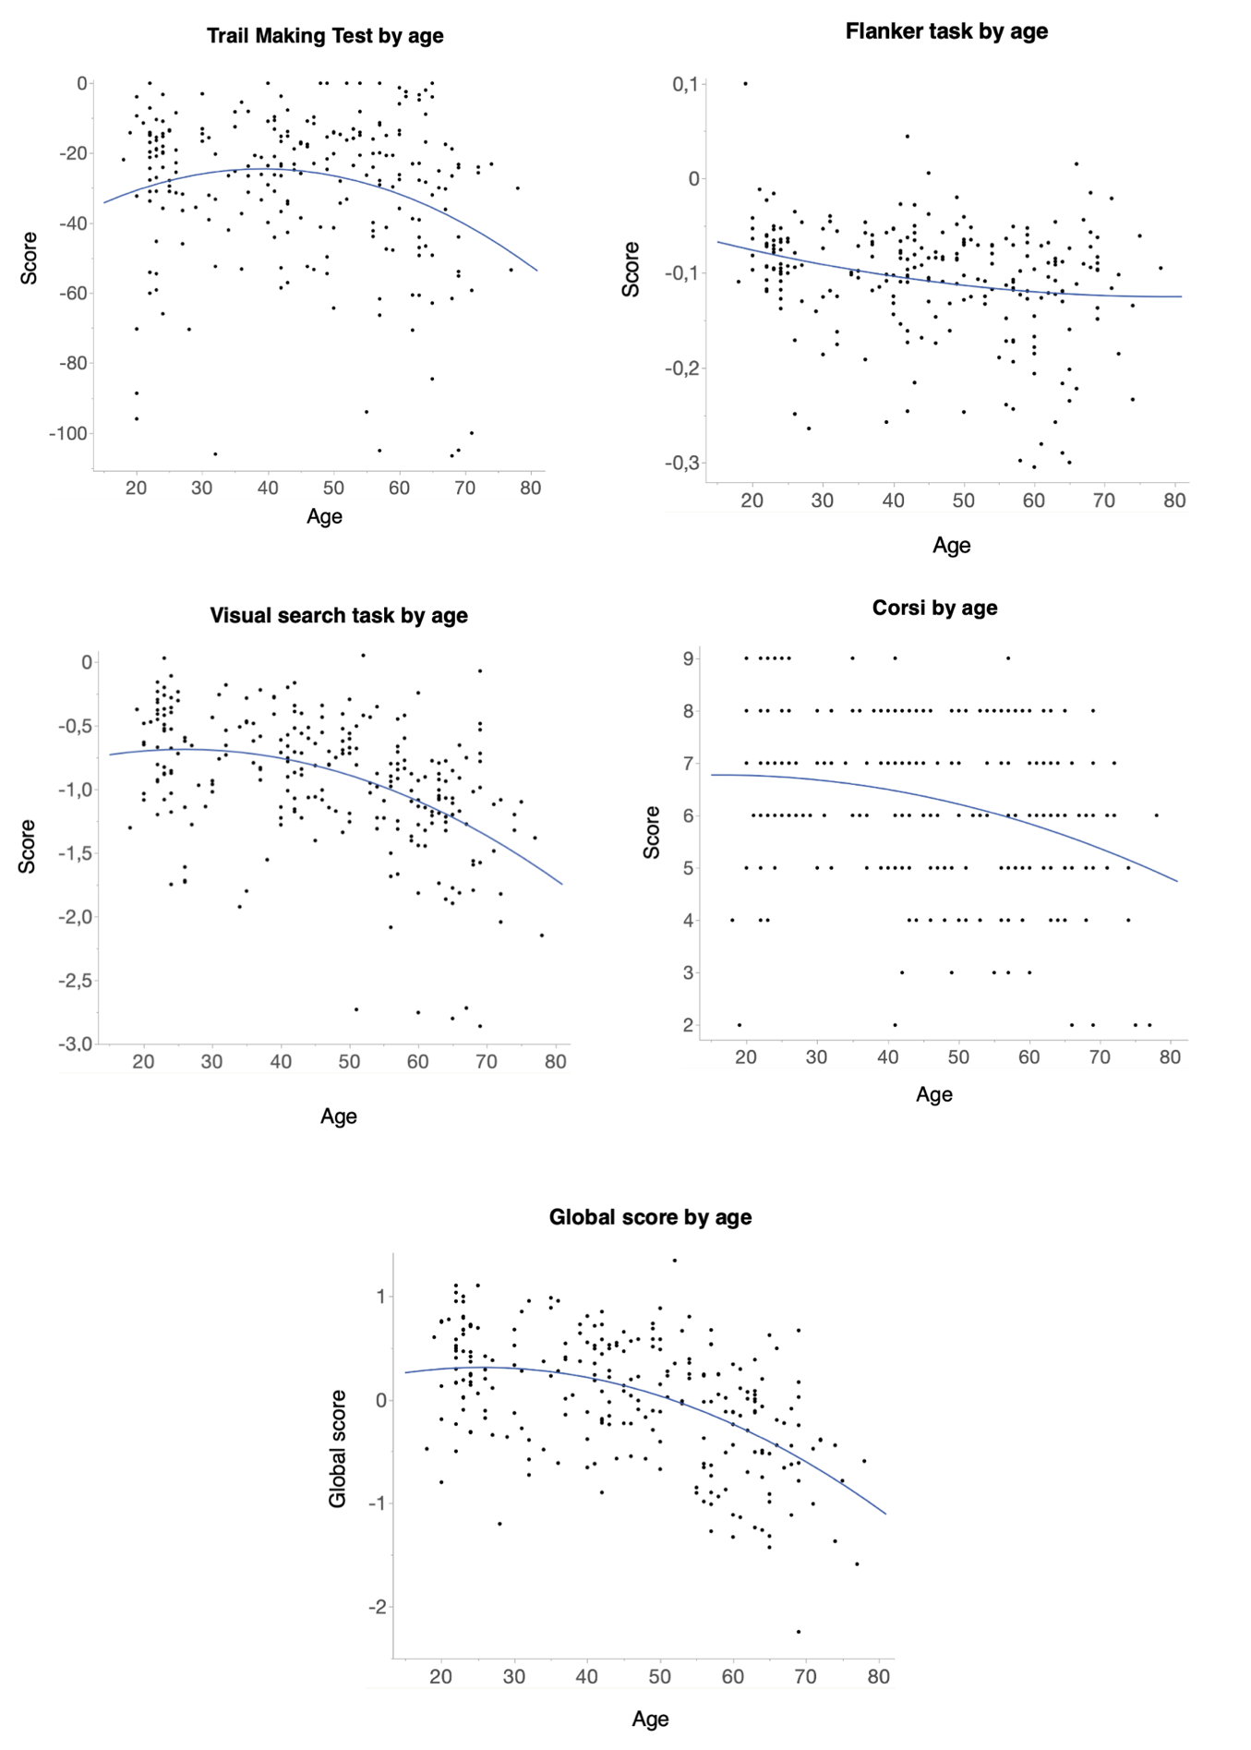
Fig. 1. Quadratic curve fit of the relationship between age and task scores. Higher score corresponds to higher cognitive performance.

