Supplemental Material

Supplemental Figure 1. Mean Mini-Mental State Exam (MMSE) scores at baseline and follow-up for primary and secondary English speakers

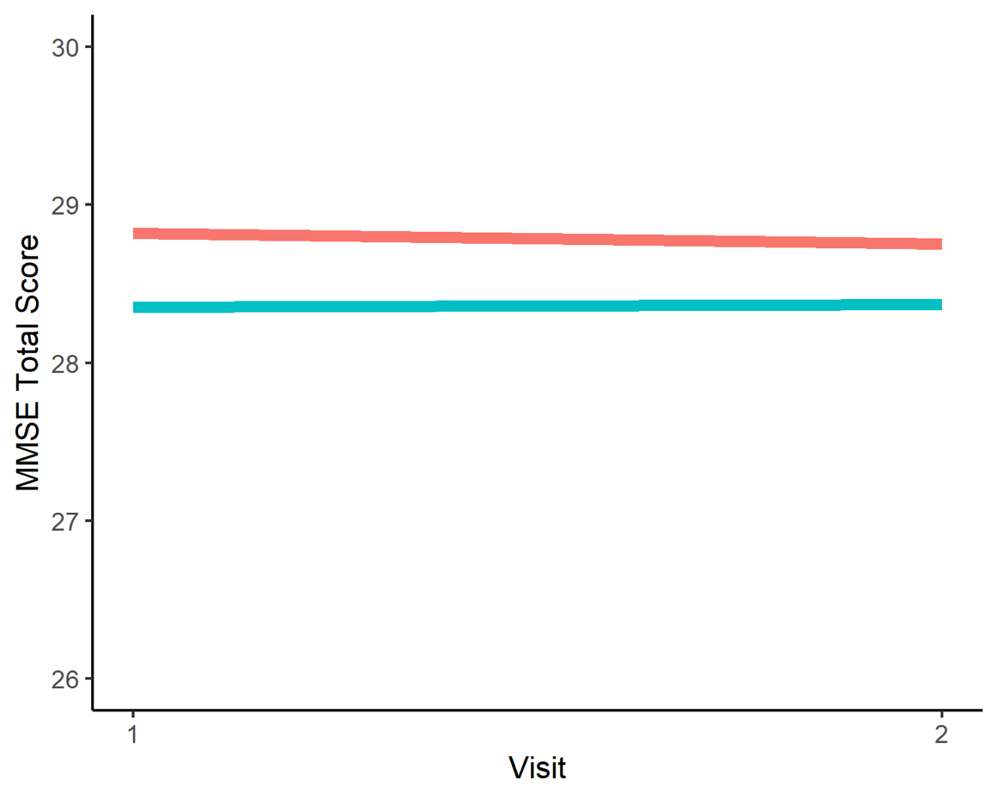
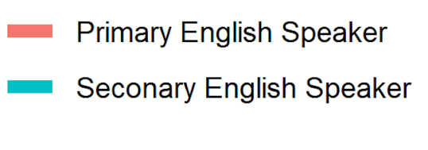
Primary English Speaker

Secondary English Speaker

Supplemental Figure 2. Mean Logical Memory Story A Immediate Recall (Logical Memory I) total scores at baseline and follow-up for primary and secondary English speakers
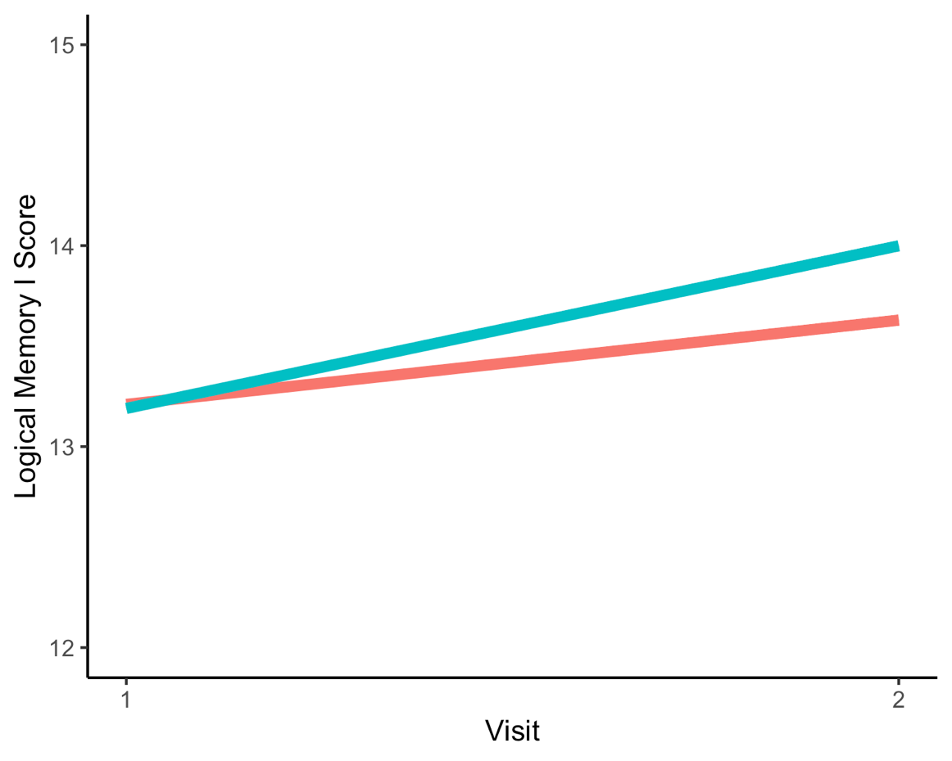

Primary English Speaker

Secondary English Speaker

Supplemental Figure 3. Mean Logical Memory Story A Delayed Recall (Logical Memory II) total scores at baseline and follow-up for primary and secondary English speakers

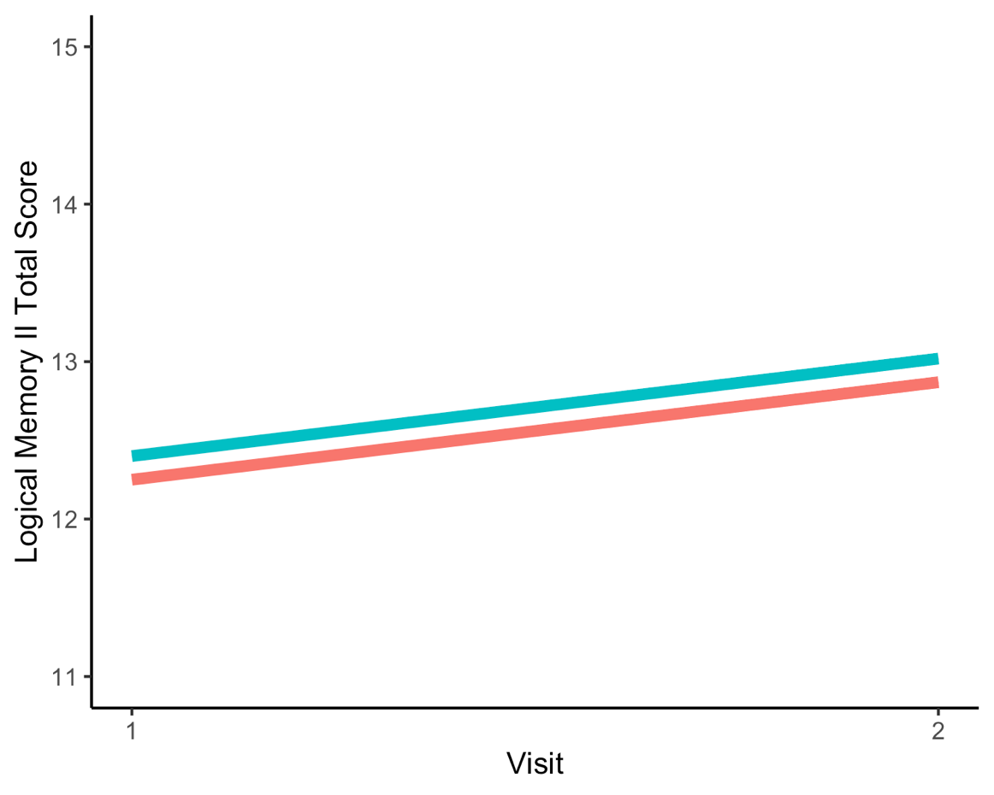
Primary English Speaker

Secondary English Speaker

Supplemental Figure 4. Mean Digit Span Forward total scores at baseline and follow-up for primary and secondary English speakers
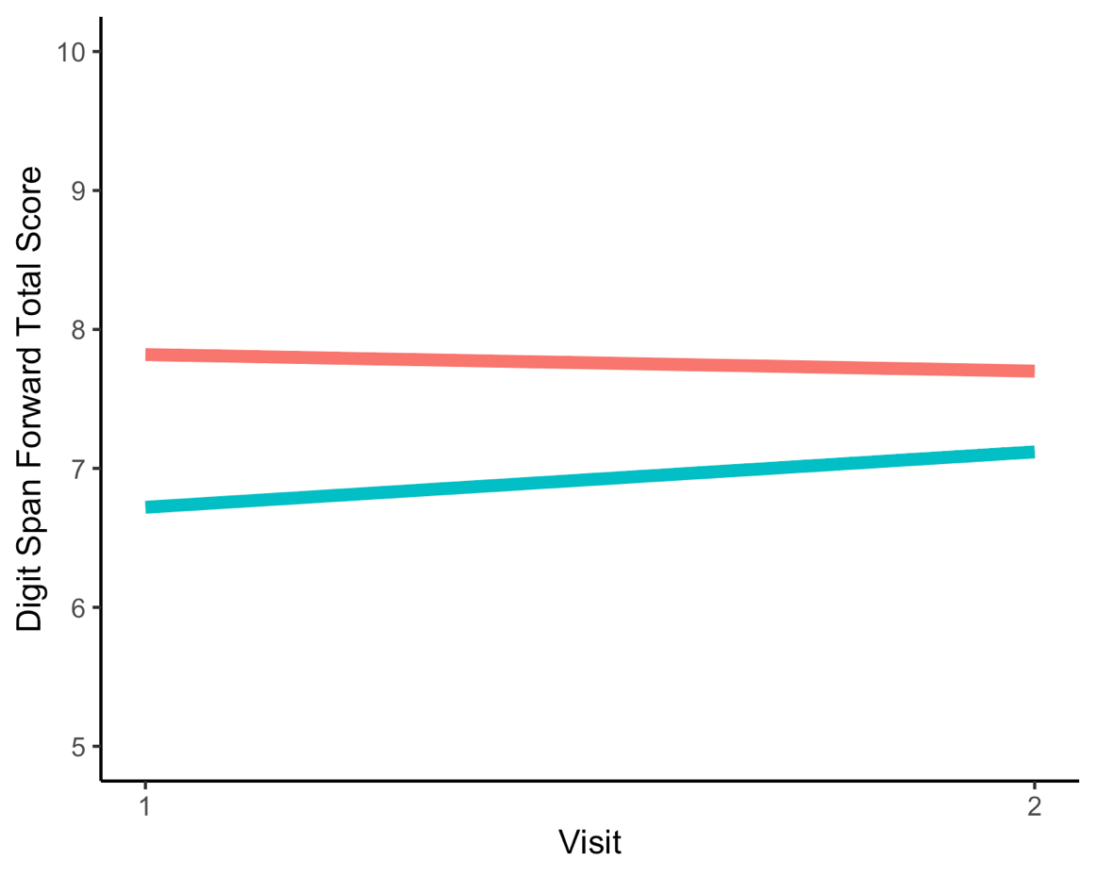
Primary English Speaker

Secondary English Speaker

Supplemental Figure 5. Mean Digit Span Forward span scores at baseline and follow-up for primary and secondary English speakers
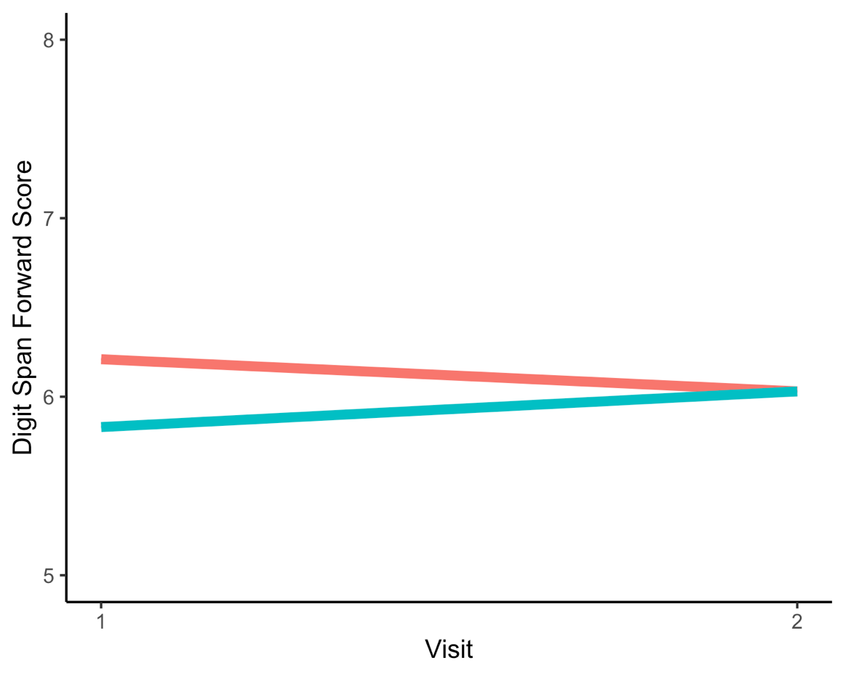
Primary English Speaker

Secondary English Speaker

Supplemental Figure 6. Mean Digit Span Backward total scores at baseline and follow-up for primary and secondary English speakers

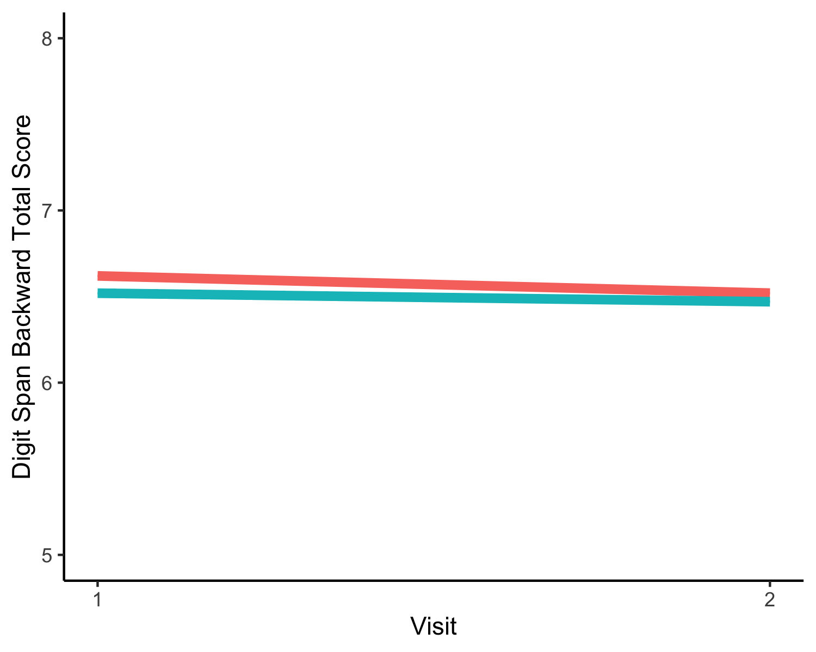
Primary English Speaker

Secondary English Speaker

Supplemental Figure 7. Mean Digit Span Backward span scores at baseline and follow-up for primary and secondary English speakers

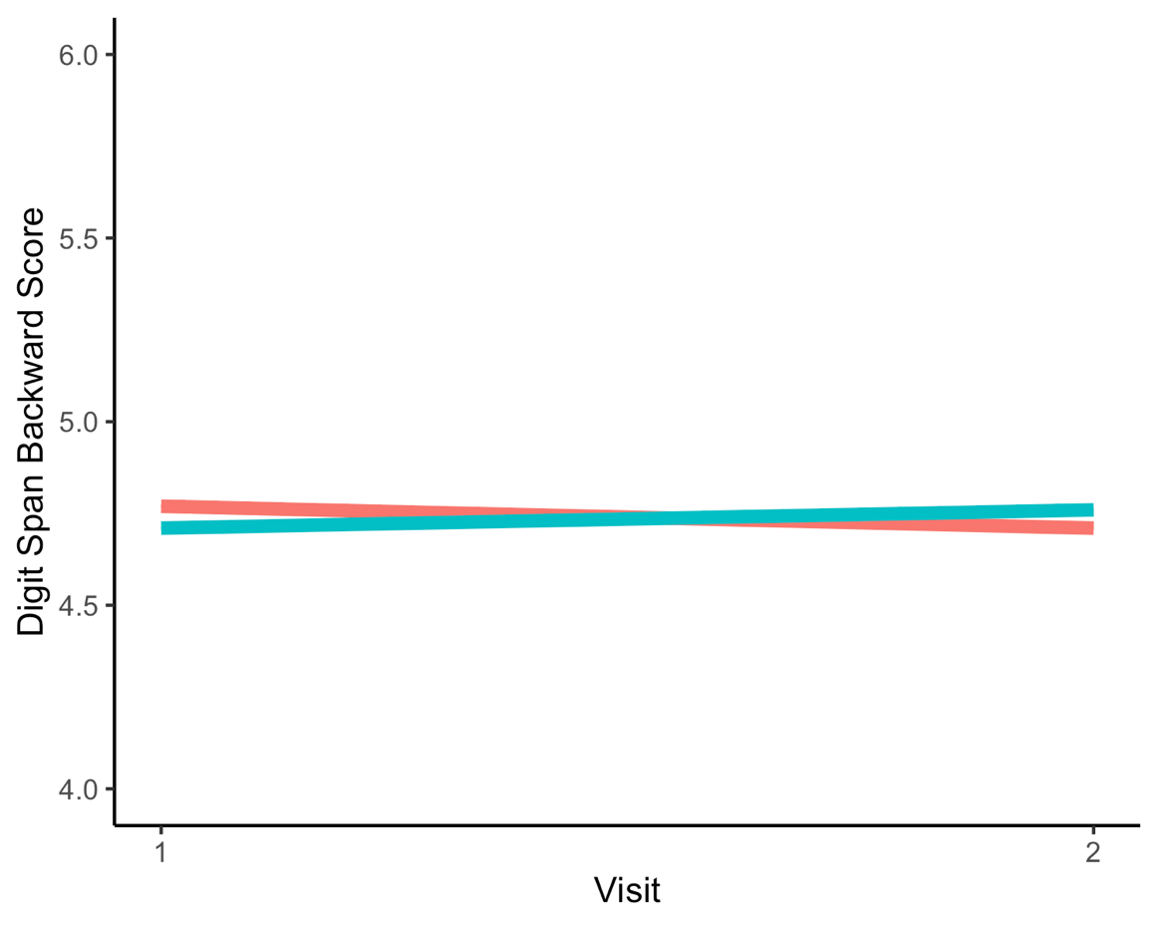
Primary English Speaker

Secondary English Speaker

Supplemental Figure 8. Mean Animals total score at baseline and follow-up for primary and secondary English speakers

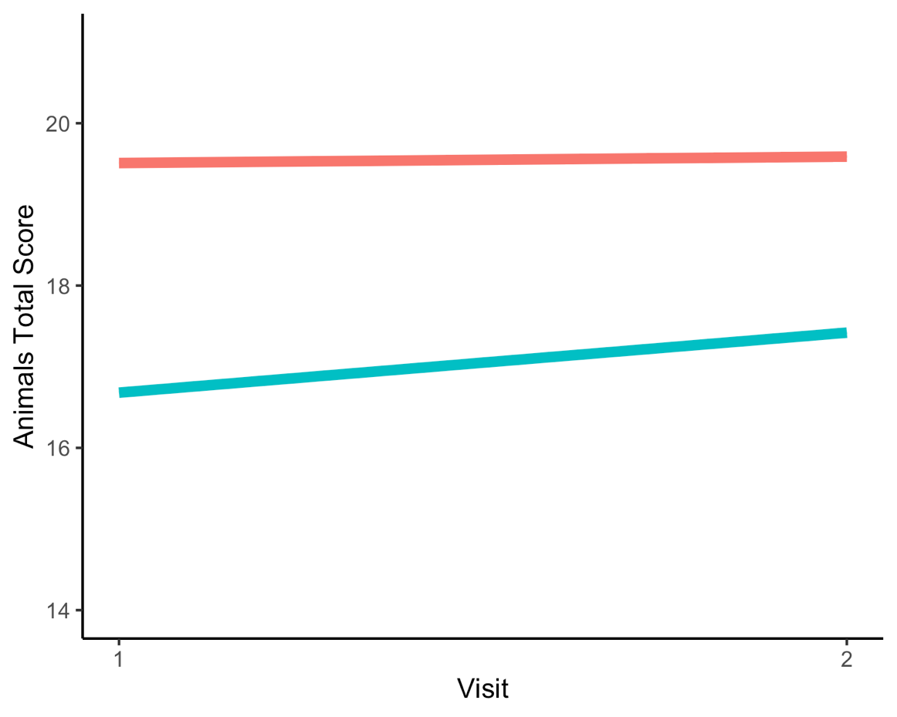

Primary English Speaker

Secondary English Speaker

Supplemental Figure 9. Mean Vegetables total score at baseline and follow-up for primary and secondary English speakers

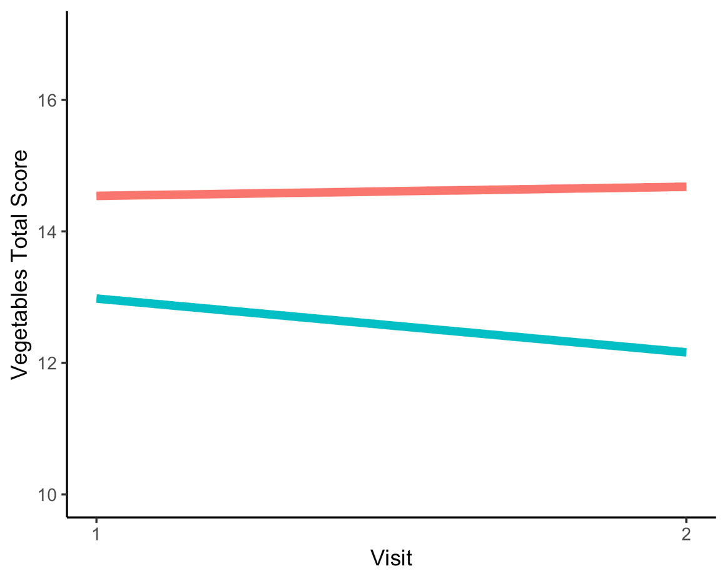
Primary English Speaker

Secondary English Speaker

Supplemental Figure 10. Mean Trail Making Test Part A total time at baseline and follow-up for primary and secondary English speakers

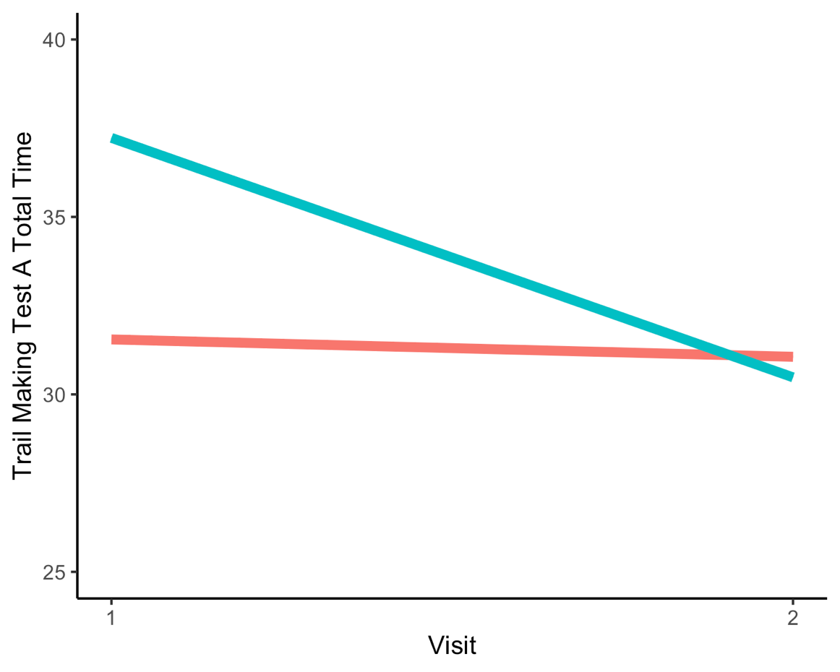

Primary English Speaker

Secondary English Speaker

Supplemental Figure 11. Mean Trail Making Test Part B total time at baseline and follow-up for primary and secondary English speakers
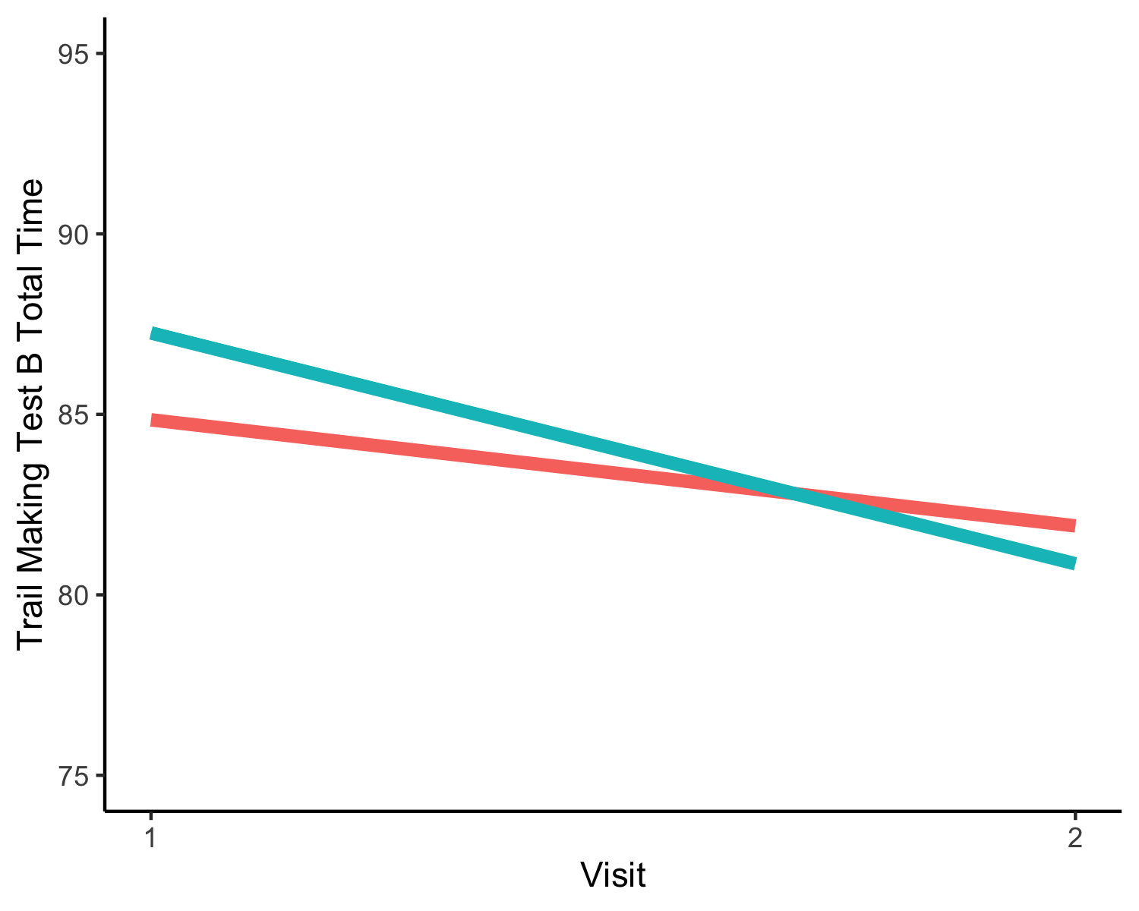
Primary English Speaker

Secondary English Speaker

Supplemental Figure 12. Mean Digit Symbol total score at baseline and follow-up for primary and secondary English speakers

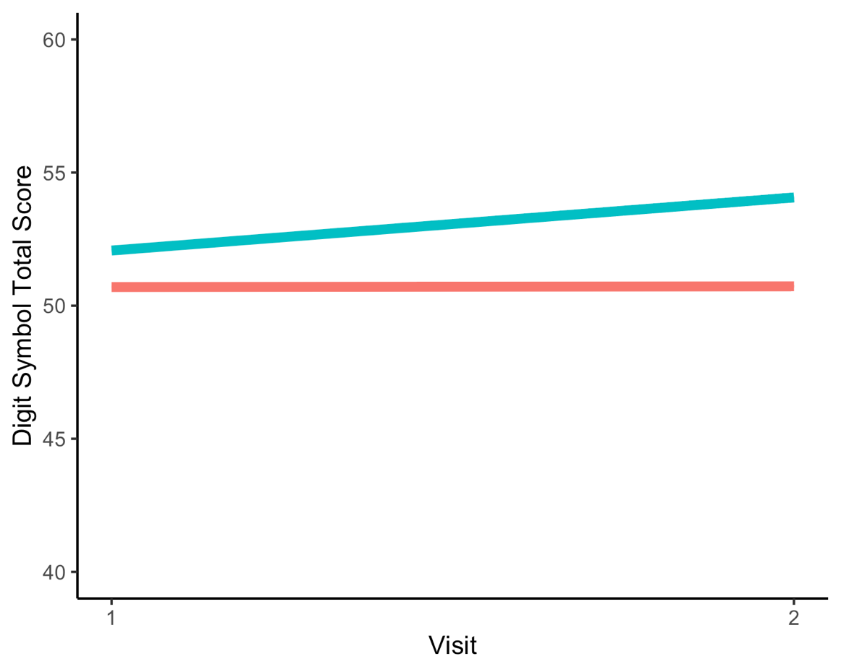

Primary English Speaker

Secondary English Speaker

Supplemental Figure 13. Mean Boston Naming Test-30 total score at baseline and follow-up for primary and secondary English speakers

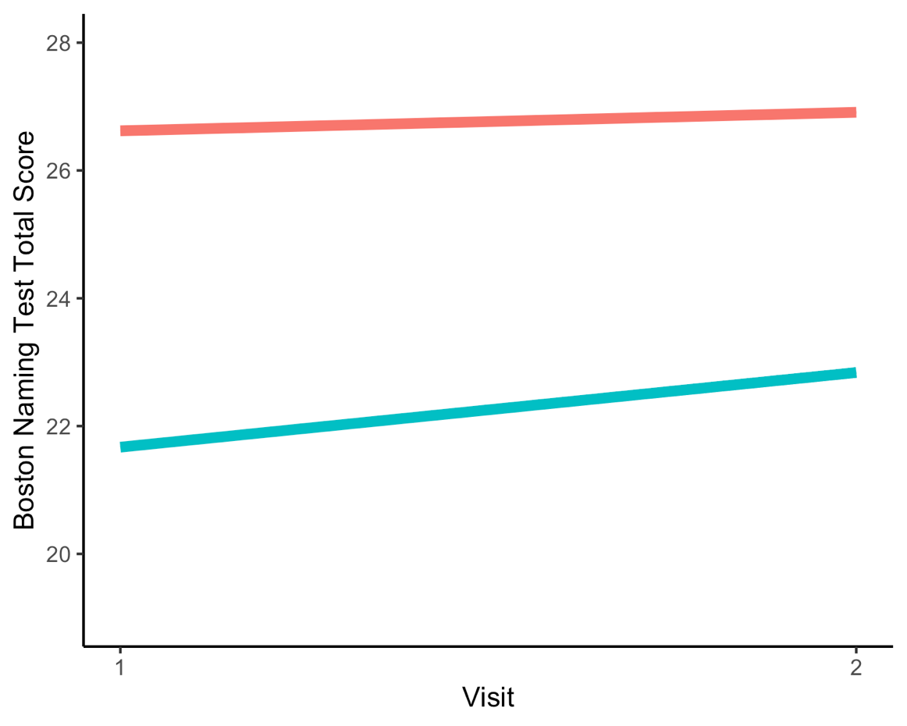

Primary English Speaker

Secondary English Speaker

