A01

B02

C03

D04

E05

**Fig 2. Weekly measures of mood instability (Internal State Scale), emotional dysregulation (DERS-16) and anxiety (BAI) scores in 10 subjects undergoing Imagery focused cognitive therapy during the baseline (B1-B4), treatment (T1-T10) and follow-up (F1-F4) phases**

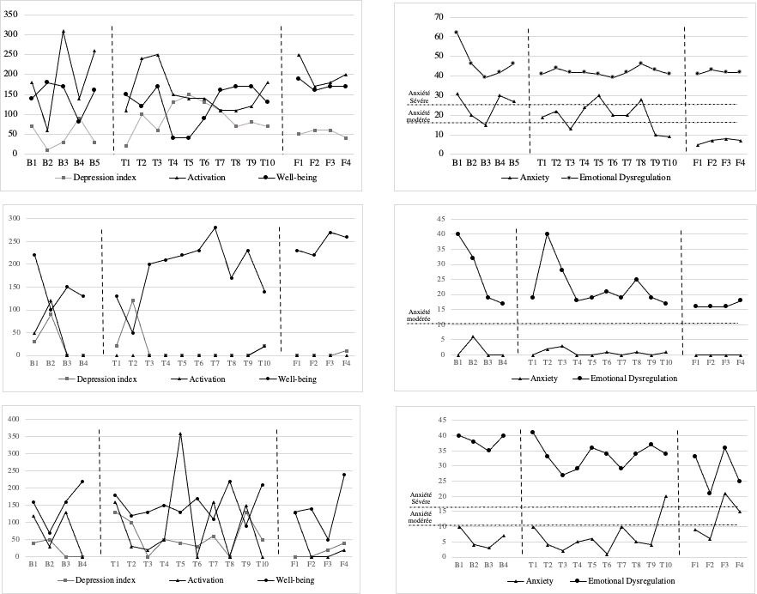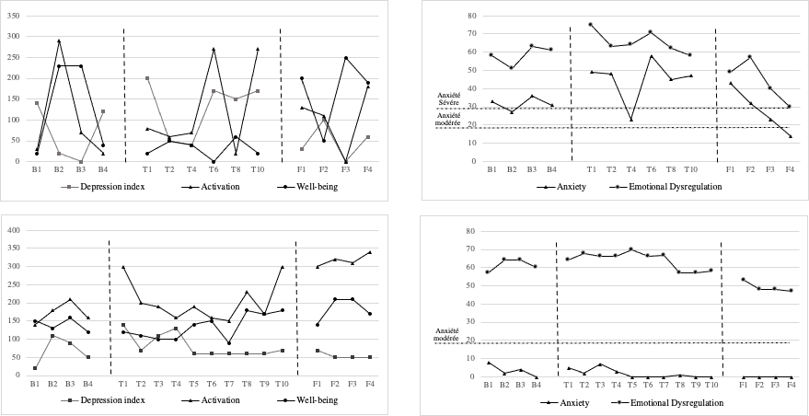

J10

F06

D07

H08

I09

*The scoring method of the ISS uses the activation and the well-being subscales as measures of euthymia, depression, (hypo)mania or mixed state. Hypomania (ACT > 155, WB > 125), mixed state (ACT > 155, WB < 125), euthymia (ACT < 155, WB > 125), and depression (ACT < 155, WB < 125)*

